HPC Use Cases – Base Case and Common Cases

Motivations
Points to understand about defining an HPC base use case:
- This case represents the simplest use case, which all job scheduling clients and services are expected to understand and support.
- This case represents the simplest HPC use case, not the simplest HPC Grid use case. Assuming that the term “Grid” refers to interactions among parties spanning organization boundaries, this use case reflects the fact that there are important and common HPC use cases that do not span multiple organizations.
Points to understand about defining additional, richer, common HPC use cases:
- The goal is to identify a set of important use cases that any HPC interoperability design should be able to cover as selectively offered extensions to a simple, basic, HPC interoperability design.
- Common use cases represent use cases that some significant fraction of the HPC community wishes to support. They do not represent use cases that all participants of the HPC community are expected to support. For example, it is conceivable that some significant fraction of the HPC community will eventually participate in a global distributed “grid file system” that spans virtual organizations. However, it may be equally likely that a significant fraction – perhaps even a majority – of the HPC community does not participate in such a system. Common use cases would need to be defined for both these scenarios, with an understanding that in this instance they represent alternative use cases rather than aspects of some global use case that everyone is expected to participate in and support.
- The set of common use cases defined implicitly represent the class of use cases at which an extensible HPC Grid interoperability design will be targeted. It should be understood that esoteric use cases not included in the common use case set may not be supportable by the extensible HPC Grid design that this design effort (and eventually the associated working group) will be creating. That is, to enable better understanding and predictability of the implications of composing multiple, independent design extensions a limited form of extensibility will likely be chosen rather than a fully general one. How limited a form of extensibility is chosen will be informed by the requirement that the set of common use cases defined must be realizable by it.
- Use cases capture client-visible functionality requirements rather than being technology/system-design-driven. Thus, for example, a use case might specify that a “meta-scheduling” service be available that allows users to submit jobs to the set of all compute clusters within an organization. In this document the use case would not concern itself with how that meta-scheduling service is implemented or what component services it might consist of.

Base Case
The simplest HPC use case is a high-throughput compute cluster that is managed by a batch job scheduler and that is used only from within an organization. It has the following characteristics:
- Users can make the following requests to a job scheduler:
- Submit a job for execution, with a specification of resource requirements. The scheduler will return either a scheduler-relative unique jobID or a fault reply.
- Query a specific job for its current state. Users can only query jobs that were submitted using their user credentials. The scheduler will return either a standard description (to be defined) of the specified job’s state, including its current execution state (see below) and a copy of the submission request, or a fault reply if the job is unknown.
- Cancel a specific job. Users can only cancel jobs that were submitted using their user credentials. The scheduler will return either an indication that the cancellation succeeded or a fault reply.
- List jobs. Users can request a list of the IDs of all jobs that have been submitted using their user credentials. The scheduler will return either a list of jobIDs or a fault reply.
- The state diagram for jobs that have been submitted by a client to a job scheduler contains three states: queued, running, and finished. A job is in the queued state while it is waiting to run. Once the scheduler has dispatched the job to actually run on resources that have been allocated to it, the job is in state running. When the job terminates – for whatever reason – it enters the finished state. Jobs may terminate because they successfully exit, exit with an error code, get cancelled by someone, or because the resources they depend on fail in some manner.
- Only a small set of "standard" resources can be specified in resource descriptions, such as number of CPUs/compute nodes needed, memory requirements, disk requirements, etc. While not described in this document, it is assumed that there are (or at least will be) standardized, well-known semantics associated with the meanings of these resource descriptions and any associated scheduling behaviors they imply. Part of the semantics that must be defined for these resource descriptions is the set of comparison operations that may be used in a description. Only equality of string values and numeric relationships among pairs of numeric values are provided in the base use case.
- Once a job has been submitted it can be cancelled, but its resource requests can't be modified.
- Data access issues are considered to be out-of-band, e.g. because of the presence of a distributed file system. Stated somewhat differently, data access is considered to be an application issue rather than something that is supported as part of the underlying HPC infrastructure (for this base use case).
- Program provisioning is also considered to be out-of-band. That is, programs are assumed to be pre-installed – either directly on the compute nodes of the cluster or on something like a distributed file system that is accessible from the nodes of the compute cluster.
- Creation and management of user security credentials is considered to be out-of-band. Users are assumed to have the necessary credentials needed to submit both data and work to the compute cluster. Note that this covers, among other scenarios, systems where all jobs are run using “anonymous” credentials and users must explicitly stage any private data they wish to use to common “pool” storage facilities.
- The compute cluster's job scheduler is reachable at a well-known communications endpoint. Thus there is no need for directory services beyond something like DNS.
- Management of the system resources (i.e. compute nodes) and services of the compute cluster is out-of-band and indeed opaque to users of the cluster. This is not to say that there isn’t a standard means of managing a compute cluster; just that system management is not part of the HPC cluster use case.
- Fault tolerance model:
- If a job fails due to system problems then it must be resubmitted by the client (as a new job); the job scheduler will not automatically rerun the job.
- The scheduler can fail but must keep information about jobs it has received on persistent storage. The scheduler may discard information about jobs that have finished longer than a given time period ago, with the value for that time period being a standardized value (likely to be at least 1 day). If persistent storage fails then all job information – past and present – is assumed lost.
- Failure of the scheduler may or may not cause currently running jobs to fail.
- Jobs eventually time out and are garbage collected if they don't finish of their own accord or get cancelled by a user request.
- When a job exits (for whatever reason) information is kept about the following:
- Whether it exited successfully, with an error code, or terminated due to some other fault situation.
- How long it ran in terms of wall-clock time.
This information is kept for a time period determined by the administration policy of the compute cluster.
- The only scheduling policy supported is FIFO, with each job at the front of the job queue getting assigned to the first available free compute node. Concepts such as quotas and other forms of SLAs are out-of-scope for this basic use case.
- Jobs are completely independent of each other. The notion of dependencies among jobs is out-of-scope.
- A job consists of a single program running on a single compute node; infrastructure support for parallel, distributed programs – such as MPI programs – is not assumed in the base HPC use case.
- Reservation of resources separate from allocation to a running job is out-of-scope. That is, things like reserving resources for use at some particular time in the future is not supported.
- Interactive access to running jobs is out-of-scope. It is not prohibited, but is viewed as being an application-level concept that has no system support (at least in the base use case).

Common Cases
It is worth reemphasizing here that the purpose of enumerating common use cases is primarily to inform the design of the extension mechanisms that the HPC Grid profile working group will define. Various common use cases may be alternatives to each other while others may represent incremental extensions of each other.

Exposing existing schedulers’ functionality
Existing popular HPC batch job schedulers represent, almost by definition, common HPC use cases. A list of schedulers – presented in alphabetical order and not intended to be comprehensive by any means – to be explored to understand the functionality they offer includes the following:
- Condor
- Globus
- LSF
- Maui
- Microsoft-CCS
- PBS
- SGE
Appendix A gives an overview of the functionality of various commonly used batch job schedulers.

Polling vs. Notifications
The base use case requires that client users and/or their software poll a job scheduler in order to determine the status of a submitted job. An alternative approach is to allow clients to optionally request the receipt of notification “call-back” messages for significant changes in the state of a job (meaning changes from queued to running or running to finished).
The base case does not include this capability because there is a spectrum of different delivery guarantees that can be associated with a notification interface. The easiest-to-provide design offers best-effort delivery semantics, where there are no guarantees concerning whether or how soon after a job state change takes place a notification message will be delivered to a registered client user. That is, fault events occurring within the job scheduler, the compute cluster, the network between the scheduler and the client, or elsewhere may cause notification messages to be delayed for arbitrary amounts of time or not delivered at all.
Unfortunately, whereas best-effort notification delivery semantics may provide significant efficiency gains over a polling interface, they do not reduce the programming complexity required to implement client software that may be trying to do something like orchestrate a workflow of multiple jobs. However, to support a significant reduction in client complexity would require substantially more difficult-to-provide guarantees of a system’s infrastructure than best-effort notification delivery guarantees do. Since job schedulers are not required to be highly available in the base use case, the client must be prepared to poll in any case for the situation where a scheduler has crashed and will not recover for a longer period of time. Since network partitions can occur, the client must be prepared to deal with arbitrary delays in notification delivery and with the ambiguity of distinguishing between scheduler crashes and network partitions. Similarly, the scheduler must keep trying to delivery notifications in the face of client inaccessibility – be it due to client crash/disappearance or network partition. How often should the scheduler try to deliver a notification message? How to trade-off additional overhead vs. timeliness of delivery does not have an obvious answer. (Consider that a high throughput computing facility may have many thousands of jobs queued up to run, all of which can queue up notification messages to be sent out during a network partition.) All these considerations make it unclear whether there is a practically useful common case that involves the use of stronger than best-effort notification delivery semantics.

At-Most-Once and Exactly-Once Submission Guarantees
The base use case allows the possibility that a client can’t directly tell whether its job submission request has been successfully received by a job scheduler or not. This is because the request or the reply message may get lost or the scheduler may crash at an inopportune time. Since the scheduler is required to maintain a persistent list of jobs that it has received and started executing, clients can obtain at-most-once execution semantics (subject to the scheduler’s persistent storage facilities not being destroyed) as follows:
- If the client receives a reply message for its job submission request then it knows that the scheduler has received the request and has or will eventually execute the job.
- If the client does not receive a reply message for a given job submission request then it must issue a list-jobs request to the scheduler and compare the list of jobIDs returned against its own list of previously returned jobIDs to see if there are jobs that are unaccounted for.
Some systems allow clients to include a client-supplied unique jobID in a job submission request in order to enable things like suppression semantics for duplicated job submissions. This enables somewhat simpler client middleware code to be written since clients always have a list of jobIDs that they can employ to query a job scheduler about whether a particular job submission has been received or not.
While this is a reasonable extension use case to consider, it is not part of the base use case for the following reasons:
- Not all schedulers provide it.
- It requires that clients be able to verifiably create globally unique IDs, which requires infrastructure that is not currently assumed by the base use case. In particular, verifiable generation of globally unique IDs – so that buggy or malicious clients can’t interfere with others’ job submissions – requires suitable trust authorities and an associated security infrastructure, which are not presumed in the base use case.
An alternative approach to simplifying client middleware is to require exactly-once job submission semantics. In this case, a client knows precisely, at the time of submission, whether a job submission request has been received and persistently recorded or not. Furthermore, it knows this without having to verifiably generate a globally unique ID. The disadvantage of this use case is that exactly-once submission semantics require heavy-weight mechanisms, such as distributed two-phased commits between client and job scheduler, for their implementation.

Types of Data Access
The base use case assumes that data staging is something that occurs at the application level and hence is out-of-band to the HPC support infrastructure. At least two additional common use cases can occur:
- The HPC infrastructure explicitly supports non-transparent staging of data between independent storage systems.
- The HPC infrastructure explicitly supports transparent data access within a virtual organization or across a federated set of organizations.
Several different forms of explicit data staging can be imagined:
- The simplest form is simply the ability to copy files and directories of files between independent storage systems. Within an organization that may be as simple as using a (recursive) file copy utility. Copying data between systems that reside in different organizations requires additional support to deal with matters such as fire walls in particular and security in general.
- Users may also want convenience/efficiency features, such as “rsync”-style differencing capabilities between two copies of a data set. In this use case, clients copy a data set to a second storage system and then subsequently “synchronize” the two copies on demand by copying only the differences that have occurred on either side to the other side (and flagging conflicting updates for out-of-band – e.g. human – resolution).
Transparent data access – typically in the form of a distributed file system – can also be embellished with various additional features:
- The simplest form allows transparent (remote) access to data that can be named using a distributed, shared name space. As with explicit data staging, this may be fairly trivial within an organization and may require additional, mostly security-related capabilities when enabled across multiple organizations.
- More sophisticated systems may also support caching and/or replication of data. However, from a user’s point-of-view, such features would be mostly transparent, unless also used in support of scenarios such as disconnected/partitioned operation of systems.

Types of Programs to Install/Provision/Run
Another axis along which various use cases can be distinguished is the kinds of programs to install, provision and run. The base case posits programs that are pre-installed, so that the supporting HPC infrastructure does not have to concern itself with issues such as provisioning. However, users may have programs that require explicit installation of some form. The simplest form of explicit installation involves copying the relevant files comprising a program (and its associated support data) to a location that is accessible from the compute nodes on which it is to run. A more complicated form of installation involves explicit subsequent installation operations, such as updating of OS registries, etc. In order for the underlying HPC infrastructure to support this kind of extended installation, the process must follow a standardized set of installation steps.
An interesting variation on the standardized installation approach is to employ client-supplied virtual machine images as the standard form of executable unit. This has several advantages:
- Complicated installation of things like services can be performed by the client before-hand; the HPC infrastructure need only understand how to receive a virtual machine image from a client and then run it on a suitable compute node.
- Cleanup after a job has finished is also very simple: all relevant data and processes to clean up are contained within the virtual machine.
Unfortunately virtual machines also have some disadvantages: They are potentially much larger than the corresponding programs that a client might supply otherwise. They may also incur an unacceptable performance overhead, for example, if their IO emulation is substantially slower than the underlying raw hardware.

Multiple Organization Use Cases
Arguably the most common Grid HPC use case involves submission of HPC jobs to a compute facility that resides in a different organization than the submitting client user does. This adds several addition wrinkles to the basic HPC use case:
- Submission of jobs requires additional security support in order to deal with either federation of identity information or, more simply, with authenticating a “foreign” user and mapping their identity to relevant credential and authorization information within the organization of the computing facility.
- Data residing on storage facilities controlled by the client’s organization must be either copied to suitable storage facilities controlled by the computing facility’s organization or made access across organizational boundaries. (This is one of the data access use cases described earlier.)
- If users from foreign organizations are trusted less than “local” users then their programs may need to be run with additional sandbox functions in place to prevent them from doing harm to the facilities of the computing facility or its organization.
An extension of the above use case is one in which the data needed by a program is controlled by a different organization than the one that either the job-submitting client or the computing facility reside in. In this case access to the data – either for purposes of explicit copying or as part of transparent remote access – must involve the use of delegated credentials/access rights.

Extended Resource Descriptions
The base use case assumes a small, fixed set of “standard” resources that may be described/requested in a job submission. Various systems may have additional kinds of resources that a client might want to specify, such as GPUs. One can imagine common use cases that define additional “standard” resource types. Another approach is to allow arbitrary resource types whose semantics are not understood by the HPC infrastructure, which deals with them only as abstract entities whose names can be compared textually and whose associated values can be compared textually or numerically depending on their data type. It is important to understand that, whereas the “mechanical” aspects of an HPC infrastructure can mostly be built without having to know the semantics of these abstract resource types, their semantics must still be standardized and well-known at the level of the human beings using and programming the system. Both the descriptions of available computational resources and of client requests for reserving and using such resources must be specified in a manner that will cause the underlying HPC “matchmaking” infrastructure to do the right thing. This matchmaking approach is exemplified by systems such Condor’s class ads system.
Another place where extended descriptions can occur is in the accounting information returned for a job. The base case only returns how long a job ran in terms of wall-clock time. Other common use cases may involve returning additional information, such as memory, disk, and network resources employed/consumed.

Extended Client/System Administrator Operations
Various common use cases involve client user-specified operations that are not supported by the base case. For example, users may wish to modify the requirements for a job after it has already been submitted to the job scheduling service – e.g. to extend the maximum lifetime it should be allowed to exist before getting forcibly terminated and garbage-collected.
Another common use case involves efficient interaction with arrays of jobs rather than just a single job. For example, a client user may wish to cancel all jobs currently running under their credentials – which might involve the cancellation of many hundreds or even thousands of jobs. Ideally this could be done with a single cancel request rather than having to issue hundreds or thousands of separate, individual cancel requests with all the attendant overhead that might be involved.
Several common use cases involve additional job scheduling operations that are most likely issued by system administrators rather than client users. These include suspension/resumption of jobs and migration of jobs among compute nodes (assuming that a given computing facility supports such operations – which may or may not be the case). Although implementation of such system administrator-issued requests may involve use of a separate system management infrastructure and associated interaction interfaces, the HPC infrastructure still needs to be aware of what is going on and may wish to reflect/expose some or all of the associated state information back to the owners of the affected jobs. For example, a job scheduling service might wish to expose the fact that a supposedly running job has been suspended.
An important aspect of exposing such information is that it must be done in a fashion that will not confuse simple client software (and unsophisticated client users) that will likely have no understanding of the semantics of such extended state information. Thus, for example, if a job that was in state running is suspended then client software and users expecting to see the job in one of the states queued, running, or finished should still see that state displayed, except perhaps with an extension or annotation that indicates that the job is in the suspended sub-state of state running.

Extended Scheduling Policies
There are a plethora of commonly employed scheduling policies beyond the simple one of first-come-first-served with round-robin allocation. These include everything from shortest/smallest-job-first to weighted-fair-share scheduling. Other concepts that are commonly supported are multiple submission queues, job submission quotas, and various forms of SLAs, such as guarantees on how quickly a job will be scheduled to run.

Parallel Programs and Workflows of Programs
The base use case concerns itself only with single instances of programs (also sometimes referred to as serial programs). There are several common use cases that involve multiple programs:
- Parallel, distributed programs, such as MPI programs require that the HPC infrastructure be able to instantiate such programs across multiple compute nodes in a suitable manner, including provision of information that will allow the various program instances to find each other within the cluster.
- Programs may have execution dependencies on each other. These may be static dependencies, such as which tasks must complete before a given task may be started. They may also be dynamic dependencies, implying the need for some sort of workflow orchestration system.
Whereas the HPC infrastructure needs to be cognizant of how to deploy MPI programs – so that concurrent program instances can be co-scheduled at the same time and can informed of which compute nodes the other instances are residing on – that is not necessarily the case for implementing either static or dynamic dependency criteria. These can be implemented as client-side applications, although an HPC infrastructure might choose to offer support for this kind of functionality in order to enable a more efficient implementation thereof – e.g. by trying to schedule dependent jobs that employ the same data on the same compute node.

Advanced Reservations and Interactive Use Cases
One common use case is the ability to reserve resources for use at a specific future time, for example, to run an interactive application.
Support for interactive applications also requires that these applications be able to communicate in real time with external client users and/or their externally running software. Depending on the system configuration and security policies of the computing facility this may or may not be easy to support.

Cycle Scavenging
The base HPC use case involves submitting batch jobs to a dedicated compute cluster. A common variation on this scenario is cycle scavenging, where a batch job scheduler dispatches jobs to machines that have dynamically indicated to it that they are currently available for running guest jobs.
From a users’ point-of-view a cycle scavenging infrastructure can be viewed as a “virtual cluster” whose compute nodes are potentially more flakey than those of a dedicated compute cluster (assuming that a cycle scavenging machine will terminate guest jobs whenever the machine’s owner reclaims the machine for his own work). From the point-of-view of the owners of the donating machines the cycle scavenging infrastructure can be viewed as a “virus submission infrastructure” since foreign jobs might be buggy or even malicious. Thus, a key aspect of cycle scavenging use cases is whether or not they provide robust sandboxing guarantees to the owners of the machines being employed.

Multiple Schedulers
In an environment where there is more than just one computing facility, a common use case is to be able to submit work to the whole of the computing infrastructure without having to manually select which facility to submit to. Assuming that any compute clusters within the infrastructure still run their own job scheduling services, this use case involves employing meta-schedulers that schedule jobs by either dispatching them directly to individual computing facilities – e.g. to desktop machines that have made themselves available for cycle scavenging – or by forwarding them to the scheduling services that control some fraction of the computing infrastructure, be it a single compute cluster or a swath of multiple clusters and/or individual computing nodes.
The simplest meta-scheduler use case is a strictly hierarchical two-level one, in which there are only dedicated compute clusters and a single meta-scheduler that fronts them. All job submissions go to the meta-scheduler, who therefore has complete knowledge and control over which jobs should be scheduled on which compute clusters and forwards them to compute cluster job scheduling services accordingly.
A somewhat more complicated variation on this use case includes cycle scavenging nodes in the infrastructure. The meta-scheduler still receives all HPC job submissions that clients wish to execute remotely, but must be prepared to deal with nodes that may preempt running jobs to favor their owners’ work and that may become altogether unavailable for arbitrary lengths of time. Both clients and the meta-scheduler must also understand the security implications of running various jobs either on dedicated compute clusters or on arbitrary cycle scavenging machines.
Another variation is to create an arbitrary hierarchy of meta-schedulers. For example, if the computing infrastructure is spread across the wider area or across multiple organizations then it may make sense to have a meta-scheduler per geographic site and/or per organization.
Strictly hierarchical – and hence inherently centralized – meta-scheduling schemes have the advantage that they can avoid various problems inherent in decentralized scheduling environments wherein imperfect scheduling information can lead to quite poor scheduling decisions under various circumstances. However, such schemes also have significant disadvantages, including the danger of bottlenecks and single points of failure (and/or partitioning of top-level meta-schedulers away from clients and segments of the infrastructure that could service local clients).
An alternative is to present users with an environment in which there are effectively multiple competing scheduler services. One of the simplest use cases is one in which users submit their jobs directly to the job scheduling service controlling a local “preferred” compute cluster. That scheduler either runs the job locally – perhaps even preferring it over queued “remote” jobs – or forwards it to a meta-scheduler for execution somewhere in the rest of the wider computing infrastructure. From the users’ point-of-view this may look effectively the same as a strictly hierarchical meta-scheduling design, except that it may result in a greater variation in job service times: jobs that can get run “locally” will likely have noticeably quicker completion times (perhaps also because they don’t have to traverse the wider area to be submitted to a remote meta-scheduler) whereas those jobs that end up getting executed “remotely” will suffer noticeably longer completion times because the meta-scheduling system is effectively now scavenging resources from locally controlled compute clusters.
Once the notion of competing schedulers has been introduced one can imagine scenarios in which multiple competing meta-schedulers offer different kinds of scheduling policies. From the users’ point-of-view such an environment may offer greater variety in available scheduling policies, but it may also yield poorer overall utilization of resources, depending on how competing schedulers partition or share those resources among themselves.

Appendix A

Condor
To be supplied by a person with the appropriate knowledge …

Globus
To be supplied by a person with the appropriate knowledge …

LSF
To be supplied by a person with the appropriate knowledge …

Maui Scheduler
To be supplied by a person with the appropriate knowledge …

Microsoft-CCS Scheduler
The top-level concepts exported to clients are – using Microsoft’s terminology – job and task. Jobs are used to reserve resources for subsequent use by one or more tasks. A task represents the execution of one or more programs on one or more compute nodes. Once a job (and the corresponding resource reservations) has been created, clients can submit task requests to run under its context. “Scheduling” is thus a two-part process in the CCS scheduler: The scheduler performs matchmaking between client job requests and existing compute cluster resources in order to obtain sets of resources to reserve for exclusive use by individual jobs. Once the scheduler has reserved resources for any given job, it then schedules the execution of tasks associated with that job against the resources reserved to the job.
Jobs obey the state transition diagram shown in figure 1. A client can create a job, which puts it in the not-submitted state in which the scheduler will not yet perform matchmaking to reserve resources for the job. The job can be viewed as effectively being in a “hold” state at this point, giving the client the opportunity to modify/augment the job’s request description or simply delay when it enters the scheduler’s reservation queue. Once a job is submitted, it enters the queued state and becomes a candidate for obtaining reserved resources. Once it actually obtains all the resources it has requested, it enters the run state.
Tasks obey the state transition diagram shown in figure 2. Tasks can be added to a job while the job is in a not-submitted state. Once the job has obtained its requested resources, the job’s associated tasks enter the queued state and are eligible for being dispatched to actually execute. Once dispatched by the scheduler they enter the run state.
Both jobs and tasks can be cancelled by the client user (or a system administrator) and will then end up in the canceled state. Once all the tasks added to a job have run the job releases the resources reserved to it and enters the finished state. Similarly, once a task has run to completion it enters the finished state. Exceptions cause both jobs and tasks to enter the failed state. From this state they will be re-queued if appropriate. For example, if a compute node reserved to a job fails then the job will be re-queued so that it can reserve alternative resources. Similarly, if a task has been marked as re-executable then it will be re-queued for re-execution if the compute node it was running on fails.
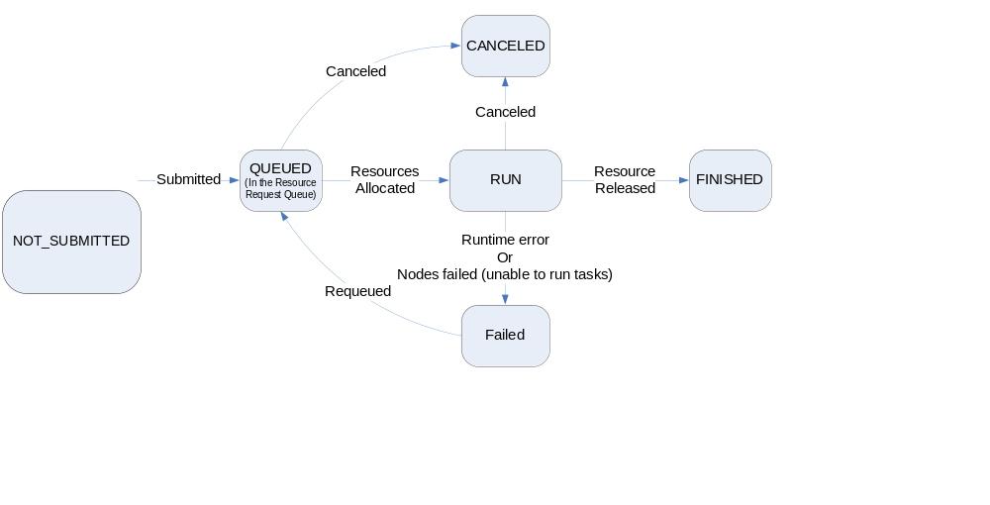
Figure 1. Job Life Cycle / State transition Diagram
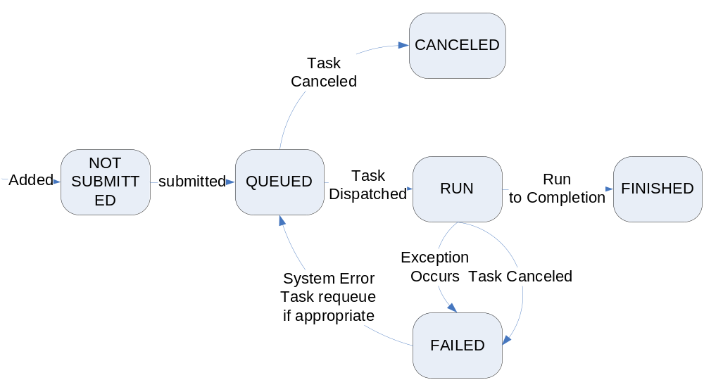

Figure 2. Task Life Cycle / State Transition Diagram
The list of operations currently supported by the CCS scheduler includes the following (cluster management operations have been left out):
- CreateJob
- AddTaskToJob
- SetCredentials: used if the job is to run under credentials other than those of the requestor (e.g. if the request is being made by a system administrator).
- SubmitJob
- ViewJob
- ListTasksInJob
- RequeueJob: this causes a running job – and any associated tasks currently running – to be cancelled and re-queued.
- ModifyJob
- CancelJob
- ViewTask
- RequeueTask: this causes a running task to be cancelled and re-queued for later execution.
- CancelTask
- ListJobs
The CCS scheduler does not implement callback notifications, nor does it explicitly implement duplicate suppression semantics. It does use a reliable transport facility for interactions with remote clients, but any client-side middleware that accidentally resubmits job/task creation/addition requests will cause new instances of the same to be created.
Resource descriptions allow clients to describe the following:
- Jobs:
- The number of CPUs and/or compute nodes to reserve. Compute nodes can optionally be reserved on an exclusive basis.
- Maximum lifetime for this job.
- Priority. There is a single queue of jobs in the scheduler. Jobs get resources reserved to them according to their priority, followed by the order in which they were submitted.
- Project name to associate with this job.
- Default values to use for task standard IO connections, working directory, and environment variables.
- A list of “advisory”/”extension” information that is ignored by the core CCS scheduler but is passed to, and can be exploited by system administrator-defined extensibility filters that the scheduler invokes whenever a job or task is about to enter the queued state and whenever a task is about to enter the run state (see below for more details on scheduler extensibility).
- List of software licenses to acquire before dispatching a task.
- Tasks:
- Program to run, including its command-line arguments, standard IO connections, working directory, and environment variables.
- The number of CPUs and/or compute nodes required to run the task. Compute nodes can be requested on an exclusive basis (i.e. no other task may run concurrently on the same node).
- Whether the task should be re-executed if a system failure occurs.
- Maximum lifetime for this task.
- Tasks may define static dependencies on other tasks; i.e. a task may specify a set of tasks that must run and finish before it may be dispatched.
The scheduler provides two points of extensibility that can be used to implement things like quotas and dynamic software license acquisition. Whenever a job or task is about to enter the queued state, a system administrator-supplied admission filter is invoked that can rewrite the job/task request information. This enables, for example, the imposition of quotas by rewriting the set of resources requested. Similarly, when a task is about to enter the run state, an activation filter is invoked that can perform activities such as software license acquisition.
Data staging and program provisioning/installation are treated as application-level issues that the job scheduler does not concern itself with. That is, if the compute cluster has been configured in a manner that allows compute nodes to directly access the distributed file shares of an organization then tasks can simply directly run programs existing on those file shares as well as read/write data existing on those file shares. Alternatively, if the compute cluster has been configured so that compute nodes cannot directly access an organization’s distributed storage facilities – e.g. because the compute nodes reside on a private network – then it is the responsibility of client users to stage (and install) program and data files to appropriate storage facilities access from inside the compute cluster.
The CCS scheduler is integrated with the Windows IT infrastructure; in particular, with facilities such as Active Directory. As a consequence, users can use their standard (Windows) organization credentials for security purposes. (Active Directory employs Kerberos for its credentials infrastructure.)
CCS schedulers are reachable by naming the DNS name of the compute cluster head node on which the scheduler resides.
System management is opaque to client users. Similarly, interactions between the job scheduler and the compute nodes it employs is opaque to client users and employs a proprietary means of interaction/management.
The fault tolerance model supported is one in which the job scheduler employs persistent storage to enable job/task meta-data to survive cluster head node crashes. However, high availability in the form of head node fail-over is not supported. Tasks continue to run undisturbed on compute nodes when the cluster head node crashes. Should a compute node crash, the scheduler will re-queue any affected jobs and tasks if appropriate.
The CCS scheduler currently supports the following scheduling policies:
- FIFO/round-robin
- Backfill
Although there is an explicit notion of resource reservation independent of task execution, the initial version of the scheduler does not support advanced reservations (i.e. scheduling for some explicit future time) nor does it provide any explicit support for interactive tasks. Of course, tasks can communicate directly with clients and other client applications – if the network configuration of the compute cluster is suitably configured – but this is fundamentally a batch job system in which tasks don’t necessarily run immediately or at any predictable time in the future.

PBS
To be supplied by a person with the appropriate knowledge …

SGE
To be supplied by a person with the appropriate knowledge …

