Information Dissemination in the Grid Environment – Base Specifications

Status of This Memo
This memo provides a recommendation to the Grid communities. The intention is to define a standard. Distribution is unlimited.
Copyright Notice
Copyright © Global Grid Forum (2004-2006). All Rights Reserved
Abstract
Notification-based interaction is very common as noted by the authors of the WS-Notification family of specifications. WS-Notification offers a basic topic-based publish/subscribe pattern complemented by a notify operation.
INFOD (Information Dissemination) uses the same notify operation. Additionally, INFOD provides a general means to determine which messages are to be sent from which publishers to which consumers based upon information kept in a registry. To support this, INFOD allows the characterization of publishers, consumers and various other components using vocabularies that are meaningful to members of the communities they belong to.
INFOD also extends the publish/subscribe paradigm by allowing consumers to be determined dynamically based on the message content. Additionally, INFOD allows subscribers to determine which messages should be created in response to events.

Table of Contents
Table of Contents 2
1 Introduction 3
1.1 The Registry 5
1.1.1 Resources 5
1.1.1.1 Publisher Entry, Consumer Entry and Subscriber Entry 5
1.1.1.2 Data Vocabularies and Data Source Entries 5
1.1.1.3 Property Vocabularies and Property Vocabulary Instances 6
1.1.1.4 Subscriptions and Constraints 6
1.1.2 Dependencies 7
1.1.3 Matching Publishers to Subscriptions 7
1.2 Security 8
1.3 Lifetime Management 8
1.4 Summary of key aspects of INFOD 8
1.5 Glossary 8
1.6 Terminology 11
1.7 Namespaces 12
1.8 Fault Definitions 13

Introduction
Information Dissemination (INFOD) allows data sources to make data available to consumers by a notification mechanism. State changes of data may generate events; events may generate messages; messages are created by publishers and sent to consumers.
State Changes
Events
Messages
Figure 1: INFOD Message Provenance
Publishers publish messages for consumption by consumers. Subscribers create subscriptions to match publishers’ data with consumers’ needs. Subscriber and consumer are distinct roles; it will be common that a subscriber creates a subscription to act as a consumer however a subscriber may create a subscription which results in a third party being notified as a consumer. The subscriber may make subscriptions If needed, subscribers are able to specify what is considered to be an event, what message gets published in response to which event and which consumer should receive a message. Messages are sent directly from publishers to consumers.
INFOD says nothing about the size of the notification message. If the notification message indicates that data should be collected from somewhere else this is not the concern of INFOD and INFOD does not offer a way to express this.
This document currently specifies WSN (Web Services Notification) as the underlying notification mechanism. This was a pragmatic choice at the time of writing this specification. An INFOD conforming implementation must use WSN however a revision of this specification may indicate how a different underlying notification mechanism could be used.
Information about publishers, consumers and subscribers theses external objects is stored in the INFOD registry along with subscriptions and other entries. This allows the registry to match publishers and consumers and notify the publisher, which can then send a message to the consumer. Instead of identifying publishers and consumers explicitly, subscribers only need to specify the properties of publishers and consumers. The registry is the heart of INFOD.
Figure 2 shows a typical interaction. The publisher, subscriber and consumer ask the registry to create and store a corresponding entity. There is an important distinction between, for example, a consumer, which is a web service with its own end point reference, and the consumer entry, which is information about the consumer that is stored in the INFOD registry and which also has its own end point reference. A subscription is different in that it only exists in the registry, which is why it is shown with a broken line in the diagram. When the registry detects that a subscription has indicated that a publisher should send a message to a consumer it notifies the publisher, which in turn constructs and sends the message as a notification directly to the consumer. This notification sent by the registry could be triggered by the arrival of a new consumer, the passing of time or any other change in state detected by the registry.
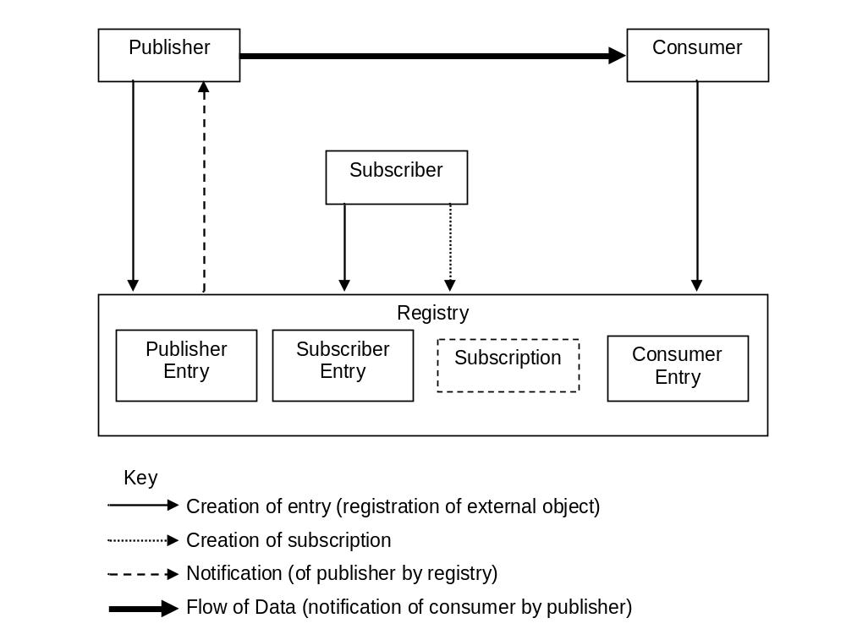
Figure 2: A typical INFOD interaction
The publisher in Figure 2 must also be a web service to receive the notification. If the publisher is not a web service, or if notifications are not desired, the publisher may poll the registry to search for suitable consumers.

The Registry

Resources
The registry manages various resources as listed below. A resource is used here as meaning something which is held in the registry. Each resource type has calls to create and drop it from the registry. Some resources have a call to replace them.

Publisher Entry, Consumer Entry and Subscriber Entry
As already explained, an entry is the information stored in the registry about an external object. Each is identified in the registry by a unique EPR (endpoint reference). Operations are provided to create, replace and drop entities. Note that these verbs are with respect to the entries in the registry and not the external object, so we talk about creating a Publisher Entry rather than registering a publisher. The act of creation involves storing information and returning the EPR of the entity. The creation operation will often store the EPR of the external object. This is the only place the external EPR, identifying the external object, is stored. All other references to EPRs are to EPRs of resources.
Each entry has a name and description, both of which are optional, not necessarily unique and have string values. They are also both expected to be meaningful to humans.
The replace operation (for example Error: Reference source not found in Section Error: Reference source not found) takes the EPR that was returned by the create operation as an additional parameter and keeps only the identity of the entity: all the data associated with it by the create operation is replaced by new data however all relations established after the original entity was created are preserved as the identity of the entity remains unchanged. The drop operation (for example Error: Reference source not found in Section Error: Reference source not found) takes the EPR of the entity and makes the stored entity unavailable and so makes subsequent use of the EPR invalid. The drop operation is not allowed to make the system inconsistent (see Section 1.1.2) so, by default, an error will be reported if an attempt is made to drop an entity which is still referenced. There is an optional flag which can be set to “DISABLE NEW REFERENCES” which results in the entity being dropped when the last reference to the entity has been removed and “CASCADE”, which also drops (recursively) all entities referencing that entity

Data Vocabularies and Data Source Entries
Data are only useful if there is a shared understanding of these data by publishers, consumers and subscribers. For this purpose INFOD uses vocabularies, which are maintained within the registry. Data vocabularies describe the structure of the data that is available from publishers. It is the responsibility of a community of users with a common interest to define a data vocabulary and register it as the first step in using INFOD. For flexibility data vocabularies can be specified using SQL, XML, RDF or any other data model. The INFOD registry will not manage instances of user data. A data vocabulary is used by the registry to carry out vocabulary specific operations. Vocabularies are managed, with operations such as CreateDataVocabulary (Section Error: Reference source not found) to store information about the data vocabulary in the registry.
A Data Source Entry is created by a call to CreateDataSourceEntry. The INFOD registry manages associations between data vocabularies and entries – specifically publisher entries thereby identifying the publisher as a source of some specific type of information.
Data Source Entities, like other entities have their own EPR and an optional name and description. In addition they have the EPR of the two things they are relating.

Property Vocabularies and Property Vocabulary Instances
A user community may also define property vocabularies to allow property constraints to be defined. For example a business community may decide that consumers should have a postal address. This mechanism allows this postal address to be precisely defined. These vocabularies, which are optional, are expressed by an XML schema.
The CreatePropertyVocabularyInstance call (Section Error: Reference source not found) is then used to create a The Property Vocabulary Instance which holds actual values for a particular Publisher, Consumer or Subscriber entry. The Property Vocabulary Instance references a Property Vocabulary.
Constraints identifying which other entities are of interest or unacceptable may be expressed using these properties. For example a publisher may choose to only send messages to consumers whose address matches some pattern.
Property vocabularies can be used as an extension mechanism to define notions such as quality of service. In a future version of the document this extensions mechanism may be used to formalize some properties; e.g., operational characteristics.

Subscriptions and Constraints
No information starts flowing in an INFOD system until a subscription is created. A subscription normally defines various constraints. In the absence of all constraints a subscription will cause all messages to be sent from all publishers to all consumers. In practice producers have constraints to indicate who they will send messages to, consumers have constraints to say who they will get messages from and a subscription will normally have at least a data constraint indicating what kind of messages are wanted. The registry acts on subscriptions by finding matching publishers and consumers using the property constraints of publisher entries, consumer entries, subscriber entries, subscriptions and data source entries along with data constraints of subscriptions expressed in terms of a data vocabulary.
In addition a subscription may include dynamic consumer constraints. These are constraints which are evaluated by the consumer rather than the registry by looking at the contents of a potential message.
As already mentioned the subscription is not an entity as it has no counterpart outside the registry. The create operation returns an EPR.

Dependencies
There is a basic dependency rule that governs the creation, modification and removal of resources within the INFOD registry: only resources that are registered in the INFOD registry SHALL be referenced.
Figure 3 shows the relations between the various INFOD resources. The arrows show the direction of reference. In addition the P or D in the box shows which resources may hold property or data constraints respectively.
Property Vocabulary
Property Vocabulary
Instance
Data Vocabulary
Subscriber Entry
P
Subscription
D
P
Data Source Entry
P
Publisher Entry
P
Consumer Entry
P
Figure 3: Relation between INFOD resources

Matching Publishers to Subscriptions
Discovery of publishers to match a specific subscription requires the registry to examine the vocabularies and all the constraints so that it can generate correct notifications. Instead of using notifications the GetMetaData operation (see section Error: Reference source not found) may be used to query the information in the INFOD registry to look up entities, vocabularies and associations and, most importantly, to look up matching subscriptions and publishers.
INFOD objects, especially publishers need to react immediately to changes in the INFO registry. They may register to be notified by WSN of any changes that are significant for them.

Security
INFOD uses existing security mechanisms to ensure that the dissemination of information happens according to security policies. The specification of communities can be used to complement and enhance security policies.

Lifetime Management
The INFOD specification does not contain any specific resource lifetime management other than the facilities to remove INFOD entities, for example DropSubscription etc. However, to ensure that in cases where a client becomes disconnected from the INFOD Registry and is unable or unwilling to destroy obsolete INFOD entities, some form of lifetime management should be employed such as WS-ResourceLifetime (see http://docs.oasis-open.org/wsrf/2004/06/wsrf-WS-ResourceLifetime-1.2-draft-03.pdf). This should provide a mechanism by which resources may be destroyed after a period of time unless the scheduled termination time is extended.

Summary of key aspects of INFOD
The INFOD base specification may be summarized:
- Publishers should be able to describe their available messages, events and states in terms of a data vocabulary
- Subscribers must be able to constrain messages based on message content and publisher and consumer information.
- Publishers must be able to choose what messages to publish based on consumer and subscription information.
- Consumers must be able to constrain messages based on message content, publisher information and subscription information.
- Any service can request that it be notified by the registry, via WSN, of changes that it considers relevant.
- The INFOD registry can apply constraints simultaneously.

Glossary
Constraint A constraint is used to restrict what data is sent from a publisher to a consumer. Constraints must be formulated in the constraint language(s) that are associated to the vocabularies, which are used to structure the referenced data. Most constraints are evaluated by the registry but dynamic consumer constraints are dealt with by the consumer.
Constraint Language The grammar of the constraints specification associated to a type system.
Entry An entity is the information about an external object that is stored in the registry. There of four types of entities: publisher, consumer, subscriber and data source.
Data Vocabulary A data vocabulary defines the structure of the data associated to a vocabulary association. Data vocabularies can be specified using any type system.
Consumer A consumer is able to receive messages delivered by publishers. Property vocabularies can be used to extend the description of consumers; consumers can limit the flow of messages by defining constraints.
Consumer Entry Information about a consumer stored in a registry
EPR An EPR (Endpoint Reference) is an XML structure encapsulating information useful for addressing a message to a Web service. This includes the destination address of the message, any additional parameters (called reference parameters) necessary to route the message to the destination, and optional metadata about the service.
Event An event is a view at a state transition specified by a publisher or a subscriber. Publishers may allow subscribers to reference events (those defined by publishers) to create messages or to define events by referencing state transitions.
In many cases, publishers do not provide access to events but allow only access to (and selection of) messages. In this case the state and event definitions are hidden to subscribers.
Message A message is used to deliver data from publishers to consumers. A message normally contains information about an event that is observed by a publisher.
Property Vocabulary A property vocabulary specifies the structure of properties associated to entities or vocabulary associations. Data vocabularies must be specified using XML as the type system.
Property Vocabulary Instance A property vocabulary instance represents the (values of) properties that are associated to specific entries. A property vocabulary instance has to be structured according to a property vocabulary.
Publisher A publisher is able to create and deliver data in the form of messages to consumers. Property vocabularies can be used to extend the description of publishers; publishers can limit subscriptions requests by defining constraints.
Publishers may create and deliver messages unconditionally or make the delivery of messages dependent on subscriptions. Publisher may allow subscribers (using subscriptions) to specify which messages should be created in response to which events; events maybe pre-defined or based on (subscriptions) specifications referencing state changes.
Publisher Entry Information about a publisher that is stored in a registry as a resource
Registry A repository of INFOD resources able to deliver notifications
Resource A resource is an elementary object in the registry that may be created, replaced or dropped.
State Change A data source as specified by vocabulary association may expose states; e.g., the values of all its entities at a specific time. A state change happens if at least one value of one entity changes and becomes visible.
State changes can only be referenced if the grammar of the constraint language exposes state transitions.
In many cases, the time is an (implicit) part of some or all entities; consequently, the change of time implies a state change.
Subscriber A subscriber is an entity specifying subscriptions. Subscriptions are the primary means of specifying the message flow from publishers to consumers.
Subscriber Entry Information about a subscriber that is stored in a registry as a resource.
Subscription A subscription defines which information has to be delivered by which publishers to which consumers. The information is selected by constraint specifications; publishers and consumers are identified through explicit references (EPR’s) or constraints on property vocabularies.
Type System A type system is an enumeration that defines the list of acceptable value domains, their value ranges and binary representation in a digital system.
Vocabulary A vocabulary defines the structure of data in the context of a type system; e.g., a schema in the context of XML. Vocabularies are used to facilitate a common understanding of data between publishers, consumers and subscribers.
WSN Web Service Notification is a pattern-based approach to allow Web services to disseminate information to one another
Data Source entry A data source entry specifies that data structured with the referenced vocabulary (and constraint language) is offered by the referenced publisher.

Terminology
Except in this introductory chapter, the keywords "MUST", "MUST NOT", "REQUIRED", "SHALL", "SHALL NOT", "SHOULD", "SHOULD NOT", "RECOMMENDED", "MAY", and "OPTIONAL" in this document are to be interpreted as described in [IETF RFC 2119].
When describing abstract data models, this specification uses the notational convention used by the “XML Information Set” (see http://www.w3.org/TR/xml-infoset/). Specifically, abstract property names always appear in square brackets (e.g., [some property]).
This specification uses a notational convention, referred to as “Pseudo-schemas”. A Pseudo-schema uses a BNF-style convention to describe attributes and elements:
- `?' denotes optionality (i.e. zero or one occurrences),
- `*' denotes zero or more occurrences,
- `+' one or more occurrences,
- `[' and `]' are used to form groups,
- `|' represents choice.
- Attributes are conventionally assigned a value which corresponds to their type, as defined in the normative schema.
- Elements with simple content are conventionally assigned a value which corresponds to the type of their content, as defined in the normative schema.
- The use of {any} indicates the presence of an element wildcard (<xs:any/>).
- The use of @{any} indicates the presence of an attribute wildcard (<xs:anyAttribute/>).
- In the interest of brevity, some extensibility points have been omitted from the Pseudo-schemas.

<!-sample pseudo-schema -->
<element
required_attribute_of_type_QName="xs:QName"
optional_attribute_of_type_string="xs:string"? >
<required_element />
<optional_element /> ?
<one_or_more_of_these_elements /> +
[ <choice_1 /> | <choice_2 /> ] *
</element>

Where there is disagreement between the separate XML schema and WSDL files describing the messages defined by this specification and the normative descriptive text (excluding any pseudo-schema) in this document, the normative descriptive text will take precedence over the separate files. The separate files take precedence over any pseudo-schema and over any schema and WSDL included in the appendices.

Namespaces
The following namespaces are used in this document:
Prefix | Namespace | Meaning
S | http://schemas.xmlsoap.org/soap/envelope/ OR http://www.w3.org/2003/05/soap-envelope | SOAP Envelope
xsd | http://www.w3.org/2001/XMLSchema | XML Schema
wsa | http://www.w3.org/2005/08/addressing | WS-Addressing
wsrf-bf | http://docs.oasis-open.org/wsrf/bf-2 | WS Base Faults
wsnt | http://docs.oasis-open.org/wsn/b-2 | WS-Base Notification
wsntw | http://docs.oasis-open.org/wsn/bw-2 | WS-Base Notification
wstop | http://docs.oasis-open.org/wsn/t-1 | WS-Topics
infod | http://www.ggf.org/infod | INFOD
The INFOD name space is divided into two subcomponents (INFODRegistry and INFODNotify

Fault Definitions
All faults generated by a NotificationProducer or SubscriptionManager should be compliant with the WS-BaseFaults (see http://docs.oasis-open.org/wsrf/wsrf-ws_base_faults-1.2-spec-os.pdf) specification.
All faults defined by this specification MUST use the following URI for the WS-Addressing [action]:
http://www.ggf.org/infod/fault.

The INFOD Base Use Case Scenarios (see http://forge.gridforum.org/sf/go/doc13626?nav=1) provide helpful background information. It describes INFOD patterns and their implementation as well as INFOD Use Cases

