INFOD (Information Dissemination) Base Use Case Scenarios

Status of This Memo
This memo provides information to the Grid community motivating scenarios for the Information Dissemination working group. It does not define any standards or technical recommendations. Distribution is unlimited.
Copyright Notice
Copyright © Global Grid Forum (2006). All Rights Reserved.
Abstract
INFOD (Information Dissemination) is a working group in GGF focusing on publishing and consuming data within a grid or distributed system infrastructure. A variety of commercial and scientific scenarios are introduced in this document to illustrate how the INFOD base specification interfaces are used. They may also provide a source of materials for the data and information architecture activities in the OGSA working group. INFOD patterns are also included in this document.

Contents
Contents 2
1 Introduction 4
2 NextGRID Graphical Animations Use Case 5
2.1 Introduction 5
2.2 Actors 5
2.3 Scenarios 5
2.3.1 Vocabularies 6
2.3.2 Subscriptions 8
2.3.3 Joining the media community 9
2.3.4 Designer and Reviewer Subscription 10
2.3.5 Examples of XML messages 11
2.4 Security 22
2.5 Performance 23
2.6 Requirements Implied 23
3 Car Dealer Use Case 24
3.1 Introduction 24
3.2 Actors 24
3.3 Scenarios 24
3.3.1 Creating the Car Dealer/Buyer Communities 24
3.3.2 Joining/Leaving the Car Dealer Community 27
3.3.3 Joining/Leaving the Car Buyer Community 28
3.3.4 Subscribing to the Inventory of Car Dealer 30
3.3.5 Publishing Information 31
3.3.6 Consuming Information 31
3.3.7 Examples of XML messages 31
3.4 Security 37
3.5 Performance 37
3.6 Requirements Implied 37
4 Sensor Networks Use Case 39
4.1 Introduction 39
4.2 Actors 39
4.3 Scenarios 39
4.3.1 Sensor and Applications – Common Vocabulary of the Community 40
4.3.2 Sensor Characteristics 41
4.3.3 Application Subscription 42
4.3.4 Scenario Steps 44
4.3.5 Examples of XML messages 44
4.4 Security 47
4.5 Performance 48
4.6 Requirements Implied 48
5 3rd Party Delivery of Query Results Use Case 49
5.1 Introduction 49
5.2 Actors 49
5.3 Scenarios 49
5.3.1 Creating Data Vocabularies 50
5.3.2 Creating Property Vocabularies 50
5.3.3 Creating Entities 50
5.3.4 Creating Vocabulary Associations 50
5.3.5 Examples of XML Messages 50
5.4 Security 53
5.5 Performance 53
5.6 Requirements Implied 53
6 Editor and Contributor Information 55
7 Acknowledgements 57
8 Intellectual Property Statement 58
9 Full Copyright Notice 59
10 References 60
11 Appendix A – INFOD Patterns of Interaction 61
11.1 Introduction 61
11.2 Description of Patterns 61
11.2.1 No Subscriptions 61
11.2.2 Subscriptions - Managed by Registry 62
11.2.3 Subscription Based Publications 63
11.3 Outline of Operations 63
11.3.1 No Subscriptions 63
11.3.2 Subscriptions - Managed by Registry 65
11.3.3 Subscription Based Publications 66
12 Appendix B – Accessing the INFOD Registry 68
12.1 The Publisher View 68
12.2 The Consumer View 69
12.3 The Subscription View 69
12.4 The Consumer/Publisher View 70
12.5 The Publisher/Consumer View 71
12.6 Other Important Views 71

Introduction
The goal of this document is to define use cases to illustrate the use of the INFOD base specification interfaces [INFOD] in a variety of environments. The document ends with appendices on use case patterns and ways of accessing the INFOD registry.
The following use cases are included:
- NextGRID Graphical Animations Use Case
- Car Dealer Use Case
- Sensor Networks Use Case
- 3rd Party Delivery of Query Results Use Case
You will note that each use case in its general form follows the same structure:
1. Define a community which is achieved by defining vocabularies in the INFOD registry.
2. Create instances which are achieved by defining publishers, subscriptions, and consumers associated with particular vocabularies in the INFOD registry.
3. Determine whether to publish which publishers achieve by checking if there are any relevant subscriptions in the INFOD registry.
4. Publish which publishers achieve by producing messages.
4. Consume which consumers achieve through the consume interface.
When you read the use cases, please keep in mind that in most scenarios, portions of the use cases would not be repeated, e.g., defining communities (defining vocabularies) would be done once for each use case. Vocabularies are often re-used.

NextGRID Graphical Animations Use Case

Introduction
This use case is based on the Digital Media use case described in the NextGRID Vision and Architecture White Paper, http://www.nextgrid.org/download/publications/NextGRID_Architecture_White_Paper.pdf.
Nowadays, almost all films and commercials use computer graphics animations to implement the special effects that the artists want to depict on the screen. Designers can use several software applications for creating 3D scenes like 3D Studio Max and Maya. These applications can build a 3D environment or just a single scene and render it. The large number of objects, textures, light sources and effects, like shiny surfaces and fog, is a factor that limits the design of a scene due to the increased computational effort. The best solution is to combine the summed power of many single PCs to accomplish the job with the existing software, thus combining the advantages of a powerful computer cluster with the “single PC” way.
The designer develops the job on a single PC with the client’s instructions followed as well as possible to ensure that the final result is the expected one. A close online collaboration between the client and the designer is required in order to obtain results close to the client’s needs.
KINO, a leading producer of TV commercials and films in Greece, anticipates this novel business model can be supported by a Grid enabled rendering infrastructure that can handle not only the in-house production of urgent jobs and small jobs, but also large tasks with a task based negotiation. This negotiation, on the outsourcing of large tasks, has such parameters as the deadline, the complexity of the task, the number of frames and the total computational time needed.

Actors
In this use case the actors are the Designers, Reviewers, Bosses, Rendering Services and the INFOD Registry. The Designer has submitted animation rendering jobs to the Grid, and the Designer and Reviewers are interested in knowing when those jobs have finished.
The Designer and Reviewer want to be informed as soon as each animation is completed.
The Boss wants to know which Designers are available between certain dates.
The Publisher is the Rendering Service.
The INFOD Registry manages the vocabularies and subscriptions etc.

Scenarios
In these scenarios the designer submits jobs (i.e., animated scenes to be rendered) to the rendering service (compute cluster). On submitting the rendering job, parameters such as time limit, complexity, number of frames in the scene, type of rendering software to use, data transport protocol etc may all be specified. But how the job is submitted to the rendering service and the animation data transport are outside the scope of this document.
These scenarios will just concentrate on the notification of job completion to the designer and reviewers, within the INFOD framework.
It is also assumed that the Rendering Services have already been created and their addresses are known.

Vocabularies
The first stage is to define the appropriate vocabularies for the Animators, Reviewers, Bosses & Rendering Services community:
Rendering Service Vocabulary Components | Comment
Organisation_Name | Name of the organisation hosting the rendering service.
Organisation_Location | Address of the organisation hosting the rendering service.
Organisation_Email | General e-mail address of organisation.
Organisation_Website | URL.
BBB_rating | A number between 1 and 5.
Security_Policy | Security policy.
Table 2-1: Media Organisation Vocabulary.
Rendering Service Vocabulary Components | Comment
Service_Name | Name of rendering service.
Service_Address | URL.
Organisation_Name | Name of the organisation hosting the rendering service.
Organisation_Location | Address of the organisation hosting the rendering service.
BBB_rating | A number between 1 and 5.
Rendering_Software | List of rendering software products available, e.g. 3D Studio Max, Maya.
Table 2-2: Rendering Service Vocabulary.
Designer Vocabulary Components | Comment
Employee_Name | Name of the animator/designer, reviewer or boss.
Employee_Email | E-mail address.
Employee_Type | Designer, Reviewer or Boss.
Organisation_Name | Name of the organisation hosting the rendering service.
Organisation_Location | Address of the organisation hosting the rendering service.
Hourly_Rate | Hourly rate, for example for designing animations.
Availability | Dates and times when the employee is available.
Table 2-3: Employee Vocabulary.
Animation Vocabulary Components | Comment
Designer_Name | Name of the designer that submitted the animation for rendering.
Rendering_Job_Name | Name for the submitted rendering job.
Project_Name | Name of the project (e.g. film or commercial perhaps).
Number_of_Scenes | Number of scenes to be rendered (i.e. some measure of the complexity of the animation).
Rendering_Software | Rendering software used, e.g. 3D Studio Max or Maya etc.
Job_Time_Limit | Maximum completion time for the rendering job.
Job_Start | Actual start time for the rendering job.
Job_End | Actual end time for the rendering job.
Job_Status | Status of the rendering job, e.g. Accepted, Rejected, Submitted, Started, Completed, Reviewed, Passed, Failed, Exceeded Time Limit.
Animation_EPR | Location (EPR) of the resulting stored animation.
Table 2-4: Animation Vocabulary.

Subscriptions
The next stage is to create relevant subscriptions:
Subscription Entity  INFOD Component | Values
infod:Type | Subscription
infod:Name | Find a Rendering Service
infod:Description | Watch available Rendering Services
infod:Data_Constraints | Rendering_Service_Inventory: SHOW (Service Name, Organisation, Website) FOR Rendering_Software = 3D Studio Max
infod:Property_Constraints | Rendering Service Organisation: BBB_Rating > 2
Table 2-5: Designer finding a rendering service subscription.
Subscription Entity  INFOD Component | Values
infod:Type | Subscription
infod:Name | Find completed animations
infod:Description | Watch for completed animations
infod:Data_Constraints | Rendering_Jobs_Inventory: SHOW (Rendering_Job_Name, Animation_EPR) FOR Designer Name = designer, Project = Toy Story 3, Status = Completed
infod:Property_Constraints | None
Table 2-6: Designer monitoring animation jobs subscription.
Subscription Entity  INFOD Component | Values
infod:Type | Subscription
infod:Name | Find animations for review
infod:Description | Watch for animations requiring review
infod:Data_Constraints | Rendering_Jobs_Inventory: SHOW (Designer Name, email, job name, Animation_EPR) FOR Project = Toy Story 3, Status = Completed
infod:Property_Constraints | None
Table 2-7: Reviewers monitoring animation jobs subscription.
Subscription Entity  INFOD Component | Values
infod:Type | Subscription
infod:Name | Find a designer.
infod:Description | Watch for available designers.
infod:Data_Constraints | Employee_Inventory: SHOW (Name, Email) FOR Type = Designer, Rendering_Software = 3D Studio Max, Hourly rate < x £ per hour, Availability ∩ [25/12/2005:27/12/2005] = true
infod:Property_Constraints | Employees Organisation:  BBB_Rating > 3
Table 2-8: Boss watching for available designers’ subscription.

Joining the media community
Each appropriate Boss needs to enroll themselves and the Designers and Reviewers that they manage into the INFOD Registry. They (or an Administrator at one of the organizations) also need to add the relevant vocabularies and subscriptions.
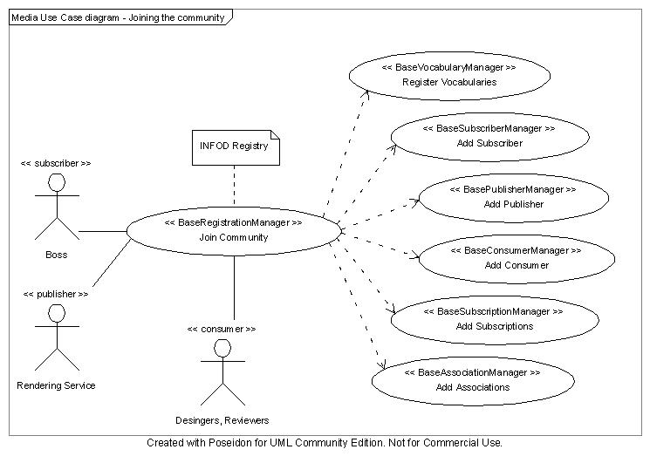
Figure 2-1: Use case diagram for joining the media community.
A summary of these steps is as follows:
- Boss (or Organization Admin) registers the vocabularies with the INFOD Registry.
- Rendering Service adds itself as a publisher.
- Boss adds himself into the INFOD Registry as a subscriber.
- Boss adds their designers and reviewers as consumers.
- Boss creates associations between the publisher and the data vocabulary.
- Boss creates instances of the relevant property vocabularies for the publisher, subscriber and consumers, identifying for example the designer and reviewer from roles and job characteristics defined in their employee property vocabulary.
- Boss adds the relevant subscriptions to the INFOD Registry.

Designer and Reviewer Subscription
Designer and Reviewer want to be informed as soon as each animation is completed.
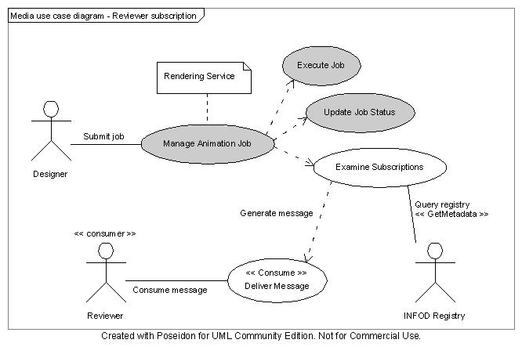
Figure 2-2: Use case diagram for a designer or reviewer subscription.
Note that the steps in italics (and also shown in grey in Figure 2-2) take place outside of the INFOD framework.
- Designer submits an animation job to the Rendering Service, which adds the job to its inventory.
- The job completes (i.e. Job Status = “Completed”) and the rendered animation is stored by the Rendering Service.
- The Rendering Service examines the associated subscriptions which it has been notified of by the INFOD Registry.
- The Rendering Service generates messages for the relevant consumers.

Examples of XML messages
The following text gives an example of part of the XML messages that would be sent to and from the INFOD Registry when each of the relevant interfaces is called:

Step 1: Register the vocabularies with the INFOD Registry.

a) Registration of Animation (Data) Vocabulary
Request message:
<infod:RegisterDataVocabulary>
<infod:VocabularyName>NextGridAnimationDataVocab </infod:VocabularyName>
<infod:VocabularyLanguage>XML Schema(Namespace/URI of DataFormat) </infod:VocabularyLanguage>
<infod:VocabularyBody>
<?xml version="1.0"?>
<xsd:schema xmlns:xsd="http://www.w3.org/2001/XMLSchema"
xmlns:ident="http://www.w3.org/INFOD/Entity"
targetNamespace="http://www.w3.org/INFOD/Entity">
<xsd:element name = “DesignerName” type = “xs:string”/>
<xsd:element name = “RenderingJobName” type = “xsd:string”/>
<xsd:element name = “JobStart” type = “xsd:time”/>
<xsd:element name = “JobStatus” type = “xsd:string”/>
</infod:VocabularyBody>
</infod:RegisterDataVocabulary>
Response message (for success case):
<infod:RegisterVocabularyResponse>
<infod:INFODVocabularyIdentifier>
<wsa:Address>http://www.nextgrid.org/NGInfoDRegistry/NextGridAnimationDataVocabEPR</wsa:Address>
</infod:INFODVocabularyIdentifier>
</infod:RegisterVocabularyResponse>

b) Registration of Rendering Service (Property) Vocabulary
Request message:
<infod:RegisterPropertyVocabulary>
<infod:VocabularyName>NextGridRenderingServicePropertyVocab </infod:VocabularyName>
<infod:VocabularyBody>
<?xml version="1.0"?>
<xsd:schema xmlns:xsd="http://www.w3.org/2001/XMLSchema"
xmlns:ident="http://www.w3.org/INFOD/Entity"
targetNamespace="http://www.w3.org/INFOD/Entity">
<xsd:element name = “ServiceName” type = “xsd:string”/>
<xsd:element name = “ServiceAddress” type = “xsd:uri”/>
<xsd:element name = “ServiceOrganization” type = “xsd:string”/>
<xsd:element name = “RenderingSoftware” type = “xsd:complexType”/>
<xsd:element name = “PricingModel” type = “xsd:string”/>
</infod:VocabularyBody>
</infod:RegisterPropertyVocabulary>
The response message would be very similar to that for step 1a and would include the EPR of the INFOD vocabulary identifier. In this example the EPR returned is:
http://www.nextgrid.org/NGInfoDRegistry/NextGridRenderingServicePropertyVocabEPR
Similarly request and response messages would be sent for registering the employee and organization property vocabularies.
The graphic in Fig. 3 depicts the relations of INFOD objects.
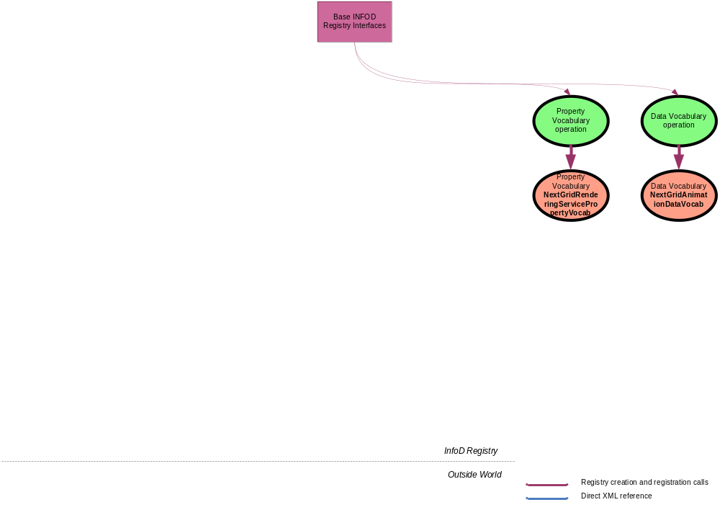Figure 3 – Step 1 INFOD object relations

Step 2: Rendering Service added as a Publisher.
Request message:
<infod:CreatePublisher>
<infod:WSEntityIdentifier>
<wsa:Address> http://www.nextgrid.org/NextGridRenderingService </wsa:Address>
</infod:WSEntityIdentifier>
<infod:PublisherName>NextGridRenderingService</infod:PublisherName>
<infod:Notification>
TRUE
</infod:Notification>
</infod:CreatePublisher>
Again, there would be a similar response message which would include the EPR of the INFOD entity identifier. In this example the EPR returned is:
http://www.nextgrid.org/NGInfoDRegistry/NextGridRenderingServiceEPR
The graphic in Fig. 4 depicts the relations of INFOD objects.
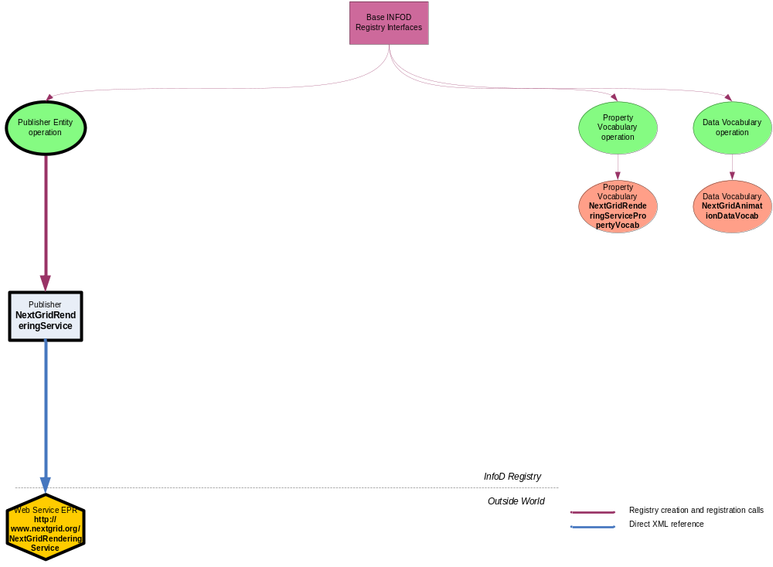Figure 4 - Step 2 INFOD object relations

Step 3: Boss added to the INFOD Registry as a Subscriber.
Request message:
<infod:CreateSubscriber>
<infod:SubscriberName>John Boss</infod:SubscriberName>
</infod:CreateSubscriber>
In this example the returned EPR is:
http://www.nextgrid.org/NGInfoDRegistry/JohnBossEPR
The graphic in Fig. 5 depicts the relations of INFOD objects.
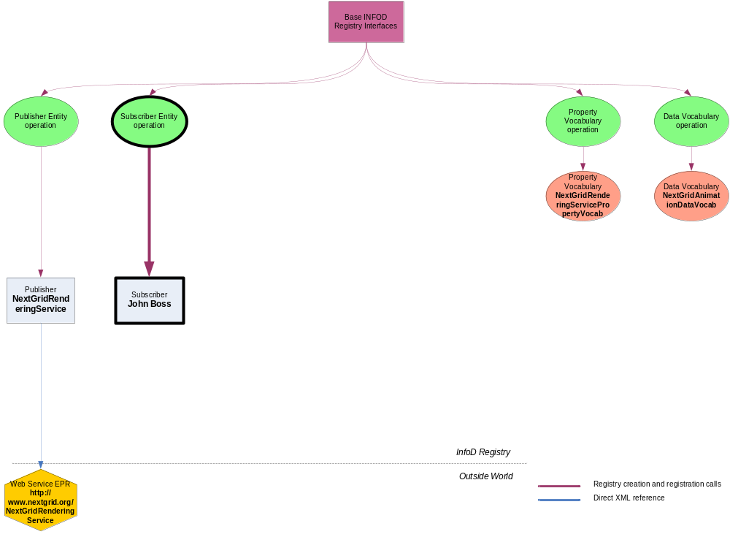Figure 5 - Step 3 INFOD object relations

Step 4: Add Designer as a Consumer.
Request message:
<infod:CreateConsumer>
<infod:WSEntityIdentifier>
<wsa:Address>http://www.films.tv/PeterDesigner </wsa:Address>
</infod:WSEntityIdentifier>
<infod:ConsumerName>Peter Designer</infod:ConsumerName>
</infod:CreateConsumer>
In this example the returned EPR is:
http://www.nextgrid.org/NGInfoDRegistry/PeterDesignerEPR
The graphic in Fig. 6 depicts the relations of INFOD objects.
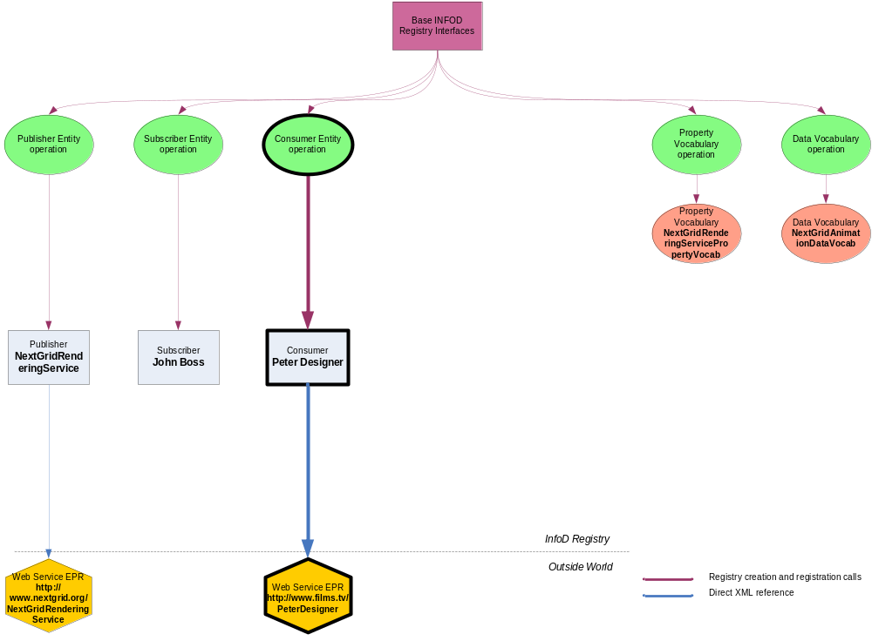Figure 6 - Step 4 INFOD object relations

Step 5: Create associations between the publisher and the data vocabulary.
Request message:
<infod:AssociateVocabulary>
<infod:AssociateVocabularyName>PublisherAndDataVocabAssociation </infod:AssociateVocabularyName>
<infod:AssociationEntityReference>
<wsa:Address>http://www.nextgrid.org/NGInfoDRegistry/ NextGridRenderingServiceEPR</wsa:Address>
</infod:AssociationEntityReference>
<infod:VocabularyReference>
<wsa:Address>http://www.nextgrid.org/NGInfoDRegistry/NextGridAnimationDataVocabEPR</wsa:Address>
</infod:VocabularyReference>
</infod:AssociateVocabulary>
In this example the returned EPR is:
http://www.nextgrid.org/NGInfoDRegistry/PublisherAndDataVocabAssociationEPR
The graphic in Fig. 7 depicts the relations of INFOD objects.
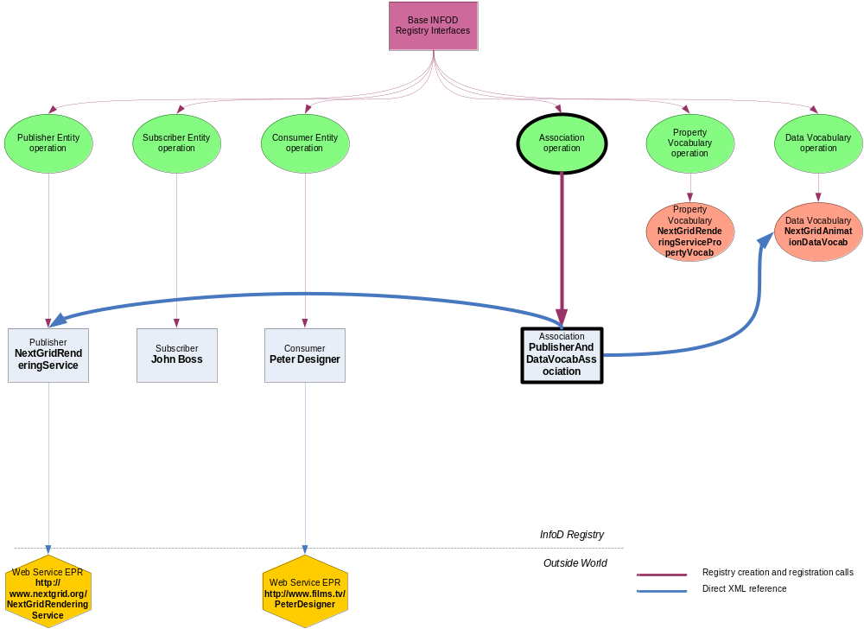Figure 7 - Step 5 INFOD object relations

Step 6: Create instances of the relevant property vocabularies for the publisher, subscriber and consumers.
Request message:
<infod:CreatePropertyVocabularyInstance>
<infod:VocabularyInstanceEntityReference>
<wsa:Address>
http://www.nextgrid.org/NGInfoDRegistry/NextGridRenderingServiceEPR
</wsa:Address>
</infod:VocabularyInstanceEntityReference>
<infod:VocabularyInstanceVocabularyReference>
<wsa:Address>
http://www.nextgrid.org/NGInfoDRegistry/
NextGridRenderingServicePropertyVocabEPR
</wsa:Address>
</infod:VocabularyInstanceVocabularyReference>
<infod:VocabularyInstanceVocabularyBody>
<?xml version="1.0"?>
<xsd:schema xmlns:xsd="http://www.w3.org/2001/XMLSchema"
xmlns:ident="http://www.w3.org/INFOD/Entity"
targetNamespace="http://www.w3.org/INFOD/Entity">
<ServiceName>NextGrid Rendering Service</ServiceName>
<ServiceOrganisation>SuperInc</ServiceOrganization>
<ServiceAddress>
http://www.nextgrid.org/NextGridRenderingService
</ServiceAddress>
<RenderingSoftware>3D Max</RenderingSoftware>
<PricingModel>myPricingModel</PricingModel>
</infod:VocabularyInstanceVocabularyBody>
</infod:CreatePropertyVocabularyInstance>
In this example the returned EPR is:
http://www.nextgrid.org/NGInfoDRegistry/PublisherVocabInstanceEPR
Similar messages would be sent for creating the instances of the subscriber and consumer property vocabularies.
The graphic in Fig. 8 depicts the relations of INFOD objects.
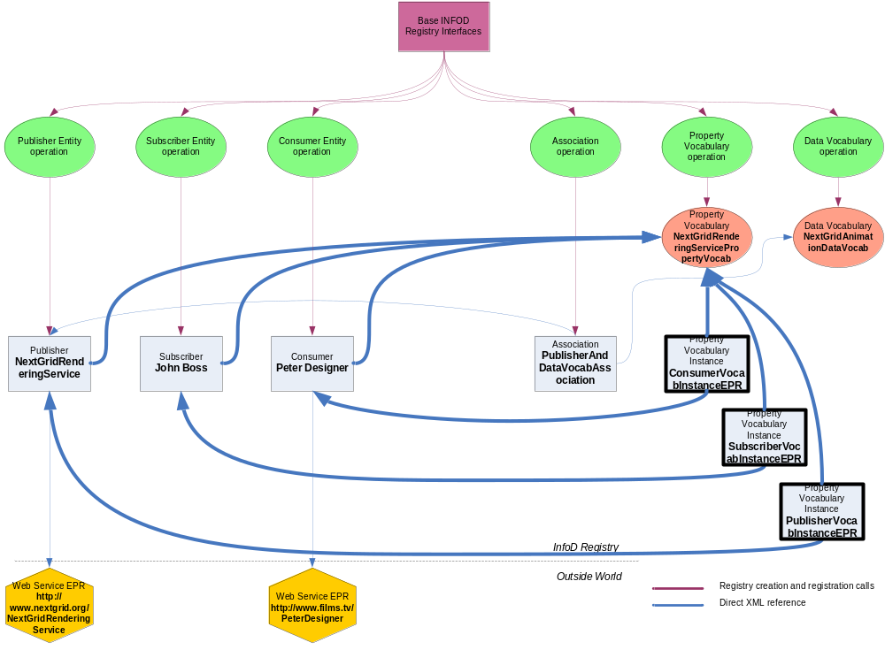Figure 8 - Step 6 INFOD object relations

Step 7: Boss adds the relevant subscriptions to the INFOD Registry.
Request message:
<infod:CreateSubscription>
<infod:SubscriptionName>
DesignerMonitoringJobsSubscription
</infod:SubscriptionName>
<infod:SubscriptionDescription>
Designer monitoring animation jobs subscription
</infod:SubscriptionDescription>
<infod:SubscriberReference>
<wsa:Address>
http://www.nextgrid.org/NGInfoDRegistry/JohnBossEPR
</wsa:Address>
</infod:SubscriberReference>
<infod:DataConstraints>
For $data in doc(“http://www.nextgrid.org/NGInfoDRegistry/
datavocabularies/AnimationDataVocabEPR”)
Where
$data/DesignerName = $StaticConsumers/EmployeeName
$data/Status = “Completed”
$data/Project= “Toy Story 3”
Return
$data/Project
$data/JobName
$data/DesignerName
$data/Status
</infod:DataConstraints>
<infod:DynamicConsumerConstraints>
For $employees in doc(“http://www.nextgrid.org/NGInfoDRegistry/
propertyvocabularyinstances/EmployeeVocabEPR”)
For $consumers in
doc(“http://www.nextgrid.org/NGInfoDRegistry/consumers
/infodConsumer”)
Where
$employees/VocabularyInstanceEntityReference = GetEPR($consumers)
Return
$consumers/WSEntityIdentifier
</infod:DynamicConsumerConstraints>
</infod:CreateSubscription>
In this example the returned EPR is:
http://www.nextgrid.org/NGInfoDRegistry/MonitoringJobsSubscriptionEPR
Similar request messages would be sent for the other subscriptions.
The graphic in Fig. 9 depicts the relations of INFOD objects.
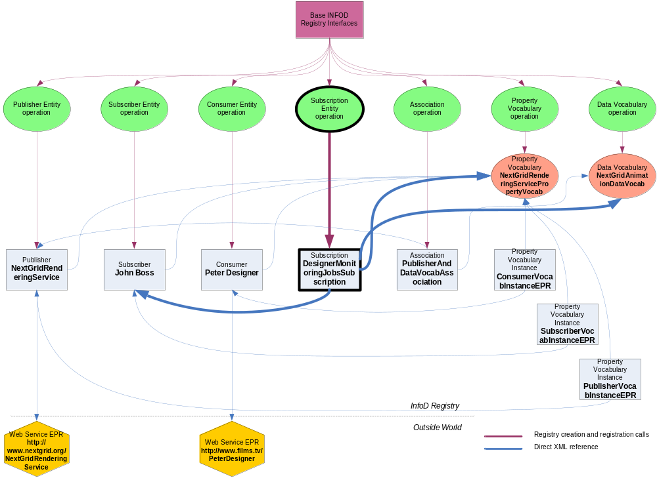Figure 9 - Step 7 INFOD object relations

Step 8: INFOD registry sends Subscription Notification to Rendering Service
The text below gives an example XML for the notification message body.
<Body>
<infod:SubscriptionNotification>
<infod:SubscriptionReference>
<wsa:Address> http://www.nextgrid.org/NGInfoDRegistry/MonitoringJobsSubscriptionEPR
<wsa:Address>
</infod:SubscriptionReference>
<infod:StaticConsumers>
<wsa:Address>
http://www.nextgrid.org/NGInfoDRegistry/PeterDesignerEPR
<wsa:Address>
</infod:StaticConsumers>
<infod:DataConstraints>
For $data in doc(“http://www.nextgrid.org/NGInfoDRegistry/ datavocabularies/AnimationDataVocabEPR”)
Where
$data/DesignerName = $StaticConsumers/EmployeeName
$data/Status = “Completed”
$data/Project= “Toy Story 3”
Return
$data/Project
$data/JobName
$data/DesignerName
$data/Status
</infod:DataConstraints>
</infod:SubscriptionNotification>
</Body>

Step 9: The Rendering Service generates messages for the relevant consumers.
Output message to consumers:
The text below gives some example XML for a message body. The structure of the message is as defined in WS-BaseNotification.
<wsnt:Notify>
<wsnt:NotificationMessage>
<wsnt:SubscriptionReference>
<wsa:Address> http://www.nextgrid.org/NGInfoDRegistry/MonitoringJobsSubscriptionEPR
<wsa:Address>
</wsnt:SubscriptionReference>
<wsnt:ProducerReference>
<wsa:Address> http://www.nextgrid.org/NextGridRenderingService </wsa:Address>
</wsnt:ProducerReference>
<wsnt:Message>
<Type>XML</Type>
<Length>196</Length>
<Data>
<ProjectName>Toy Story 3</ProjectName>
<JobName>AnimationJobID12345</JobName>
<DesignerName>Peter Designer</DesignerName>
<Status>Completed</Status>
</Data>
<Flag>1</Flag>
<Transform>None</Transform>
</wsnt:Message>
</wsnt:NotificationMessage>
</wsnt:Notify>
The following diagram shows the entities and vocabularies that have been defined and the relations between them - Figure 2-10.
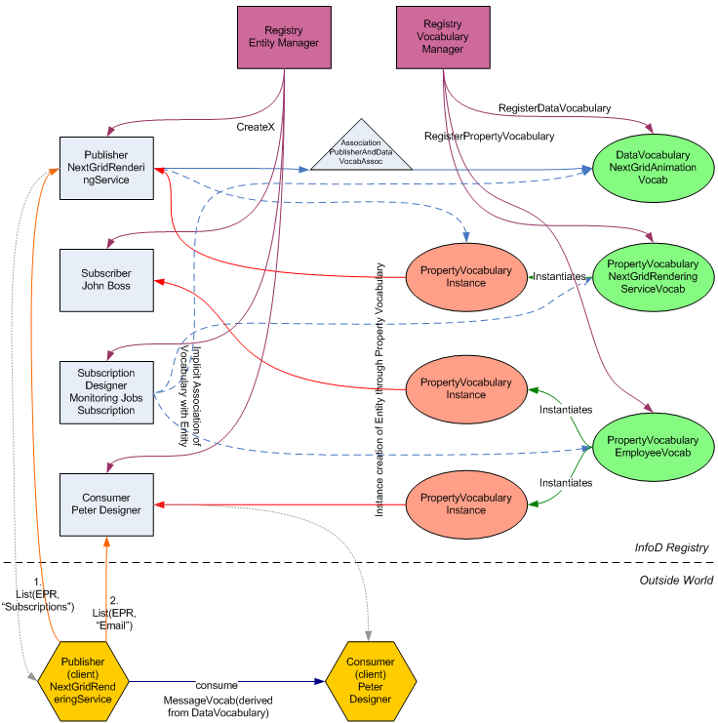
Figure 2-10: Relationships between entities and vocabularies.
  - Security
Security would be very important for a film that is currently in production say. As well as the need to authenticate the identities of designers, reviewers & rendering services, one may also want job submission data and returned animations (MPEGs) to be encrypted.
But it is assumed that no additional security requirements would be needed beyond the security common to the entire set of scenarios.

Performance
Response times of around a few seconds would be required but this is unlikely to be beyond the typical performance requirements common to many of the use cases.

Requirements Implied
R1 | Constraints, which restrict the flow of messages from publishers to consumers, must be composable. | The constraints contained in subscriptions must be composed with the constraints specified by the rendering services and designers.
R2 | Publishers should be able to describe their available messages, events and states in terms of a vocabulary. | Rendering services need to define the information about rendering jobs that consumers can receive.
R3 | Subscribers must be able to constrain messages based on message content and publisher information. | Designers, acting as their own subscribers, must be able to select publishers based on their properties.
R4 | Publishers must be able to choose what messages to publish based on consumer and subscriber information. | Rendering services must be able to restrict consumers according to their policies (constraints on designers etc).
R5 | Consumers must be able to constrain messages based on message content, publisher information and subscriber information. | Designers and reviewers need to define the messages they receive from which rendering services.
R6 | Any component can request that it be notified by the registry, via WSN, of changes that the component considers interesting. | Rendering services need to know which subscriptions are relevant to them and of any changes or additions that occur.

Car Dealer Use Case
  - Introduction
Car buyers like to be aware of all cars of interest from those dealers who are located close by and who have good BBB and service ratings. Instead of receiving pre-canned information buyers like to specify which information is relevant to them.
Car dealer too like to put restrictions on potential buyers; they like to communicate only with those buyers who have good credit rating and do not live too far away.
Car dealers as well as buyers dealers like to specify their interest and constraints in a terminology that is meaningful to the car buyer and seller community and does not require any IT terminology.
  - Actors
The actors are car dealers (acting as publishers) and car buyers (acting as subscribers and consumers).
It is assumed that car dealers and car buyers form a (virtual) community. This community is described through community vocabularies, the car dealers (buyers) by the car dealer (buyer) vocabulary respectively.
  - Scenarios
The scenario requires the following activities:
- The creation of the Car Dealer and a Car Buyer community
- Joining and leaving the car dealer community
- Joining and leaving the car buyer community
- Subscribing to (the inventory of) car dealers
- Publishing Information
- Consuming Information
XML schema and data are presented in tables; Operations are provided in each sub-section.

Creating the Car Dealer/Buyer Communities
The (ideal) car dealer community consists of all car dealers independent of the place of business; this community is described by the Car_Dealer vocabulary. Here is an example of a Car_Dealer property dealer vocabulary.
Car Dealer Vocabulary Components | Comment
Name | Name of dealer
Location | Address of dealer
Phone | Phone number of dealer
E-mail | E-mail address of dealer
Web-site | URL
Open_since | Year founded
BBB_rating | A number between 1 and 5 –  this information must contain a source reference
Service_Rating | A number between 1 and 12 – this information must contain a source reference
Table 3-9: Car_Dealer Vocabulary
The (ideal) car buyer community consists of all people or organizations interested in buying cars; this community could be defined by the Car_Buyer property vocabulary. Here is an example of a Car_Buyer vocabulary:
Car Buyer Vocabulary  Components | Comment
Name | Name of car buyer
Location | Address of car buyer
Phone | Phone number of car buyer
E-mail | An e-mail address of car buyer
Credit_Rating | A number between 360 and 720 – this information must contain a source reference
Interest | Optional expression describing interest of the buyer; could be used to create subscriptions
Table 3-10: Car_Buyer Vocabulary
Car dealers and buyers also need a data vocabulary to describe and select the item of their shared interest - the cars in the inventory of the car dealers. Here is an example of a Car_Inventory.
Car Inventory Vocabulary Components | Comment
Inventory number | Inventory number
Make | Brand name
Model | Model
Year | Model year
Type | Type of car
External Color | External color
Internal Color | Internal color
Dealer | Dealer – this could be a reference
Price | Amount $
Table 3-11: Car_Inventory Vocabulary
The Car_Inventory data vocabulary is an XML schema. As a consequence XQuery can be used the select cars of interest. The specific query is part of the subscription. Since the consumer is interested in relevant changes the specified query will be re-evaluated whenever there is a change of the car inventory. If there is a new result set either the new results set or the changes will be disseminated to the consumer (depending on the subscription directives).
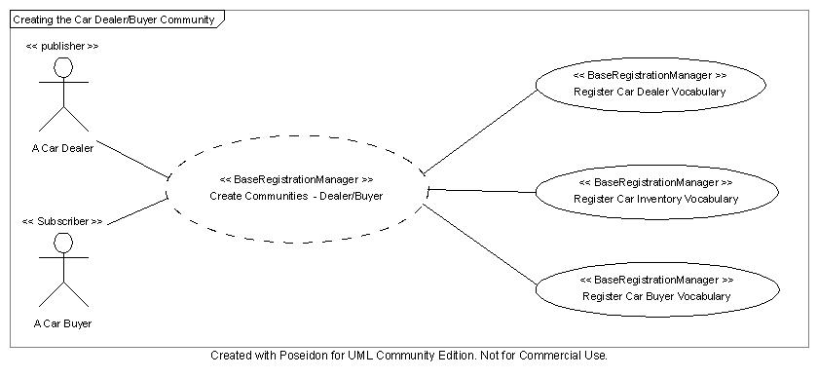
Figure 3-3-11: Creating Car Dealer / Buyer Communities

Joining/Leaving the Car Dealer Community
In order to join the car dealer community, a car dealership has to represent itself as a publisher and as a car dealer.
Here is an example of a car dealer represented as publisher (representing the IT perspective) and as a dealer (representing the community perspective):
Publisher Entity  INFOD Components | Values
infod_Type | Publisher
wsinfod _Name | Frontier Ford
wsinfod _Description | Oldest Ford Dealer in SFO Bay Area Featuring also fine Italian Cars
wsinfod _Property_Constraint | Consumer: Buyer (Distance to customer < 30 miles, Credit rating > 700)
Table 3-12: Car Dealer as Publisher
Assignment of a publisher to a Dealer Vocabulary | Values
EntityReference | The EPR of the publisher entity:
Name | Frontier Ford
Location | 101 Auto Row, Redwood city, CA 94065
Phone | +1-650-000-0000
E-mail | Info@Frontier_Ford .com
Web-site | www.Frontier_Ford.com
Open_since | 1953
BBB_rating | 5
Service_Rating | 10
Table 3-13: Car Dealer as Member of Car Dealer Community
Publishers (dealers) can specify if they should be notified about new, Replaced, and deleted subscriptions. In order to get these notifications the publisher (dealer) has to support the consume interface and must be able to process notification regarding subscriptions.
The publishers (dealers) have to indicate that they have instances based on the car vocabulary. Creating a vocabulary association does this. The car data are characterized through the car data vocabulary and its vocabulary association to the specify car dealer. There are no user properties associated to the vocabulary association.
Association of publisher to Car_Inventory Vocabulary | Values
Infod_Type | Vocabulary Association
Infod_Name | Inventory
Infod_Description | Cars on sale by Frontier Ford
Infod_Entity | Publisher1 (EPR to publisher entity)
Infod_Associate | CarVocab (EPR to vocabulary entity)
Table 3-14: Inventory Data of Frontier Ford
It is assumed that all the cars of the large set of dealers are contained in one collection. So the dealer has to describe which part of the selection represents his cars.
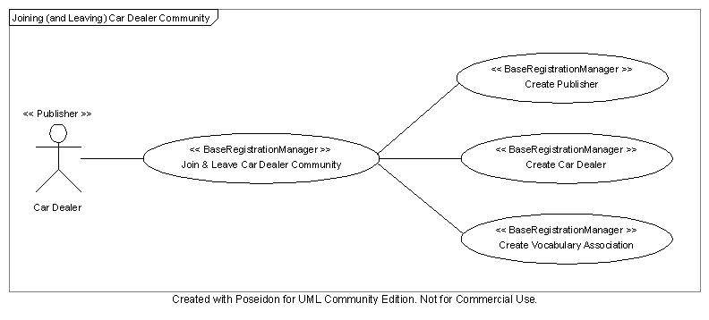
Figure 3-2: Joining (and Leaving) Car Dealer Community

Joining/Leaving the Car Buyer Community
In order to join the car buyer community, a car buyer has present him/herself as a consumer and as a car buyer.
Here is an example of a car buyer represented as consumer (representing the IT perspective) and as a buyer (representing the community perspective):
Consumer Entity  INFOD Components | Values
infod_Type | Consumer
infod_Name | Susan Maria Callas
infod_Description | Buyer of fancy cars
infod_Property_Constraint | Dealer: Years in business > 10 years, BBB rating > 3, Service rating > 10
Table 3-15: Car Buyer as Consumer
Assignment of a consumer
to a Buyer Vocabulary
EntityReference | EPR of consumer entity (Consumer1 - see below)
VocabReference | EPR of vocabulary (BuyerVocab – see above)
Name | Susan Maria Callas
Location | 15998 Portola Off Road, Portola Valley, CA
Phone | +1-650-000-000
E-mail | callas&opera.music
Credit_Rating | 700
Interest | Cars: Make = ‘Italian’ and Model = ‘Sport’ cars’ and Year < 1995 and Exterior Color ‘Red’
Table 3-16: Car Buyer as Member of Car Buyer Community
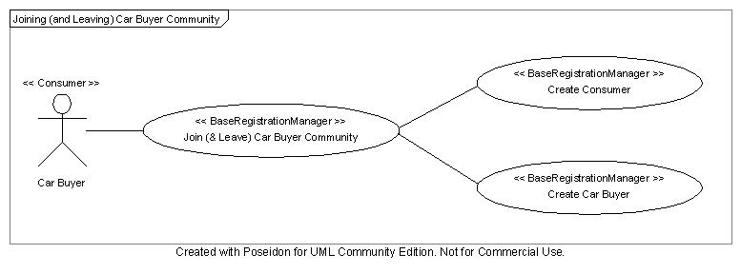
Figure 3-3-12: Joining (and Leaving) Car Buyer Community
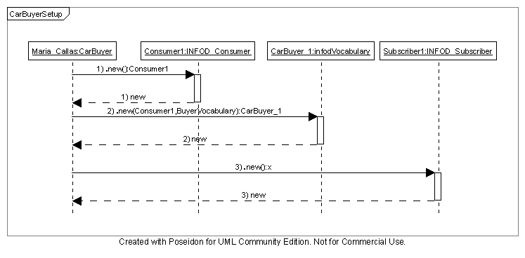
Figure 3-4: Joining (and Leaving) Car Buyer Community (interaction diagram)

Subscribing to the Inventory of Car Dealer
The consumer (car buyer), acting as subscriber, has to specify which cars are of interest. Specifying a subscription does this: Before this can be done the car buyer has to register as a consumer
Subscription Entity  INFOD Component | Values
infod_Type | Subscription
infod_Name | Find a Car
infod_Description | Watch for car offers
infod_Data_Constraint | Make Italian, Price < 250000
infod_Property_Constraints | Dealer: Distance < 25 miles
Table 3-17: Subscription
The subscription manager processes the subscription and notifies the relevant publishers (car dealers). Car dealers who are matching the (property) constraint defined by car buyers will be informed if the consumer (buyer) matches their (property) constraint.
The notification to the publisher contains the data constraints, what information is of interest and the consumer reference.
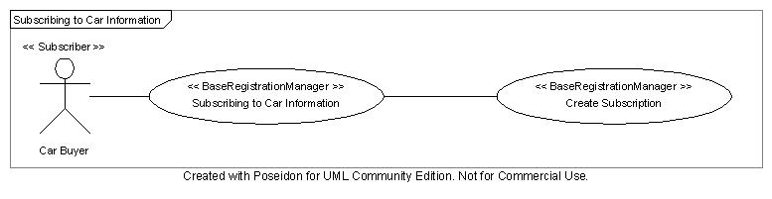
Figure 3-5: Creating a Subscription
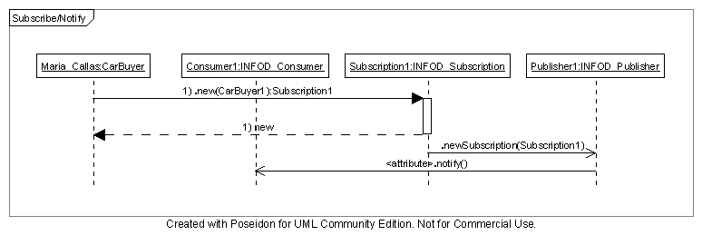
Figure 3-6: Creating a Subscription (interaction diagram)

Publishing Information
The publisher publishes information according to the subscription; e.g.; the publications are tailored to the request of the consumer.
After receiving the subscription the publisher sends immediately a message for each car that matches the criteria. Once this is done the publisher sends a message for each car that is either added or removed from the inventory and matches the criteria.

Consuming Information
The consumer receives the messages from the publisher using the consume interface.

Examples of XML messages
The following text gives an example of part of the XML messages that would be sent to and from the INFOD Registry when each of the relevant interfaces is called:

Step 1: Register the vocabularies with the INFOD Registry.

a) Registration of Car Dealer (Property) Vocabulary
Request message:
<infod:RegisterPropertyVocabulary>
<infod:VocabularyName>CarCommunityDealerVocab </infod:VocabularyName>
<infod:VocabularyLanguage>XML Schema(Namespace/URI of DataFormat) </infod:VocabularyLanguage>
<infod:VocabularyBody>
NOTE: this would need to be encoded correctly (escaped etc.)
e.g. “<” becomes &lt
<?xml version="1.0"?>
<xsd:schema xmlns:xsd="http://www.w3.org/2001/XMLSchema"
xmlns:ident="http://www.w3.org/INFOD/Entity"
targetNamespace="http://www.w3.org/INFOD/Entity">
<xsd:element name = “DealerName” type = “xsd:string”/>
<xsd:element name = “DealerLocation” type = “xsd:string”/>
<xsd:element name = “DealerPhoneNo” type = “xsd:string”/>
<xsd:element name = “DealerEmail” type = “xsd:string”/>
<xsd:element name = “DealerURL” type = “xsd:string”/>
<xsd:element name = “DealerOpened” type = “xsd:int”/>
<xsd:element name = “DealerBBBRating” type = “xsd:int”/>
<xsd:element name = “DealerServiceRating” type = “xsd:int”/>
</infod:VocabularyBody>
</infod:RegisterPropertyVocabulary>
Response message (for success case):
<infod:RegisterPropertyVocabularyResponse>
<infod:INFODVocabularyIdentifier>
<wsa:Address>http://www.carcommunity.com/CCInfoDRegistry/CarCommunityDealerVocabEPR</wsa:Address>
</infod:INFODVocabularyIdentifier>
</infod:RegisterPropertyVocabularyResponse>

b) Registration of Car Buyer (Property) Vocabulary
Request message:
<infod:RegisterPropertyVocabulary>
<infod:VocabularyName>CarCommunityBuyerVocab </infod:VocabularyName>
<infod:VocabularyLanguage>XML Schema(Namespace/URI of DataFormat) </infod:VocabularyLanguage>
<infod:VocabularyBody>
NOTE: this would need to be encoded correctly (escaped etc.)
e.g. “<” becomes &lt
<?xml version="1.0"?>
<xsd:schema xmlns:xsd="http://www.w3.org/2001/XMLSchema"
xmlns:ident="http://www.w3.org/INFOD/Entity"
targetNamespace="http://www.w3.org/INFOD/Entity">
<xsd:element name = “BuyerName” type = “xsd:string”/>
<xsd:element name = “BuyerLocation” type = “xsd:string”/>
<xsd:element name = “BuyerPhoneNo” type = “xsd:string”/>
<xsd:element name = “BuyerEmail” type = “xsd:string”/>
<xsd:element name = “BuyerCRRating” type = “xsd:int”/>
<xsd:element name = “BuyerInterest” type = “xsd:string”/>
</infod:VocabularyBody>
</infod:RegisterPropertyVocabulary>
Response message (for success case):
<infod:RegisterVocabularyResponse>
<infod:INFODVocabularyIdentifier>
<wsa:Address>:http://www.carcommunity.com/CCInfoDRegistry/CarCommunityBuyerVocabEPR</wsa:Address>
</infod:INFODVocabularyIdentifier>
</infod:RegisterVocabularyResponse>

c) Registration of Car (Data) Vocabulary
Request message:
<infod:RegisterDataVocabulary>
<infod:VocabularyName>CarCommunityCarVocab </infod:VocabularyName>
<infod:VocabularyLanguage>XML Schema(Namespace/URI of DataFormat) </infod:VocabularyLanguage>
<infod:VocabularyBody>
NOTE: this would need to be encoded correctly (escaped etc.)
e.g. “<” becomes &lt
<?xml version="1.0"?>
<xsd:schema xmlns:xsd="http://www.w3.org/2001/XMLSchema"
xmlns:ident="http://www.w3.org/INFOD/Entity"
targetNamespace="http://www.w3.org/INFOD/Entity">
<xsd:element name = “CarInvNumber” type = “xsd:number”/>
<xsd:element name = “CarMake” type = “xsd:string”/>
<xsd:element name = “CarModel” type = “xsd:string”/>
<xsd:element name = “CarYear” type = “xsd:int”/>
<xsd:element name = “CarType” type = “xsd:string”/>
<xsd:element name = “CarExtColor” type = “xsd:string”/>
<xsd:element name = “CarIntColor” type = “xsd:string”/>
<xsd:element name = “CarDealer” type = “xsd:string”/>
<xsd:element name = “CarPrice” type = “xsd:int”/>
</infod:VocabularyBody>
</infod:RegisterDataVocabulary>
Response message (for success case):
<infod:RegisterPropertyVocabularyResponse>
<infod:INFODVocabularyReference>
<wsa:Address>:http:www.carcommunity.com/CCInfoDRegistry/CarCommunityCarVocabEPR</wsa:Address>
</infod:INFODVocabularyReference>
</infod:RegisterPropertyVocabularyResponse>

Step 2: Car Dealer added as a Publisher and Community Member

a) Registration of Car Dealer as Publisher
Request message:
<infod:CreatePublisher>
</infod:WSEntityReference>
wsa:http://www.carcommunity.com/CarDealerServices
</infod:WSEntityReference>
<infod:PublisherName>Frontier Ford</infod:PublisherName>
<infod:PublisherDescription>Oldest Ford Dealer in SFO Bay Area Featuring also fine Italian Cars</infod:PublisherDescription>
<infod:PropertyConstraints>Car_Buyer (Distance < 30 miles) and CR > 4) </infod:PropertyConstraints>
</infod:CreatePublisher>
Returned EPR:
http://www.carcommunity.com/CCInfoDRegistry/Publisher/Frontier_Ford

b) Registration of Car Dealer as Community Member
Request message:
<infod:CreatePropertyVocabularyInstance>
<infod:VocabularyInstanceEntityReference>
<wsa:Address>:http://www.carcommunity.com/CCInfoDRegistry/Publisher/Frontier_FordEPR</wsa:Address>
</infod:VocabularyInstanceEntityReference>
<infod:VocabularyInstanceVocabularyReference>
<wsa:Address>:http://www.carcommunity.com/CCInfoDRegistry/CarCommunityDealerVocabEPR</wsa:Address>
</infod:VocabularyInstanceVocabularyReference>
<infod:VocabularyInstanceVocabularyBody>
NOTE: this would need to be encoded correctly (escaped etc.)
e.g. “<” becomes &lt
<?xml version="1.0"?>
<xsd:schema xmlns:xsd="http://www.w3.org/2001/XMLSchema"
xmlns:ident="http://www.w3.org/INFOD/Entity"
targetNamespace="http://www.w3.org/INFOD/Entity">
<DealerName>Frontier Ford</DealerName>
<DealerLocation>101 Auto Row, Redwood City, CA 94065</DealerLocation>
<DealerPhoneNo>+1-650-000-000</DealerPhoneNo>
<DealerEmail>info@frontier_ford.com</DealerEmail>
<DealerURL>www.frontier_ford.com</DealerURL>
<DealerOpened>1953</DealerOpened>
<DealerBBBRating>5</DealerBBBRating>
<DealerServiceRating>10</DealerServiceRating>
</infod:VocabularyInstanceVocabularyBody>
</infod:CreatePropertyVocabularyInstance>
Returned EPR:
http://www.carcommunity.com/CCInfoDRegistry/CarDealer/Frontier_Ford

Step 3: Car Dealer creates Association with Data Vocabulary
Request message:
<infod:AssociateVocabulary>
<infod:AssociateVocabularyName>
CarsAtFrontierFord
</infod:AssociateVocabularyName>
<infod:AssociateVocabularyDescription>
A full list of cars at Frontier Ford
</infod:AssociateVocabularyDescription>
<infod:AssociateEntityIdentifier>
<wsa:Address>:http://www.carcommunity.com/CCInfoDRegistry/CarCommunityDealerVocabEPR</wsa:Address>
</infod:AssociateEntityIdentifier>
<infod:AssociateVocabularyIdentifier>
<wsa:Address>:http://www.carcommunity.com/CCInfoDRegistry/CarCommunityCarVocabEPR<wsa:Address>
</infod:AssociateEVocabularyIdentifier>
</infod:AssociateVocabulary>
Returned EPR:
http://www.carcommunity.com/CCInfoDRegistry/Association/Frontier_FordCars

Step 4: Car Buyer added as a Consumer and Community Member

a) Registration of Car Buyer as Consumer
Request message:
<infod:CreateConsumer>
</infod:WSEntityIdentifier>
<wsa:Address>http://www.carcommunity.com/CarBuyerEmail</wsa:Address>
</infod:WSEntityIdentifier>
<infod:ConsumerName>Susan Maria Callas</infod: ConsumerName>
<infod:ConsumerDescription>Buyer of fancy cars </infod:ConsumerDescription>
<infod:PropertyConstraints>Car_Dealer (Dealer: Years in business > 10 years, BBB rating > 3, Service rating > 10) </infod:PropertyConstraints>
</infod:CreateConsumer>
Returned EPR:
http://www.carcommunity.com/CCInfoDRegistry/Consumer/Susan_Maria_Callas

b) Registration of Car Buyer as Community Member
Request message:
<infod:CreatePropertyVocabularyInstance>
<infod:VocabularyInstanceEntityReference>
<wsa:Address>http://www.carcommunity.com/CCInfoDRegistry/Consumer/Susan_Maria_Callas</wsa:Address>
</infod:VocabularyInstanceEntityReference>
<infod:VocabularyInstanceVocabularyReference>
<wsa:Address>http://www.carcommunity.com/CCInfoDRegistry/CarCommunityBuyerVocabEPR</wsa:Address>
</infod:VocabularyInstanceVocabularyReference>
<infod:VocabularyInstanceVocabularyBody>
NOTE: this would need to be encoded correctly (escaped etc.)
e.g. “<” becomes &lt
<?xml version="1.0"?>
<xsd:schema xmlns:xsd="http://www.w3.org/2001/XMLSchema"
xmlns:ident="http://www.w3.org/INFOD/Entity"
targetNamespace="http://www.w3.org/INFOD/Entity">
<BuyerName>Susan Maria Callas</BuyerName>
<BuyerLocatiom>15998 Portola Off Road, Portola Valley, CA</BuyerLocation>
<BuyerPhoneNo>+1-650-000-0000</BuyerPhoneNo>
<BuyerEmail>callas&opera.music</BuyerEmail>
<BuyerCRRating>705</BuyerCRRating>
<BuyerInterest>Cars (Make = ‘Italian’ and Model = ‘Sport’ and Year < 1995 and ExtColor “Red’) = </BuyerInterest>
</infod:VocabularyInstanceVocabularyBody>
</infod:CreatePropertyVocabularyInstance>
Returned EPR:
http://www.carcommunity.com/CCInfoDRegistry/CarBuyerr/Susan_Maria_Callas

Step 5: Car Buyer added as a Subscriber
Request message:
<<infod:CreateSubscriber>
</infod:WSEntityReference>
<wsa:Address>http://www.carcommunity.com/CarBuyerEmail</wsa:Address>
</infod:WSEntityReference>
<infod:SubscriberName>Susan Maria Callas</infod:SubscriberName>
<infod:SubscriberrDescription>Interested in fancy cars</infod:SubscriberDescription>
Returned EPR:
http://www.carcommunity.com/CCInfoDRegistry/Subscriber/Susan_Maria_Callas

Step 6: Car Buyer adds Subscription
Request message:
<infod:CreateSubscription>
<infod:SubscriptionName>
SusanMariaCallasFancyCars
</infod:SubscriptionName>
<infod:SubscriptionDescription>
Maria Callas is looking for fancy cars
</infod:SubscriptionDescription>
<infod:SubscriberReference>
<wsa:Address>http://www.carcommunity.com/CCInfoDRegistry/Subscriber/Susan_Maria_Callas</wsa:Address>
</infod:SubscriberReference>
<infod:DataConstraints>
CarCommunityCarVocabEPR.Make = ‘Italian’
CarCommunityCarVocabEPR.Price = < 250000
</infod:DataConstraints>
<infod:PropertyConstraints>
Distance (CarCommunityDealerVocabEPR.Location, http://www.carcommunity.com/CCInfoDRegistry/CarBuyerr/Susan_Maria_Callas) < 25</infod:PropertyConstraints>
</infod:CreateSubscription>
Returned EPR:
http://www.carcommunity.com/CCInfoDRegistry/Subscription/SusanMariaCallasFancyCars
Subscribers could determine the information they like to see; this has been omitted in order to reduce complexity

Step 7: INFOD registry sends Subscription Notification to Car Dealers
The text below gives an example XML for a message body. The type of the body is infoDMsg:BodyType
<Body>
<infod:SubscriptionNotification>
<infod:SubscriptionReference>
<wsa:Address>http://www.carcommunity.com/CCInfoDRegistry/Subscription/SusanMariaCallasFancyCars<wsa:Address>
</infod:SubscriptionReference>
<infod:StaticConsumers>
<wsa:Address>http://www.carcommunity.com/CCInfoDRegistry/Consumer/Susan_Maria_Callas<wsa:Address>
</infod:StaticConsumers>
<infod:DataConstraints>
fn:doc('INFODRegistry.xml')/datavocabularies/infodDataVocabulary/CarCommunityCarVocab(Make =‘Italian’ andPrice = < 250000)
</infod:DataConstraints>
</infod:SubscriptionNotification>
</Body>

Step 8: Car Dealer sends Message to Buyer
The car dealer receives the message using the CONSUME operation. It has the same forma as the WS-Notification; the consumer could use NOTIFY as alias.

Step 9: Car Dealer sends Message to Buyer
The text below gives an example XML for a message body delivered by the car dealer (publisher) to the car buyer (consumer). The type of the body is infoDMsg:BodyType
<Body>
<Type>XML</Type>
<Length>as calculated</Length>
<Data>
<CarMake>Ferrari</CarMake>
<CarModel>Roma</CarModel>
<CarYear>1990</CarYear>
<CarType>Sports</CarType>
<CarExtColor>Red</CarExtColor>
<CarIntColor>White</CarIntColor>
<CarDealer>Frontier Ford</CarDealer>
<CarPrice>$150000</CarPricer>
</Data>
</Body>

Step 10: Car Buyer receives Message from Car Dealer
The car buyer receives the message using the CONSUME operation. It has the same forma as the WS-Notification; the consumer could use NOTIFY as alias.
  - Security
Existing security technology allows the protection of the data.
A message is only delivered when the consumer has the right to see (access) the data.
  - Performance
Matching publishers and buyers in large communities such as the car dealer/buyer may require the mutual filtering of a large set of constraints. Creating efficient indices for constraints will be very important.
The performance of the actual message traffic between publisher and consumers and not impacted by the INFOD registry.
  - Requirements Implied
R1 | Constraints, which restrict the flow of messages from publishers to consumers, must be composable. | The constraints contained in subscriptions must be composed with the constraints specified by the car dealers and car buyers
R2 | Publishers should be able to describe their available messages, events and states in terms of a vocabulary. | Car dealers need to define what information about cars is available and what information people can receive.
R3 | Subscribers must be able to constrain messages based on message content and publisher information. | Car buyers, acting as their own subscribers, must be able to select publishers based on their properties.
R4 | Publishers must be able to choose what messages to publish based on consumer and subscriber information. | Car dealers must be able to restrict consumers according to their policies (constraints on car buyers)
R5 | Consumers must be able to constrain messages based on message content, publisher information and subscriber information. | Car buyers, acting as their own subscribers, need to define which message they receive from which car dealer.
R6 | Any component can request that it be notified by the registry, via WSN, of changes that the component considers interesting. | Car dealers need to know which subscriptions are relevant to them.

Sensor Networks Use Case
  - Introduction
We describe the requirement and use for data dissemination for Sensor networks and applications that run on them. A sensor is typically a piece of hardware that detects an aspect of the environment. A sensor may also be a software module that acts as a source of data. Examples of sensors include radiation detectors, cameras, etc.. The sensors we consider here have a means of communicating with Nodes (also known as Sensor Data Hubs) which are compute entities that aggregate, dispatch, and receive data over a network connection. We consider the Node as the publisher of the data since it acts as a proxy for sensors.
Applications are the computational processing modules that operate on sensor network data. Applications model the intelligence that produces utility from the sensor network. Although the usage of the term applications may include a broader function in the sensor network, for purposes of this use case we use the term application for a single software module with well-defined inputs and outputs. Examples of applications include modules that perform data archiving, alert detection, and chemical concentration analysis.
The sensor networks we consider here have sufficient computing power and network bandwidth to participate in a middleware that supports data exchange and sharing.
  - Actors
Actors are the Nodes (equivalent in functionality are the SDH), Applications (the AlertListener), and the INFOD Registry.
Sensors are the producers of data and consumers of commands and data.
Nodes are publishers of data in the sensor network. Nodes may also consume directives such as commands and data from applications (not illustrated here).
Applications are consumers of data from the publishers. Applications also publish data consumed by the Nodes as well as other Applications, and so they will appear in the sensor network as publishers as well. We focus on an alert listener application
The INFOD Registry manages the vocabularies and subscriptions etc.
  - Scenarios
The scenario focusses narrowly on the following activities:
- The creation of the publishing entity.
- An application subscribing to sensor alerts
- A Node publishing Information
- An application consuming Information
XML schema and data are presented in tables; Operations are provided in each sub-section;
Figure 1 describes the scenario pictorially. We consider here the scenario of a Node sending a message to an application that consumes it (for recording and displaying alerts). We do not discuss the production and consumption of data between individual Sensors and Nodes in this use case. (The relationship between the Sensors and the Nodes is also a publisher and consumer type relationship with the Sensor publishing data and the Node consuming based on certain filters that the Node may impose on the data that it receives.)

Applications
Node
Node
Sensors produce data and consume data from Node
Applications
Applications
…
Registry
Applications
Use-case scenario focus
Figure 5.4-134-14: Sensor Network Component Diagram

Sensor and Applications – Common Vocabulary of the Community
Name of Predicate | Comment
Id | Sensor Source unique identification
Name | Org. Name
Spatio-temporal Location | X, Y, Z, t
(Feature)Type | Type of data source
Data Ranges | Range of detection
Owner | Sensor or Org. Owner
Data schema EPR | Pointer to data-schema itself
Confidence level | Accuracy
Functional label | For case-based access
Table 5-1: Community Vocabulary
Name of Predicate | Comment
ID | IP address of SDH
Name | Name of SDH
StateChange1 | Describes a type of Event that is published by the SDH.  Example could be:  ChemSpill  Temperature Change  ZoneChangeEvent  ZoneAccessException  SecurityAlert  These events contain a pointer to the relevant data schemas
StateChange2…
Table 5-2: SDH Community Vocabulary
We assume that there is a vocabulary registered (somewhere?) for the Gamma Radiation Sensor and others like it as well as a community vocabulary for each of the SDH StateChanges. Also, a vocabulary for Chemicals is required in this case which contains the MSDS (Material Safety Data Sheet) information detailing the chemical components and safety procedures. In this example, the MSDS information is published as a standard web-service accessible for every federal facility. As soon as a new chemical product is released, the MSDS information is made available. Each INFOD entity requiring information from that source is responsible to deploy a web service to this source (but could also cache it since its stale data)

Sensor Characteristics
Publisher Entity  INFOD Components | Values
infod_Type | (Feature) Type = Gamma-Sensor
wsinfod _Name | Name = Gamma Radiation Sensor
wsinfod _Description | Nuc Safe Technologies
wsinfod _Data_Constraint | Reading Range[A, B]
wsinfod _Property_Constraint | Spatio-temporal Location = [X,Y,Z,t]
infod_Property_Constraint | Owner = dhs.tn.rad.nucsafe.*
infod_vocabulary | Data schema EPR = Rad_sensor_vocabulary(EPR-of xsd)
infod_Property_Constraint | Functional label = first_responder
infod_Property_Constraint | Confidence level = 10%
Table 5-3: Node/Sensor as Publisher

Application Subscription
infod_Type | Subscription
infod_Name | AlertListener
infod_Description | Retrieve all current alerts
infod_Data_Constraint | Reading > C
infod_Property_Constraints | Sensors’s X, Y, Z, t values within requested range
infod_Property_Constraint | wisinfod_Name == Gamma Radiation Sensor
infod_Property_Constraint | infod_vocabulary==Required_EPR of sensor community vocabulary
Table 5-4: Application Subscription
Name of Predicate | Values
infod_Type | Subscription
infod_Name | ChemSpillDetection
infod_Description | Detection of Chemical Spills
infod_Data_Constraint | Sensor Data Inventory: SHOW (Chemical(Obs.SensorReading.Data), Obs.SensorReading.Time) FOR Obs.SensorReading.SubType = SPILL
infod_Property_Constraint | Publisher: Obs.SensorReading.Type = RFID Sensor
infod_Property_Constraint | infod_vocabulary==Required_EPR of Chemical, Chemical_Spill and RFID_Sensor community vocabulary (static, enabled through other web services)
infod_Property_Constraint | Consumer: Authorized to receive Spill Information && Inventory(Chemical).Organization == Consumer.Organization
Figure 5-4: SDH as Subscriber to detect Chemical Spills
INFOD_Type | Subscription
INFOD_Name | MyChemSpills
INFOD_Description | Notify me of Chemical Spills in my Zone
INFOD_Data_Constraint | Chemical_Spill.RFID.Zone=My Current Zone &&  Chemical_Spill.Chemical.HazardLevel > 3 &&  Chemical_Spill.time = within working hours
INFOD_Property_Constraints | Publisher: Name = NASA SDH
infod_Property_Constraints | infod_vocabulary==Required_EPR of Chemical & Chemical_Spill community (static, enabled through other web services)
Figure 5-5: End-user / application Subscription for ChemSpill to SDH

Scenario Steps
Nodes/SDH (Publishers) and AlertListener (Subscriber and Consumer) registers the vocabularies with the INFOD Registry.
Node adds itself as a publisher.
AlertListener adds itself into the INFOD Registry as a subscriber.
AlertListener adds itself as a consumer.
Nodes and AlertListeners add the relevant subscriptions to the INFOD Registry.
Nodes creates associations between the instances and the data vocabulary.

Examples of XML messages
The following text gives an example of part of the XML messages that would be sent to and from the INFOD Registry when each of the relevant interfaces is called:

Step 1: Register the vocabularies with the INFOD Registry.

a) Registration of Sensor Vocabulary
Request message:
<infod:RegisterDataVocabulary>
<infod:VocabularyName>SensorDataVocabulary </infod:VocabularyName>
<infod:VocabularyLanguage>XML Schema(Namespace/URI of DataFormat) </infod:VocabularyLanguage>
<infod:VocabularyBody>
<?xml version="1.0"?>
<xsd:schema xmlns:xsd="http://www.w3.org/2001/XMLSchema"
xmlns:ident=http://www.w3.org/INFOD/Entity
xmlns:sn=http://infod.sensornetwork.com/snschema
targetNamespace="http://www.w3.org/INFOD/Entity">
<xsd:element name = “ID” type = “xsd:string”/>
<xsd:element name = “Name” type = “xsd:string”/>
<xsd:element name = “Type” type = “xsd:time”/>
<xsd:element name = “SpatioTemporalLocation” type = “sn:coordinates1”/>
<xsd:element name = “DataRange” type = “sn:range”/>
<xsd:element name = “StateChange” type = “xsd:string” />
</infod:VocabularyBody>
</infod:RegisterDataVocabulary>
Response message (for success case):
<infod:RegisterVocabularyResponse>
<infod:INFODVocabularyIdentifier>
<wsa:Address>http://infod.sensornetwork.com/vocabEPR </wsa:Address>
</infod:INFODVocabularyIdentifier>
</infod:RegisterVocabularyResponse>

b) Registration of Application (Alert Subscriber) Vocabulary
Request message:
<infod:RegisterPropertyVocabulary>
<infod:VocabularyName>AlertSubscriberVocabulary </infod:VocabularyName>
<infod:VocabularyBody>
<?xml version="1.0"?>
<xsd:schema xmlns:xsd="http://www.w3.org/2001/XMLSchema"
xmlns:ident="http://www.w3.org/INFOD/Entity"
targetNamespace="http://www.w3.org/INFOD/Entity">
<xsd:element name = “ApplicationType” type = “xsd:string”/>
<xsd:element name = “Name” type = “xsd:uri”/>
<xsd:element name = “ListenSourcesType” type = “xsd:string”/>
</infod:VocabularyBody>
</infod:RegisterPropertyVocabulary>
The response message would be very similar to that for the previous step and would include the EPR of the INFOD vocabulary identifier. In this example the EPR returned is:
http://infod.sensornetwork.com/alertlistenervocabEPR

Step 2: Node added as a Publisher.
Request message:
<infod:CreatePublisher>
<infod:WSEntityIdentifier>
<wsa:Address> http://infod.sensornetwork.com/publisher/node1 </wsa:Address>
</infod:WSEntityIdentifier>
<infod:PublisherName>Node1</infod:PublisherName>
</infod:CreatePublisher>
Again, there would be a similar response message which would include the EPR of the INFOD entity identifier. In this example the EPR returned is:
http://infod.sensornetwork.com/publisherEPR/node1

Step 3: Alert Listener added to the INFOD Registry as a Subscriber.
Request message:
<infod:CreateSubscriber>
<infod:SubscriberName>AlertListener1 </infod:SubscriberName>
</infod:CreateSubscriber>
In this example the returned EPR is:
http://infod.sensornetwork.com/subscriberEPR/AlertListener1

Step 4: Alert Listener also added as a Consumer.
Request message:
<infod:CreateConsumer>
<infod:WSEntityIdentifier>
<wsa:Address>http://infod.sensornetwork.com/consumer/A lertListener1 </wsa:Address>
</infod:WSEntityIdentifier>
<infod:ConsumerName>AlertListener1</infod:ConsumerName>
</infod:CreateConsumer>
In this example the returned EPR is:
http://infod.sensornetwork.com/consumerEPR/AlertListener1

Step 5: Alert Listener adds the relevant subscriptions to the INFOD Registry.
Request message:
<infod:CreateSubscription>
<infod:SubscriptionName>
GetNodeSDHAlerts
</infod:SubscriptionName>
<infod:SubscriptionDescription>
Listening for Node and SDH Alerts
</infod:SubscriptionDescription>
<infod:SubscriptionSubscriberIdentifier>
<wsa:Address> http://infod.sensornetwork.com/subscriberEPR/AlertListener1
</wsa:Address>
</infod:SubscriptionSubscriberIdentifier>
<infod:SubscriptionDataConstraints>
http://infod.sensornetwork.com/vocabEPR.StateChange = “TemperatureChange”
</infod:SubscriptionDataConstraints>
<infod:SubscriptionPropertyConstraints>
http://infod.sensornetwork.com/vocabEPR.Type=”Thermometer”
</infod:SubscriptionPropertyConstraints>
</infod:CreateSubscription>
In this example the returned EPR is:
http://infod.sensornetwork.com/subscriptions/AlertListener1

Step 6: Node/SDH creates associations between the publisher and the data vocabulary.
Request message:
<infod:AssociateVocabulary>
<infod:AssociateVocabularyName>PublisherAndDataVocabAssociation </infod:AssociateVocabularyName>
<infod:AssociateVocabularyEntityIdentifier>
<wsa:Address> http://infod.sensornetwork.com/publisherEPR/node1 </wsa:Address>
</infod:AssociateVocabularyEntityIdentifier>
<infod:AssociateVocabularyVocabularyIdentifier>
<wsa:Address> http://infod.sensornetwork.com/vocabEPR </wsa:Address>
</infod:AssociateVocabularyVocabularyIdentifier>
</infod:AssociateVocabulary>

Step 7: Node/SDHs create instances of the relevant property vocabularies for the publisher, subscriber and consumers.
Request message:
<infod:CreatePropertyVocabularyInstance>
<infod:VocabularyInstanceEntityReference>
<wsa:Address> </wsa:Address>
</infod:VocabularyInstanceEntityReference>
<infod:VocabularyInstanceVocabularyReference>
<wsa:Address> http://infod.sensornetwork.com/vocabEPR </wsa:Address>
</infod:VocabularyInstanceVocabularyReference>
<infod:VocabularyInstanceVocabularyBody>
<?xml version="1.0"?>
<xsd:schema xmlns:xsd="http://www.w3.org/2001/XMLSchema"
xmlns:ident="http://www.w3.org/INFOD/Entity"
targetNamespace="http://www.w3.org/INFOD/Entity">
<xsd:element name = “ID” type = “xsd:string”/>
<ID>uuidAA298320</ID>
<Name>node1</Name>
<Type>chemicalAggregator</Type>
<SpatioTemporalLocation><lat>85.2</lat><long>-50</long>
</SpatioTemporalLocation>
<DataRange><low>0</low><high>124</high></DataRange>
</infod:VocabularyInstanceVocabularyBody>
</infod:CreatePropertyVocabularyInstance>
In this example the returned EPR is:
http://infod.sensornetwork.com/vocabinstances/PublisherVocabInstanceEPR

Step 8: The AlertListener examines possible publishers.
Request message:
The format of the request message for a GetMetadata operation that finds out types of publishers with a certain type is:
<infod:GetMetadata>
<infod:INFODQueryExpression Dialect=”SQL”>
InfodRegistry: SHOW (InfodRegistry.Entities.*) FOR Entity.Type = Publisher AND http://infod.sensornetwork.com/vocabEPR.Type=”Thermometer”
</infod:INFODQueryExpression>
</infod:GetMetadata>

Step 9: The Publisher generates messages for the relevant consumers.
Output message to consumers:
The text below gives some example XML for a message body. The type of the body is infoDMsg:BodyType
<Body>
<Type>XML</Type>
<Length>100</Length>
<Data type=”StateChange”>
<Source>SourceEPR</Source>
<Type>TemperatureChange</Type>
</Data>
</Body>
  - Security
The registration of the subscription should be authenticated against the application. This can appear as a service outside INFO-D. A certificate infrastructure enables applications to create their subscriptions in the registry.
Once a sensor publishes data of interest (e.g., a data element that satisfies a subscription) the data will need to be transmitted securely to the correct consumer application. This means that the pub-sub (or dissemination) channel needs to support privacy, and authentication, and non-repudiation – this will be provided outside INFO-D. There is a need for a way of specifying the security requirement to the publisher and consumer when the registry finds that a publisher’s data matches a subscription.
  - Performance
The typical requirement on alert messages is a detection and dispatch in under a second.
  - Requirements Implied
R1 | Constraints, which restrict the flow of messages from publishers to consumers, must be composable. | Subscriptions can compose vocabulary elements.
R2 | Publishers should be able to describe their available messages, events and states in terms of a vocabulary. | Nodes and SDH devices describe their available data as a vocabulary.
R3 | Subscribers must be able to constrain messages based on message content and publisher information. | Subscriptions can select based on vocabulary instances.
R4 | Publishers must be able to choose what messages to publish based on consumer and subscriber information. | Nodes and SDH can impose publish constraints based on receiver vocabulary (not illustrated in above use-case)
R5 | Consumers must be able to constrain messages based on message content, publisher information and subscriber information. | Shown similar to R3.
R6 | Any component can request that it be notified by the registry, via WSN, of changes that the component considers interesting. | Nodes and Alert Listeners can talk directly to the registry (not illustrated in above use-case).

3rd Party Delivery of Query Results Use Case
  - Introduction
Clients of databases may be interested in disseminating query results to a set of consumers. Therefore, it should be possible to send query results to selected consumers; consumers should also be able to receive query results as they become available.
  - Actors
3rd party delivery of query results requires the following actors:
- (Database) clients as providers of queries-
- Owners of tables/files/collections as publishers of query results; the tables/files/collections become associations
- Clients as recipients of query results
- Owners of tables/files/collections or clients in the role of subscribers as providers of Continuous Queries
  - Scenarios
3rd party delivery can leverage the INFOD infrastructure on various levels. The INFOD registry can be used to identify the proper publishers and consumers by using the getMetaData operation.
Continuous Queries can be treated like subscriptions and handled by the INFOD registry directly. The Continuous Queries can be issued by clients or owners.
These scenarios will be covered:
- Publishers identified by Clients, Consumers identified by Publishers - a client uses the INFOD registry to identify publishers, sends a query request to the publisher along with consumer constraints. The publisher uses the INFOD registry to determine the proper consumers. The model allows publishers to determine consumers based on query results.
- Publishers and Consumers identified by Clients - a client uses the INFOD registry to identify the proper publishers and consumers. The query request with the list of consumers is directed to the selected publishers.
- Continuous Queries - a client or an owner of a table/file/collection acting as subscriber sends a Continuous Query to the INFOD registry; the INFOD registry evaluates the request and notifies each publisher along with the list of consumers. The INFO registry notifies effected databases of any changes. This scenario obviously assumes support for Continuous Queries.
These scenarios, like any other scenario, require the specification of vocabularies and the creation of entities and communities.
Consumers will only receive messages if they are entitled to do so according to the security settings.
Note: In it simplest case, the client knows the publisher and the consumers, 3rd party delivery does not require any INFOD support.
Details of the following steps will not be described; they are covered in the proceeding use cases.

Creating Data Vocabularies
Data vocabularies are best created by importing vocabularies of participating data bases into an INFOD registry. We will assume that data base repositories are able to (automatically) create, modify and drop data vocabularies as a result of operations involving vocabularies.

Creating Property Vocabularies
Property vocabularies have to be added if the creation of communities is required. This is done – as described in previous use cases – by defining property vocabularies and creating instances that are associated to INFOD entities.

Creating Entities
The description of entities can be driven by the database repository (repositories) or by using directly the INFOD operations. The owner of tables/files/collections can become publishers; all or a subsets of the clients can become consumers and subscribers. Obviously, consumers and publishers that are not in database registries can be added.

Creating Vocabulary Associations
One more step is required; publishers have to be associated to vocabularies. This can be done by the database registries by associating the owners of tables/files/collections to the appropriate vocabulary.
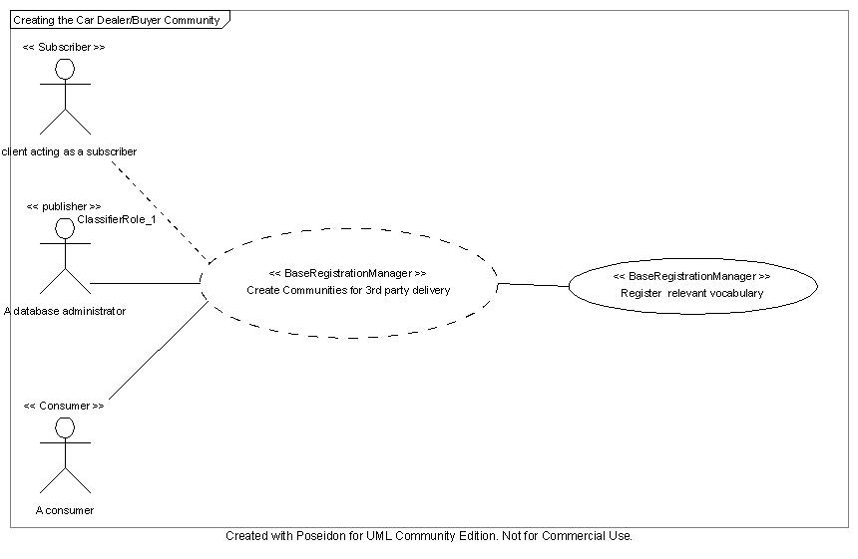
Figure 4-5-15: 3rd Party Delivery Use Case - Creating Communities

Examples of XML Messages
The examples are constructed following the discussion in Appendix B.
Case 1: Publishers identified by Clients, Consumers identified by Publisher

Step 1: Client identifies Publishers
The setup from the Car Use Case is used to formulate the getMetaData the following XQuery statement.
For $CD in doc('www.carcommunity.com.xml')//CarDealers
$Asc in doc('www.carcommunity.com.xml')//Associations
$Voc in doc('www.carcommunity.com.xml')//Vocabularies
$Pub in doc('www.carcommunity.com.xml')//Publishers

Where

$CD/DealerOpened < 1996 and $CD/DealerBBBRating > 3 and $CD/DealerServiceRating >10 and Fn:WithinDist($CD/DealerLocation, ‘15998 Portola Off Road, Portola Valley, CA’ ) < 25 and
$Voc/infod:VocabularyName = ‘CarCommunityCarVocab’ and
$CD/infod:VocabularyInstanceEntityReference=$Asc/infod:AssociateEntityIdentifier and
$CD/infod:VocabularyInstanceEntityReference = Fn:GetEPR($Pub) and
$Asc/infod:VocabularyInstanceEntityReference = Fn.GetEPR($Voc)

Return

($Pub/infod:WSEntityIdentifier)

Step 2: Client sends Requests to Publishers
This is the same request as specified in the Car Use Case, see Step 7: INFOD registry sends Subscription Notification to Car Dealers ..

Step 3: Publishers identify Consumers
The setup from the Car Use Case is used to formulate the getMetaData the following XQuery statement.
For $CB in doc('www.carcommunity.com.xml')//CarBuyer
$Con in doc('www.carcommunity.com.xml')//Consumer

Where

$CB/BuyerCRRating > 700 and Fn:WithinDist($CB/BuyerLocation, ‘101 Auto Row, Redwood City, CA 94065’) and
$CB/infod:VocabularyInstanceEntityReference = Fn:GetEPR/($Con)

Return

($Con/infod:WSEntityIdentifier)
Note: This XQuery is added to show how publishers can find consumers; in this specific use case there is one specific consumer.

Step 4: Publishers send Results to Consumers
This step has been covered by the previous use cases.
Case 2: Publishers and Consumers identified by Clients

Step 1: Client identifies Publishers and Consumers
The setup from the Car Use Case is used to formulate the getMetaData the following XQuery statement.
For $Pub in doc('www.carcommunity.com.xml')//Publishers,
$Con in doc('www.carcommunity.com.xml')//Consumers,
$Voc in doc('www.carcommunity.com.xml')//Vocabularies,
$Asc in doc('www.carcommunity.com.xml')//Associations,
$CD in doc('www.carcommunity.com.xml')//CarDealers,
$CB in doc('www.carcommunity.com.xml')//CarBuyer,

Where

Fn:WithinDist($CD/DealerLocation, ‘15998 Portola Off Road, Portola Valley, CA ’) < 25 and
$Voc/infod:VocabuklaryName = ‘CarCommunityCarVocab’ and
fn:evaluate($Pub/PublisherPropertyConstraint, $CB) = 1 and
fn:evaluate($Con/ConsumerProperttyConstraints, $CD) = 1 and
$CD/infod:VocabularyInstanceEntityReference = $Asc/infod:VocabularyInstanceEntityReference and
$Asc/infod:VocabularyInstanceEntityReference = Fn:GetEPR/($voc)

$CB/infod:VocabularyInstanceEntityReference = Fn:GetEPR/($con)
return
<PublisherRecipientMapping>
{
$pub, $Con
}
</PublisherRecipientMapping>
Note: This XQuery is more complex than necessary to show mutual filtering between publishers and consumers; in this specific use case there is one specific consumer.

Step 2: Client sends Request to Publishers
This is the same request as specified in the Car Use Case, see Step 7: INFOD registry sends Subscription Notification to Car Dealers on page63. on page

Step 3: Publishers send Results to Consumers
This is the same request as specified in previous use case.
Case 3: Continuous Queries

Step 1: Client sends Requests to INFOD Registry
This is the same request as specified in the Car Use Case see Step 6: Car Buyer adds Subscription.

Step 2: INFOD identifies Publishers and Consumers and notifies Publishers
This is the same request as specified in the Car Use Case, see Step 7: INFOD registry sends Subscription Notification to Car Dealers .
Note: The INFOD registry will inform any publisher if any change in the registry changes the respective consumer list.

Step 3: Publishers send Results to Consumers
This step has been covered by the previous use cases.
  - Security
If consumers of query results are database clients, the database (fine grain) security can be used to ensure that data are only distributed to those consumers that are entitled to receive the query results.
If consumers are not database clients the constraint information in the INFOD registry will be used to ensure that data are only distributed to those consumers that are entitled to receive the query results.
  - Performance
The identification of the databases and consumers with an INFOD registry has to be added to the response time. The performance of such a request is highly dependent on the implementation of that registry.
The performance of the creation of the query result and the notification of the clients depends on the databases acting as query engine and as publisher.
  - Requirements Implied
R1 | Constraints, which restrict the flow of messages from publishers to consumers, must be composable. | The constraints contained in queries must be composed with the constraints related to security
R2 | Publishers should be able to describe their available messages, events and states in terms of a vocabulary. | Depending on the support of the database, there may be access to messages, events, and states. The focus is the access to a single state.
R3 | Subscribers must be able to constrain messages based on message content and publisher information. | N/A - clients acting as subscribers determine the content of the message.
R4 | Publishers must be able to choose what messages to publish based on consumer and subscriber information. | N/A – databases acting as publishers react only to requests of clients
R5 | Consumers must be able to constrain messages based on message content, publisher information and subscriber information. | Consumers must be able to reject messages based on content and client acting as subscriber.
R6 | Any component can request that it be notified by the registry, via WSN, of changes that the component considers interesting. | If a database shares a repository with other databases it needs to be informed of changes. These changes are of special importance if the database offers Continuous Query support.

Editor and Contributor Information
Vijay Dialani
IBM Corporation
Almaden Research Center
650 Harry Road,
San Jose, CA 95120-6099
vdialani@us.ibm.com

Steven Davey
EPCC,
University of Edinburgh,
James Clerk Maxwell Building,
Mayfield Road,
Edinburgh EH9 3JZ,
United Kingdom.
sdavey@nesc.ac.uk

Ronny Fehling
Oracle Corporation
600 Blvd. de Maisonneuve Ouest
Montreal
Quebec H3A 3J2
Canada

Steve Fisher
Rutherford Appleton Laboratory (CCLRC)
Chilton
Didcot
Oxon OX11 0QX, UK
s.m.fisher@rl.ac.uk

Dieter Gawlick
Oracle Corporation
500 Oracle Parkway
Redwood Shores
CA 94065
dieter.gawlick@oracle.com

Christopher Kantarjiev
Oracle Corporation
500 Oracle Parkway
Redwood Shores
CA 94065
chris.kantarjiev@oracle.com

Cecile Madsen
IBM Silicon Valley Laboratory
555 Bailey Avenue
San Jose, CA 95141
madsen@us.ibm.com

Susan Malaika,
IBM Corporation,
Silicon Valley Laboratory,
555 Bailey Avenue,
San Jose, CA 95141,
USA.
malaika@u.ibm.com

Shailendra Mishra
Oracle Corporation
500 Oracle Parkway
Redwood Shores
CA 94065
shailendra.mishra@oracle.com

Mallikarjun Shankar
Oak Ridge National Laboratory
Oak Ridge
TN 37831
shankarm@ornl.gov

Acknowledgements
The INFOD Working Group of the Global Grid Forum has benefited from many people contributing to discussions within the group.

Intellectual Property Statement
The GGF takes no position regarding the validity or scope of any intellectual property or other rights that might be claimed to pertain to the implementation or use of the technology described in this document or the extent to which any license under such rights might or might not be available; neither does it represent that it has made any effort to identify any such rights. Copies of claims of rights made available for publication and any assurances of licenses to be made available, or the result of an attempt made to obtain a general license or permission for the use of such proprietary rights by implementers or users of this specification can be obtained from the GGF Secretariat.
The GGF invites any interested party to bring to its attention any copyrights, patents or patent applications, or other proprietary rights which may cover technology that may be required to practice this recommendation. Please address the information to the GGF Executive Director.

Full Copyright Notice
Copyright (C) Global Grid Forum (2005). All Rights Reserved.
This document and translations of it may be copied and furnished to others, and derivative works that comment on or otherwise explain it or assist in its implementation may be prepared, copied, published and distributed, in whole or in part, without restriction of any kind, provided that the above copyright notice and this paragraph are included on all such copies and derivative works. However, this document itself may not be modified in any way, such as by removing the copyright notice or references to the GGF or other organizations, except as needed for the purpose of developing grid Recommendations in which case the procedures for copyrights defined in the GGF Document process must be followed, or as required to translate it into languages other than English.
The limited permissions granted above are perpetual and will not be revoked by the GGF or its successors or assigns.
This document and the information contained herein is provided on an "AS IS" basis and THE GLOBAL GRID FORUM DISCLAIMS ALL WARRANTIES, EXPRESS OR IMPLIED, INCLUDING BUT NOT LIMITED TO ANY WARRANTY THAT THE USE OF THE INFORMATION HEREIN WILL NOT INFRINGE ANY RIGHTS OR ANY IMPLIED WARRANTIES OF MERCHANTABILITY OR FITNESS FOR A PARTICULAR PURPOSE."

References
[EVAL]
. Dieter Gawlick, Dmitry Lenkov, Aravind Yalamanchi, Lucy Chernobrod, "Applications for Expression Data in Relational Database Systems," icde, p. 609, 20th International Conference on Data Engineering (ICDE'04), 2004
[OGSA]
I. Foster (Ed), H. Kishimoto (Ed), A. Savva (Ed), D. Berry, A. Djaoui, A. Grimshaw, B. Horn, F. Maciel, R. Subramaniam, J. Treadwell, J. Von Reich. The Open Grid Services Architecture, Version 1.0. Global Grid Forum. GFD-I.030. 29 January 2005. http://forge.gridforum.org/projects/ggf-editor/document/GFD.30/en/1.
[OGSA Glossary]
J. Treadwell, Open Grid Services Architecture Glossary of Terms, GFD-I.044, January 25th 2005. http://forge.gridforum.org/projects/ggf-editor/document/GFD.44/en/1.

Appendix A – INFOD Patterns of Interaction

Introduction
INFOD is designed to support a variety of information dissemination patterns. The following patterns have been identified.
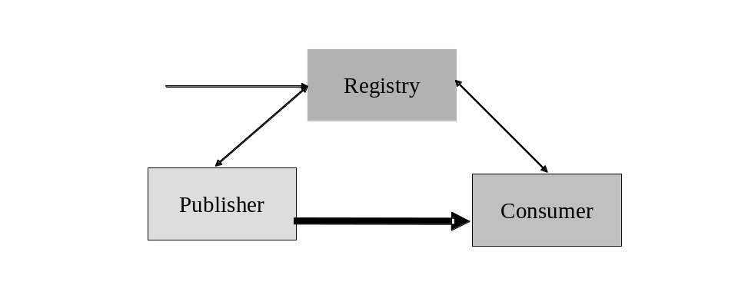
Figure 12-16: Base INFOD Service
- No subscriptions – publishers send messages to consumers of their choice. The following sub-pattern are identified:
- Publishers use an INFOD registry to find consumers
- Consumers use an INFOD registry to filter publishers
- Publishers and consumers use an INFOD registry to share vocabularies
- Subscriptions managed by an INFOD registry – subscribers send subscriptions to an INFOD registry. The INFOD registry identifies publishers (and consumers) and sends subscriptions to publishers
- Subscription based publications - publishers create and deliver messages according to subscription requests.

Description of Patterns

No Subscriptions
The patterns of this section represent the basic form of disseminating information: publishers send messages to consumers of their choice.
The following information in the INFOD registry provides the context for this pattern:
- User data vocabularies - optional
- Publishers and consumers - optional
- Vocabulary associations - optional
- User property vocabularies - optional
- User properties - optional
The following functionality is available:
- Publishers query the INFOD registry to find matching consumers – requires consumer and optionally property vocabulary entries in INFOD registry.
Publishers should avoid querying the INFOD registry for each single message. Instead, publishers should group messages into classes and associated consumers to these classes and additionally cache the consumer information.
If requested, changes of the result set of any query trigger notification of the publisher. These notifications contain updated information about consumers.
- Consumer filter messages based on publishers properties - requires publisher and optionally property vocabulary entries in INFOD registry.
Consumers can query the INFOD registry to find information about publisher using the information about publishers in the manifest section of the INFOD message.
Consumers should avoid querying the INFOD registry for each single message. Consumers have to obtain and cache relevant information.
If requested, changes to the result set of any query will trigger notification of the consumers. These notifications contain updated information about publishers.
- Publishers and consumers use vocabulary information in the INFOD registry before sending/consuming a message - requires user data vocabulary entries in INFOD registry.
Publishers and consumers should avoid querying the INFOD registry for each message. Both, publishers and consumers, should obtain and the cache relevant vocabulary information.
If requested, changes to the result set of any query will trigger notification of the publishers and consumers respectively. These notifications contain updated information about vocabularies.
Note: Publishers and consumers use only limited set services of the INFOD registry; e.g., publishers and consumers are not matched by the INFOD registry but do so using the GetMetaData interface.

Subscriptions - Managed by Registry
The association of publishers and consumers to a subscription is the responsibility of the INFOD registry.
The following information in the INFOD registry provides the context for this pattern:
- User data vocabularies - mandatory
- Publishers and consumers - mandatory
- Subscribers - mandatory
- Subscriptions - mandatory
- Vocabulary associations - mandatory
- User property vocabularies – optional
- User properties - optional
The following functionality is available:
- Subscribers manage subscriptions using the Create/Replace/DropSubscription operation.
The INFOD registry determines which publishers are offering messages of interest using the vocabulary and vocabulary association information. The evaluation of all constraints that may limit the selection of publishers and consumers follows. The INFOD registry will make adjustment if subscriptions, publishers or consumers are created, replaced or dropped.
If requested, changes that impact subscriptions will trigger notification of the publishers. These notifications contain updated information about subscriptions.

Subscription Based Publications
Publishers are often not able to determine which messages are of interest to consumers. Therefore, publishers must allow the creation of messages based on subscription referencing events or states.
The following information in the INFOD registry provides the context for this pattern:
- User data vocabularies - mandatory
- Publishers and consumers - mandatory
- Subscribers - mandatory
- Subscriptions - mandatory
- Vocabulary associations - mandatory
- User property vocabularies – optional
- User properties - optional
The following functionality is available:
- Subscribers specify what messages are published in reaction to events or state changes.
Publishers have to support vocabularies that include events or even allow the specification of events. The associate language must allow filtering of events and also include the ability to define what messages need to be created to reaction to events and state changes respectively.
The difference between this and the previous patterns is the functionality of the information source (vocabulary associations). In the previous patterns, publishers use vocabularies that represent messages; using this pattern publishers offer access to events and state transitions. Messages are created when an event satisfies certain constraints or when a state transition results in certain constraint becoming true.
If requested, changes that impact subscriptions will trigger notification of the publishers and subscribers. These notifications contain updated information about vocabularies.

Outline of Operations

No Subscriptions
The following functionality is available:
- Publishers find relevant consumers in INFOD registry
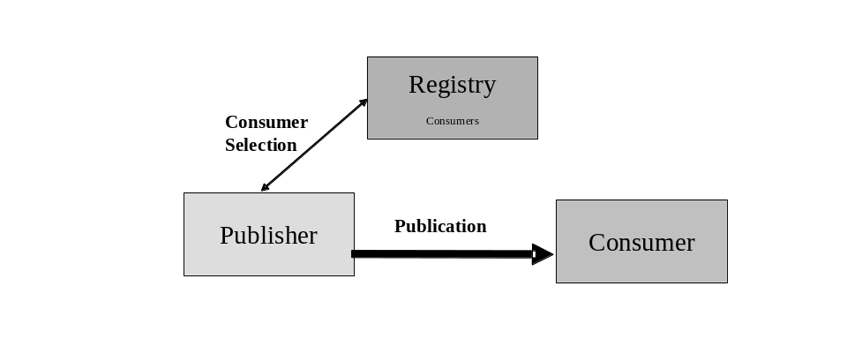
Figure 12-17 Base INFOD Service - No Subscription, Consumer Selection
Tasks:
- Manage consumer information in INFOD registry with
- Create/Replace/DropConsumer operation - mandatory
- RegisterPropertyVocabulary operation – optional
- Create/DropPropertyVocabularyInstance operation - optional
- UnregisterVocabulary operation - optional
- Publishers select consumers using the GetMetaData operation
- If requested, publishers receive update notifications from the INFOD registry reflecting changes of consumer information
- Publishers create and send messages using WS-Notification message structure.
The INFOD registry provides up-to-date information about consumers.
- Consumers filter messages based on publishers properties
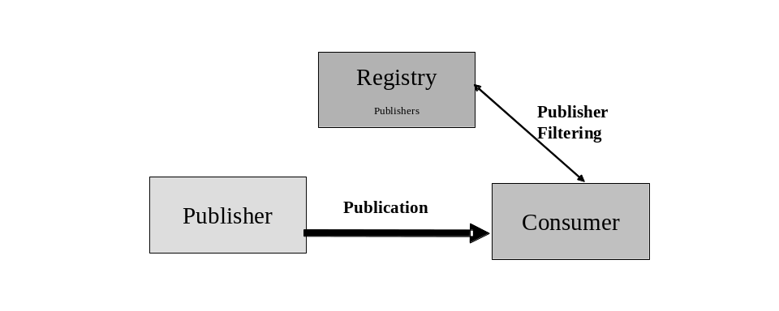
Figure 12-18 Base INFOD Service - No Subscription, Publisher Filtering
Tasks:
- Manage publisher information in INFOD registry with
- Create/Replace/DropPublisher operation - mandatory
- RegisterPropertyVocabulary operation – optional
- Create/DropPropertyVocabularyInstance operation - optional
- UnregisterVocabulary - optional
- Consumers find publisher information using the GetMetaData operation
- If requested, consumers receive update notifications form the INFOD registry reflecting changes of publisher information
- Publishers create and send messages using WS-Notification message structure
- Consumers verifies publishers and consumes message
The INFOD registry provides up-to-date information about publishers.
- Consumer can filter message based on message content
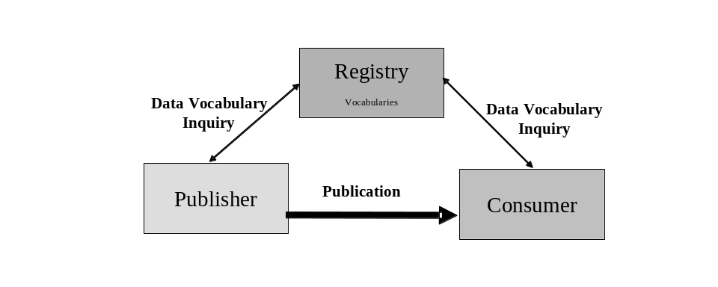
Figure 12-19 Base INFOD Service - Vocabulary Inquiry
Tasks:
- Manage vocabulary information in INFOD registry with
- RegisteDataVocabulry operation - mandatory
- UnregisterVocabulry operation - optional
- Publishers find vocabularies using the GetMetaData operation
- If requested, publishers receive update notifications reflecting changes of vocabularies
- Consumers find vocabularies using the GetMetaData operation
- If requested, consumers receive update notifications reflecting changes of vocabularies
- Publishers create and send messages using WS-Notification message structure with a payload according to a vocabulary
- Consumers interprets message using vocabulary information and processes it
The INFOD registry provides up-to-date information about data vocabularies.

Subscriptions - Managed by Registry
- Publishers publish messages according to subscription directives
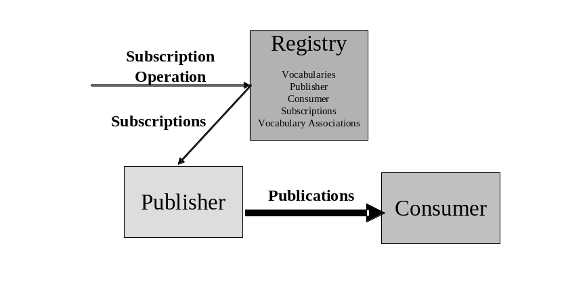
Figure 12-20 Base INFOD Service - Subscription Managed by INFOD Registry
Tasks:
- Manage information in INFOD registry with
- Create/Replace/DropPublisher operation – mandatory
- Create/Replace/DropSubscriber operation – mandatory
- Create/Replace/DropConsumer operation – mandatory
- Create/Replace/DropSubscription operation – mandatory
- RegisterPropertyVocabulary operation – optional
- Create/DropPropertyVocabularyInstance operation - optional
- RegisteDataVocabulry operation - mandatory
- UnregisterVocabulry operation - optional
- Manage vocabularies, publishers, consumers and vocabulary associations in INFOD registry using the Create/Replace/DropPublisher/Consumer and the Register/AddVersion/DeregisterVocabulary operation respectively
- Subscribers direct subscribe request to INFOD registry
- INFOD registry determines relevant publishers
- INFOD registry checks all constraints
- INFOD registry notifies publisher about new subscriptions – these subscription requests reflect constraints in the INFOD registry
- INFOD registry notifies publishers about altered/dropped subscriptions
- Publishers receive and process subscription request
- Publishers create and send messages to all relevant consumers using WS-Notification message structure
- Consumers receive message using the consume operation
By directing subscription request to the INFOD registry, subscribers can direct the INFOD registry to find relevant publishers, check all the constraints, and create a tailored subscription to each of the appropriate publishers. Furthermore, the INFOD registry informs publishers if changes in the directory information require changes in the subscription. This includes that a publication is retracted from some publisher while other publishers are added.

Subscription Based Publications
The only difference to the previous pattern is the structure and the language support for selected user data vocabularies. The subscriber chooses vocabularies, which support the creation of messages based on events or even supports the definition of events.
- Publishers create and publish messages according to subscription directives
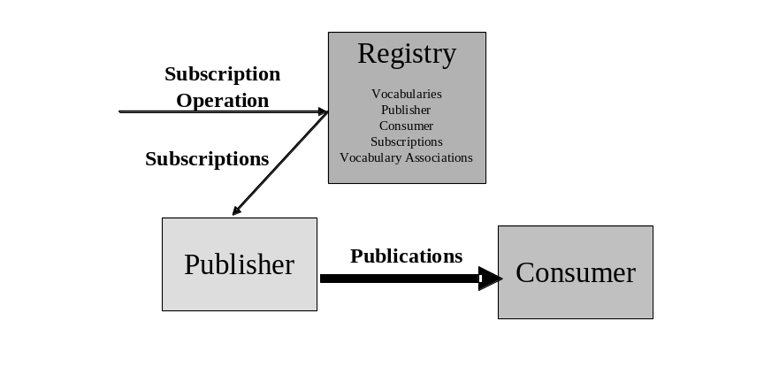
Figure 12-21 Base INFOD Service - Subscription Managed by INFOD Registry - Messages and Events Specified by Subscriber
Tasks:
- Manage information in INFOD registry with
- Create/Replace/DropPublisher operation – mandatory
- Create/Replace/DropSubscriber operation – mandatory
- Create/Replace/DropConsumer operation – mandatory
- Create/Replace/DropSubscription operation – mandatory
- RegisterPropertyVocabulary operation – optional
- Create/DropPropertyVocabularyInstance operation - optional
- RegisteDataVocabulry operation - mandatory
- UnregisterVocabulry operation - optional
- Subscribers direct subscribe request to INFOD registry
- INFOD registry determines relevant publishers
- INFOD registry checks all constraints
- INFOD registry notifies publisher about new subscriptions – these subscription requests reflect constraints in the INFOD registry
- INFOD registry notifies publishers about Replaced/dropped subscriptions
- Publishers receive and process subscription request
- Publishers create and send messages to all relevant consumers using the WS-Notification message structure
- Consumers receive message using the consume operation

Appendix B – Accessing the INFOD Registry
The use of XQuery to access the information in the INFOD registry to described in this appendix. It is expected that providers of INFOD will provide tools automating steps and hiding details of the implementation from the INFOD users.
The first step is to describe publishers, consumers and subscriptions as seen in a specific context.

The Publisher View
Given a context, publishers are best described by an XML document called PublisherView – in a real application the name should reflect the context.
Here is a generic example – the boxes of the picture represent entities and property instances expressed with the named XML schema:
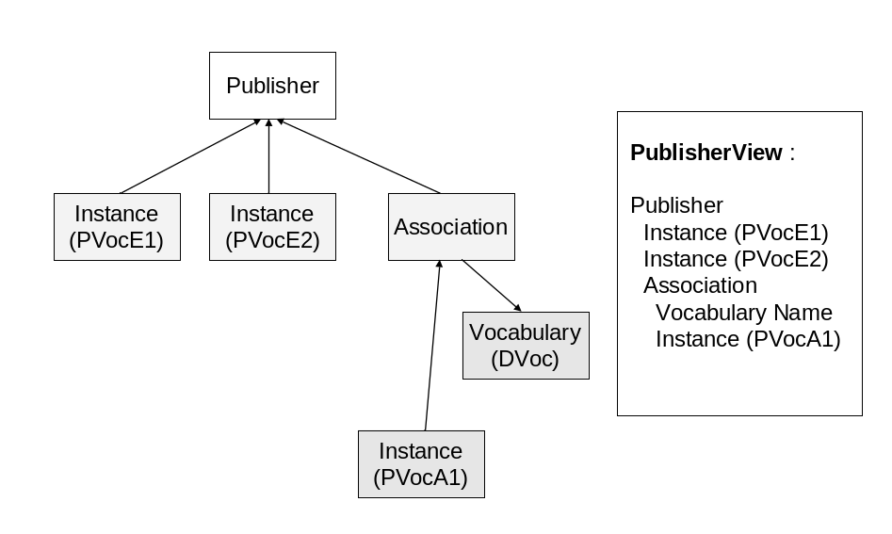
Figure 13-22: PublisherView
The PublisherView document can be created with the following XQuery statements:
For $Pub in doc('MyINFODRegistry.xml')//Publishers,
$PVocE1 in doc('MyINFODRegistry.com.xml')//PVocE1,
$PVocE2 in doc(‘MyINFODRegistry.xml')//PVocE2,
$Asc in doc(‘MyINFODRegistry.asc')//Associations,
$DVoc in doc(‘MyINFODRegistry.xml')//Vocabularies,
$PVocA1 in doc(‘MyINFODRegistry.xml')//PVocA1

Where

$PVocE1/infod:VocabularyInstanceEntityReference = Fn:GetEPR($Pub) and
$PVocE2/infod:VocabularyInstanceEntityReference = Fn:GetEPR($Pub) and
$Asc/infod:AssociationEntityIdentifier = Fn:GetEPR($Pub) and
$Asc/infod: AssociationVocabularyIdentifier = Fn:GetEPR($DVoc) and
$PVocA1/infod:VocabularyInstanceEntityReference = Fn:GetEPR($Asc)

Return

<PublisherView>
{$Pub, $PVoc1, $PVoc2, $Asc, $DVoc//wsinfod.VocabularyName, $AVoc1}

</PublisherView>

The Consumer View
The same idea can be applied to the consumer; there is, however, no reference to associations.
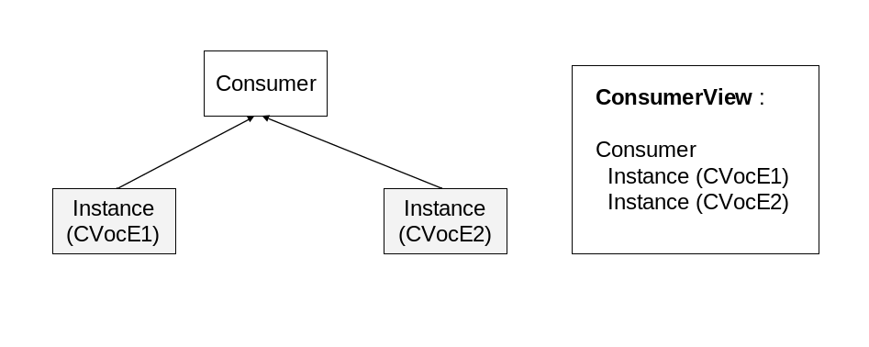
Figure 13-23: ConView
The XQuery statements for ConsumerView are constructed following the patterns of PublisherView. Please note that one arrow goes from instances of CVocE1 to optional instances of CVocE11.
For $Con in doc(‘MyINFODRegistry.xml')//Consumers,
$CVocE1 in doc(‘MyINFODRegistry.xml')//CVocE1,
$CVocE2 in doc(‘MyINFODRegistry.xml')//CVocE2

Where

$CVocE1/infod:VocabularyInstanceEntityReference = Fn:GetEPR($Con) and
$CVocE2/infod:VocabularyInstanceEntityReference = Fn:GetEPR($Con) and

Return

<ConsumerView>
{$Con, $CVoc1, PVocE2,}

</ConsumerView>

The Subscription View
The next step is to include the subscription information. One could also discuss the subscriber view; but that view is generally not so important.
The same idea can be applied to the consumer; there is, however, no reference to associations.
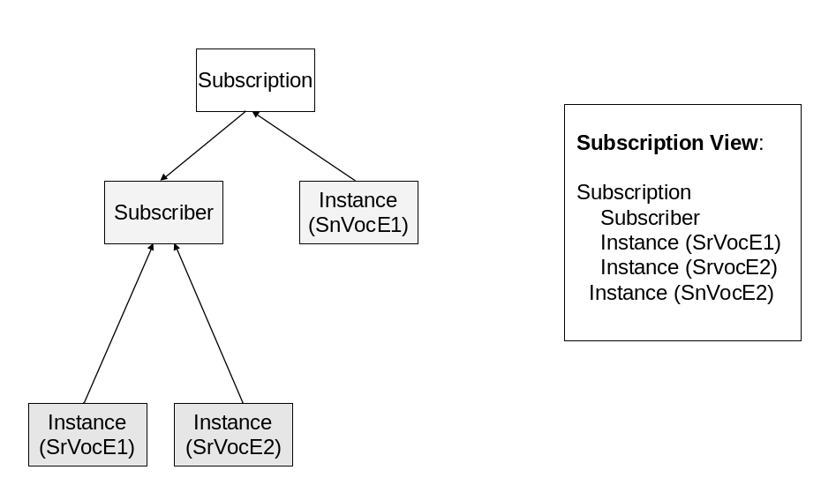
Figure 13-24: SubView
The XQuery statements for SubView are constructed following the patterns of PubView or ConView.
For $Sub in doc(‘MyINFODRegistry.xml')//Subscriptions,
$Subr in doc(‘MyINFODRegistry.xml')//Subscriber,
$SrVocE1 in doc(‘MyINFODRegistry.xml')//SrVocE1,
$SrVocE2 in doc(‘MyINFODRegistry.xml')//SrVocE2,
$SnVocE1 in doc(‘MyINFODRegistry.xml')//SnVocE1

Where

$Sub/infod:SubscriptionSubscriberIdentifyer = Fn:GetEPR($Subr) and
$SrVocE1/infod:VocabularyInstanceEntityReference = Fn:GetEP($Subr) and
$SrVocE2/infod:VocabularyInstanceEntityReference = Fn:GetEP($Subr) and
$SnVocE1/infod:VocabularyInstanceEntityReference = Fn:GetEP($Sub)

Return

<SubsriptionView>
{$Sub, $Subr, $SrVocE1, $ SrVocE2, SnVocE1}

</SubscriptionView>

The Consumer/Publisher View
The nest step is to create a special community to enable the interaction between publishers and consumers. This requires the inclusion of constraints.
Let us use assume the following (XPATH) constraints exist:
- PVocE1 referencing CVocE2 – limits publishers interest in consumers
- DVocA1 referencing CVocE1 – limits consumers access to data
- CVocE2 referencing PVocE1 – limits consumers interest in publishers

Applying these constraints would describe which consumer would be acceptable to which publisher.
For $PView doc(‘MYINFODRegistry.xml’)//PublisherView,
$CView doc(‘MyINFODRegistry.xml’)//ConsumerView,
Where
fn:evaluate($PView/PVocE1/PropertyConstraint, $CView/CVocE2) = 1 and
fn:evaluate($PView/DVocE1/PropertyConstraint, $CView/CVocE1) = 1 and
fn:evaluate($PView/PVocE2/PropertyConstraint, $CView/CVocE1) = 1
return
<PublisherConsumerView>
{
$PView/Publishers, $CView/Consumers
}
</PublisherConsumerView>

The Publisher/Consumer View
Changing the return clause would describe which publisher would be acceptable to which consumer
return
<ConsumerPublisherView>
{
$CView/Consumers, $PView/Publishers
}
</ConsumerPublisherView>
Note that PublisherConsumerView and ConsumerPublisherView can be automatically generated once PublisherView and ConsumerView are generated.

Other Important Views
The following views/functions are of interest:
- SubsriptionPublisherView – publisher organized by subscription
- SubsriptionConsumerView – consumers organized by subscription
- SubsriptionPublisherConsumerView - consumers organized by subscription and publishers
- SubsriptionConsumerPublisherView – publishers organized by subscriptions and consumers
Note: Details will be added if reviews indicate a need.

It is assumed that a performing implementation does not require a full evaluation of each query after each change.
We use the term sensor networks to refer to both sensor and actuator networks that cover a feedback loop of sense, response, and actuation. Actuators are entities that have the inverse behavior of sensors, that is, they effect actions on the environment (e.g., a camera turn, or change in a sensitivity setting of a sensor).
INFOD does not manage user data
The evaluate function [EVAL} is one way to process multiple constraints as part of an XML statement.

