INFOD Patterns

These notes may become part of the INFOD use case document.

Introduction

INFOD is designed to support a variety of information dissemination patterns.

The following patterns will be described in this section.

Base INFOD Service – No POBox, No disseminator:

- No subscriptions – publishers send message to consumers of their choice
- Subscriptions without registry support – publishers send messages to consumers according to subscription requests
- Subscription managed by registry – publishers and consumers are identified by registry
- Subscription based publication - publishers create and deliver messages according to subscription requests

POBox INFOD Service:

- Without subscription - messages are send to POBox, consumer can retrieve messages from POBoxes within property and data constraints
- With subscriptions – messages are sent to POBoxes; designated consumers are able to retrieve them

Single Disseminator INFOD Service:

- With subscription processed by publishers – a single disseminator is used to disseminate a single message from a set of publishers to a set of consumers according to subscription directives
- With subscriptions processed by disseminator (disseminator acting as/on behalf of publisher) – publishers send messages to disseminators and disseminators distribute messages according to subscriptions. A single disseminator is used to disseminate a single message.

Multi-Disseminator INFOD Service:

- Multi-disseminator message delivery – disseminators deliver messages through other disseminators

Section 2 of these notes explains the steps required to set up each pattern and the interfaces used by the INFOD entities to execute the actions; section 3 describes outlines how the patterns are implemented while section 4 describes the interfaces in detail.

Description of Patterns

Base INFOD Service – No POBox, No disseminator

It should be noted that all patterns in this section do not provide decoupling between publishers and consumers and require sophisticated publishers and consumers to achieve even basic operational quality.

No Subscriptions

This pattern represents the most elementary way of disseminating information. Publishers send message to consumers of their choice.

Optionally, consumers are able to accept or reject messages using information about the publisher in the INFOD registry and evaluating the message content.

The following information in the INFOD registry provides the context for this pattern:

- A set of user data vocabularies – optional
- A set of user property vocabularies - optional
- A set of publishers and consumers: name, optional properties, … - optional

The following functionality is available:

- Publishers publish messages to consumers of their choice

Publishers send messages to consumers of their choice. It is assumed that publishers know the intended consumers and how to reach them. It is assumed that consumers understand the structure of the payload.
The only difference to standard WS-messaging is the structure of the message. The added functionality results for the use of the INFOD registry as explained in the following paragraphs.

Optional functionality:

- Publishers can find relevant consumers – requires consumer entries in INFOD registry

Publishers could query the INFOD registry to find matching consumers. If this is done for each single message the implementation would not be scalable. Instead, publishers should group messages into classes and associated consumers to these classes by querying the INFOD registry. Publishers may request notification by the INFOD registry when the result set for any of the queries changes.

- Consumer can filter messages based on publishers properties - requires property vocabulary in INFOD registry

Consumers should avoid querying the INFOD registry for each single message. Consumers have to cache relevant information and request notification by the INFOD registry when the result sets change.

- Consumer can filter message based on message content - requires user data vocabulary in INFOD registry. Consumers are responsible to match the query expressions to the vocabulary of the payload.

Subscriptions Without Registry Support

This pattern allows consumers (subscribers) to define messages of interest. An example for this pattern is WS-Notification.

The following information in the INFOD registry provides the context for this pattern:

- A set of user data vocabularies – optional
- A set of user property vocabularies - optional
- A set of publishers and consumers: name, optional properties, … - optional

The following functionality is available:

- Publishers publish messages based on subscriptions

Consumers (subscribers) are subscribing directly to publishers.

Optional functionality:

- Consumers can find relevant publishers – requires publisher entries in INFOD registry

Consumers (subscribers) could query the INFOD registry to find relevant publishers by querying their properties and their associations to vocabularies. Consumers may request notification by the INFOD registry when the result set changes.

- Publishers can filter subscriptions based on consumers properties - requires property vocabulary in INFOD registry

Publishers should avoid querying the INFOD registry for each single message. Publishers should cache and group relevant information and request notification by the INFOD registry when the result set changes

Subscriptions Managed by Registry

This pattern represents the preferred way of managing subscriptions. The association of publishers to a subscription becomes the responsibility of the INFOD registry. The WS-Notification with registry is a very simple example for this pattern.

The following information in the INFOD registry provides the context for this pattern:

- A set of user data vocabularies - mandatory
- A set of user property vocabularies - optional
- A set of publishers and consumers: name, optional properties, … - mandatory
- A set of subscriptions - mandatory

The following functionality is available:

- Publishers publish messages according to subscription directives

The INFOD registry will evaluate which publishers are publishing messages of interest. Constraints of publishers and consumers will limit the selection of publishers and consumers. The INFOD registry will also validate the data vocabulary constraint.
The INFOD registry will make adjustment if subscriptions, publishers or consumers are created, altered or dropped.
Publishers can react immediately to adjustment assuming they receive notification about changes. Publishers may also choose not to support notification and must therefore inquire the INFOD registry about adjustment. The INFOD registry supports both models; e.g.; it acts as a publisher and as a POBox for meta-data.

Subscription Based Publication

Publishers are often not able to determine which messages are of interest to consumers. Therefore, publishers must allow the creation of messages based on subscription referencing events or states.

The difference between this and the previous patterns is the functionality of the information source (vocabulary associations). In the previous patterns publishers use vocabularies that represent message streams; in this pattern publishers offer access to events and state transitions. Messages are created when an event satisfies the constraints or when a state transition results in a constraint becoming true.

The following information in the INFOD registry provides the context for this pattern:

- A set of user data vocabularies - mandatory
- A set of user property vocabularies - optional
- A set of publishers and consumers: name, optional properties, … - mandatory
- A set of subscriptions (name, optional properties, constraints (especially for vocabulary associations), … - mandatory

The following functionality is available:

- Publishers create and publish messages according to subscription directives

Publishers have to specify vocabularies that provide selection and access to data associated to a set of well-specified events; publishers may even allow the specification of events. Furthermore, the language must include the ability to specify which message payload has to be created.
In response to the creation of subscriptions, relevant publishers will be informed which message should be create and disseminated to which consumers. Changes (deletion) of the subscriptions, publishers and consumers may result in changes of the consumer list. Effected publishers will be informed of any change that impacts them.

POBox INFOD Service

Without Subscriptions

This pattern represents classical messaging with significantly enhanced functionality and operational characteristics.

Another important example for this pattern is the DAIS 3rd party delivery. In this context a significant part of the INFOD registry information can be derived from the DAIS meta-data, an obvious example is the user data vocabulary.

POBoxes optionally provide a series of functions and operational characteristics such as transactional support, retention and auditing. These operational characteristics will not be discussed explicitly.

The following information in the INFOD registry provides the context for this pattern:

- A set of user data vocabularies – optional
- A set of user property vocabularies - optional
- A set of POBoxes: name, properties, … - mandatory
- A set of publishers and consumers: name, optional properties, … - optional

The following functionality is available:

- Publishers publish messages to POBoxes with or without specifying consumers

Publishers publish messages to POBoxes without determining which consumer is interested in the messages.

- Consumers retrieve messages from POBox – browse, consume

Consumers select messages using data constraints.

- POBox applies property constraints as specified in the INFOD registry

Consumers will only be able to retrieve message if there is no property constraint violation.

With Subscriptions

This pattern represents a generalization of the WS-Notification pull-point delivery.

The following information in the INFOD registry provides the context for this pattern:

- A set of user data vocabularies – optional
- A set of user property vocabularies - optional
- A set of POBoxes: name, properties, … - mandatory
- A set of publishers and consumers: name, optional properties, … - optional
- A set of subscriptions (name, optional properties, constraints (especially for vocabulary associations), … - mandatory

The following functionality is available:

- Publishers publish messages to the POBoxes according to subscriptions

Only messages that are within the property constraints will be delivered.

- Consumers can retrieve messages from the POBox – browse, consume

Consumers can only retrieve messages that are directed to them. Consumers should use data constraints only to achieve processing according to priorities.

Single Disseminator INFOD Service

Disseminators support the functions of POBoxes; therefore the functionality associated to POBoxes applies to disseminators as well. Only the added functionality is covered in the discussion of following patterns

With Subscriptions

This pattern similar to the second POBox pattern providing increased functionality and increased scalability.

The following information in the INFOD registry provides the context for this pattern:

- A set of user data vocabularies – optional
- A set of user property vocabularies - optional
- A set of disseminators: name, properties, … - mandatory
- A set of publishers and consumers: name, optional properties, … - optional
- A set of subscriptions - mandatory

The following functionality is available:

- Publishers publish messages to a disseminator according to subscriptions

Messages will be delivered according to the subscription directives.

With Subscriptions Processed by Disseminator

This pattern represents an extension of the previous pattern allowing publishers to out-source the selection of consumers to disseminators.

This pattern also allows disseminators to act as a publisher and provide added value by adding information to messages, by combining messages and by creating subscriptions to get required information. The WS Brokered Notification is an example for this pattern.

The following information in the INFOD registry provides the context for this pattern:

- A set of user data vocabularies – mandatory
- A set of user property vocabularies - optional
- A disseminator: name, properties, associations, … - mandatory
- A set of publishers and consumers: name, optional properties, … - mandatory
- A set of subscriptions: name, optional properties, constraints (especially for vocabulary associations), … - mandatory

The following functionality is available:

- Publishers publish send messages to disseminator.

Messages will be delivered according to the subscription directives. These subscriptions my reference the publishers directly or consider the disseminator as publisher.

Some possible features:

- Disseminator creates publication derived from consumer publications.

This allows disseminators to direct publishers only to publish messages when needed. This behavior is mandatory for subscription-based publication.
Disseminators may negotiate the use of propagation protocols to optimize the interaction with each other.
- Disseminators can create directed optimize networks to optimize the flow of messages

It is not necessary that each disseminator interact with every other disseminator.

Multi-Disseminator INFOD Service

This is arguable the most important pattern since it is the base for every well managed business communication.

Furthermore, it simplifies the development of publishers and consumers It allows publishers to concentrate on the publishing of messages and consumers to concentrate on the consumption of messages. The complex task of matching publishers to consumers and the difficult task to support required operational characteristics is left to the INFOD registry and the disseminators.

Multi-Disseminator Message Delivery

This pattern pushes the burden of sending a message to a large number of consumers using a wide variety of technologies. It also hides from producers the potentially large variety of operational characteristics that need to be supported.

This pattern is also used for any message delivery when publishers and consumers belong to different environments and operational characteristics such exactly once behavior, non-repudiation is required.

The following information in the INFOD registry provides the context for this pattern:

- A set of user data vocabularies – mandatory
- A set of user property vocabularies - optional
- A set of disseminators: name, properties, associations, … - mandatory
- A set of publishers and consumers: name, optional properties, associations, … - mandatory
- A set of subscriptions: name, optional properties, constraints (especially for vocabulary associations), … - optional

The following functionality is available:

- Publishers publish messages to selected disseminator and consumers

Messages will be published to a home publishers with the according to property constraints.

- Disseminators disseminate messages to other (home) disseminators or directly to consumers

Messages will be forwarded to (home) disseminator according or to consumer according to the subscription directives.

Outline of Operations

Base INFOD Service – No POBox, No disseminator

No Subscriptions

Base functionality:

- Publishers publish messages to consumers of their choice


Figure 1 Base INFOD Service - No Subscriptions

Tasks:
- Publishers create and send messages to the intended consumers using INFOD message structure
- Consumers receive messages using the INFOD consume operation

No INFOD registry support is required. It is assumed that publishers and consumers know each other and understand each other’s vocabularies.
Except for the message structure this is equivalent WS-messaging.

Optional functionality:

- Publishers find relevant consumers in INFOD registry

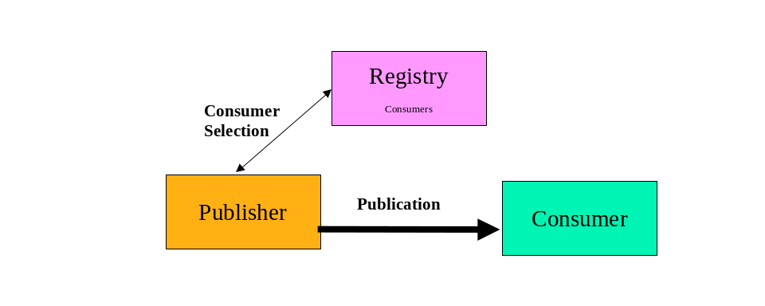
Figure 2 Base INFOD Service - no Subscription, Consumer Selection

Tasks:
- Manage consumer information in INFOD registry using the Create/Alter/DropConsumer operation
- Publishers select consumers using the getMdata operation
- If requested, publishers receive update notifications from the INFOD registry reflecting changes of consumer information using the INFOD consume operation

- Publishers create and send messages using INFOD message structure
- Consumers receive messages using the INFOD consume operation

The INFOD registry provides up-to-date information about consumers to publishers.

- Consumer filter messages based on publishers properties

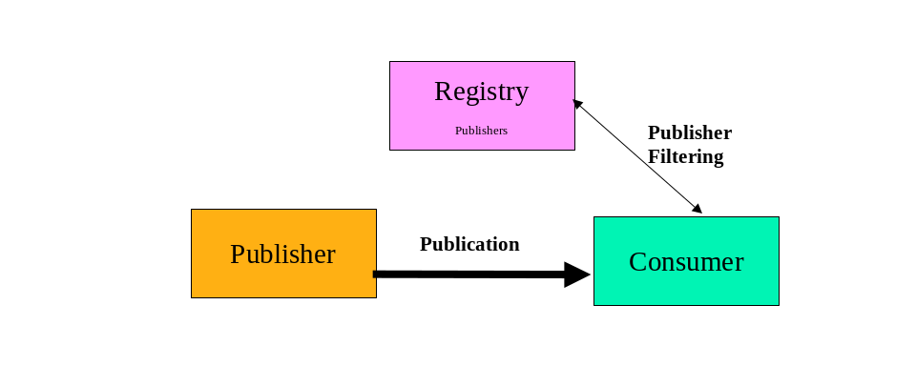
Figure 3 Base INFOD Service - no Subscription, Publisher Filtering

Tasks:
- Manage publisher information in INFOD registry using the Create/Alter/DropPublisher operation
- Consumers find publisher information using the getMdata operation
- If requested, consumers receive update notifications form the INFOD registry reflecting changes of publisher information using the INFOD consume operation

- Publishers create and send messages using INFOD message structure
- Consumers receives message using the INFOD consume operation
- Consumers verifies publishers and consumes message

The INFOD registry provides up-to-date information about publishers to consumers.

- Consumer can filter message based on message content

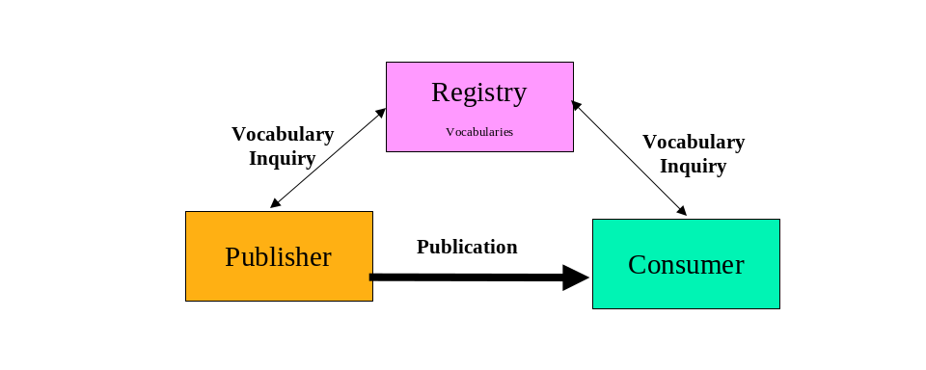
Figure 4 Base INFOD Service – Vocabulary Inquiry

Tasks:
- Manage publisher information in INFOD registry using the Register/DeregisterVocabulary operation
- Publishers find vocabularies using the getMdata operation
- If requested, publishers receive update notifications reflecting changes of vocabularies using the INFOD consume operation
- Consumers find vocabularies using the getMdata operation
- If requested, consumers receive update notifications reflecting changes of vocabularies using the INFOD consume operation

- Publishers create and send messages using INFOD message structure with a payload according to a vocabulary
- Consumers receives message using the INFOD consume operation
- Consumers interprets message using vocabulary information and consumes it

The INFOD registry provides up-to-date information about consumers to publishers.

Subscriptions Without Registry Support

The following functionality is available:

Base functionality:

- Publishers publish messages based on subscriptions


Figure 5 Base INFOD Service – Subscriptions Without Registry Support

Tasks:
- Subscriber direct subscribe request to publishers
- Publishers receive and process publication request

- Publishers create messages according to subscription directives and send these messages to the requesting consumers using INFOD message structure
- Consumers receive messages using the INFOD consume operation

It is also assumed that publishers and consumers know each other and understand each other’s vocabularies.
No INFOD registry support is required.

Optional functionality:

- Consumers finds relevant publishers in INFOD registry

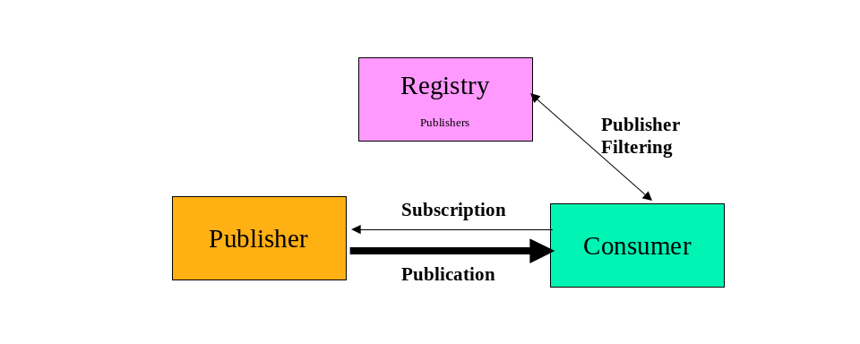
Figure 6 Base INFOD Service – Subscription, Publisher Filtering

Tasks:

- Manage publisher information in INFOD registry using the Create/Alter/DropPublisher operation
- Consumers select publishers using the getMdata operation
- If requested, consumers receive update notifications from the INFOD registry reflecting changes of publisher information using the INFOD consume operation
- Subscribers direct subscribe request to publishers
- Publishers receive and process publication request

- Publishers create and send messages using INFOD message structure
- Consumers receives message using the INFOD consume operation

The INFOD registry provides up-to-date information about publishers to consumers.

- Publishers can filter subscriptions based on consumers properties
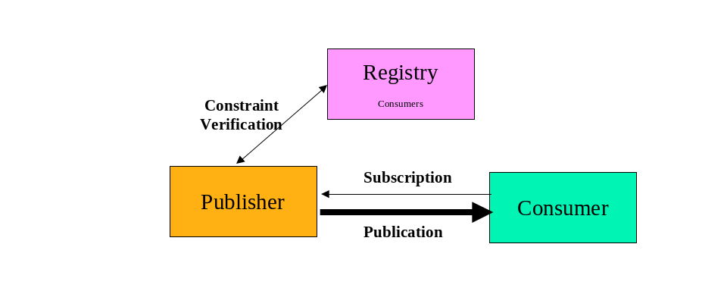
Figure 7 Base INFOD Service - Subscription, Consumer Filtering

Tasks:

- Manage consumer information in INFOD registry using the Create/Alter/DropConsumer operation
- Subscribers direct subscribe request to publishers
- Publishers receive publication request
- Publishers finds consumer information using the getMdata operation and processes publication request
- If requested, publishers receive update notifications from the INFOD registry reflecting changes of consumer information using the consume operation

- Publishers create and send messages using INFOD message structure
- Consumers receives message using the INFOD consume operation

The INFOD registry provides up-to-date information about publishers to consumers.
It is obviously possible that both, publishers and consumers can find information about each other in the INFOD registry. Additional, vocabularies could be used to ensure coherent understanding of data structures; i.e., the message payload.

Subscriptions Managed by Registry

- Publishers publish messages according to subscription directives
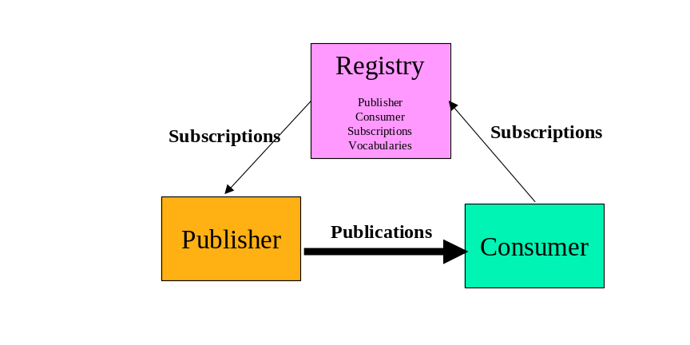
Figure 8 Base INFOD Service – Subscription Managed by INFOD Registry

Tasks:

- Manage publishers, consumers, and vocabularies in INFOD registry using the Create/Alter/DropPublisher/Consumer and the Register/DeresgisterVocabulary operation respectively
- Subscribers direct subscribe request to INFOD registry
- INFOD registry determines relevant publishers
- INFOD registry checks all constraints
- INFOD registry sends specific subscription request to each subscriber – these subscription request reflect constraints in the INFOD registry
- INFOD registry notifies publishers when changes in the INFOD registry modifies their specific subscription
- Publishers receive and process subscription request

- Publishers create and send information to all relevant consumers using the INFOD message structure
- Consumers receive message using the consume operation

By directing subscription request to the INFOD registry, subscribers can direct the INFOD registry to find relevant publishers, check all the constraints, and create a tailored subscription to each of the appropriate publishers. Furthermore, the INFOD registry informs publishers if changes in the directory information require changes in the subscription. This includes that a publication is retracted from some publisher while other publishers are added.

Subscription Based Publication

The only difference to the previous pattern is the structure and the language support for selected user data vocabularies. The subscriber chooses vocabularies, which support the creation of messages based on events or even supports the definition of events.

- Publishers create and publish messages according to subscription directives
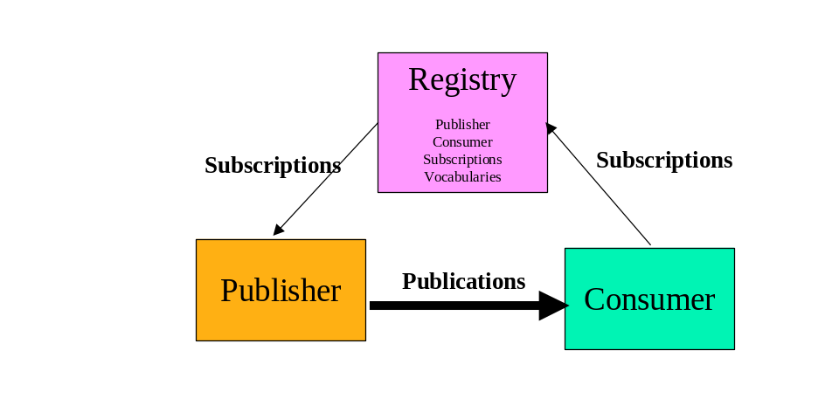
Figure 9 Base INFOD Service – Subscription Managed by INFOD Registry – Messages and Events Specified by Subscriber

Tasks:

- Manage publishers, consumers and vocabularies in INFOD registry using the Create/Alter/DropPublisher/Consumer and the Register/DeresgisterVocabulary operation respectively. The selected vocabularies support the creation of messages based on event or even the definition of events.
- Subscribers direct subscribe request to INFOD registry
- INFOD registry determines relevant publishers
- INFOD registry checks all constraints
- INFOD registry sends specific subscription request to each subscriber – these subscription request reflect constraints in the INFOD registry
- INFOD registry notifies publishers when changes in the INFOD registry modifies their specific subscription
- Publishers receive and process subscription request

- Publishers create and send messages to all relevant consumers using the INFOD message structure
- Consumers receive message using the consume operation

POBox INFOD Service

Without Subscriptions

- Publishers publish messages to POBoxes with or without specifying consumers
- Consumers retrieve messages from POBox – browse, consume
- POBox applies property constraints as specified in the INFOD registry
- Consumers will only be able to retrieve message if there is no property constraint violation

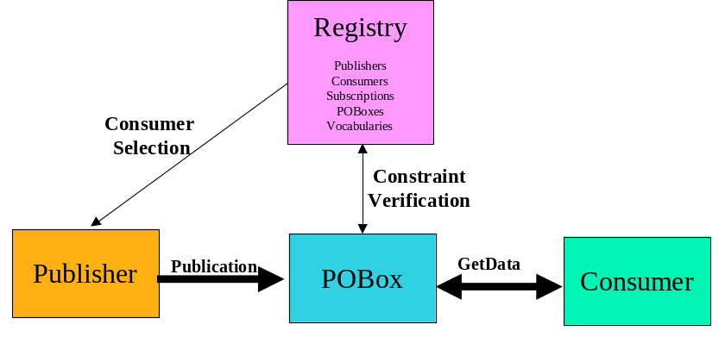
Figure 10 POBoxes without Subscriptions

Tasks:

- Manage publishers, consumers, POBoxes and vocabularies in INFOD registry using the Create/Alter/DropPublisher/Consumer/POBox and the Register/DeresgisterVocabulary operation respectively. Some consumers will direct delivery of messages to POBoxes.

- Publishers create and send messages to POBoxes using the INFOD message structure – messages may or may not be directed to specific consumers
- POBoxes will only accept messages for specific consumers if constraints are satisfied
- POBoxes make messages only available to consumers if specified constraints are satisfied
- Publishers can retrieve message from POBoxes - within retention constraints - even after they have been consumed
- Consumers retrieve message from POBoxes – POBoxes ensure that all property constraints are met. Users use getData operations with filters and optionally the WAIT_FOR option and also specify if a message is consumed for not.
- Consumers can retrieve message from POBoxes - within retention constraints - even after they have been consumed.

A significant part of the complexity of information dissemination has been moved to the POBoxes; e.g., the consumption of a message by POBoxes and consumers respectively can be part of a transaction.

With Subscriptions

This pattern represents a generalization of the WS-Notification pull-point delivery.

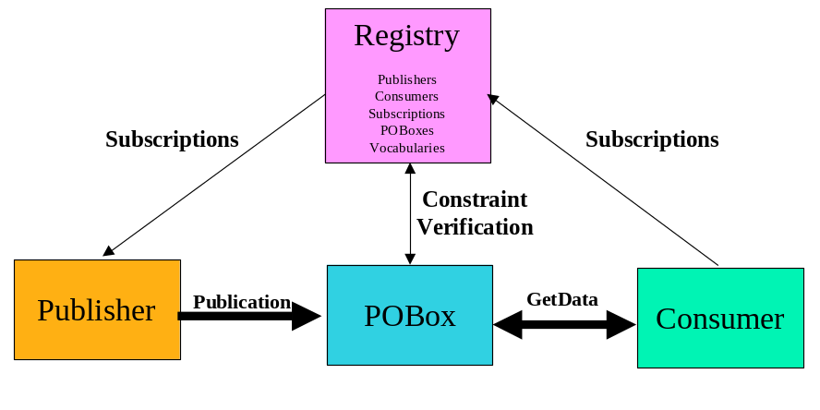
Figure 11 POBoxes with Subscriptions Managed by Registry

Tasks:

- Manage publishers, consumers, POBoxes and vocabularies in INFOD registry using the Create/Alter/DropPublisher/Consumer/POBox and the Register/DeresgisterVocabulary operation respectively. Some consumers will direct delivery of messages to POBoxes.
- Subscribers direct subscribe request to INFOD registry
- INFOD registry determines relevant publishers
- INFOD registry checks all constraints
- INFOD registry sends specific subscription request to each subscriber – these subscription request reflect constraints in the INFOD registry
- INFOD registry notifies publishers when changes in the INFOD registry modify their specific subscriptions. Optionally, publishers can use the getData operation
- Publishers receive and process subscription request

- Publishers create and send messages to all relevant POBoxes using the INFOD message structure
- POBoxes will only accept messages for specific consumers if constraints are satisfied
- POBoxes make messages only available to consumers if specified constraints are satisfied
- Publishers can retrieve message from POBoxes - within retention constraints - using the getData operation
- Consumers retrieve message from POBoxes – POBoxes ensure that all property constraints are met. Users use getData operations with filters and optionally the WAIT_FOR option and also specify if a message is consumed for not.
- Consumers can retrieve message from POBoxes - within retention constraints - even after they have been consumed using the getData operation.

The following functionality is available:

- Publishers publish messages to the POBoxes according to subscriptions

- Consumers can retrieve messages from the POBox – browse, consume

Single Disseminator INFOD Service

Disseminators support the functions of POBoxes; therefore the functionality associated to POBoxes applies to disseminators as well. Only the added functionality is covered in the discussion of following patterns

With Subscriptions to publishers

This pattern similar to the second POBox pattern providing increased functionality and increased scalability.

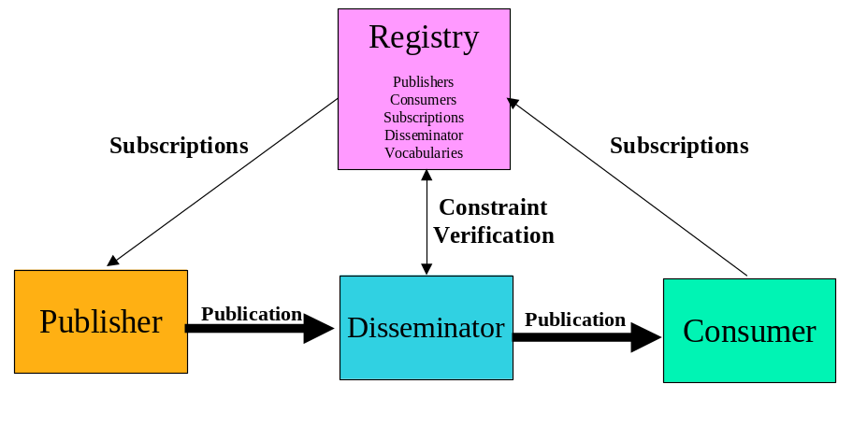
Figure 12 Disseminators with Subscriptions Processed By Publisher

Tasks:

- Manage publishers, consumers, Disseminator(s) and vocabularies in INFOD registry using the Create/Alter/DropPublisher/Consumer/Disseminators and the Register/DeresgisterVocabulary operation respectively. Some consumers will direct delivery of messages to POBoxes.
- Subscribers direct subscribe request to INFOD registry
- INFOD registry determines relevant publishers
- INFOD registry checks all constraints
- INFOD registry sends specific subscription request to each subscriber – these subscription request reflect constraints in the INFOD registry
- INFOD registry notifies publishers when changes in the INFOD registry modify their specific subscriptions. Optionally, publishers can use the getData operation
- Publishers receive and process subscription request.

- Publishers create and send messages to (home) disseminator using the INFOD message structure – messages are directed to specific consumers
- Disseminator(s) ensure that messages are within specified constraints if directed to specific consumers.
- Disseminator(s) send messages to all relevant Consumers using the INFOD message structure.
- Publishers can retrieve message from (home) disseminators - within retention constraints - using the getData operation.
- Consumers receive message using the consume operation
- Consumers can retrieve message from (home) disseminators - within retention constraints - even after delivery by disseminators using the getData operation.

With Subscriptions Processed by Disseminator

This pattern represents an extension of the previous pattern allowing publishers to out-source the selection of consumers to disseminators.

Disseminators act as publishers; the original publishers will still be visible in the message manifest.

This pattern also allows disseminators to direct publishers only to publish messages when needed. This behavior is mandatory for subscription-based publication.

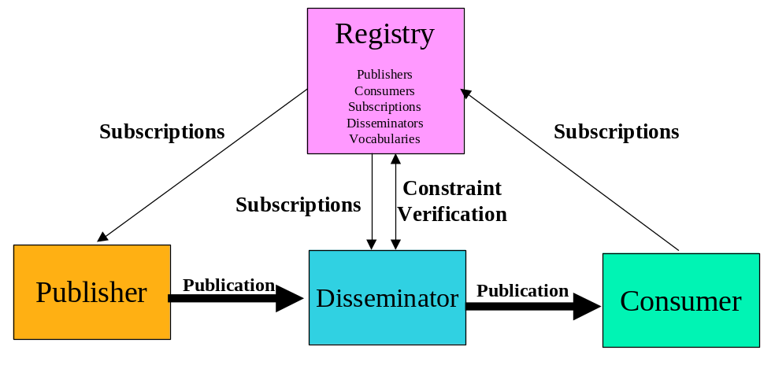
Figure 13 Disseminators with Subscriptions Processed By Disseminator

Tasks:

- Manage publishers, consumers, subscriptions, disseminators and vocabularies in INFOD registry using the Create/Alter/DropPublisher/Consumer/Disseminators and the Register/DeresgisterVocabulary operation respectively. Some consumers will direct delivery of messages to POBoxes.- Disseminators may act as publishers.
- Subscribers direct subscribe request to INFOD registry
- INFOD registry determines relevant publishers
- INFOD registry checks all constraints
- INFOD registry sends specific subscription request to each subscriber – these subscription request reflect constraints in the INFOD registry
- INFOD registry notifies disseminators when changes in the INFOD registry modify their specific subscriptions
- Publishers receive and process subscription request

- Publishers create and send messages to (home) disseminator using the INFOD message structure – messages may or may not be directed to specific consumers
- Disseminator(s) ensure that messages are within specified constraints if directed to specific consumers.
- Disseminator(s) send messages to all relevant consumers according to the publishers’ directives and the subscription directives using the INFOD message structure.
- Publishers can retrieve message from (home) disseminators - within retention constraints - using the getData operation.
- Consumers receives messages using the consume operation.
- Consumers can retrieve message from (home) disseminators - within retention constraints - even after delivery by disseminators using the getData operation.

Multi-Disseminator INFOD Service

This pattern pushes the burden of sending a message to a large number of consumers using a wide variety of technologies. It also hides from producers the potentially large variety of operational characteristics that need to be supported.

This pattern is also used for any message delivery when publishers and consumers belong to different environments and operational characteristics such exactly once behavior, non-repudiation is required

Multi-Disseminator Message Delivery

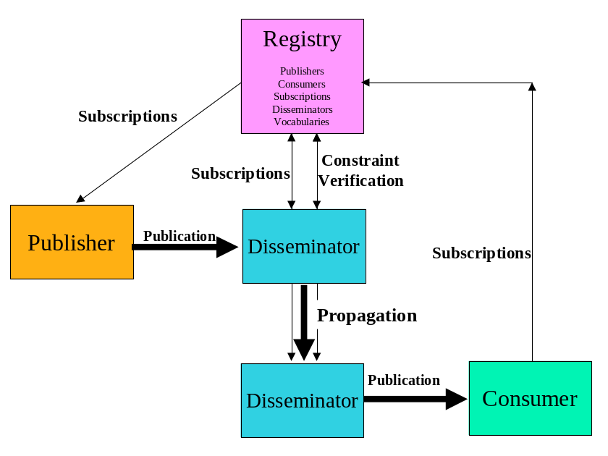
Figure 14 Multiple Disseminators

Tasks:

- Manage publishers, consumers, subscriptions, disseminators and vocabularies are managed by INFOD registry using the Create/Alter/DropPublisher/Consumer/Disseminators and the Register/DeregisterVocabulary operation respectively. Some consumers will direct delivery of messages to POBoxes.- Disseminators may act as publishers.
- Subscribers direct subscribe request to INFOD registry
- INFOD registry determines relevant publishers
- INFOD registry checks all constraints
- INFOD registry sends specific subscription request to each subscriber – these subscription request reflect constraints in the INFOD registry
- INFOD registry notifies publishers and disseminators when changes in the INFOD registry modify their specific subscriptions. Optionally, publishers can use the getData or consume operation
- Publishers receive and process subscription request

- Publishers create and send messages to (home) disseminator using the INFOD message structure – messages may or may not be directed to specific consumers
- (Publishers’) Disseminator(s) ensure that messages are within specified constraints if directed to specific consumers.
- (Publishers’) Disseminator(s) send messages to all relevant consumers and other disseminators according to the publishers’ and subscription directives using the INFOD message structure.
- (Publishers) Disseminator(s) send messages to all relevant consumers and other disseminators according to the publishers’ and subscription directives using the INFOD message structure.
- Publishers can retrieve message from (home) disseminators - within retention constraints - using the getData operation.
- (Consumers’) Disseminator(s) ensure that messages are within specified constraints if directed to specific consumers.
- Consumers consume messages using the consume operation.
- Consumers can retrieve message from (home) disseminators - within retention constraints - even after delivery by disseminators using the getData operation

It has to be noted that most of the functionality is out-sourced to INFO registry and the disseminators.

Operations

To be added by Steve D and Dieter?

Lets make sure the interface covers the change notification
INFOD does not have a subscriber object (yet?); the invoker of a subscribe request will be called a subscriber to simplify the presentation
The specification have to state this explicitly
The INFOD registry must be able to accept data as well as filters that allow the INFOD registry to reference and import data and also gets notified of relevant chances.
The get data interface is assumed to have a wait for clause
The get data interface is assumed to have a ordered by clause
Just a reminder; INFOD does not have a subscriber object; the invoker of a subscribe request will be called a subscriber
This has to be in the specifications
The get data interface is assumed to have a wait for clause

