INFOD Patterns

It is assumed that the reader is familiar with the INFOD model as described in the INFOD Interface Draft.

Introduction

INFOD is designed to support a variety of information dissemination patterns. The following patterns have been identified.

- Base INFOD Services – No POBox, No disseminator:
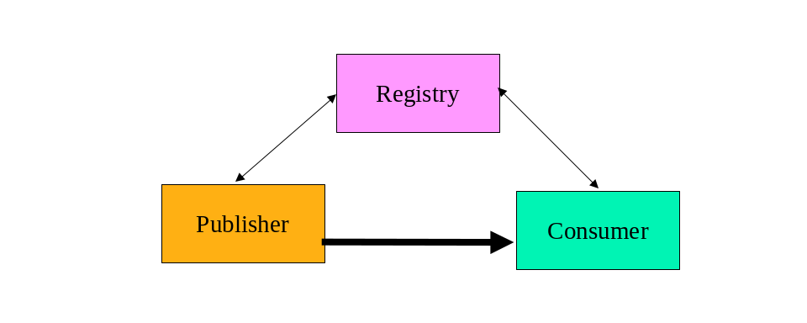
Figure 1 Base INFOD Service
- No subscriptions – publishers send messages to consumers of their choice. The following sub-pattern are identified:
- No use of an INFOD registry
- Publishers use an INFOD registry to find consumers
- Consumers use an INFOD registry to filter publishers
- Publishers and consumers use an INFOD registry to share vocabularies
- Subscriptions managed by subscribers – subscribers send subscriptions to publishers, publishers send messages according to subscriptions. The following sub-patterns are identified:
- No use of an INFOD registry
- Subscribers use an INFOD registry to find publishers
- Publishers use an INFOD registry to filter consumers
- Subscriptions managed by an INFOD registry – subscribers send subscriptions to an INFOD registry. The INFOD registry identifies publishers (and consumers) and sends subscriptions to publishers.
- Subscription based publications - publishers create and deliver messages according to subscription requests.

- POBox INFOD Service:
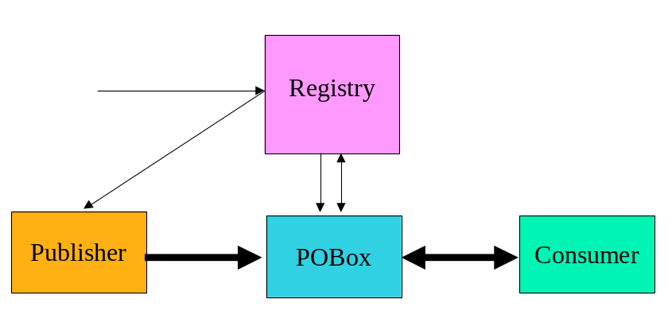
Figure 2 POBoxes INFO Service
- Subscriptions and publishers determine consumers – publishers send messages to POBoxes; consumers (select and) retrieve messages directed to them from POBoxes. POBoxes verify constraints.
- Consumers select messages of interest – publishers send messages to POBoxes; consumers select and retrieve messages from POBoxes; POBoxes verify constraints.

- Single Disseminator INFOD Service:
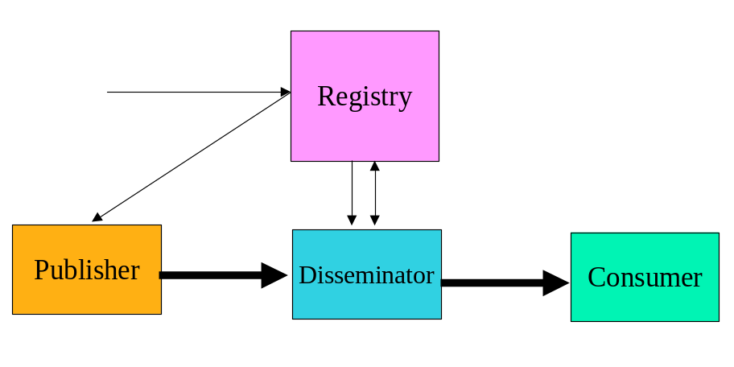
Figure 3 Single Disseminator INFOD Service
- Publishers send messages to disseminators, disseminators send messages to consumers - subscriptions and publishers determine consumers. Disseminators verify constraints.

- Multi-Disseminator INFOD Service:
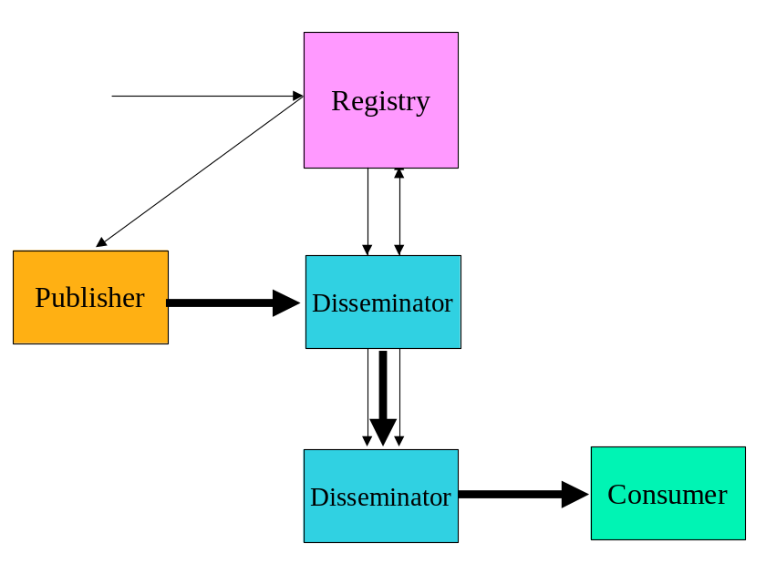
Figure 4 Multi Disseminator INFOD Service
- Publishers send messages to disseminators; disseminators send messages to other disseminators - subscriptions and publishers determine consumers. Disseminators verify constraints.

The rest of the note is organized as follows: section 2 explains each pattern in more detail; section 3 outlines the tasks to implement each pattern while section 4 describes which interfaces. Have to be used to implement each pattern.

Table of Content:
1. Introduction 1
2. Description of Patterns 5
2.1 Base INFOD Service – No POBox, No disseminator 5
2.1.1 No Subscriptions 5
2.1.2 Subscriptions Managed by Subscribers 6
2.1.3 Subscriptions Managed by Registry 7
2.1.4 Subscription Based Publications 7
2.2 POBox INFOD Service 8
2.2.1 Consumers Determined by Publishers and Subscriptions 8
2.2.2 Consumers Select Messages of Interest 9
2.3 Single Disseminator INFOD Service 9
2.4 Multi-Disseminator INFOD Service 10
3. Outline of Operations 11
3.1 Base INFOD Service – No POBox, No disseminator 11
3.1.1 No Subscriptions 11
3.1.2 Subscriptions Managed By Subscribers 14
3.1.3 Subscriptions Managed by Registry 16
3.1.4 Subscription Based Publications 17
3.2 POBox INFOD Service 18
3.2.1 Consumers Determined by Publishers and Subscriptions 18
3.2.2 Consumers Select Messages of Interest 19
3.3 Single Disseminator INFOD Service 19
3.4 Multi-Disseminator INFOD Service 20
4. Operations 22

Table of Figures:

Figure 1 Base INFOD Service 1
Figure 2 POBoxes INFO Service 2
Figure 3 Single Disseminator INFOD Service 2
Figure 4 Multi Disseminator INFOD Service 3
Figure 5 Base INFOD Service - No Subscriptions 12
Figure 6 Base INFOD Service - No Subscription, Consumer Selection 12
Figure 7 Base INFOD Service - No Subscription, Publisher Filtering 13
Figure 8 Base INFOD Service - Vocabulary Inquiry 13
Figure 9 Base INFOD Service - Subscriptions Without Registry Support 14
Figure 10 Base INFOD Service - Subscription, Publisher Selection 15
Figure 11 Base INFOD Service - Subscription, Consumer & Subscription Filtering 15
Figure 12 Base INFOD Service - Subscription Managed by INFOD Registry 16
Figure 13 Base INFOD Service - Subscription Managed by INFOD Registry - Messages and Events Specified by Subscriber 17
Figure 14 POBoxes INFOD Service - Consumer Determined by Publishers & Subscriptions 18
Figure 15 POBoxes INFOD Service - Consumers Select Messages of Interest 19
Figure 16 Single Disseminators INFOD Service 20
Figure 17 Multiple Disseminators INFOD Service 21

Description of Patterns

Base INFOD Service – No POBox, No disseminator

It should be noted that in all patterns of this section publishers send messages directly to consumers; e.g., there is no decoupling between publishers and consumers. These patterns require sophisticated publishers and consumers to achieve advanced operational characteristics such as exactly once message delivery, recoverability and auditing and tracking.

No Subscriptions

The patterns of this section represent the basic form of disseminating information: publishers send messages to consumers of their choice.

The following information in the INFOD registry provides the context for this pattern:

- User data vocabularies – optional
- Publishers and consumers - optional
- Vocabulary associations - optional
- User property vocabularies - optional

The following basic functionality is available:

- Publishers send information to consumers neither publishers nor consumers consul the INFOD registry.

Publishers send messages to consumers without any formal support to identify relevant consumers; e.g., it is assumed that publishers somehow know the intended consumers and how to reach them. It is also assumed that consumers somehow know about the publishers when consuming messages. It is further assumed that publishers and consumers have a shared understanding of the structure of the payload.
The only difference to standard WS-messaging is the structure of the message.

Optional functionality – using information in the INFOD registry:

- Publishers query the INFOD registry to find matching consumers – requires consumer and optionally property vocabulary entries in INFOD registry.

Publishers should avoid querying the INFOD registry for each single message. Instead, publishers should group messages into classes and associated consumers to these classes and additionally cache the consumer information.
If requested, changes of the result set of any query trigger notification of the publisher. These notifications contain updated information about consumers.

- Consumer filter messages based on publishers properties - requires publisher and optionally property vocabulary entries in INFOD registry.

Consumers can query the INFOD registry to find information about publisher using the information about publishers in the manifest section of the INFOD message.
Consumers should avoid querying the INFOD registry for each single message. Consumers have to obtain and cache relevant information.
If requested, changes to the result set of any query will trigger notification of the consumers. These notifications contain updated information about publishers.

- Publishers and consumers use vocabulary information in the INFOD registry before sending/consuming a message - requires user data vocabulary entries in INFOD registry.

Publishers and consumers should avoid querying the INFOD registry for each message. Both, publishers and consumers, should obtain and the cache relevant vocabulary information.
If requested, changes to the result set of any query will trigger notification of the publishers and consumers respectively. These notifications contain updated information about vocabularies.

Subscriptions Managed by Subscribers

This pattern allows subscribers to define messages of interest and inform publishers directly.

Note: While INFOD allows this pattern it is highly recommend not using it.

The following information in the INFOD registry provides the context for this pattern:

- User data vocabularies – optional
- Publishers and consumers - optional
- Vocabulary associations - optional
- User property vocabularies - optional

The following basic functionality is available:

- Subscribers subscribe - directly - to publishers without consulting the INFOD registry

In response to subscriptions, publishers send matching messages to consumers.
Subscribers send subscriptions to publishers without any formal support for identifying relevant publishers; e.g., it is assumed that subscribers somehow know the relevant publishers and how to reach them. It is also assumed that publishers somehow know about the subscribers and consumers when filtering a subscription. It is further assumed that publishers and consumers have a shared understanding of the structure of the payload.
The only difference to standard WS-Notification is the structure of the message.

Optional functionality using information in the INFO registry:

- Subscribers query the INFOD registry to find relevant publishers and consumers – requires publisher, consumer and optionally property entries in INFOD registry.

If requested, changes to the result set of any query will trigger notification of the subscribers. These notifications contain updated information about publishers and consumers.

- Publishers filter subscriptions by querying the INFOD registry about consumers - requires consumer and optionally property entries in INFOD registry.

If requested, changes to the result set of any query will trigger notification of the publishers. These notifications contain updated information about consumers.

Subscriptions Managed by Registry

This pattern represents the preferred way of managing subscriptions. The association of publishers and consumers to a subscription is the responsibility of the INFOD registry.

The following information in the INFOD registry provides the context for this pattern:

- User data vocabularies - mandatory
- Publishers and consumers - mandatory
- Subscriptions - mandatory
- Vocabulary associations - mandatory
- User property vocabularies - optional

The following functionality is available:

- Subscribers manage subscriptions using the Create/Alter/DropSubscription operation.

The INFOD registry determines which publishers are offering messages of interest using the vocabulary and vocabulary association information. The evaluation of all constraints that may limit the selection of publishers and consumers follows. The INFOD registry will make adjustment if subscriptions, publishers or consumers are created, altered or dropped.
If requested, changes that impact subscriptions will trigger notification of the publishers. These notifications contain updated information about subscriptions.
The WS-Notification with registry provides a subset of this functionality.

Subscription Based Publications

Publishers are often not able to determine which messages are of interest to consumers. Therefore, publishers must allow the creation of messages based on subscription referencing events or states.

The following information in the INFOD registry provides the context for this pattern:

- User data vocabularies - mandatory
- Publishers and consumers - mandatory
- Subscriptions - mandatory
- Vocabulary associations - mandatory
- User property vocabularies - optional

The following functionality is available:

- Subscribers specify what messages are published in reaction to events or state changes.

Publishers have to support vocabularies that include events or even allow the specification of events. The associate language must allow filtering of events and also include the ability to define what messages need to be created to reaction to events and state changes respectively.
The difference between this and the previous patterns is the functionality of the information source (vocabulary associations). In the previous patterns, publishers use vocabularies that represent messages; using this pattern publishers offer access to events and state transitions. Messages are created when an event satisfies certain constraints or when a state transition results in certain constraint becoming true.
If requested, changes that impact subscriptions will trigger notification of the publishers and subscribers. These notifications contain updated information about vocabularies.

POBox INFOD Service

Using POBoxes consumers are able to get messages without implementing a consume operation. Consumers have to use the GetData operation. When the GetData operation is used with the WAIT_FOR option consumers will receive messages as soon as they are available in the POBox. If the WAIT_FOR option is not used consumers will only receive new messages by periodically re-issuing the GETData operation.

POBoxes provide decoupling of publishers and consumers; a desirable function for most messaging environments: e.g., publishers and consumers do not need to be simultaneously active to send respectively receive a message.

POBoxes may provide support for a set of functions and operational characteristics without requiring sophisticated publishers or consumers; examples are transactional support, retention and auditing which are required for many mission critical applications. Details are not described here.

The following patterns focus on the issue whether the subscriptions and publishers determine the consumers of a message or not.

Consumers Determined by Publishers and Subscriptions

The following information in the INFOD registry provides the context for this pattern:

- User data vocabularies – mandatory
- Publishers and consumers - mandatory
- Subscriptions - mandatory
- POBoxes - mandatory
- Entity associations - optional
- Vocabulary associations - mandatory
- User property vocabularies - optional

The following functionality is available:

- Publishers publish messages to the POBoxes specifying consumers

Publishers publish messages with or without subscriptions request; subscriptions and consumer constraints identify consumers. If necessary, POBoxes determine the individual consumers of each message by applying the information in the messages; e.g., by applying subscriptions and constraints.
Messages are only accepted if all constraints are met.

- Consumers retrieve messages directed to them from POBoxes

Consumers can only retrieve messages that are directed to them. Consumers can use data constraints to sequence the retrieval of messages.
The getData operation can be used in browse or consume mode and with and without the WAIT_FOR option. A message can only be retrieved once in consume mode.
If a POBox supports message retention messages can also be retrieved after they have been consumed.
This pattern represents a generalization of the WS-Notification pull-point delivery.

Consumers Select Messages of Interest

The following information in the INFOD registry provides the context for this pattern:

- User data vocabularies – mandatory
- Publishers and consumers - mandatory
- Subscriptions - mandatory
- POBoxes - mandatory
- Entity associations - optional
- Vocabulary associations - mandatory
- User property vocabularies - optional

The following functionality is available:

- Publishers publish messages to the POBoxes without specifying consumers

Neither publishers nor subscriptions determine which consumer can see which message.
- Consumers retrieve messages of their choice from the POBox – browse, consume

Consumers can any message of interest using constraint to select message of interest. These constraints may also be used to sequence the retrieval of messages. Message will only be delivered if all constraints associated to getData and to INFOD registry entries are met.
The getData operation can be used in browse or consume mode and with and without the WAIT_FOR option. A message can only be retrieved once in consume mode.
If a POBox supports message retention messages can also be retrieved after they have been consumed.

This pattern represents classical messaging with enhanced functionality and operational characteristics.

Single Disseminator INFOD Service

Disseminators provide decoupling of publishers and consumers a desirable function for most messaging environments; e.g., publishers and consumers do not need to be simultaneously active to send respectively receive a message.

Disseminators may also support a set of functions and operational characteristics without requiring sophisticated publishers or consumers; examples are transactional support, retention and auditing which are required for many mission critical applications. Details are not described here.

Compared to POBoxes disseminators are able to provide higher scalability in respect to the number of consumers, since consumers do not need to use the getData operation to receive messages.

The following information in the INFOD registry provides the context for this pattern:

- User data vocabularies – mandatory
- Publishers and consumers - mandatory
- Subscriptions - mandatory
- Disseminators – mandatory
- Entity associations - optional
- Vocabulary associations - mandatory
- User property vocabularies - optional

The following functionality is available:

- Publishers publish messages to disseminators – consumers are always specified

Publishers publish messages with or without subscriptions request; subscriptions and consumer constraints identify consumers. If necessary, disseminators determine the individual consumers of each message by applying the information in the messages; e.g., by applying subscriptions and constraints.
Messages will only be accepted if all constraints are met.
- Disseminators send messages or information about the existence of messages to consumers

Consumers have to support the consume operation.
- Consumers can retrieve messages directed to them from disseminators.

If consumers are only informed about the existence of messages they have to use the getData operation either in browse or consume mode to retrieve these messages, the WAIT_FOR option cannot be used. A message can only be retrieved once in consume mode.
If a disseminator supports message retention messages can also be retrieved after they have been consumed.

Multi-Disseminator INFOD Service

This is arguably the most complex and also the most important pattern; it is the base for every well-managed business communication. This pattern is used in any message delivery where publishers and consumers belong to different environments and operational characteristics such as exactly once behavior and non-repudiation are required.

This pattern makes it also possible to send messages to a large number of consumers. Disseminators may negotiate the use of propagation protocols to optimize the interaction with each other. A variety of strategies accomplishing this task are known.

The following information in the INFOD registry provides the context for this pattern:

- User data vocabularies – mandatory
- Publishers and consumers - mandatory
- Subscriptions - mandatory
- Disseminators – mandatory
- Entity associations - mandatory
- Vocabulary associations – mandatory
- User property vocabularies - optional

The following functionality is available:

- Publishers publish messages to disseminators – consumers are always specified

Publishers publish messages with or without subscriptions request; subscriptions and consumer constraints identify consumers. If necessary, disseminators determine the individual consumers of each message by applying the information in the messages; e.g., by applying subscriptions and constraints.
Messages will only be accepted if all constraints are met.
- Disseminators send messages to other disseminators to reach consumers.

Disseminators determine to which disseminators each message has to be propagated.
Disseminators send messages to other disseminators supporting optional operational characteristic such as exactly once or non-repudiation.
Receiving disseminators accept messages after verify all constraints.
- Disseminators send messages or information about the existence of messages to consumers

Consumers have to support the consume operation.
- Consumers can retrieve messages directed to them from disseminators.

If consumers are only informed about the existence of messages they use the getData operation either in browse or consume mode to retrieve these messages, the WAIT_FOR option cannot be used. A message can only be retrieved once in consume mode.
If a disseminator supports message retention messages can also be retrieved after they have been consumed.

Outline of Operations

Base INFOD Service – No POBox, No disseminator

No Subscriptions

Base functionality:

- Publishers publish messages to consumers of their choice


Figure 5 Base INFOD Service - No Subscriptions

Tasks:
- Publishers create and send messages to the intended consumers using INFOD message structure
- Consumers receive messages using the INFOD consume operation

No INFOD registry support is used.

Optional functionality:

- Publishers find relevant consumers in INFOD registry

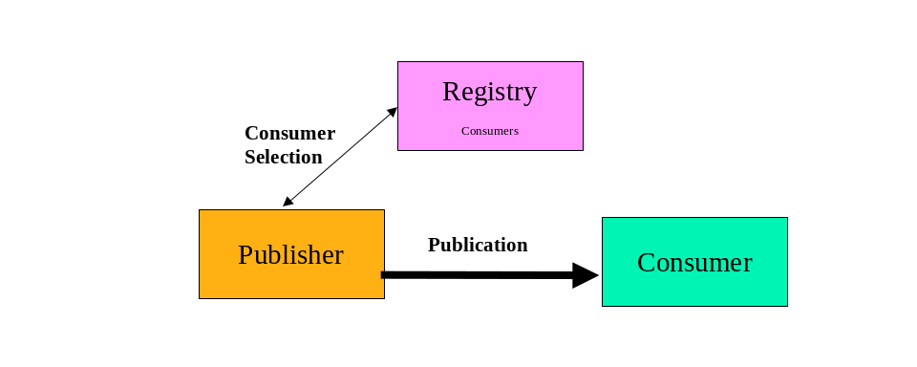
Figure 6 Base INFOD Service - No Subscription, Consumer Selection

Tasks:
- Manage consumer information in INFOD registry using the Create/Alter/DropConsumer operation

- Publishers select consumers using the getMdata operation
- If requested, publishers receive update notifications from the INFOD registry reflecting changes of consumer information

- Publishers create and send messages using INFOD message structure.
- Consumers receive messages using the INFOD consume operation

The INFOD registry provides up-to-date information about consumers.

- Consumer filter messages based on publishers properties

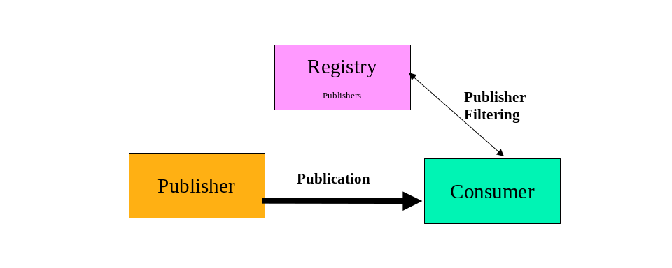
Figure 7 Base INFOD Service - No Subscription, Publisher Filtering

Tasks:
- Manage publisher information in INFOD registry using the Create/Alter/DropPublisher operation

- Consumers find publisher information using the getMdata operation
- If requested, consumers receive update notifications form the INFOD registry reflecting changes of publisher information

- Publishers create and send messages using INFOD message structure
- Consumers receives message using the INFOD consume operation
- Consumers verifies publishers and consumes message

The INFOD registry provides up-to-date information about publishers.
- Consumer can filter message based on message content

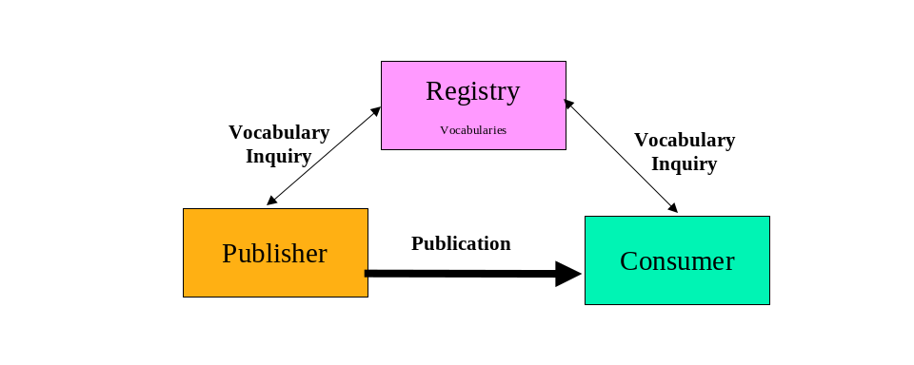
Figure 8 Base INFOD Service - Vocabulary Inquiry

Tasks:
- Manage vocabulary information in INFOD registry using the Register/Evolve/DeregisterVocabulary operation

- Publishers find vocabularies using the getMdata operation
- If requested, publishers receive update notifications reflecting changes of vocabularies
- Consumers find vocabularies using the getMdata operation
- If requested, consumers receive update notifications reflecting changes of vocabularies

- Publishers create and send messages using INFOD message structure with a payload according to a vocabulary
- Consumers receives message using the INFOD consume operation
- Consumers interprets message using vocabulary information and consumes it

The INFOD registry provides up-to-date information about vocabularies.

Subscriptions Managed By Subscribers

The following functionality is available:

Base functionality:

- Publishers publish messages based on subscriptions


Figure 9 Base INFOD Service - Subscriptions Without Registry Support

Tasks:
- Subscriber send subscribe request to publishers
- Publishers receive and process publication request

- Publishers create messages according to subscription directives and send these messages to the requesting consumers using INFOD message structure
- Consumers receive messages using the INFOD consume operation

No INFOD registry support is used.

Optional functionality:

- Subscriber selects publishers from INFOD registry

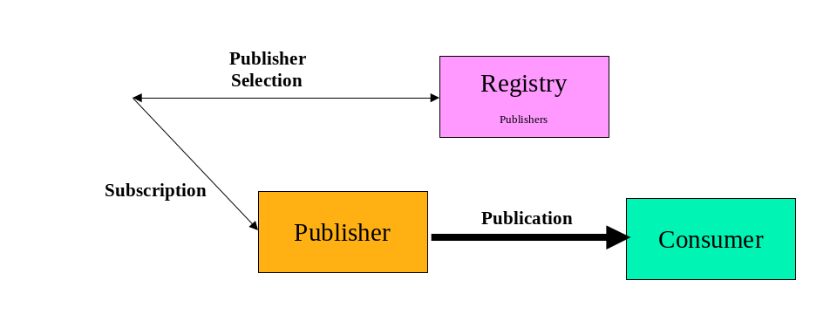
Figure 10 Base INFOD Service - Subscription, Publisher Selection

Tasks:

- Manage publisher information in INFOD registry using the Create/Alter/DropPublisher operation

- Subscriber select publishers using the getMdata operation
- If requested, subscriber receive update notifications from the INFOD registry reflecting changes of publisher information
- Subscribers direct subscribe request to publishers
- Publishers receive and process publication request

- Publishers create and send messages using INFOD message structure
- Consumers receives message using the INFOD consume operation

The INFOD registry provides up-to-date information about publishers to consumers.

- Publishers can filter subscriptions based on consumers properties
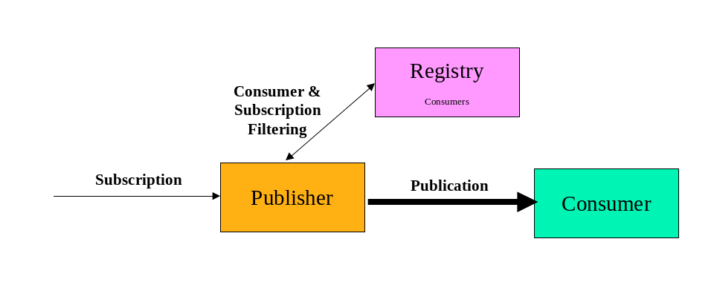
Figure 11 Base INFOD Service - Subscription, Consumer & Subscription Filtering

Tasks:

- Manage consumer information in INFOD registry using the Create/Alter/DropConsumer operation

- Subscribers sends subscribe request to publishers
- Publishers receive subscription request
- Publishers filters consumers and subscriptions using the getMdata operation and processes publication request
- If requested, publishers receive update notifications from the INFOD registry reflecting changes of consumer information

- Publishers create and send messages using INFOD message structure
- Consumers receives message using the INFOD consume operation

The INFOD registry provides up-to-date information about publishers to consumers.
It is obviously possible that both, publishers and consumers can find information about each other in the INFOD registry. Additional, vocabularies could be used to ensure coherent understanding of data structures; i.e., the message payload.

Subscriptions Managed by Registry

- Publishers publish messages according to subscription directives
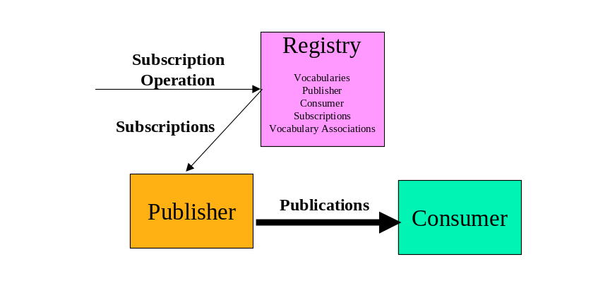
Figure 12 Base INFOD Service - Subscription Managed by INFOD Registry

Tasks:

- Manage vocabularies, publishers, consumers and vocabulary associations in INFOD registry using the Create/Alter/DropPublisher/Consumer and the Register/Evolve/DeregisterVocabulary operation respectively

- Subscribers direct subscribe request to INFOD registry
- INFOD registry determines relevant publishers
- INFOD registry checks all constraints
- INFOD registry informs publisher about new subscriptions – these subscription requests reflect constraints in the INFOD registry
- INFOD registry informs publishers about altered/dropped subscriptions
- Publishers receive and process subscription request

- Publishers create and send messages to all relevant consumers using the INFOD message structure
- Consumers receive message using the consume operation

By directing subscription request to the INFOD registry, subscribers can direct the INFOD registry to find relevant publishers, check all the constraints, and create a tailored subscription to each of the appropriate publishers. Furthermore, the INFOD registry informs publishers if changes in the directory information require changes in the subscription. This includes that a publication is retracted from some publisher while other publishers are added.

Subscription Based Publications

The only difference to the previous pattern is the structure and the language support for selected user data vocabularies. The subscriber chooses vocabularies, which support the creation of messages based on events or even supports the definition of events.

- Publishers create and publish messages according to subscription directives
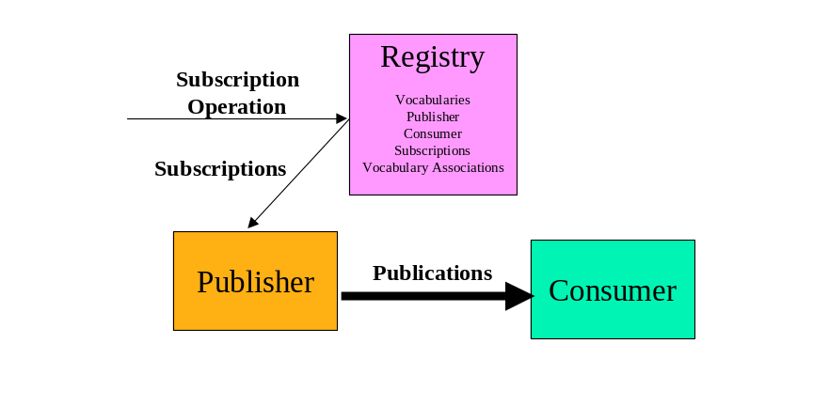

Figure 13 Base INFOD Service - Subscription Managed by INFOD Registry - Messages and Events Specified by Subscriber

Tasks:

- Manage vocabularies, publishers, consumers, subscriptionss and vocabulary associations in INFOD registry using the Create/Alter/DropPublisher/Consumer and the Register/Evolve/DeresgisterVocabulary operation respectively. The selected vocabularies support the creation of messages based on event or even the definition of events.

- Subscribers direct subscribe request to INFOD registry
- INFOD registry determines relevant publishers
- INFOD registry checks all constraints
- INFOD registry informs publisher about new subscriptions – these subscription requests reflect constraints in the INFOD registry
- INFOD registry informs publishers about altered/dropped subscriptions
- Publishers receive and process subscription request

- Publishers create and send messages to all relevant consumers using the INFOD message structure
- Consumers receive message using the consume operation

POBox INFOD Service

Consumers Determined by Publishers and Subscriptions

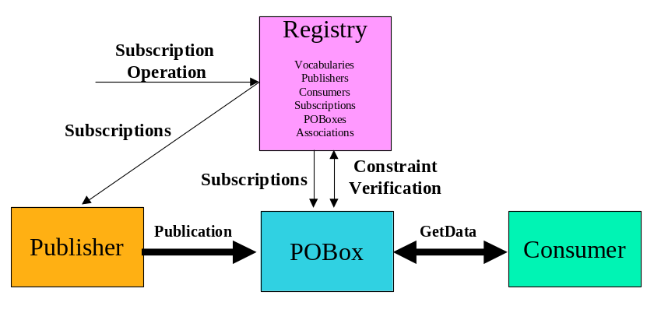
Figure 14 POBoxes INFOD Service - Consumer Determined by Publishers & Subscriptions

Tasks:

- Manage vocabularies, publishers, consumers, subscriptions, POBoxes and associations in INFOD registry using the Create/Alter/DropPublisher/Consumer/POBox, the Associate/Disassociate and the Register/Evolve/DeregistersVocabulary operation respectively.

- Subscribers direct subscribe request to INFOD registry
- INFOD registry determines relevant publishers
- INFOD registry checks all constraints
- INFOD registry informs publisher and POBoxes about new subscriptions – these subscription requests reflect constraints in the INFOD registry
- INFOD registry informs publishers and POBoxes about altered/dropped subscriptions
- Publishers and POBoxes receive and process subscription request

- Publishers create and send messages to POBoxes
- POBoxes will only accept messages for specific consumers if constraints are satisfied
- POBoxes will add determine (additional) users based on directive in messages and subscriptions
- Publishers can retrieve message from POBoxes - within retention constraints - even after they have been consumed
- Consumers retrieve message from POBoxes. Consumers use getData operations with filters and optional WAIT_FOR option and also select consume/browse mode.
- Consumers can retrieve message from POBoxes - within retention constraints - even after they have been consumed.

A significant part of the complexity of information dissemination has been moved to the POBoxes; e.g., the consumption of a message by POBoxes and consumers respectively can be part of a transaction.

Consumers Select Messages of Interest

This pattern represents a generalization of the WS-Notification pull-point delivery.

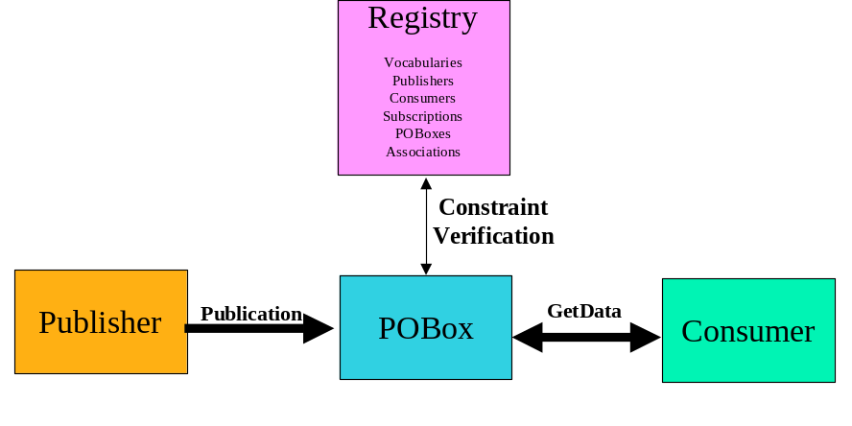
Figure 15 POBoxes INFOD Service - Consumers Select Messages of Interest

Tasks:

- Manage vocabularies, publishers, consumers, subscriptions, POBoxes and associations in INFOD registry using the Create/Alter/DropPublisher/Consumer/POBox, the Associate/Disassociate and the Register/Evolve/DeregistersVocabulary operation respectively.
- INFOD registry notifies publishers and POBoxes about changes in the INFOD registry. Publishers and POBoxes have to identify changes of interest using the getDMdata interface.

- Publishers create and send messages to POBoxes using the INFOD message structure
- POBoxes consume messages
- Publishers can retrieve message from POBoxes - within retention constraints - using the getData operation
- Consumers retrieve message from POBoxes – POBoxes ensure that all property constraints are met. Consumers use getData operations with filters and optional WAIT_FOR option and also select consume/browse mode.
- Consumers can retrieve message from POBoxes - within retention constraints - even after they have been consumed using the getData operation

Single Disseminator INFOD Service

Disseminators support the functions of POBoxes; therefore the functionality associated to POBoxes applies to disseminators as well. Only the added functionality is covered in the discussion of following patterns.

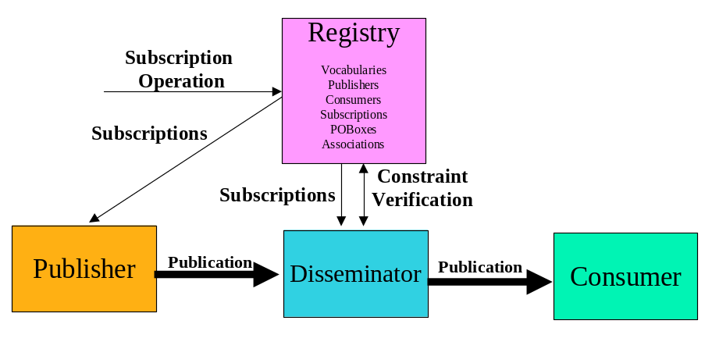
Figure 16 Single Disseminators INFOD Service

Tasks:

- Manage vocabularies, publishers, consumers, subscriptions, disseminators and associations in INFOD registry using the Create/Alter/DropPublisher/Consumer/POBox, the Associate/Disassociate and the Register/Evolve/DeregistersVocabulary operation respectively.

- Subscribers direct subscribe request to INFOD registry
- INFOD registry determines relevant publishers
- INFOD registry checks all constraints
- INFOD registry informs publisher and disseminators about new subscriptions – these subscription requests reflect constraints in the INFOD registry
- INFOD registry informs publishers and disseminators about altered/dropped subscriptions
- Publishers and Disseminators receive and process subscription request

- Publishers create and send messages to disseminators
- Disseminators will only accept messages for specific consumers if constraints are satisfied
- Disseminators will add (additional) users based on directive in messages and subscriptions
- Publishers can retrieve message from disseminators - within retention constraints - even after they have been consumed
- Disseminators send messages to consumers
- Consumers receive message using the consume operation
- Consumers can retrieve message from disseminators - within retention constraints - even after delivery by disseminators using the getData operation.

Multi-Disseminator INFOD Service

This pattern enables disseminators to send messages to a large number of consumers.

This pattern is very important for any message delivery where publishers and consumers belong to different environments and operational characteristics such exactly once behavior, non-repudiation are required

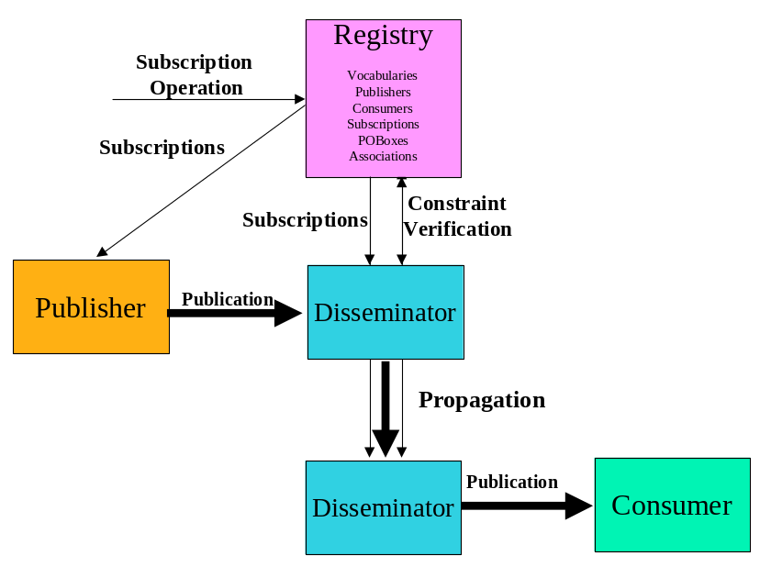
Figure 17 Multiple Disseminators INFOD Service

Tasks:

- Manage vocabularies, publishers, consumers, subscriptions, disseminators and associations in INFOD registry using the Create/Alter/DropPublisher/Consumer/POBox, the Associate/Disassociate and the Register/Evolve/DeregistersVocabulary operation respectively.

- Subscribers direct subscribe request to INFOD registry
- INFOD registry determines relevant publishers
- INFOD registry checks all constraints
- INFOD registry informs publisher and disseminators about new subscriptions – these subscription requests reflect constraints in the INFOD registry
- INFOD registry informs publishers and disseminators about altered/dropped subscriptions
- Publishers and Disseminators receive and process subscription request

- Publishers create and send messages to (home) disseminator using the INFOD message structure – messages may or may not be directed to specific consumers
- (Publishers’) Disseminator(s) ensure that messages are within specified constraints if directed to specific consumers.
- (Publishers’) Disseminator(s) send messages to all relevant disseminators according to the publishers’ and subscription directives
- (Consumers’) Disseminator(s) ensure that messages are within specified constraints and send messages to specified consumers.
- Publishers can retrieve message from (home) disseminators - within retention constraints - using the getData operation.
- Consumers consume messages using the consume operation.
- Consumers can retrieve message from (home) disseminators - within retention constraints - even after delivery by disseminators using the getData operation

It has to be noted that most of the functionality is out-sourced to INFO registry and the disseminators.

Operations

To be added by Steve D and Dieter?

INFOD does not have a subscriber object; however, subscribers have the role of specifying subscriptions.
There are 2 options to request a notification: the getMData operation (with WAIT_FOR) or a request to send a message - a message request assumes the support of the consume interface with the ability to receive INFOD meta-data messages. Without a request for notification changes are only known after using periodically the getMData operation (without WAIT_FOR).
This is only possible if the GetData operation support an ordered by clause.
This has to be added to the specifications

