INFOD Patterns

Note: This document will become part of the Use Case document.

It is assumed that the reader is familiar with the INFOD model as described in the INFOD Interface Draft.

Introduction

INFOD is designed to support a variety of information dissemination patterns. The following patterns have been identified.

- Base INFOD Services – No POBox, No disseminator:
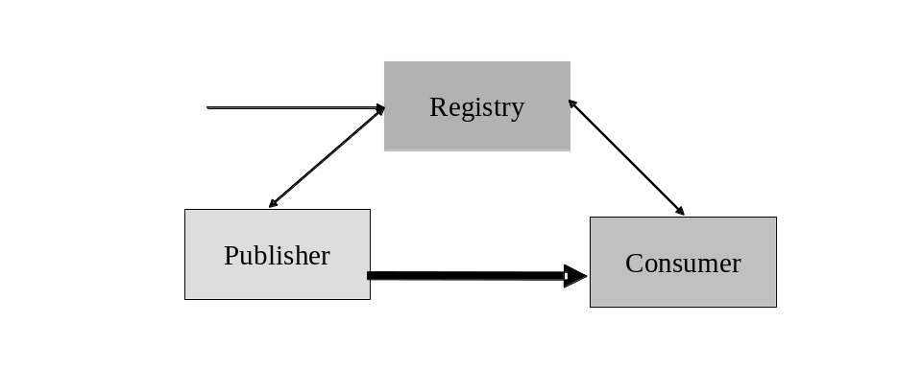
Figure 1 Base INFOD Service
- No subscriptions – publishers send messages to consumers of their choice. The following sub-pattern are identified:

- Publishers use an INFOD registry to find consumers
- Consumers use an INFOD registry to filter publishers
- Publishers and consumers use an INFOD registry to share vocabularies

- Subscriptions managed by an INFOD registry – subscribers send subscriptions to an INFOD registry. The INFOD registry identifies publishers (and consumers) and sends subscriptions to publishers

- Subscription based publications - publishers create and deliver messages according to subscription requests.
- POBox INFOD Service:
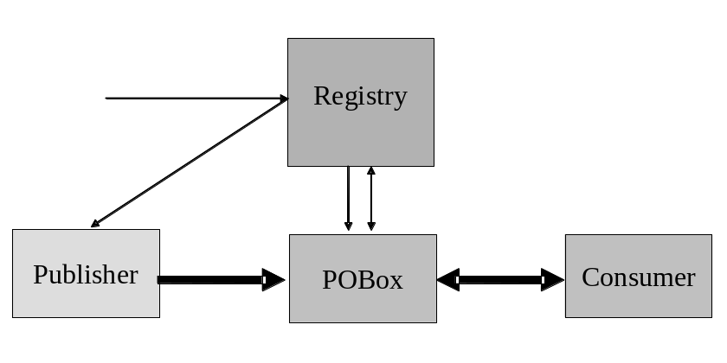
Figure 2 POBoxes INFO Service
- Subscriptions and publishers determine consumers – publishers send messages to POBoxes; consumers (select and) retrieve messages directed to them from POBoxes. POBoxes verify constraints.

- Consumers select messages of interest – publishers send messages to POBoxes; consumers select and retrieve messages from POBoxes; POBoxes verify constraints.

- Single Disseminator INFOD Service:
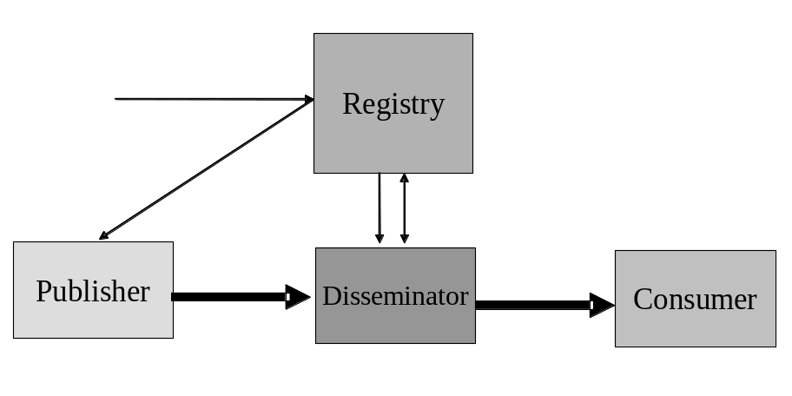
Figure 3 Single Disseminator INFOD Service
- Publishers send messages to disseminators, disseminators send messages to consumers - subscriptions and publishers determine consumers. Disseminators verify constraints.

- Multi-Disseminator INFOD Service:
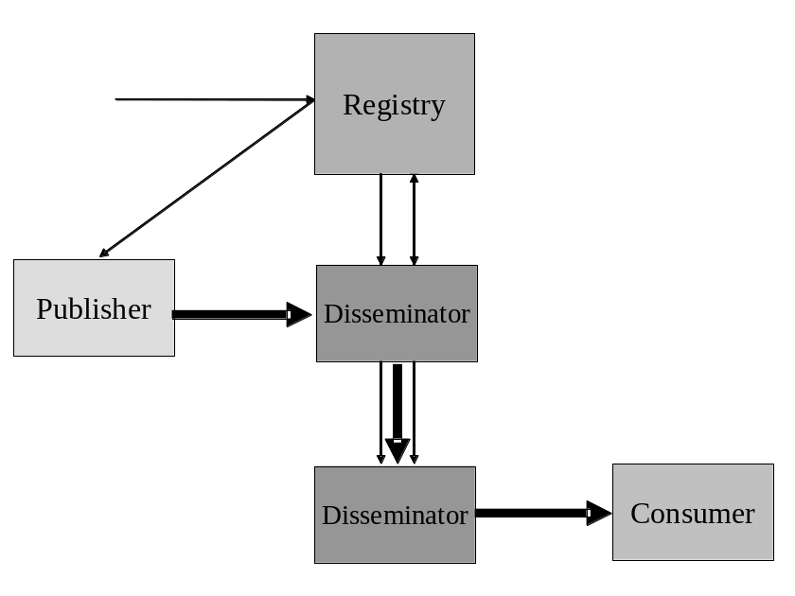
Figure 4 Multi Disseminator INFOD Service
- Publishers send messages to disseminators; disseminators send messages to other disseminators - subscriptions and publishers determine consumers. Disseminators verify constraints.

It is important to remember that the (basic/IT) description of INFOD entities can complemented by user properties. These user properties are expressed with vocabularies that are meaningful for a community of publishers, consumers, and subscribers. Constraints against these properties can be used for matching entities. These constraints can used to specify policies and interest; so, a car buyer can identify car dealers with the desired properties when looking for information instead thinking about a publisher; a car dealer can identify car buyers with the desired properties when looking for customers instead of thinking about consumers (as defined in INFOD).

INFOD encourages the use of user properties; the Use Cases will showcase the value of user properties.

The rest of the note is organized as follows: section 2 explains each pattern in more detail; section 3 outlines the tasks to implement each pattern while section 4 describes which interfaces. Have to be used to implement each pattern.

Table of Content:
1. Introduction 1
2. Description of Patterns 5
2.1 Base INFOD Service – No POBox, No disseminator 5
2.1.1 No Subscriptions 5
2.1.2 Subscriptions - Managed by Registry 6
2.1.3 Subscription Based Publications 6
2.2 POBox INFOD Service 7
2.2.1 Consumers Determined by Publishers and Subscriptions 7
2.2.2 Consumers Select Messages of Interest 8
2.3 Single Disseminator INFOD Service 9
2.4 Multi-Disseminator INFOD Service 10
3. Outline of Operations 11
3.1 Base INFOD Service – No POBox, No disseminator 11
3.1.1 No Subscriptions 11
3.1.2 Subscriptions - Managed by Registry 13
3.1.3 Subscription Based Publications 14
3.2 POBox INFOD Service 15
3.2.1 Consumers Determined by Publishers and Subscriptions 15
3.2.2 Consumers Select Messages of Interest 16
3.3 Single Disseminator INFOD Service 17
3.4 Multi-Disseminator INFOD Service 18
4. Operations 19
4.1 Base INFOD Service – No POBox, No disseminator 19
4.1.1 No Subscriptions 20
4.1.2 Subscriptions – Managed by Registry 20
4.1.3 Subscription Based Publication 20
4.2 POBox INFOD Service 20
4.2.1 Consumers determined by Publishers and Subscriptions 20
4.2.2 Consumers Select Messages of Interest 20
4.3 Multi Disseminator INFOD Service 20
4.4 Single Disseminator INFOD Service 20

Table of Figures:

Figure 1 Base INFOD Service 1
Figure 2 POBoxes INFO Service 2
Figure 3 Single Disseminator INFOD Service 2
Figure 4 Multi Disseminator INFOD Service 3
Figure 5 Base INFOD Service - No Subscription, Consumer Selection 11
Figure 6 Base INFOD Service - No Subscription, Publisher Filtering 12
Figure 7 Base INFOD Service - Vocabulary Inquiry 12
Figure 8 Base INFOD Service - Subscription Managed by INFOD Registry 13
Figure 9 Base INFOD Service - Subscription Managed by INFOD Registry - Messages and Events Specified by Subscriber 14
Figure 10 POBoxes INFOD Service - Consumer Determined by Publishers & Subscriptions 15
Figure 11 POBoxes INFOD Service - Consumers Select Messages of Interest 16
Figure 12 Single Disseminators INFOD Service 17
Figure 13 Multiple Disseminators INFOD Service 18

Description of Patterns

Base INFOD Service – No POBox, No disseminator

It should be noted that in all patterns of this section publishers send messages directly to consumers; e.g., there is no decoupling between publishers and consumers. These patterns require sophisticated publishers and consumers to achieve advanced operational characteristics such as exactly once message delivery, recoverability and auditing and tracking.

No Subscriptions

The patterns of this section represent the basic form of disseminating information: publishers send messages to consumers of their choice.

The following information in the INFOD registry provides the context for this pattern:

- User data vocabularies – optional
- Publishers and consumers - optional
- Vocabulary associations - optional
- User property vocabularies - optional
- User properties - optional

The following functionality is available:

- Publishers query the INFOD registry to find matching consumers – requires consumer and optionally property vocabulary entries in INFOD registry.

Publishers should avoid querying the INFOD registry for each single message. Instead, publishers should group messages into classes and associated consumers to these classes and additionally cache the consumer information.
If requested, changes of the result set of any query trigger notification of the publisher. These notifications contain updated information about consumers.

- Consumer filter messages based on publishers properties - requires publisher and optionally property vocabulary entries in INFOD registry.

Consumers can query the INFOD registry to find information about publisher using the information about publishers in the manifest section of the INFOD message.
Consumers should avoid querying the INFOD registry for each single message. Consumers have to obtain and cache relevant information.
If requested, changes to the result set of any query will trigger notification of the consumers. These notifications contain updated information about publishers.

- Publishers and consumers use vocabulary information in the INFOD registry before sending/consuming a message - requires user data vocabulary entries in INFOD registry.

Publishers and consumers should avoid querying the INFOD registry for each message. Both, publishers and consumers, should obtain and the cache relevant vocabulary information.
If requested, changes to the result set of any query will trigger notification of the publishers and consumers respectively. These notifications contain updated information about vocabularies.

Note: Publishers and consumers may not use any services of the INFOD registry; e.g., publishers know the intended consumers and how to reach them. Furthermore, consumers may know about the publishers when consuming messages and publishers and consumers have a shared understanding of the structure of the payload. The only difference to standard WS-messaging is the structure of the message.

Subscriptions - Managed by Registry

The association of publishers and consumers to a subscription is the responsibility of the INFOD registry.

The following information in the INFOD registry provides the context for this pattern:

- User data vocabularies - mandatory
- Publishers and consumers - mandatory
- Subscriptions - mandatory
- Vocabulary associations - mandatory
- User property vocabularies – optional
- User properties - optional

The following functionality is available:

- Subscribers manage subscriptions using the Create/Alter/DropSubscription operation.

The INFOD registry determines which publishers are offering messages of interest using the vocabulary and vocabulary association information. The evaluation of all constraints that may limit the selection of publishers and consumers follows. The INFOD registry will make adjustment if subscriptions, publishers or consumers are created, altered or dropped.
If requested, changes that impact subscriptions will trigger notification of the publishers. These notifications contain updated information about subscriptions.
The WS-Notification with registry provides a subset of this functionality.

Note: Publishers and consumers may not use any services of the INFOD registry; e.g., subscribers know the intended publishers and how to reach them. Furthermore, consumers know about the publishers when consuming messages and subscribers, publishers and consumers have a shared understanding of the structure of the payload. The only difference to standard WS-Notification is the structure of the message.

Subscription Based Publications

Publishers are often not able to determine which messages are of interest to consumers. Therefore, publishers must allow the creation of messages based on subscription referencing events or states.

The following information in the INFOD registry provides the context for this pattern:

- User data vocabularies - mandatory
- Publishers and consumers - mandatory
- Subscriptions - mandatory
- Vocabulary associations - mandatory
- User property vocabularies – optional
- User properties - optional

The following functionality is available:

- Subscribers specify what messages are published in reaction to events or state changes.

Publishers have to support vocabularies that include events or even allow the specification of events. The associate language must allow filtering of events and also include the ability to define what messages need to be created to reaction to events and state changes respectively.
The difference between this and the previous patterns is the functionality of the information source (vocabulary associations). In the previous patterns, publishers use vocabularies that represent messages; using this pattern publishers offer access to events and state transitions. Messages are created when an event satisfies certain constraints or when a state transition results in certain constraint becoming true.
If requested, changes that impact subscriptions will trigger notification of the publishers and subscribers. These notifications contain updated information about vocabularies.

POBox INFOD Service

Using POBoxes consumers are able to get messages without implementing a consume operation. Consumers have to use the GetData operation. When the GetData operation is used with the WAIT_FOR option consumers will receive messages as soon as they are available in the POBox. If the WAIT_FOR option is not used consumers will only receive new messages by periodically re-issuing the GETData operation.

POBoxes provide decoupling of publishers and consumers; a desirable function for most messaging environments: e.g., publishers and consumers do not need to be simultaneously active to send respectively receive a message.

POBoxes may provide support for a set of functions and operational characteristics without requiring sophisticated publishers or consumers; examples are transactional support, retention and auditing which are required for many mission critical applications. Details are not described here.

The following patterns focus on the issue whether the subscriptions and publishers determine the consumers of a message or not.

Consumers Determined by Publishers and Subscriptions

The following information in the INFOD registry provides the context for this pattern:

- User data vocabularies – mandatory
- Publishers and consumers - mandatory
- Subscriptions - mandatory
- Entity associations - optional
- Vocabulary associations - mandatory
- User property vocabularies – optional
- User properties - optional

The following functionality is available:

- Publishers publish messages to the POBoxes specifying consumers

Publishers publish messages with or without subscriptions request; subscriptions and consumer constraints identify consumers. If necessary, POBoxes determine the individual consumers of each message by applying the information in the messages; e.g., by applying subscriptions and constraints.
Messages are only accepted if all constraints are met.

- Consumers retrieve messages directed to them from POBoxes

Consumers can only retrieve messages that are directed to them. Consumers can use data constraints to sequence the retrieval of messages.
The getData operation can be used in browse or consume mode and with and without the WAIT_FOR option. A message can only be retrieved once in consume mode.
If a POBox supports message retention messages can also be retrieved after they have been consumed.
This pattern represents a generalization of the WS-Notification pull-point delivery.

Consumers Select Messages of Interest

The following information in the INFOD registry provides the context for this pattern:

- User data vocabularies – mandatory
- Publishers and consumers - mandatory
- Subscriptions - mandatory
- Entity associations - optional
- Vocabulary associations - mandatory
- User property vocabularies – optional
- User properties - optional

The following functionality is available:

- Publishers publish messages to the POBoxes without specifying consumers

Neither publishers nor subscriptions determine which consumer can see which message.
- Consumers retrieve messages of their choice from the POBox – browse, consume

Consumers can any message of interest using constraint to select message of interest. These constraints may also be used to sequence the retrieval of messages. Message will only be delivered if all constraints associated to getData and to INFOD registry entries are met.
The getData operation can be used in browse or consume mode and with and without the WAIT_FOR option. A message can only be retrieved once in consume mode.
If a POBox supports message retention messages can also be retrieved after they have been consumed.

This pattern represents classical messaging with enhanced functionality and operational characteristics.

Single Disseminator INFOD Service

Disseminators provide decoupling of publishers and consumers a desirable function for most messaging environments; e.g., publishers and consumers do not need to be simultaneously active to send respectively receive a message.

Disseminators may also support a set of functions and operational characteristics without requiring sophisticated publishers or consumers; examples are transactional support, retention and auditing which are required for many mission critical applications. Details are not described here.

Compared to POBoxes disseminators are able to provide higher scalability in respect to the number of consumers, since consumers do not need to use the getData operation to receive messages.

The following information in the INFOD registry provides the context for this pattern:

- User data vocabularies – mandatory
- Publishers and consumers - mandatory
- Subscriptions - mandatory
- Disseminators – mandatory
- Entity associations - optional
- Vocabulary associations - mandatory
- User property vocabularies – optional
- User properties - optional

The following functionality is available:

- Publishers publish messages to disseminators – consumers are always specified

Publishers publish messages with or without subscriptions request; subscriptions and consumer constraints identify consumers. If necessary, disseminators determine the individual consumers of each message by applying the information in the messages; e.g., by applying subscriptions and constraints.
Messages will only be accepted if all constraints are met.
- Disseminators send messages or information about the existence of messages to consumers

Consumers have to support the consume operation.
- Consumers can retrieve messages directed to them from disseminators.

If consumers are only informed about the existence of messages they have to use the getData operation either in browse or consume mode to retrieve these messages, the WAIT_FOR option cannot be used. A message can only be retrieved once in consume mode.
If a disseminator supports message retention messages can also be retrieved after they have been consumed.

Multi-Disseminator INFOD Service

This is arguably the most complex and also the most important pattern; it is the base for every well-managed business communication. This pattern is used in any message delivery where publishers and consumers belong to different environments and operational characteristics such as exactly once behavior and non-repudiation are required.

This pattern makes it also possible to send messages to a large number of consumers. Disseminators may negotiate the use of propagation protocols to optimize the interaction with each other. A variety of strategies accomplishing this task are known.

The following information in the INFOD registry provides the context for this pattern:

- User data vocabularies – mandatory
- Publishers and consumers - mandatory
- Subscriptions - mandatory
- Disseminators – mandatory
- Entity associations - mandatory
- Vocabulary associations – mandatory
- User property vocabularies – optional
- User properties - optional

The following functionality is available:

- Publishers publish messages to disseminators – consumers are always specified

Publishers publish messages with or without subscriptions request; subscriptions and consumer constraints identify consumers. If necessary, disseminators determine the individual consumers of each message by applying the information in the messages; e.g., by applying subscriptions and constraints.
Messages will only be accepted if all constraints are met.
- Disseminators send messages to other disseminators to reach consumers.

Disseminators determine to which disseminators each message has to be propagated.
Disseminators send messages to other disseminators supporting optional operational characteristic such as exactly once or non-repudiation.
Receiving disseminators accept messages after verify all constraints.
- Disseminators send messages or information about the existence of messages to consumers

Consumers have to support the consume operation.
- Consumers can retrieve messages directed to them from disseminators.

If consumers are only informed about the existence of messages they use the getData operation either in browse or consume mode to retrieve these messages, the WAIT_FOR option cannot be used. A message can only be retrieved once in consume mode.
If a disseminator supports message retention messages can also be retrieved after they have been consumed.

Outline of Operations

Base INFOD Service – No POBox, No disseminator

No Subscriptions

The following functionality is available:

- Publishers find relevant consumers in INFOD registry

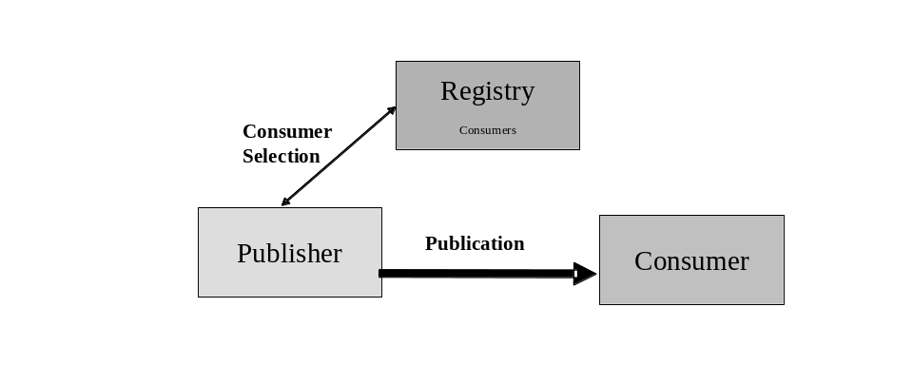
Figure 5 Base INFOD Service - No Subscription, Consumer Selection

Tasks:
- Manage consumer information in INFOD registry with
- Create/Alter/DropConsumer operation - mandatory
- Create/AddVersion/DeregisterVocabulary - optional
- Create/Alter/DropEntity - optional

- Publishers select consumers using the getMdata operation
- If requested, publishers receive update notifications from the INFOD registry reflecting changes of consumer information

- Publishers create and send messages using INFOD message structure.
- Consumers receive messages using the INFOD consume operation

The INFOD registry provides up-to-date information about consumers.

- Consumers filter messages based on publishers properties

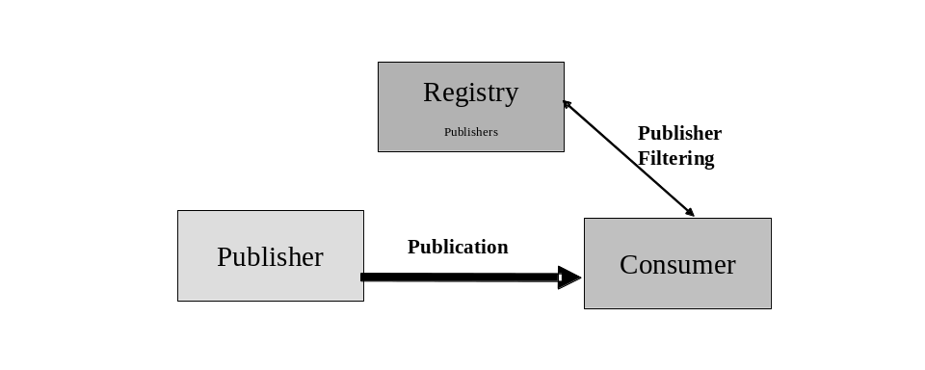
Figure 6 Base INFOD Service - No Subscription, Publisher Filtering
Tasks:
- Manage publisher information in INFOD registry with
- Create/Alter/DropPublisher operation - mandatory
- Create/AddVersion/DeregisterVocabulary – optional
- Create/Alter/DropEntity - optional

- Consumers find publisher information using the getMdata operation
- If requested, consumers receive update notifications form the INFOD registry reflecting changes of publisher information

- Publishers create and send messages using INFOD message structure
- Consumers receives message using the INFOD consume operation
- Consumers verifies publishers and consumes message

The INFOD registry provides up-to-date information about publishers.
- Consumer can filter message based on message content

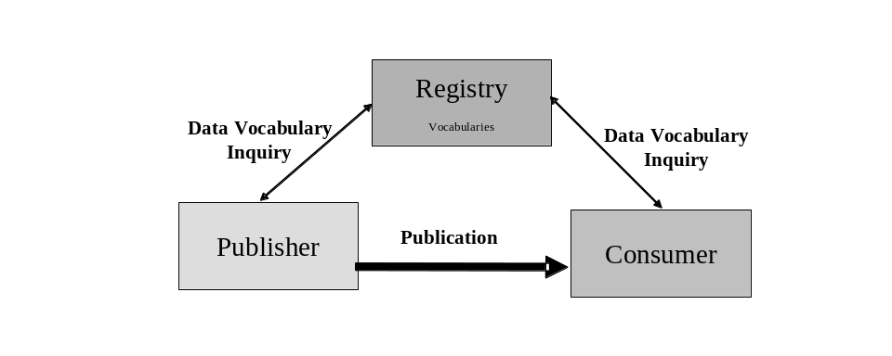
Figure 7 Base INFOD Service - Vocabulary Inquiry

Tasks:
- Manage vocabulary information in INFOD registry using the Register/AddVersion/DeregisterVocabulary operation

- Publishers find vocabularies using the getMdata operation
- If requested, publishers receive update notifications reflecting changes of vocabularies
- Consumers find vocabularies using the getMdata operation
- If requested, consumers receive update notifications reflecting changes of vocabularies

- Publishers create and send messages using INFOD message structure with a payload according to a vocabulary
- Consumers receives message using the INFOD consume operation
- Consumers interprets message using vocabulary information and consumes it

The INFOD registry provides up-to-date information about vocabularies.

Subscriptions - Managed by Registry

- Publishers publish messages according to subscription directives
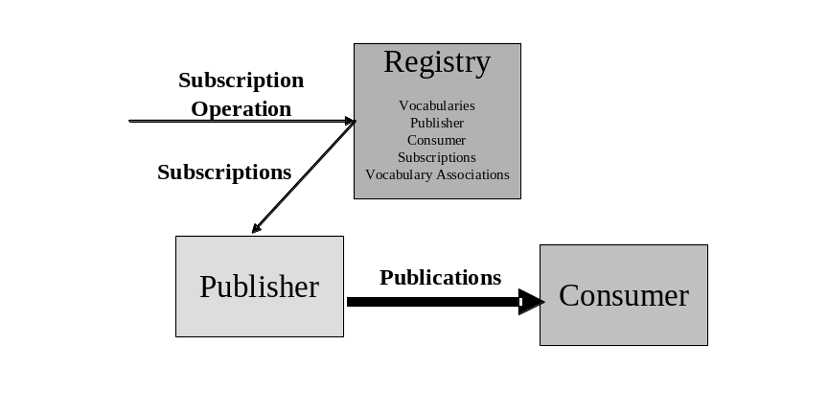
Figure 8 Base INFOD Service - Subscription Managed by INFOD Registry

Tasks:

- Manage information in INFOD registry with
- Create/Alter/DropPublisher operation – mandatory
- Create/Alter/DropConsumer operation – mandatory
- Create/Alter/DropSubscription operation – mandatory
- Create/AddVersion/DeregisterVocabulary – mandatory data vocabularies/optional for property vocabularies
- Create/Alter/DropEntity - optional

- Manage vocabularies, publishers, consumers and vocabulary associations in INFOD registry using the Create/Alter/DropPublisher/Consumer and the Register/AddVersion/DeregisterVocabulary operation respectively

- Subscribers direct subscribe request to INFOD registry
- INFOD registry determines relevant publishers
- INFOD registry checks all constraints
- INFOD registry informs publisher about new subscriptions – these subscription requests reflect constraints in the INFOD registry
- INFOD registry informs publishers about altered/dropped subscriptions
- Publishers receive and process subscription request

- Publishers create and send messages to all relevant consumers using the INFOD message structure
- Consumers receive message using the consume operation

By directing subscription request to the INFOD registry, subscribers can direct the INFOD registry to find relevant publishers, check all the constraints, and create a tailored subscription to each of the appropriate publishers. Furthermore, the INFOD registry informs publishers if changes in the directory information require changes in the subscription. This includes that a publication is retracted from some publisher while other publishers are added.

Subscription Based Publications

The only difference to the previous pattern is the structure and the language support for selected user data vocabularies. The subscriber chooses vocabularies, which support the creation of messages based on events or even supports the definition of events.

- Publishers create and publish messages according to subscription directives
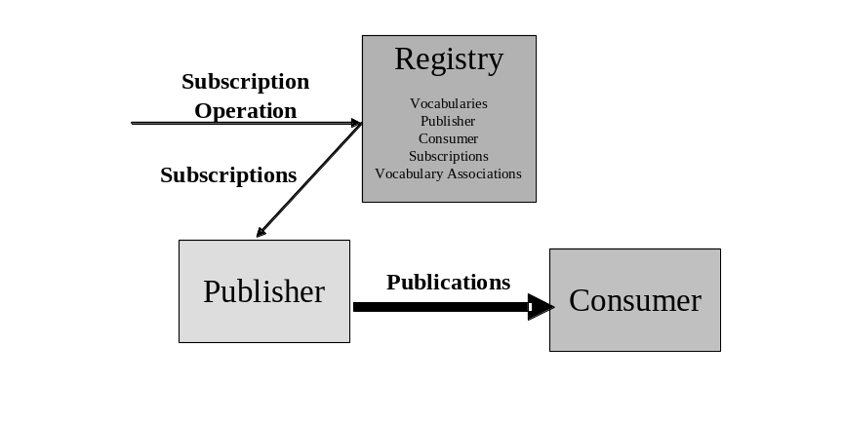
Figure 9 Base INFOD Service - Subscription Managed by INFOD Registry - Messages and Events Specified by Subscriber

Tasks:

- Manage information in INFOD registry with
- Create/Alter/DropPublisher operation – mandatory
- Create/Alter/DropConsumer operation – mandatory
- Create/Alter/DropSubscription operation – mandatory
- Create/AddVersion/DeregisterVocabulary – mandatory data vocabularies/optional for property vocabularies
- Create/Alter/DropEntity - optional

- Subscribers direct subscribe request to INFOD registry
- INFOD registry determines relevant publishers
- INFOD registry checks all constraints
- INFOD registry informs publisher about new subscriptions – these subscription requests reflect constraints in the INFOD registry
- INFOD registry informs publishers about altered/dropped subscriptions
- Publishers receive and process subscription request

- Publishers create and send messages to all relevant consumers using the INFOD message structure
- Consumers receive message using the consume operation

POBox INFOD Service

Consumers Determined by Publishers and Subscriptions

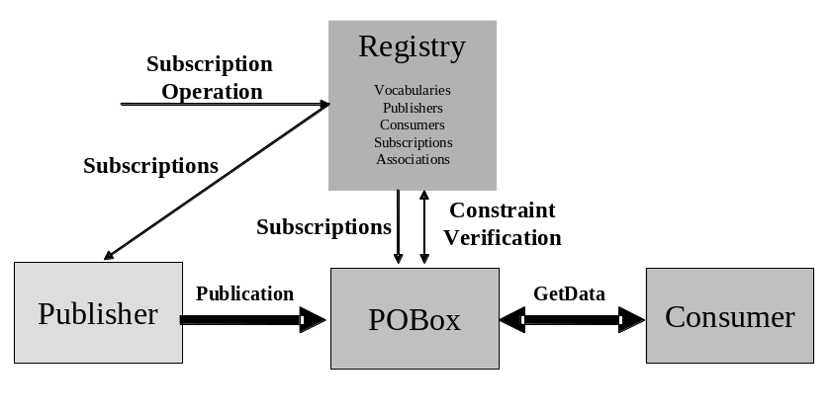
Figure 10 POBoxes INFOD Service - Consumer Determined by Publishers & Subscriptions

Tasks:

- Manage information in INFOD registry with
- Create/Alter/DropPublisher operation – mandatory
- Create/Alter/DropConsumer operation – mandatory
- Create/Alter/DropSubscription operation – mandatory
- Create/Alter/DropPOBox operation – mandatory
- Create/AddVersion/DeregisterVocabulary – mandatory data vocabularies/optional for property vocabularies
- Create/Alter/DropEntity - optional.

- Subscribers direct subscribe request to INFOD registry
- INFOD registry determines relevant publishers
- INFOD registry checks all constraints
- INFOD registry informs publisher and POBoxes about new subscriptions – these subscription requests reflect constraints in the INFOD registry
- INFOD registry informs publishers and POBoxes about altered/dropped subscriptions
- Publishers and POBoxes receive and process subscription request

- Publishers create and send messages to POBoxes
- POBoxes will only accept messages for specific consumers if constraints are satisfied
- POBoxes will add determine (additional) users based on directive in messages and subscriptions
- Publishers can retrieve message from POBoxes - within retention constraints - even after they have been consumed
- Consumers retrieve message from POBoxes. Consumers use getData operations with filters and optional WAIT_FOR option and also select consume/browse mode.
- Consumers can retrieve message from POBoxes - within retention constraints - even after they have been consumed.

A significant part of the complexity of information dissemination has been moved to the POBoxes; e.g., the consumption of a message by POBoxes and consumers respectively can be part of a transaction.

Consumers Select Messages of Interest

This pattern represents a generalization of the WS-Notification pull-point delivery.

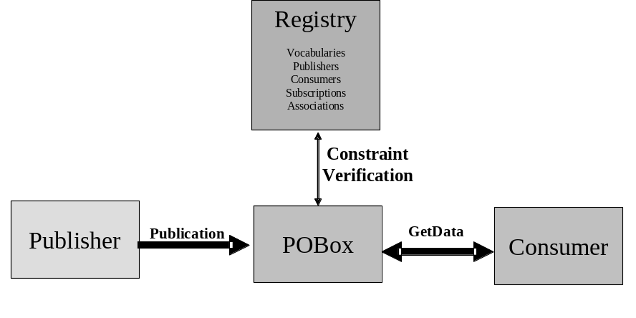
Figure 11 POBoxes INFOD Service - Consumers Select Messages of Interest

Tasks:

- Manage information in INFOD registry with
- Create/Alter/DropPublisher operation – mandatory
- Create/Alter/DropConsumer operation – mandatory
- Create/Alter/DropSubscription operation – mandatory
- Create/Alter/DropPOBox operation – mandatory
- Create/AddVersion/DeregisterVocabulary – mandatory data vocabularies/optional for property vocabularies
- Create/Alter/DropEntity – optional

- INFOD registry notifies publishers and POBoxes about changes in the INFOD registry. Publishers and POBoxes have to identify changes of interest using the getDMdata interface.

- Publishers create and send messages to POBoxes using the INFOD message structure
- POBoxes consume messages
- Publishers can retrieve message from POBoxes - within retention constraints - using the getData operation
- Consumers retrieve message from POBoxes – POBoxes ensure that all property constraints are met. Consumers use getData operations with filters and optional WAIT_FOR option and also select consume/browse mode.
- Consumers can retrieve message from POBoxes - within retention constraints - even after they have been consumed using the getData operation

Single Disseminator INFOD Service

Disseminators support the functions of POBoxes; therefore the functionality associated to POBoxes applies to disseminators as well. Only the added functionality is covered in the discussion of following patterns.

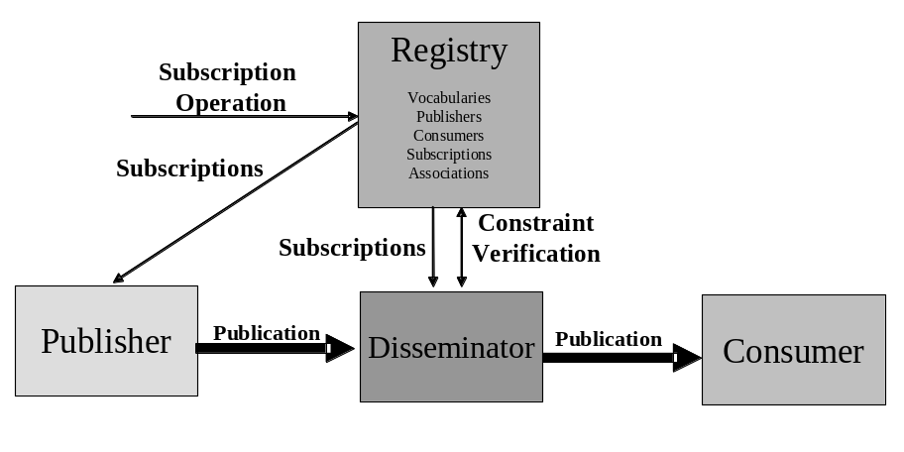
Figure 12 Single Disseminators INFOD Service

Tasks:

- Manage information in INFOD registry with
- Create/Alter/DropPublisher operation – mandatory
- Create/Alter/DropConsumer operation – mandatory
- Create/Alter/DropSubscription operation – mandatory
- Create/Alter/DropDisseminator operation – mandatory
- Create/AddVersion/DeregisterVocabulary – mandatory data vocabularies/optional for property vocabularies
- Create/Alter/DropEntity – optional

- Manage vocabularies, publishers, consumers, subscriptions, disseminators and associations in INFOD registry using the Create/Alter/DropPublisher/Consumer, the Associate/Disassociate and the Register/AddVersion/DeregistersVocabulary operation respectively.

- Subscribers direct subscribe request to INFOD registry
- INFOD registry determines relevant publishers
- INFOD registry checks all constraints
- INFOD registry informs publisher and disseminators about new subscriptions – these subscription requests reflect constraints in the INFOD registry
- INFOD registry informs publishers and disseminators about altered/dropped subscriptions
- Publishers and Disseminators receive and process subscription request

- Publishers create and send messages to disseminators
- Disseminators will only accept messages for specific consumers if constraints are satisfied
- Disseminators will add (additional) users based on directive in messages and subscriptions
- Publishers can retrieve message from disseminators - within retention constraints - even after they have been consumed
- Disseminators send messages to consumers
- Consumers receive message using the consume operation
- Consumers can retrieve message from disseminators - within retention constraints - even after delivery by disseminators using the getData operation.

Multi-Disseminator INFOD Service

This pattern enables disseminators to send messages to a large number of consumers.

This pattern is very important for any message delivery where publishers and consumers belong to different environments and operational characteristics such exactly once behavior, non-repudiation are required

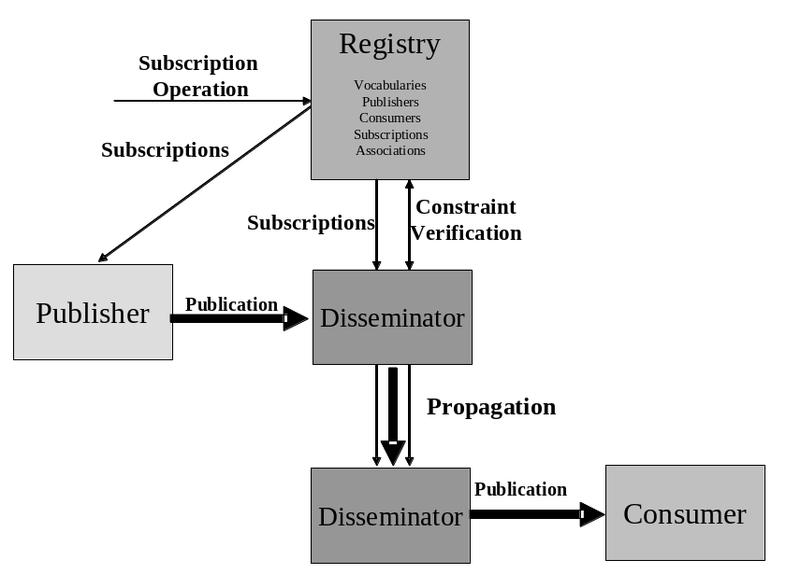
Figure 13 Multiple Disseminators INFOD Service

Tasks:

- Manage information in INFOD registry with
- Create/Alter/DropPublisher operation – mandatory
- Create/Alter/DropConsumer operation – mandatory
- Create/Alter/DropSubscription operation – mandatory
- Create/Alter/DropDisseminator operation – mandatory
- Create/AddVersion/DeregisterVocabulary – mandatory data vocabularies/optional for property vocabularies
- Create/Alter/DropEntity – optional

- Subscribers direct subscribe request to INFOD registry
- INFOD registry determines relevant publishers
- INFOD registry checks all constraints
- INFOD registry informs publisher and disseminators about new subscriptions – these subscription requests reflect constraints in the INFOD registry
- INFOD registry informs publishers and disseminators about altered/dropped subscriptions
- Publishers and Disseminators receive and process subscription request

- Publishers create and send messages to (home) disseminator using the INFOD message structure – messages may or may not be directed to specific consumers
- (Publishers’) Disseminator(s) ensure that messages are within specified constraints if directed to specific consumers.
- (Publishers’) Disseminator(s) send messages to all relevant disseminators according to the publishers’ and subscription directives
- (Consumers’) Disseminator(s) ensure that messages are within specified constraints and send messages to specified consumers.
- Publishers can retrieve message from (home) disseminators - within retention constraints - using the getData operation.
- Consumers consume messages using the consume operation.
- Consumers can retrieve message from (home) disseminators - within retention constraints - even after delivery by disseminators using the getData operation

It has to be noted that most of the functionality is out-sourced to INFO registry and the disseminators.

Operations

Note: This section will be completed in time for GGF16.

This section lists the interfaces that are used to implement the various patterns.

Base INFOD Service – No POBox, No disseminator

Management of INFOD registry:

- Register/AddVersion/Deregister (Property) Vocabularies
- Register/AddVersion/Deregister (Data) Vocabularies
- Create/Alter/Drop Publishers
- Create/Alter/Drop Consumers
- Create/Alter/Drop Vocabulary Associations
- Create/Alter/Drop User Property (Instance)

No Subscriptions

Subscriptions – Managed by Registry

Subscription Based Publication

POBox INFOD Service

Consumers determined by Publishers and Subscriptions

Consumers Select Messages of Interest

Multi Disseminator INFOD Service

Single Disseminator INFOD Service

Just a reminder, a POBox is a consumer that also implements the getData operation. For convenience, in this note the term consumer is limited to those consumers that do not support the getData operation.
There are 2 options to request a notification: the getMData operation (with WAIT_FOR) or a request to send a message - a message request assumes the support of the consume interface with the ability to receive INFOD meta-data messages. Without a request for notification changes are only known after using periodically the getMData operation (without WAIT_FOR).
This is only possible if the GetData operation support an ordered by clause.
INFOD does not manage user data

