Access

Information Dissemination in the Grid Environment – White Paper

Status of This Memo

This memo is designed to inform the Grid community about Information Dissemination. Distribution is unlimited.

Copyright Notice

Copyright © Global Grid Forum (2006). All Rights Reserved.

Abstract

Grid applications must be able to access, manage and share data in a timely fashion at a very large scale and potentially across organizational boundaries. Challenges arise from the number and variety of involved parties, the size of the data, the number of recipients (consumers) of each data element and the geographical distance. Critical data must be protected while providing efficient access to and distribution of these data with the required Quality of Service (QoS).

“Information Dissemination” (INFOD) addresses these requirements. INFOD supports timely and efficient dissemination of customized information within user communities. The dissemination is mainly based on consumers needs and is subject to constraints limiting the information dissemination. Constraints typically reflect community rules and policies and personal preferences.

The INFOD specification will be published in two documents, the Base Specifications [INFODBASE] and the Advanced Specifications. For both levels there will be documents describing patterns and use cases.

This is an early draft that has not yet been reviewed by the INFOD group.

Table of Content

Abstract 1
1. Introduction 4
1.1 Base Functionality 4
1.2 Advanced Functionality 5
1.3 INFOD as Part of it’s Ecosystem 7
1.4 Requirements 8
2. INFOD Base Functionality 8
2.1 INFOD Vocabulary Management 9
2.2 INFOD Entities 10
2.3 INFOD Association 11
2.4 User Property Instances 11
2.5 Handling Subscription Requests in the INFOD Registry 12
2.6 Retrieving Information 13
2.7 Notifications 13
3. INFOD Advanced Functionality 13
3.1 INFOD Vocabulary Management 14
3.2 INFOD Entities 14
3.3 INFOD Associations 14
3.4 User Property Instances 15
3.5 Handling Subscription Requests in the INFOD Registry 15
3.6 Retrieving Information 16
3.7 Notifications 17
3.8 INFOD Registry Synchronization 17
4. INFOD as Part of it’s Ecosystem 17
4.1 Data Vocabularies with Push Languages (CQs) 17
4.2 Distributed CEP 18
4.3 (Semantic) Transformations 18
4.4 Trusted Information Exchange 19
4.5 Transactional Support 20
4.6 Verified Dissemination 20
4.7 Security and Constraints 20
5. Patterns 21
5.1 Overview 21
5.1.1 Base INFOD Services – No POBox, No disseminator: 21
5.1.2 POBox INFOD Service: 22
5.1.3 Single Disseminator INFOD Service: 22
5.1.4 Multi-Disseminator INFOD Service: 23
5.2 Detailed Description of Patterns 23
5.2.1 Base INFOD Service – No POBox, No disseminator 23
5.2.2 POBox INFOD Service 26
5.2.3 Single Disseminator INFOD Service 27
5.2.4 Multi-Disseminator INFOD Service 28
5.3 Outline of Operations 29
5.3.1 Base INFOD Service – No POBox, No disseminator 29
5.3.2 POBox INFOD Service 33
5.3.3 Single Disseminator INFOD Service 35
5.3.4 Multi-Disseminator INFOD Service 37
Author Information 38
Glossary 39
Intellectual Property Statement 41
Full Copyright Notice 41
References 42

Figure 1-1: INFOD Basic Elements 4
Figure 1-2: INFOD Base Functionality 4
Figure 1-3: INFOD Advanced Functionality 5
Figure 1-4: Disseminators and POBoxes 6
Figure 5-1 Base INFOD Service 21
Figure 5-2 POBoxes INFO Service 22
Figure 5-3 Single Disseminator INFOD Service 22
Figure 5-4 Multi Disseminator INFOD Service 23
Figure 5-5 Base INFOD Service - No Subscription, Consumer Selection 30
Figure 5-6 Base INFOD Service - No Subscription, Publisher Filtering 30
Figure 5-7 Base INFOD Service - Vocabulary Inquiry 31
Figure 5-8 Base INFOD Service - Subscription Managed by INFOD Registry 32
Figure 5-9 Base INFOD Service - Subscription Managed by INFOD Registry - Messages and Events Specified by Subscriber 33
Figure 5-10 POBoxes INFOD Service - Consumer Determined by Publishers & Subscriptions 34
Figure 5-11 POBoxes INFOD Service - Consumers Select Messages of Interest 35
Figure 5-12 Single Disseminators INFOD Service 36
Figure 5-13 Multiple Disseminators INFOD Service 37

Introduction

Information Dissemination (INFOD) allows data sources to make data available to consumers in a timely fashion.
State changes of data may generate events; events may generate messages; messages are created by publishers and sent to consumers.

Figure 1-1: INFOD Basic Elements

Subscriptions match publishers’ data with consumers’ needs; subscribers create subscriptions. If needed, subscribers should be able to specify what is considered to be an event, what message gets published in response to which event and which consumer should receive a message.
INFOD supports these requirements and provides an infra-structure that enables subscribers to find and match publishers and consumers with specific properties. INFOD also defines services, POBoxes and disseminators that significantly simplify the dissemination of information. These services support a wide range of operational characteristics.

Base Functionality

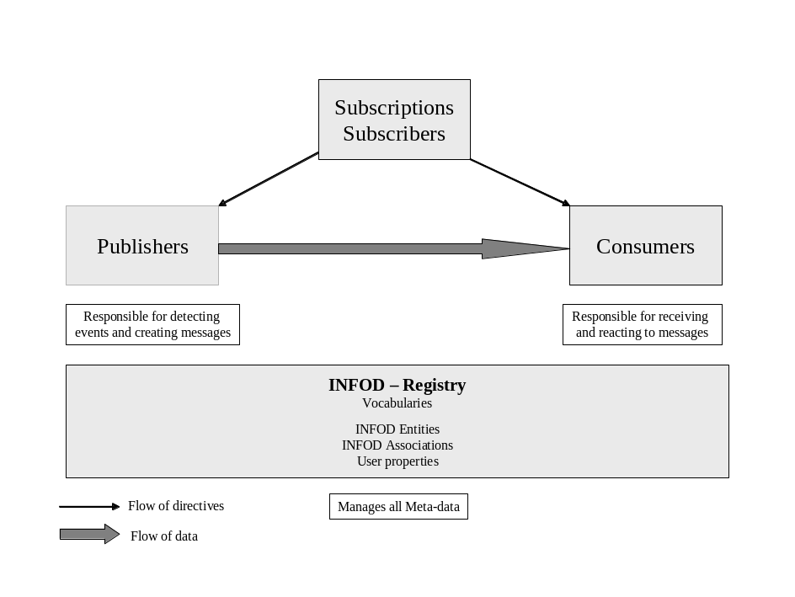
Figure 1-2: INFOD Base Functionality

Publishers and consumers are the main actors of an INFOD system; publishers publish messages for consumption by consumers. Publishers react to subscriptions specified by subscribers. The information about these objects, called INFOD entities, is contained in the INFOD Registry.
Data are only useful if there is a shared understanding of these data by publishers, consumers and subscribers. INFOD uses data vocabularies (e.g., an XML schema) to achieve this; the INFOD registry manages these data vocabularies. The INFOD registry also manages associations, which are relation between publishers and vocabularies.
It is often necessary to extend the description of INFOD entities (and associations) beyond the standard properties as defined by INFOD; therefore INFOD supports user property vocabularies. User property vocabularies are designed to create communities of entities using vocabularies that are familiar to the members of these communities. Referencing user property vocabularies, entities can specify constraints identifying which other entities (community members) are of interest or unacceptable. Interaction requires mutual consensus; mutual consensus as lack thereof and specified by constraints may be based on personal preferences or rules governing communities.
Subscriptions are used to match the needs of the consumers with the offering of the publishers in the context of communities and their rules. When a subscription is added or modified the INFOD registry will determine which publisher needs to publish what to which consumers. The effected entities will be notified, assuming they are able to receive such a notification. Subscription may also be effected by changes of other entities; i.e., the addition of a consumer which matches existing subscriptions will result in the notification of the effected publishers.
INFOD uses existing security mechanism to ensure that the dissemination of information happens according to security policies. The specification of communities can be used to complement and enhance security policies.

Advanced Functionality

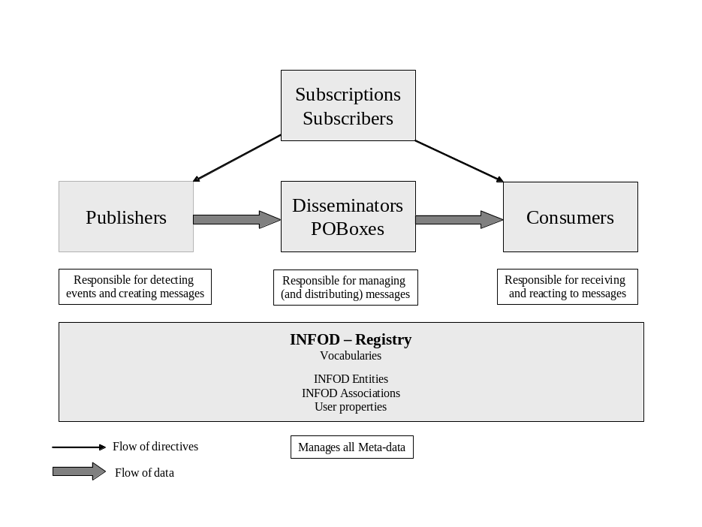
Figure 1-3: INFOD Advanced Functionality
A significant part of the advanced functionality of INFOD is provided by two additional entities: disseminators and POBoxes. Disseminators are designed to send messages on behalf of publishers. POBoxes are designed to receive messages on behalf of consumers; consumers can retrieve messages at their convenience.

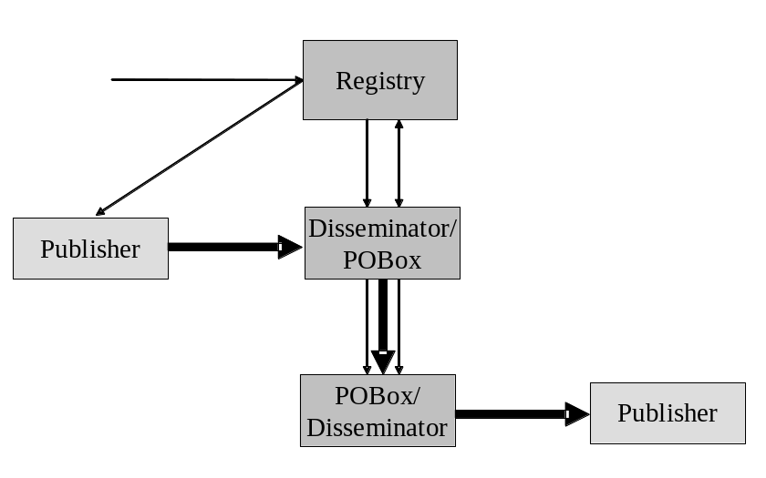
Figure 1-4: Disseminators and POBoxes

The information about these additional entities will be managed by the INFOD registry. User property vocabularies can be used to characterize POBoxes and disseminators; constraints can be used to specify which entities are willing to interact with which these additional entities and vises versa.

The basic INFOD functionality requires publishers to send messages directly to consumers. The consequence is that publishers and consumers may have to support operational characteristics that are difficult to implement; e.g., delivery of messages to a large set of consumers, exactly once creation and consumption and exactly once delivery of messages, non-repudiation and auditing and tracking. Furthermore, publishers and consumers have to be active when messages are sent. To solve this problem INFOD introduces home disseminators and home POBoxes. A home disseminator disseminates the message on behalf of publishers; A home POBox receives messages on behalf of a consumer.

Home disseminators and home POBoxes are designed to allow publishers (consumers) to focus on the creation (consumption) of messages respectively; the operational issues mentioned above are covered by the home disseminators and POBoxes respectively. Consequently, the support for complex functionality and demanding operational characteristics can be moved to these services.

Disseminators are responsible for the efficient dissemination of messages. There are many strategies to do this; streaming and late fan-out are good examples. Important strategies for efficient message dissemination will be identified and specified.

Messages have to be at least retained until every consumer gets it. In many cases, however, this is not sufficient. When auditing and tracking is required, messages have to be retained even after they are consumed according to retention policies. POBoxes and disseminators will support this requirement. Consequently, publishers and consumers will have access to all messages using the getData interface.

It will be obviously impossible to manage INFOD services using a single registry; therefore INFOD will support the (partial) synchronization of INFOD registries. Using these specifications, INFOD registries can be synchronized with non-INFOD registries too.

INFOD as Part of it’s Ecosystem

As for any other technology, INFOD has to be integral part of its Ecosystem.

The INFOD group intends to reach out to these communities and to show how these technologies can leverage and be integrated with INFOD. Since members of the interested Grid community may not be familiar with the interaction of some of these technologies with INFOD a subset of these technologies will be listed.

The following technologies will be reviewed:

- Data Vocabularies with Push Languages (CQs) - data vocabularies are used to structure the information that is shared by a community. Publishers and consumers are free to use model (SQL92/99, XML, RDF etc.) to specify vocabularies; as long as the specific implementation of the INFOD registry supports that model.

Vocabularies have an implied (query) language which is derived from the model and the specific vocabulary. These languages are typically designed to work in pull mode – an ad-hoc request returning existing data. INFOD, however, requires languages that are designed for push mode – a request specifying continuous interest in future data. These languages are often named Continuous Queries.

- Distributed CEP - Information needs of consumers may require information from several resources. Push languages (continuous queries) must be able to combine and even request information from several publishers.

- (Semantic) Transformations - Publishers and subscribers do not need to use the same vocabulary to communicate with each other. Transformations are a bridge between vocabularies. These transformation start from very simple examples – the translation of tags – and go as far as translating the content of information based on semantics.

- Trusted Information Exchange - Information maybe of high value and must be distributed carefully. Trusted Information Exchange defines the rules of consuming high value information. One can consider it as an extension of the constraint processing of the INFOD registry.

- Transactional Support - Existing transaction models do not have adequate support for information dissemination; propagation may send non-recoverable data.

- Verified Dissemination - Publisher may have to deliver information by a deadline. This information may be carried one message to a single consumer or by a set of related messages to several consumers. What if one or more consumers do not receive or confirm the message? Commonly agreed upon intermediaries are required to deal with this problem.

- Security and Mutual Filtering – Processing subscriptions requires the verification of constraints in the INFOD registry; this activity represents the mutual filtering between INFOD objects. Security policies limiting the access to information are a special case of these constraints.

Other technologies will be added as their importance becomes apparent.

Requirements

To meet its goals, the INFOD specification must explicitly address the following requirements:
- Subscribers must be able to select publishers of interest: Subscriber must be able to specify which publishers are of interest to consumers. If subscribers use filters to identify publishers they must be able to request confirmation of eligible publishers. Furthermore, subscribers must be able to request notification if the list of eligible publishers changes.
- Subscribers must be able to select messages of interest: Subscribers must be able to specify which messages are of interest to which consumers.
- Publishers must be able to select consumers: Publishers must be able to specify eligible consumers as well as the appropriate consumers for each message.
- Subscribers must be able to select messages of interest based only on vocabularies (e.g., XML schema): Subscribers must be able to specify which messages are of interest without explicitly defining a specific (set of) publisher(s). Subscribers must be able limit the selection of publishers.
- Subscribers may be able to specify which messages should be published in response to an event: If publishers expose events subscribers must be able to specify which events are of interest and which message should be created in response to an event.
- Subscribers may be able to define what is considered a single event: If publishers expose states subscribers must be able to define what is considered an event and what message should be created in response to an event. Events may be based on the expiration of time. Events can be based on any retained or future state.
- Subscribers must be able to relate events. In many cases events have to be correlated to other events. Examples of event correlation are events composition (composite events), event ordering (to control the consumption of events) and the bundling of events (to form conversations):
- Consumers must be able to specify how and when messages are received: Consumers should be able to specify the distribution channel for receiving messages based on message content, their own status as well as external factors, such as time of day. Additionally, consumers may request notifications about the existence of a message as well as reminders they have not consumed these messages in time. Furthermore, consumers must be able to specify the reaction(s) in response to a message.
- Consumers must be able to limit the messages received: Consumers must be able to specify which messages can be delivered and which publishers (subscribers) are allowed.
- Consumers may be able to retrieve past messages: Consumers must be able to access past messages.
- Publishers, consumers and subscribers must be able to specify QoS requirements: QoS requirements relate to security, performance, scalability, reliability, transactional publications and consumptions, exactly once propagation to one or more consumers as well auditing and tracking.
- Publishers, subscribers and consumers may be known to Identity Management: In case that security is of importance, Identity Management will be used to verify information about publishers, subscriber and consumers.
- It must be possible to use multiple filters: Filters are used to select messages, publishers, subscribers and disseminators. It multiple filters are specified INFOD must ensure proper composition.

INFOD Base Functionality

The base functionality of INFOD is described in [INFODBASE]. The following is a short overview.

The INFOD registry is the core service of the INFOD base functionality; it manages the following types of objects:

- Vocabularies - INFOD as well as non-INFOD vocabularies
- INFOD entities - subscribers, publishers, consumers, subscribers and subscriptions
- INFOD vocabulary associations - relations between entities and vocabularies
- User properties – user defined specifications complementing the descriptions of INFOD entities and associations

INFOD Vocabulary Management

Vocabularies are used to describe the structure of data; a vocabulary has an implied constraint language.

The INFOD registry manages the following types of vocabularies:

- INFOD Vocabularies – INFOD vocabularies are XML schema describing the structure of INFOD objects; i.e., XML schema describing subscribers, publishers, consumers, subscriptions, associations and messages.
- User Property Vocabularies – user property vocabularies are XML schema describing properties of INFOD entity and associations; i.e., they allow extending the descriptions of INFOD entities and associations. The INFOD registry is managing instances of user properties as discussed in section 2.4.
- User Data Vocabularies – user data vocabularies are XML schema or non-XML vocabularies (e.g., SQL99 objects). They describe the structure of the data that is available from publishers (and disseminators), is understood by consumers and can therefore be used in messages. User data vocabularies can be specified using SQL, XML, RDF or any other data model. The INFOD registry will not manage instances of user data. The INFOD registry, however, will check the validity of data vocabulary definitions and constraints.

It is the responsibility of INFOD users to define property and user data vocabularies; user property vocabularies are optional while user data vocabularies are mandatory.

Vocabularies are managed with the vocabulary management interface using the following operations:

- Register – the register operation allows the creation of a new vocabulary
- Add Version – the add-version operation allows the evolution of a vocabulary
- Deregister – the deregister operation allows the deletion of a vocabulary

INFOD vocabularies are part of any INFOD registry deployment. INFOD specifies the following vocabularies:

- The INFOD Message vocabularies
- The INFOD Entity vocabulary
- The INFOD Association vocabulary

The INFOD message vocabulary contains the following sections:

- Header section – the header section contains information about messages
- Body section – the body section describes the payload of messages

Messages are consumed by consumers using the Consume operation.

INFOD Entities

INFOD following entities are described by the INFOD entity vocabulary.

- Publishers – publishers are the information sources
- Consumers – consumers are the information sinks
- Subscribers – subscribers are the entities managing subscriptions
- Subscriptions – subscriptions are used to specify which data are of interest to which consumer; subscriptions are managed by subscribers

This vocabulary contains the following sections:

- Core section – the core section specifies basic properties of the INFOD entities such as EPR, name, type of entity and a description. The core section is mandatory for all entities.

- Constraint section – the constraint section specifies acceptable data content and properties for any interaction/cooperation between entities.

The most common use of constraints is the user data constraint (filters) in subscriptions. The data constraints in subscriptions specify which data are of interest and therefore trigger the flow of messages to consumers. INFOD does not understand whether this constraints references messages, events or states; this information is derived from the vocabulary and the constraints.
Any property constraints are used to specify whether entities and associations are willing to interact with each other; e.g., that any interaction is mutually acceptable. Any constraints violation will prevent information dissemination.

- Policy section – the policy section specifies operational characteristics associated to entities. The policy section is optional.

Examples for policies include: transactions, recoverability, security, query support, retention, auditing, non repudiation, best effort, at least/most/exactly once delivery, timely delivery.
This section is complementary to the policy section of associations. Policies specified in associations override policies specified in entities.

- Scheduling section – the scheduling section specifies at which time entities or specific operations such as consumption are active. The scheduling section is optional.

For time based schedules iCalendar will be used; however, iCalender needs to be complemented by the ability to react to the existence of events.

- Processing section – the processing section describes procedures that maybe used for message creation, transformation, composition and consumption. The processing section is optional.

The INFOD registry manages the instances of INFOD entities. This is done with the following operations:

- CREATE - this operation creates a new INFOD entity
- ALTER – this operation changes an INFOD entity
- DELETE – this operation deletes an existing INFOD entity

There is a specific version of these operations for each of the INFOD entities.

INFOD Association

Vocabulary associations are used to relate vocabularies to publishers and to specify properties of the data that is available for publication from a specific publisher.

INFOD vocabulary associations are described by the INFOD association vocabulary. This vocabulary contains the following sections:

- Core section – the core section specifies basic properties of the INFOD entities such as EPR, name, type of entity, a description and a vocabulary reference. The core section is mandatory for all entities.

- Constraint section – the constraint section specifies acceptable data content and properties for any interaction/cooperation with entities.

Data constraints are used to limit the flow of information; e.g., data can only be disseminated to consumers that are entitled to see this information. These constraints complement constraints that are derived for access rights.
Property constraints are used to ensure that entities, associations are mutually acceptable to each other. Any constraints violation will prevent information dissemination.

- Policy section – the policy section specifies operational characteristics associated to associations. The policy section is optional.

Specifies the (operational) policies that are supported.
Examples for policies include: transactions, recoverability, security, query support, retention, auditing, non repudiation, best effort, at least/most/exactly once delivery, timely delivery.
This section is complementary to the policy section of entities. Policies specified in associations override policies specified in entities.
If no policy is defined the policy specification of the associated entity - the publisher - is used.

- Data Sources - this is a reference to the actual data. Examples for such a reference are files, tables, views, collections and streams.

The INFOD registry manages the instances of INFOD associations. This is done with the following operations:

- ASSOCIATE – this operation associates a vocabulary to a publisher
- DISASSOCIATE – this operation disassociates a vocabulary from a publisher

The operation is identified additionally as a vocabulary association.

User Property Instances

User property vocabularies are used to extend the descriptions of INFOD entities and associations. The INFOD registry manages not only the vocabularies but also the instances according to these user property vocabularies. Instances are managed with the vocabulary management interface using the following operations:

- Add Instances – this operation allows the creation of a new instance
- Alter Instances – this operation allows the modification of an existing instance
- Delete Instance – this operation allows the deletion of an exiting instance

Instances are selected if they meet constraints that are specified in INFOD entities and associations. Each instance has to reference an INFOD entity or association.

Handling Subscription Requests in the INFOD Registry

The primary focus of the INFOD registry is to match publishers and subscribers in response to a request to create a subscription. This process is designed to match the process one has to go through in order to find or share information:

- To find information provider (publisher) who understand the subject and the question
- To make sure that the information recipient (consumer) understands the information
- Make sure that the publisher has the right properties and credentials and that the information is of interest
- Make sure that the publisher is willing to share information with the consumer and that the consumer is actually entitled to see the information
- Makes sure that the publishers and consumers are actually willing to follow the directives of the subscriber.

This translates into the following constraint evaluations:

- Identify potential publishers - using the data vocabulary referenced in the subscription the INFOD registry identifies those publishers that are offering information structured with the specified vocabulary and are also able to support the specified constraints. Using - optional - user property constraints, the selection of publishers will be limited to those publishers that adhere to these constraints.
- Identify potential consumers - using the data vocabulary referenced in the subscription the INFOD registry identifies those consumers that are able to consume information structured with the specified vocabulary. Using - optional - user property constraints, the selection of consumers will be limited to those consumers that adhere to these constraints.
- Limiting publishers using constraints associated to consumers - using the constraints associated to a consumer the selection of publishers will be limited to those consumers that adhere to all property constraint. Such a property constraints can be contained in the consumer’s specification or the - community - property specification associated to consumers.
- Limiting consumers using constraints associated to publishers - using the constraints associated to a publisher the selection of consumers will be limited to those consumers that adhere to any property constraint. Such a property constraints can be contained in of the publisher’s specification, the association specification associating publishers and vocabularies or any - community - property specification associated to the publisher.
- Limiting consumers and publishers using constraints associated to subscribers - using the constraints associated to a publisher, a consumer and directed towards subscribers some consumers and publishers may reject a subscription.

One of the consequences of this constraint evaluation is that more than one publisher may react to a publication and that each publisher may publish to a different set of consumers.

While this looks very complex, the use case document [INFODU] shows how these constraints is a natural part of daily information sharing and that the definition is often intuitive. This process represents an example of the mutual filtering that is present in the majority of interaction between entities/community members.

The implementation, however, creates some challenges; an example of an implementation is explained in [EXPR_FILTER].

Retrieving Information

Using the GetMetadata operation INFOD users are able to query the information in the INFOD registry to find objects with specific properties. This interface allows subscribers to find vocabularies, publishers and consumers.

INFOD users are also able to find related objects such as publishers related to specific subscriptions. When identifying related objects the INFOD registry will only list objects that are within the specified constraints; a publisher will only be listed as being associated to a subscription if all constraints, those of the publishers, consumers and subscriptions, are met.

Notifications

Section 3.5 titled ‘Handling Subscription Requests in the INFOD Registry.’ describes how publishers and subscribers are matched when a subscription is created, altered or dropped.

INFOD entities, especially publishers, need to react immediately to changes in the INFO registry. Therefore, the INFOD registry will notify effected entities immediately if they are affected by the creation of a publication. Obviously, this is only possible if the is the effected entity supports the consume interface and is able to react to INFOD messages containing metadata data information.

Subscription may last for along time. During this time the subscription, the subscribers, the publishers or the consumers may be altered. Whenever, there is a change; the effected entities will be directed to react accordingly through notification.

Meta-data messages are used to inform INFOD entities about changes in the INFOD registry. These messages will be published if a vocabulary, entity or association is created, altered or changed.

INFOD entities consume Meta-data messages using the ConsumeMetadata operation.

INFOD Advanced Functionality

The base functionality is extended by providing additional entities and associations:

- INFOD entities – there are two additional entities: Disseminators and POBoxes. Disseminators are designed to disseminate messages on behalf of publishers; POBoxes are designed to receive messages on behalf of consumers. These entities support additional operations.
- INFOD associations – there is a new set of associations called entity associations. Entity associations relate publishers to disseminators and consumers to POBoxes.

A new Getdata operation allows INFOD entities retrieve data from disseminators and POBoxes; messages maybe retrieved for consumption, review or auditing. The getData operation may be offered by any INFOD entity to give access to data even if these data do not represent messages.

INFOD Vocabulary Management

The INFOD entity, association and message vocabularies will be extended to accommodate the additional entities and associations as well as the enhanced message dissemination support.

The vocabulary management will become open to the support of transformation – details will be discussed in section 4.3 titled ‘(Semantic) Transformations.’

INFOD Entities

Two types of INFOD entities will be added, disseminators and POBoxes. The primary goal of these entities is to allow publishers and consumers to out-source complex functionality and operational characteristics; e.g., the efficient delivery of messages to a large set of consumers and the support for difficult operational characteristics such tracking, auditing and non-repudiation.

Instead of sending messages directly to consumers publishers can send message to disseminators with the request for further dissemination.

POBoxes can receive (consume) messages on behalf of consumers; these messages are not processed by POBoxes, however, consumer may retrieve (and consume) these message for consumption using the GetData interface.

The optimal dissemination of message (called propagation) is an important task of disseminators. A set of technologies will be used to do this:

- Streaming will be used in case of high message rate to another disseminator or to a POBox.
- Intermediary disseminators will be used for high fan out
- Additional functions may be added

The messages vocabulary will be enhanced to support these functions.

The value of disseminators and POBoxes can be enhanced by association these entities to publishers and consumers respectively. This is discussed in detail in section 3.3 titled ‘INFOD Associations.’

The e-mail system is an excellent use case for home disseminators, home POBoxes and propagation. INFOD, however, significantly generalizes and extends the functionality of this use case.

Disseminators and POBoxes can act as publishers and consumers respectively. This allows INFOD to represent classical messaging and publish/subscribe.

INFOD Associations

Disseminators are designed to support publishers in the dissemination of messages. This support can be significantly extended if publishers and disseminators are associated to each other; i.e., a disseminator becomes a home disseminator of a publisher.

A home disseminator provides the following support:

- Transactional support: if messages are created in the context of transaction; messages will only be delivered once the transaction is committed. Messages from aborted transactions will be discarded.
- All messages will be disseminated by the home disseminator according to the directive of publishers and the INFOD registry.
- Before messages will be disseminated all constraints specified by the publisher or captured in the INFOD registry will be checked.
- At least once, at most once and exactly once message dissemination will be supported.
- Non-reputable message delivery will be supported.
- Messages will be retained according to policies; all messages can be accessed using the getData operation. Important aspects of the getData operation are discussed in section 3.6 titled ‘Retrieving Information.’
- Publishers will be informed if a message has no consumer.
- Directives of the registry are sent to the home disseminator; the home disseminator may send (simplified) directives to its publisher(s).

A home disseminator can be shared by many publishers.

POBoxes are designed to support publishers in the consumption of messages. This support can be significantly extended if consumers and POBoxes are associated to each other; i.e., a POBox becomes a home POBox of a consumer.

A home POBox provides the following support:

- All messages can be accessed using the getData operation. Important aspects of the getData operation are discussed in section 3.6 titled ‘Retrieving Information.’
- Transactional support: if messages are created in the context of transaction; messages will only be considered as consumed once the transaction is committed.
- All messages will be received through (consumed by) the home POBox.
- Before messages will be consumed all constraints, specified in the INFOD registry, applying to that message will be checked.
- At least once, at most once and exactly once message consumption will be supported.
- Non-reputable message consumption will be supported.
- Messages will be retained according to policies; the getData operation provides access to retained data.
- Directives of the registry are sent to the home POBox; the home POBox may send (simplified) directives to its consumer(s).

A home POBox can be shared by many consumers.

The association between publisher and home disseminator and consumer and home POBox are called entity associations.

Specific versions of the ASSOCIATE/DISASSOCIATE operation will be added for each of the entities; the association vocabulary will be extended to support the advanced functionality. User property vocabularies can be used to extend the description of entities

User Property Instances

User property vocabularies can be used to create user property instances associated to disseminators, POBoxes and entity associations. Constraints can be used to select or restrict the interaction with specific instances.

Handling Subscription Requests in the INFOD Registry

The Publish/Subscribe match will include the evaluation of constraints referencing disseminators, POBoxes, and entity associations.

A major objective of disseminators and POBoxes is to simplify publishers and consumers. The INFOD registry will support this objective by directing as much work as possible away from publishers and subscribers towards home disseminators and POBoxes. This is done by sending relevant information to home disseminators and POBoxes. Home disseminators and POBoxes may need to forward information to there publishers and consumers respectively.

Here are two examples to illustrate this interaction:

- If a publisher has a home disseminator and the publisher offers a stream of messages that are unconditionally published only the disseminator needs to know about subscriptions. The disseminator does not need to forward any information directive to the publisher(s).

- If messages are created in reaction subscription the home disseminator will be informed about the dissemination and the creation of the message. The home disseminator has to notify effected publishers which messages need to be created. The message creation may be in response to selected events or in response to state changes.

The matching process may involve many constraints associated to a variety of entities. With the INFOD base functionality all constraints have to be met. The advanced functionality allows specifying how different constraints are combined; e.g., user can specify that a constraints my or may not be overwritten by another constraint.

Retrieving Information

The INFOD base functionality disseminates all messages directly to consumers as soon as these messages become available. Using POBoxes, consumers have to options to direct messages to (home) POBoxes of their choice. Using the getData operation these messages can be retrieved by their consumers whenever these consumers are ready to do so.

The getData operation allows consumers to browse through or consume message; i.e., query them in the conventional sense or query them for consumption.

The getData operation with the browse option can be used to access any message as often as consumers need to so; it can also be used before and after consuming a message. Using this operation before consuming a message allows obviously pre-screening this message before it is consumed, using this operation after consuming a message allows for auditing and tracking. Auditing and tracking maybe done out of curiosity, to settle a dispute, or to analyze data.

The getData operation with the consume option can only be executed once for any message.

The getData operation will also have an option to request the delivery of future message; i.e., messages will be delivered as soon as they become available. The option requesting delivery of future messages can be combined with the consume option.

A getData operation with the consume option can be embedded in a transaction. Using transactions provides exactly once consumption of messages in the context of transactions; a feature that is heavily used by existing message systems.

The getData operation is primarily designed to support the access to home POBoxes by subscribers. However, the getData operation can be offered by any INFOD entity, including disseminators and publishers, however, certain options (consume / access to future data) my not be supported.

Since the getData operation leverages the matching of the INFOD registry it allows access to data in the context of communities.

Notifications

The notification will be enhanced to reflect the additional functionality; e.g., notifications to home disseminators include information that has to be forwarded to publishers. This information is explicitly identified.

INFOD Registry Synchronization

It is assumed that INFOD registries will be designed to serve a set of communities or organizations – an organization can be considered as a community. It is often mandatory to keep information limited to these communities; the most important reason are most likely privacy, security and scalability; e.g., a government organization like the CIA or DOD is not allowed to share information about the communities – vocabularies, publishers, consumers, subscriptions – with outside communities.

While most of their communication will be restricted to other members of their own communities there is often a need to reach out to outside communities. This will be done by sharing selected INFOD registry information with other qualified INFOD registries.

INFOD registries will subscribe to each; i.e., INFOD registries act in this context as publishers and subscribers. Subscribing registries will be notified by publishing directories about relevant changes.

Since the interaction to other INFOD registries is based on message interchange, the registry synchronization obviously work with any service that offers the specified operations.

In some cases, synchronization of the registry information maybe not needed. INFOD registries can forward subscription request to other INFOD registries instead. These other INFOD registries will respond to a request back to the first INFOD registry. The first INFOD registry will combine all responses and notify the effected entities. This approach allows the local INFOD registries to collaborate with other INFOD registry while minimizing the exposure of information.

INFOD as Part of it’s Ecosystem

As for any other technology, INFOD has to be integral part of its Ecosystem. Since members of the interested Grid community may not be familiar for some of these technologies a subset of these technologies will be discussed.

The INFOD group has to reach out to these communities and to show how these technologies can leverage and be integrated with INFOD. The list of technologies that will be covered is most likely changing over time.

Data Vocabularies with Push Languages (CQs)

For many years (data) language specifications have focused on the selection and retrieval of existing data. The support for selection and retrieval of future data, the focus of INFOD, has been very limited.

What exist as what is needed?

- Access to all data of a data sources containing messages; typically perceived as broadcasting.
- Access to selected messages of a data sources. Subscribers are allowed to specify selection criteria against single messages according to the vocabulary of the data sources. In many systems, there is a specific attribute representing called a topic space with its specific operations. In most cases the notion of a vocabulary is very vague, so use of expressions assumes implicit additional knowledge. These language typically lack support for delivery constraints (fine grain security).
- Access to all or specific events exposed by data sources. This technology is closely related to the technology providing access to messages. The selection – if any – is based on information associated to single events. In this model subscribers can specify the message content.
- Access to a set of messages belonging to a (temporal) window of a single data source. Vocabularies are formally specified and expressions represent extension of database languages. Subscribers can specify what message should be created.
- Access to a set of messages belonging to (temporal) windows of multiple local data sources. Vocabularies are formally specified and expressions represent extension of database languages. Subscribers can specify what message should be created. The technology is typically known as Continuous Queries. While Continuous Queries represent a major enhancements they lack a clean temporal model, proper transactional support and support for delivery constraints (fine grain security). The availability of this technology could significantly extend the value of disseminators.
- Access to transaction temporal data. In this model subscribers have the ability to specify expressions representing state transitions of interest. This model represents a generalization of transaction temporal normalization as used in temporal database technology. This model is quite different from all other models since it allows the specification of events. While normalization is well understood the use of this technology for event definition has not been sufficiently investigated.

The INFOD WG suggests the creation of a research group to categories this area, to identify existing approaches specifics requirements coming from INFOD; e.g., the matching process of the INFOD registry and the existence of POBoxes provide significant challenges and opportunities. Finally, the research group ha to identify standard bodies that best positioned to provide the missing interfaces.

Distributed CEP

The previous section discussed language for access to local data sources, e.g., data sources associated to a single INFOD entity. In many cases, however, information from a set of data sources must be combined.

Much of classical data base research and development as well as the research on Continuous Queries have focused on this issue. The topic is of special interest to INFOD since it allows publishers and disseminators to act as a focus for the selection and acquisition of data from other sources.

The INFOD WG suggests adding this subject as follow-on work to the previous subject: ‘Data Vocabularies with Push Languages.’

(Semantic) Transformations

The INFOD registry assumes that entities can only communicate if they share vocabularies. This is obviously too restrictive for many applications. Therefore, the INFOD registry will need to be complemented by a transformation service that is able to transform constraints and messages between vocabularies.

There are many levels of transformation. In its simplest case; structures and meaning are the same only the names of attributes are the different; on the other side of the complexity scale structures and meaning of attributes are quite different but there is still a shared semantics.

It is the responsibility of the transformation service to identify all vocabularies for which the constraints and messages can be transformed, and provide this transformation to the INFOD registry. The INFOD registry will match entities even if a transformation is required; the INFOD registry will inform the effected entities after the transformation of constraints has been applied.

The transformation of messages can be handled by publishers, disseminators, POBoxes and consumers; disseminators and POBoxes being the preferred place. Whenever possible the transformation of messages will be done according to directives of the transformation services; e.g., XSLT. If this is not possible, the transformation service has to be involved.

INFOD is not interested in the transformation of vocabularies but in the transformation of the elements that drive the information dissemination, the constraints and the messages.

The INFOD group recommends adding a transformation service to OGSA.

Trusted Information Exchange

Trusted Information Exchange (TIE) has only recently come into the focus of the IT community. TIE has three major components:

- A trust agreement
- A signed conformation of the trust agreement also called semantic non-reputation
- Trust propagation

The following is a quote from a paper prepared for XML 2005 [TIE] describes the issues well.

Information interchange whether intentional or inadvertent, authorized or unauthorized, malicious or benign, has become a prime concern for executives and government decision-makers in today’s environment of digital information, instant global distribution, and cyber-crime. Security alone is not a sufficient condition to control or motivate information sharing in today’s distributed systems environment. The 9/11 Commission concluded that it was not the security of information but the inability for government agencies to easily share information that hampered prevention and directed the president to implement a “trusted information network". This need for trust equally applies in today’s regulated world, where governments, medical centers, universities, and businesses alike have a real need to share data with principals who are trusted and appropriately authorized.

When working to prevent, prepare for, or respond to crises and disasters, federal intelligence and military agencies as well as federal, state, and local government departments, such as police departments and fire departments, must share highly sensitive information. Given concerns about immediate terrorist threats and critical infrastructure vulnerabilities, they must quickly find ways to securely share information while providing a level of assurance and control that both protects sensitive information and encourages organizations to share that information with others outside their domain. Exchanging sensitive information across organizational boundaries requires that data be controlled, managed, and limited in its access and distribution.

Businesses also demand faster, better, more secure communication processes without sacrificing trust. Over the years, this has led to the development of more sophisticated and robust processes in the physical world, driving the creation and success of overnight delivery services and the acceptance of the facsimile for business use. In today’s environment, enterprises recognize the value of electronic communication as a faster and more convenient means of doing business, but security and trust remain elusive.

The challenge for organizations is how to exchange sensitive or valuable data without losing control of it or having it end up in the wrong hands. It is very important that the mutual trust between agencies and government departments is preserved, as is the confidentiality of the digital content being exchanged. To preserve the trust and allow this trust to be propagated across multiple agencies and/or enterprises requires a new technology that supports exchange of content (digital assets) based on trusted information agreements between organizations. This technology should be simple enough to encourage broad use and acceptance, yet robust, scalable, and flexible enough to be used in mission-critical and crisis situations.

Transactional Support

Interfaces allowing the control of transaction lack granularity that is important in the context of message processing. It is certainly important to indicate whether a process should be committed or aborted. What is additionally needed is the control over the need for recoverability before a process can continue. There are two cases to consider:

- Recoverable Read - if disseminators need to guarantee at least once delivery, they need to send messages before commit. Since messages may not recoverable yet disseminators need to specify that are prepared to wait until this is the case.
- No-Wait at Commit - if all external communication is done via queues there no need for processes the wait to proceed after commit until its data are made recoverable.

The issues discussed in this section are documented in detail by the Transaction RG at GGF [TR].

The INFOD workgroup Intends to bring these issues to the attention of standard bodies dealing with transaction specifications.

Verified Dissemination

Messages may need to reach a consumer by a deadline. There are many reasons that this may be hard to achieve; the consumer may not be able accept and to confirm the arrival of a message in a timely fashion due to system problems or, even worse, the consumer intentionally refuses to accept a message.

This problem is aggravated if a set of related messages have to reach set of consumers; e.g., a trip makes only sense if all providers receive and accept my commitment by a given deadline.

The problem can be solved by introducing verification services. The goal of these services is to accept messages, confirm that they arrived and at what time and forward them to the intended consumers.

The effect of a verification services is that a publishers could send atomically a set of related messages to set of consumers.

Obviously, the publisher and all consumers have to agree ahead of time on a (single) verification service and consumers have to verify with the verification service before assuming that an expected message has not arrived in time.

The INFOD group has to discuss with OGSA whether a dissemination service should be an explicitly identified service or a property of disseminators. The message structure will have to be extended for the support of verification services.

Security and Constraints

A major objective of security is to ensure that a consumer of information has the right to see the requested information. While a course grain security can be achieved with Access Control List, fine grain security requires a more sophisticated approach; typically a mix of expressions and procedures is used to achieve this goal. Using the INFOD terminology, fine grain security can be represented by one more constraints specified in a vocabulary association and referencing potential consumers.

Following this argument the INFOD constraint specifications are a generalization of fine grain security. The INFOD group recommends including this model into OGSA.

Patterns

INFOD is designed to support a variety of information dissemination patterns. The following patterns have been identified.

Overview

Base INFOD Services – No POBox, No disseminator:
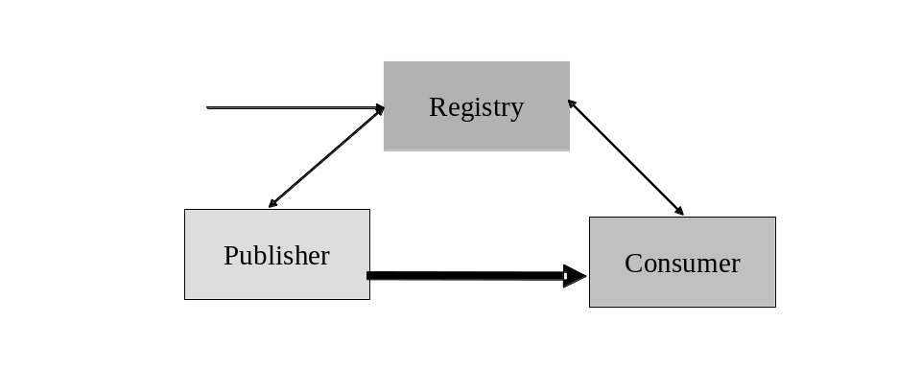
Figure 5-5 Base INFOD Service
- No subscriptions – publishers send messages to consumers of their choice. The following sub-pattern are identified:

- Publishers use an INFOD registry to find consumers
- Consumers use an INFOD registry to filter publishers
- Publishers and consumers use an INFOD registry to share vocabularies

- Subscriptions managed by an INFOD registry – subscribers send subscriptions to an INFOD registry. The INFOD registry identifies publishers (and consumers) and sends subscriptions to publishers

- Subscription based publications - publishers create and deliver messages according to subscription requests.

POBox INFOD Service:
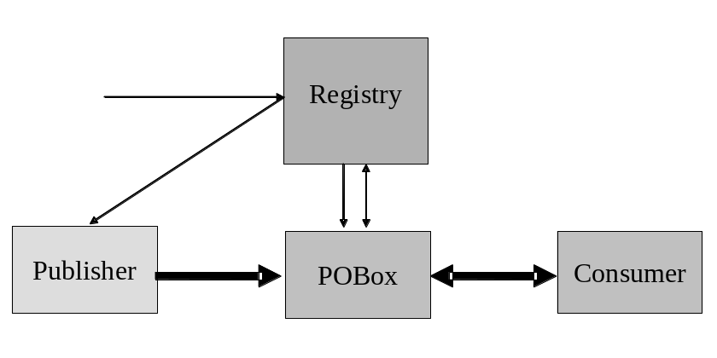
Figure 5-6 POBoxes INFO Service
- Subscriptions and publishers determine consumers – publishers send messages to POBoxes; consumers (select and) retrieve messages directed to them from POBoxes. POBoxes verify constraints.

- Consumers select messages of interest – publishers send messages to POBoxes; consumers select and retrieve messages from POBoxes; POBoxes verify constraints.

Single Disseminator INFOD Service:
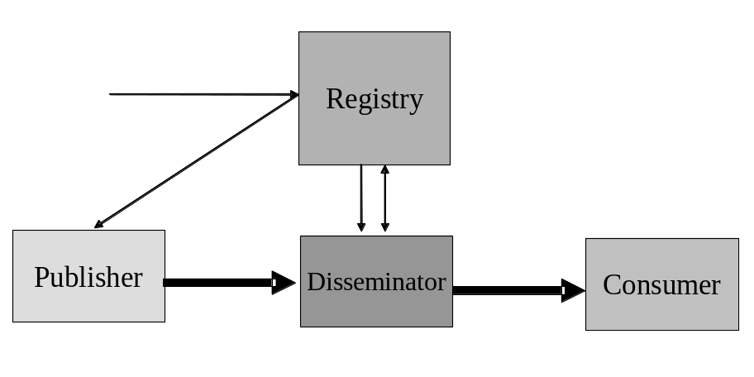
Figure 5-7 Single Disseminator INFOD Service
- Publishers send messages to disseminators, disseminators send messages to consumers - subscriptions and publishers determine consumers. Disseminators verify constraints.

Multi-Disseminator INFOD Service:
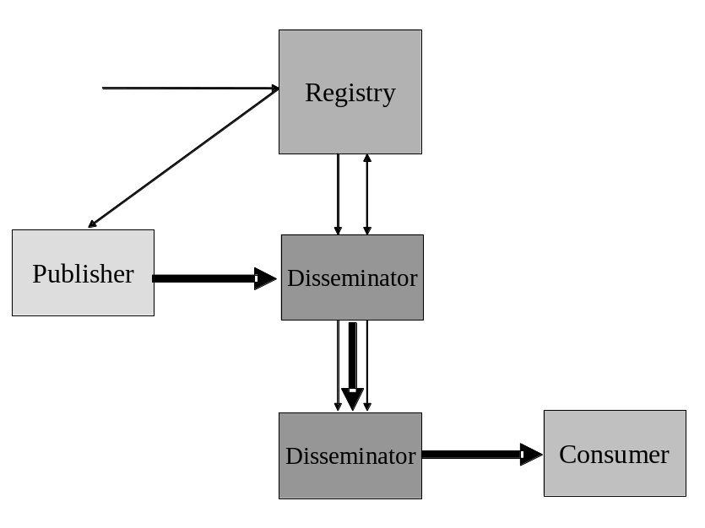
Figure 5-8 Multi Disseminator INFOD Service
- Publishers send messages to disseminators; disseminators send messages to other disseminators - subscriptions and publishers determine consumers. Disseminators verify constraints.

It is important to remember that the (basic/IT) description of INFOD entities can complemented by user properties. These user properties are expressed with vocabularies that are meaningful for a community of publishers, consumers, and subscribers. Constraints against these properties can be used for matching entities. These constraints can used to specify policies and interest; so, a car buyer can identify car dealers with the desired properties when looking for information instead thinking about a publisher; a car dealer can identify car buyers with the desired properties when looking for customers instead of thinking about consumers (as defined in INFOD).

INFOD encourages the use of user properties; the Use Cases will showcase the value of user properties.

The rest of the note is organized as follows: section 2 explains each pattern in more detail; section 3 outlines the tasks to implement each pattern while section 4 describes which interfaces. Have to be used to implement each pattern.

Detailed Description of Patterns

Base INFOD Service – No POBox, No disseminator

It should be noted that in all patterns of this section publishers send messages directly to consumers; e.g., there is no decoupling between publishers and consumers. These patterns require sophisticated publishers and consumers to achieve advanced operational characteristics such as exactly once message delivery, recoverability and auditing and tracking.

No Subscriptions

The patterns of this section represent the basic form of disseminating information: publishers send messages to consumers of their choice.

The following information in the INFOD registry provides the context for this pattern:

- User data vocabularies – optional
- Publishers and consumers - optional
- Vocabulary associations - optional
- User property vocabularies - optional
- User properties - optional

The following functionality is available:

- Publishers query the INFOD registry to find matching consumers – requires consumer and optionally property vocabulary entries in INFOD registry.

Publishers should avoid querying the INFOD registry for each single message. Instead, publishers should group messages into classes and associated consumers to these classes and additionally cache the consumer information.
If requested, changes of the result set of any query trigger notification of the publisher. These notifications contain updated information about consumers.

- Consumer filter messages based on publishers properties - requires publisher and optionally property vocabulary entries in INFOD registry.

Consumers can query the INFOD registry to find information about publisher using the information about publishers in the manifest section of the INFOD message.
Consumers should avoid querying the INFOD registry for each single message. Consumers have to obtain and cache relevant information.
If requested, changes to the result set of any query will trigger notification of the consumers. These notifications contain updated information about publishers.

- Publishers and consumers use vocabulary information in the INFOD registry before sending/consuming a message - requires user data vocabulary entries in INFOD registry.

Publishers and consumers should avoid querying the INFOD registry for each message. Both, publishers and consumers, should obtain and the cache relevant vocabulary information.
If requested, changes to the result set of any query will trigger notification of the publishers and consumers respectively. These notifications contain updated information about vocabularies.

Note: Publishers and consumers may not use any services of the INFOD registry; e.g., publishers know the intended consumers and how to reach them. Furthermore, consumers may know about the publishers when consuming messages and publishers and consumers have a shared understanding of the structure of the payload. The only difference to standard WS-messaging is the structure of the message.

Subscriptions - Managed by Registry

The association of publishers and consumers to a subscription is the responsibility of the INFOD registry.

The following information in the INFOD registry provides the context for this pattern:

- User data vocabularies - mandatory
- Publishers and consumers - mandatory
- Subscriptions - mandatory
- Vocabulary associations - mandatory
- User property vocabularies – optional
- User properties - optional

The following functionality is available:

- Subscribers manage subscriptions using the Create/Alter/DropSubscription operation.

The INFOD registry determines which publishers are offering messages of interest using the vocabulary and vocabulary association information. The evaluation of all constraints that may limit the selection of publishers and consumers follows. The INFOD registry will make adjustment if subscriptions, publishers or consumers are created, altered or dropped.
If requested, changes that impact subscriptions will trigger notification of the publishers. These notifications contain updated information about subscriptions.
The WS-Notification with registry provides a subset of this functionality.

Note: Publishers and consumers may not use any services of the INFOD registry; e.g., subscribers know the intended publishers and how to reach them. Furthermore, consumers know about the publishers when consuming messages and subscribers, publishers and consumers have a shared understanding of the structure of the payload. The only difference to standard WS-Notification is the structure of the message.

Subscription Based Publications

Publishers are often not able to determine which messages are of interest to consumers. Therefore, publishers must allow the creation of messages based on subscription referencing events or states.

The following information in the INFOD registry provides the context for this pattern:

- User data vocabularies - mandatory
- Publishers and consumers - mandatory
- Subscriptions - mandatory
- Vocabulary associations - mandatory
- User property vocabularies – optional
- User properties - optional

The following functionality is available:

- Subscribers specify what messages are published in reaction to events or state changes.

Publishers have to support vocabularies that include events or even allow the specification of events. The associate language must allow filtering of events and also include the ability to define what messages need to be created to reaction to events and state changes respectively.
The difference between this and the previous patterns is the functionality of the information source (vocabulary associations). In the previous patterns, publishers use vocabularies that represent messages; using this pattern publishers offer access to events and state transitions. Messages are created when an event satisfies certain constraints or when a state transition results in certain constraint becoming true.
If requested, changes that impact subscriptions will trigger notification of the publishers and subscribers. These notifications contain updated information about vocabularies.

POBox INFOD Service

Using POBoxes consumers are able to get messages without implementing a consume operation. Consumers have to use the GetData operation. When the GetData operation is used with the WAIT_FOR option consumers will receive messages as soon as they are available in the POBox. If the WAIT_FOR option is not used consumers will only receive new messages by periodically re-issuing the GETData operation.

POBoxes provide decoupling of publishers and consumers; a desirable function for most messaging environments: e.g., publishers and consumers do not need to be simultaneously active to send respectively receive a message.

POBoxes may provide support for a set of functions and operational characteristics without requiring sophisticated publishers or consumers; examples are transactional support, retention and auditing which are required for many mission critical applications. Details are not described here.

The following patterns focus on the issue whether the subscriptions and publishers determine the consumers of a message or not.

Consumers Determined by Publishers and Subscriptions

The following information in the INFOD registry provides the context for this pattern:

- User data vocabularies – mandatory
- Publishers and consumers - mandatory
- Subscriptions - mandatory
- Entity associations - optional
- Vocabulary associations - mandatory
- User property vocabularies – optional
- User properties - optional

The following functionality is available:

- Publishers publish messages to the POBoxes specifying consumers

Publishers publish messages with or without subscriptions request; subscriptions and consumer constraints identify consumers. If necessary, POBoxes determine the individual consumers of each message by applying the information in the messages; e.g., by applying subscriptions and constraints.
Messages are only accepted if all constraints are met.

- Consumers retrieve messages directed to them from POBoxes

Consumers can only retrieve messages that are directed to them. Consumers can use data constraints to sequence the retrieval of messages.
The getData operation can be used in browse or consume mode and with and without the WAIT_FOR option. A message can only be retrieved once in consume mode.
If a POBox supports message retention messages can also be retrieved after they have been consumed.
This pattern represents a generalization of the WS-Notification pull-point delivery.

Consumers Select Messages of Interest

The following information in the INFOD registry provides the context for this pattern:

- User data vocabularies – mandatory
- Publishers and consumers - mandatory
- Subscriptions - mandatory
- Entity associations - optional
- Vocabulary associations - mandatory
- User property vocabularies – optional
- User properties - optional

The following functionality is available:

- Publishers publish messages to the POBoxes without specifying consumers

Neither publishers nor subscriptions determine which consumer can see which message.
- Consumers retrieve messages of their choice from the POBox – browse, consume

Consumers can any message of interest using constraint to select message of interest. These constraints may also be used to sequence the retrieval of messages. Message will only be delivered if all constraints associated to getData and to INFOD registry entries are met.
The getData operation can be used in browse or consume mode and with and without the WAIT_FOR option. A message can only be retrieved once in consume mode.
If a POBox supports message retention messages can also be retrieved after they have been consumed.

This pattern represents classical messaging with enhanced functionality and operational characteristics.

Single Disseminator INFOD Service

Disseminators provide decoupling of publishers and consumers a desirable function for most messaging environments; e.g., publishers and consumers do not need to be simultaneously active to send respectively receive a message.

Disseminators may also support a set of functions and operational characteristics without requiring sophisticated publishers or consumers; examples are transactional support, retention and auditing which are required for many mission critical applications. Details are not described here.

Compared to POBoxes disseminators are able to provide higher scalability in respect to the number of consumers, since consumers do not need to use the getData operation to receive messages.

The following information in the INFOD registry provides the context for this pattern:

- User data vocabularies – mandatory
- Publishers and consumers - mandatory
- Subscriptions - mandatory
- Disseminators – mandatory
- Entity associations - optional
- Vocabulary associations - mandatory
- User property vocabularies – optional
- User properties - optional

The following functionality is available:

- Publishers publish messages to disseminators – consumers are always specified

Publishers publish messages with or without subscriptions request; subscriptions and consumer constraints identify consumers. If necessary, disseminators determine the individual consumers of each message by applying the information in the messages; e.g., by applying subscriptions and constraints.
Messages will only be accepted if all constraints are met.
- Disseminators send messages or information about the existence of messages to consumers

Consumers have to support the consume operation.
- Consumers can retrieve messages directed to them from disseminators.

If consumers are only informed about the existence of messages they have to use the getData operation either in browse or consume mode to retrieve these messages, the WAIT_FOR option cannot be used. A message can only be retrieved once in consume mode.
If a disseminator supports message retention messages can also be retrieved after they have been consumed.

Multi-Disseminator INFOD Service

This is arguably the most complex and also the most important pattern; it is the base for every well-managed business communication. This pattern is used in any message delivery where publishers and consumers belong to different environments and operational characteristics such as exactly once behavior and non-repudiation are required.

This pattern makes it also possible to send messages to a large number of consumers. Disseminators may negotiate the use of propagation protocols to optimize the interaction with each other. A variety of strategies accomplishing this task are known.

The following information in the INFOD registry provides the context for this pattern:

- User data vocabularies – mandatory
- Publishers and consumers - mandatory
- Subscriptions - mandatory
- Disseminators – mandatory
- Entity associations - mandatory
- Vocabulary associations – mandatory
- User property vocabularies – optional
- User properties - optional

The following functionality is available:

- Publishers publish messages to disseminators – consumers are always specified

Publishers publish messages with or without subscriptions request; subscriptions and consumer constraints identify consumers. If necessary, disseminators determine the individual consumers of each message by applying the information in the messages; e.g., by applying subscriptions and constraints.
Messages will only be accepted if all constraints are met.
- Disseminators send messages to other disseminators to reach consumers.

Disseminators determine to which disseminators each message has to be propagated.
Disseminators send messages to other disseminators supporting optional operational characteristic such as exactly once or non-repudiation.
Receiving disseminators accept messages after verify all constraints.
- Disseminators send messages or information about the existence of messages to consumers

Consumers have to support the consume operation.
- Consumers can retrieve messages directed to them from disseminators.

If consumers are only informed about the existence of messages they use the getData operation either in browse or consume mode to retrieve these messages, the WAIT_FOR option cannot be used. A message can only be retrieved once in consume mode.
If a disseminator supports message retention messages can also be retrieved after they have been consumed.

Outline of Operations

Base INFOD Service – No POBox, No disseminator

No Subscriptions

The following functionality is available:

- Publishers find relevant consumers in INFOD registry

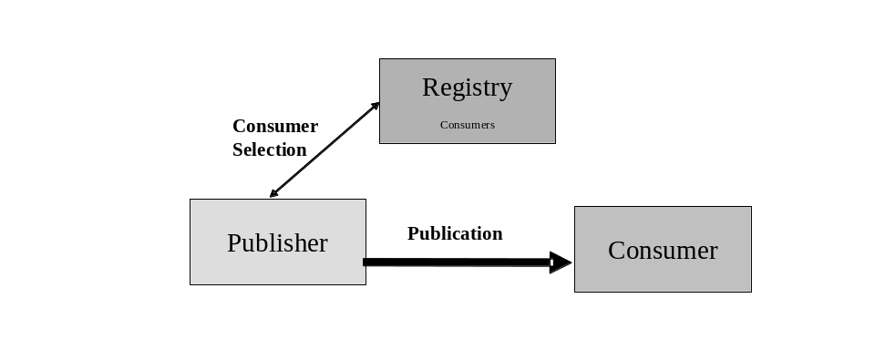
Figure 5-9 Base INFOD Service - No Subscription, Consumer Selection

Tasks:
- Manage consumer information in INFOD registry with
- Create/Alter/DropConsumer operation - mandatory
- Create/AddVersion/DeregisterVocabulary - optional
- Create/Alter/DropEntity - optional

- Publishers select consumers using the getMdata operation
- If requested, publishers receive update notifications from the INFOD registry reflecting changes of consumer information

- Publishers create and send messages using INFOD message structure.
- Consumers receive messages using the INFOD consume operation

The INFOD registry provides up-to-date information about consumers.

- Consumers filter messages based on publishers properties

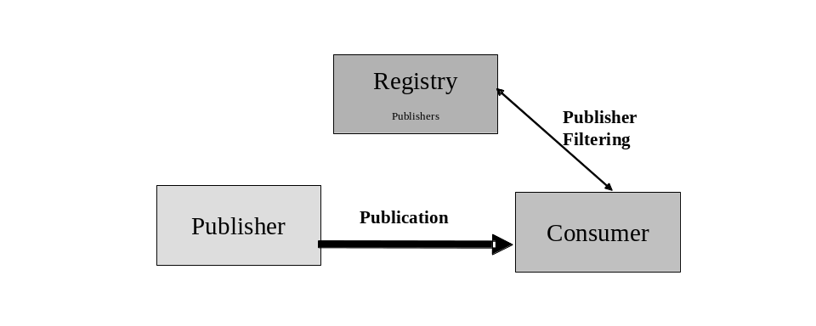
Figure 5-10 Base INFOD Service - No Subscription, Publisher Filtering
Tasks:
- Manage publisher information in INFOD registry with
- Create/Alter/DropPublisher operation - mandatory
- Create/AddVersion/DeregisterVocabulary – optional
- Create/Alter/DropEntity - optional

- Consumers find publisher information using the getMdata operation
- If requested, consumers receive update notifications form the INFOD registry reflecting changes of publisher information

- Publishers create and send messages using INFOD message structure
- Consumers receives message using the INFOD consume operation
- Consumers verifies publishers and consumes message

The INFOD registry provides up-to-date information about publishers.
- Consumer can filter message based on message content

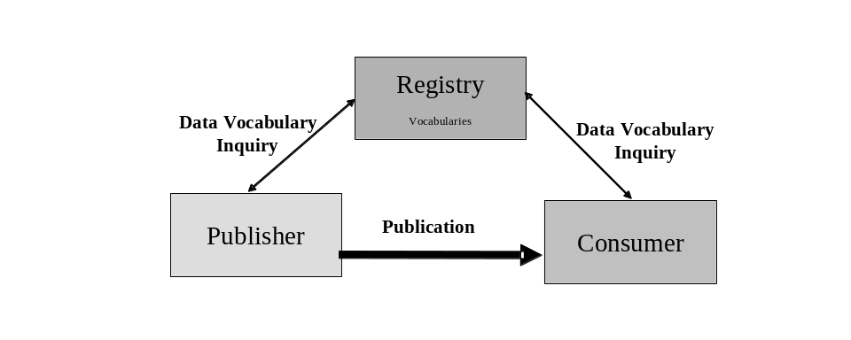
Figure 5-11 Base INFOD Service - Vocabulary Inquiry

Tasks:
- Manage vocabulary information in INFOD registry using the Register/AddVersion/DeregisterVocabulary operation

- Publishers find vocabularies using the getMdata operation
- If requested, publishers receive update notifications reflecting changes of vocabularies
- Consumers find vocabularies using the getMdata operation
- If requested, consumers receive update notifications reflecting changes of vocabularies

- Publishers create and send messages using INFOD message structure with a payload according to a vocabulary
- Consumers receives message using the INFOD consume operation
- Consumers interprets message using vocabulary information and consumes it

The INFOD registry provides up-to-date information about vocabularies.

Subscriptions - Managed by Registry

- Publishers publish messages according to subscription directives
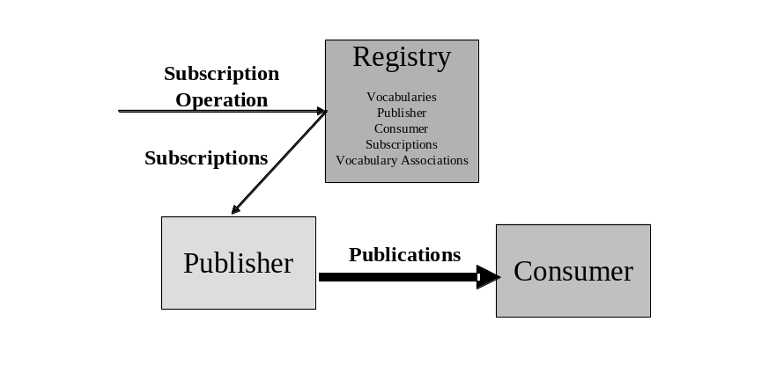
Figure 5-12 Base INFOD Service - Subscription Managed by INFOD Registry

Tasks:

- Manage information in INFOD registry with
- Create/Alter/DropPublisher operation – mandatory
- Create/Alter/DropConsumer operation – mandatory
- Create/Alter/DropSubscription operation – mandatory
- Create/AddVersion/DeregisterVocabulary – mandatory data vocabularies/optional for property vocabularies
- Create/Alter/DropEntity - optional

- Manage vocabularies, publishers, consumers and vocabulary associations in INFOD registry using the Create/Alter/DropPublisher/Consumer and the Register/AddVersion/DeregisterVocabulary operation respectively

- Subscribers direct subscribe request to INFOD registry
- INFOD registry determines relevant publishers
- INFOD registry checks all constraints
- INFOD registry informs publisher about new subscriptions – these subscription requests reflect constraints in the INFOD registry
- INFOD registry informs publishers about altered/dropped subscriptions
- Publishers receive and process subscription request

- Publishers create and send messages to all relevant consumers using the INFOD message structure
- Consumers receive message using the consume operation

By directing subscription request to the INFOD registry, subscribers can direct the INFOD registry to find relevant publishers, check all the constraints, and create a tailored subscription to each of the appropriate publishers. Furthermore, the INFOD registry informs publishers if changes in the directory information require changes in the subscription. This includes that a publication is retracted from some publisher while other publishers are added.

Subscription Based Publications

The only difference to the previous pattern is the structure and the language support for selected user data vocabularies. The subscriber chooses vocabularies, which support the creation of messages based on events or even supports the definition of events.

- Publishers create and publish messages according to subscription directives
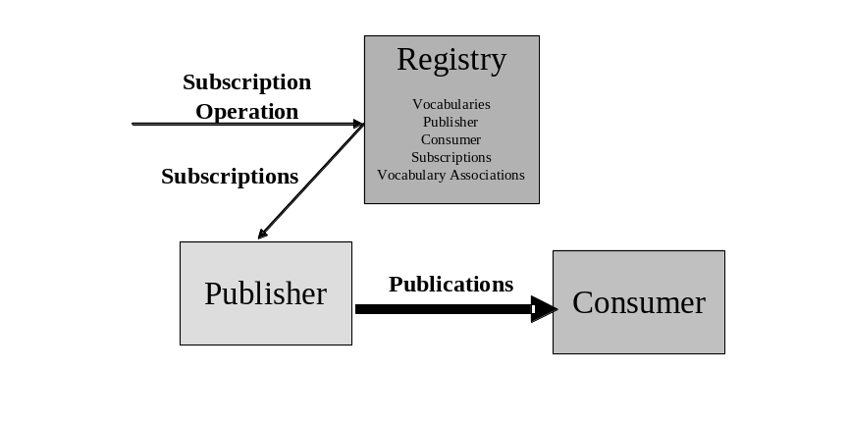
Figure 5-13 Base INFOD Service - Subscription Managed by INFOD Registry - Messages and Events Specified by Subscriber

Tasks:

- Manage information in INFOD registry with
- Create/Alter/DropPublisher operation – mandatory
- Create/Alter/DropConsumer operation – mandatory
- Create/Alter/DropSubscription operation – mandatory
- Create/AddVersion/DeregisterVocabulary – mandatory data vocabularies/optional for property vocabularies
- Create/Alter/DropEntity - optional

- Subscribers direct subscribe request to INFOD registry
- INFOD registry determines relevant publishers
- INFOD registry checks all constraints
- INFOD registry informs publisher about new subscriptions – these subscription requests reflect constraints in the INFOD registry
- INFOD registry informs publishers about altered/dropped subscriptions
- Publishers receive and process subscription request

- Publishers create and send messages to all relevant consumers using the INFOD message structure
- Consumers receive message using the consume operation

POBox INFOD Service

Consumers Determined by Publishers and Subscriptions

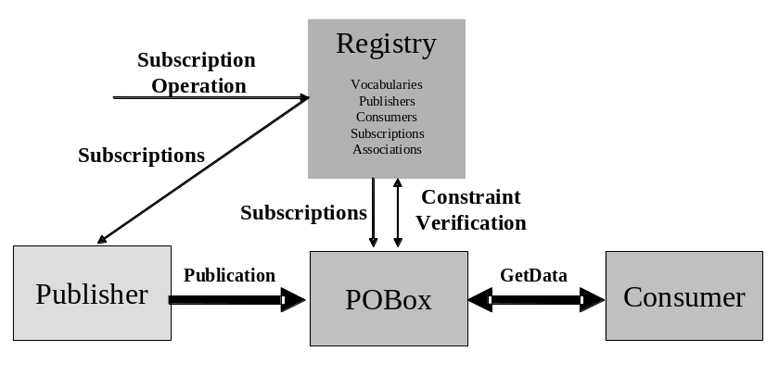
Figure 5-14 POBoxes INFOD Service - Consumer Determined by Publishers & Subscriptions

Tasks:

- Manage information in INFOD registry with
- Create/Alter/DropPublisher operation – mandatory
- Create/Alter/DropConsumer operation – mandatory
- Create/Alter/DropSubscription operation – mandatory
- Create/Alter/DropPOBox operation – mandatory
- Create/AddVersion/DeregisterVocabulary – mandatory data vocabularies/optional for property vocabularies
- Create/Alter/DropEntity - optional.

- Subscribers direct subscribe request to INFOD registry
- INFOD registry determines relevant publishers
- INFOD registry checks all constraints
- INFOD registry informs publisher and POBoxes about new subscriptions – these subscription requests reflect constraints in the INFOD registry
- INFOD registry informs publishers and POBoxes about altered/dropped subscriptions
- Publishers and POBoxes receive and process subscription request

- Publishers create and send messages to POBoxes
- POBoxes will only accept messages for specific consumers if constraints are satisfied
- POBoxes will add determine (additional) users based on directive in messages and subscriptions
- Publishers can retrieve message from POBoxes - within retention constraints - even after they have been consumed
- Consumers retrieve message from POBoxes. Consumers use getData operations with filters and optional WAIT_FOR option and also select consume/browse mode.
- Consumers can retrieve message from POBoxes - within retention constraints - even after they have been consumed.

A significant part of the complexity of information dissemination has been moved to the POBoxes; e.g., the consumption of a message by POBoxes and consumers respectively can be part of a transaction.

Consumers Select Messages of Interest

This pattern represents a generalization of the WS-Notification pull-point delivery.

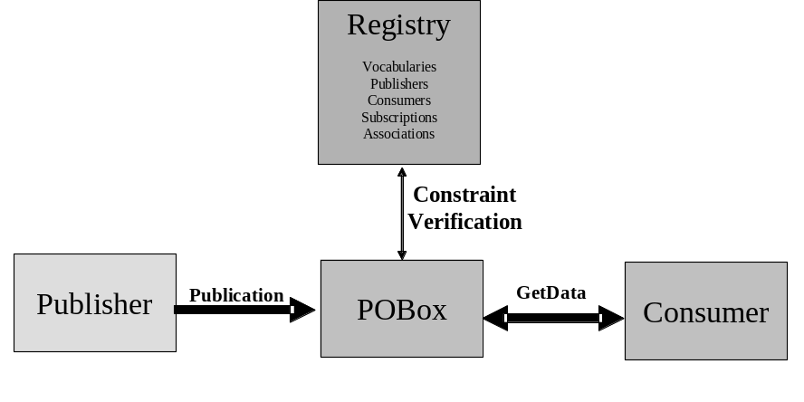
Figure 5-15 POBoxes INFOD Service - Consumers Select Messages of Interest

Tasks:

- Manage information in INFOD registry with
- Create/Alter/DropPublisher operation – mandatory
- Create/Alter/DropConsumer operation – mandatory
- Create/Alter/DropSubscription operation – mandatory
- Create/Alter/DropPOBox operation – mandatory
- Create/AddVersion/DeregisterVocabulary – mandatory data vocabularies/optional for property vocabularies
- Create/Alter/DropEntity – optional

- INFOD registry notifies publishers and POBoxes about changes in the INFOD registry. Publishers and POBoxes have to identify changes of interest using the getDMdata interface.

- Publishers create and send messages to POBoxes using the INFOD message structure
- POBoxes consume messages
- Publishers can retrieve message from POBoxes - within retention constraints - using the getData operation
- Consumers retrieve message from POBoxes – POBoxes ensure that all property constraints are met. Consumers use getData operations with filters and optional WAIT_FOR option and also select consume/browse mode.
- Consumers can retrieve message from POBoxes - within retention constraints - even after they have been consumed using the getData operation

Single Disseminator INFOD Service

Disseminators support the functions of POBoxes; therefore the functionality associated to POBoxes applies to disseminators as well. Only the added functionality is covered in the discussion of following patterns.

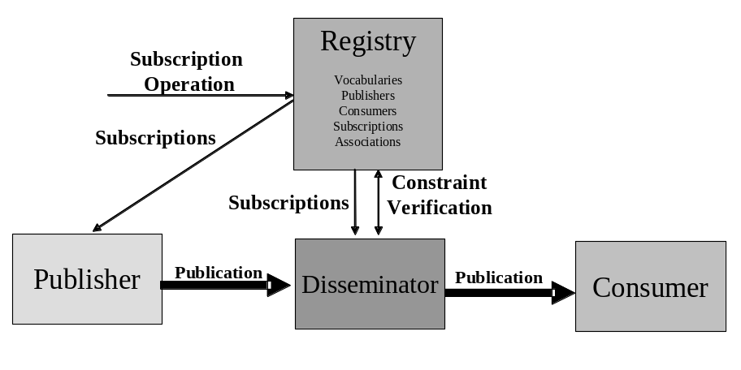
Figure 5-16 Single Disseminators INFOD Service

Tasks:

- Manage information in INFOD registry with
- Create/Alter/DropPublisher operation – mandatory
- Create/Alter/DropConsumer operation – mandatory
- Create/Alter/DropSubscription operation – mandatory
- Create/Alter/DropDisseminator operation – mandatory
- Create/AddVersion/DeregisterVocabulary – mandatory data vocabularies/optional for property vocabularies
- Create/Alter/DropEntity – optional

- Manage vocabularies, publishers, consumers, subscriptions, disseminators and associations in INFOD registry using the Create/Alter/DropPublisher/Consumer, the Associate/Disassociate and the Register/AddVersion/DeregistersVocabulary operation respectively.

- Subscribers direct subscribe request to INFOD registry
- INFOD registry determines relevant publishers
- INFOD registry checks all constraints
- INFOD registry informs publisher and disseminators about new subscriptions – these subscription requests reflect constraints in the INFOD registry
- INFOD registry informs publishers and disseminators about altered/dropped subscriptions
- Publishers and Disseminators receive and process subscription request

- Publishers create and send messages to disseminators
- Disseminators will only accept messages for specific consumers if constraints are satisfied
- Disseminators will add (additional) users based on directive in messages and subscriptions
- Publishers can retrieve message from disseminators - within retention constraints - even after they have been consumed
- Disseminators send messages to consumers
- Consumers receive message using the consume operation
- Consumers can retrieve message from disseminators - within retention constraints - even after delivery by disseminators using the getData operation.

Multi-Disseminator INFOD Service

This pattern enables disseminators to send messages to a large number of consumers.

This pattern is very important for any message delivery where publishers and consumers belong to different environments and operational characteristics such exactly once behavior, non-repudiation are required

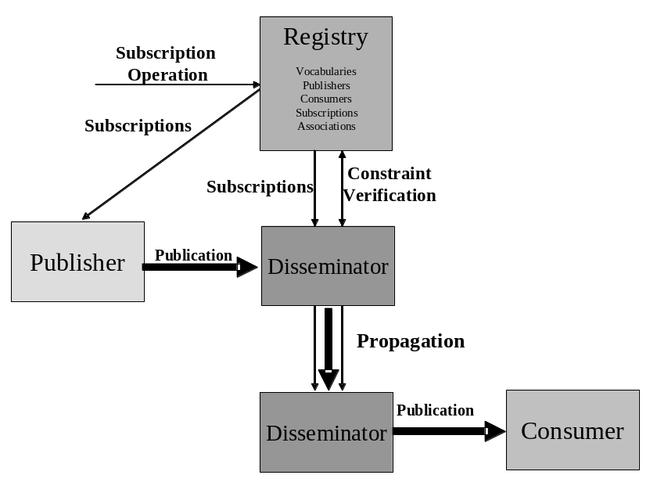
Figure 5-17 Multiple Disseminators INFOD Service

Tasks:

- Manage information in INFOD registry with
- Create/Alter/DropPublisher operation – mandatory
- Create/Alter/DropConsumer operation – mandatory
- Create/Alter/DropSubscription operation – mandatory
- Create/Alter/DropDisseminator operation – mandatory
- Create/AddVersion/DeregisterVocabulary – mandatory data vocabularies/optional for property vocabularies
- Create/Alter/DropEntity – optional

- Subscribers direct subscribe request to INFOD registry
- INFOD registry determines relevant publishers
- INFOD registry checks all constraints
- INFOD registry informs publisher and disseminators about new subscriptions – these subscription requests reflect constraints in the INFOD registry
- INFOD registry informs publishers and disseminators about altered/dropped subscriptions
- Publishers and Disseminators receive and process subscription request

- Publishers create and send messages to (home) disseminator using the INFOD message structure – messages may or may not be directed to specific consumers
- (Publishers’) Disseminator(s) ensure that messages are within specified constraints if directed to specific consumers.
- (Publishers’) Disseminator(s) send messages to all relevant disseminators according to the publishers’ and subscription directives
- (Consumers’) Disseminator(s) ensure that messages are within specified constraints and send messages to specified consumers.
- Publishers can retrieve message from (home) disseminators - within retention constraints - using the getData operation.
- Consumers consume messages using the consume operation.
- Consumers can retrieve message from (home) disseminators - within retention constraints - even after delivery by disseminators using the getData operation

It has to be noted that most of the functionality is out-sourced to INFO registry and the disseminators.

Author Information

Stephen Davey
National e-Science Centre
15 South College Street
Edinburgh
EH8 9AA
U.K.
sdavey@nesc.ac.uk

Vijay Dialani
IBM Corporation
Almaden Research Center
650 Harry Road,
San Jose, CA 95120-6099
vdialani@us.ibm.com

Ronny Fehling
Oracle Corporation
600 Blvd. de Maisonneuve Ouest
Montreal
Québec H3A 3J2
Canada
Ronny.fehling@oracle.com

Steve Fisher
Rutherford Appleton Laboratory
Chilton
Didcot
Oxon
OX11 0QX
U.K.
S.M.Fisher@rl.ac.uk

Dieter Gawlick
Oracle Corporation
500 Oracle Parkway
Redwood Shores
CA 94065
dieter.gawlick@oracle.com

Christopher Kantarjiev
Oracle Corporation
500 Oracle Parkway
Redwood Shores
CA 94065
chris.kantarjiev@oracle.com

Cecile Madsen
IBM Silicon Valley Laboratory
555 Bailey Avenue
San Jose, CA 95141
madsen@us.ibm.com

Susan Malaika
IBM Corporation
Silicon Valley Laboratory
555 Bailey Avenue
San Jose, CA 95141
malaika@us.ibm.com

Shailendra Mishra
Oracle Corporation
500 Oracle Parkway
Redwood Shores
CA 94065
shailendra.mishra@oracle.com

Mallikarjun Shankar
Oak Ridge National Laboratory
Oak Ridge
TN 37831
shankarm@ornl.gov

Glossary

Publisher A content/event provider that advertises and publishes its contents/events, which may be evaluated in accordance to the subscription rules.

Expanded Definition
A publisher is an entity that is capable of creating messages in response to an event that it is capable of detecting. The publisher does not have to have (or be) an endpoint. The publisher may support the ability to define what constitutes an event is and what message is created as a result, in this case the publisher must have an endpoint.
The publisher may deliver messages to consumers or it may delegate that function to a disseminator.

Consumer A recipient of published contents. The contents are obtained as a result of evaluation of a subscription against a single or multiple publications. The consumer receives the non-evaluated set of publications when no subscriptions have been specified.

Subscriber An entity used to establish and control the flow of messages (by means of subscription rules) - between a publisher/set of publishers and a consumer.

Disseminator A message routing intermediary for publishers and consumers, used for match making the list of publications and subscriptions.

Propagator A component that retains publications produced for a subscription. It also provides the access mechanism for a deferred consumption.

Continuous Query Unlike normal queries that evaluate the state as of a snapshot in time, continuous queries evaluate the expression for a period of time. Continuous queries produce incremental results as the data becomes available.

Pushing A propagation mechanism in which the communication is initiated by the publisher of data/publications.

Pulling A propagation mechanism in which the communication is initiated by the consumer of data/publications.

Polling A propagation mechanism in which the consumer/publisher initiates the communication to validate the “state” of the recipients.

Action In Event-Condition-Action paradigm, an action denotes the declarative statement that needs to be executed when a certain condition is met by the published event.

Event Correlation
Content A content based correlation verifies a prescribed condition against the contents of two messages produced either by the same publisher or different publishers.

Event Correlation Creation A mechanism that verifies a prescribed condition against two or more publications/messages.

Type System An enumeration that defines the list of acceptable value domains, their value ranges and binary representation in a digital system.

Language A common shared expression list used to specify a list of principles (tokens) and the operations permitted on these tokens.

Registry A repository of resource advertisement used primarily for match making between resource providers and resource consumers.

History A persistent and temporal record of previously encountered publications/messages.

Latest queries A causally ordered list of most recent queries processed by the entity.

Mediation A match making mechanism used for filtering resource advertisements in accordance to resource queries.

Profiles Resource description of an entity.

Demand Driven Publishing A publication mechanism in which publications are made available only if there exists a set of consumers for that publication.

Targeted Publishing A publication mechanism in which a publisher commences to publish the contents in response to demand from consumers.

Intellectual Property Statement

The GGF takes no position regarding the validity or scope of any intellectual property or other rights that might be claimed to pertain to the implementation or use of the technology described in this document or the extent to which any license under such rights might or might not be available; neither does it represent that it has made any effort to identify any such rights. Copies of claims of rights made available for publication and any assurances of licenses to be made available, or the result of an attempt made to obtain a general license or permission for the use of such proprietary rights by implementers or users of this specification can be obtained from the GGF Secretariat.

The GGF invites any interested party to bring to its attention any copyrights, patents or patent applications, or other proprietary rights which may cover technology that may be required to practice this recommendation. Please address the information to the GGF Executive Director.

Full Copyright Notice

Copyright (C) Global Grid Forum (date). All Rights Reserved.

This document and translations of it may be copied and furnished to others, and derivative works that comment on or otherwise explain it or assist in its implementation may be prepared, copied, published and distributed, in whole or in part, without restriction of any kind, provided that the above copyright notice and this paragraph are included on all such copies and derivative works. However, this document itself may not be modified in any way, such as by removing the copyright notice or references to the GGF or other organizations, except as needed for the purpose of developing Grid Recommendations in which case the procedures for copyrights defined in the GGF Document process must be followed, or as required to translate it into languages other than English.

The limited permissions granted above are perpetual and will not be revoked by the GGF or its successors or assigns.

This document and the information contained herein is provided on an "AS IS" basis and THE GLOBAL GRID FORUM DISCLAIMS ALL WARRANTIES, EXPRESS OR IMPLIED, INCLUDING BUT NOT LIMITED TO ANY WARRANTY THAT THE USE OF THE INFORMATION HEREIN WILL NOT INFRINGE ANY RIGHTS OR ANY IMPLIED WARRANTIES OF MERCHANTABILITY OR FITNESS FOR A PARTICULAR PURPOSE."

References

To be reworked

[EXPR_FILTER] INFOD Registry Constraint Filtering
[INFODBASE] Information Dissemination in the Grid Environment – Base Specifications
[INFODU] INFOD Base Use Case Scenarios for GGF16
[TIES] Trusted Information Sharing, Dmitry Lenkov and Mark Scasrdina, XML2005 conference proceedings, 2005
[TR] See documents @ https://forge.gridforum.org/projects/tm-rg

[EXPR_FILTER], [INFODBASE] and [INFODU] can be found in the GGF16 folder of the INFOD working group: https://forge.gridforum.org/docman2/ViewCategory.php?group_id=139&category_id=1208

INFOD does not manage user data

