INFOD Scenarios - Cases 1, 2 and 3 (to be added for wsn comparison)

Updated:

May 27, 05 (infod-wg make-up call)

Meeting Notes:

- infod resources relationships:
- multitude of combinations (may have scenario with publication and subscription only, or publication and consumption
only, or …); how is that reflected in specs and how to help readers understand which combination is applicable to their
scenario
-> proposal is to define a list of typical patterns from which most scenarios can be derived

- the infod ‘resource relationship’ (previously known as ‘resource references’) and the infod filters
- key elements of most of infod resources
- we need to describe them in detail; in particular, the type of relationships and filters we are to support (limits the
openness that currently exists in the specs)

- question was raised whether base infod (stage 1 with no disseminator) is basic enough
- proposal is to further simplify it by having publications and subscriptions only (no mention of consumptions) to have our
most basic level match the base wsn scenarios
-> will add a case in this document that addresses that very basic scenario after we know more of updated wsn specs

- vocabulary…
- attached to publisher or publication? agreement is publication (vocabulary is an xml schema for ex)
- publications can inherit vocabulary attributes from publisher (or dialect rather ?)
- vocabulary for an artifact provides context for that artifact (for filtering, etc) so should always be known
for ex, consumer will point to publication vocabulary to define its interest, so that publication vocabulary needs to be
made available to consumer; not clear how done; specs stay silent on this (known issue)

- disseminator functions:
- do we allow disseminations to deliver a different vocabulary than the publication they are derived from ? rationale was
transformations that disseminators would deliver to provide value-add; What is the scope of infod disseminators:
routers/mediators or also transformers… need to clarify

- entity resources are not described in this version of the doc
-> should eventually add arrows in diagram and section descriptions for creating publisher, disseminator, etc.

- data operations are not described in this version of the doc
-> should add soon the getDataForBrowse operation description, because we need to describe its parms: how will a
consumer know which dissemination or publication to retrieve data for ? that flow needs to be documented (and may
not be fully complete now)

- removed the case where vocabulary 1 (publication) is different from vocabulary 2 (consumption) in scenarios below
- documenting it as an eventual case to support but for the purpose of this stage 1, let’s keep vocabulary mapping out of
scope (!)

- fyi - editing:
- reworded case 1 to mention that subscriber = consumer instead of saying ‘no subscriber’
- updated diagram for case 2 (added arrow from Registration Manager to Disseminator)
- updated cases 1b and 2 with typos/clarifications/simplifications

Case 1: smart publisher, discriminative consumer, subscriber=consumer, no disseminator

Case 1a:
- publisher posts its publication info
- consumer pulls publication info (queries registration manager)
- consumer posts its interest using either the publication info or a vocabulary context
- publisher pushes appropriate data to consumer

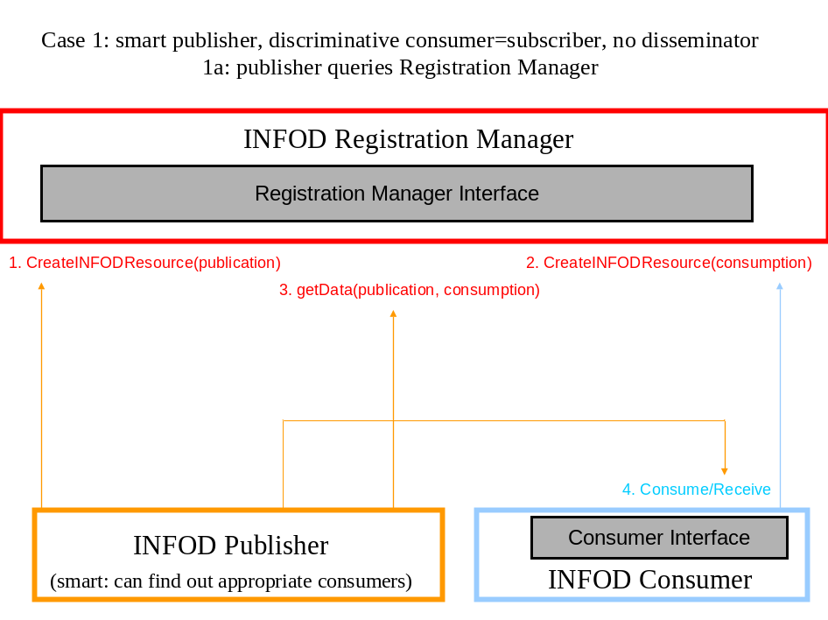

Case 1a Tasks:

1a-1: publisher creates a new resource for a new publication

1a-2: consumer posts its interests; has 2 options:
1a-2-1: consumer knows which publication it is interested in;
1a-2-2: consumer relies on a vocabulary to describe interest;
an infod service finds the appropriate publication, if available

1a-3: publisher polls Registration Manager to get updates on consumption

1a-4: publisher pushes appropriate data to consumer

1a-1: Publisher creates a new resource for new publication:

create infod resource: publication

Core
- resource type = publication
- resource name = publication for radio models for fancy cars
- resource relationships =
- publisher resource: 'provenance type': 'independent wholesaler xxx'

Constraints
- resource descriptions = 'car stereo high-end'
- resource vocabularies = 'my car vocabulary 1' (-> cdmodel, carprice, features, consumer...)

- resource filters =
- publication resource: 'list type': EPR of the publication of interest
- consumer resource: 'query type': carprice > ...

1a-2: Consumer posts its interests so creates (new) consumption:

2 options for the constraints section of the consumption:

1a-2-1: post interest against some known publications
1a-2-2: post interest without knowing what is being published so relying on a vocabulary

1a-2-1: create a resource with the context of an explicit publication

create infod resource: consumption

Core
- resource type = consumption
- resource name = interest in radio models
- resource relationships =
- consumer resource: 'provenance type': 'car dealer xxx'

Constraints
- resource descriptions = 'stereo system cars for cars I sell'
- resource vocabularies = 'my car vocabulary 1' -- the vocabulary of the publication of interest
- resource filters (against the vocabulary of the publication so only filters messages) =
- publication resource: 'query type': carprice =... features = ..., price < xx
- publication resource: 'explicit type': resource uid = xxx (pub)

1a-2-2: create a consumption resource without explicit publication:

create infod resource: consumption

Core
- resource type = consumption
- resource name = interest in radio models
- resource relationships =
- consumer resource: 'provenance type': 'car dealer xxx'

Constraints
- resource descriptions = 'stereo system cars for cars I sell'
- resource vocabularies = 'my car vocabulary 1' ← publication vocabulary
- vocabulary filters (against the vocabulary above so defines a subscription essentially) =
- publication resource: 'query type': carprice =... features = ..., price < xx

Case 1b:
- publisher posts its publication info
- publisher gets notified when new consumptions are available
- consumer posts its interest based on notification updates
- publisher pushes appropriate data to consumer

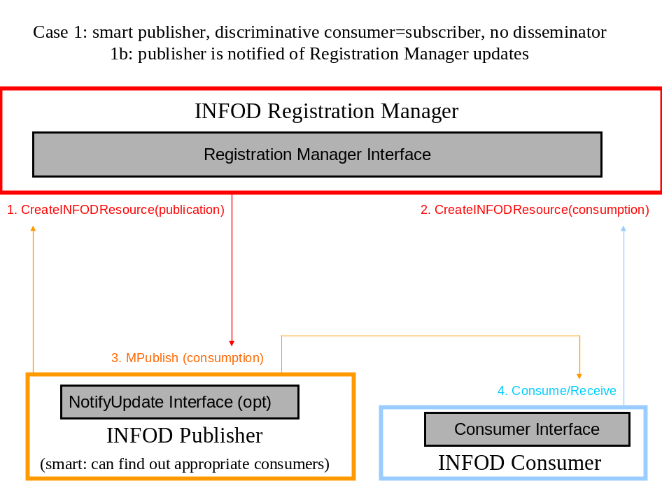

Case 1b Tasks:

1b-1: publisher creates a new resource for a new publication

1b-2: consumer posts its interests; has 2 options:
1b-2-1: consumer knows which publication it is interested in;
1b-2-2: consumer relies on a vocabulary to describe interest;
an infod service finds the appropriate publication, if available

1b-3: Registration Manager pushes consumption updates to appropriate publisher

1b-4: publisher pushes appropriate data to consumer

1b-1: same as 1a-1

1b-2: same as 1a-2

→ From a resource creation perspective, same discussion as 1a…

Case 2: publisher, discriminative consumer=subscriber and disseminator

Case 2a:
- publisher posts its publication info
- disseminator posts its dissemination info
- consumer posts its interest using either the publication info or a vocabulary context
- publisher pushes its data to disseminator
- disseminator is notified when Registration Manager is updated with new consumption info
- disseminator pushes appropriate data to consumer

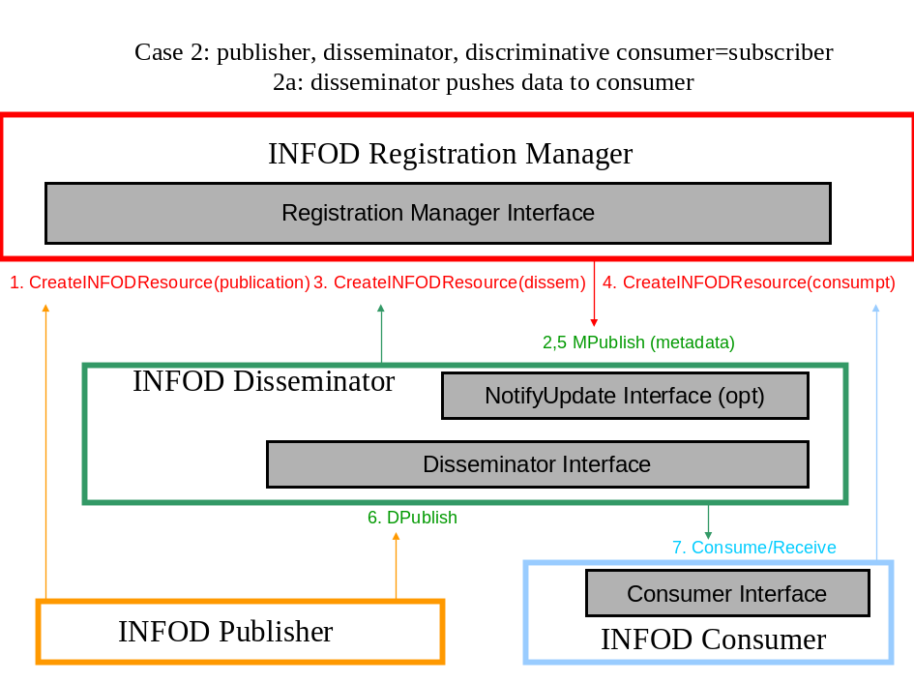

Case 2a Tasks:

2a-1: publisher creates a new resource for a new publication

2a-2: Registration Manager updates disseminator with publication information – the disseminator now knows to create a consumption resource because the publication defined it as its home disseminator

2a-3: disseminator creates a new resource for dissemination (for that publication)

2a-4: consumer posts its interests; has 2 options:
2a-4-1: consumer knows which publication or dissemination it is interested in;
2a-4-2: consumer relies on a vocabulary to describe interest;
an infod service finds the appropriate publication, if available

2a-5: Registration Manager updates disseminator with consumption information

2a-6: publisher pushes data to disseminator

2a-7: consumer receives data from disseminator

2a-1: same as 1a-1: Publisher creates a new resource for new publication:
with added relationship constraint that publishing is only done to disseminator

create infod resource: publication

Core
- resource type = publication
- resource name = publication for radio models for fancy cars
- resource relationships =
- publisher resource: 'provenance type': 'independent wholesaler xxx'
- disseminator resource: ‘home type’: ‘trusted disseminator yyy’

Constraints (basically inherited from publication…)
- resource descriptions = 'car stereo high-end'
- resource vocabularies = 'my car vocabulary 1' (-> cdmodel, carprice, features, consumer...)

- resource filters =
- publication resource: 'list type': EPR of the publication of interest
- consumer resource: 'query type': carprice > ...

2a-3: Disseminator creates a new resource for new dissemination:

create infod resource: dissemination

Core
- resource type = dissemination
- resource name = dissemination for radio models for fancy cars
- resource relationships =
- publisher resource: 'list type': 'independent wholesaler xxx'
- disseminator resource: ‘provenance type’: ‘trusted disseminator yyy’

Constraints
- resource descriptions = 'car stereo high-end'
- resource vocabularies = 'my car vocabulary 1' (-> cdmodel, carprice, features, consumer...)

- resource filters (also inherited from publication but more can be added if disseminator does transforms…) =
- publication resource: 'list type': EPR of the publication of interest
- consumer resource: 'query type': carprice > ...

2a-4: consumer creates consumption: 2 options for the constraints section of the consumption:

2a-4-1: post interest against some known dissemination
2a-4-2: post interest without knowing what is being published so relying on a vocabulary

2a-4-1: create a resource with the context of an explicit dissemination

create infod resource: consumption

Core
- resource type = consumption
- resource name = interest in radio models
- resource relationships =
- consumer resource: 'provenance type': 'car dealer xxx'

Constraints
- resource descriptions = 'stereo system cars for cars I sell'
- resource vocabularies = 'my car vocabulary 1' -- the vocabulary of the publication of interest
- resource filters (against the vocabulary of the publication so only filters messages) =
- dissemination resource: 'query type': carprice =... features = ..., price < xx
- dissemination resource: 'explicit type': resource uid = xxx

2a-3-2: create a consumption resource without explicit dissemination:

create infod resource: consumption

Core
- resource type = consumption
- resource name = interest in radio models
- resource relationships =
- consumer resource: 'provenance type': 'car dealer xxx'

Constraints
- resource descriptions = 'stereo system cars for cars I sell'
- resource vocabularies = 'my car vocabulary 1'
- vocabulary filters (against the vocabulary above so defines a subscription essentially) =
- dissemination resource: 'query type': carprice =... features = ..., price < xx

2a-5: Registration Manager updates disseminator with consumption information

2a-6: publisher pushes data to disseminator

2a-7: consumer receives data from disseminator

Case 2b:

2a-1: publisher creates a new resource for a new publication

2a-2: Registration Manager updates disseminator with publication information

2a-3: disseminator creates a new resource for dissemination

2a-4: consumer posts its interests; has 2 options:
2a-4-1: consumer knows which dissemination it is interested in;
2a-4-2: consumer relies on a vocabulary to describe interest;
an infod service finds the appropriate publication, if available

2a-5: Registration Manager updates disseminator with consumption information

2a-6: publisher pushes data to disseminator

2a-7: consumer pulls data from disseminator

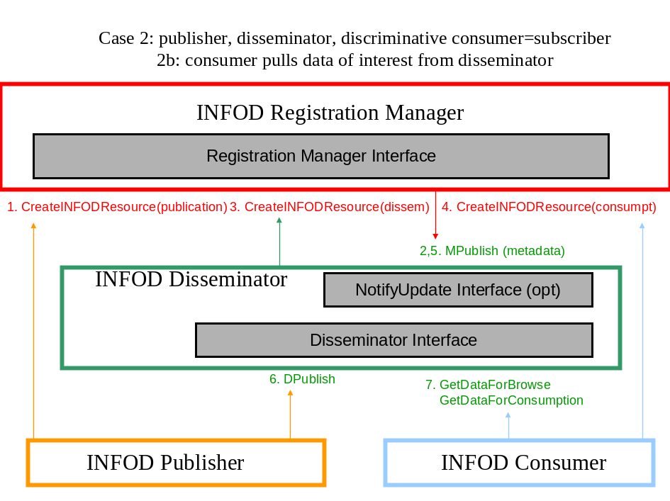

Case 2b Tasks:

→ From a resource creation perspective, same discussion as 2a…

Case 3 – to be added - base wsn: publishers, subscribers, with subscriber = consumer; no broker

→ todo

