Core Services
“Core” services are implementations of those functions that are generally used by a wide variety of higher-level services and that implement broadly useful capabilities. While dependencies between core services and non core services (by higher-level functions) are likely, there is presently no known requirement that any particular core service be present in order to implement a Grid. The organization of these “core” services into the areas below is for the convenience of explanation and is not meant to imply dependencies among functions that are grouped together.
<Tom will rewrite this text>

Service Interaction Services
These are services primarily intended to provide interaction mechanism for the collection of services in the Grid. They provide a means for services to be registered and to locate each other, as well as mechanisms for combining multiple lower-level services into aggregations. They also include functions for deploying the software images that implement services in hosting environments, and for collecting data about their operation for management, accounting, and billing purposes.
This service category includes the following services:
- Virtual organizations
- Service group and discovery services
- Service domain, service composition, orchestration, workflow
- Transaction
<Andreas will rewrite this text>

Security
<See Takuya and Frank’s text>

Information Services
These services are intermediaries of message exchanges. They mediate between information producers and consumers in variety of communication models or patterns to permit effective inter-service communication.
This service category includes the following services:
- Distributed logging: producer write records sequentially and consumer only read (no update) to the records. There may be multiple producers and consumers and both may set filters for records. The message exchange is optimized for performance and the records are kept in persistent storage for period of time.
- Message broker: move message from producer to interested consumers with a variety of reliability QoS. There may be multiple producers and consumers. Message broker may store and forward messages in stable storage not for persistency but for reliable message delivery.
- Directory service: producer add or update records and consumer read the latest information. The service has persistent storage for latest information and is optimized for searches by consumer. Low latency responses to hi-volume queries are required. The directory may replication for scalability and may have may have temporary inconsistencies.
Fig. 1 shows examples of information services.
(1)“Grid resource manager” registers resource information into “directory service”
(2)“Scheduler” retrieves available resource information from “directory service”
(3)“Grid resource manager” logs usage records into “logging service”
(4)“Metering service” collects usage records from “logging service” for billing
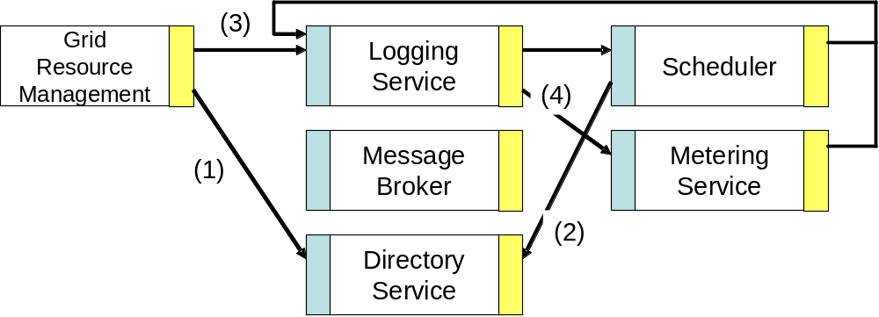
Fig 1 Information service example
OGSA Standard event schema will be defined based on the event schema defined by WSDM-TC and CMM-WG. Logging service and message broker use the OGSA event. We will define “event schema” but not “event service.”
Message service has two aspects; plumbing and rich semantics. Plumbing include reliable delivery is binding (transport) issue and is not OGSA service, Sophisticated messaging semantics is provided by “message broker” thus it is a part of information service.

Grid Resource Management
These are functions for managing Grid Resources (aka supply side resources, like servers, storages, and networks). Service management automates and assists with a variety of installation, maintenance, monitoring, and troubleshooting tasks within a Grid system. This includes functions for deploying the system components. It also includes functions for collecting and exchanging data about the operations of the Grid. This data is used for both “online” and “offline” management operations and includes information about faults, events, problem determination, auditing, and metering. Grid resource management may also depend on models and schema that describe dependency relationships between different components and installation steps and processes, and external capabilities.
This service category includes the following services:
- Deployment: transfers the necessary contents to hosting environments.
- Configuration: sets up hosting environment based on the parameters for the deployed services.
- Lifecycle management: manages lifecycle of the deployed service. The operations include initialize, start, and terminate.
- Metering
- Fault Management
- Problem Determination
<will be rewrite based on Kojo’s text>

Posix syslog, mainframe’s system logger are examples of distributed logging service.
JMS, CORBA notification, WS-Event are examples of message brokers.
LDAP, DNS, NIS/YP, CORBA COS naming, MDS are example of directory service.
Jay’s original text says “deployed services” instead. I have narrowed down here.
I think Installation service is the same as deployment. Also I delete “provisioning” in this section since “provisioning” in wide sense include not only resource management but also usage analysis, performance planning and resource allocation.

