Metadata
Mario Antonioletti, Shannon Hastings, Peter Kunszt, Stephen Langella, Simon Laws, Susan Malaika, Gavin McCance, Alex Woehrer.

Context
OGSA is currently refining its architecture through design teams. The data design team, led by Dave Berry, is defining the data services within OGSA. This break out group is exploring the scope and role of metadata within OGSA, in particular when applied to data services. The objective is to define the role of meta data and the minimal services that are required to manage and access it.

Summary
This document enumerates many categories and mechanisms, such as notations and stores, for metadata.

Metadata
Metadata Category | Metadata Notations | Metadata Stores
Data about resources | UML (Unified Modelling Language), e.g., CIM (Common Information Model)  XML schemas and annotations, e.g., regular XML schemas, DFDL (Data Format Definition language), XMI (XML Metadata Interchange)  Domain specific notations, e.g., file attributes, DDL for relational databases, MOF (Meta Object Facility) | Materialized on the fly  Registries  Repositories  Database catalogs
Data about services | WSDL and annotations  WS-Metadata Exchange | Materialized on the fly  Registries  Databases or file systems
Data about relationships between services and resources  (WS-Resources) | Resource Properties and annotations | Materialized on the fly  Databases or file systems
Data spanning groups of services or resources | RDF, DAML | Registries, or data resources.

Metadata

Background
The most usual definition of metadata is data about data. However, the term can be used in more specific ways:

- From the OGSA v1.0 document:
  - Data that describes OGSA services or other data. Metadata may include references to schemas, provenance, and information quality.
  - Data that describes the definition, structure, and syntax of other data (XML schema or relational database schema)
  - Data that describes the semantic relationship between different data (RDF, OWL)

From WS-Metadata Exchange [WS-MetadataExchange]:
  - Web services use metadata to describe what other endpoints need to know to interact with them. Specifically:
  - WS-Policy [WS-Policy] describes the capabilities, requirements, and general characteristics of Web services;
  - WSDL [WSDL 1.1] describes abstract message operations, concrete network protocols, and endpoint addresses used by Web services;
  - XML Schema [XML Schema Part 1, Part 2] describes the structure and contents of XML-based messages received by and sent by Web services

Specifications that seem to have some bearing on metadata include:

- From WSRF:
  - The declaration of the WS-Resource’s properties represents a projection of or a view on the WS-Resource’s state. This projection is defined in terms of a resource properties document. This resource properties document serves to define a basis for access to the resource properties through Web service interfaces
  - (A WS-Resource represents the relationship between a service and a resource)

From DMTF Common Information Model:
  - CIM provides a common definition of management information for systems, networks, applications and services, and allows for vendor extensions
- From relational database:
  - Database metadata is comprehensive information about the database as a whole

What
Clearly the term metadata can mean many different things in the context of data services, for example,

- Data about the data in the data resource, e.g. its provenance or structure
- Data about the data resource, e.g. its type and capabilities
- Data about the web service that provides and interface to the data resource, e.g. its WSDL
- Data about the relationship between web service and data resource, e.g. its lifetime
- Data about the organization and relationships of the web service and data resource with others

It is clear that is some cases metadata can just be treated as more data.

Where
Metadata can be held in a number of places, for example,

- Data held and managed by the data resource, e.g. a database schema
- Data held and managed by the web service, e.g. the service WSDL.
- Data held by a third party but referring to the web service or the data resource, e.g. annotations, audit or provenance information

How
There are several layers of metadata where the semantics of the binding to the data is different.

- Implicit metadata. For example, mime-types. It is possible, for example, by virtue of file extension, to deduce the mime type of a file. .jpg and .mp3 carry a lot of implicit metadata (a book describing the mp3 or jpeg formats would contain all of it). This is not restricted to files, a database table also carries implicitly its ‘nature’ as metadata. It is stored in a book describing RDBMS tables.
- Explicit, tightly coupled metadata or status information. Such metadata sometimes is repeated inside the data block. It may be the size of the data, its latest modification time, creation time, owner, checksum information, encryption type, etc. Such metadata is usually used by low-level system services and not by the users themselves. For files this is the ‘stat’ information, for databases it is internal metadata on tables (there is a concept like this in JDBC for example).
- Explicit, loosely coupled metadata. Such metadata is application specific and may have again several layers. It may be stored with the data or may be put in a completely different location. The organization owning the data may have a different set of metadata than groups within the VO and individual members of different groups may again have their own metadata. As an example, a medical image might have metadata on where it was taken, patient data, etc in the global VO metadata, but may have additional metadata concerning the symptoms, etc, in some group of doctor’s metadata and again may have metadata in the personal metadata store of a medical researcher who needs it as part of an example for some publication.

The way that metadata is created and changed also varies, for example

- Static
- Updateable by the service and/or by the service consumer
- Extendable (through annotations)

It may also be the case that metadata has a lifetime associated with it.

Assumptions And Scope
Every data resource that has a presence in OGSA is exposed through one or more services. These services represent the access capabilities available to consumers. There will of course be other OGSA services that do not depend on resources to provide their capabilities.

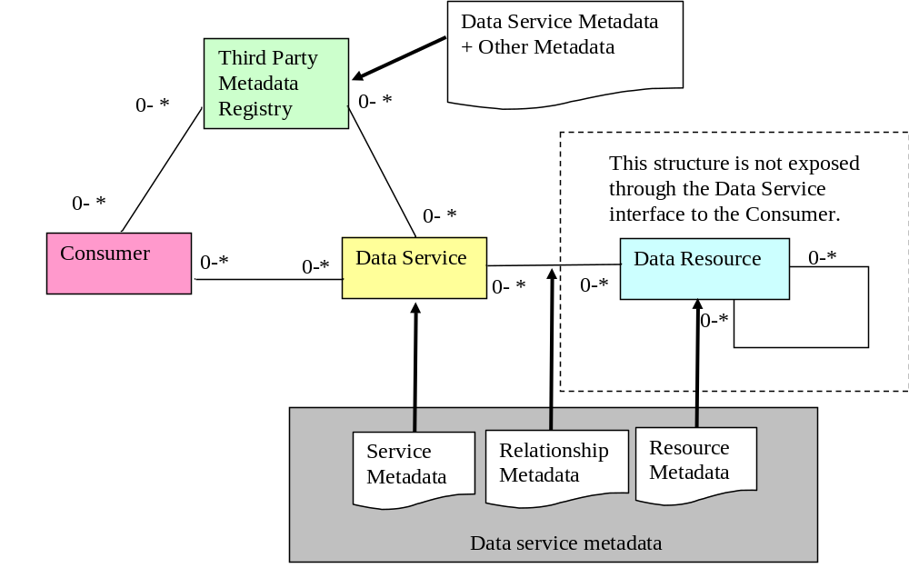
There are two broad classes of metadata that are of interest here:

- Metadata available from the data service
  - Metadata about the data resource
  - Metadata about the service and its capabilities.
  - Metadata about the relationship between the service and the data resource
- Other metadata that spans multiple services or resources

The notations and formats can be used for metadata are not specified and are not restricted.

The meta data may be obtained directly from the data service or may be obtained from a third party, such as a registry service, which provides metadata on the data service’s behalf. However all metadata is logically associated with a data service.

Data Service

Overview
TODO

Operations
Access to metadata at the data service is supported using a simple interface

QueryMetadata
UpdateMetadata
AugmentMetadata
DeleteMetadata
GetAllMetadata (will query do this?)
GetMetadataList (will query do this?)

Metadata Registry

Overview
A Metadata Registry (MR) is any third party service that provides mechanisms for publishing metadata about services, their capabilities and the resources they represent. Satisfying the requirements of such a service a MR provides interfaces for:

- managing the MR and its own metadata
- publication and removal of metadata
- discovering services and resources and obtaining metadata relating to services and resources
- annotation of metadata
- subscribing for notification of changes in metadata

The MR may aid service discovery by providing for the standard categorization of the meta data that it holds. (ref UDDI).

Metadata provided by a MR is exposed in XML format and is queried using XPath or XQuery statements. It should be possible to obtain references for services that satisfy the query.

If the result of service or resource discovery through the MR is an address it can be used directly to locate the service providing access to the data resource. Otherwise further work must be undertaken to retrieve the address associated with the returned name.

OGSA, in the Glossary, currently defines a registry as:

An authoritative, centrally-controlled store of information.

Web services use registries to advertise their existence and to describe their interfaces and other attributes. Prospective clients query registries to locate required services and to discover their attributes.

Is this something that we agree with? I don't think it can be authoritative and centrally controlled is violating one of the design objectives (site autonomy).

I assume we want distributed but connected registries.

A distinction could be made between an MR and a Registry in that the latter type of service will in general provide capabilities to do a rapid name mapping to resolve human names or abstract names to the corresponding addresses (this is a bit tenuous).

Operations

Function to be provided
- Publish
  - Should be able to publish metadata securely (you are the owner of the metadata and the only person that can modify it) or anonymously (the metadata has no owner)
- Update
  - Should only be able to modify if the metadata has an owner and you are the owner of the metadata.
- Classify
  - Do we define a classification mechanism?
- Augment
  - Add to the meta data stored for a service
- Delete
  - Should only be able to delete if the metadata has an owner and you are the owner of the metadata.

- Find
  - Find services give metadata based query
- Subscribe
  - Subscribe to any changes in the metadata available for a service
- Management
  - ?

Need to expand these - we should borrow/steal from UDDI?
[UDDI V1
- Inquiry API
  - Find things
    - find_business
    - find_service
    - find_binding
    - find_tModel
  - Get Details about things
    - get_businessDetail
    - get_serviceDetail
    - get_bindingDetail
    - get_tModelDetail
- Publishing API
  - Save things
    - save_business
    - save_service
    - save_binding
    - save_tModel
  - Delete things
    - delete_business
    - delete_service
    - delete_binding
    - delete_tModel
  - security…
    - get_authToken
    - discard_authToken]

Publish

There are many different possible types of publishing

- Secure
Requires services to authenticate. The service/service provider must be pre-registered with the registry. This validates the metadata. Changes in metadata require authentication.
- Insecure I
Services register and publish metadata. Registration is for a time duration. This allows services to make changes to metadata.
- Insecure II
Services are not registered. Metadata published for a fixed period of time. Metadata is read only (else how do you ensure no one corrupts the data).

Question: Could infod be used to establish publishing rules for propagating registrations between registries?

A Registry may update service metadata by querying the services themselves (don't think this is a good idea as it will affect scalability).

Metadata may be published by the services themselves, may be indexed by an automatic discovery mechanism (say a gridbot) or may be replicated from other MRs.

When metadata is cached in an MR it should be refreshed using selectable strategies. For example,

- Don’t cache, i.e. always read from the service
- Cache once, i.e. I know the data is static and will not change
- Cache timeout, i.e. it is not vital that the data is bang up to date so refresh every n seconds
- Update on event, i.e. update the cache whenever the data changes.

In addition there will also be metadata about the MR itself - i.e. when a metadata entry was last updated, capabilities, etc.

OGSA will define the function required of the MR but these functions (or a subset of these functions) may be realised by a number of different approaches.

- Service groups
- UDDI
- ?

Security

Metadata registries may employ different trust models. In order for a service to publish metadata with a MR it may have to pre-register with the service. This reassures a client that the metadata comes from a trusted source. The content that may be queried may depend on the credentials used by a client. The trust model used within a Virtual Organisation may be implicit, i.e. members of that VO are automatically trusted. However as metadata may be replicated from one MR to another as in the figure below, other VO domains may be less trusted and the amount of information replicated may be a subset of that available at the original MR. An MR client may have to drill down through the services in order to obtain the full information (surely a lot of this has already been solved by UDDI except that the information model here is more dynamic).

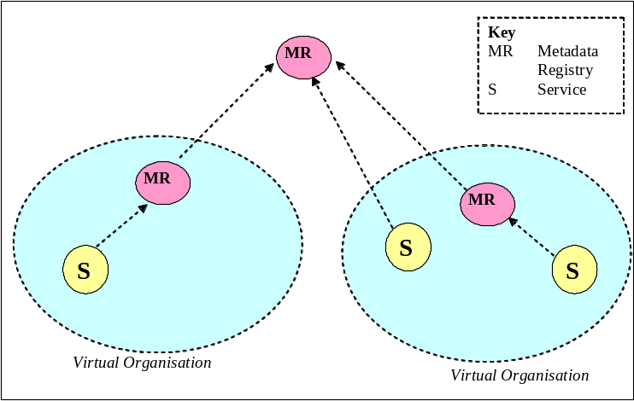

Also, why are we worrying about MR that span VOs at this stage?

Roadmap
Our plans once we know what we are doing and when we are going to do it by.

References

- [WS-Metadata Exchange]

http://www-106.ibm.com/developerworks/library/specification/ws-mex/

[WS-Policy]
http://www-106.ibm.com/developerworks/library/specification/ws-polfram/

[WS-Resource Properties]
http://docs.oasis-open.org/wsrf/2004/06/wsrf-WS-ResourceProperties-1.2-draft-04.pdf

- [CIM]
http://www.dmtf.org/standards/cim/

- [Relational Database]
http://java.sun.com/j2se/1.4.2/docs/api/java/sql/DatabaseMetaData.html

- [Infod]
http://forge.gridforum.org/projects/infod-wg

Notes

Metadata

The metadata about the resource may be modelled as a resource itself.
An important thing that needs to be addressed is:

- HOW a service exposes this metadata and whether this is different for the three different types of metadata presented above.

More assumptions and requirements:

- Metadata is logically associated with a service.
  - That is the authoritative version of metadata is always derived from the service representing a resource.
  - Counterargument: Not sure this is true. You could have a third party hold information about data provenance for example.
  - Issue: If Metadata is annotated what is this logically bound to? To the service that supports the metadata annotation, which could be the so-called registry. But it must be related to the metadata that has been annotated.
- If a resource is represented by more than one service then the metadata that these services provide in relation to the resource must be the same.
  - Counterargument: This is not true, each service could present a subset of available metadata. You may say that when common metadata is presented is should have the same value but it is very hard to guarantee it. Depends on when you call is and caching etc.

  - Counteragrument: The resource itself may have specific metadata pertaining to the resource, as stated in the three types of metadata in the scope section, associated to it. No matter which service exposes this data/metadata the data/metadata values should be the same. Think of metadata to a data resource as an entry in a database, metadata of a resource should be treated the same as the resource as it pertains to the resource and not to the service exposing it. These are the issues in where to hang the metadata from. Metadata of the service is just that, metadata of that instance of the service and any other instance of that service may not provide the same metadata values.
- How the binding of metadata to data is done is out scope for this document.
- Any changes that take place in the metadata of the resource exposed by a service should be bound to the data in the same way that is already being used.
  - Don’t understand what this is trying to say. Does bound to the data mean associated with the data?

In order to be able to provide a discovery service we need to:

- Characterise the intrinsic types of metadata for the service.
  - Capabilities
  - Relationship with the resource
  - Metadata about the resource (where the resource would be the service that represents it).

In order to do service/resource discovery you need to be able to query the metadata of:

- The resource itself
- The capability of the service that represents it
- Other metadata services

Metadata Service Functional Requirements

- Data service repository for publishing metadata
  - Publish this metadata about my service, only allow me to modify it, restrict access to the metadata depending on who wants to access it
- Data service discovery
  - Find me a service that provides SQL access to the Trades database
- Data service description
  - Show me the structure of the Trades database
  - Many different aspects to description, e.g. provenance, security, policy, QoS, semantics, structure, relationships etc.
- A source of topics for event notification
- Tell me when the Trades database reaches 80% capacity
- Tell me is the structure of the trades database has changed.
  - Additional attributes may be added
- A place to store annotations
- Record that the Trades database has been backed up today
- A place to store and version data type definitions

Non Functional Drivers/Requirements
- Be scaleable to allow large amounts of metadata for large numbers of data service to be stored and retrieved
- Be secure so that published data can only be read authorised clients and so that data can only be changed by authorised clients

Implementations

Should Registries be based on service groups? If not why not?
Implementation detail

Does UDDI good enough? If not why not?

- Pros:
  - Should leverage off existing standards if these are deemed to be adequate.
  - A lot of thought has gone into the APIs and data models.
- Cons:
  - Content model is mainly static
  - Language seems to be very business orientated (minor quibble)
  - UDDI has not been widely adopted.

We should consider why UDDI is not generally used, yet relational database catalogs are used constantly. What’s the magic?

UDDI Vision is – a "meta service" for locating web services by enabling robust queries against rich metadata.

Either way we could "borrow" a lot of their functionality.

Need to make a distinction between the metadata that is registered at the service and the metadata of the service itself?

When was the metadata last updated? etc.

