Resource Modeling in OGSA

Status of This Memo
This memo provides information to the Grid community on resource modeling in OGSA (Open Grid Services Architecture). It does not define any standards or technical recommendations. Distribution is unlimited.

Copyright Notice
Copyright © Global Grid Forum (2005). Portions are copyright © DMTF (2005). All Rights Reserved.

Abstract

Contents

1. Introduction 3
2. Basic concepts and nomenclature 3
2.1 Model and Meta-model 3
2.2 Semantics and Rendering 4
2.3 Functional and manageability interfaces 4
3. Requirements on an OGSA resource model 5
3.1 Less is better, one is ideal 5
3.2 Potential for wide coverage if/when needed 6
3.3 Re-use of existing work 6
3.4 Resource descriptions and system management 7
3.5 Extensibility 7
3.6 Functional and manageability interfaces 7
3.7 Implementation of manageability is optional 7
3.8 Compatibility with multiple kinds of instrumentation 7
3.9 Meeting the conditions in the OGSA profile definition 7
3.10 Low barrier of entry 7
3.11 Licensing 8
4. Existing models 8
4.1 CIM 8
4.2 GLUE 10
4.3 Other models 10
5. Proposal 10
5.1 Semantics 10
5.2 Rendering 12
5.3 Framework 13
Appendix: The resource management design team 13
6. Security Considerations 14
Author Information 14
Glossary 14
Intellectual Property Statement 14
Full Copyright Notice 14
References 15

Introduction
Resource models describe resources by defining their properties, operations, and events, and their relationships with each other. Resources are managed (monitored, allocated, etc.) by following the description given by the model, and therefore resource models are essential to all facets of resource management. Resource models are used for both the functional and manageability interfaces.
This document provides background information and a proposal on the usage of resource models in OGSA [1, 2, 3]. Its main parts are a list of requirements on a resource model for OGSA in Section 3, background information on existing models on Section 4, and a proposal in Section 5.

Basic concepts and nomenclature
This section defines basic terms which need to be uniformly used on discussions on resource models in the OGSA-WG.

Model and Meta-model
A model (also called resource model or schema), is an abstract representation of manageable entities which defines their schema (conceptual hierarchy and inter-relationships) and characteristics such as properties, management operations (methods), etc. An example is given in Figure 1, which is a single class of CIM that models a batch job. This class has a name (BatchJob), properties and methods. Not shown in Figure 1 are other classes of the model such as hosts and file systems, and inter-relationships between classes, which are also part of the model.
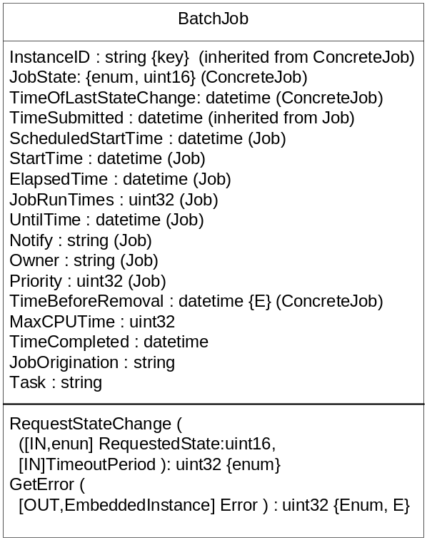
Figure 1: An example of a class in a resource model (CIM’s BatchJob)
A meta-model (also called meta-schema) is the model on which a resource model is based, i.e., it is the model of the model. This can be better understood by the example given in Figure 2, which is the CIM meta-model. It specifies, for instance, that a Class in the model (such as the one shown in Figure 1) has one name (inherited from Named Element), and zero or more Properties and Methods. So, the meta-model describes the classes, properties, methods, etc., differently from the model, which describes hosts, operating systems, licenses, etc.

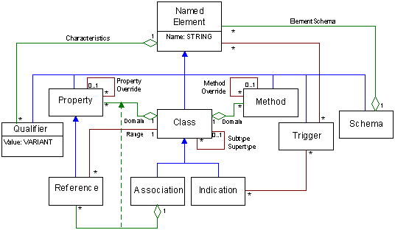
Figure 2: An example of a meta-model (the CIM meta-model)

Semantics and Rendering
The semantics contain the concepts of the model (its entities, their properties, methods and relationships). For instance, CIM itself contains only semantics – it is simply an UML model (Figure 1), and textual descriptions of its contents (defined in “MOF (Manageable Object Format) files”).
A rendering is a representation of the semantics in a given language, and/or a specification of how to transmit and access the model on the wire. A rendering of a model allows its semantics to be conveyed. For instance, the CIM model has a rendering composed by an XML representation and an HTTP mapping.
The semantics may have multiple renderings: for instance, new CIM renderings have been proposed.
It should be noticed that operations in the model semantics (such as RequestStateChange in Figure 1) are different from operations in the rendering (e.g., an operation to get the value of a property in an instance of a class). In CIM the former are called extrinsic operations, and the latter are called intrinsic operations.

Functional and manageability interfaces
There are two types of resource management interfaces in OGSA:
- Functional interfaces: Some common OGSA capabilities (such as job management) are a form of resource management. Services that provide these capabilities expose them through functional interfaces.
- Manageability interfaces: Each capability has a specific manageability interface through which the capability is managed (e.g., monitoring of registries, monitoring of a job manager, etc.). This interface could extend the generic manageability interface, adding any manageability interfaces that are specific to the management of this capability.
A simple example of these interfaces for a job manager service is given in Figure 3.
The functional and manageability interfaces are often not clearly separated (especially in the case of resource managers). While overlap is inevitable, some distinction is desirable, since these interfaces are invoked by different users with different roles and access permissions. For instance, in Figure 3, the functional interface is used by the manager (or user) of the application being run (the “Grid administrator” in the Commercial Data Center use case [3]), and the manageability interface is used by the system manager (the “IT business activity manager” in [3]).
Manageability is often an afterthought, so often the functional interface is present but not the manageability interface.

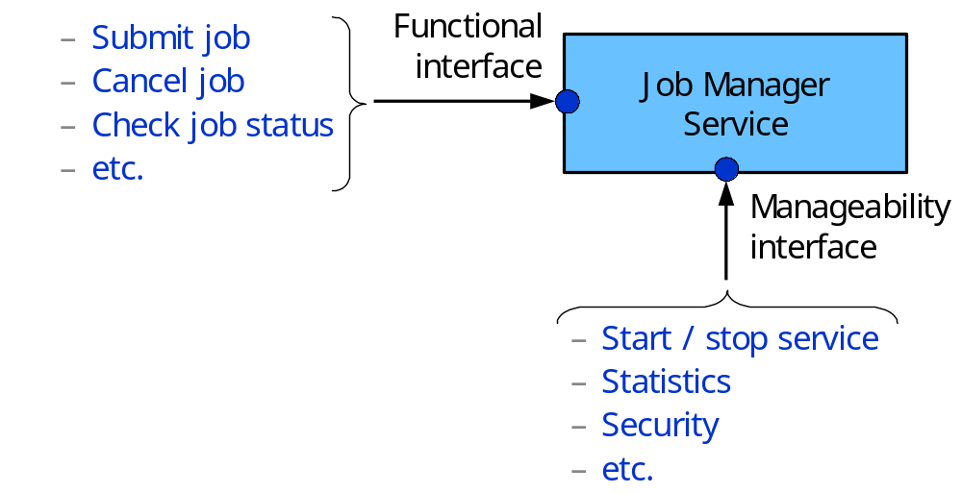
Figure 3: An Example of the Functional and Manageability Interfaces

Requirements on an OGSA resource model
The following sections contain requirements (and desirable features) of a resource model for OGSA, focusing mainly on the semantics (the renderings have a different set of requirements such as scalability, security and interoperability).

Less is better, one is ideal
The semantics of a resource model contain its meaning, and thus they are more important in achieving interoperability than its renderings: translating between two renderings of a single model is not a difficult problem, but translating between the semantics of two different models is likely to be complex. For instance, in different models a fan may be a physical or a logical entity; it may be classified under chassis, cooling devices, enclosure services or physical packaging; or it may have similar properties, such as a status, which have different value sets. Automatic translation between semantics can’t be done unless these semantics are matched. An example of this matching is the mapping between Globus and UNICORE resources being done as part of the GRIP project [10] (see also http://www.grid-interoperability.org). Also, CIM has mechanisms to map its semantics to those of other resource models [11].
The target for OGSA should be:
- One model (semantics), in order to:
- Unify the concepts in OGSA (i.e., what is a job, what is a host)
- Avoid translation of semantics
- One rendering per basic profile. There should be as much commonality between these renderings as possible, e.g., common XML schemas across basic profiles, and common parts to the WSDL to access the information, to simplify translation between renderings.

Potential for wide coverage if/when needed
OGSA services span multiple areas (execution management, data services, security services, etc.) and multiple activities in these areas such as:
- reservation, brokering and scheduling
- installation, deployment and provisioning
- metering
- aggregation (service groups, WSDM collections, etc.)
- VO management
- security management
- monitoring (performance, availability, etc.)
- control (start, stop, etc.)
- problem determination and fault management
These activities are applied to multiple types of resources:
- physical (e.g., a node, a network switch or a disk) or logical (e.g., a process, a file system, a print job, or a service)
- discrete (e.g., a single host) or composite (e.g., a cluster)
- transient (e.g., a print job) or persistent (e.g., a host)
A resource model for OGSA should be potentially applicable to these multiple areas, activities and types of resources. It is not possible to currently define a precise scope for all the entities that OGSA will target, so this requirement intends to make possible to use the model on entities that are not currently under consideration.
Coverage is needed for the entities at the semantic level of OGSA, which comprises more abstract and higher-level entities such as jobs, hosts, etc. For instance, execution management (jobs, etc.) are within scope of OGSA, but fan and power supply management (monitoring, events in case of failure, etc.) is not. However, given that some users of OGSA will need the latter, it is desirable that the resource model allows coverage of these entities also (but, again, specifying this functionality is not in scope of OGSA).

Re-use of existing work
A resource model seems simple and obvious after it is complete; however modeling is a time-consuming work that can often takes years even for the definition of a handful of classes. Thus it is desirable that new resource models are created by re-using existing models, which not only allows higher interoperability but also requires less work. For instance, this new resource model could be created as a subset or superset of another resource model. Or, multiple resource descriptions could be created as renderings of a single resource model (with each resource description language representing this model, or a subset of it, using its own syntax, e.g., its own XML schema).
The re-use is restricted only to the parts of existing work that are meaningful to OGSA.
Given that the different components in OGSA will not be developed simultaneously, the model should allow piecewise selection and extension.

Resource descriptions and system management
Two kinds of resource models exist:
- Resource descriptions, used mostly for brokering, metering and provisioning
- System management, used mostly for system monitoring and control
A resource model for OGSA should be useable for both tasks above. Resource descriptions should also include amount of resources and system structure.

Extensibility
A resource model for OGSA must be extensible for the following reasons:
- OGSA specs will be extended and refined for years, and these changes will probably require additions to the model.
- Existing models probably do not have all the features needed in OGSA, and these need to be added to the model.
In case of a UML-based model, the extensions will correspond to:
- Additions of classes
- Additions of properties and methods to classes

Functional and manageability interfaces
The resource model must be useable in functional interfaces (including resource requirement descriptions) and also in manageability interfaces. This will prevent OGSA systems to deal with different abstractions of the entities they control for different tasks.

Implementation of manageability is optional
While management functionality is important, it is expected that in many Grids many management tasks (e.g., rebooting a host) will be done manually, so manageability functionality should be optional. It is worth repeating that it is often difficult to separate functional and manageability interfaces, making the choice of optional features difficult. For instance, discovery and health monitoring are on the borderline between these two.

Compatibility with multiple kinds of instrumentation
Systems using OGSA interfaces will have different forms of instrumentation, including standards such as CIM, SNMP, JMX, etc., proprietary interfaces, or interfaces specific to a software package. While this instrumentation is not in scope of OGSA, OGSA services will use information that will come from it, so it must be possible to use different kinds of instrumentation in OGSA. This implies that matching needs to be done between the information coming from the instrumentation and the one used in the resource model.

Meeting the conditions in the OGSA profile definition
A resource model and its renderings must meet the conditions in the OGSA profile definition in terms of status and adoption.

Low barrier of entry
In the case of re-use of an existing model, there must be easy ways to:
- Study the model
- Use the model, for instance through open source software
- Access to information on the development of the model

Licensing
- The licensing of the model and renderings should be RAND-Z or RF.
- It should be possible to create free software that implements the model and the renderings.

Existing models

CIM
CIM (Common Information Model) provides a common definition of management information for systems, networks, applications and services, and allows for vendor extensions. As mentioned above, CIM itself is only of the model semantics; CIM and its rendering (XML schema and HTTP mapping) are known as WBEM (Web-Based Enterprise Management). CIM includes models (schemas) for the following areas:
- Core: high-level abstractions (logical and physical elements, collections)
- Physical: things that can be seen and touched (e.g., physical package, rack and location)
- System: computer systems, operating systems, file systems, processes, jobs, diagnostic services, etc.
- Device: logical functions of hardware (e.g., battery, printer, fan, network port and storage extent)
- Network: services, endpoints/interfaces, topology, etc.
- Policy: if/then rules and their groupings and applicability
- User and Security: identity and privilege management, white/yellow page data, RBAC (Role-Based Access Control), etc.
- Applications and Metrics: deployment and runtime management of software and software services
- Database: properties and services performed by a database (addresses database components, backing storage, status and statistics)
- Event: notifications and subscriptions
- Interoperability: management of the Web-Based Enterprise Management (WBEM) infrastructure
- Support: help desk knowledge exchange and incident handling
- Security Protection and Management: notifications for and management of intrusion detection, firewall, anti-virus and other security mechanisms
- Block and file storage
- Application Server: updates JSR77's CIM mapping, for managing the J2EE environment
- New work in the areas of Behavior and State (modeling state and transitions), utility computing (management of utility computing services and related data for provisioning, accounting and metering, reservation handling, etc.) and virtualization.
CIM is used in practice, with multiple vendors ship WBEM. The following are some of the main examples:
- HP has support for HP-UX, Linux, OpenVMS and Tru64 UNIX, plus management software (see http://www.hp.com/go/wbem for details)
- IBM has support for iSeries and pSeries
- Dell OpenManage supports CIM, including management software and support on server, client and storage product lines.
- Sun: Solaris WBEM Services provides WBEM for the Solaris operating environment.
- Cisco has CIM-based database design for inventory, Storage modeling, CiscoWorks interface.
- Microsoft: WMI (Windows Management Instrumentation), the unified instrumentation service embedded within the Windows 2000, Windows XP and Windows Server 2003 operating systems, is based on CIM.
- Linux: support is available in multiple free software projects (see below).
- Several vendors ship storage management solutions (management software and support on storage and SAN devices) based on WBEM. The standards created by SNIA (Storage Networking Industry Association) are based on CIM, and are the only open and widely-applicable way for storage management. Examples include Hitachi, Cisco, EMC, Brocade, CA, HP, IBM, Sun, Veritas, McData, QLogic and many others.
- A major undertaking by several vendors to create standards for server management was taken to the DMTF, resulting in the SMASH (Systems Management Architecture for Server Hardware) specs. The first batch of specs is expected to be released in the end of 2005, and support by major server vendors is expected shortly after.
There are several open-source software projects on CIM/WBEM. The WBEMsource initiative (see www.wbemsource.org) provides coordination between open source WBEM projects, with the goal of achieving interoperability and portability between them. Five projects are participating in the initiative. These projects are autonomous, with WBEMsource acting as an umbrella organization. Other CIM-related tools are available to DMTF members at http://www.dmtf.org/members/tools.
CIM as a whole is defined in several places:
- The CIM schema (the model itself) definitions are at http://www.dmtf.org/standards/cim. The definition is composed of the UML model (available in PDF and Visio format) and MOF (Managed Object Format) files. The latter contains a textual description of model, with:
- A full definition of the structure of the model (structure, classes, properties, metadata, etc.) which can be input to CIM software as the definition of the model
- Human-readable explanations of the classes, properties and methods
- The conceptual definition of CIM, including the meta-model, mapping to other resource models, etc. is in [11].
- Profiles constrain the model and its usage to a specific area.
- White papers also give additional information on the model and its usage for specific areas.
There are still few books on CIM. One of the best is [12], which includes practical aspects on usage. There is also a tutorial on CIM in the DMTF site (see http://www.dmtf.org/education).
There are multiple mechanisms in CIM to map other resource models to CIM. Currently there are mappings from CIM to SMBIOS, IETF MIBs, DMI MIFs, TMF (TeleManagement Forum) models, JSR77, and others. Mapping CIM to Grid-related standards such as GLUE is a work in progress.
CIM is updated 3 to 4 times a year. Starting in CIM v2.10, the schema is divided in “Final” and “Experimental” parts (parts of the model become “Final” when there is implementation experience on it). This does not mean that the model is unstable – changes are backward compatible, usually consisting of additions on areas under development, which recently have been mainly storage management and server management. Even a major version-up of the model is backward compatible by mapping the new version to the previous one using the mechanisms to map to other resource models.
CIM is one of the standards being created by the DMTF (Distributed Management Task Force). The DMTF is “the industry organization leading the development of management standards and integration technology for enterprise and Internet environments”. DMTF standards provide common management infrastructure components for instrumentation, control and communication in a platform-independent and technology-neutral way. The DMTF has more than 3,000 active participants. There are 111 member companies, including most industry leaders in all areas of IT. There are also 15 alliance partner members (other organizations that collaborate with the DMTF), the Global Grid Forum being one of them. There is also the Academic Alliance membership, a free membership for accredited institutions of higher learning, with are 58 members. Academic Alliance Members have access to the DMTF members-only Web pages and member email lists, and are eligible to participate in DMTF working groups, in the DMTF Marketing and Technical Committees as a non-voting member. Every year the DMTF has invited all of its Academic Alliance Members to submit a paper on their work with DMTF standards, and a winner chosen by the DMTF Board (see http://www.dmtf.org/education/academicalliance/ for a list of papers submitted). Finally, the DMTF can have individual members who have to be sponsored by a member company. These multiple classes of membership allows most, if not all, active members of the OGSA-WG and related WGs can have access to information in the DMTF.
There has been collaboration on CIM between the GGF and the DMTF with many results:
- JSIM (Job Submission Information Model, GFD-I.028) was an extension of CIM for batch jobs created in the CGS-WG (CIM Grid Schema WG). It has been contributed to the DMTF, and is present in CIM 2.10.
- JSDL bases its definition of a number of types (such as Operating System types) on CIM.
- DAIS-WG is collaborating with the DMTF on the creation of SRIM (Software Resource Information Model) extensions.

GLUE
The GLUE (Grid Laboratory Uniform Environment) Information Model (a.k.a. GLUE Schema) is the result of a collaboration effort started in April 2002 by the EU-DataTAG and US-iVDGL projects. Current projects that are participating in this activity are EGEE, LCG, Grid3/OSG, Globus and NorduGrid. The aim is to define an information model and mapping to concrete schemas for representing Grid resources (see http://infnforge.cnaf.infn.it/glueinfomodel/).
GLUE v1.1 is deployed and in use, and GLUE v1.2 is currently in development.

Other models
- SNMP MIBs (Management Information Bases), which cover mainly network management but are also used in other areas such as host management.
- JMX’s JSR77, a resource model for the manageability aspects of the J2EE (Java 2 Enterprise Edition) platform [9].
- WSDM MOWS Web service model.
- Resource descriptions for reservation/brokering/scheduling:
- UNICORE Resource Schema
- Globus RSL (Resource Specification Language) and the GLUE schema
- JSDL (Job Submission Description Language, being defined by GGF’s JSDL-WG)
- Resource descriptions for accounting/metering:
- Usage Record (defined by GGF’s UR-WG)
- Resource descriptions for installation/deployment/provisioning:
- Configuration Description Language (CDL, being defined by GGF’s CDDML-WG)
- Data Center Markup Language (DCML, see http://www.dcml.org)
Note that although some resource descriptions are not intended to be models by themselves, they contain an implicit model which defines, for instance, which entities exist, and what their attributes are.

Proposal

Semantics
CIM is the best fit for a resource model for OGSA since it is the one that best satisfies the requirements outlined in this document:
- It already covers a wide variety of entities, and also activities in multiple OGSA capabilities such as security, execution management, self-management, etc.
- Re-using CIM can leverage the enormous amount of time spent by the DMTF in its creation, saving the GGF time and effort
- CIM is extensible, and the collaboration between the GGF and DMTF to extend CIM has worked quite well.
- CIM can handle functional and manageability interfaces.
- In CIM only the parts that make sense for an implementation need to be used (parts not implemented, if accessed, can return a “not supported” error). So manageability can be made optional if desired. In fact, even specific properties and methods in a class can be left unsupported if the implementer decides to do so.
- CIM has good mappings to existing models, which should ease the use of existing instrumentation
- CIM meets the conditions of the OGSA profile definition as follows. CIM “Experimental” schemas correspond to “Evolving Institutional Standard” and “Unimplemented”, which is enough only for informational profiles. CIM “Final” schemas correspond to “Institutional Standard,” however the adoption level has to be evaluated for each set of classes being used, which could rank from “Adopted” to “Implemented”.
- CIM schemas are released just “copyright DMTF” – there is no licensing. There are no cases known to the DMTF in which a WBEM implementation needed licensing.
Acquiring knowledge of CIM, both conceptually and of the schema, is the biggest difficulty in adopting it. The GGF will have to continue relying on the DMTF, and especially on the liaisons, to help understanding CIM.
The creation of resource models for OGSA based on CIM will consist of:
- Selecting which parts of the CIM schema to use in which parts of OGSA, i.e., creating a CIM profile for OGSA. CIM was never supposed to be used as a whole (and is never used as a whole), but instead profiles define which parts of the model are used for specific areas. In OGSA one should expect one profile for each major area (execution management, data, etc.). These CIM profiles will be added to the related OGSA profiles. This is expected to happen in a bottom-up way: as the work of each of the OGSA capabilities progresses, models will be needed and the schema selected for it. In other words, the CIM schema will be selected in a piecewise fashion as the work on each capability progresses. Merging the pieces of the CIM schema adopted by the different design teams will not be necessary, since CIM already links everything into a coherent whole.
- Creating extensions to CIM where needed. These extensions will be provided by the DMTF, in collaboration with the OGSA-WG and perhaps other GGF WGs requiring these extensions. This addresses the issue of the complexity of CIM and the lack of knowledge and experience with CIM by GGF WGs. The DMTF will be responsible for the development of CIM and all parts thereof. The GGF WGs will be responsible for delineating the needs of the spec.
- Comparing CIM to existing Grid-related resource models, either implicit or explicit ones. This should mainly result in mappings between CIM and other resource models, and possibly in finding features in these models not yet in CIM.
- For work that has been completed, such as GLUE, this provides interoperability.
- For work in progress in the GGF, this provides synchronization of the specs and unification of the work.
Mapping between CIM and Grid-related standards can be done by using the mechanisms in CIM mentioned above to map CIM to other models.
The work above is already in progress for the container and activities. An initial proposal of a subset of CIM for these entities exists, and a comparison with JSDL shows a few extensions that are needed. A comparison with GLUE is under way.
Ultimately, this provides a mapping of existing GGF and other Grid-related work onto CIM. CIM would then allow one to see how GGF WGs (e.g., OGSA-WG and related WGs) connect and overlap, where there are disconnects, and how they are related to the DMTF.
The schedule and the content of the work will vary for each GGF WG, since they are expected to have different needs and schedules. Specifically, work in the OGSA-WG will be demand-driven, focusing on the design teams making most progress, which will therefore be the first to need resource models. Currently, this means the Execution Management and Data design teams of the OGSA-WG.

Renderings

WSRF Basic Profile
[The contents in this section are still very incomplete].
A rendering for CIM must be created by the DMTF (needless to say, XML-based). This rendering must allow both resource descriptions and system management tasks. System structure in these descriptions is given by the CIM associations and aggregations.
Access to, and exchange of, CIM-based information among OGSA services and resources corresponds to the exchange of XML documents through Web services, which does not need to be done through current WBEM standards as rendering or to use a CIMOM (CIM Object Manager) as implementation. For instance, an independent software module implementing functionality for containers and activities will only implement the classes that are meaningful to it, and it can do the rendering and XML document exchange by itself. Using a CIMOM in this case is probably overkill. On the other hand, if a CIMOM is already in use, a provider to link it with this software module could be a simpler way to implement the functionality needed. The above applies to entities and services at the OGSA functions level in Figure 4; at the resource level, CIMOM is definitely useful to do instrumentation for servers, storage, etc. since free software such as Pegasus is available.
Another desirable direction for work is model neutrality on the mechanisms for resource management. This allows the unification of the mechanisms to use multiple resource models despite there being no unification on the models themselves – for instance, accessing instrumentation information in SNMP MIBs, JMX JSR77, CIM, etc. WSRF and WSDM MUWS [5, 6] are examples of these mechanisms. They provide a layer (the “Infrastructure services” in Figure 4) that makes uniform the access to information.
The WSDM MUWS specifications also allows one to logically separate the functional and manageability interfaces by using management “capabilities” such as those for Metrics, Operational Status, Relationships, Identity etc. This classification allows manageability interfaces to be functional interfaces as well, and it also enables access control policies to be set up at the interface/category level, based on roles and privileges.

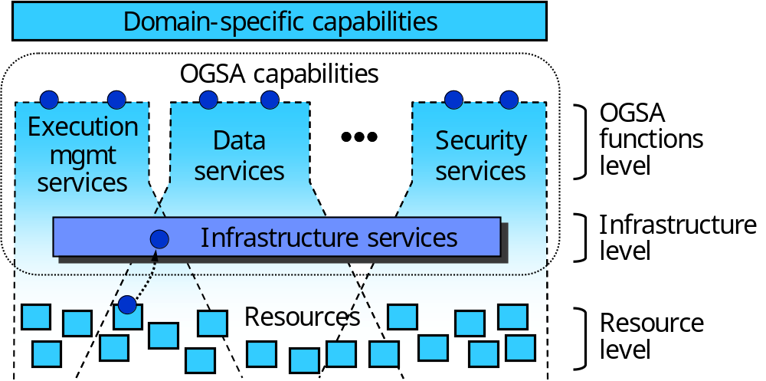
Figure 4: Levels of management in OGSA

Other Basic Profiles
TBD by those who create these profiles.

Framework
TBD by the Information Services design team.
While such a framework is not defined, existing renderings, instrumentation, etc. can be used to exchange information.

A Simple Example
Figure 5 shows a simple example of the above applied to the container and activities. OGSA-BES is one of the interfaces to the container concerning basic execution services. There could be another interface (or set of interfaces) to provide information and management services for the container. Notice that the picture is conceptual and shows interfaces, not implementation. Also, this is just an example, and not a proposal.
Clients of the information and management services can retrieve static and dynamic information on the container (operating system, CPU type, CPU load) and the activities (execution status, etc.). The information semantically follows the CIM schema or, more precisely, a small subset of the CIM schema with some extensions defined for OGSA. The representation of this information follows the rendering; in the case of the WSRF Basic Profile it is expected to use WSRF and WSDM. Conversely, if manageability is implemented, several operations on these entities (e.g., shutting down the container) can also be performed through the same service.
It must be noticed that:
- CIM does not mandate an implementation. For instance, the information collected on the container and activities does not need to be stored under the CIM semantics, but only represented as such when the service is accessed.
- CIM has only semantics, which are distinct from the rendering, including the service. For instance, even if the rendering is changed, or even if the nature of the information and management service changes, semantic information on the container and activities can still be conveyed using CIM.

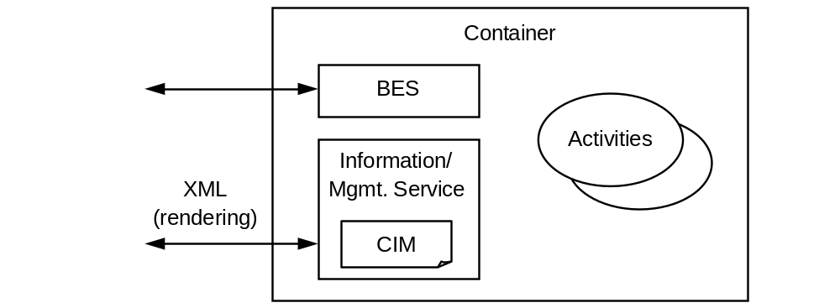
Figure 5: A simple example for the EM container and activities

Appendix: The resource management design team
The responsibility of the resource management design team is to execute and coordinate work on resource management on OGSA. This includes activities that are not exclusively related to CIM or other resource models, such as:
- Make sure that management and manageability is present in OGSA. This includes promoting the adoption of existing manageability work (e.g., JSIM and WSDM) and driving the resolution of the gaps found in the CMM-WG gap analysis.
- Make sure that OGSA follows a single framework for management and manageability, namely the framework already defined by the CMM-WG. Refine this framework where needed (e.g., for the inclusion of the GMA work).
- Use and promote CIM as a way to provide unification in OGSA (e.g., unification of concepts).
- Provide a place for consultations on resource models needed by other GGF WGs. Collaboration between these WGs and the DMTF can be initiated as a result of these consultations.
- Assign a DMTF representative to any WG working with CIM.
- Promote the adoption of software by the WBEMsource initiative.
On the short term, the design team will perform some of the work in Section Error: Reference source not found:
- Profiling CIM for use in OGSA
- Comparing CIM to existing Grid-related resource models
Conversely, the resource management design team will not do:
- Creation of extensions to CIM: these are normative, and therefore not in the scope of the OGSA-WG. This effort will be coordinated, but not conducted, by the resource management design team. Extensions to CIM should be defined by the area experts in other GGF WGs, in direct collaboration with the DMTF. This applies to both the CIM model and to its renderings.
- Define functional interfaces for resource management (e.g., execution management). These are defined by other design teams and GGF WGs.

Security Considerations
Naaaaah…

Author Information
Editor:
Frederico Buchholz Maciel
Hitachi America, Ltd., Research & Development Division
750 Central Expressway, MS: 3224
Santa Clara, CA 95050
Phone: +1 (408) 970-4833
E-mail: Fred.Maciel@hds.com
Contributors: nobody yet, not even the editor, who created this document by copy-and-paste from other sources.
Thanks to Tom Roney and to the members of the OGSA-WG, for discussions that helped improve the contents in this document.

Glossary
Huh?

Intellectual Property Statement
The GGF takes no position regarding the validity or scope of any intellectual property or other rights that might be claimed to pertain to the implementation or use of the technology described in this document or the extent to which any license under such rights might or might not be available; neither does it represent that it has made any effort to identify any such rights. Copies of claims of rights made available for publication and any assurances of licenses to be made available, or the result of an attempt made to obtain a general license or permission for the use of such proprietary rights by implementers or users of this specification can be obtained from the GGF Secretariat.
The GGF invites any interested party to bring to its attention any copyrights, patents or patent applications, or other proprietary rights which may cover technology that may be required to practice this recommendation. Please address the information to the GGF Executive Director.

Full Copyright Notice
Copyright © Global Grid Forum (2005). Portions are copyright © DMTF (2005). All Rights Reserved.
This document and translations of it may be copied and furnished to others, and derivative works that comment on or otherwise explain it or assist in its implementation may be prepared, copied, published and distributed, in whole or in part, without restriction of any kind, provided that the above copyright notice and this paragraph are included on all such copies and derivative works. However, this document itself may not be modified in any way, such as by removing the copyright notice or references to the GGF or other organizations, except as needed for the purpose of developing Grid Recommendations in which case the procedures for copyrights defined in the GGF Document process must be followed, or as required to translate it into languages other than English.
The limited permissions granted above are perpetual and will not be revoked by the GGF or its successors or assigns.
This document and the information contained herein is provided on an "AS IS" basis and THE GLOBAL GRID FORUM DISCLAIMS ALL WARRANTIES, EXPRESS OR IMPLIED, INCLUDING BUT NOT LIMITED TO ANY WARRANTY THAT THE USE OF THE INFORMATION HEREIN WILL NOT INFRINGE ANY RIGHTS OR ANY IMPLIED WARRANTIES OF MERCHANTABILITY OR FITNESS FOR A PARTICULAR PURPOSE."

References
- I. Foster et al., “The Open Grid Services Architecture, Version 1.0,” Global Grid Forum, Lemont, Illinois, U.S.A., GFD-I.30, 2005, http://www.ggf.org/documents/final.htm
- J. Treadwell (Ed.). “Open Grid Services Architecture Glossary of Terms,” Global Grid Forum, Lemont, Illinois, U.S.A., GFD-I.44, 2005, http://www.ggf.org/documents/final.htm
- I. Foster, D. Gannon, H. Kishimoto, J. J. Von Reich (Ed.). "Open Grid Services Architecture Use Cases,” Global Grid Forum, Lemont, Illinois, U.S.A., GFD-I.029, 2004, http://www.ggf.org/documents/final.htm
- Igor Sedukhin (Ed.). "Web Services Distributed Management: Management of Web Services (WSDM-MOWS) 1.0, Committee Draft," OASIS, December 2004, http://www.oasis-open.org/apps/org/workgroup/wsdm/download.php/10567/cd-wsdm-mows-1.0.pdf
- William Vambenepe (Ed.). “Web Services Distributed Management: Management Using Web Services (MUWS 1.0) Part 1, Committee Draft,” OASIS, December 2004, http://www.oasis-open.org/apps/org/workgroup/wsdm/download.php/10558/cd-wsdm-muws-part1-1.0.pdf
- William Vambenepe (Ed.). “Web Services Distributed Management: Management Using Web Services (MUWS 1.0) Part 2, Committee Draft,” OASIS, December 2004, http://www.oasis-open.org/apps/org/workgroup/wsdm/download.php/10557/cd-wsdm-muws-part2-1.0.pdf
- B. Tierney et al., "A Grid Monitoring Architecture," Global Grid Forum, Lemont, Illinois, U.S.A., GFD-I.7, January 2002, http://www.ggf.org/documents/final.htm.
- R. Aydt et al., "A Simple Case Study of a Grid Performance System," Global Grid Forum, Lemont, Illinois, U.S.A., GFD-I.8, May 2002, http://www.ggf.org/documents/final.htm.
- Hans Hrasna, “Java 2 Platform, Enterprise Edition Management Specification,” Java Community Process, JSR-77, June 2002, http://jcp.org/jsr/detail/77.jsp
- J. Brooke, D. Fellows, K. Garwood, C. Goble, “Semantic Matching of Grid Resource Descriptions,” UoM. 2nd European Across-Grids Conference (AxGrids 2004), January 2004, Cyprus, http://www.grid-interoperability.org/semres.pdf
- “Common Information Model (CIM) Specification, Version 2.2,” Distributed Management Task Force, 1999, http://www.dmtf.org/standards/documents/CIM/DSP0004.pdf
- Chris Hobbs, "A Practical Approach to WBEM/CIM Management," CRC Press, 2004, ISBN 0-8493-2306-1

The work on JSIM (Job Submission Information Model, defined by GGF’s CGS-WG) was added to the schemas of multiple areas.

