NAREGI beta2 Resource Description Schema Specification and Relational Data Model [draft]

March, 2007

Hitachi,Ltd.
Contents

NAREGI beta2 Resource Description Schema Specification and Relational Data Model [draft] 1-1
1 Introduction 1
2 NAREGI information Service 1
3 Outline of NAREGI resource description schema 2
3.1 Computer system 2
3.2 Job queue 4
3.3 Service 4
3.4 Software 4
3.5 Site location 7
3.6 Application 7
3.7 Network resource 9
3.8 VO membership 9
3.9 Log record 10
3.10 Usage record 10
4 Data model 12
4.1 Relational data representation of a CIM object 12
4.2 Inheritance 12
4.3 Association and aggregation 13
4.4 CIM datetime type 14
4.5 Array type 14
4.6 Repository schema 14
4.7 Node DB schema 15
5 Information providers in NAREGI IS 16
5.1 List of classes and information providers 16
5.2 Computer System 18
5.2.1 NRG_OperatingSystem 18
5.2.2 NRG_FileSystem 22
5.2.3 CIM_Processor 24
5.2.4 CIM_UnitaryComputerSystem 28
5.3 JobQueue and VO 29
5.3.1 NRG_ClusterJobQueue 29
5.3.2 NRG_VomsJobQueue 31
5.3.3 CIM_QueueStatisticalData 32
5.3.4 CIM_ElementStatisticalData (association) 33
5.3.5 NRG_Account 34
5.3.6 NRG_VomsAccount 35
5.3.7 NRG_AccountOnJobQueue (association) 36
5.3.8 NRG_VomsAccountOnJobQueue (association) 36
5.3.9 NRG_VomsAccountOnClusterJobQueue (association) 36
5.4 Service and Service Access Point 37
5.4.1 CIM_BatchService 37
5.4.2 CIM_SoftwareFeatureServiceImplementation (association) 38
5.4.3 NRG_GridService 38
5.4.4 CIM_ServiceAvailableToElement (association) 39
5.4.5 CIM_ServiceAccessURI 40
5.4.6 NRG_ServiceAccessPath 41
5.4.7 CIM_ServiceAccessBySAP (association) 42
5.4.8 NRG_QueueForSAP (association) 42
5.5 Software/Application 43
5.5.1 NRG_SoftwareElement 43
5.5.2 CIM_InstalledSoftwareElement (association) 44
5.5.3 CIM_SoftwareFeatureクラス 45
5.5.4 CIM_SoftwareFeatureSoftwareElements (aggregation) 46
5.5.5 CIM_ExecuteProgram 46
5.5.6 CIM_InstalledProduct 48
5.6 Cluster system and Storage 49
5.6.1 CIM_RedundancySet 49
5.6.2 CIM_MemberOfCollection (aggregation) 49
5.6.3 CIM_ComputerSystem 50
5.6.4 CIM_LogicalIdentity (association) 50
5.6.5 CIM_CollectionInOrganization (aggregation) 51
5.6.6 CIM_StorageExtent 51
5.6.7 CIM_ResidesOnExtent (association) 52
5.7 Network resource 53
5.8 VO membership 53
5.9 Log 53
5.9.1 NRG_LogRecord 53
5.9.2 NRG_JobStatusLogRecord 55
5.9.3 NRG_ConcreteJobReservationLog 56
5.10 Usage Record 58
6 NAREGI CIM extensions 62
6.1 Account and Queue 62
6.2 Path and Queue 62
6.3 Service and Service Access Point 63
6.4 Service and Account 63
6.5 OperatingSystem and SoftwareElement 64
6.6 StorageExtent and FileSystem 64
6.7 Information service 64
6.8 Network configuration 65
6.9 Network statistics 65
6.10 VOMS 66
6.11 LogRecord 66

Introduction
This document presents the resource description schema and the relational data model showing how to map the information to relational database used in NAREGI information service version beta 2. NAREGI adopts a resource information model based on CIM schema that specifies abstract and standard resource description. CIM schema is an object-oriented resource information model defined by the DMTF (Distributed Management Task Force) which provides management infrastructure components for instrumentation, control and communication in a platform-independent and technology neutral way. The schema used in NAREGI beta 2 is based on a small subset of CIM schema version 2.12 that is necessary for the resource management of research grids and extends it to support grid standards defined by the OGF such as job queue and accounting information, including information of computing systems, devices, networks, users and applications. Classes in the part of NAREGI extensions are distinguished by prefix of “NRG_” from classes defined in CIM Schema with prefix of “CIM_”.

NAREGI information Service
NAREGI information service (Fig.2-1) provides functions to manage and retrieve the resource information stored in the distributed RDBs and the search function is used by, for example, NAREGI super scheduler to select candidate sites for job execution. The information service utilizes OGSA-DAI as its information retrieval interface and accepts queries expressed by SQL with Java-API via the client toolkit.
NAREGI develops a lightweight CIMOM (CIM Object Manager) that is a grid service dealing with CIM objects to be registered to NAREGI information service, which doesn’t have full set of CIMOM operations specified by DMTF. The information provider programs managed by the CIMOM service provide resource information in the xmlCIM format for the cell domain aggregator service to collect the information from individual grid resources and decode to SQL insert expressions to the RDB.
When state of a grid resource changed, the cell domain aggregator acquires the updated resource information in the form of xmlCIM document from a CIMOM service in the cell domain, parses it, gets the updated values of attributes in the CIM object and replaces the old record corresponding to the CIM object with the same values of key properties in the DB for the latest information. On the other hand, the replaced record is retained in “repository DB” for history information of grid resources for a given period of time.
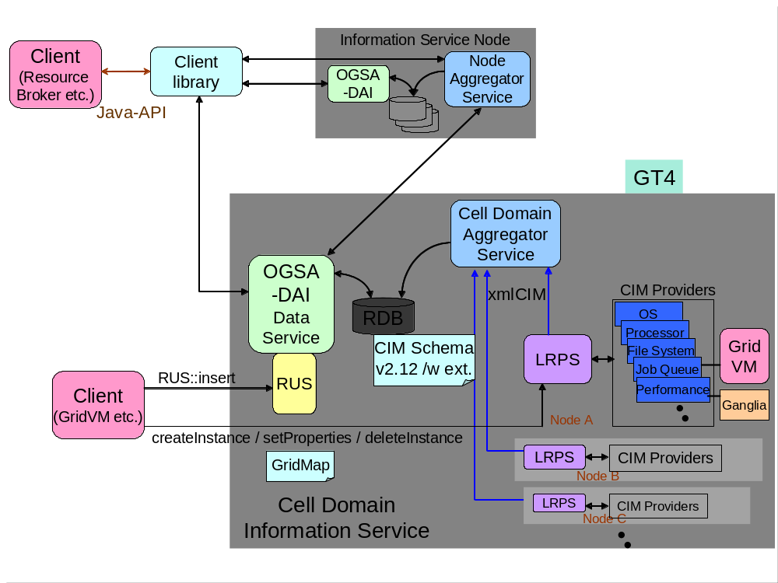
Figure 2-1 NAREGI information service

Outline of NAREGI resource description schema

Computer system
Fundamental information about computer systems is shown around CIM_UnitaryComputerSystem class. Different classes are used for the OS, processors, file system and so on related with the CIM_UnitaryComputerSystem via association or aggregation classes (Fig.3-1). Although a cluster system should be represented by CIM_RedunduncySet class as a collection of computer systems, the information service may have information only about a front-end node by deputy and omits each of computing nodes in many cases, where CIM_UnitaryComputerSystem object representing the front-end node is associated with an object of job submission service.
In the UML class diagram, information providers corresponding to classes in bold-faced type have been developed and provide values of the attributes in boldface. Purple classes and attributes mean that they were newly developed for beta 2 version (to be released in 2007), blue or purple ones are used for grid interoperation and black or blue ones were developed for beta version (released in 2006). A brown box shows that it is a class of NAREGI extensions.
Details are described in chapter 5.
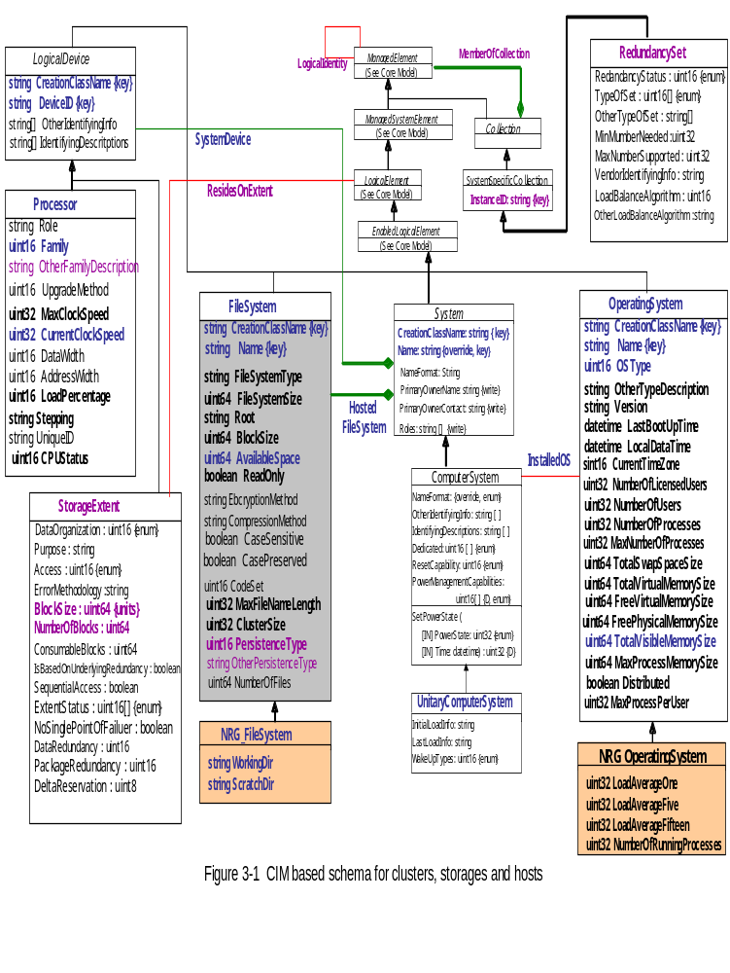

Job queue
The CIM_JobQueue class shows status and configuration of a job queue (Fig.3-2). The CIM_JobQueue is extended for representing some of the policies and parallel job executions. NRG_JobQueue class extends CIM_JobQueue and NRG_ClusterJobQueue class extends NRG_JobQueue. NRG_QueueForSAP association class is used to relate CIM_JobQueue descendants with the service access point entries of a job execution service. (It isn’t possible to represent the case that multiple queues exist in a job execution service and each of them has different access point by using CIM_HostedJobDestination, CIM_HostedService and CIM_ServiceAccessBySAP association classes.)
A virtual organization whose members can submit their jobs to the job queue is represented as a NRG_VomsAccount object and NRG_VomsAccountOnClusterQueue association class relates the queue with VO.
Not only local schedulers but also NAREGI GridVMs manage resource usage of jobs according to VO membership of submitting user. The NRG_VomsJobQueue class is used to represent the usage and the NRG_VomsAccountOnQueue association class relates it with VO.

Service
A CIM_Service object is a logical element that contains the information that is necessary to represent and manage the functionality provided by a CIM_Device or a CIM_SoftwareFeature object. The CIM_SoftwareFeature class defines a particular function or capability of a product or application system. This class captures a level of granularity describing a unit of installation, rather than the units that reflect how the product is built or packaged. CIM_SoftwareFeatures are always defined in the context of a CIM_Product, using the CIM_ProductSoftwareFeature association. Features are delivered through Products.
CIM_ServiceAccessURI represents the ability to utilize or invoke a service using a URI. In the context of a CIM_ServiceAccessPoint, a URI contains the information necessary to access an associated service (associated through CIM_ServiceAccessBySAP), using a syntax that is specific to that service.

Software
The CIM_InstalledProduct object allows the grouping of CIM_SoftwareElement and CIM_SoftwareFeature objects that represent the result of the installation of a product. CIM_InstalledProduct is defined to be associated to a CIM_Product.
All of the SoftwareElements and SoftwareFeatures of a single install are grouped by an instance of CIM_InstalledProduct. These are defined using the associations, CIM_CollectedSoftwareFeatures and CIM_CollectedSoftwareElements.

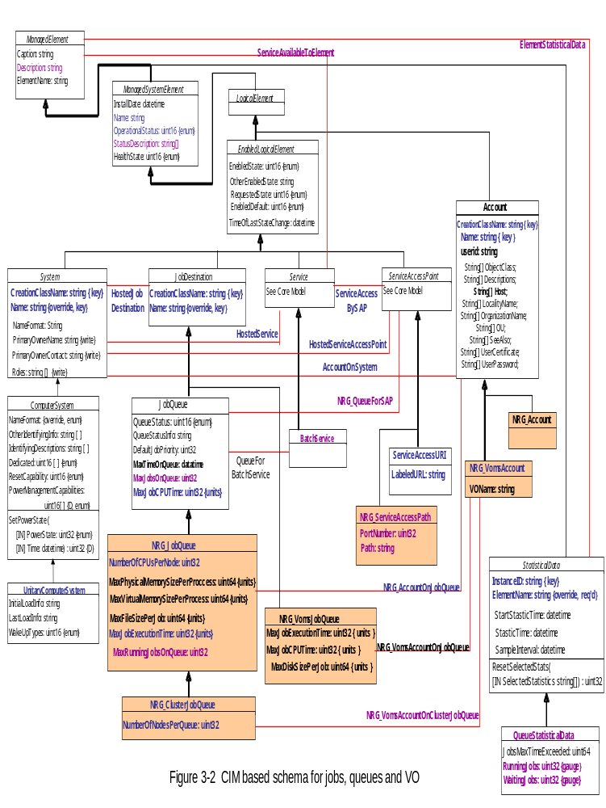

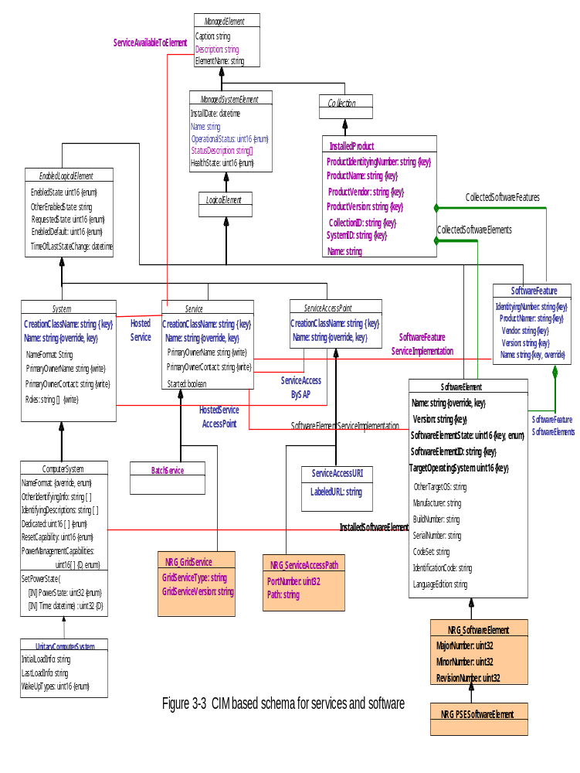

Site location
The NRG_Organization class extends CIM_Organization class to represent location coordinate of site which the cluster resides in and the Name property shows unique name of the site. The NRG_Organization object is associated with the CIM_RedundancySet object via CIM_CollectionInOrganization class.
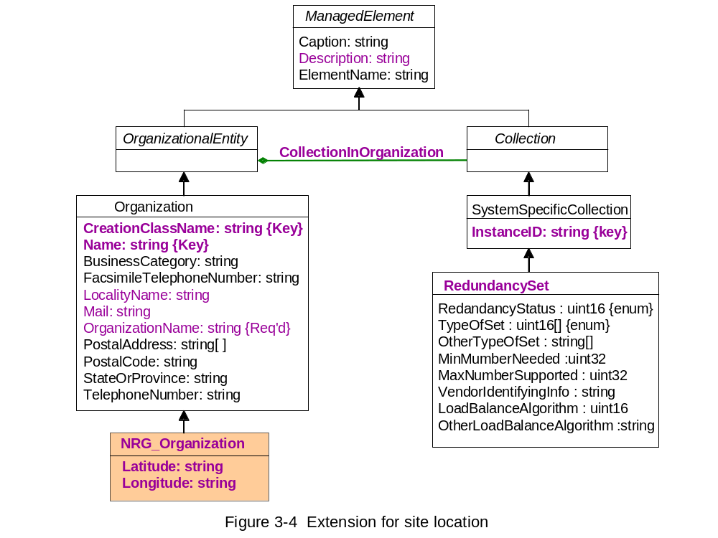

Application
NAREGI PSE registers information about deployed application to information service. Requirements of the application are described in CIM_Check descendants and CIM_Action descendants describe procedure for the application to transit to next state.

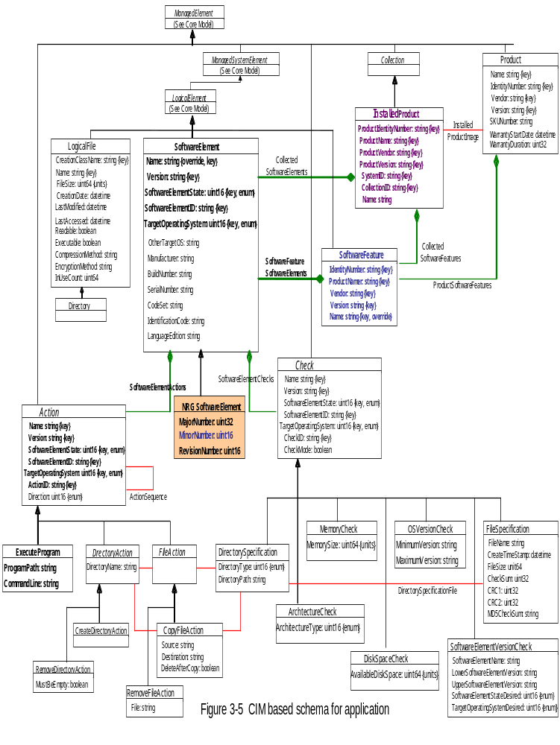

Network resource
NAREGI Network Resource Management service maintains network topology information, monitors traffic and registers the information to information service.

[delay till later]

Figure 3-6 Network

VO membership
NAREGI adopts VOMS server to define and manage membership of VOs. NAREGI information service gets Information about the membership information from VOMS servers and associates it with information about computer resources to which members of the VO have access right.

[delay till later]

Figure 3-7 VO membership

Log record
Information of logs output by NAREGI components and information about jobs handled by NAREGI middleware is classified into the classes extending CIM_LogRecord class.
For example, NAREGI middleware allows users to execute complex jobs such as coupled simulations using appropriate resources across multiple sites on the Grid and utilizes the job information registered to the information service about computing nodes reserved for a coupled simulation so that each component of the coupled simulation could know where other components are allocated by the super scheduler.
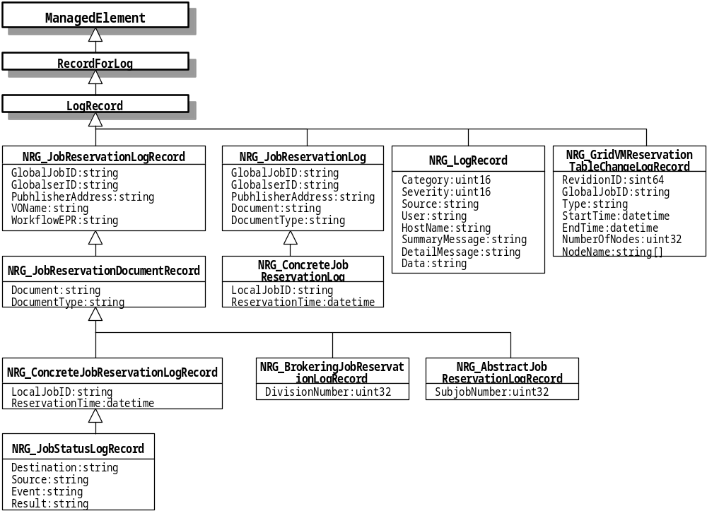Figure 3-8 Log record

Usage record
CIM_JobProcessingStatistics class is extended so as to include the Usage Record XML Schema of OGF. In NAREGI, GridVM attaches to user jobs and collects raw information of resource usage, gathers and arranges it in the form of the UR XML.
The interface to insert the usage records to information service is Resource Usage Service proposed by OGF RUS-WG and the information is classified according to our schema and is accumulated into RDB.
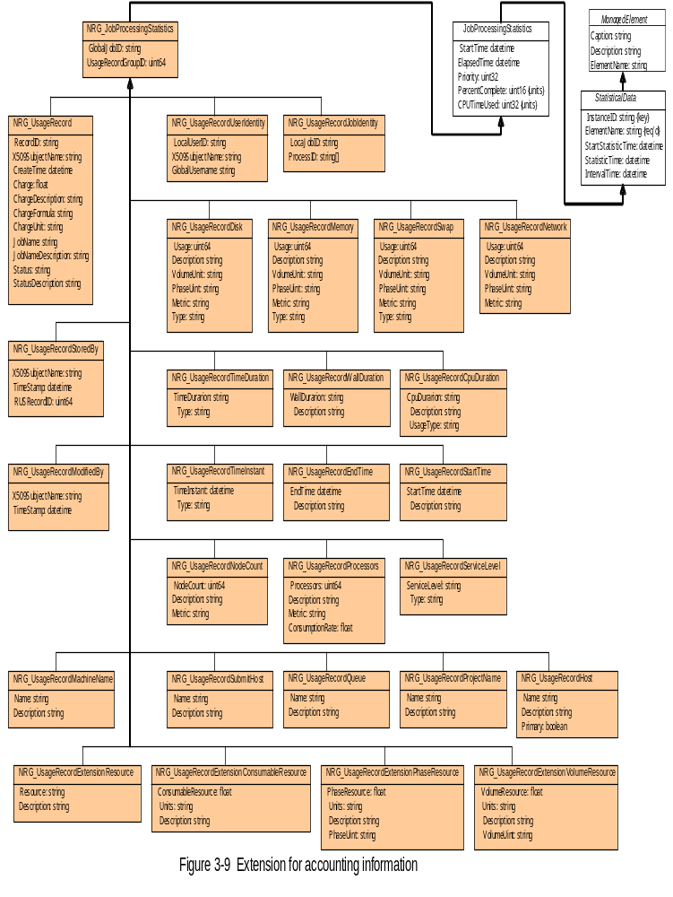

Data model

Relational data representation of a CIM object
Each CIM class corresponds to an RDB table and CIM objects of the class correspond to records in the table. So the RDB schema can be defined straightforwardly from definition of the CIM Schema subset and extension we use.
Key properties defined in each CIM class are used to distinguish the CIM objects one another. On the other hand, we define primary key: ID in all of the RDB tables as
:class name.name of key property1=value of key property1, name of key property2=value of key property2,…
in TEXT type, where names of key properties are arranged in alphabetic order. For example, ID of a CIM_UnitaryComputerSystem object has value of
“:CIM_UnitaryComputerSystem.CreationClassName=CIM_UnitaryComputerSystem,Name=png1037.naregi.org”,
where CreationClassName and Name are key properties of the CIM_UnitaryComputerSystem class. The RDB schema also defines that set of values corresponding to CIM key properities must be unique and not null.
In the tables of the repository DB, the ID is defined as
:class name.name of key property1=value of key property1, name of key property2=value of key property2,…@GMT registration time
with the time in the form of YYYY-MM-DD hh:mm:ss.micro in Grrenwich Mean Time when the record was registered.

Inheritance
PostgreSQL is used for RDB in NAREGI information service because its object oriented feature is useful for representation of the inheritance defined in CIM Schema. For example, CIM_ManagedSystemElement class extends CIM_ManagedElement class and it means that the CIM_ManagedSystemElement table has all attributes of the CIM_ManagedElement table as follows.

Attribute name | Data type
Caption | text
Description | text
ElementName | text
Table 3-1 CIM_ManagedElement table

Attribute name | Data type
Caption | text
Description | text
ElementName | text
InstallDate | timestamp(6) without timezone
Name | text
OperationalStatus | integer[]
StatusDescriptions | text[]
Status | text
Table 3-2 CIM_ManagedSystemElement table

Result of a query to the super class (e.g. SELECT * FROM “CIM_ManagedElement”;) includes objects of the sub classes (CIM_ManagedSystemElement and its sub classes). In case of excluding objects of the sub classes, ONLY is required in the FROM phrase (e.g. SELECT * FROM ONLY “CIM_ManagedElement”;).
We define db_root table as the root table, which is extended by the CIM_ManagedElement and other root classes defined in CIM Schema, so that all tables may have the ID attribute as the primary key.

Association and aggregation
An association or aggregation class in CIM Schema relates two CIM classes. It has key properties which refer to key properties of both of the CIM classes and an association or aggregation object distinguishes two objects of the CIM classes related with each other. The related CIM objects can be those of sub classes which extend the classes related by the association or aggregation class in CIM Schema definition. In the DB schema, a table corresponding to an association or aggregation class has two attributes which take values of the ID keys in two records corresponding to CIM objects related with each other. In addition to them, the ID attribute of the association or aggregation table is defined as the primary key.
For example, CIM_InstalledSoftwareElement is defined as the association class relating CIM_SoftwareElement class with CIM_ComputerSystem class in CIM Schema. Figure 3-1 shows the relation among three tables above, where CIM_UnitaryComputerSystem class is a sub class of CIM_ComputerSystem and NRG_SoftwareElement class is used as a NAREGI extension of CIM_SoftwareElement.

“Name”
abc
def
“ID”
001
002
“Version”
1.2.3
3.2.1
ghi
003
1.1.1
…
…
…
…
“NRG_SoftwareElement”
“CIM_InstalledSoftwareElement”
“Software”
“System”
430
001
002
430
“ID”
501
502

“CIM_UnitaryComputerSystem”
“CreationClassName”
“ID”
“Name”
…

CIM_UnitaryComputerSystemm
410
aaa.bb.cc
…
CIM_UnitaryComputerSystem
420
ddd.ee.ff
…

CIM_UnitaryComputerSystem
430
ggg.hh.ii
…

Figure 3-1 Representation of CIM_InstalledSoftwareElement association class

Note:
External reference restriction should be set in DBMS for reference between records as above, however, PostgreSQL doesn’t support the case of reference to an inherited record.

CIM datetime type
The datetime type is defined in CIM Schema for values of time instant or time duration. In NAREGI information service, a value in the CIM datetime type is transformed to the "TIMESTAMP (6) WITHOUT TIME ZONE" type in case of time instant and to the he "BIGINT" type in case of time duration.
A value of the time instant is represented in the form of YYYY-MM-DD hh:mm:ss.micro, where microsecond is shown by micro: 6 digit and value of the time zone is 0. A value of the time duration in the BIGINT type is the duration measured in the unit of microsecond.
Note:
Whether this time instant value is in UT1, UTC or TAI depends on the kind of time value in the CIM datetime type in so-called Greenwich mean time.

Array type
Because OGSA-DAI used for the information retrieval in NAREGI information service doesn’t support array data type, we treat it in TEXT type of the CVS (Comman Separated Value) form according to the rule as shown below.
- Each element is transformed to string type representation.
- All the elements in string representation are put in order of the array with delimiter of “,” .
- In case an element in string representation includes character “,”, whole of the element is enclosed in double quotes and a double quotation in the element enclosed in double quotes is replaced with two double quotations.

Repository schema
The latest information is stored according to “public” schema and the history information is stored according to “repository” schema in the cell domain DB.
Column 1
～
～
ID
001
002
Column 2
～
～
～
003
～
…
…
…
…
public.CIM_YYY
Column 1
～
～
ID
410
420
Column 2
～
～
～
430
～
…
…
…
…
repository.CIM_YYY
Public schema
Repository schema
～
～
440
450
～
～
～
460
～
…
…
…
～
:
～
～
:
～
…
…
Public schema(schema for the latest data)
Repository schema(schema for history data)
Database
Figure 3-2 Accumulation of history information

A CIM object delivered from a CIMOM service is used to update data in both of the schema. In case there is a record with the same key value as the key of the new record generated from the CIM object in the table of the public schema, the existing record is replaced with the new one. In terms of the repository schema, the new record is inserted to the corresponding table, where the key value of ID includes registration time even though the new CIM object has the same values of key properties as those of the same class previously registered.

Node DB schema
The repository schema is only defined in the cell domain DB and not defined in “node DB” in the upper layer of the hierarchical configuration of NAREGI information service (Fig.2-1).
Schema for accounting information is in the part of NAREGI extensions, where classes in the schema are sub classes of CIM_JobProcessingStatistics class. The DB schema for accounting information is only defined in the cell domain DB and not defined in node DB in the upper layer.

Information providers in NAREGI IS

List of classes and information providers
Table 5-1 shows list of classes and information providers we developed. There are information providers which provide values of the attributes about resources managed by NAREGI middleware and those which retrieve information from BDII with translator function. With respect to the classes without the corresponding information provider, another components in NAREGI register values of the attributes.

Table 5-1 List of classes and information providers
Class name | Information provider of NAREGI resources | Information providers with BDII translator
CIM_AuthorizedTarget | ✔
CIM_BatchService | ✔ | ✔
CIM_CollectionInOrganization | ✔ | ✔
CIM_ComputerSystem | ✔ | ✔
CIM_ContainedDomain
CIM_ElementStatisticalData | ✔ | ✔
CIM_ExecuteProgram
CIM_FileSystem |  | ✔
CIM_InstalledProduct | ✔ | ✔
CIM_InstalledSoftwareElement | ✔ | ✔
CIM_LogicalIdentity | ✔ | ✔
CIM_MemberOfCollection | ✔ | ✔
CIM_Processor | ✔ | ✔
CIM_QueueStatisticalData | ✔ | ✔
CIM_RedundancySet | ✔ | ✔
CIM_ResidesOnExtent | ✔ | ✔
CIM_ServiceAccessBySAP | ✔ | ✔
CIM_ServiceAccessURI | ✔ | ✔
CIM_ServiceAvailableToElement | ✔ | ✔
CIM_SoftwareFeature | ✔ | ✔
CIM_SoftwareFeatureServiceImplementation | ✔ | ✔
CIM_SoftwareFeatureSoftwareElements
CIM_StorageExtent | ✔ | ✔
CIM_SystemAdministrator | ✔
CIM_SystemAdministratorRole | ✔
CIM_UnitaryComputerSystem | ✔ | ✔
CIM_PolicyRule | ✔
CIM_VendorPolicyCondition | ✔
CIM_VendorPolicyAction | ✔
NRG_AbstractJobReservationLogRecord
NRG_Account | ✔
NRG_AccountOnJobQueue | ✔
NRG_AuthorizedPrivilege | ✔
NRG_AuthorizedPrivilegePerson | ✔
NRG_AuthorizedPrivilegeRole | ✔
NRG_BrokeringJobReservationLogRecord
NRG_ClusterJobQueue | ✔ | ✔
NRG_ConcreteJobReservationLog
NRG_ConcreteJobReservationLogRecord
NRG_EndpointOfNetworkFlow
NRG_FileSystem | ✔
NRG_FlowOnPipe
NRG_GridService | ✔ | ✔
NRG_GridVMReservationTableChangeLogRecord
NRG_JobReservationDocumentRecord
NRG_JobReservationLogRecord
NRG_JobStatusLogRecord
NRG_LogRecord | ✔
NRG_Mcd
NRG_NetworkFlow
NRG_NetworkFlowStatistics
NRG_NetworkPipe
NRG_NetworkPipeBandwidthStats
NRG_NetworkPipeDelayStats
NRG_NetworkPipeJitterStats
NRG_NetworkPipePacketLossStats
NRG_NetworkPipeStatistics
NRG_NetworkPortStatistics
NRG_Node
NRG_OperatingSystem | ✔ | ✔
NRG_Organization | ✔ | ✔
NRG_Person | ✔
NRG_QueueForSAP | ✔ | ✔
NRG_Rcd
NRG_RelayPointOfNetworkPipe
NRG_Role | ✔
NRG_Scd
NRG_ServiceAccessPath | ✔ | ✔
NRG_SoftwareElement | ✔ | ✔
NRG_SwitchPortStatistics
NRG_TCPProtocolEndpoint
NRG_UDPProtocolEndpoint
NRG_VomsAccount | ✔ | ✔
NRG_VomsAccountOnClusterJobQueue | ✔ | ✔
NRG_VomsAccountOnJobQueue | ✔
NRG_VomsJobQueue | ✔

Computer System

NRG_OperatingSystem
CIM_OperatiingSystem class describes operating system on a computer system and NRG_OperatingSystem extends it to show load average information. The MOF file (textual description of a CIM class) is shown below.

class NRG_OperatingSystem : CIM_OperatingSystem {
real32 LoadAverageOne;
real32 LoadAverageFive;
real32 LoadAverageFifteen;
uint32 NumberOfRunningProcesses;
};
class CIM_OperatingSystem : CIM_EnabledLogicalElement {
string CSCreationClassName;
string CSName;
string CreationClassName;
string Name;
uint16 OSType;
string OtherTypeDescription;
string Version;
datetime LastBootUpTime;
datetime LocalDateTime;
sint16 CurrentTimeZone;
uint32 NumberOfLicensedUsers;
uint32 NumberOfUsers;
uint32 NumberOfProcesses;
uint32 MaxNumberOfProcesses;
uint64 TotalSwapSpaceSize;
uint64 TotalVirtualMemorySize;
uint64 FreeVirtualMemory;
uint64 FreePhysicalMemory;
uint64 TotalVisibleMemorySize;
uint64 SizeStoredInPagingFiles;
uint64 FreeSpaceInPagingFiles;
uint64 MaxProcessMemorySize;
boolean Distributed;
uint32 MaxProcessesPerUser;
};

The NRG_OperatingSystem information provider of NAREGI resources provides values of the following properties.
(1) CSCreationClassName
Type: string
Key
Propagated from CIM_ComputerSystem.CreationClassName
MaxLen: 256
The scoping ComputerSystem’s CreationClassName.

(2) CSName
Type: string
Key
Propagated from CIM_ComputerSystem.Name
MaxLen: 256
The scoping ComputerSystem’s Name.

(3) CreationClassName
Type: string
Key
MaxLen: 256
The name of the class or the subclass used in the creation of an instance.

(4) Name
Type: string
Key
MaxLen: 256
The name serves as key of an OperatingSystem instance within a ComputerSystem.

(5) OSType
Type: uint16
A value indicating the type of operating system, where the value map is defined in Table 5-2.
Table 5-2 Value map of CIM_OperationSystem.OSType
value | OS Type | value | OS Type
0 | Unknown | 36 | LINUX
1 | Other | 37 | Lynx
2 | MACOS | 38 | XENIX
3 | ATTUNIX | 39 | VM
4 | DGUX | 40 | Interactive UNIX
5 | DECNT | 41 | BSDUNIX
6 | Tru64 UNIX | 42 | FreeBSD
7 | OpenVMS | 43 | NetBSD
8 | HPUX | 44 | GNU Hurd
9 | AIX | 45 | OS9
10 | MVS | 46 | MACH Kernel
11 | OS400 | 47 | Inferno
12 | OS/2 | 48 | QNX
13 | JavaVM | 49 | EPOC
14 | MSDOS | 50 | IxWorks
15 | WIN3x | 51 | VxWorks
16 | WIN95 | 52 | MiNT
17 | WIN98 | 53 | BeOS
18 | WINNT | 54 | HP MPE
19 | WINCE | 55 | NextStep
20 | NCR3000 | 56 | PalmPilot
21 | NetWare | 57 | Rhapsody
22 | OSF | 58 | Windows 2000
23 | DC/OS | 59 | Dedicated
24 | Reliant UNIX | 60 | OS/390
25 | SCO UnixWare | 61 | VSE
26 | SCO OpenServer | 62 | TPF
27 | Sequent | 63 | Windows (R) Me
28 | IRIX | 64 | Caldera Open UNIX
29 | Solaris | 65 | OpenBSD
30 | SunOS | 66 | Not Applicable
31 | U6000 | 67 | Windows XP
32 | ASERIES | 68 | z/OS
33 | HP NonStop OS | 69 | Microsoft Windows Server 2003
34 | HP NonStop OSS | 70 | Microsoft Windows Server 2003  64-Bit
35 | BS2000 | 70 | Microsoft Windows Server 2003  64-Bit

(6) OtherTypeDescription
Type: string
MaxLen: 64
A string describing the manufacturer and OS type used when the OperatingSystem.OSType is set to 1 or 59 ("Other" or "Dedicated"). It should be set to NULL when OSType is any value other than 1 or 59.

(7) Version
Type: string
A string describing the operating system’s version number. The format is as follows:
<Major Number>.<Minor Number>.<Revision>
<Major Number>.<Minor Number>.<Revision Letter>

(8) LastBootUpTime
Type: datetime
Time when the OS was last booted.

(9) LocalDateTime
Type: datetime
OS’s notion of the local date and time of day.

(10) CurrentTimeZone
Type: sint32
The number of minutes the OS is offset from Greenwich Mean Time.

(11) NumberOfUsers
Type: uint32
The number of user sessions.

(12) NumberOfProcesses
Type: uint32
The number of processes currently loaded or running on the OS.

(13) TotalSwapSpaceSize
Type: uint64
Unit: KBytes
Total swap space in Kbytes.

(14) TotalVirtualMemorySize
Type: uint64
Unit: KBytes
Number of Kbytes of virtual memory. For example, this may be calculated by adding the amount of total RAM to the amount of paging space.

(15) FreeVirtualMemory
Type: uint64
Unit: KBytes
Number of Kbytes of virtual memory currently unused and available.

(16) FreePhysicalMemory
Type: uint64
Unit: KBytes
Number of Kbytes of physical memory currently unused and available.

(17) TotalVisibleMemorySize
Type: uint64
Unit: KBytes
Total amount of physical memory in Kbytes available to the OS.

(18) LoadAverageOne
Type: real32
Load average during the last one minute.

(19) LoadAverageFive
Type: real32
Load average during the last five minutes.

(20) LoadAverageFifteen
Type: real32
Load average during the last fifteen minutes.

NRG_FileSystem
CIM_FileSystem class describes a file store local to a System or remotely mounted from a file server.
NRG_FileSystem extends it to show information of working directory and scratch directory for job execution. The MOF file is shown below.

class NRG_Fileystem : CIM_FileSystem {
string WorkingDir;
string ScratchDir;
};
class CIM_FileSystem : CIM_EnabledLogicalElement {
string CSCreationClassName;
string CSName;
string CreationClassName;
string Name;
string Root;
uint64 BlockSize;
uint64 FileSystemSize;
uint64 AvailableSpace;
boolean ReadOnly;
string EncryptionMethod;
string CompressionMethod;
boolean CaseSensitive;
boolean CasePreserved;
uint16 CodeSet[];
uint32 MaxFileNameLength;
uint32 ClusterSize;
string FileSystemType;
uint16 PersistenceType;
string OtherPersistenceType;
uint64 NumberOfFiles;
uint16 IsFixedSize;
uint64 ResizeIncrement;
};

The CIM_FileSystem information provider of NAREGI resources provides values of the following properties.
(1) CSCreationClassName
Type: string
Key
Propagated from CIM_System.CreationClassName (CIM_ComputerSystem class is derived from CIM_System class)
MaxLen: 256
The scoping System’s CreationClassName.

(2) CSName
Type: string
Key
Propagated from CIM_System.Name
MaxLen: 256
The scoping System’s Name.

(3) CreationClassName
Type: string
Key
MaxLen: 256
The name of the class or the subclass used in the creation of an instance.

(4) Name
Type: string
Key
MaxLen: 256
The name serves as key of a FileSystem instance within a System.

(5) Root
Type: string
Path name or other information defining the root of the FileSystem.

(6) FileSystemSize
Type: uint64
Unit: Bytes
Total size of the FileSystem in bytes. If unknown, enter 0.

(7) AvailableSpace
Type: uint64
Unit: Bytes
Total amount of free space for the FileSystem in bytes. If unknown, enter 0.

(8) PersistenceType
Type: uint16
An enumerated value representing the FileSystem's perception of its own persistence characteristics.
Table 5-3 Value map of CIM_FileSystem.PersistenceType
Value | Persistence type
0 | Unknown
1 | Other
2 | Persistent
3 | Temporary
4 | External

(9) WorkingDir
Type: string
Path information of the working directory in case the system administrator specifies it.

(10) ScratchDir
Type: string
Path information of the scratch directory in case the system administrator specifies it.

CIM_Processor
CIM_Processor class describes capabilities and management of the processor as a logical device on a system. It extends CIM_LogicalDevice class and inherits the key properties. The MOF file is shown below.

class CIM_Processor : CIM_LogicalDevice {
string Role;
uint16 Family;
string OtherFamilyDescription;
uint16 UpgradeMethod;
uint32 MaxClockSpeed;
uint32 CurrentClockSpeed;
uint16 DataWidth;
uint16 AddressWidth;
uint16 LoadPercentage;
string Stepping;
string UniqueID;
uint16 CPUStatus;
};

The CIM_Processor information provider of NAREGI resources provides values of the following properties.
(1) SystemCreationClassName
Type: string
Key
Propagated from CIM_System.CreationClassName and inherited from CIM_LogicalDevice
MaxLen: 256
The scoping System’s CreationClassName.

(2) SystemName
Type: string
Key
Propagated from CIM_System.Name and inherited from CIM_LogicalDevice
MaxLen: 256
The scoping System’s Name.

(3) CreationClassName
Type: string
Key
Inherited from CIM_LogicalDevice
MaxLen: 256
The name of the class or the subclass used in the creation of an instance.

(4) DeviceID
Type: string
Inherited from CIM_LogicalDevice
Key
MaxLen: 64
An address or other identifying information used to uniquely name the processor within a System.

(5) Family
Type: uint16
A value indicating the processor family type, where the value map is defined in Table 5-4.
Table 5-4 Value map of CIM_Processor.Family
Value | Processor Family Type
1 | Other
2 | Unknown
3 | 8086
4 | 80286
5 | 80386
6 | 80486
7 | 8087
8 | 80287
9 | 80387
10 | 80487
11 | Pentium(R) brand
12 | Pentium(R) Pro
13 | Pentium(R) II
14 | Pentium(R) processor with MMX(TM) technology
15 | Celeron（TM)
16 | Pentium(R) II Xeon(TM)
17 | Pentium(R) III
18 | M1 Family
19 | M2 Family
24 | K5 Family
25 | K6 Family
26 | K6-2
27 | K6-3
28 | AMD Athlon(TM) Processor Family
29 | AMD(R) Duron(TM) Processor
30 | AMD29000 Family
31 | K6-2+
32 | Power PC Family
33 | Power PC 601
34 | Power PC 603
35 | Power PC 603+
36 | Power PC 604
37 | Power PC 620
38 | Power PC X704
39 | Power PC 750
48 | Alpha Family
49 | Alpha 21064
50 | Alpha 21066
51 | Alpha 21164
52 | Alpha 21164PC
53 | Alpha 21164a
54 | Alpha 21264
55 | Alpha 21364
64 | MIPS Family
65 | MIPS R4000
66 | MIPS R4200
67 | MIPS R4400
68 | MIPS R4600
69 | MIPS R10000
80 | SPARC Family
81 | SuperSPARC
82 | microSPARC II
83 | microSPARC IIep
84 | UltraSPARC
85 | UltraSPARC II
86 | UltraSPARC IIi
87 | UltraSPARC III
88 | UltraSPARC IIIi
96 | 68040
97 | 68xxx Family
98 | 68000
99 | 68010
100 | 68020
101 | 68030
112 | Hobbit Family
120 | Crusoe(TM) TM5000 Family
121 | Crusoe(TM) TM3000 Family
128 | Weitek
130 | Itanium(TM) Processor
144 | PA-RISC Family
145 | PA-RISC 8500
146 | PA-RISC 8000
147 | PA-RISC 7300LC
148 | PA-RISC 7200
149 | PA-RISC 7100LC
150 | PA-RISC 7100
160 | V30 Family
176 | Pentium(R) III Xeon(TM)
177 | Pentium(R) III Processor with Intel(R) SpeedStep(TM) Technology,
178 | Pentium(R) 4
179 | Intel(R) Xeon(TM)
180 | AS400 Family
181 | Intel(R) Xeon(TM) processor MP
182 | AMD Athlon(TM) XP Family
183 | AMD Athlon(TM) MP Family,
184 | Intel(R) Itanium(R) 2,
185 | Intel(R) Pentium(R) 4 processor with HT Technology,
190 | K7
200 | S/390 and zSeries Family
201 | ESA/390 G4,
202 | ESA/390 G5,
203 | ESA/390 G6
204 | z/Architectur base
250 | i860
251 | i960
260 | SH-3
261 | SH-4
280 | ARM
281 | StrongARM
300 | 6x86
301 | MediaGX
302 | MII
320 | WinChip
350 | DSP
500 | Video Processor

(6) OtherFamilyDescription
Type: string
A string that describes the processor family type It is used when the Family property is set to 1 (“Other”). This string should be set to NULL when the Family property is any value other than 1.

(6) MaxClockSpeed
Type: uint32
Unit: MHｚ
The maximum speed (in MHz) of this processor.

(7) CurrentClockSpeed
Type: uint32
Unit: MHｚ
The current speed (in MHz) of this processor.

(8) LoadPercentage
Type: uint16
Unit: Percent
Loading of this processor, averaged over the last minute.

CIM_UnitaryComputerSystem
CIM_UnitaryComputerSystem class is derived from CIM_ComputerSystem and CIM_System class. It represents a server, desktop, mobile or other type of a single node computer system.
The CIM_UnitaryComputerSystem information provider of NAREGI resources provides values of the following properties.
(1) CreationClassName
Type: string
Key
Inherited from CIM_System
MaxLen: 256
The name of the class or the subclass used in the creation of an instance.

(2) Name
Type: string
Key
Inherited from CIM_System
MaxLen: 256
The name serves as key of a System instance.

JobQueue and VO

NRG_ClusterJobQueue
NRG_ClusterJobQueue class is a subclass of NRG_JobQueue, CIM_JobQueue and CIM_JobDestination class. It represents status and configuration of a batch queue hosted on a System to which a parallel job can be submitted.
The NRG_ClusterJobQueue information provider of NAREGI resources provides values of the following properties.
(1) SystemCreationClassName
Type: string
Key
Propagated from CIM_System.CreationClassName and inherited from CIM_JobDestination
MaxLen: 256
The scoping System’s CreationClassName.

(2) SystemName
Type: string
Key
Propagated from CIM_System.Name and inherited from CIM_JobDestination
MaxLen: 256
The scoping System’s Name.

(3) CreationClassName
Type: string
Key
Inherited from CIM_JobDestination
MaxLen: 256
The name of the class or the subclass used in the creation of an instance.

(4) Name
Type: string
Key
Inherited from CIM_JobDestination
MaxLen: 256
The name serves as key of a JobDestination instance in a System.

(5) MaxJobCPUTime
Type: uint32
Unit: MiliSeconds
Maximum limit of total CPU time usage in a job execution.

(6) MaxJobExecutionTime
Type: uint32
Unit: Seconds
Maximum limit of wall time in a job execution.

(7) NumberOfCPUsPerNode
Type: uint32
Number of CPUs per computing node.

(8) NumberOfNodesPerQueue
Type: uint32
Maximum number of allocated nodes for a job.

(9) MaxPhysicalMemorySizePerProcess
Type: uint64
Unit: KBytes
Physical memory capacity per process.

(10) MaxVirtualMemorySizePerProcess
Type: uint64
Unit: KBytes
Virtual memory capacity per process.

(11) MaxFileSizePerJob
Type: uint64
Unit: Byte
Maximum file creation size per job.

(12) OperationalStatus
Type: uint16
Inherited from CIM_ManagedSystemElement
A value indicating the queue status, where the value map is defined in Table 5-5.
Table 5-5 Value map of CIM_ManagedSystemElement.OperationalStatus
Value | Queue status | Value | Queue status
0 | Unknown | 11 | In Service
1 | Other | 12 | No contact
2 | OK | 13 | Lost Communication
3 | Degraded | 14 | Aborted
4 | Stressed | 15 | Dormant
5 | Predictive Failure | 16 | Supporting Entity in  Error
6 | Error | 16 | Supporting Entity in  Error
7 | Non-Recoverable Error | 17 | Completed
8 | Starting | 18 | Power Mode
9 | Stopping | 19 – 0x7FFF | DMTF Reserved
10 | Stopped | 0x8000 – 0xFFFF | Vendor Reserved

NRG_VomsJobQueue
NRG_VomsJobQueue class is derived from CIM_JobDestination class and it represents resource usage policies for a job execution submitted by a member of a VO. The policies are enforced by NAREGI GridVM working on a System with local scheduler managing the queue. The VO of which the GridVM controls resource usage is shown as a NRG_VomsAccount instance related with the NRG_VomsJobQueue instance via NRG_VomsAccountOnJobQueue association class.
The NRG_VomsJobQueue information provider of NAREGI resources provides values of the following properties.

SystemCreationClassName
Type: string
Key
Propagated from CIM_System.CreationClassName and inherited from CIM_JobDestination
MaxLen: 256
The scoping System’s CreationClassName.

SystemName
Type: string
Key
Propagated from CIM_System.Name and inherited from CIM_JobDestination
MaxLen: 256
The scoping System’s Name.

CreationClassName
Type: string
Key
Inherited from CIM_JobDestination
MaxLen: 256
The name of the class or the subclass used in the creation of an instance.

Name
Type: string
Key
Inherited from CIM_JobDestination
MaxLen: 256
The name serves as key of a JobDestination instance in a System.

MaxJobExecutionTime
Type: unit32
Unit: Seconds
Maximum limit of wall time allowed for a job execution submitted by a member of the VO related with a NRG_VomsJobQueue via a NRG_VomsAccountOnJobQueue.

MaxJobCPUTime
Type: unit32
Unit: MiliSeconds
Maximum limit of total CPU time usage allowed for a job execution submitted by a member of the VO.

MaxDiskSizePerJob
Type: unit64
Unit: Bytes
Maximum file creation size for a job execution submitted by a member of the VO.

CIM_QueueStatisticalData
The statistical data of a JobQueue. An instance of this class is associated with a specific JobQueue using the inherited ElementStatisticalData relationship.
The CIM_ QueueStatisticalData information provider of NAREGI resources provides values of the following properties.

InstanceID
Type: string
Key
Inherited from CIM_StatisticalData
Within the scope of the instantiating Namespace, InstanceID opaquely and uniquely identifies an instance of this class, e.g. “cd_pbg1051.naregi.org_q_pbg2048_0”.

ElementName
Type: string
Required
Inherited from CIM_ StatisticalData
MaxLen: 256
The user friendly name for this instance.

RunningJobs
Type: uint32
The number of jobs in the running state for the related Queue.

WaitingJobs
Type: uint32
The number of jobs waiting to be put in the running state for the related Queue.

CIM_ElementStatisticalData (association)
CIM_ElementStatisticalData is an association that relates a ManagedElement to its StatisticalData, where CIM_ManagedElement class is top of the inheritance tree for non-association classes and the ManagedElement is a JobQueue instance in case of relating a QueueStatisticalData with the JobQueue.

ManagedElement
Type: reference
Key
Cardinality: Min(1), Max(1)
The ManagedElement for which statistical or metric data is defined.

Stats
Type: reference
Key
The statistic information.

NRG_Account
NRG_Account class is derived from CIM_Account class and it represents local account information which is retrieved by getpwent() on a System and the relationship with global distinguished name of users listed in gridmap-file of Globus Toolkit on the System.
The NRG_Account information provider of NAREGI resources provides values of the following properties.

SystemCreationClassName
Type: string
Key
Propagated from CIM_System.CreationClassName and inherited from CIM_Account
MaxLen: 256
The scoping System’s CreationClassName.

SystemName
Type: string
Key
Propagated from CIM_System.Name and inherited from CIM_Account
MaxLen: 256
The scoping System’s Name.

CreationClassName
Type: string
Key
Inherited from CIM_Account
MaxLen: 256
The name of the class or the subclass used in the creation of an instance.

Name
Type: string
Key
Inherited from CIM_Account
MaxLen: 1024
Local user ID which is pw_name field of the passwd struct retrieved by getpwent() or global distinguished name of a user listed in the gridmap-file.

UserID
Type: string
Inherited from CIM_Account
MaxLen: 256
Local user ID which is pw_name field of the passwd struct retrieved by getpwent() or local user ID in the gridmap-file corresponding to the global name shown in the Name property.

Host
Type: string[]
Inherited from CIM_Account
The host name of the Systems for which the account applies.

NRG_VomsAccount
NRG_VomsAccount class is derived from CIM_Account class and it represents VO membership of users who may have access right to a System.
The NRG_VomsAccount information provider of NAREGI resources provides values of the following properties.

SystemCreationClassName
Type: string
Key
Propagated from CIM_System.CreationClassName and inherited from CIM_Account
MaxLen: 256
The scoping System’s CreationClassName.

SystemName
Type: string
Key
Propagated from CIM_System.Name and inherited from CIM_Account
MaxLen: 256
The scoping System’s Name.

CreationClassName
Type: string
Key
Inherited from CIM_Account
MaxLen: 256
The name of the class or the subclass used in the creation of an instance.

Name
Type: string
Key
Inherited from CIM_Account
MaxLen: 1024
The VO membership of users who may have access right to the System. The VO membership is described in the form of FQAN(Fully Qualified Attribute Name) in VOMS:
/VO[/group[/subgroup(s)]][/Role=role][/Capability=cap]

VOName
Type: string
Name of the VO. In case the membership has neither group, role nor capability, VOName is obtained by removing “/” from value of the Name property.

NRG_AccountOnJobQueue (association)
An association between a NRG_JobQueue and an Account with access right to submit jobs to the JobQueue.
The NRG_AccountOnJobQueue information provider of NAREGI resources provides values of the following properties.

Antecedent
Type: reference
Key
The JobQueue .

Dependent
Type: reference
Key
An Account with access right to submit jobs to a JobQueue.

NRG_VomsAccountOnJobQueue (association)
An association between a NRG_VomsJobQueue and a NRG_VomsAccount for which policies shown in the NRG_VomsJobQueue are applied.
The NRG_AccountOnJobQueue information provider of NAREGI resources provides values of the following properties.

Antecedent
Type: reference
Key
The NRG_VomsJobQueue.

Dependent
Type: reference
Key
A NRG_VomsAccount for which policies shown in a NRG_VomsJobQueue are applied.

NRG_VomsAccountOnClusterJobQueue (association)
NRG_VomsAccountOnClusterJobQueue class is derived from NRG_AccountOnJobQueue class and it represents an association between a NRG_ClusterJobQueue and VO membership shown as a NRG_VomsAccount with access right to submit jobs to the JobQueue.
The NRG_VomsAccountOnClusterJobQueue information provider of NAREGI resources provides values of the following properties.

Antecedent
Type: reference
Key
The NRG_ClusterJobQueue.

Dependent
Type: reference
Key
A NRG_VomsAccount with access right to submit jobs to a NRG_ClusterJobQueue.

Service and Service Access Point

CIM_BatchService
CIM_BatchService class is derived from CIM_Service class and it represents the Service hosted on a System that provides support for processing batch job requests.
The CIM_BatchService information provider of NAREGI resources provides values of the following properties.

SystemCreationClassName
Type: string
Key
Propagated from CIM_System.CreationClassName and inherited from CIM_Service
MaxLen: 256
The CreationClassName of the scoping System.

SystemName
Type: string
Key
Propagated from CIM_System.Name and inherited from CIM_Service
MaxLen: 256
The Name of the scoping System.

CreationClassName
Type: string
Key
Inherited from CIM_Service
MaxLen: 256
The name of the class or the subclass used in the creation of an instance.

Name
Type: string
Key
Inherited from CIM_Service
MaxLen: 256
The name property uniquely identifies the Service and provides an indication of the functionality.

OperationalStatus
Type: uint16
Inherited from CIM_ManagedSystemElement
A value indicating status of the batch service, where the value map is defined in Table 5-5.

CIM_SoftwareFeatureServiceImplementation (association)
An association between a Service and how it is implemented in software.
The CIM_SoftwareFeatureServiceImplementation information provider of NAREGI resources provides values of the following properties.

Antecedent
Type: reference
Key
The SoftwareFeature implementing the Service.

Dependent
Type: reference
Key
The Service being implemented.

NRG_GridService
NRG_GridService class is derived from CIM_Service class and it represents the Service hosted on a System that provides a function to realize grid computing environment.
The NRG_GridService information provider of NAREGI resources provides values of the following properties.

SystemCreationClassName
Type: string
Key
Propagated from CIM_System.CreationClassName and inherited from CIM_Service
MaxLen: 256
The CreationClassName of the scoping System.

SystemName
Type: string
Key
Propagated from CIM_System.Name and inherited from CIM_Service
MaxLen: 256
The Name of the scoping System.

CreationClassName
Type: string
Key
Inherited from CIM_Service
MaxLen: 256
The name of the class or the subclass used in the creation of an instance.

Name
Type: string
Key
Inherited from CIM_Service
MaxLen: 256
The name property uniquely identifies the Service and provides an indication of the functionality.

GridServiceVersion
Type: string
A string describing the grid service’s version number. The format is as follows:
<Major Number>.<Minor Number>.<Revision>

OperationalStatus
Type: uint16
Inherited from CIM_ManagedSystemElement
A value indicating status of the grid service, where the value map is defined in Table 5-5.

CIM_ServiceAvailableToElement (association)
CIM_ServiceAvailableToElement conveys the semantics of a Service thay is available for the use of a ManagedElement, where CIM_ManagedElement class is top of the inheritance tree for non-association classes.
The CIM_ServiceAvailableToElement information provider of NAREGI resources provides values of the following properties.

ServiceProvided
Type: reference
Key
The Service that is available.

UserOfService
Type: reference
Key
The ManagedElement that can use the Service.

CIM_ServiceAccessURI
CIM_ServiceAccessURI class is derived from CIM_ServiceAccessPoint class and it represents the ability to utilize or invoke a Service using a URI which contains the information necessary to access the Service associated with the ServiceAccessURI through CIM_ServiceAccessBySAP class.
The CIM_ServiceAccessURI information provider of NAREGI resources provides values of the following properties.

SystemCreationClassName
Type: string
Key
Propagated from CIM_System.CreationClassName and inherited from CIM_ServiceAccessPoint
MaxLen: 256
The CreationClassName of the scoping System.

SystemName
Type: string
Key
Propagated from CIM_System.Name and inherited from CIM_ServiceAccessPoint
MaxLen: 256
The Name of the scoping System.

CreationClassName
Type: string
Key
Inherited from CIM_ServiceAccessPoint
MaxLen: 256
The name of the class or the subclass used in the creation of an instance.

Name
Type: string
Key
Inherited from CIM_ServiceAccessPoint
MaxLen: 256
The name property uniquely identifies the ServiceAccessPoint and provides an indication of the functionality.

LabeledURI
Type: string
Required
MaxLen: 256
URI to utilize or invoke a Service associated with the ServiceAccessURI through CIM_ServiceAccessBySAP class. The Labeled URI property is based on RFC 2079.

NRG_ServiceAccessPath
NRG_ServiceAccessPath class is derived from CIM_ServiceAccessPoint class and it represents the ability to utilize or invoke a Service using host name, port number and path information, for example, to show prews-GRAM contact string. It contains the information necessary to access the Service associated with the ServiceAccessPath through CIM_ServiceAccessBySAP class.
The NRG_ServiceAccessPath information provider of NAREGI resources provides values of the following properties.

SystemCreationClassName
Type: string
Key
Propagated from CIM_System.CreationClassName and inherited from CIM_ServiceAccessPoint
MaxLen: 256
The CreationClassName of the scoping System.

SystemName
Type: string
Key
Propagated from CIM_System.Name and inherited from CIM_ServiceAccessPoint
MaxLen: 256
The Name of the scoping System.

CreationClassName
Type: string
Key
Inherited from CIM_ServiceAccessPoint
MaxLen: 256
The name of the class or the subclass used in the creation of an instance.

Name
Type: string
Key
Inherited from CIM_ServiceAccessPoint
MaxLen: 256
The name property uniquely identifies the ServiceAccessPoint and provides an indication of the functionality.

PortNumber
Type: uint32
Port number to utilize or invoke a Service associated with the ServiceAccessPath through CIM_ServiceAccessBySAP class.

Path
Type: string
Path information to utilize or invoke the Service, e.g. “/jobmanager-pbs” in case of showing a prews-GRAM contact string.

CIM_ServiceAccessBySAP (association)
CIM_ServiceAccessBySAP is an association that identifies the access point for a Service, where multiple access points for a Service might be hosted on different Systems .
The CIM_ServiceAccessBySAP information provider of NAREGI resources provides values of the following properties.

Antecedent
Type: reference
Key
The Service.

Dependent
Type: reference
Key
A ServiceAccessPoint for the Service.

NRG_QueueForSAP (association)
An association between a JobQueue and a ServiceAccessPoint of the service, such as GRAM and NAREGI GridVM, managing job execution submitted to the JobQueue.
The NRG_QueueForSAP information provider of NAREGI resources provides values of the following properties.

Antecedent
Type: reference
Key
The JobQueue.

Dependent
Type: reference
Key
The ServiceAccessPoint for managing job execution submitted to the JobQueue.

Software/Application

NRG_SoftwareElement
CIM_SoftwareElement class represents a component of software. The CIM_SoftwareElement objects referenced by CIM_SoftwareFeatureSoftwareElements aggregations are used to decompose a CIM_SoftwareFeature object into a set of individually manageable or deployable parts, for a particular platform.
NRG_SoftwareElement extends CIM_SoftwareElement to show major version number, minor version number and revision number individually.
The NRG_SoftwareElement information provider of NAREGI resources provides values of the following properties.

Name
Type: string
Key
MaxLen: 256
The name used to identify this SoftwareElement.

Version
Type: string
Key
MaxLen: 64
Software Version should be in the form of <Major>.<Minor>.<Revision> or <Major>.<Minor><letter><revision>.

SoftwareElementState
Type: uint16
Key
The SoftwareElementState is defined in this model to identify states of a SoftwareElement's life cycle, where the value map is defined in Table 5-6.
Table 5-6 Value map of CIM_SoftwareElement.SoftwareElementState
Value | State
0 | Deployable
1 | Installable
2 | Executable
3 | Running

SoftwareElementID
Type: string
Key
MaxLen: 256
This is an identifier for the SoftwareElement and is designed to be used in conjunction with other keys to create a unique representation of the element.

TargetOperatingSystem
Type: uint16
Key
This specifies the element’s OS environment, where the value map is defined in Table 5-2 corresponding to CIM_OperatingSystem.OSType.

(6) OtherTargetOS
Type: string
MaxLen: 64
A string describing the manufacturer and OS type for a SoftwareElement when the TargetOperatingSystem property has a value of 1 or 59 ("Other" or “Dedicated”). For all other values of TargetOperatingSystem, OtherTargetOS property should be set to NULL.

MajorNumber
Type: unit32
Major version number of the SoftwareElement.

MinorNumber
Type: uint32
Major version number of the SoftwareElement.

RevisionNumber
Type: int32
Revision number of the SoftwareElement.

CIM_InstalledSoftwareElement (association)
The CIM_InstalledSoftwareElement association allows the identification of the ComputerSystem on which a particular SoftwareElement is installed.
The CIM_InstalledSoftwareElement information provider of NAREGI resources provides values of the following properties.

Software
Type: reference
Key
Reference to the Software Element that is installed.

System
Type: reference
Key
Cardinality: Max(1)
Reference to the ComputerSystem hosting a particular SoftwareElement.

CIM_SoftwareFeature
The CIM_SoftwareFeature class defines a particular function or capability of a product or application system.
The CIM_SoftwareFeature information provider of NAREGI resources provides values of the following properties about local scheduler software and NAREGI PSE, which deploys application programs, creates instances corresponding to the programs and registers the values of the properties.

IdentifyingNumber
Type: string
Key
Propagated from CIM_Product.IdentifyingNumber
MaxLen: 64
The scoping Product's identification such as a serial number on software.

ProductName
Type: string
Key
Propagated from CIM_Product.Name
MaxLen: 256
The scoping Product's commonly used name.

Vendor
Type: string
Key
Propagated from CIM_Product.Name
MaxLen: 256
The scoping Product's supplier.

Version
Type: string
Key
Propagated from CIM_Product.Name
MaxLen: 64
The scoping Product's version.

Name
Type: string
Key
MaxLen: 256
The Name property defines the unique label by which the SoftwareFeature is identified.

CIM_SoftwareFeatureSoftwareElements (aggregation)
SoftwareFeatureSoftwareElements identifies the SoftwareElements that make up a particular SoftwareFeature.
NAREGI PSE registers the values of the following properties.

GroupComponent
Type: reference
Key
The SoftwareFeature that groups the SoftwareElement.

PartComponent
Type: reference
Key
The SoftwareElement that makes up the Feature.

CIM_ExecuteProgram
CIM_ExecuteProgram class is derived from CIM_Action which is an operation that is part of a process to change state of a software element. ExecuteProgram causes programs to be executed on the computer system associated with the software element. via CIM_InstalledSoftwareElement.
NAREGI PSE registers the values of the following properties.

Name
Type: string
Key
Propagated from CIM_SoftwareElement.Name and inherited from CIM_Action.Name
MaxLen: 256
The name used to identify the SoftwareElement that is being acted upon.

Version
Type: string
Key
Propagated from CIM_SoftwareElement.Version and inherited from CIM_Action.Version
MaxLen: 64
The version of the SoftwareElement being acted upon.

SoftwareElementState
Type: uint16
Key
Propagated from CIM_SoftwareElement.SoftwareElementState and inherited from CIM_Action. SoftwareElementState
The SoftwareElementState of the SoftwareElement being acted upon, where the value map is defined in Table 5-6.

SoftwareElementID
Type: string
Key
Propagated from CIM_SoftwareElement.SoftwareElementID and inherited from CIM_Action. SoftwareElementID
MaxLen: 256
This is an identifier for the SoftwareElement being acted upon.

TargetOperatingSystem
Type: uint16
Key
Propagated from CIM_SoftwareElement.TargetOperatingSystem and inherited from CIM_Action.TargetOperatingSystem
The target OS of the SoftwareElement being acted upon, where the value map is defined in Table 5-2.

ActionID
Type: string
Key
Inherited from CIM_Action. SoftwareElementID
MaxLen: 256
The ActionID property is a unique identifier assigned to a particular Action for a SoftwareElement.

ProgramPath
Type: string
MaxLen: 1024
The path where the program is found.

CommmandLine
Type: string
A string that can be executed and invokes program(s), from a system's command line.

CIM_InstalledProduct
The InstalledProduct object allows the grouping of SoftwareFeatures and SoftwareElements that represent the result of the installation of a Product.
The CIM_InstalledProduct information provider of NAREGI resources provides values of the following properties.

ProductIdentifyingNumber
Type: string
Key
Propagated from CIM_Product.IdentifyingNumber
MaxLen: 64
The scoping Product's identification.

ProductName
Type: string
Key
Propagated from CIM_Product.Name
MaxLen: 256
The scoping Product's commonly used name.

ProductVendor
Type: string
Key
Propagated from CIM_Product.Name
MaxLen: 256
The scoping Product's supplier.

ProductVersion
Type: string
Key
Propagated from CIM_Product.Name
MaxLen: 64
The scoping Product's version information

SystemID
Type: string
Key
MaxLen: 256
The identifying information of the System on which the Product is installed.

CollectionID
Type: string
Key
MaxLen: 256
The identification of the InstalledProduct object.

Name
Type: string
MaxLen: 256
The Name property defines a human-readable name by which the object is known to the world.

Description
Type: string
Inherited from CIM_ManagedElement
A textual description of the product.

Cluster system and Storage

CIM_RedundancySet
A class derived from CIM_SystemSpecificCollection that is a special collection of ManagedElements. This collection indicates that the aggregated elements together provide redundancy, or that redundancy is provided via sparing. All elements collected in a RedundancySet should be instantiations of the same object class.
A cluster system is represented using CIM_RedundancySet and CIM_ComputerSystem, where members of the cluster are identified using CIM_MemberOfCollection aggregation to the RedundancySet. The RedundancySet is tied to its virtual ComputerSystem via CIM_LogicalIdentity association.
The CIM_RedundancySet information provider of NAREGI resources provides values of the following properties.

InstanceID
Type: string
Key
Inherited from SystemSpecificCollection.InstanceID
The InstanceID opaquely and uniquely identifies an instance of this class.

CIM_MemberOfCollection (aggregation)
CIM_MemberOfCollection is an aggregation used to establish membership of ManagedElements in a Collection. In case of representing a cluster system, the members in a CIM_RedundancySet instance are CIM_UnitaryComputerSystem instances.
The CIM_MemberOfCollection information provider of NAREGI resources provides values of the following properties.

Collection
Type: reference
Key
The Collection that aggregates members.

Member
Type: reference
Key
The aggregated member of the Collection.

CIM_ComputerSystem
A class derived from CIM_System providing of compute capabilities that may serve as an aggregation point to associate one or more of the following elements: FileSystem, OperatingSystem, Processor and Memory. A cluster system is regarded as a virtual Computer System.
The CIM_ComputerSystem information provider of NAREGI resources provides values of the following properties.
(1) CreationClassName
Type: string
Key
Inherited from CIM_System
MaxLen: 256
The name of the class or the subclass used in the creation of an instance.

(2) Name
Type: string
Key
Inherited from CIM_System
MaxLen: 256
The name serves as key of a System instance.

CIM_LogicalIdentity (association)
CIM_LogicalIdentity is an abstract and generic association indicating that two ManagedElements represent different aspects of the same underlying entity.
The CIM_LogicalIdentity information provider of NAREGI resources provides values of the following properties.

SystemElement
Type: reference
Key
SystemElement represents one aspect of the ManagedElement (CIM_RedundancySet).

SameElement
Type: reference
Key
SameElement represents an alternate aspect of the ManagedElement (CIM_ComputerSystem).

CIM_CollectionInOrganization (aggregation)
CIM_CollectionInOrganization is an aggregaation class used to establish a parent-child relationship between a collection and an 'owning' OrganizationalEntity. It shows a site (NRG_Organization) where a cluster (CIM_RedundancySet) is located.
The CIM_CollectionInOrganization information provider of NAREGI resources provides values of the following properties.

Parent
Type: reference
Key
Cardinality: Max(1)
The parent organization responsible for the collection (CIM_RedundancySet).

Child
Type: reference
Key
The collection.

CIM_StorageExtent
CIM_StorageExtent class is derived from CIM_Device class and it describes the capabilities and management of the various media that exist to store data and allow data retrieval.
The CIM_StorageExtent information provider of NAREGI resources provides values of the following properties.

SystemCreationClassName
Type: string
Key
Propagated from CIM_System.CreationClassName and inherited from CIM_LogicalDevice
MaxLen: 256
The scoping System’s CreationClassName.

SystemName
Type: string
Key
Propagated from CIM_System.Name and inherited from CIM_LogicalDevice
MaxLen: 256
The scoping System’s Name.

CreationClassName
Type: string
Key
Inherited from CIM_LogicalDevice
MaxLen: 256
The name of the class or the subclass used in the creation of an instance.

DeviceID
Type: string
Key
Inherited from CIM_LogicalDevice
MaxLen: 64
An address or other identifying information used to uniquely name the storage within a System.

BlockSize
Type: uint64
Unit: Bytes
Size in bytes of the blocks which form this StorageExtent. In case the block size is unknown or a block concept is not valid, enter a 1.

NumberOfBlocks
Type: uint64
The maximum number of blocks, of size BlockSize.

CIM_ResidesOnExtent (association)
An association between a LogicalElement and the StorageExtent where it is located. Typically, a FileSystem ResidesOn a LogicalDisk.
The CIM_ResidesOnExtent information provider of NAREGI resources provides values of the following properties.

Antecedent
Type: reference
Key
The StorageExtent.

Dependent
Type: reference
Key
The LogicalElement such as FileSystem that is located on the StorageExtent.

Network resource
[delay till later]

VO membership
[delay till later]

Log

NRG_LogRecord
NRG_LogRecord class is derived from CIM_LogRecord class and it represents log records in the syslog format.
The NRG_LogRecord information provider of NAREGI resources provides values of the following properties.

LogCreationClassName
Type: string
Key
Propagated from CIM_MessageLog.CreationClassName and inherited from CIM_LogRecord
MaxLen: 256
The scoping Log’s CreationClassName.

LogName
Type: string
Key
Propagated from CIM_MessageLog.Name and inherited from CIM_LogRecord
MaxLen: 256
The scoping Log’s Name.

CreationClassName
Type: string
Key
Inherited from CIM_LogRecord
MaxLen: 256
The name of the class or the subclass used in the creation of an instance.

RecordID
Type: string
Inherited from CIM_LogRecord
Key
MaxLen: 256
RecordID, with the MessageTimestamp property, serve to uniquely identify the LogRecord within a MessageLog.

MessageTimeStamp
Type: datetime
Key
Inherited from CIM_LogRecord
A LogRecord's key structure includes a timestamp for the entry. If the timestamp for the entry is unknown, the value "99990101000000.000000+000 should be used.

Category
Type: uint16
A value indicating category of the LogRecord, where the value map is defined in Table 5-7.
Table 5-7 Value map of NRG_LogRecord.Category
Value | Category
0 | Others
1 | Application
2 | Security
3 | System

Severity
Type: uint16
A value indicating severity of the LogRecord, where the value map is defined in Table 5-8.
Table 5-8 Value map of NRG_LogRecord.Severity
Value | Severity
0 | Unknown
1 | Emergency
2 | Alert
3 | Critical
4 | Error
5 | Warning
6 | Notice
7 | Informational
8 | Debug

Source
Type: string
Name of the application or service which is source of the LogRecord.

User
Type: string
Name of the user executing the application or service which is source of the LogRecord.

HostName
Type: string
Name of the host where the situation generating the LogRecord occurs.

SummaryMessage
Type: string
Summary message of the LogRecord.

DetailMessage
Type: string
Detailed message of the LogRecord if it exists.

Data
Type: string
Data in the situation generating the LogRecord if it can be retrieved.

NRG_JobStatusLogRecord
NRG_JobStatusLogRecord class is derived from CIM_LogRecord class and it represents status changes in job execution handled by NAREGI middleware.
NAREGI super scheduler registers the values of the properties in Table 5-9 when the super scheduler accepts a request to handle workflow (a series of job execution and file staging) from a user and finishes the execution of the workflow, where workflow is managed as a WS resource and identified by the EPR.
Table 5-9 Properties in NRG_JobStatusLogRecord class
Property | Type | Key | Description
CreationClassName | string | key | “NRG_JobStatusLogRecord”
DataFormat | string |  | NULL
MessageTimestamp | datetime | key | yyyyMMddHHmmss.SSSSSSsgUTC  yyyy : year  MM : month  dd : day  HH : hour  mm : minute  ss : second  . : separator  SSSSSS : microsecond  sg : + or -  UTC : UTC offset 3 digits
RecordID | string | key | EPR of workflow
LogCreationClassName | string | key | “NRG_JobStatusLog”
LogName | string | key | “NRG_JobStatusLog”
GlobalJobID | string |  | NULL
GlobalUserID | string |  | Distinguished Name in user certificate
PublisherAddress | string |  | URL of NAREGI super scheduler
VOName | string |  | Name of VO the user belongs to
Source | string |  | URL of NAREGI portal
Destination | string |  | URL of super scheduler
Event | string |  | “Running”, Completed”
Result | string |  | “succeed”, “failed”, “canceled”

NRG_ConcreteJobReservationLog
NRG_ConcreteJobReservationLog class is derived from CIM_LogRecord class and it represents information about computing nodes which NAREGI middleware reserves for job execution.
NAREGI GridVM registers the values of the properties in Table 5-10 when the GridVM succeeds in reservation of requested computing nodes for the job execution. The information about computing nodes are shown in an XML document which has host name list of reserved nodes, etc..
Table 5-10 Properties in NRG_ConcreteJobReservationLog class
Property | Type | Key | Description
CreationClassName | string | key | “NRG_ConcreteJobReservationLog”
DataFormat | string |  | NULL
MessageTimestamp | datetime | key | yyyyMMddHHmmss.SSSSSSsgUTC  yyyy : year  MM : month  dd : day  HH : hour  mm : minute  ss : second  . : separator  SSSSSS : microsecond  sg : + or -  UTC : UTC offset 3 digits
RecordID | string | key | Global job id.
LogCreationClassName | string | key | “NRG_ConcreteJobReservationLog”
LogName | string | key | “NRG_ConcreteJobReservationLog”
Document | string |  | XML document showing reserved nodes
DocumentType | string |  | “SBC-XML”
GlobalJobID | string |  | Global job id.
GlobalUserID | string |  | Distinguished Name in user certificate
PublisherAddress | string |  | URL of GridVM
ReservationTime | datetime |  | Time when job start on the reserved nodes

Usage Record
Table 5-11 shows how NAREGI information service classifies accounting information in usage records of which XML schema is specified in the OGF document of “Usage record – Format Recommendation”.
Table 5-11 Schema in terms of accounting information
Class name | Property | Element @ Attribute name in OGF UsageRecord XML Schema
ManagedElement
 | Caption
 | Description
 | ElementName
StatisticalData extends ManagedElement
 | InstanceID
 | ElementName
 | StartStatisticTime
 | StatisticTime
 | SampleInterval
JobProcrsingStatistics extends StatisticalData
 | CPUTimeUsed
 | ElapsedTime
 | PercentComplete
 | Priority
 | StartTime
NRG_JobProcessingStatistics extends JobProcrsingStatistics
 | GlobalJobID | JobIdentity/GlobalJobId
 | UsageRecordGroupID
NRG_UsageRecord extends NRG_JobProcessingStatistics
 | RecordID | RecordIdentity@recordId
 | X509SubjectName | RecordIdentity/KeyInfo/X509Data/X509SubjectName
 | CreateTime | RecordIdentity@createTime
 | Charge | Charge
 | ChargeDescription | Charge@description
 | ChargeFormula | Charge@formula
 | ChargeUnit | Charge@unit
 | JobName | JobName
 | JobNameDescription | JobName@description
 | Status | Status
 | StatusDescription | Status@description
NRG_UsageRecordUserIdentity extends NRG_JobProcessingStatistics
 | LocalUserID | UserIdentity/LocalUserId
 | GlobalUsername | UserIdentity/GlobalUsername
 | X509SubjectName | UserIdentity/KeyInfo/X509Data/X509SubjectName
NRG_UsageRecordJobIDentity extends NRG_JobProcessingStatistics
 | LocalJobID | JobIdentity/LoocalJobId
 | ProcessID | JobIdentity/ProcessId
NRG_UsageRecordDisk extends NRG_JobProcessingStatistics
 | Usage | Disk
 | Description | Disk@description
 | VolumeUnit | Disk@storageUnit
 | PhaseUnit | Disk@phaseUnit
 | Metric | Disk@metric
 | Type | Disk@type
NRG_UsageRecordMemory extends NRG_JobProcessingStatistics
 | Usage | Memory
 | Description | Memory@description
 | VolumeUnit | Memory@storageUnit
 | PhaseUnit | Memory@phaseUnit
 | Metric | Memory@metric
 | Type | Memory@type
NRG_UsageRecordSwap extends NRG_JobProcessingStatistics
 | Usage | Swap
 | Description | Swap@description
 | VolumeUnit | Swap@storageUnit
 | PhaseUnit | Swap@phaseUnit
 | Metric | Swap@metric
 | Type | Swap@type
NRG_UsageRecordNetwork extends NRG_JobProcessingStatistics
 | Usage | Network
 | Description | Network@description
 | VolumeUnit | Network@storageUnit
 | PhaseUnit | Network@phaseUnit
 | Metric | Network@metric
NRG_UsageRecordTimeDuration extends NRG_JobProcessingStatistics
 | TimeDuration | TimeDuration
 | Type | TimeDuration@type
NRG_UsageRecordTimeInstant extends NRG_JobProcessingStatistics
 | TimeInstant | TimeInstant
 | Type | TimeInstant@type
NRG_UsageRecordWallDuration extends NRG_JobProcessingStatistics
 | WallDuration | WallDuration
 | Description | WallDuration@description
NRG_UsageRecordNodeCount extends NRG_JobProcessingStatistics
 | NodeCount | NodeCount
 | Description | NodeCount@description
 | Metric | NodeCount@metric
NRG_UsageRecordCpuDuration extends NRG_JobProcessingStatistics
 | CpuDuration | CpuDuration
 | Description | CpuDuration@description
 | UsageType | CpuDuration@usageType
NRG_UsageRecordProcessors extends NRG_JobProcessingStatistics
 | Processors | Processors
 | Description | Processors@description
 | Metric | Processors@metric
 | ConsumptionRate | Processors@consumptionRate
NRG_UsageRecordEndTime extends NRG_JobProcessingStatistics
 | EndTime | EndTime
 | Description | EndTime@description
NRG_UsageRecordMachineName extends NRG_JobProcessingStatistics
 | Name | MachineName
 | Description | MachineName@description
NRG_UsageRecordStartTime extends NRG_JobProcessingStatistics
 | StartTime | StartTime
 | Description | StartTime@description
NRG_UsageRecordServiceLevel extends NRG_JobProcessingStatistics
 | ServiceLevel | ServiceLevel
 | Type | ServiceLevel@type
NRG_UsageRecordSubmitHost extends NRG_JobProcessingStatistics
 | Name | SubmitHost
 | Description | SubmitHost@description
NRG_UsageRecordQueue extends NRG_JobProcessingStatistics
 | Name | Queue
 | Description | Queue@description
NRG_UsageRecordProjectName extends NRG_JobProcessingStatistics
 | Name | ProjectName
 | Description | ProjectName@description
NRG_UsageRecordHost extends NRG_JobProcessingStatistics
 | Name | Host
 | Description | Host@description
 | Primary | Host@primary
NRG_UsageRecordExtensionVolumeResource extends NRG_JobProcessingStatistics
 | VolumeResource | VolumeResource
 | Units | VolumeResource@units
 | Description | VolumeResource@description
 | VolumeUnit | VolumeResource@storageUnit
NRG_UsageRecordExtensionConsumableResource extends NRG_JobProcessingStatistics
 | ConsumableResource | ConsumableResource
 | Units | ConsumableResource@units
 | Description | ConsumableResource@description
NRG_UsageRecordExtensionResource extends NRG_JobProcessingStatistics
 | Resource | Resource
 | Description | Resource@description
NRG_UsageRecordExtensionPhaseResource extends NRG_JobProcessingStatistics
 | PhaseResource | PhaseResource
 | Units | PhaseResource@units
 | Description | PhaseResource@description
 | PhaseUnit | PhaseResource@phaseUnit

NAREGI CIM extensions
UML class diagrams in this chapter show the part extending CIM Schema version 2.12 for the NAREGI information service implementation of beta 2 version. They show only attributes in the NAREGI extensions where class names are distinguished by prefix of “NRG_”. Refer to CIM Schema version 2.12 specification in terms of the other part.

Account and Queue
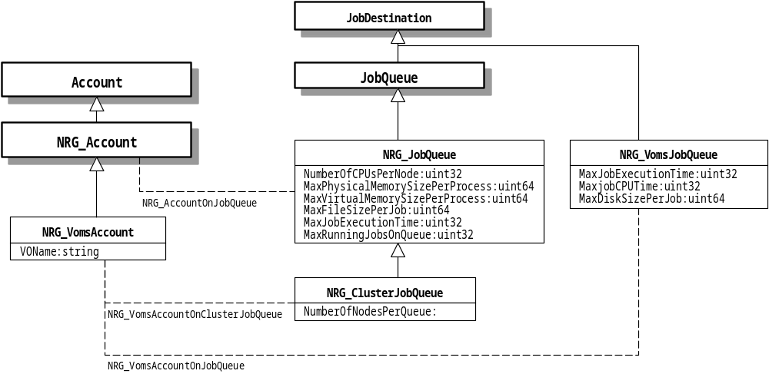Figure 6-1 Extensions for account and queue

Path and Queue
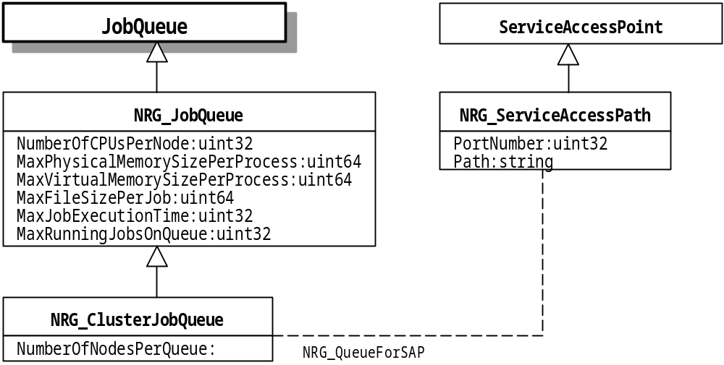
Figure 6-2 Extensions for path and queue

Service and Service Access Point
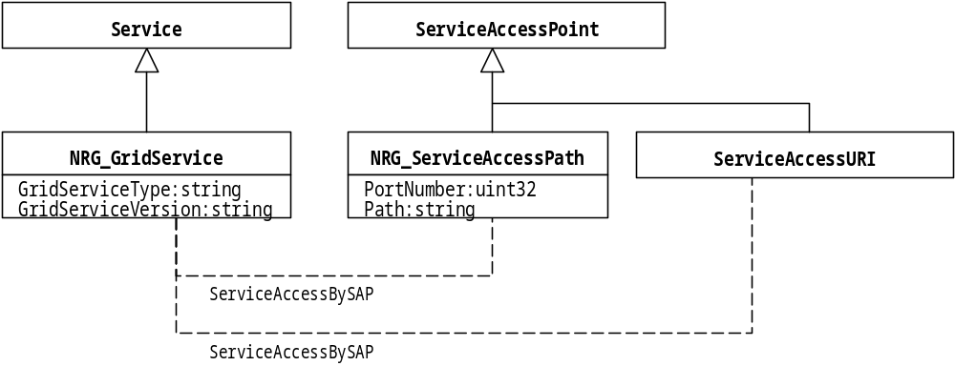Figure 6-3 Extensions for service and the access point

Service and Account
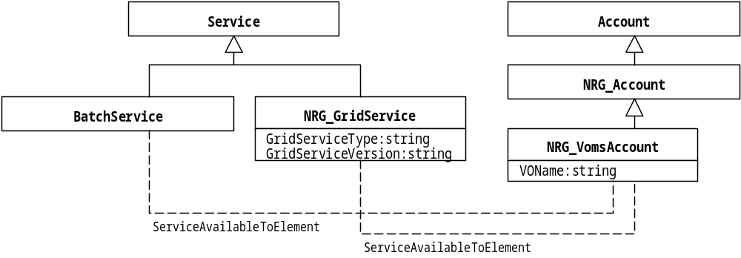Figure 6-4 Extensions for service and account

OperatingSystem and SoftwareElement
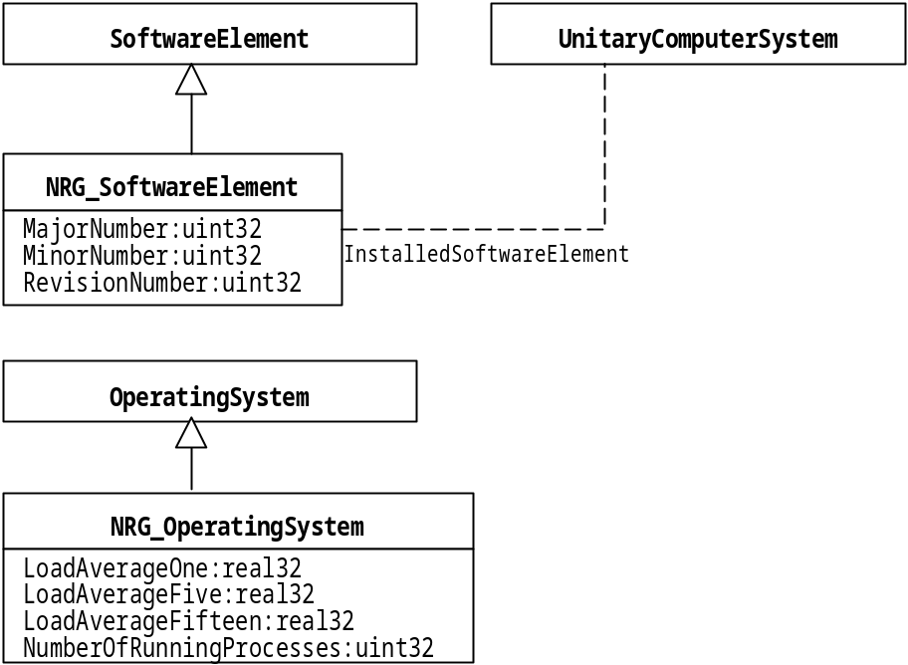
Figure 6-5 Extensions for OS and software

StorageExtent and FileSystem
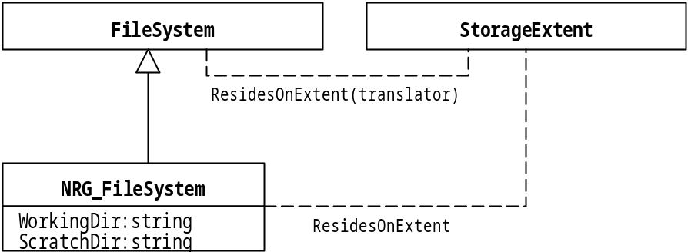
Figure 6-6 Extension for file system

Information service
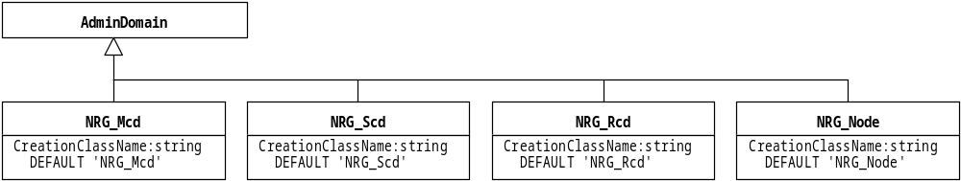Figure 6-7 Extensions for information service

Network configuration
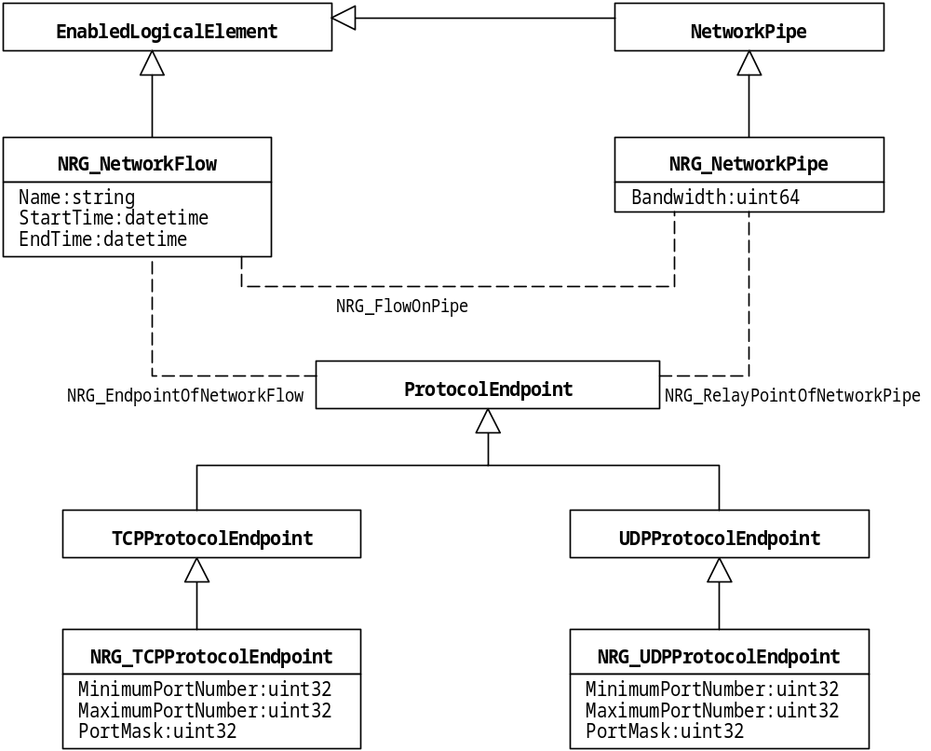
Figure 6-8 Extensions for network configuration

Network statistics
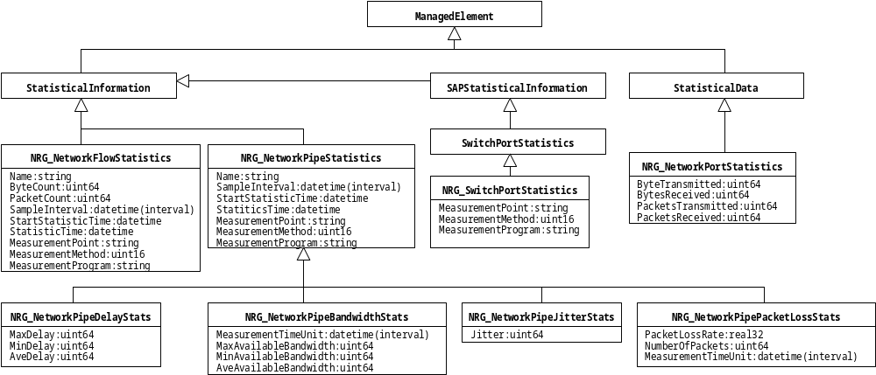Figure 6-9 Extensions for network statistics

VOMS
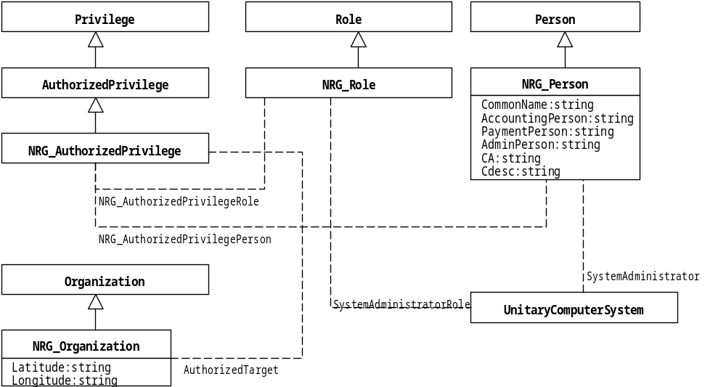Figure 6-10 Extensions for VOMS

LogRecord
Figure 6-10 Extensions for log record

