NSI Architecture Issues

Overview

Documents Overview

This set of documents in the NSI Issues folder contain a compilation of issues that need to be addressed in the architecture subgroup of the NSI working group. The intent of documenting these is to document issues separately so they can be discussed and resolved individually. The separation of issues is not perfect so there will be interaction between topics, but hopefully we can focus and make progress on each faster than trying to do all at once.

At Catania and on calls and by mail afterwards the wg will decide which issues are in scope and the priority of each relative to creating the a first version of a an NSI architecture document. Tentatively the goal is to have an initial architecture document by the June OGF meeting in Chapel Hill.

The documents in the file have the following titles. Each file is named as NSIarc.<sec#>.<title> where section numbers correspond to the sections below and titles are shortened versions of titles below.

- Overview of NSI and basic concepts
- Network vs Application centric (Daisy Chain vs Tree model)
- Abstract /Topology specific parameters
- Negotiation capabilities
- Separation of resource reservation from connection instantiation
- Book ahead capabilities
- Trust, Authentication and Policy
- Naming of Links, edge points and connections
- Sharing of topology information by NS
- Path finding
- Endsite involvement
There is also a folder of misc issues where I have collected some of the discussion inputs that are not included in the above sections but seem important for future discussions. The intent is to have a place holder for these.

NSI Overview

This section gives an overview of a Network Service and a Network Service Interface. This description is base on discussion during wg calls over the past couple months, and is a strawman for further discussion.

On calls, the wg has agreed that its goal is to support connection oriented, not connectionless, networks. The name NSI implies any Network, and so we have discussed some alternate names for this that would make clear the limited nature of the service being requested. We have not agreed as a group on a name, but for purposes of this strawman the editor is using Connection Oriented Network Service (CO-NS] as a placeholder for a name the group agrees on.

CO-NSI Overview

The OGF NSI working group has defined a Connection Oriented Network Service Interface (CO-NSI) as being the interface between a Requestor Agent and a Network Service Agent.

The wg charter is to define the messages between Requestor Agent and Network Service Agent to support establishing, changing, monitoring, and terminating network connections

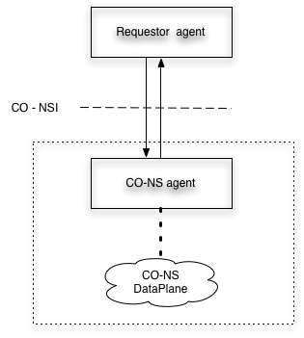
NSI elements

The CO-NSI interface will have several functions that will be supported, including

- request, modify, terminate connections
- monitor connections
- share topology

There may be additional functions defined by the group as work progresses.

One goal of NSI wg: to create ‘atomic’ capabilities which might be combined in a number of ways, similar to the way Unix shell commands can be combined to use the capabilities in different ways.

The following discusses how these functions may be used.

The NSI capabilities enhances the way the majority of network services may be provided. Many existing connection services provide fairly static resources that are centrally provided by service organizations to user communities. Users have little or no control over the basic characteristics of those services or over the resources that support those services. The only choice for the user is to use or not to use the service as provided (user<=>provider). This traditional model limits the way that new CO- NS may be deployed, and how new uses of the service may evolve, and the how the enhancement of existing services is accomplished.

NSI will support existing models of providing network services as well as the emerging new model for Network Services which does not require service providers to be either centralized or in the middle of services provisioning. The new model assumes highly distributed resources may exist that any entity, individual, process, or organization can use or provide to customized and manage their own services and resources. Using this model any user can be a provider, and any provider can be a user. The CO-NS being developed by NSI wg should be capable of being used anywhere by anyone.

Connection Oriented Network Service Overview

The principal function of an CO-NS is to create connections between edge points on the Network A diagram of this is shown below followed by a set of names for architectural items. It should be noted that the names are not agreed to as working group names, but are used to identify specific concepts. There is work started to define and coordinate names between the NML and NSI groups. See the section on Naming later in the document.

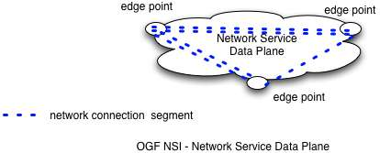

The elements in the above diagram are

Network Service Data Plane –Resource infrastructure that allows connection segments to be made between edge points.
Edge point – point on NS where network connection segments terminate
Network Connection segment – Connection over the network between edge points over a particular resource

Interconnecting Connection Oriented Network Services [CO-NS]

A CO Network Service can be integrated with other CO-NSs by Linking the NSs. End devices (hosts, routers, switches) also have a Link to a NS. A Link is a resource over which link connection segments can allocated. These link segments are concatenated with network segments to create an larger connection segment segment or an ete connection.

ETE connections between end sites are concatenated connection segments. There are two kinds of connection segments: network connection segments and link connection segments.

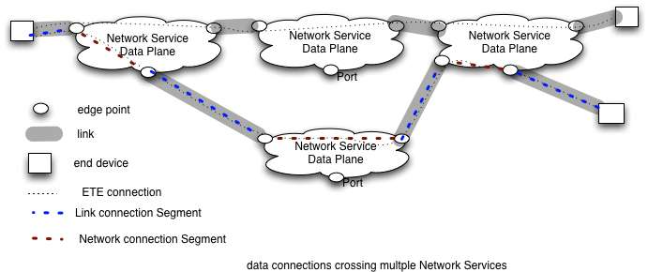

A set of definitions for items in the above diagram
Network Service Data Plane –Resource infrastructure that allows connection segments to be made between edge points.
Edge point – point on NS where network connection segments terminate and can be cross-connected to other segments.
End point – edge point at where end-device interfaces with network
Link – Resource that attaches to edge points on different NSs and and can allocate
its resources to multiple connection-segments
Connection segment – resources that provide a connection between edge points
Link connection segment – connection segment over a link
(aka inter-network segment)
Network connection segment – connection segment over a Network
Service (aka intra-network segment)
(Generic) connection segment – any connection segment or concatenated
sequence of connection segments
ETE connection - a connection segment between two end points

Technology agnostic architecture

Note that a Network Service Connection may be created at different network layers. For example a connection might be a VLAN, a wave carried by a fiber, a fiber that is terminated in a fiber-switch or perhaps a TCP connection. (Note that there is some discussion about how tcp sessions as connections as discussed in a few paragraphs).

A Link for a VLAN would be an Ethernet trunk (or a SONET trunk that carries VLANs as VCGs), for a wave the link would be a fiber, for fiber switch the link would be a fiber. The figures above show a set of resources that could be at any of these layers.

These do not translate to situations level changing where one modify the topology at one layer by adding a links at another layer. To do that one would need to determine that additional Links at a give layer would be helpful, add or modify links, then describe the new topology as a revised set of CO-NSs and Links.

A specific question being considered in the wg is about how TCP fits in the connection oriented model. The model is layer and protocol neutral. Almost all transport protocols can be used to support connection oriented services, and therefore none can be automatically excluded for consideration as a protocols for use with the NSI. TCP for example almost always supports non-connection oriented services. Nonetheless, TCP can be (and has been) used to support connection oriented services. This will be considered further in this group

Naming and Glossary
Naming of the elements in the diagram is necessary to build a clear definition of what can be requested over an NSI. Actual naming will be done in conjunction with the NML working group. NSI and NML expect to create a data model that accommodates the multi-layer model concepts needed to monitor and debug networks and the NSI single layer model of links and networks with multiplexed segments, and the connections that consists of concatenated segments.

The Glossary below is for NSI terms

NS -Network Service - A resource that can be requested from a NS agent
NSI – Network Service Interface – the interface between a user agent and a NS agent
CO-NS - Connection Oriented NS - . A resource that can be requested from a NS agent . The resource that is requested is a connection segment between endpoints of the Network. The segment has parameters like bandwidth, duration, and others to be defined in the wg.
CO-NSI – Connection oriented Network Service Interface Participant in
Requestor Agent - Participant in protocol from the side requesting service
CO-NS Agent - Participant in protocol from the side providing resources
Edge Point - point on NS where network connection segments terminate
End Point – edge point at where user interfaces with network
Network Service Data Plane –Resource infrastructure that allows connection segments to be made between edge points.
Link– Resource that attaches to edge points on different NSs and and can allocate
its resources to multiple connection-segments
Connection segment any connection segment or concatenated sequence of connection segments
Link connection segment – connection segment over a link
NS connection segment – connection segment over a Network Service
Ete connection - - a connection segment between two end points

