Arch Issue 1 Network vs Requestor Centric

The title Network vs Requestor Centric reflects the idea that a network centric organization of NSs would have a request go to on NS and it would negotiate with other NSs if necessary. In the Requestor Centric model, the requestor would choose resources and contact individual NSs on its own.

Section 1 and 2 are different contributions – section one describes issues, section 2 from Eduard Escalona shows how requests for different models could be implemented in XML.

Section was originally started as a description of Tree vs Chain model of doing multidomain reservations and authorizations. The main part of the doc is the paper by Radek Krzywania. After discussing this group agreed that either model (tree or chain) could support the different ways of sharing resource and topology information (network vs requestor centric).

A couple items I remember about the discussion about tree vs chain is that two phase commits require slightly different protocol across NSI and that the two methods can interoperate.

Jeroen points out that there are also issues about how to share knowledge of one’s topology and how one does pathfinding that may be different in each of these approaches.

My belief is that this is likely continue to be confusing for people expecting to see one or the other approach, and needs to be spelled out so that people understand what the NSI is supporting.

Tree vs. chain model

There are two ways of messages forwarding related to resources negotiations, advertisements, reservations, etc. Both options has pro and cons, which are shortly described on this paper.

Daisy chain communication model
Daisy Chain communication model is based on message forwarding from one site to another in defined order, without loops or creation of nets. A message is not expected to reach the same site more than one. The chain model is depicted on Figure 1:
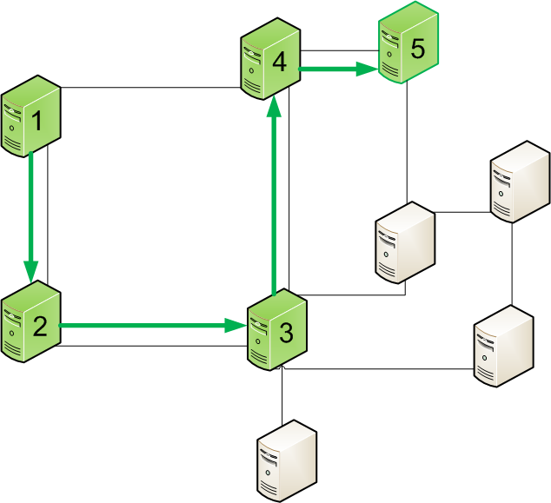
Figure 1 Chain communication model

The message from the server 1 is expected to reach server 5. Servers 2,3, and 4 may or may not be a recipient of a message (also may or may not modify it). In objects along path are not a message recipients, they need to be able to forward the message in a proper way to the next object on a routing path. A route of the message is out of scope of this paper. It can be done in OSPF like manner, BGP like manner, or any graph searching algorithm. A route can be predefined since the message sender push the message out, or can be computed at each intermediate element (next hop). The path where message can be routed depends on physical and/or logical connections between objects.

Tree communication model
Tree communication model assumes that there is no physical boundaries for reaching particular nodes. An example is depicted on Figure 2
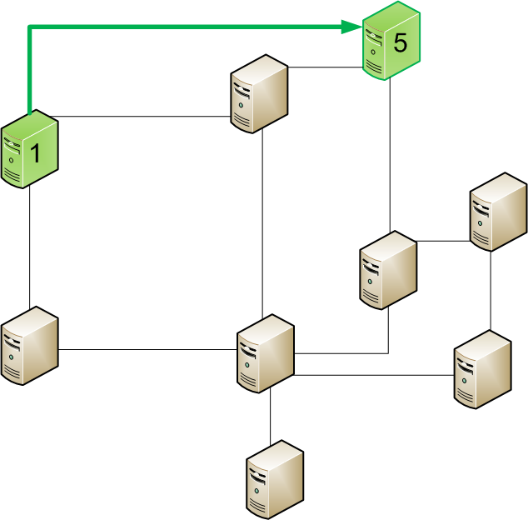
Figure 2 Tree communication model

The object 1 does not care about routing a message to the object 5 and is able to send the message directly. The message can be routed with regular IP packets routing basis, using routing tables available in the network. The message may or may not pass intermediate objects, depending on implementation. That means that message forwarding mechanism may be independent from communicating objects, and perform as a simple point-to-point connection. All nodes are independent and are expected to be reachable, despite of resources interconnectivity.

Consequences of selection of communication model
Both communication model has direct influence o capabilities and implementation of communication protocols, as they introduce some potential opportunities as well as some threads. The main difference between chain and tree model, is that chain model forces to follow step by step approach in communication.
In case of topology depicted on Figure 3 a scheduler (placed in object 1) pre-defines the path and wants to book resources in objects 1,2,3,4, and 5. There are several scenarios of performing this task.

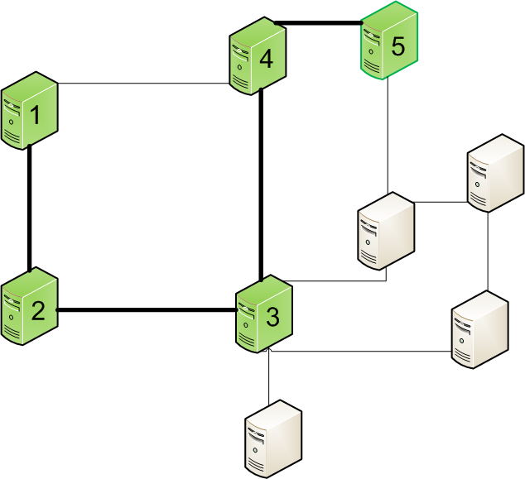
Figure 3 Resources negotiation example

Case 1: Chain model with response concatenation mechanism
A single request is forwarded from domain to domain, and responses are concatenated into one message. The response is merged at each domain on the way back to object one, as depicted on Figure 4:
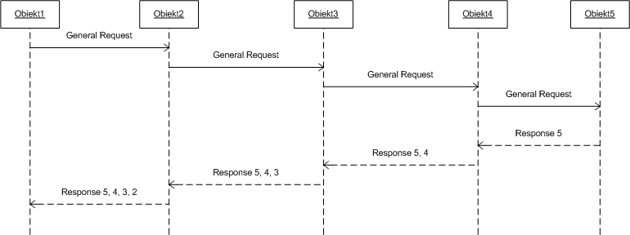
Figure 4 Chain model with response concatenation

Case 2: Chain model with “personalized” requests
Each object is receiving a separate “personalized” request and is expected to response. The messages are forwarded in chain model, and intermediate objects needs to implement mechanism to forward messages without reading it (communication layer). The communication schema for this case is depicted on Figure 5:
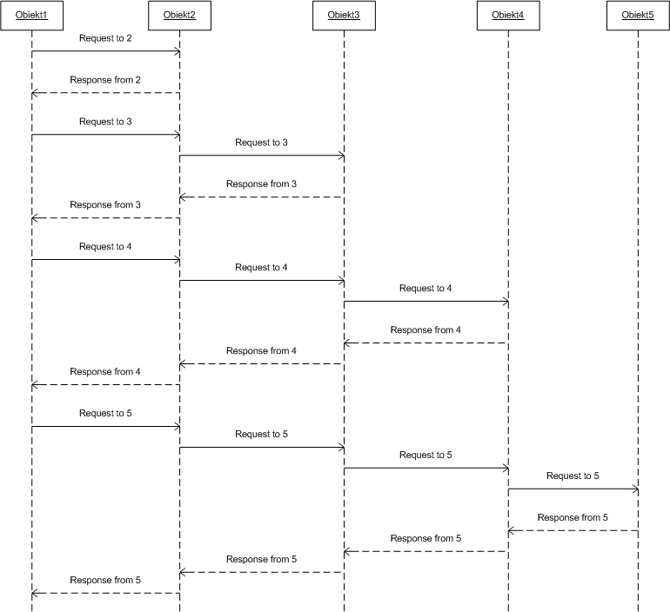
Figure 5 Chain model with "personalized" requests

Case 3: Chain model with generic request and “personalized” responses
The request is forwarded in object-to-object manner, while each domain is responsible to create an independent “personalized” response and send it back to the object 1. Intermediate objects needs to implement mechanism to forward messages without reading it (communication layer). The communication schema for this case is depicted on Figure 6:
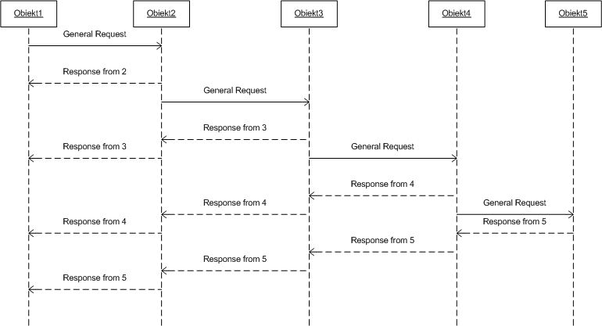
Figure 6 Chain model with generic request and "personalized" responses

Case 4: Tree model
Each object receives a “personalized” request directly from the object 1, and sends “personalized” response directly to the object 1. The communication schema is depicted on Figure 7:
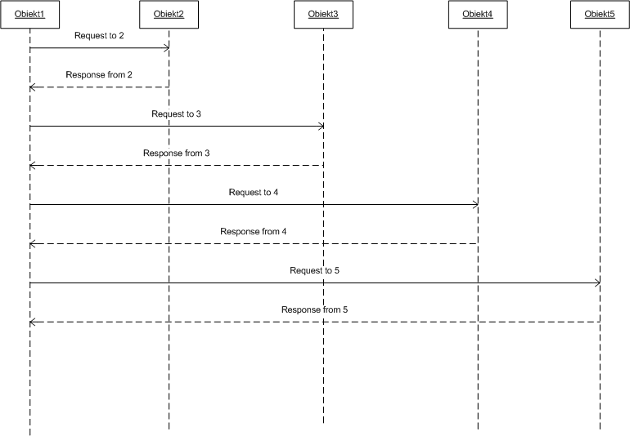
Figure 7 Tree model

The main advantages and disadvantages of chain and tree model can be easily observer in case of failures and critical situations. As tree model does not care for physical/logical connectivity between objects, the message is just sent to the destination object. Success or failure of message delivery depends on the algorithms of message routing or simply IP network layer. In case of chain model, failure of single object may disturb reachability of other objects behind.

NSI structure in XML
Basic XML structure can be seen as a family tree with a hierarchical view of data. There is a root element which contains different categories; each category can be divided in several sub-categories and so on. When using XML to describe general service requests, for instance, with SOAP messages, these categories and sub-categories can be mandatory or optional. Thus, some elements can be present or not depending on how the service is described.
For the NSI, a way to describe service requests could be using a common body format and inside this structure define different service types, connection types, reservation types, etc. which can be imported as separate schemas. This way, any future service can be added as a new schema and the NSI main schema is not altered. The following example shows how this approach could be handled using XML.
<! Request>
<body>
<setupRequest>
<serviceID></serviceID>
<priority></priority>
<serviceType>OpticalConnection</serviceType>
<serviceData>
...
</serviceData>
<connectionType>PointToMultipoint</connectionType>
<connectionData>
...
</connectionData>
<reservationType>FixedReservation</reservationType>
<reservationData>
...
</reservationData>
<securityType></securityType>
<securityData>
...
</securityData>
</setupRequest>
</body>

<! Service Types>
<opticalConnection>
<bandwidth></bandwidth>
<opticalConstraints>
...
</opticalConstraints>
<fsc>
<fiberID></fiberID>
</fsc>
<lsc>
<wavelengthID></wavelengthID>
</lsc>
<subwavelength>
<label></label>
</subwavelength>
</opticalConnection>

<ethernetConnection>
<vlanTag></vlanTag>
</ethernetConnection>

<! Connection Types>
<pointToPoint>
<directionality></directionality>
<source></source>
<destination></destination>
</pointToPoint>
<pointToMultipoint>
<directionality></directionality>
<source></source>
<destinations>
...
</destinations>
</pointToMultipoint>
<multipointToPoint>
<directionality></directionality>
<sources>
...
</sources>
<destination></destination>
</multipointToPoint>
<multipointToMultipoint>
<directionality></directionality>
<sources>
...
</sources>
<destinations>
...
</destinations>
</multipointToMultipoint>

<! Reservation Types>
<fixedReservation>
<startTime></startTime>
<endTime></endTime>
</fixedReservation>

<malleableReservation>
...
</malleableReservation>

