**Description of parameters for CIM2Simulink**

**Introduction**

This document describes some important electrical equipments of the CIM model 14 with its parameters and the format to translate the information in CIM/XML/RDF to Simulink.

The tool used to create the CIM documents is PyCIM; a python module which contain the classes of each equipment and auxiliary objects of the CIM model and the only task needed to create a cim-text is to initialize the instances needed with their parameters, including their UUID, and save all them in a dictionary that is going to be used to generate the cim-text automatically with the PyCIM function cimwrite.

# Power Line

## Power Line in CIM

### CIM text

A power line in CIM is generated by the object ACLineSegment and when it is given all the 'important' attributes it delivers a cim like this: (assume that ns1=cim)

<ns1:ACLineSegment rdf:ID="035b7c00-b880-11e5-8359-34159e94f85a">

<ns1:IdentifiedObject.name>Line_632_633</ns1:IdentifiedObject.name>

<ns1:Conductor.length>1</ns1:Conductor.length>

<ns1:ACLineSegment.r>1</ns1:ACLineSegment.r>

<ns1:ACLineSegment.x0>1</ns1:ACLineSegment.x0>

<ns1:ACLineSegment.x>1</ns1:ACLineSegment.x>

<ns1:ACLineSegment.r0>1</ns1:ACLineSegment.r0>

<ns1:ConductingEquipment.phases rdf:resource="<http://iec.ch/TC57/2010/CIM-schema-cim15#PhaseCode.ABC>" />

</ns1:ACLineSegment>

### Parameters description

Although the ACLineSegment has many more attributes in summary there are some basic parameters/attributes to model the equipment properly:

* Name
* Length [km]
* R1 [Ohm]
* R0 [Ohm]
* X1 [Ohm]
* X0 [Ohm]

All this parameters are given in Ohms, which means the ohms for the whole line’s length

* Phases

The parameter "number of phases" is tricky because CIM give just this options: **"A", "AC", "AN", "ABCN", "B", "C", "BN", "CN", "splitSecondary12N", "ABC", "splitSecondary2N", "N", "ABN", "BC", "BCN", "AB", "splitSecondary1N", "ACN".** This issue will be discussed in: Power Line in Simulink.

## Power Line in Simulink

The power line in Simulink is represented by the object named: **"Distrubuted Parameters Line"**, from the SimPowerSystems’ Toolbox, has the following parameters (take into account the units):

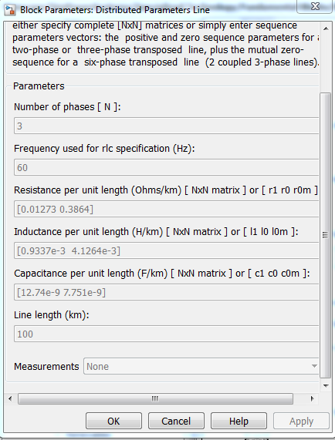

* Sequence parameters:

R1, r0, x1, x0 from CIM in terms of Ohms, then to put the right value in Simulink in terms of Ohms/km it is needed to divide them by the Length of the ACLineSegment given also on the CIM. The other parameters (r0m, l0m and all the capacitances can be assumed as 0).

* As the inductance is in terms of H/km the reactances (x1 and x0) has to be used to calculate it as follows:

The relation between L and X is given by X=jwL, then the magnitude of L is:

L=X/w , where w=2pi*f and f is given by the system. In European case for default is 50Hz. Finally L=X/(2*pi*50)

* Phases:

Given that CIM just give the options described, in case CIM give just one letter, for example 'A', then Number of phases =1, if CIM gives 2 letters, for example 'AB', then =2, and if CIM give 3 letters (for example 'ABC') then =3. The letter 'N' represents the Neutral that have to be ignored given that it is not a phase. The neutral wire is not considered because Simulink has the object earth implicitly.

* If there are additional parameters from CIM that are not needed in Simulink, just can be ignored.

# Source / Equivalent Network

## Source in CIM

### CIM text

A Source or Equivalent Network in CIM is generated by the object EnergySource and when it is given all the 'important' attributes, it delivers a cim like this: (assume that ns1=cim):

<ns1:EnergySource rdf:ID="xxxx">

<ns1:IdentifiedObject.name>energy_source</ns1:IdentifiedObject.name>

<ns1:EnergySource.x>1.0</ns1:EnergySource.x>

<ns1:EnergySource.activePower>5000</ns1:EnergySource.activePower>

<ns1:EnergySource.r>1.0</ns1:EnergySource.r>

<ns1:EnergySource.nominalVoltage>4160</ns1:EnergySource.nominalVoltage>

<ns1:ConductingEquipment.phases rdf:resource="http://iec.ch/TC57/2010/CIM-schema-cim15#PhaseCode.ABCN" />

</ns1:EnergySource>

### Parameters description

The CIM EquivalentEquipment could contain more attributes, however, with the following basic parameters can be well modeled:

* Phases

Has the same conditions described in ACLineSegment phases.

* nominalVoltage [Vrms]

Assign the voltage of the soure.

* activePower [Watts]

Assign the active power (P) of the source.

* X is the reactance of the source
* R is the resistance of the source
* Phases

same options as in ACLine but has different implications explained in 2.2.

## Energy Source in Simulink

The Source in Simulink is represented by the object named: **"Three-Phases Source"**, from the SimPowerSystems’ Toolbox, has the following parameters (take into account the units):

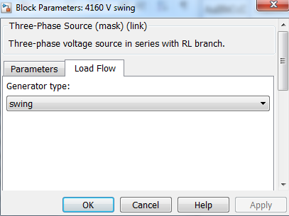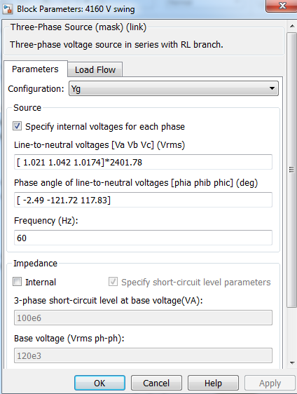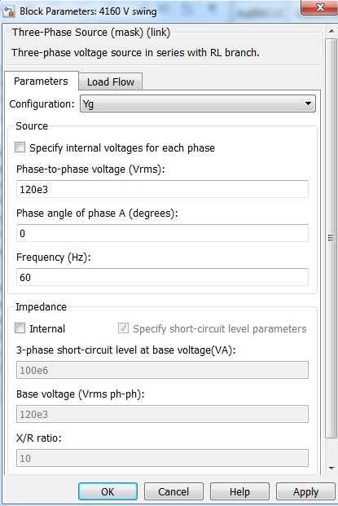

* Configuration:

In this parameter it is important to take into account the CIM attribute Phases, which is going to indicate if the source has Neutral or not. If the value of phases is for instance: ‘ABCN’ It’s recommend to set the configuration option in: “Yg”. Moreover, “Y” should be set as default.

* Voltage [Vrms], and Phase angle:

Simulink gives the option to define the initial voltage values (to define the sequence of the phases), but for simplicity it is better to define just the voltage and the angle of phase A = 0 as default parameter. Therefore the check-box: ‘specify internal voltage for each phase’ should be unchecked. (notice the difference on the two upper images)

* Frecuency:

Assume default value as 50 Hz (European standard frecuency)

* Impedance:

This parameter can be leaved unchecked as default. When the source specifies X and R, this check-box can be used and use the ratio R/X and the base voltage as defined on the nominalVoltage on the CIM EnergySource.

* Load Flow:

The generator type (the only parameter in the Load Flow sub-list), can be: swing, PV or PQ, which in the case of a simple network with only one source can be put in **swing** **as default**.

# Power transformer

## Power Transformer in CIM

### CIM text

A Power Transformer in CIM is generated by the following objects:

* One PowerTransformer and
* two TransformerWinding: One TransformerWinding for the primary winding (HV) and other TransformerWinding for the secondary (LV).

When it is given all the 'important' attributes, it delivers a cim like this: (assume that ns1=cim):

<ns1:PowerTransformer rdf:ID="a1fd6950-bbcc-11e5-bfc1-34159e94f85a">

<ns1:IdentifiedObject.name>XFM-1</ns1:IdentifiedObject.name>

</ns1:PowerTransformer>

* Which just contain the information of the two windings (the transformerwindings will refer to this powertransformer object via its rdf ID)

And:

<ns1:TransformerWinding rdf:ID="a1fca602-bbcc-11e5-9565-34159e94f85a">

<ns1:IdentifiedObject.name>HV_winding</ns1:IdentifiedObject.name>

<ns1:TransformerWinding.x>1.0</ns1:TransformerWinding.x>

<ns1:TransformerWinding.r>1.0</ns1:TransformerWinding.r>

<ns1:TransformerWinding.ratedU>4160</ns1:TransformerWinding.ratedU>

<ns1:TransformerWinding.ratedS>500</ns1:TransformerWinding.ratedS>

<ns1:ConductingEquipment.phases rdf:resource="http://iec.ch/TC57/2010/CIM-schema-cim15#PhaseCode.A" />

<ns1:TransformerWinding.connectionType rdf:resource="http://iec.ch/TC57/2010/CIM-schema-cim15#WindingConnection.Yn" />

<ns1:TransformerWinding.windingType rdf:resource="http://iec.ch/TC57/2010/CIM-schema-cim15#WindingType.primary" />

<ns1:TransformerWinding.PowerTransformer rdf:resource="#a1fd6950-bbcc-11e5-bfc1-34159e94f85a" />

</ns1:TransformerWinding>

### Parameters description

Is to be noted that each TransformerWinding make reference to the PowerTransformer which belongs to (that contain both windings).

* Name (trivial)
* x and r : can be given in [Ohm] or [p.u.] (r(pu)=r(ohm)*(ratedS/ratedV^2)). But for default assume that these data is given in Ohms.

For a two winding transformer, the full reactance and resistance of the transformer should be entered on the primary (high voltage) winding, then the r and x will just be in the HV winding and not in both.

* ratedU

Represents the High Voltage (HV) for the primary or Low Voltage(LV) for the secondary voltage in Vrms.

* ratedS [VA]

Represents the apparent power of the transformer

* phases

Is the same as in other conducting equipments already described

* ConnectionType

Represents the phases’ connection. Values are: "Yn", "Y", "D", "I", "Z", "A", "Zn". The most common cases are D, Y and Yn.

* windingType:

The type of winding. Values are: "primary", "quaternary", "secondary", "tertiary". In a two winding transformer the only options are primary and secondary.

* Rdf ID make reference to the PowerTransformer this winding belongs to.

## Power Transformer in Simulink

The Power Transformer in Simulink represented by the object named: **"Three-Phase Transformer"**, from the “**Fundamental Blocks/Elements**” Library, has the following parameters (take into account the units): (http://es.mathworks.com/help/physmod/sps/powersys/ref/lineartransformer.html)

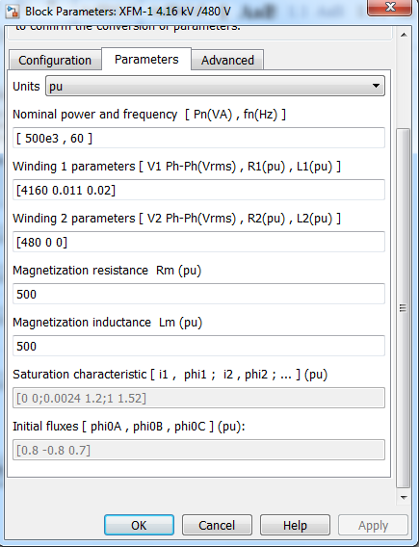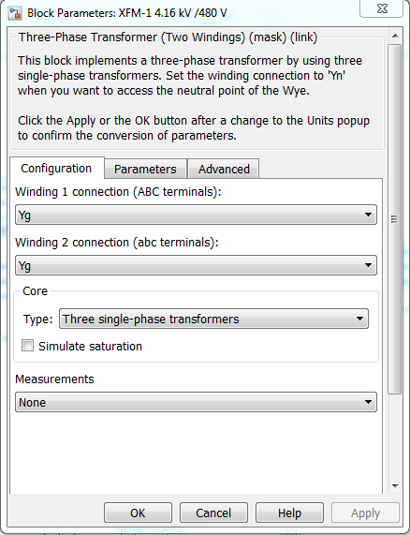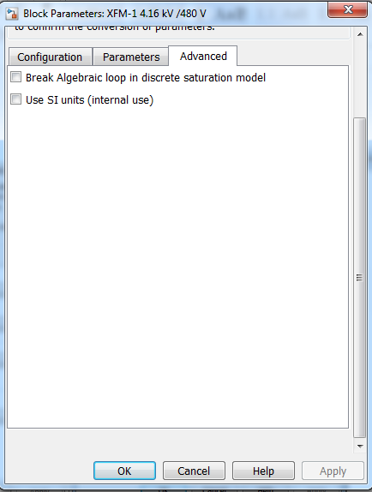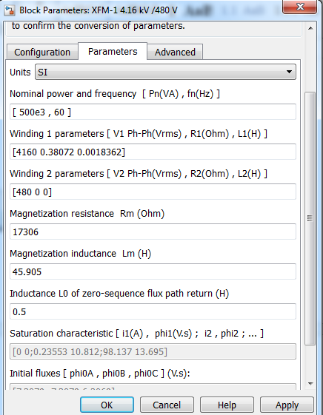

Taking into account the images above:

Configuration:

* Winding 1 connection refers to the primary (HV) windings type of connection, and Winding 2 connection refers to the secondary (LC). This information is taken from the CIM TransformerWinding as described in the parameter ***ConnectionType***.
* The transformer type will always be assumed as ***“Three single-phase transformer”,*** without saturation and no measurements.

Parameters:

The parameters will be set in S.I. units as default.

* Nominal power and frequency:

Set the vector with the ratedS of the WindingTransformer also given in [VA], and the frequency is set as default in 50 Hz.

* Winding 1 (or 2) parameters:

As the primary TransformerWinding is the only one that contain the r and x of the whole transformer these values will be set only in Winding 1, while in the Winding 2 will be set in zero.

Here the value of for the reactance is given as inductance in [H], then the x given by the TransformerWinding has to be modified with the same formula explained in 1.2. L=X/(2*pi*50).

The voltages V1 and V2 are from the primary and secondary respectively.

* Magnetization resistance and Magnetization inductance are values for a precise model of the transformer. Here these values will be set for default as follows: Rm=20000 Ohms. Lm=50 Henrious [H].
* As the saturation model is not going to be used, the other parameters are ignored.

Advanced:

* When the parameters are set in S.I. units. The advanced parameter “Use SI units” is checked.

# Load (Still in process)

## Load in CIM

### CIM text

A load in CIM will be modeled with and generated by the object EnergyConsumer and has the following cim/xml text:

<ns1:EnergyConsumer rdf:ID="05969b11-da16-11e5-916e-34159e94f85a">

<ns1:IdentifiedObject.name>load</ns1:IdentifiedObject.name>

<ns1:EnergyConsumer.pfixed>1000000</ns1:EnergyConsumer.pfixed>

<ns1:EnergyConsumer.qfixed>200000</ns1:EnergyConsumer.qfixed>

<ns1:ConductingEquipment.phases rdf:resource="http://iec.ch/TC57/2010/CIM-sc

hema-cim15#PhaseCode.ABCN" />

</ns1:EnergyConsumer>

### Parameters Description

* Name (trivial)
* Qfixed and Pfixed

These parameters are the reactive and active power respectively for a balanced (same power for all the phases) load modeled as constant power consumer. These values are given in VAR (volt-ampers-reactive) and W (watts).

* Phases (same as other conducting equipments)

## Load in Simulink

The Load in Simulink represented by the object named: **"Three-Phase Series RLC Load"**, from the “**Fundamental Blocks/Elements**” Library, has the following parameters (take into account the units):

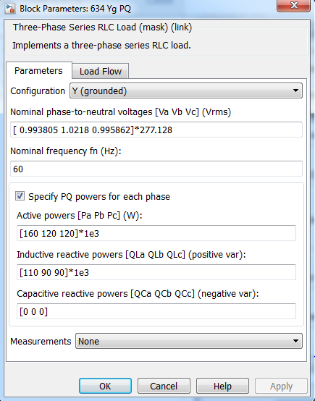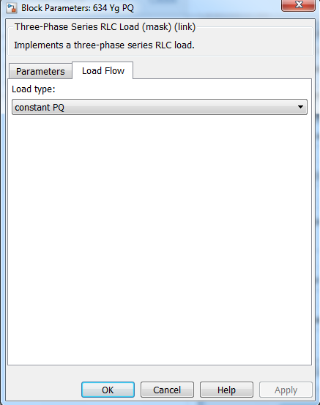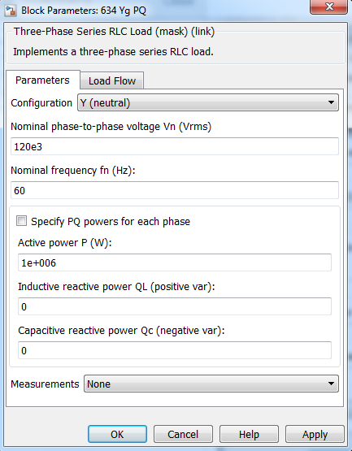

Parameters:

* Nominal phase-to-phase voltage