OpenHDS Codes and Parameters Configuration
Codes and parameters that are common for project sites can be configured using a Web Form. This Web Form allows a project site to define how the demographic data is to be represented, certain validation rules, and how the user interface will behave. This tutorial will explain how these settings can be modified.
The Web Form can be accessed under CONFIGURATION -> Codes and Parameters
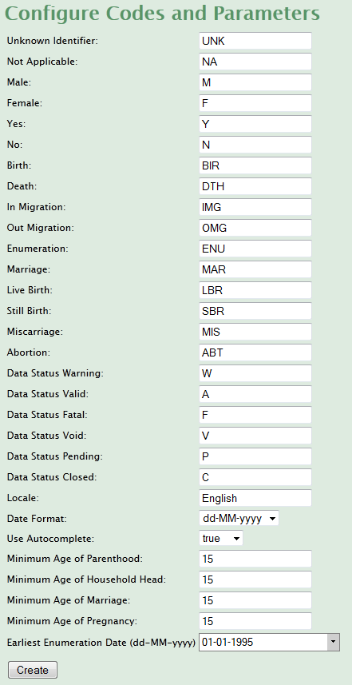
All of the properties specified (i.e. Male as ‘M’ and Female as ‘F’) will be persisted as they are represented here. Additionally, the date format can be specified as well as simple validation rules. It’s not recommended to change these values after data has been added to the system.

