OpenHDS Database Configuration
Database Configuration can be performed in two ways, using the Web Form or by modifying a configuration file. This tutorial will demonstrate both approaches.

Modifying the Database Configuration with the Web Form
The Web Form can be accessed under CONFIGURATION -> Database
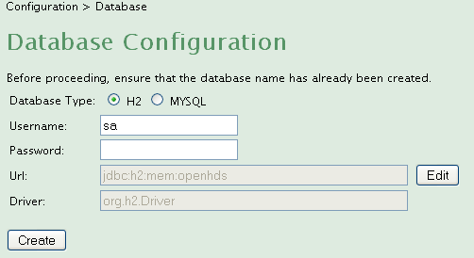
The default configuration is an in-memory H2 database. This web form also supports setting up a MySQL database. Make sure that the database name specified already exists before pressing ‘create’. Once the create button is pressed, the required data scripts will be executed and the OpenHDS database will be ready for use. The application will need to be redeployed.

Modifying the Database with the Configuration File
In Tomcat, you will need to proceed to the openhds\WEB-INF\classes\database.properties file. This file contains the same information as the Web Form, such as the following:
dbDriver=com.mysql.jdbc.Driver
hibernateExport=create
dbUser=root
dbPassword=password
dbUrl=jdbc\:mysql://localhost/openhds
If you wish to configure your own database, you are responsible for setting up the proper dependencies yourself.
The following values may be used:
property | values | description
dbDriver | com.mysql.jdbc.Driver | Connects to a MySQL database
 | org.h2.Driver | In-memory H2 database
hibernateExport | validate | Validate existing DB schema; do not change DB
 | update | Update DB schema
 | create | Create schema clearing all data
 | create-drop | Create and delete data at session end
dbUser | username | MySQL authentication
dbPassword | password | MySQL authentication
dbUrl | jdbc:h2:tcp://localhost/mem:openhds | H2 database connection
 | jdbc:mysql://localhost/openhds?createDatabaseIfNotExist=true | MySQL database connection

