OpenHDS Location Hierarchy Configuration
The Location Hierarchy must be configured before any data is added to the system. The Location Hierarchy represents the geographical area where the OpenHDS will be used. It’s required that the Location Levels are specified before the Location Hierarchy is created. This tutorial will explain how to configure a simple Location Hierarchy show below.
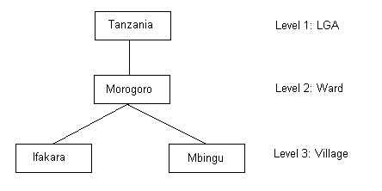
The Location Hierarchy can be modified using the Web Form under UTILITY ROUTINES -> Location Hierarchy
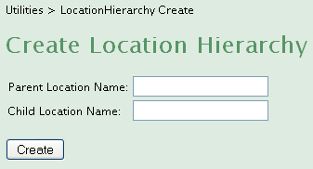
To create the root, the Parent Location Name must be left blank and the Child Location Name will be specified as Tanzania. Next, the Parent Location Name will be specified as Tanzania and the Child Location Name will be Morogoro. Ifakara and Mbingu will be created Child Location Names and will share the same Parent Location Named Morogoro. Each node that’s created will automatically be given a reference to the Location Level that it belongs to.
The system will not allow a hierarchy node to be deleted unless it’s a leaf and it’s not referenced by a Location. The system will also not allow a hierarchy to extend beyond the Location Level configuration. It will not allow for duplicated location names. This configuration must not be changed after data has been added to the system.

