OpenHDS Location Levels Configuration
Location Levels must be configured before any data is added to the system. Location Levels refer to each layer in the Location Hierarchy. The OpenHDS can be customized to work for any Location Hierarchy up to nine levels deep. This tutorial will explain how to configure these Location Levels.
Location Levels can be modified using the Web Form under CONFIGURATION -> Location Levels.
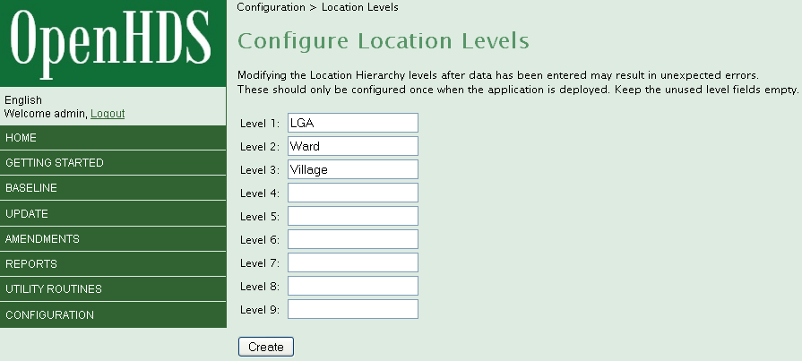
By default, LGA, Ward, and Village are specified but these can be modified. The values for each level should be modified starting at Level 1 and the remaining unused fields should remain empty, as they will be ignored. This is only recommended to be configured once and should not be changed after data has been added.

