OpenHDS Internationalization Configuration
Translated language files can be defined and swapped out for international language support. Every Web Form references this language file to display forms presentable to the user in their preferred language. This tutorial will demonstrate how the OpenHDS can be configured for use in the Swahili language.
The first step is to create a Message Resource file. It’s recommended to start with the file located in the tomcat directory, openhds\Web-INF\classes\MessageResource_English and translate their values. Name the resource file MessageResource_Swahili and place it in the same directory. The translated file may look something like the following:
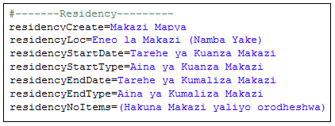
Redeploy the application and proceed to CONFIGURATION -> Codes and Parameters. Under the Locale field, enter Swahili and press ‘create’. Redeploy the application for the changes to take effect. The Swahili language file defined will now be in use.
