OpenHDS Security Configuration
Securing OpenHDS can be done using some Web Forms. The tutorial will demonstrate how to create new roles and assign them to new Users.
To create new Roles can be done by proceeding to CONFIGURATION -> Role Management
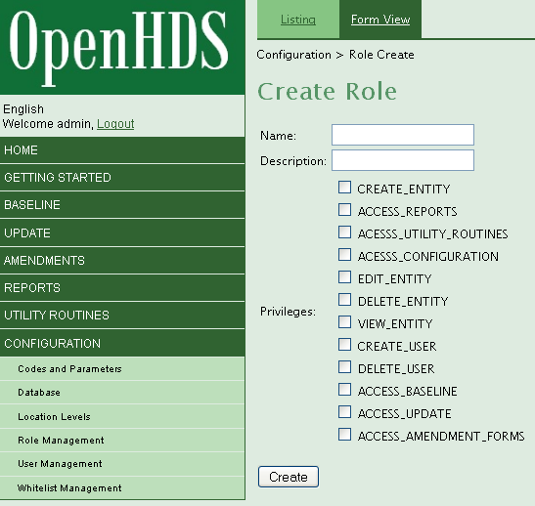
Several roles have already been created, which can be seen in the ‘Listing’ tab. New roles can be created by specifying a name, description, and checking the associated amount of Privileges allowed with the role. Users can be created and Roles can be associated with them.

To create a new User, proceed to CONFIGURATION -> User Managerment
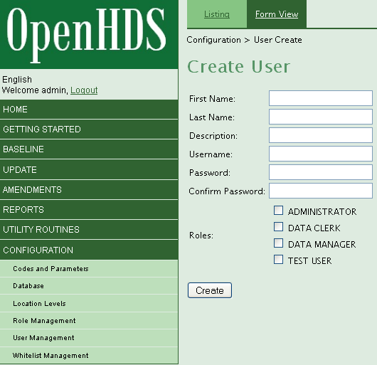
Modifying existing users can be done by pressing the ‘Listing’ tab and editing each User (such as the default admin User). New Roles that were created will be displayed here and can be associated to the defined User. Once the User is created, you will need to log out and then log back in for the changes to take effect.

