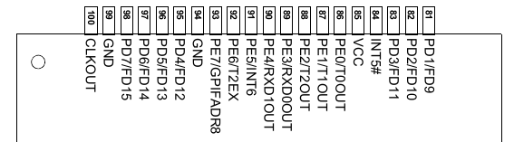
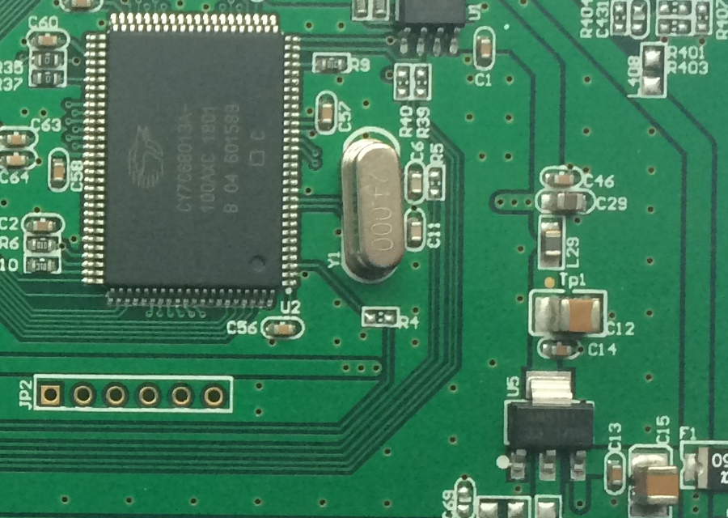
Jitter-free Calibration Out for HANTEK 6022BE/BL
PE2
U5
GND 3V3 5V
| | |
PE0 PE1 PE2 PE3 PE4 PE5

An issue of the Hantek scope is the jitter of the calibration out signal. It is generated by toggling an output pin in an interrupt routine triggered by counter/timer 2 overflow.
Due to interrupt latency the signal jitters by some µs, this leads to a high phase jitter on high output frequencies. The EzUSB can provide the T2 overflow signal on pin PE2/T2OUT (PE2, available on JP2 of the PCB, at least 6022BE) as an alternate port function. According to TRM (rev. G, p.193) the signal is "one CLKOUT pulse".
Connect a toggle flipflop to PE2 to create the correct output frequency with 50% duty cycle.
You can use e.g. 74HC74 (dual D flipflop), 74HC161 / 74HC163 (4-bit binary counter), or 74HC4024 ( 7-bit binary counter). These are even available in maker-friendly DIL packages.
Depending on your needs, supply the chip either with 5V (pin 3 of U5 - AMS1117-3.3) or with 3.3V (pin 2 of U5), GND is U5/pin1.

The 6022BL has no JP2, you must solder directly on pin 88 (PE2/T2OUT)

Original Software Solution
Software created calibration output for 6022BE:
#define TOGGLE_CALIBRATION_PIN() \
do { \
PA7 = !PA7; \
} while ( 0 )

void timer2_isr( void ) __interrupt TF2_ISR {
/* Toggle the probe calibration pin. */
TOGGLE_CALIBRATION_PIN();
#ifdef LED_RED_TOGGLE
// Avoid nasty sdcc 4.0 REGRESSION:
// Do not use "if ( ledcounter && --ledcounter == 0 )"
// Write separate statements!
// Otherwise the ISR uses registers for reload -> additional push/pop ...
// ... more cycles, fails for 100 kHz
if ( ledcounter ) {
--ledcounter;
if ( ledcounter == 0 ) { // led timed out?
ledcounter = ledinit; // reload
LED_RED_TOGGLE();
}
}
#endif
TF2 = 0;
}

SDCC builds this assembler code, that toggles almost immediately (line 1209):
000136 1205 _timer2_isr:
000136 C0 E0 [24] 1206 push acc
000138 C0 D0 [24] 1207 push psw
1208 ; scope6022.inc:78: TOGGLE_CALIBRATION_PIN();
00013A B2 87 [12] 1209 cpl _PA7
1210 ; scope6022.inc:85:
if ( ledcounter ) {
00013C E5*06 [12] 1211 mov a,_ledcounter
00013E 45*07 [12] 1212 orl a,(_ledcounter + 1)
000140 60 19 [24] 1213 jz 00110$
…

The neccessary firmware modification sets bit 2 of PORTECFG to 1, this enables the alternate function T2OUT on PE2.
/* PE2: T2OUT for HW calibration output, other bits are port E output */
#define INIT_PORTECFG 0x04

