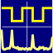
OpenHantek6022
User Manual

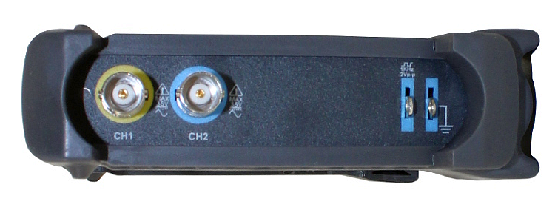

The digital storage scope Hantek6022BE (as well as the similar Hantek 6022BL) measures two voltage channels CH1 (yellow) and CH2 (blue).
The input impedance is 1 MΩ || 25 pF (a typical value for scope inputs).
The measurable input signal range is ±5 V.
Input voltages outside the safe range of ± 35 V can lead to permanent damage!

The calibration output (blue, right side) delivers a square wave 0 V / 2 V @ 1 kHz that can be used to adjust the frequency compensation of 10X probes.
The frequency can be varied between 50 Hz and 100 kHz to deliver a versatile test signal.

Each input section contains an 8-bit ADC (analog to digital converter) that allows to sample the input voltage at a chosen sampling rate (10 kS/s .. 30 MS/s) and to transfer the digital value to the PC via USB where it will be processed and displayed.
The Hantek6022 uses USB 2.0 high-speed transfer. It must be connected directly to the PC without an USB hub in between. Make sure that the device does not share its high-speed bus with other devices, this can be checked with the Linux command lsusb.

The device is powered over USB with a typical current consumption of less than 500 mA, so a good quality USB 2.0 cable is sufficient, no need to use the strange red/black Y-cable.

The program OpenHantek6022 allows the usage of the scope under the Linux operating system. The development and test platform is Debian stable.

OpenHantek6022 requires a recent Linux system with libusb-1.0, libfftw3 and the Qt libraries. The source code compiles also under MacOSX and Windows, but these systems are untested.

Fork me on GitHub! https://github.com/OpenHantek/OpenHantek6022

This document describes program version 2.13, subject to change without notice.

Starting OpenHantek6022

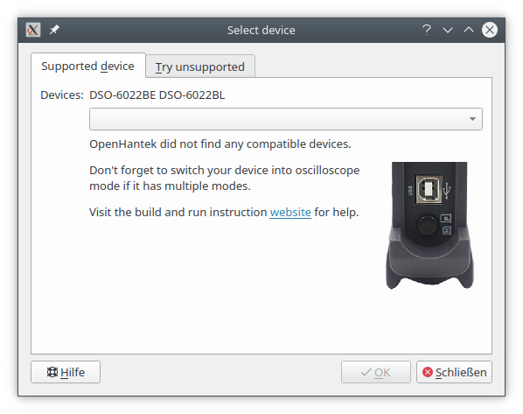

The scopes Hantek6022 contain a Cypress EzUSB processor that controls the data sampling and the USB transfer. The device does not contain a flash, the firmware must be loaded into the RAM at the 1st program start after powering the device.
The uploaded firmware is lost after switching off the scope or disconnecting the USB, so the device can never be bricked.

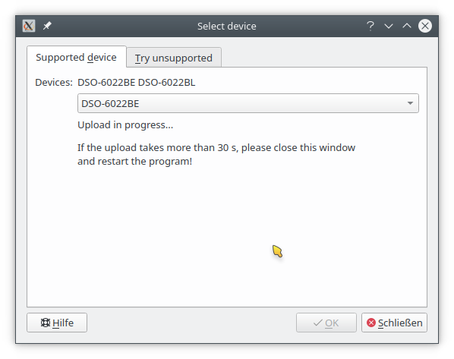
After starting the program, OpenHantek6022 searches for a supported device (either a Hantek6022BE or Hantek6022BL) by checking the USB VID/PID (vendor ID and product ID) of all connected USB devices.
6022BE: VID 0x04B4 / PID 0x6022
6022BL: VID 0x04B4 / PID 0x602A

If a scope is found, the firmware will be uploaded and the VID is changed from 0x04B4 to 0x04B5 while keeping the PID unchanged.
If the firmware is uploaded successfully the led left of the CH1 connector blinks red.

If the upload takes more than 30 s,
please close the window and restart the program.

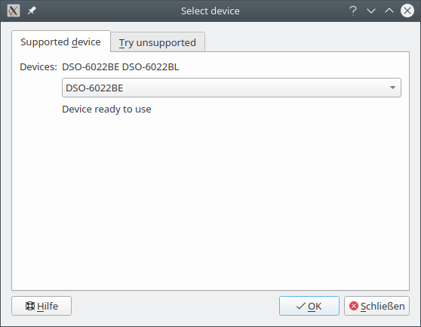

If the device is ready to use, select OK or press the return key to start the program and display the scope window.

Follow the Quick Start Guide to get a feeling for the program or start your real measuring job.

Quick Start Guide
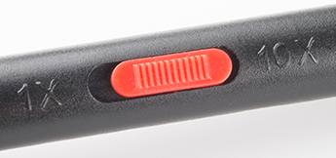
- Use one of the two supplied probes and connect it to CH1.
- Switch the red slider on the probe into the 1X position.
- Connect the hook of the probe tip to the left calibration out connector.
- Connect the alligator clamp of the probe to the right calibration out connector.
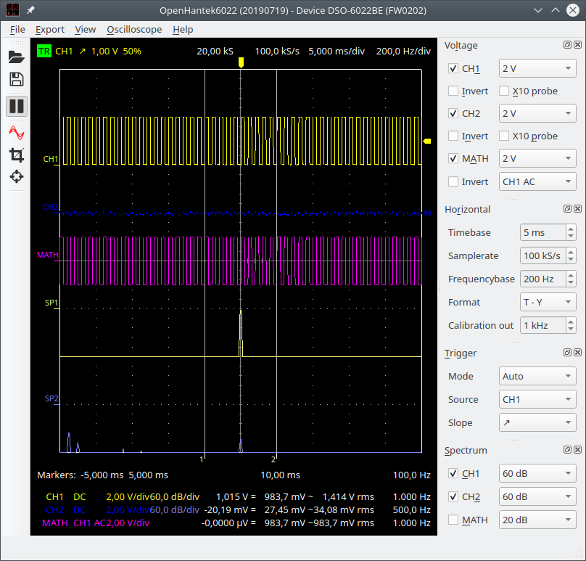
- The scope will show a yellow square wave trace.
- If the trace isn't stable drag the small yellow arrow on the right of the trace a little bit up, so that it is positioned in the middle of the trace.
- The trace will snap into position and the top left red TR will turn into green TR.
- Play a little with the settings to gain experience.
Detailed descriptions of all features can be found on the following pages.
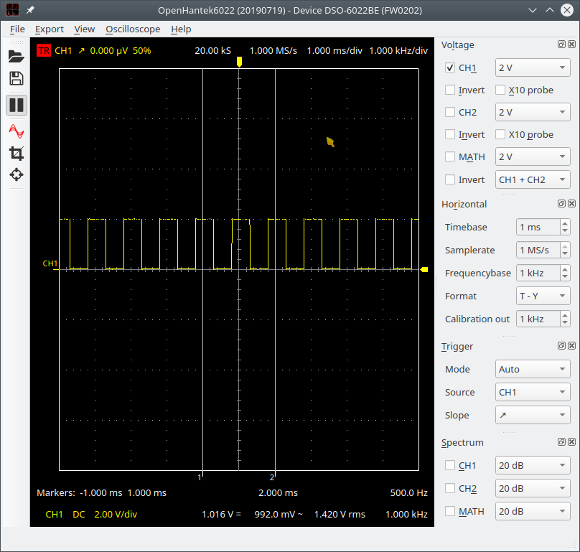
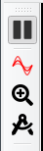

Using OpenHantek6022
The OpenHantek6022 program resembles the typical view of a real hardware oscilloscope, so anyone who has experience with scopes (including analog CRT devices) should be able to operate it. Those who lack this experience should keep in mind that a scope is a complex measuring instrument, so a basic understanding of how it works is required to perform correct measurements.

The program version, device type and firmware version are displayed in the top line of the window. This information helps when reporting issues or supposing enhancements.

The scope functions can be controlled by the four sections (marked orange) on the right:
- Voltage
- Horizontal
- Trigger
- Spectrum.

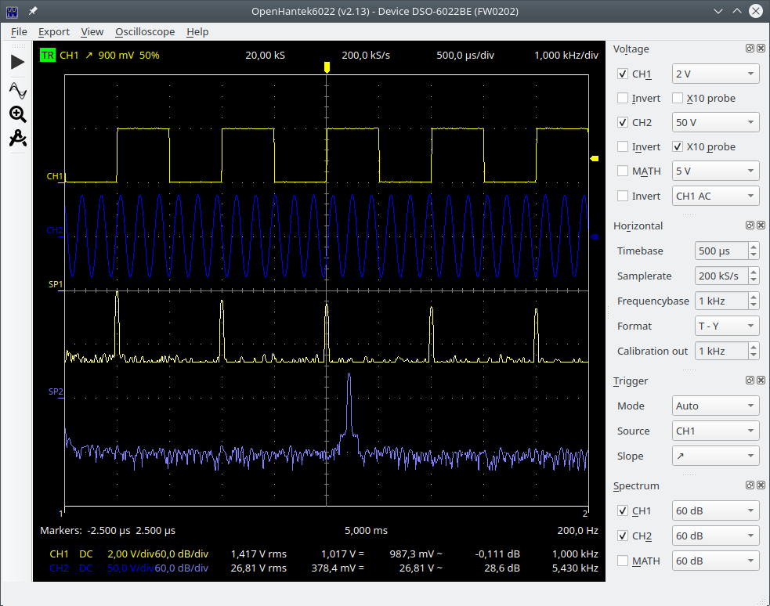
The selected settings are automatically saved when you exit and restored the next time you start the program.

Voltage
Both channels measure the voltage related to GND.
GND is directly connected also to the PC and to the main's GND so never ever connect GND of the scope to other voltages as it can destroy the scope and the PC!
This is not a limitation of this device but typical for most scopes, even for much more expensive ones.
Each channel can be selected or deselected by ticking CH1 or CH2. Input signal polarity can be Inverted.
The vertical position of the trace can be changed by dragging the name label left of the trace.
The default colors of the traces CH1 and CH2 correspond to the channel colors on the front of the scope hardware.
The maximum measurable input signal range is -5 V … +5 V, values outside this range are clipped (shown as minimum or maximum value).
Input voltages outside the safe range of ±35 V can lead to permanent damage!
Each channel has an amplifier with selectable gain that allows the amplification of the input signal by the factor 1X, 2X, 5X or 10X, the available input voltage range decreases accordingly from ±5 V to ±2.5 V, ±1 V and ±500 mV.
Input sensitivity per division can be selected from 20 mV/div up to 5 V/div (1/2/5 steps) by the control field, e.g. 2 V.
The display's height is 8 div, marked with horizontal dotted lines on the screen.
The two supplied Hantek probes allow a signal attenuation of 1/10, so the possible maximum input voltage range is increased ten times to ±50 V (e.g. 12 V input will be measured by the scope as 1.2 V). The X10 probe setting eases the usage of this X10 range by multiplying the displayed value by 10 (the measured example value of 1.2 V from above will be displayed correctly as 12 V).
The MATH channel (purple color) allows simple calculations with measured signals:
- CH1+CH2, CH1-CH2, CH2-CH1, CH1*CH2, CH1 AC, CH2 AC
The subtract functions allow the measurement of voltages between two points in a circuit by measuring both with CH1 and CH2 and subtracting the values.
Math mode CH1*CH2 can be used to calculate the momentary power as product of voltage and current (when current is measured with a 1 Ω shunt in the GND line then 1 V in MATH display equates a power of 1 W). Or you can use a current probe and scale accordingly.
The AC modes calculate the AC component of a channel by averaging over the sampled signal and subtracting this value from the samples, leaving only AC.
The scope also calculates typical values of each active channel and displays them in the colored bottom lines, the values from left to right are:
Channel name, coupling (only DC available) or math mode, voltage range, spectrum range,
RMS voltage ( i.e. sqrt(DC² + AC²) ), DC voltage (average), AC voltage, AC as dB and frequency.
A red channel marking (e.g. CH1) warns when the input signal exceeds the channel's physical input range and clipping has occurred.

Horizontal
The displayed time range of the trace can be selected by Timebase between 10 ns/div and 100 ms/div in 1/2/5 steps. The display's width is 10 div, marked with vertical dotted lines on the screen.
The optimal Samplerate will be selected automatically but the user can also change this manually within the realistic range. The maximum sample rate is 15 MS/s when sampling two channels.
If only CH1 is used, the maximum sample rate is doubled to
30 MS/s.
The effective sample size used for display, calculations and export is always 20 kS. For (effective) sample rates lower or equal 1 MS/s a 10 times oversampling is used, i.e. to get 20 kS @ 1 MS/s the scope samples 200 kS @ 10 MS/s and averages over 10 samples each to decrease the noise floor by 10 dB and increase the effective sample width of the 8-bit ADC to almost 10 bit.
(It's exactly 9.66 bit, each 4X oversampling adds one bit, 4X → 9 bit, 16X→10 bit, …).

The Frequencybase setting selects the resolution of the spectrum in Hz/div.
An overview of all settings is also visible top right of the trace window.

Format selects T-Y (i.e. normal scope display, voltage (Y) over time (X))
or X-Y (CH1 = X, CH2 = Y, the position on the screen can be changed by dragging the channel markers CH1 and CH2 left of the traces window).

Calibration out selects the frequency of the calibration output (a 2 Vpp square wave) on the right of the scope, set to 1 kHz at each program start. The frequency can be selected between 50 Hz .. 100 kHz in 1/2/5 steps.

Two Markers (vertical lines, marked with 1 and 2) allow time measurement (and the corresponding frequency) of the traces by dragging the lines. New markers can be positioned also by click and drag inside the trace window.

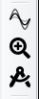
- The digital phosphor function (sine waves icon) simulates a slow fade out of traces to detect short events.
- The zoom function (magnifying glass icon) displays a new window below the main window with zoomed time range equating the markers distance.
- The measure function (drafting compass icon) opens an extra section and allows measurement of time or frequency span and levels.

Trigger
Triggering allows to display a stationary trace by fixing a rising or falling Slope of the signal of the selected Source channel to a defined position on the screen. The triggering is done in software by searching for the trigger condition in the sampled values and skipping the necessary amount of leading samples to position the trace accordingly.

Trigger Mode can be:
- Auto (display a running trace even if no trigger point is detected)
- Normal (display no trace without active trigger, hold the last triggered trace)
- Single (display a new trace every time the space bar is pressed)

Hitting the space bar stops and restarts the display during Auto and Normal mode.

The trigger level (voltage) can be selected by dragging the small colored (e.g. yellow) arrow to the right of the recording window. The trigger position on the screen can be selected by dragging the colored (e.g. yellow) arrow at the top of the window.

Trigger status (TR = triggered, TR = not triggered), source, slope, level and position are displayed in the upper left corner of the trace window.

Spectrum
The program calculates the voltage spectrum of the three channels using the discrete FFT and displays the results if enabled.
The displayed values are shown as dBV (0 dBV equals 1 V rms).

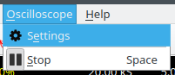
The applied Window function as well as the reference point for the spectrum calculation can be changed in this menu: Oscilloscope / Settings / Spectrum
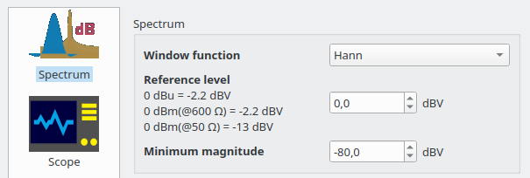

Typical window functions are Hann (raised cosine), Gauss or Flat top. The Hann window has the best frequency selectivity (narrowest bandwidth) while the Flat top window allows accurate amplitude measurements. Gauss window characteristic is in between.
The Flat top window is typically employed on data where frequency peaks are distinct and well separated from each other (e.g. for harmonic distortion measurements).
If the frequency peaks are not guaranteed to be well separated, the Hann window is preferred because it is less likely to cause individual peaks to be lost in the spectrum.
Other different window functions are available for the curious user.
The frequency range of the spectrum can be selected in the Horizontal section, minimum frequency is always zero, the maximum frequency is limited to the Nyquist frequency, i.e. ½ sampling rate.
A lower sampling rate yields a narrower frequency lobe and increases the selectivity while a higher sampling rate allows to display a wider frequency range at the cost of less selectivity.

Important: Sampling a signal with spectral components above the Nyquist frequency leads to aliasing, i.e. the higher spectral components are mirrored into the low frequency range.
This is not a limitation of this device, but should be considered when looking at the spectrum.

The default Reference level of 0 dBV converts a 1 V rms sinusoidal signal into a displayed
0 dB amplitude frequency peak.
Professional audio measurements typically use dBu (aka. dBm @ 600 Ω load):
0 dBu = 0 dBm = 0.775 V rms which corresponds to a reference level of -2.2 dBV.
Conversely, for RF with a 50 Ω load, 0 dBm equates approximately 0.224 volts:
0 dBm = 0.224 V corresponds to a reference level of -13 dBV.
The Minimum magnitude setting hides the noise floor and calms the display;
all spectral components below this level are not displayed.

Zoom function


The zoom function (magnifying glass icon) opens a second window below the main window with an enlarged time range corresponding to the distance between the markers (1 & 2).

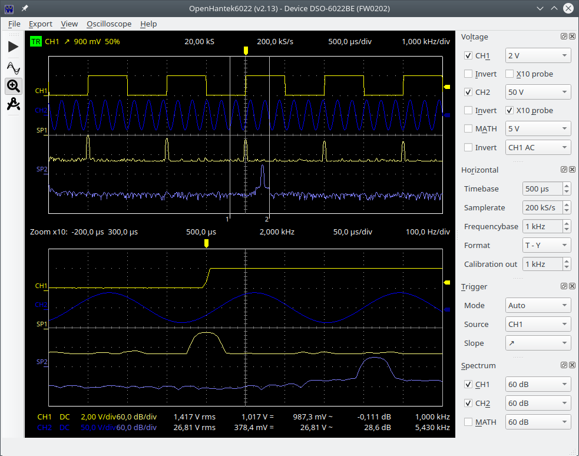

Cursor Measurements


The measurement function (drafting compass icon) allows to measure voltage or spectral amplitude as well as time or frequency intervals of one or more displayed tracks.

Select the trace (e.g. SP1), set ON and draw a (yellow) rectangle (red circle) to measure
e.g. frequency and magnitude difference.

You can also draw another (blue) rectangle (purple circle) to measure a different trace.

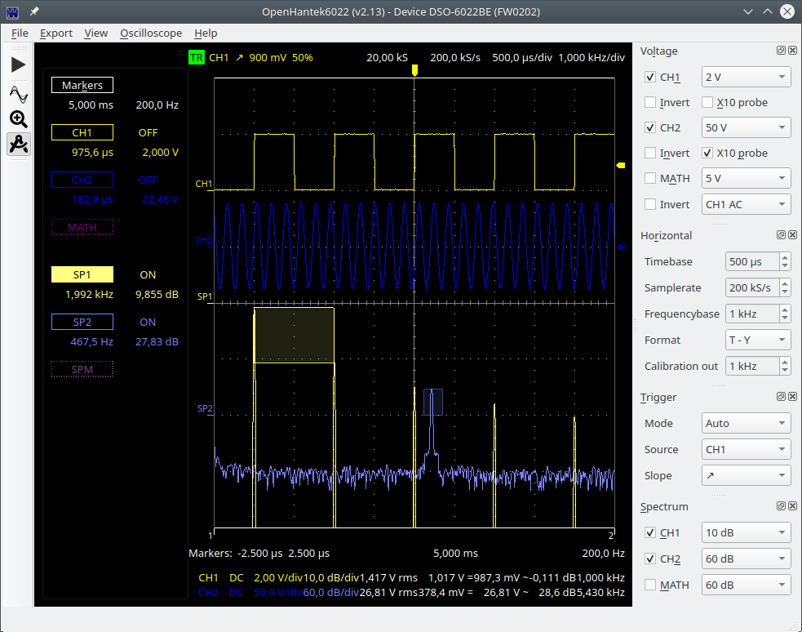

Data Export

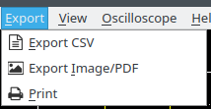
The Export CSV function allows to store the measured samples and the resulting spectral values as a *.csv file (comma separated values).
All 20000 voltage samples as well as all 10001 calculated spectral components of all active channels are stored.
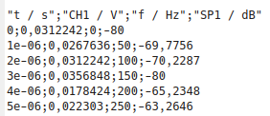
The values are stored as SI basic units:
seconds, volts, hertz and dB.
The field separator, usually a comma, is automatically changed to a semicolon for countries where the comma is used as the decimal separator, e.g. Germany.

The Export Image/PDF function stores the screen content as a *.png picture or a *.pdf file, the colors can be adjusted in the Oscilloscope/Settings/Colors menu, while the png image size is set in the Oscilloscope/Settings/File menu.

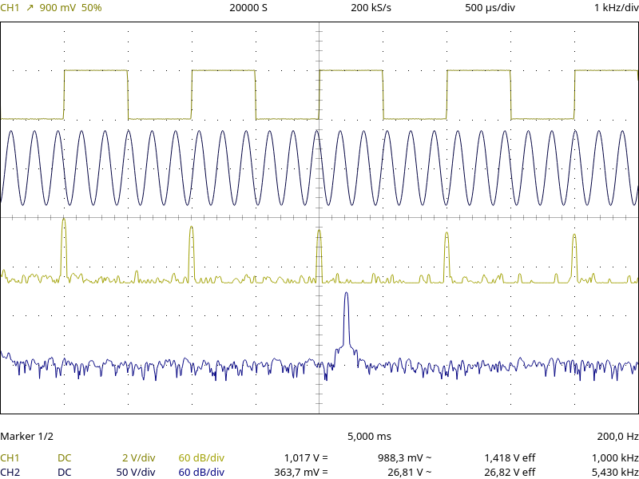

The Print function sends the screen content to the printer (as pdf), color settings as above.

Hantek6022 Analog Front End (One Channel)

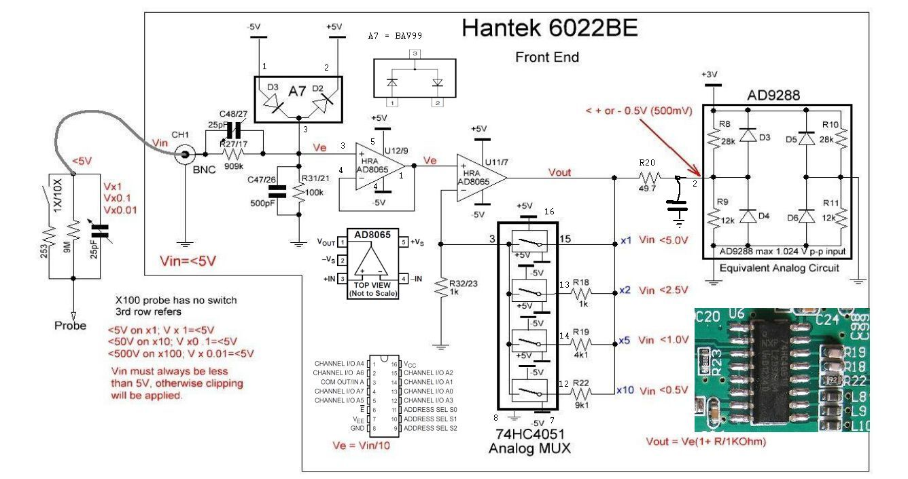

The input signal Vin is divided 1:10 by a frequency compensated resistors R27/17 and R31/21. Clamping diode A7 limits Ve to ±5 V (equates Vin = ±50 V). U11/7 together with the analog mux amplifies Ve by 1X, 2X, 5X or 10X (Vout).

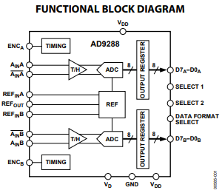
Vout is fed into the ADC AD9288 that measures the difference between Ain and /Ain and converts the difference input voltage range -512 mV .. +512 mV
into digital values 0x00 .. 0xFF (0 V equates 0x80).

Unfortunately Hantek decided to operate the ADC far out of spec with a common mode voltage Vc = 0 V, contrarely to the datasheet requirement for the common mode voltage:

Vc = 0.3 x Vd – 0.2 V .. 0.3 x Vd + 0.2 V,
with Vd = 3 V → Vc = 2.7 V .. 3.1 V

Probably due to this misdesign, the first 1000..1500 samples of a measured block are unstable, OpenHantek6022 works around this behavior by sampling more values and dropping the first ~2000.

Hantek6022 Digital Back End
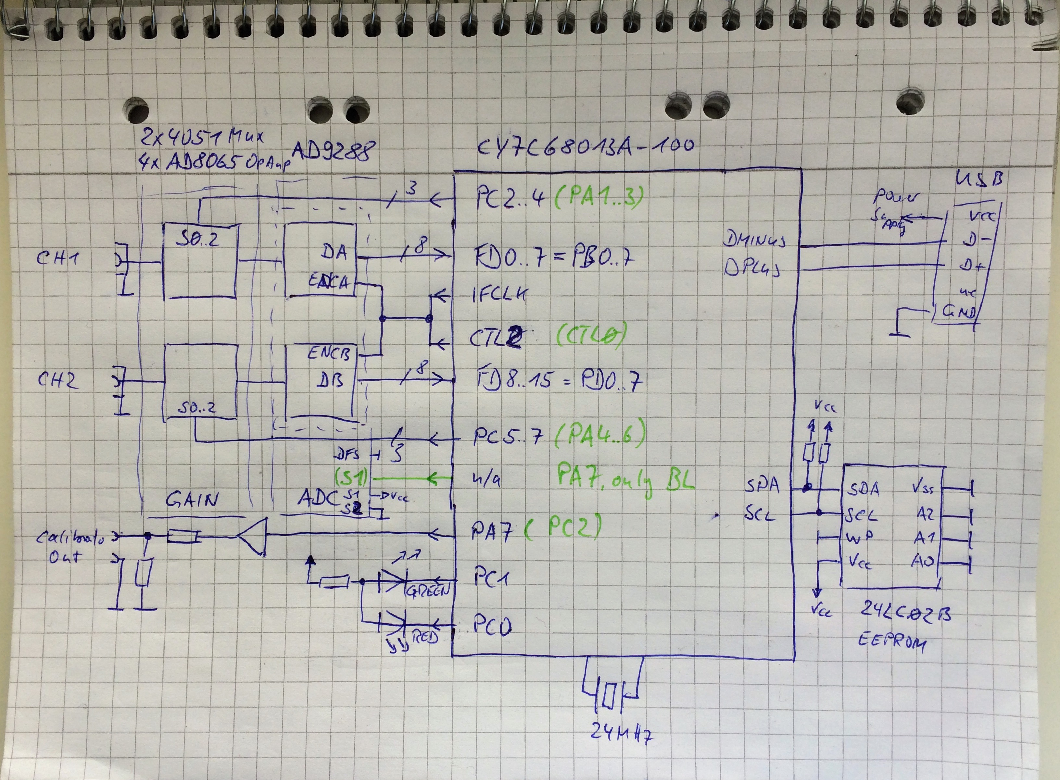

Hantek6022 (BE & BL) backend is built around the EzUSB processor CY7C68013A that handles USB communication, ADC timing, front-end channel gain setting and generates the calibration output signal. Hantek 6022BE and 6022BL (in scope mode) differ slightly in the use of the processor ports, but otherwise work identically.
EzUSB does not store the user firmware permanently in flash memory, it must be uploaded to RAM each time the unit is turned on. The program OpenHantek6022 checks if the correct firmware version is loaded. In case it detects no FW or a wrong FW version (e.g. because of using the scope with the original Hantek software before) the correct firmware will be uploaded automatically.

