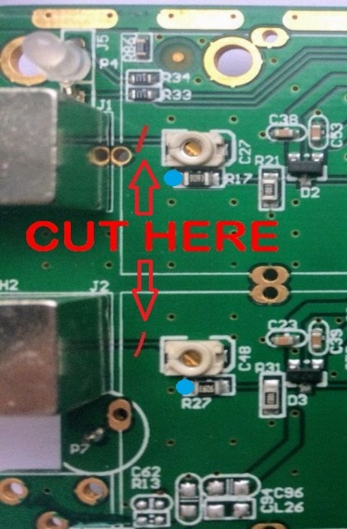
Modification of HANTEK 6022 to provide AC/DC coupling of the inputs

A big issue of the Hantek scope is the missing AC coupling (see front end schematics below).
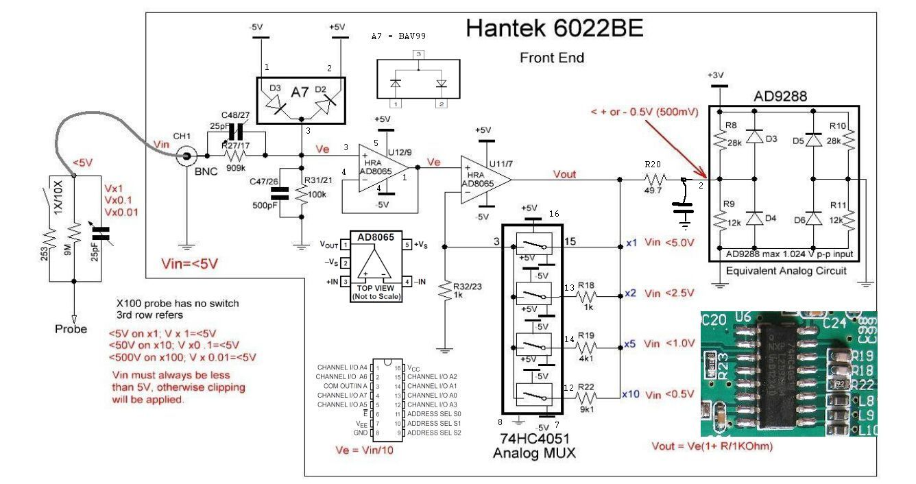
This document shows a simple hardware modification similar to the SainSmart DDS120 scope.
(HW info: https://sigrok.org/wiki/SainSmart_DDS120)
- Cut the traces between BNCs and R17/R27 and add a 100nF capacitor across.
This gives an AC coupling with cut-off frequency fc = 1.6 Hz.
(10nF in the prototype gave fc = 16Hz with a visibly tilted 1kHz square wave.)
- To select DC short the capacitor by a PhotoMOS AQY210EH.
The 1K0 resistor limits the current when the PhotoMOS shorts the 100 nF capacitor.

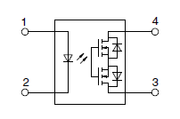
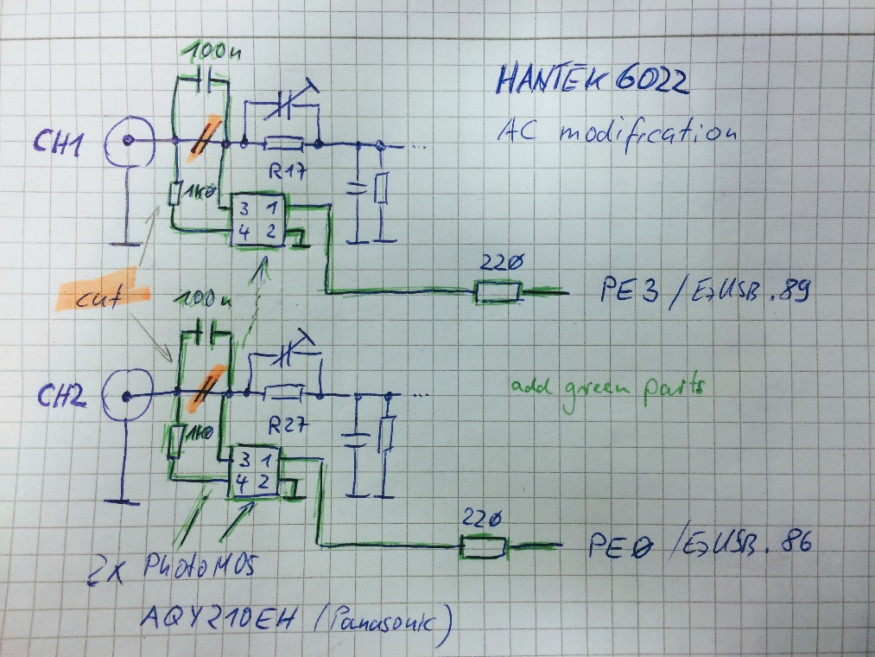
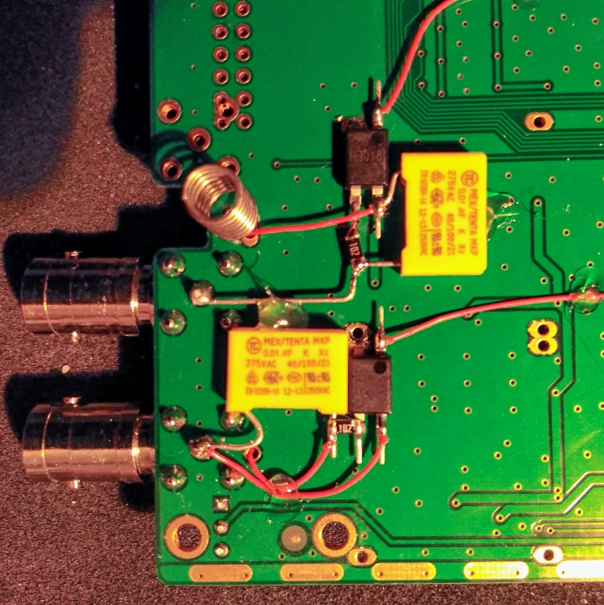
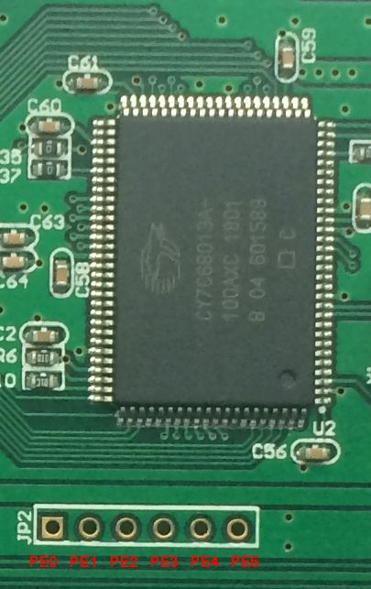
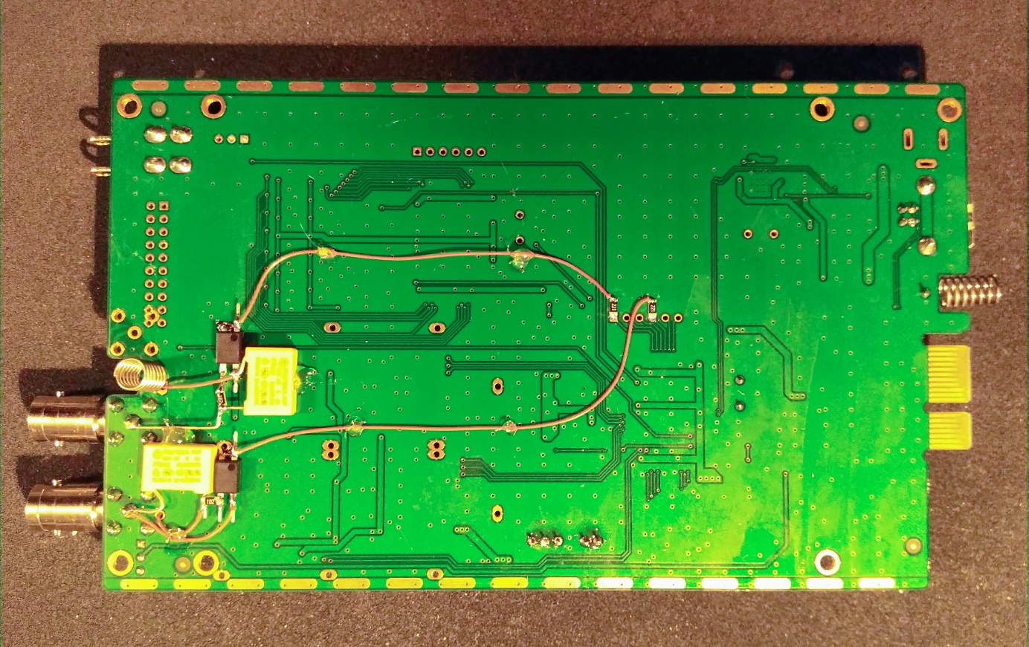
- JP2 next to the EzUSB chip delivers the signals PE0 .. PE5.
PE0 (CH2) and PE3 (CH1) are used, same as in SainSmart DDS120 (red arrows).
- All new components are soldered/glued on the bottom side of the PCB.
- One wire per channel (blue arrow) connects to R17/R27 on the top side (blue dot).

OpenHantek6022 supports this AC modification starting with version v2.17-rc6 / FW0204.
To enable this feature go to the directory build and type
cmake -D HANTEK_AC=1 ../
make -j2

Later OpenHantek6022 versions beginning with 3.1.1 offer an Oscilloscope/Settings option that allows you to use the modification without the need to compile your own version.
