J5

1 2

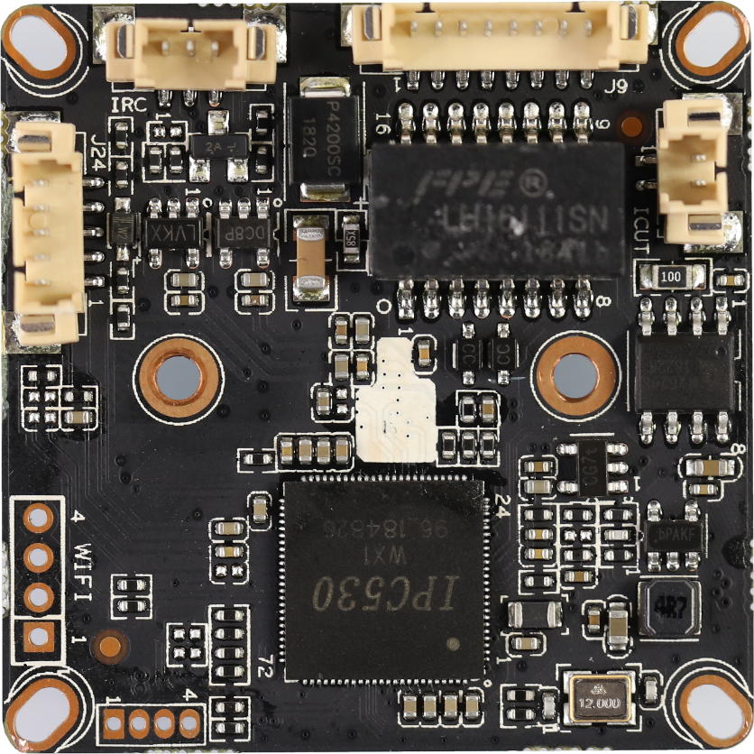

J9

8

7

...

2

1

J6

3

2

1

5 4 3 2 1

J24

4 3 2 1

J1

|  |  |  |  |  |
| --- | --- | --- | --- | --- |
| BLK530WX1-0307D-38X38-S-V1_01 Interface Description | | | | |
|
| Socket | Specific No | Interface Description | Function | |
| J9 | 1 | LED0 | LED/PHY_AD0 | Connect the tail line of the camera module |
| 2 | LED1 | LED/PHY_AD1 |
| 3 | ETHTX+ | Ethernet signal+ |
| 4 | ETHTX- | Ethernet signal- |
| 5 | ETHRX+ | Ethernet signal+ |
| 6 | ETHRX- | Ethernet signal- |
| 7 | GND | GND |
| 8 | 12V | 12V DC input |
| J5 | 1 | IR-CUTA | BOUT | IR_CUT |
| 2 | IR-CUTA | AOUT |
| J6 | 1 | IR-IN | Infrared input | Connect the camera lamp board |
| 2 | GND | GND |
| 3 | PWM-OUT | +3.3V |
| J24 | 1 | AC_OUT | AC_OUT | audio |
| 2 | AC_IN | AC_IN |
| 3 | GND | GND |
| 4 | ALARM-IN | ALARM_GPIO |
| 5 | ALARM-OUT | ALARM_GPIO（Reserve） |
| J1 | 1 | 3.3V | WIFI Module power supply | Connect the USB WIFI Module |
| 2 | USB_DN | USB |
| 3 | USB_DP | USB |
| 4 | GND | GND |