

**IVG-85X30PSA-ST**

3.0M Black light illumination H.265 IP Camera Module

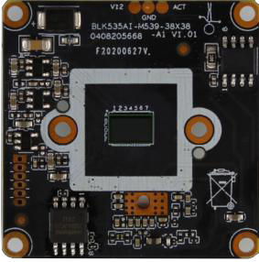Features:

* Supporting Humanoid detection and tripping line detection, and supports customization of other smart functions;
* 3.0MP HD Black light illumination resolution, clear and fine images;
* Support 2D/3D noise reduction, digital wide dynamic;
* Advanced H.265AI/H.265+ (Compatible with H.265/H.264) video compression, Super low rate high definition quality of image;
* Professional anti-lightning conform to GB/T17626.5 and IEC61000-4-5。
* Support ONVIF; access third party Support various mobile monitoring (iPhone, Android);
* Provide web, CMS center platform management software MYEYE, provide SDK development
* Support cloud technology, easy to achieve network penetration, fro in-line and alarm information pushed

Parameters：

|  |  |
| --- | --- |
| Model | IVG-85X30PSA-ST |
| System structure | Embedded RTOS, dual-core 32bit DSP(XM535AI),pure hard compression ,watch dog |
| Sensor | 3.0M 1/2.8"SC3335 Black light CMOS sensor color 0.0001Lux@F1.2,black/white [0.0001Lux@F1.2](mailto:0.0001Lux@F1.2) |
| Video compression | H.265AI/H.265+ (Compatible with H.265/H.264),support dual stream,AVI;0.1M~8Mpbs variable;1~30f/s variable |
| Image output | Main stream: 2304*1296@20fps，1920*1080@25fps; sub-stream: 800*448@25fps; |
| Shutter | 1/50(1/60)s to 1/10,000s |
| Lens | N/A |
| Day and night | Support IR-CUT,IR-CUT coil has an internal resistance of 20 ohms, the power-on time is less than 200ma, and the voltage is  3.5V-6V |
| Noise reduction | Support 2D/3D |
| Wide dynamic | Support digital |
| Auto iris | N/A |
| Audio compression | G.711,support bidirectional talk, audio & video synchronization |
| Audio interface | 1ch input,level:2Vp-p,impedance:1kΩ,support sound pick-up input;1ch output,impedance:16Ω,30mw,support microphone |
| Network interface | 1*RJ45 10/100M adaptive Ethernet port; support RTSP/FTPDHCP/NTP/UPnP etc |
| Extension interface | N/A |
| Signal interface | One photo resistance interface, one IR-CUT interface ,support photo resistance signal and IR-CUT links to IR |
| PTZ | N/A |
| Motor interface | N/A |
| Alarm I/O | N/A |
| WIFI interface | N/A |
| Reset interface | N/A |
| SD Card | N/A |
| Reliability | Comprehensive lightning protection, 7 * 24 hours -10℃～65℃high temperature stable and reliable testing |
| Intelligence analysis | Supporting Humanoid detection and supports intelligent functions such as customized face detection, number statistics, etc. |
| Other function | Support WEB OS ,live video transmission, motion detect and IO alarm, front-end storage/playback/download, and center  reminder and image linkage, support JPEG capture; united remote client monitoring software MYEYE; perfect SDK; |
| ONVIF | Support |
| Mobile monitoring | Support multiple mobile monitoring （iOS Android） |
| Power | DC12V/2A input, power consumption:≤3W, |
| Dimension | 38mm*38mm |
| Other | Support POE power supply, not support any custom The drive voltage of the light board is at 3.3V |

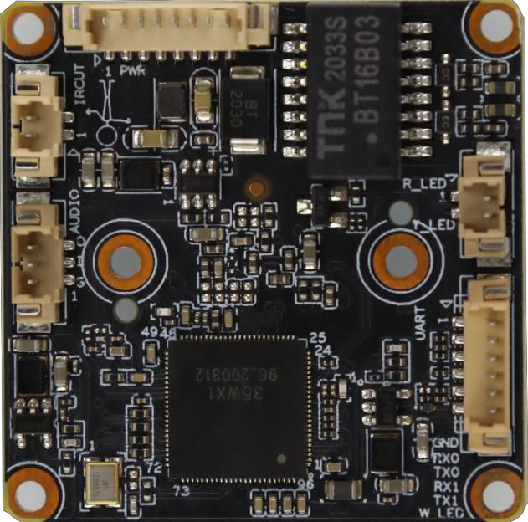

P1 Power&

Ethernet

P2 IRCUT

P5 Infrared

P4 Extension ports

P3 audio

|  |  |  |  |  |
| --- | --- | --- | --- | --- |
| Socket | Specific No | Interface  Description | Function | Socket |
| P2 | J5 | 1 | IR-CUT | IR-CUT Control line |
| 2 | IR-CUT | IR-CUT Control line |
| P4 | J44 | 1 | GND | GND |
| 2 | RXO | RXO |
| 3 | TXO | TXO |
| 4 | RX1 | RX1 |
| 5 | TX1 | TX1 |
| 6 | W_LED | White light interface |
| P1 | J1 | 1 | LED/PHY_AD0 | LED/PHY_AD0 |
| 2 | LED/PHY_AD1 | LED/PHY_AD1 |
| 3 | ETHTX+ | Ethernet signal+ |
| 4 | ETHTX- | Ethernet signal- |
| 5 | ETHRX+ | Ethernet signal+ |
| 6 | ETHRX- | Ethernet signal- |
| 7 | GND | GND |
| 8 | 12V input | 12V INPUT |
| P3 | J40 | 1 | GND | GND |
| 2 | AC_INL | AUDIO INPUT |
| 3 | AC_OUTL | AUDIO_OUT |
| P5 | J41 | 1 | R-LED | Soft infrared interface |
| 2 | Y-LED | Hard infrared interface |