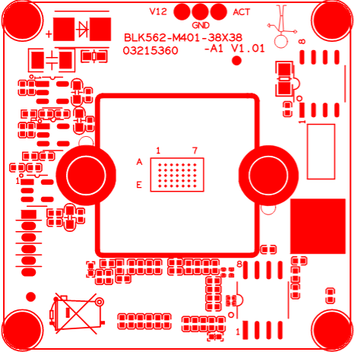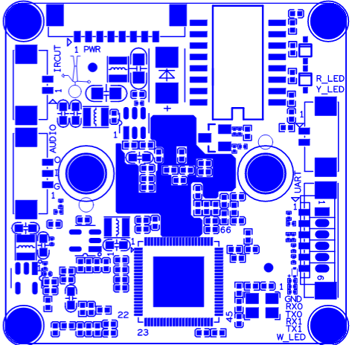
P1 Power&
Ethernet
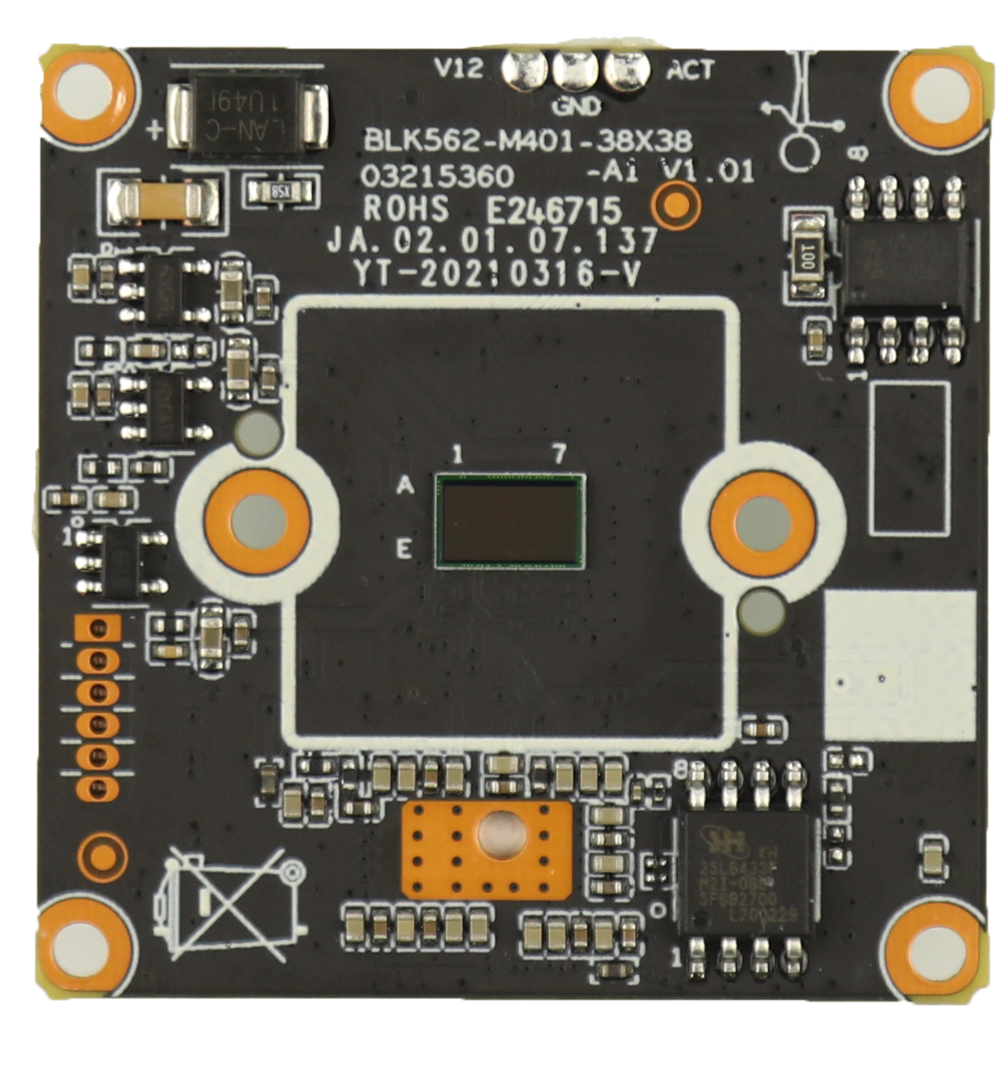
P2 IRCUT
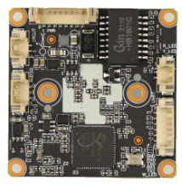

P5 Infrared

P4 Extension ports

P3 audio

Socket | Specific No | Interface Description | Function | Socket
P2 | J5 | 1 | IR-CUT | IR-CUT Control line
P2 | J5 | 2 | IR-CUT | IR-CUT Control line
P4 | J44 | 1 | GND | GND
P4 | J44 | 2 | RXO | RXO
P4 | J44 | 3 | TXO | TXO
P4 | J44 | 4 | RX1 | RX1
P4 | J44 | 5 | TX1 | TX1
P4 | J44 | 6 | W_LED | White light interface
P1 | J1 | 1 | LED/PHY_AD0 | LED/PHY_AD0
P1 | J1 | 2 | LED/PHY_AD1 | LED/PHY_AD1
P1 | J1 | 3 | ETHTX+ | Ethernet signal+
P1 | J1 | 4 | ETHTX- | Ethernet signal-
P1 | J1 | 5 | ETHRX+ | Ethernet signal+
P1 | J1 | 6 | ETHRX- | Ethernet signal-
P1 | J1 | 7 | GND | GND
P1 | J1 | 8 | 12V input | 12V INPUT
P3 | J40 | 1 | GND | GND
P3 | J40 | 2 | AC_INL | AUDIO INPUT
P3 | J40 | 3 | AC_OUTL | AUDIO_OUT
P5 | J41 | 1 | R-LED | Soft infrared interface
P5 | J41 | 2 | Y-LED | Hard infrared interface

