**Informix Time Series Plug-in 0.3 for Grafana 5.x - README**

**IMPORTANT**: This plug-in is an early access version provided as as-is. It might has some issues and might be lacking some Grafana functionality. Please feel free to fix, enhance and to add to the code. Use at your own risk.

Just extract the Informix_0.3.tar file into '<Grafana install dir>/data/plugins/' and then re-start the Grafana server.

To use the Informix plugin, first create a new 'Informix Time Serie 0.3' data source as the Grafana admin user.

Please make sure to increase the property response.documents.count.default in the REST API listener properties file to make sure that you’ll get the desired data elements back. You could e.g. set that property to:

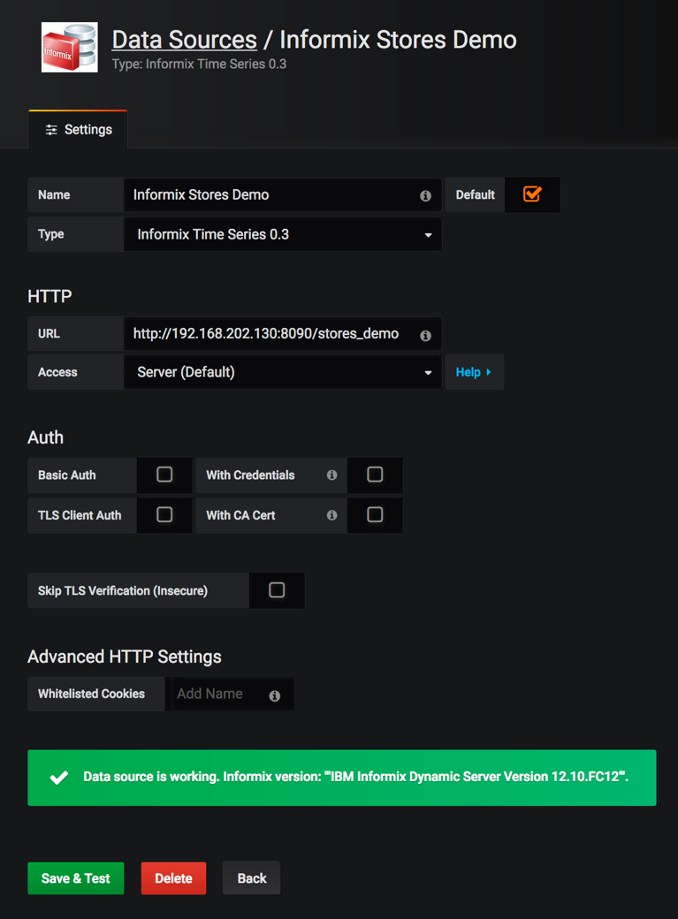response.documents.count.default=10000

The URL parameter should point to your Informix database REST API entry point like e.g. (see screenshot #1):

<http://localhost:8090/stores_demo>

Note: I haven't tested the Authentication features yet.

If you would like to define new Informix TS based metrics (like shown in screenshot #2), please use the following JSON format:

{"table": "ts_data_v", "key": {"name": "loc_esi_id", "value": 4727354321000111}, "col_ts": "tstamp", "col_value": "value"}

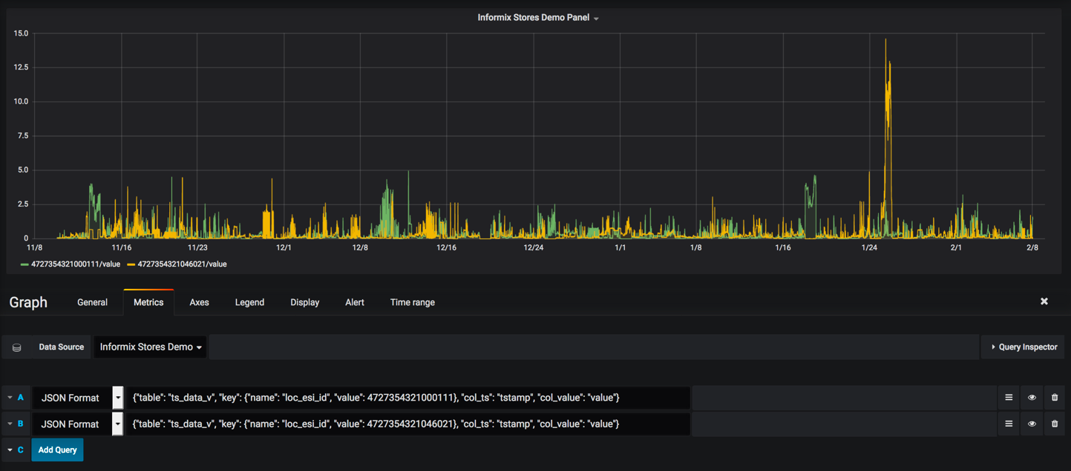

table: Name of the VTI table to read from

key.name: Name of the primary key column (at the moment the plugin only supports

single column primary keys, but I will try to remove that limit soon)

key.value: That is the search value for the primary key.

col_ts: Name of the timestamp column

col_value: Name of the measurement column

If you would like to access values of a JSON based time series, then you need to add the JSON key-value pair "json_elem":"<json_element_name>" in the metrics definition. Here is an example:

{"table": "sensor_json_data", "key": {"name": "sensor_id", "value": "ELV_Weathersensors"}, "col_ts": "timestamp", "col_value": "values", "json_elem": "t9"}

The timestamp ranges for the queries are dynamically provided by Grafana and hence dynamically added to my REST API queries.

That Informix Grafana plug-in has been developed and tested with Grafana 5.2.2 on MacOS.

Have fun using that plug-in!

Please send any feedback to Alexander.Koerner@de.ibm.com.