# Windows or Linux settings to grab the video from Luci pin

**Enable Hotspot on PC**

* Turn on the hotspot function on your PC.
* Connect your mobile phone to this hotspot.  
  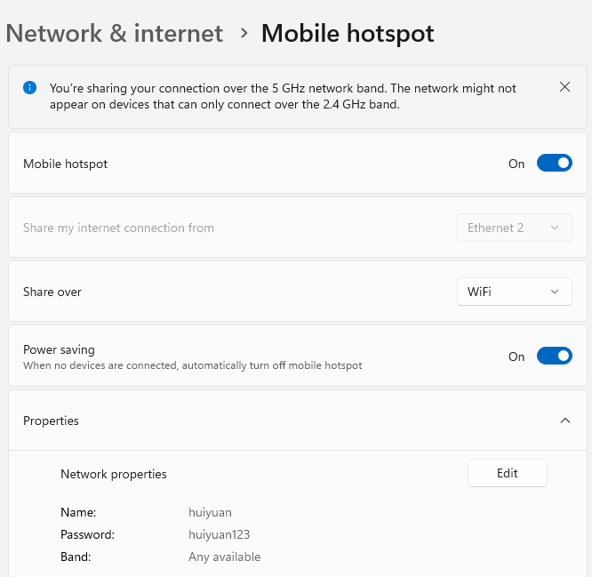

**Access LUCI**

* Open the LUCI application on your mobile phone.
* Connect LUCI to the same hotspot.
* Retrieve the IP address assigned to your PC and save LUCI’s IP address for later use.  
  A screenshot of a computer

  AI-generated content may be incorrect.

**Test Real-Time Video with VLC**

* Open VLC Media Player on your PC.
* Use the following RTSP URL to test the real-time video stream:  
    
   rtsp://192.168.137.38:50001/live/0

**Real-Time Pin View**

* Confirm that the real-time view is available.
* Install Dependencies On your PC, install OpenCV-Python or FFmpeg.

**Record Videos or Screenshots**

* Run the provided Python script to record video streams or capture screenshots.A person looking up at a window

  AI-generated content may be incorrect.