# Overview

Microsoft cloud services such as Office 365, Enterprise Mobility Suite, Dynamics CRM and other similar products, require user licenses to be assigned for each individual that needs access to these services. License management is exposed to administrators via one of the management portals (Office, Azure) and PowerShell cmdlets. License assignment state is stored in Azure Active Directory – the underlying infrastructure supporting identity management for all Microsoft cloud services.

Until now, licenses could only be assigned at individual user level which made management at large scale difficult for our customers. For example, to add or remove user licenses based on organizational changes, such as users joining or leaving the organization or a department, an administrator would have to write a complex PowerShell script that would make individual calls to the cloud service.

To address those challenges, we have introduced a new capability of the Azure AD license management system: group-based licensing. It is now possible to assign one or more product licenses to a group. Azure AD will make sure that the licenses are assigned to all members of the group. Any new members joining the group will be assigned the appropriate licenses and when they leave the group those licenses will be removed. This eliminates the need for automating license management via PowerShell to reflect changes in the organization and departmental structure on a per-user basis.

Here are the main features of group-based licensing capability:

* Licenses can be assigned to any security group in Azure AD. Security groups can be synced from on-premises using Azure AD Connect, created directly in Azure AD (also called cloud-only groups), or created automatically via the Azure AD Dynamic Group feature.
* When a product license is assigned to a group, the administrator may disable one or more service plans in the product. Typically, this is done when the organization is not yet ready to start using a service included in a product, for example the administrator wants to assign Office 365 E3 product to a department but temporarily disable the Yammer Enterprise service.
* All Microsoft cloud services that require user-level licensing are supported. This includes all Office 365 products, Enterprise Mobility Suite, Dynamics CRM, etc.
* Group-based licensing is currently available only through the Azure portal (<https://portal.azure.com>). Customers who primarily use other management portals for user and group management, such as the Office 365 portal, can continue to do so, but will need to use the Azure portal to manage licenses at group level.
* Azure AD automatically manages license modifications resulting from group membership changes. Typically, a user joining or leaving a group will have their licenses modified within minutes of the membership change.
* A user may be a member of multiple groups with license policies specified; they may also have some licenses that were directly assigned to the user outside of any groups. The resulting user state is a combination of all assigned product and service licenses.
* In some cases, licenses cannot be assigned to a user; for example, because there are not enough available licenses in the tenant or conflicting services have been assigned at the same time. Administrators have access to information about users for whom Azure AD could not fully process group licenses; they can then take corrective action based on that information.
* Group-based licensing requires a paid version of Azure AD – an Azure AD Basic or higher edition is required in the tenant. Also, all users inheriting any licenses from groups must have the paid Azure AD edition license assigned to them.

# Assigning licenses to a group

In this article, we are going to walk through a basic scenario of assigning product licenses to a group and verifying that all members of the group are correctly licensed.

In his example, the tenant contains a security group called “HR Department” which includes all members of the Human Resource department, in this case around 1,000 users. The administrator wants to assign Office 365 Enterprise E3 licenses to the entire department; the Yammer Enterprise service included in the product needs to be temporarily disabled until a later time when the department is ready to start using it. Because we are using group-based licensing, which requires a paid Azure AD license for each user, we will also assign the Enterprise Mobility Suite product license to the group.

## Step 1: Assign the required licenses

1. Sign in to the **Azure portal** (<https://portal.azure.com>) with an administrator account.
   1. To manage licenses, the account needs either the Global Administrator role or the User Account Administrator role.
2. Navigate to the **Azure Active Directory** blade located under **More services** in the left-hand side navigation pane.
   1. You may want to “favorite” this blade by clicking on the star icon or pin it to the portal dashboard.
3. On the **Azure Active Directory** blade, click **Licenses**. This opens a Bladen which you can see and manage all licensable products in the tenant.
4. Under **All products**, select both Office 365 Enterprise E3 and Enterprise Mobility Suite by selecting the product names. Click the **Assign** button on the top of the blade to start the assignment.

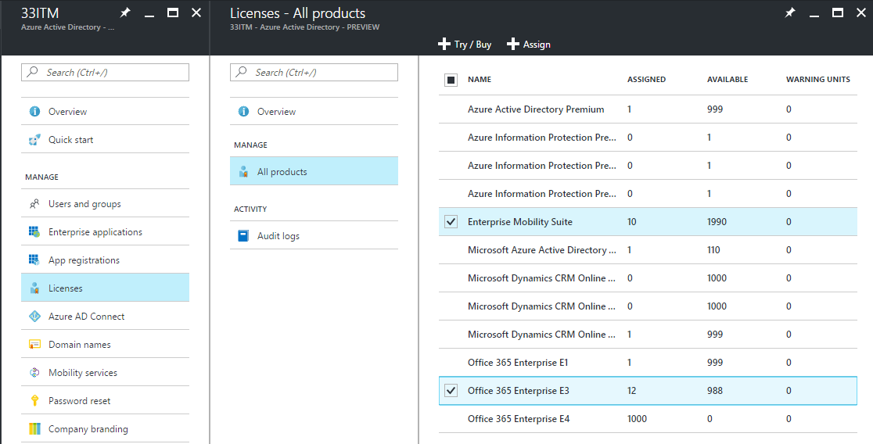

1. On the **Assign license** blade, click **Users and groups** to open the user and group blade. Search for the group name *HR Department*, select the group, and then be sure to confirm by clicking **Select** at the bottom of the blade.  
   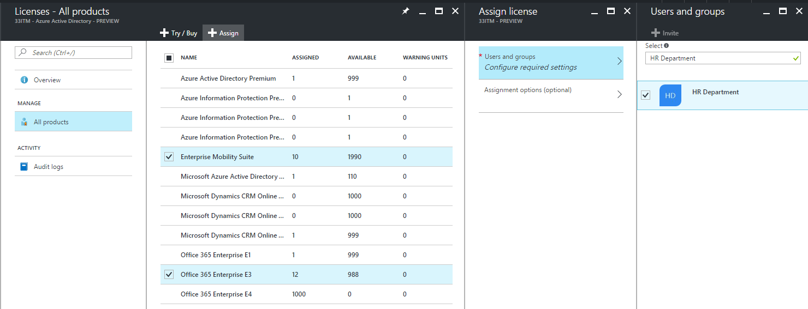
2. On the **Assign license** blade, click **Assignment options (optional)** which displays all service plans comprising the two products we selected previously. Find Yammer Enterprise turn it **Off** to disable that service from the product license. Confirm by clicking **OK** at the bottom.  
   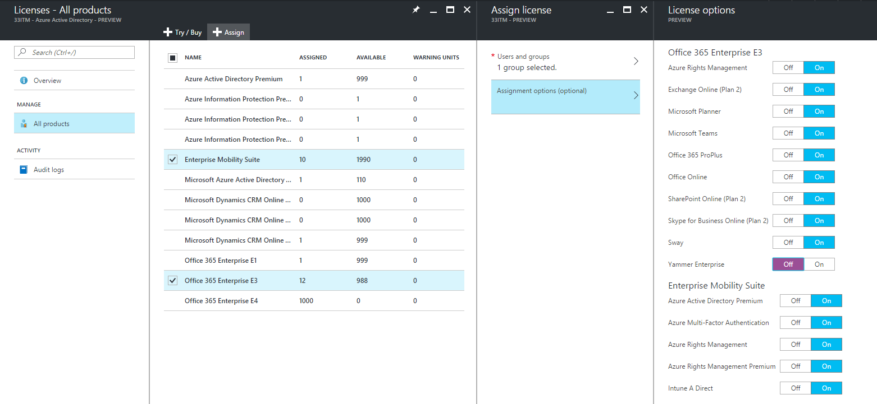
3. Finally, on the **Assign license** blade, click **Assign** at the bottom of the blade to complete the assignment.
4. A notification is displayed in the upper right hand side corner showing status and outcome of the process. If the assignment to the group could not be completed (for example due to pre-existing licenses in the group), click the notification to view details of the failure.

We have now specified a license policy on the HR Department group. A background process in Azure AD has been started to process all existing members of that group. This initial operation might take some time, depending on the current size of the group. In the next step, we will describe how to verify that the process has completed and if further attention is required to resolve problems.

Note: the same assignment can be started from an alternative location – **Users and Groups** in Azure AD. Go to **Azure Active Directory > Users and groups > All groups,** find the group, select it and go to the **Licenses** tab. The **Assign** button on top of the blade will open the license assignment blade.

## Step 2: Verify that the initial assignment has completed

1. Go to **Azure Active Directory->Users and groups->All groups** andfind the *HR Department* group to which licenses were assigned.
2. On the group blade, click **Licenses** to view the following information. This information can be used to quickly confirm if licenses have been fully assigned to users and if there are any errors requiring looking into.
   1. Product licenses that have been assigned to the group. Select an entry to show the specific services that have been enabled and to make changes.
   2. Status of the latest changes made to the license assignment; if the changes are being processed or if processing has been completed on all user members.
   3. If there were errors, information about users in error state, for whom licenses could not be assigned.

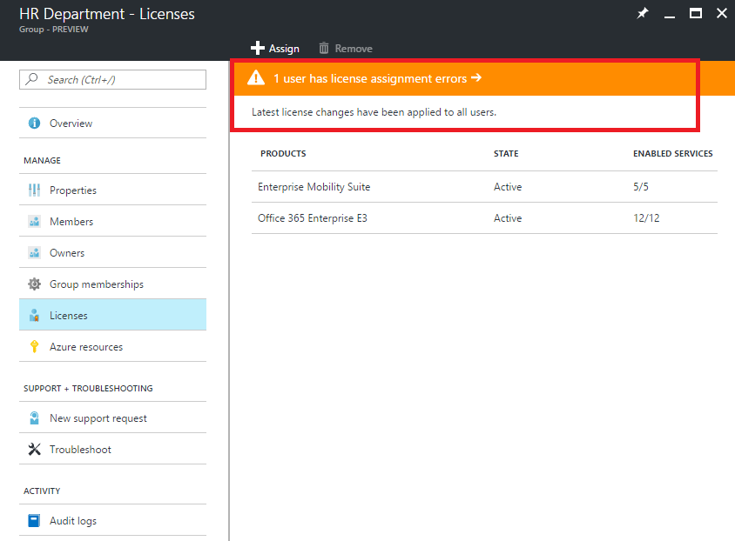

1. More detailed information about license processing is available under **Azure Active Directory > Users and groups > *groupname* >Audit logs:**
   1. Activity: *Start applying group based license to users*It is logged when our system picks up the license assignment change on the group and starts applying it to all user members. It contains information about the change that was made.
   2. Activity: *Finish applying group based license to users*It is logged when our system finishes processing all users in the group. It contains a summary of how many users were successfully processed and how many users could not be assigned the group licenses.

## Step 3: Checking for license problems and resolving them

1. Go to **Azure Active Directory->Users and groups->All groups** andfind the *HR Department* group to which licenses were assigned.
2. On the *HR Department* group blade, click **Licenses**. The notification on top of the blade signifies that there are 10 users for who licenses could not be assigned. Clicking on it opens a list of all users in licensing error state for this group.
3. The **Failed assignments** column tells us that both product licenses could not be assigned to the users. **Top reason for failure** contains the cause of the failure, in this case *Conflicting service plans*.

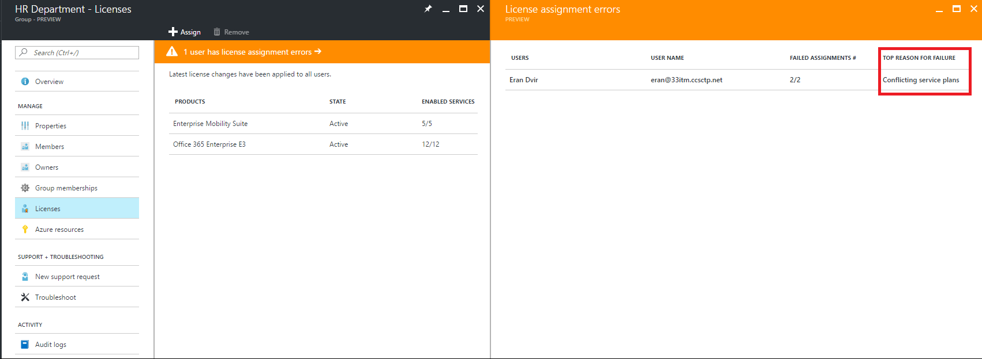

1. Select a user to open the **License details** blade showing all licenses currently assigned to the user. In this example, we can see the user has the *Office 365 Enterprise E1* license inherited from the *Kiosk users* group. This conflicts with the *E3* license that the system tries to apply from the *HR Department* group – as a result, none of the licenses from that group have been applied to the user.  
   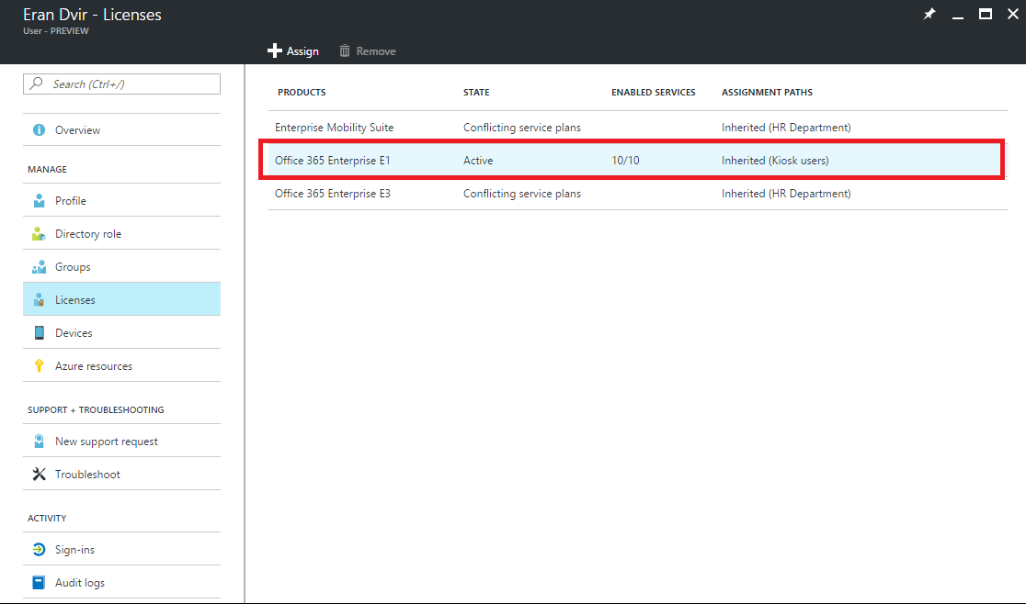
2. To solve this, we remove the user from the *Kiosk users* group. When the system processes the change, the *HR Department* licenses are now correctly applied.

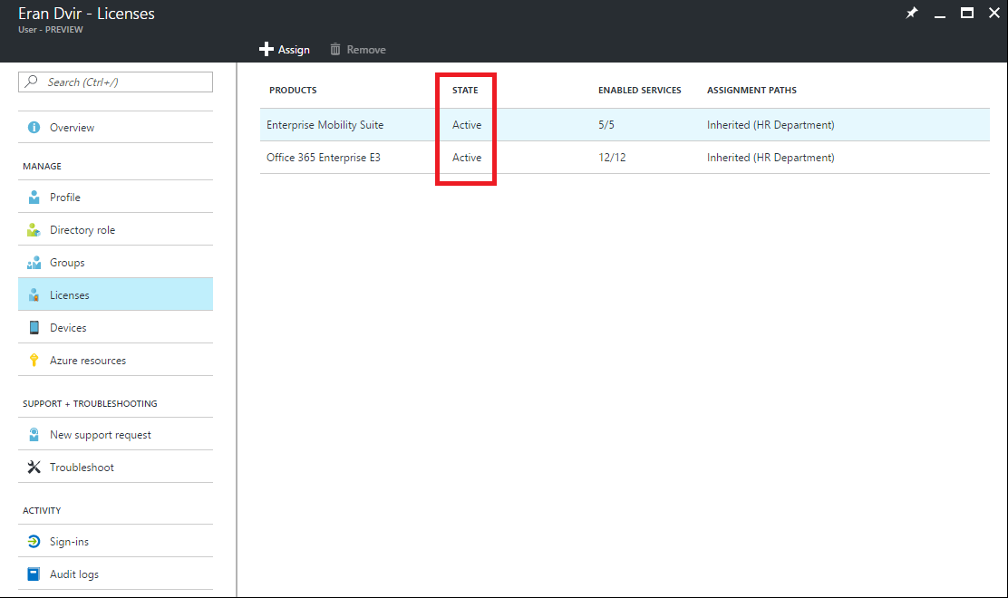

# Identifying and resolving license problems

Group-based licensing introduces the concept of users in licensing error state. In this article, we explain why users may end up in this state and describe the different types of errors as well as their resolution.

When licenses are assigned directly to individual users, without the use of group-based licensing, the assignment operation may fail. For example, when the administrator executes the PowerShell cmdlet *Set-MsolUserLicense* on a user, the cmdlet may fail for a number of reasons related to business logic, such as: insufficient licenses, a conflict between two service plans that cannot be assigned at the same time, etc. The problem is reported back immediately to the user executing the commend.

When using group-based licensing, the same errors can occur but they will happen in the background when the Azure AD service is applying licenses; for this reason they cannot be communicated immediately to the administrator. Instead they are recorded on the user object and reported via the administrative portal. The original intent to license the user is never lost, but it may be applied in active state or recorded in error state for future investigation and resolution.

To find users in error state for each group, go to the Group blade, under Licenses tab there will be a notification displayed if there are any users in error state. Clicking on that notification opens a view listing all affected users which can be viewed one by one to understand the underlying problem.

Next, we will describe each potential problem and the way to resolve it.

## “Not enough licenses”

There are not enough available licenses for one of the products specified in the group. You need to either purchase more licenses for the product, or free up unused licenses from other users or groups.

To see how many licenses are available, go to **Azure Active Directory->Licenses->All products.**

To see which users and groups are consuming licenses, click on a product. Under **Licensed users** you will see all users for whom licenses have been assigned directly or via one or more groups. Under **Licensed groups** you will see all groups that have that product assigned.

## “Conflicting service plans”

One of the products specified in the group contains a service plan that conflicts with another service plan already assigned to the user via a different product. Some service plans are configured in a way so they cannot be assigned to the same user as another related service plan.

Consider the following example: a user has a license for Office 365 Enterprise **E1** assigned directly, with all the plans enabled. The user has been added to a group that has the Office 365 Enterprise **E3** product assigned to it; this product contains service plans that cannot overlap between the E1 and E3, so the group license assignment will fail with the “Conflicting service plans” error. The 2 conflicting service plans pairs are:

* SharePoint Online (Plan 2) conflicts with SharePoint Online (Plan 1)
* Exchange Online (Plan 2) conflicts with Exchange Online (Plan 1)

To solve this conflict, you will need to disable those 2 plans either on the E1 license directly assigned to the user, or modify the entire group license assignment and disable the plans in the E3 license. Alternatively, you could decide to remove the E1 license from the user as it may be redundant in the context of the E3 license.

The decision how to resolve conflicting product licenses always belongs to the administrator. Azure AD will not automatically resolve license conflicts.

## “Other products depend on this license”

One of the products specified in the group contains a service plan that must be enabled for another service plan, in another product, to function. This error occurs when Azur AD attempts to remove the underlying service plan, for example as a result of the user being removed from the group.

## “Usage location not allowed”

Some service plans are not available in certain locations due to local laws and regulations. If you have users in locations where plans are not available, consider modifying the license assignment at the group level to disable the affected plans. Alternatively, move those users to a different group whose license assignments do not conflict with the location.

## What happens when there is more than 1 product license on a group?

You can assign more than 1 product license to a group. For example, you could assign Office 365 Enterprise E3 and Enterprise Mobility Suite to a group to easily enable all included services for users.

Azure AD will attempt to assign all license specified in the group to each user. If we cannot assign one of the products due to business logic problems (e.g. not enough licenses all conflicts with other services enabled on the user) we will not assign the other licenses in the group, either.

You will be able to see the users for whom assignment failed and check which products have been affected by this. ###reference the how to check for errors section###

## How to force processing of licenses in a group to resolve errors?

Depending on what steps were taken to resolve errors, it may be necessary to manually trigger processing of a group to update user state.

For example, if you purchased more licenses to cover all users, you will need to trigger processing of groups that previously failed to fully license all user members. To do that, find the group blade, open **Licenses** and click the “Re-process licenses”###confirm final string### button in the toolbar.

# How to migrate existing licensed users to group-based licensing

You may have existing licenses deployed to users in the organizations via “direct assignment” - using PowerShell scripts or other tools that set individual user licenses. If you would like to start using group-based licensing (GBL) to manage licenses in your organization you will need to come up with a migration plan to seamlessly replacing existing solutions with GBL.

The most important thing to keep in mind is that you should avoid a situation where migrating to GBL will result in users temporarily losing their currently assigned licenses. Any process that may result in changes to assigned licenses should be avoided to remove the risk of users losing access to services and their data.

Here is a recommended migration process followed by an example:

1. You have existing automation (e.g. PowerShell) managing license assignment and removal for users. Leave it running as is.
2. Create new licensing group (or decide which existing groups to use) and make sure that all required users are added as members.
3. Assign the required licenses to those groups; your goal should be to reflect the same licensing state your existing automation (e.g. PowerShell) is applying to those users.
4. Verify that licenses have been applied to all users in those groups. This can be done by checking the processing state on each group and by checking Audit Logs ###link to the section about this###
   1. You can spot check individual users by looking at their license details. You will see that they have the same licenses assigned “directly” and “inherited” from groups. This shows that they have parallel “assignment paths” and the original direct assignment can be safely removed.
   2. When the same product license is assigned to the user both directly and through a group, only one license is consumed by the user. Hence no additional licenses are required to perform migration.
5. Verify that no users failed their license application by checking each group for users in error state. ###link to section###
6. Consider removing the original direct assignments; you may want to do it in “waves” to monitor the outcome on a subset of users first
   1. You could leave the original direct assignments on users, however this means that when the users leave their licensed groups they will still retain the original license, which is most likely not want you would expect or desire.

## An example:

We have an organization with 1000 users. All users require Enterprise Mobility Suite (EMS) licenses. 200 users are in the Finance Department and require Office 365 Enterprise E3 licenses. We have a PowerShell script running on premises adding and removing licenses from users as they come and go. We want to replace the script with group-based licensing so licenses are managed automatically by Azure AD.

Here is what the migration process could look like:

1. Using the Azure portal assign the **EMS** license to the *All users* group in Azure AD. Assign the **E3** license to the *Finance department* group that contains all the required users.
2. For each group, confirm that license assignment has completed for all users. Go to the group, **Licenses** tab, and check the processing status on top
   1. Look for “Latest license changes have been applied to all users" to confirm processing has completed.
   2. Look for a notification on top about any users for whom licenses may have not been successfully assigned. Did we run out of licenses for some users? Do some users have conflicting license SKUs assigned preventing inheriting group assigned licenses?
3. Spot check some users to verify that they have the direct and group licenses applied. Go to the user, **Licenses** tab, and examine the state of licenses.
   1. This is the expected user state during migration:  
      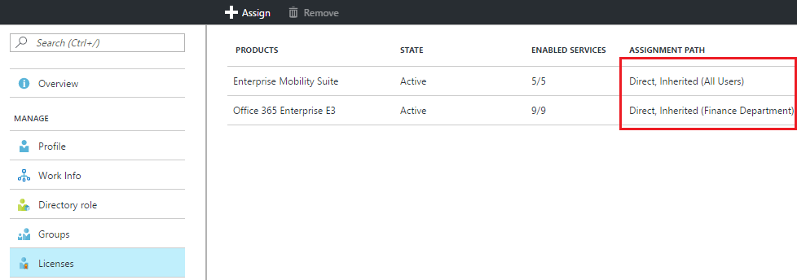  
      This confirms that the user has both direct and inherited licenses. We see that both **EMS** and **E3**
   2. Clicking on each license shows details about the enabled services. This can be used to check if the direct and group licenses enable exactly the same service plans for the user.  
      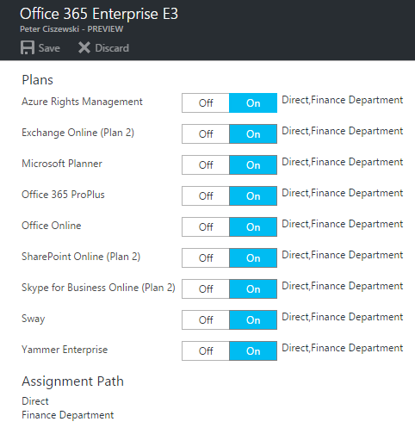
4. After confirming that both direct and group licenses are equivalent, you can start removing direct licenses from users. You can test this by removing them directly in the portal and then run automation scripts to have it removed in bulk.  
   Here is an example of the same user with the direct licenses removed using the portal. Notice that the license state is remains unchanged but we no longer see direct assignments.  
   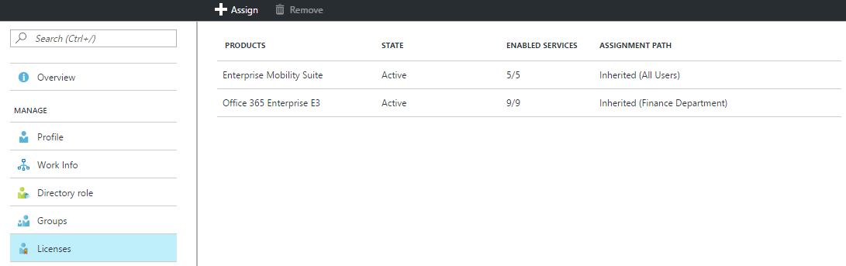

# Additional topics

## Performance/SLAs

There are two types of operations that have different performance characteristics:

### Modifying a group license assignment

When a group license is modified, which includes: adding a license, removing a license or disabling/enabling service plans within an existing license, Azure AD will process all existing users in the group to make sure the change is correctly reflected.

The time it takes to process all users increases with the size of the group, and for very large groups it make take a long time to completely finish processing.

### Adding or removing a user from a group with a license assignment

When a user is added (or removed) to a group with a license assignment, Azure AD will process that change individually. This means that incremental changes even in a large group are expected to process quickly.

###should we add more info about the planned performance/scheduling improvements?###

## Azure AD Dynamic Groups and licenses

Group-based licensing can be used with any security group, which means it can be combined with Azure AD Dynamic Groups. Dynamic Groups execute rules against user object attributes to automatically add and remove users from groups.

For example, you could create multiple dynamic groups, one per each set of products you want to assign to users. Each group contains a rule looking at a specific attribute on a user, describing which set of licenses they should receive. The attribute can be assigned on premises and synced into Azure AD, or managed directly in the cloud.

When the attribute is specified, user will be added to one or more of these dynamic licensing groups. Licenses will be assigned to the user shortly after that. When the attribute is removed, the user will leave the group(s) and licenses will be removed.

### Example

###add###

### Modifying a Dynamic Group rule

###how to safely modify a group by creating a copy to avoid accidental unlicensing when the group is re-calculated###

## Multiple groups and multiple licenses

A user can be a member of multiple groups with licenses. Here are some things to consider:

1. Multiple licenses for the same product can overlap and will result in the union of enabled services applied to the user.  
     
   For example, we created two licensing groups: *E3 – base services* contains the foundation services we want to deploy first, to all users; *E3 – extended services* contains additional services (Sway and Planner) we want to try with some users, while Yammer remains disabled for future deployment. The user belong was added to both groups:  
   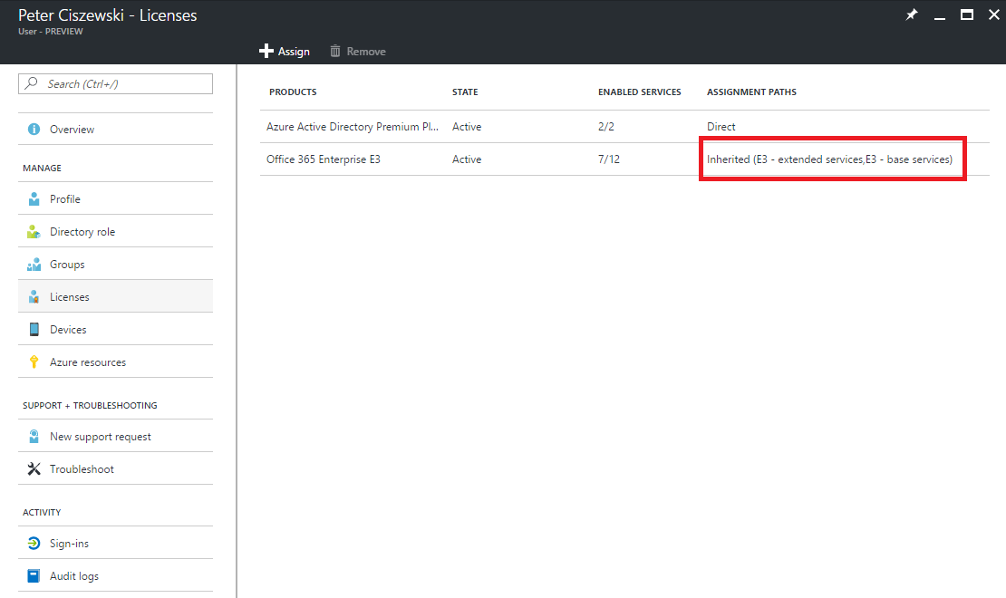As the result, they have 7 of the 12 services in the product enabled while still consuming one license for this product.
2. Clicking on the *E3* license shows more details, including the information about which groups caused what services to be enabled for the user.  
   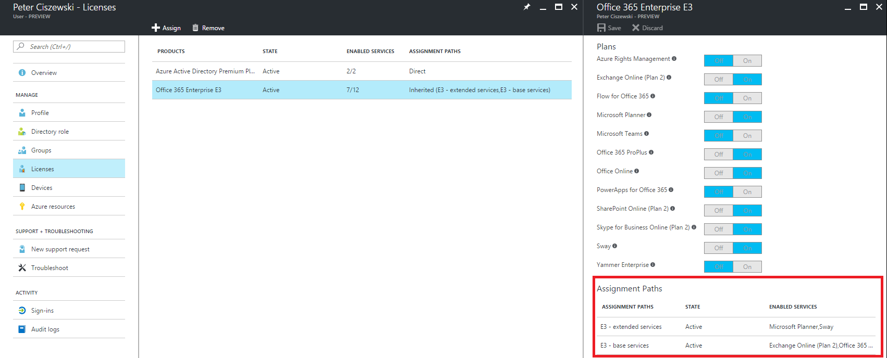

## Direct licenses coexisting with group licenses

When a user inherits a license from a group, it is not possible to remove or modify that license assignment directly on the user object. Instead, any changes must be made in the group and then propagated by the system to all users.

It is, however, possible to assign the same SKU license directly to the user in addition to the inherited license. This may be used, for example, to enable additional services from the SKU just for one user, without having to affect other users.

Directly assigned licenses can be removed, but that won’t affect the inherited license. Let’s consider the following user who inherits an *Office 365 Enterprise E3* license from a group, which enables a handful of services.

1. Initially, the user inherits the license only from the *E3 – basic services* group. This enables the 4 service plans listed below  
   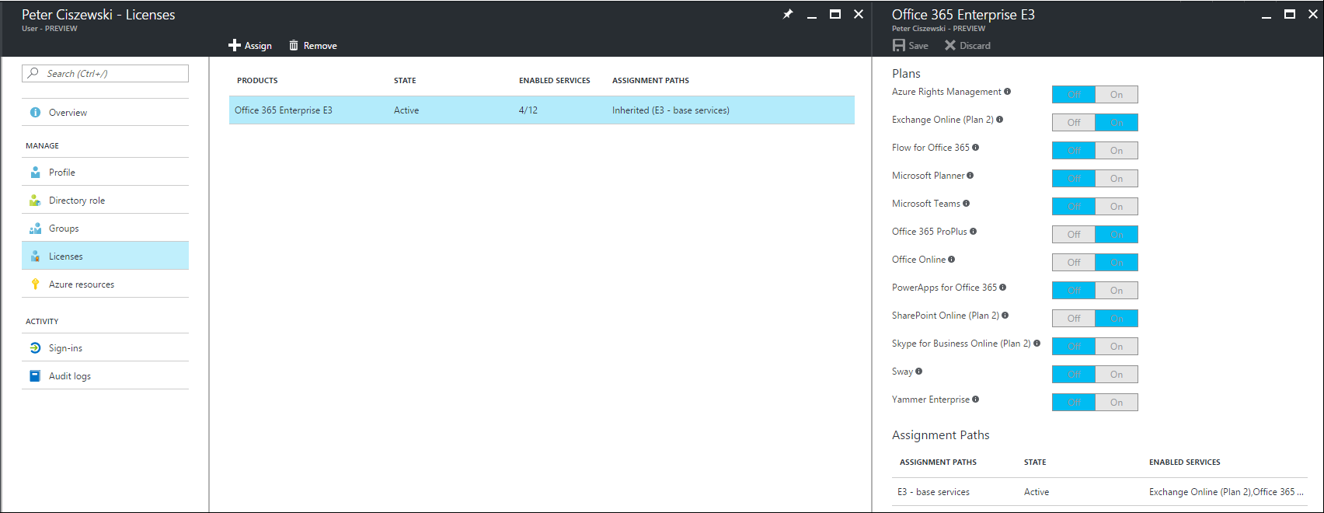
2. By clicking the **Assign** button we can directly assign an E3 license to the user – in this case we are going to disable all service plan but *Yammer Enterprise*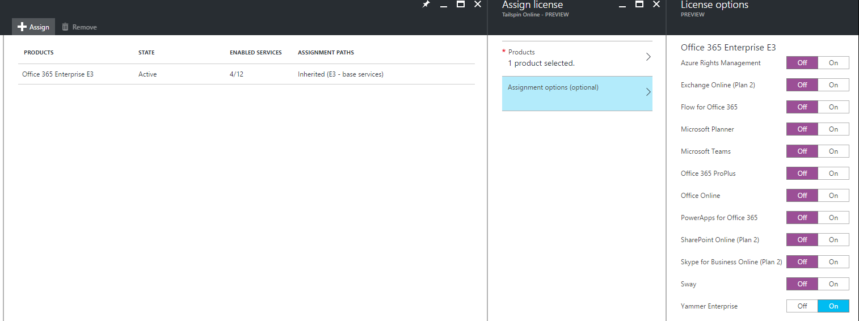
3. As a result, the user still consumes only 1 license of the E3 product, however the direct assignment enables the *Yammer Enterprise* service for that user only.  
   In the view below we can tell which services are enabled by the group membership vs. the direct assignment:  
   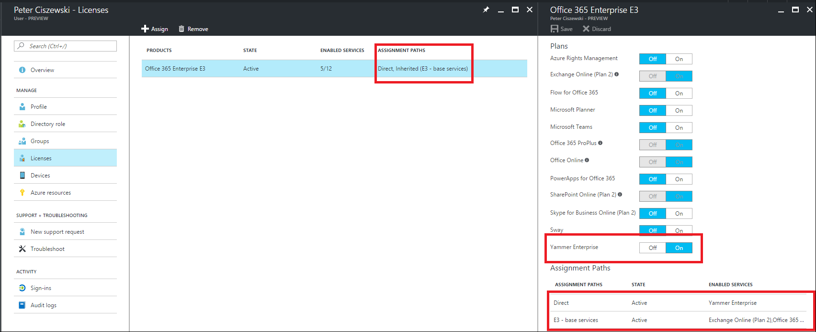
4. The following operations are allowed due to the direct assignment:
   1. *Yammer Enterprise* can be turned off on the user object directly. Notice that the On/Off toggle is enabled as opposed to the other service toggles – this is because this service is enabled directly on the user and thus can be modified.
   2. Additional services can be enabled as well, as part of the directly assigned license.
   3. The **Remove** button can be used to remove the direct license from the user. The end result is shown below – the user now only has the inherited group license and only the original services remain enabled  
      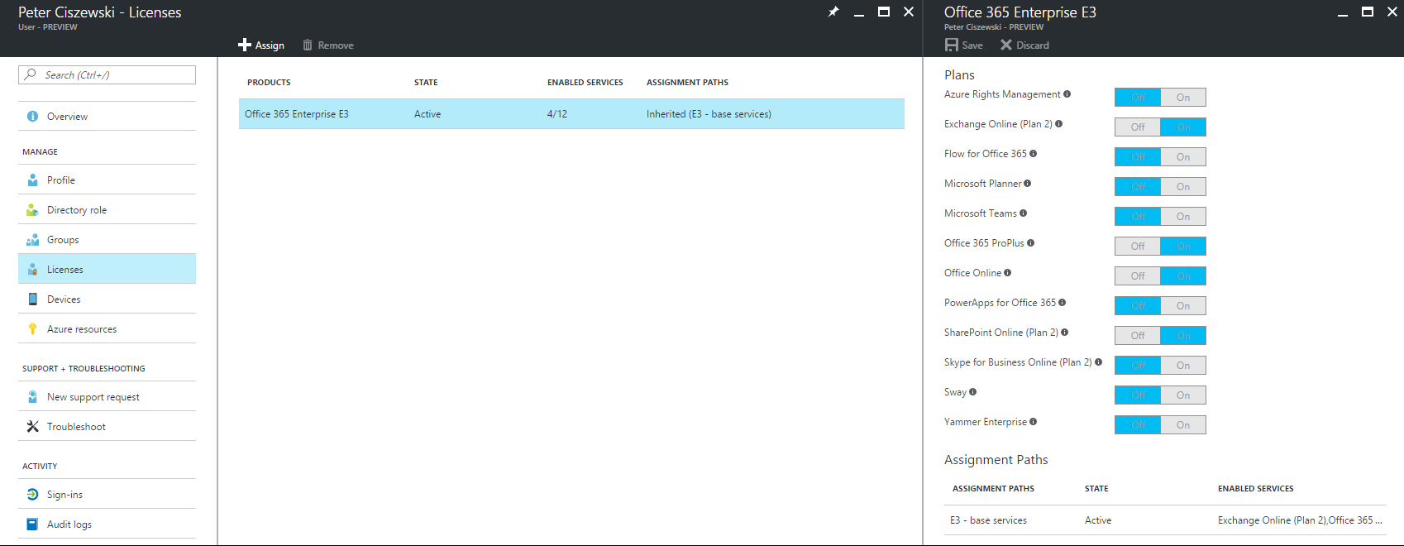

## Usage location

Some Microsoft services are not available in all locations; before a license can be assigned to a user, the administrator has to specify the “Usage location” property on the user. This can be done under User->Profile->Settings section in the Azure portal.

When using group license assignment, any users without a usage location specified will inherit the location of the directory. If you have users in different locations, make sure to reflect that correctly in your user objects before adding users to groups with licenses.

## See who has inherited vs direct licenses through PowerShell

During public preview, PowerShell cannot be used to fully control group license assignments. However, it can be used to discover basic information about user state and if licenses are inherited from a group or assigned directly. The below code sample shows how an admin can produce a basic report about license assignments.

1. Run *connect-msolservice* cmdlet to authenticate and connect to your tenant.
2. *Get-MsolAccountSku* can be used to discover all provisioned SKU licenses in the tenant:  
   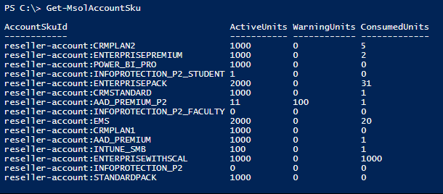
3. In this example, we want to find out which users have the *EMS* license assigned directly, from a group, or both.  
   We will use a PowerShell script that contains two functions that can answer this question for a user object and a SKU:

# Returns TRUE if the user has the license assigned directly

function UserHasLicenseAssignedDirectly

{

Param([Microsoft.Online.Administration.User]$user, [string]$skuId)

foreach($license in $user.Licenses)

{

# we look for the specific license SKU in all licenses assigned to the user

if ($license.AccountSkuId -ieq $skuId)

{

# GroupsAssigningLicense contains a collection of IDs of objects assigning the license

# This could be a group object or a user object (contrary to what the name suggests)

# If the collection is empty, this means the license is assigned directly - this is the case for users who have never been licensed via groups in the past

if ($license.GroupsAssigningLicense.Count -eq 0)

{

return $true

}

# If the collection contains the ID of the user object, this means the license is assigned directly

# Note: the license may also be assigned through one or more groups in addition to being assigned directly

foreach ($assignmentSource in $license.GroupsAssigningLicense)

{

if ($assignmentSource -ieq $user.ObjectId)

{

return $true

}

}

return $false

}

}

return $false

}

# Returns TRUE if the user is inheriting the license from a group

function UserHasLicenseAssignedFromGroup

{

Param([Microsoft.Online.Administration.User]$user, [string]$skuId)

foreach($license in $user.Licenses)

{

# we look for the specific license SKU in all licenses assigned to the user

if ($license.AccountSkuId -ieq $skuId)

{

# GroupsAssigningLicense contains a collection of IDs of objects assigning the license

# This could be a group object or a user object (contrary to what the name suggests)

foreach ($assignmentSource in $license.GroupsAssigningLicense)

{

# If the collection contains at least one ID not matching the user ID this means that the license is inherited from a group.

# Note: the license may also be assigned directly in addition to being inherited

if ($assignmentSource -ine $user.ObjectId)

{

return $true

}

}

return $false

}

}

return $false

}

1. The rest of the script gets all users and executes these functions on each user and then formats the output into a table:

# the license SKU we are interested in

$skuId = "reseller-account:EMS"

# find all users that have the SKU license assigned

Get-MsolUser -All | where {$_.isLicensed -eq $true -and $_.Licenses.AccountSKUID -eq $skuId} | select `

ObjectId, `

@{Name="SkuId";Expression={$skuId}}, `

@{Name="AssignedDirectly";Expression={(UserHasLicenseAssignedDirectly $_ $skuId)}}, `

@{Name="AssignedFromGroup";Expression={(UserHasLicenseAssignedFromGroup $_ $skuId)}}

1. Below is the output of the complete script:  
   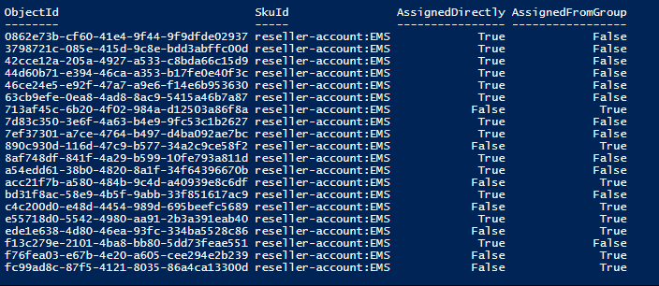

# Limitations and known issues

1. GBL currently does not support “nested groups” (groups that contain other groups).  
   If you apply a license to a nested group, only the immediate 1st level user members of the group will have the licenses applied.
2. GBL is currently only exposed via the Azure portal.  
   It is not possible to use PowerShell to set or modify licenses on groups.
3. The Office 365 admin portal (<https://portal.office.com>) is not currently aware of GBL  
   If a user inherits a license from a group, this license will show up in the Office admin portal as a regular user license. If you try to modify that license (e.g. disable a service in the license, or try to remove the license) the portal will return an error (since inherited group licenses cannot be modified directly on a user):

To assign a license that contains Azure Information Protection Plan 1, you must also assign one of the following service plans: Azure Rights Management.

### GBL and sync

###mention how GBL on large groups can impact sync###

## Manual re-processing of Groups in certain cases

###list the cases

# ----NOTES BELOW----

# Overview

Introduce GBL (mention AAD Basic and above briefly, explain in detail at the bottom of the article)

Can be used for all MS products, including O365.

Can be only used through Ibiza (for now). Explains what this means to O365 portal users (this is our main customer!)

Automation takes time and runs continuously in the background. Make statements about the time for changes to propagate.

Admins need to monitor status and errors.

# Main HOW-TO: the “Assign and verify” scenario, with screenshots

Pay particular attention to the “verify” part, including error analysis. Explain more in the next section.

# What are errors

Explain why GBL errors occur. Compare to regular assignment: errors are immediate vs delayed in time.

Explain 3 types of errors: conflict, not enough licenses, usage location.

Explain “all or nothing” and what it means.

How to check for errors.

How to analyze errors.

How to resolve errors

# Migrate from direct assignment to GBL

Describe the recommended steps: form groups, assign licenses to groups, verify the GBL outcome. Remove direct assignments using PowerShell, or the “clean up feature” (if we have it).

# Public preview limitations

Nested groups not supported

Re-assigning licenses freed up from direct assignment – the manual trigger.

Management through Ibiza portal: no PowerShell, no integration with O365 portal.

# License requirements

Explain that AAD Basic and above.

Explain how to be compliant: all users that inherit licenses from groups need to be assigned AAD Basic or above.

Explain how that can be done: assign E3 and AAD-B at the same time.

Promote getting an EMS or AAD-P trial (which one?)

Explain what happens when you use GBL but then you lose the AAD license on the tenant.