Logos Translation Server API
May 9, 2000 Version 1.0 Original document

.

OVERVIEW

The idea is to provide a clear well defined API to the Translation Server using which any client can translate a document or simple text. Term Search is another operation that is currently supported. This document discusses the general architecture of the system, high level and detailed design of the API layer through which the client interacts.

GENERAL ARCHITECTURE
The following four layers describe the Architecture of the system.

Translation Interface Classes
This contains the API classes using which a Client can create a translation or term-search request and send it to the Translation Server. This layer controls the number of simultaneous operations that can be performed on the Translation Server. The purpose of this layer is also to keep the communication details with the server transparent to the client. This layer communicates with the Proxy Classes to send the request down to the Translation Server.

Proxy Classes
This contains a representation of Server side objects on the client side. The classes in this layer could be designed using COM/CORBA/IPC. The purpose of this layer is to use an appropriate communication scheme to send requests down to the Server side object.

Server Implementation Classes
This is the actual implementation of the interfaces exposed to the client. This is based on CORBA/COM/IPC. This layer prepares a request and sends it down to the Translation Engine which performs the necessary operation.

Translation Engine
This layer performs the operation of Translation or Term-Search. It maintains a pool of threads with each thread handling a particular request. The number of requests that can be simultaneously handled is configurable.

WTS

XLATIONINTERFACE DLL

Translation Interface Classes

CLIENT

PROXYLAYER LIB

Proxy Classes
CORBA/COM/IPC

TRANSLATION SERVER

Server Implementation Classes
CORBA/COM/IPC

SERVER

Translation Engine

Figure 1: General Architecture

Translation Interface Classes - High Level Design

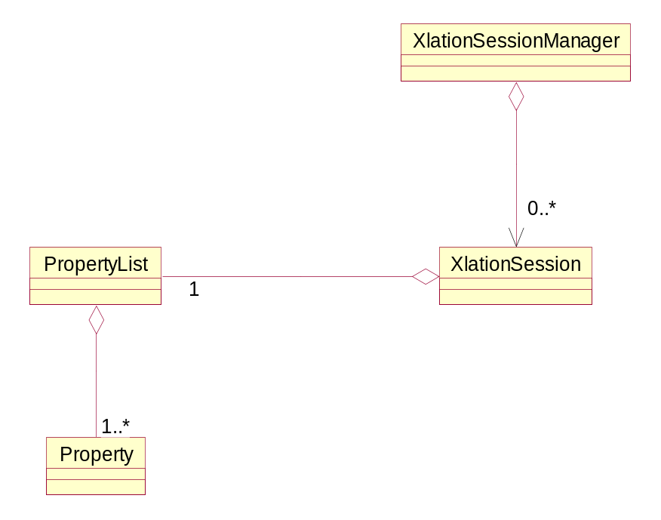
Figure 2: Translation Interface Class Diagram

XlationSession
Encapsulates the details of a particular request. This class interacts with the Proxy Classes layer to send the request to the Translation Server. This contains all the properties that are needed to carry out the operation.

XlationSessionManager
This is responsible for the creation of XlationSession. The policy of how to invoke the XlationSession is encapsulated in this class. This class also limits the number of XlationSession objects that can be active at any time.

PropertyList
This contains a list of properties. This class is used by the XlationSession to store the properties required to perform an operation and also to return the values returned by the Translation Server.

Property
This represents a Property with a name and associated value. Property is used to represent a parameter for Translation like SourceLanguage. It is also used to represent a return value from the Translation Server like the full path for the target file (Diagnostics or Output Text).

Translation Interface Classes - Detailed Level Design
The translation server can be called either synchronously or asynchronously.

Synchronous:
Request Translation Service through a function call and the call is blocked until the request is complete. When the function returns, translation is complete and the return values can be queried from the XlationSession object.
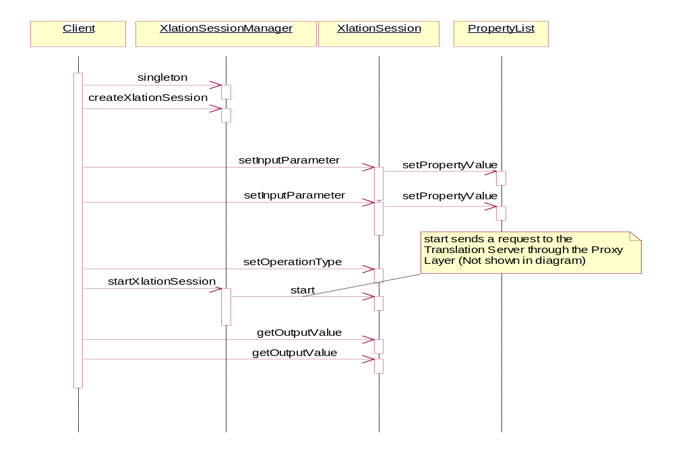

Figure 3: Synchronous Interaction Diagram

The calling sequence is described below:
- The Client starts by creating a XlationSession object by calling the method createXlationSession of the XlationSessionManager object
- Adds all the necessary properties for the operation using the addInputParameter method of the XlationSession object
- Sets the operation type (Translation/Term Search) by calling the SetOperationType of the XlationSession object
- Starts the session by calling the startXlationSession method of the XlationSessionManager object by passing the XlationSession object as a parameter. XlationSessionManager calls the start method on the XlationSession object
- Calls the GetOutputValue many times to get all returned values from the Translation Server.

Asynchronous:
Request Translation Service through a function call and the call is blocked until the request is complete. When the function returns, translation is complete and the return values can be queried from the XlationSession object.

The differences between Asynchronous mode and Synchronous mode are:
- registerCallback method is called on the XlationSession object by passing a function pointer as a parameter before the session is started
- The output values are retrieved by the Callback Function and not by the function that started the session. The callback function frees the session by calling the freeXlationSession of the XlationSessionManager

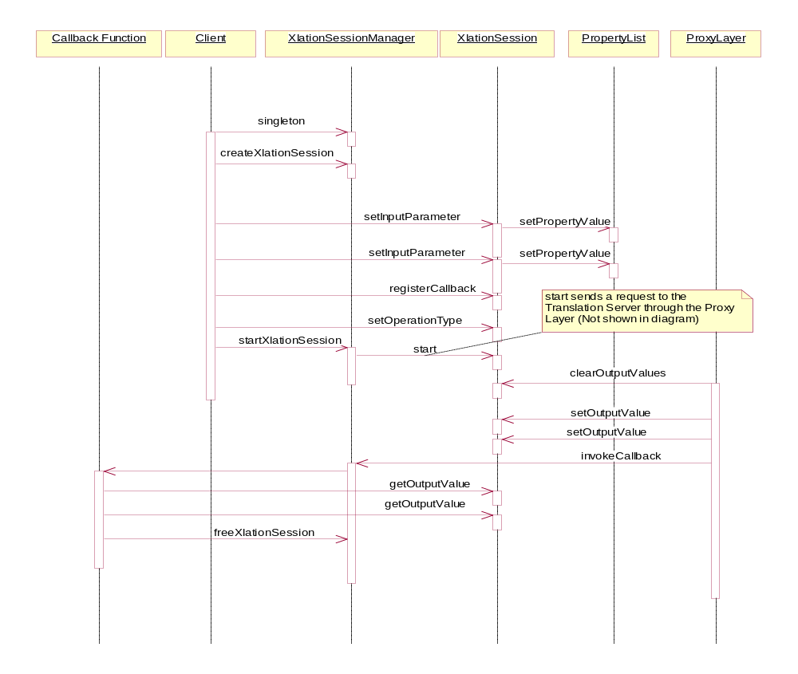

Figure 4: Asynchronous Interaction Diagram

Interface Classes – Object Design

This section describes the role, input and output for all methods in each Interface Class. This section uses the data from the previous two sections and expands on that to specify more detail.

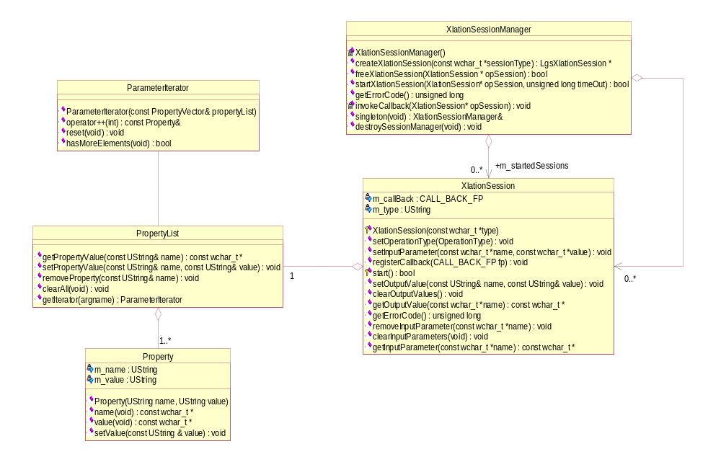

UString
The type UString used in the above classes is a Unicode string (string of wide characters (each character is 16 bit wide)).
wchar_t
This is a wide character type used to represent Unicode characters. wchar_t is two bytes long.

Figure 5: Detailed Translation Interface Class Diagram

XlationSessionManager
This is responsible for the creation of XlationSession. The policy of how to invoke the XlationSession is encapsulated in this class. This class also limits the number of XlationSession objects that can be active at any time.

singleton
This is a static member function of this class and returns the only instance of XlationSessionManager. An instance of XlationSessionManager can be obtained only by calling this method.
Input:
None.
Returns:
XlationSessionManager&: XlationSessionManager reference.

destroySessionManager
This deletes the only instance of the XlationSessionManager. This terminates the Translation Server process.
Input:
None
Returns:
None

XlationSessionManager
This is the constructor and is declared private. This class is created only in the singleton method of this class. Translation Server is started as a process by this method.
Input:
None.
Returns:
None

createXlationSession
Creates a XlationSession object if allowed. The new XlationSession object created is stored in the idle list of XlationSession(s)
Input:
sessionType: is a wide character pointer. This is an empty string by default. This is useful when XlationSession is sub-classed (string will be used to identify the type of XlationSession that has to be created)
Returns:
XlationSession*: Pointer to XlationSession object. NULL will be returned if the creation is NOT permitted. If NULL is returned look into the proxy.log file to find out the error condition.

freeXlationSession
Frees a XlationSession object and releases its associated resources.
Input:
opSession: Pointer to a XlationSession object that was obtained through a call to createXlationSession().
Returns:
bool: returns true if XlationSession is removed successfully and false if not removed.
Remarks
Call getErrorCode() to get the error code if this function returns false. Related Error codes are:
INVALID_SESSION

startXlationSession
Initiates the operation associated with the Session object passed as a parameter. This method sends the request to the Translation Server through the Proxy Classes layer. The started XlatedSession object is moved from the idle list to the started list of XlationSession objects.
Input:
opXlationSession: Pointer to a XlationSession object that was obtained through a call to createXlationSession(). This object’s start method will be called.
timeout: Reserved for future use. This is the maximum amount of time for which the call will block. If the operation is not complete within the time specified with this parameter, the operation will be cancelled. The value is infinite by default which means the call blocks for ever.
Returns:
bool: true if successfully started else returns false.
Remarks
Call getErrorCode() to get the error code if this function returns false. Related Error codes are:
INVALID_SESSION
SESSION_ALREADY_STARTED
SESSION_COUNT_EXCEEDED
PROXY_ERR_LANGUAGE (Invalid language code specified)
PROXY_ERR_CALL (Error in calling – maybe due to COM)
PROXY_ERR_SERVER (Error in translation server)
PROXY_ERR_FILE (input file not present or not readable)

getErrorCode
Returns the error code corresponding to the last operation performed on this object.
Input:
None.
Returns:
unsigned long: An unsigned integer value describing the error.

Remarks
Look into the Remarks section of each method description to find the list of error codes that are possible.

invokeCallback
Reserved for future. Calls the Callback function of the XlationSession object passed as a parameter. This method is called from the Proxy Layer.
Input:
opSession: Pointer to a XlationSession object.
Returns:
None

Property
This represents a Property with a name and associated value. Property is used to represent a parameter for Translation like SourceLanguage. It is also used to represent a return value from the Translation Server like the full path for the target file (Diagnostics or Output Text).

Property
Constructor for the class.
Input:
name: is a string reference. This is the name to identify a parameter to be passed to the Translation Server as one of the properties that is required for translation or term-search.
value: is a string reference. This is the value for the parameter to be used for the required operation.
Returns:
None.

name
Function to return the name of the Property.
Input:
None
Returns:
const wchar_t*: Pointer to a wide character string which is the name of the property.

value
Function to return the value for the Property.
Input:
None
Returns:
const wchar_t*: Pointer to a wide character string which is the value for the property.

setValue
Function to set the value for the Property.
Input:
value: string reference which is the new value for the property
Returns:
None.

PropertyList
This contains a list of properties. This class is used by the XlationSession to store the properties required to perform an operation and also to return the values returned by the Translation Server.

setPropertyValue
Searches for a particular Property object using the name passed as a parameter and sets the value for the Property. If the Property object does not exist, a new Property object is created and inserted into the list.
Input:
name: is a string reference. This is the Property name for which the value is to be set.
value: is a string reference. This is the value to be set for the Property object found.
Returns:
None.

getPropertyValue
Searches for a particular Property object using the name passed as a parameter and returns the value for the Property.
Input:
name: is a string reference. This is the Property name for which the value is to be retrieved.
Returns:
const wchar_t*: returns the value of the Property object if found else returns an empty string.

removeProperty
Searches for a particular Property object using the name passed as a parameter and removes it from the list.
Input:
name: is a string reference. Property object corresponding to this name will be removed.
Returns:
None

XlationSession
Encapsulates the details of a particular request. This class interacts with the Proxy Classes layer to send the request to the Translation Server. This contains all the properties that are needed to carry out the operation.

XlationSession
This is the constructor. This is declared protected. XlationSessionManager is a friend of this class. An object of this class can be instantiated only by the XlationSessionManager.
Input:
type: is a string reference. Default value is an empty string. When this class is constructed through one of the derived classes, then the type string will depend on the Derived class.
Returns:
None

setOperationType
Sets the operation associated with this Session object.
Input:
OperationType: The allowed values are TRANSLATE_DOC, TRANSLATE_TEXT , TERM_SEARCH_DOC, TERM_SEARCH_TEXT, QRY_CONFIGURATION
Returns:
None

setInputParameter
Calls setPropertyValue method of the PropertyList representing the input Parameter List with the name and value passed as parameters.
Input:
name: is a wide character string pointer. This is the name of the Property for which the value is to be set.
value: is a wide character string pointer. This is the value to be set for the Property object.
Returns:
None

clearInputParameters
Clears all elements in the input Parameter list. Input parameter list will be empty after this operation.
Input:
None
Returns:
None

removeInputParameter
Removes the input parameter from the input parameter list.
Input:
name: is a wide character string pointer. Input parameter corresponding to this name will be removed.
Returns:
None

registerCallback
Reserved for future use. Registers a callback function with this object. When the operation associated with this object completes, control is transferred to this Callback function registered.
Input:
fp: Pointer to a function that returns void and takes a parameter of type pointer to XlationSession (CALL_BACK_FP)
Returns:
None

start
Starts the operation associated with this Session. This sends the request down to the Translation Server through the Proxy Classes layer. All properties required for the operation should have been populated prior to calling this method. If a Callback function is registered, this method returns immediately else this method blocks until the return values are received from the Translation Server. This can only be called by the XlationSessionManager.
Input:
None
Returns:
bool: true if the method succeeds else returns false
Remarks
Call getErrorCode() to get the error code if this function returns false.

setOutputValue
Calls setPropertyValue of the PropertyList object with the name and value passed as parameters (PropertyList object mentioned here is the object which holds returned values from the Translation Server).
Input:
name: is a string reference. This is the name of the Property to be created.
value: is a string reference. This is the value of the Property object to be created.
Returns:
None.

clearOutputValues
Clears all elements in the output Parameter list. Output parameter list will be empty after this operation.
Input:
None
Returns:
None

getOutputValue
Returns the value corresponding to the name passed as a parameter. The output values sent by the Translation Server are stored in a PropertyList.
Input:
name: is a wide character string pointer. This is the output parameter name for which the value is returned.
Returns:
const wchar_t*: Value for the output parameter is returned. Empty string will be returned if such parameter does not exist.

OPERATIONS AND PARAMETERS
The various operations and their associated parameters are discussed in the following sections. The different values that the parameter can take are specified in the sections that follow. If a default value is not specified for a certain parameter, then that parameter is a required parameter and has to be specified. The parameter names and their values are case sensitive:

Translate Document
This operation type is used to translate a document from a source language to a target language. The enumerated operation type is TRANSLATE_DOC. The input and output parameters for this operation are discussed in the following sections:

Input Parameters
The input to be translated is a document file. The various required input parameters and their associated values are explained below:

- INPUT_FILE
This describes the full path for the input file. The value is a string containing the fully qualified path and name for the file containing the document to be translated.

- SOURCE_LANGUAGE
This identifies the language of the input document. The values currently supported are:
  - ENG
English
  - GER
German

- TARGET_LANGUAGE
This identifies the language of the translated document. The values currently supported are:
  - ENG
English
  - GER
German
  - SPA
Spanish
  - FRE
French
  - POR
Portuguese
  - ITA
Italian

- INPUT_FORMAT
This identifies the text format of the input file. Allowed values are:
  - RTF
  - SGML
  - HTML
  - TMX
  - XML
  - INTERLEAF_ASCII
  - FRAME_MIF
  - LGS_TXT_EXCHANGE
  - MS_WORD8
  - RTF_WINHELP
Default Value: LGS_TXT_EXCHANGE

- PROTECTION_CHAR
This specifies the character used to mark a block of text that should not be translated by the Translation Server.
Default Value: ^

- SOURCE_LOCALE
This is a string specifying the various properties for a Source Language. Each property is represented by one character except the date format. The properties appear in the following sequence:
Decimal separator – thousand separator – date separator - time separator – time decimal separator – date format
Date format specifies the order in which the day, month and year appear. Month is represented by character ‘m’, day by character ‘d’ and year by character ‘y’.
An example of Source locale:
For English the string will be “.,/:.mdy”
Default Value: An appropriate default value will be used based on the SOURCE_LANGUAGE

- TARGET_LOCALE
This is a string specifying the various properties for a Target Language. The format of the string is same as the SOURCE_LOCALE.
Default Value: An appropriate default value will be used based on the TARGET_LANGUAGE

- PM_RULES
This specifies if Pattern Matcher rules should be applied or not. Pattern matcher rules are used to replace certain strings in a document before Translation is done. Possible values are:
  - Yes
Apply Pattern Matcher rules
  - No
Do not apply Pattern Matcher rules
Default Value: No

- EXTENDED_SEARCH
This specifies the type of search to be used to decide on the relative priorities to be given to entries if there are many entries in the dictionary corresponding to a term. When Extended Search is used, the entire database is searched (includes all company codes and Subject Matter Codes). Regular search performs a word search by using the company codes specified in COMPANY_CODES parameter and Subject Matter Codes specified in the SUBJECT_MATTER_CODES parameter. The order in which a company code and subject matter code appear determines the relative weights assigned to each Subject Matter Code and Company Code.
Note: Logos default entries are always searched.

Possible values are:
  - REG_SRCH
Regular search with logos default. Only the company codes and SMCs specified in the interface are to be used.
  - EXT_SRCH
Regular search as defined above plus all company codes and SMCs in the dictionary will be searched in the order defined by the TermBuilder SMC and Company Code management utility.

Default Value: REG_SRCH

- SUBJECT_MATTER_CODES
Optional parameter that specifies an ordered list of Subject Matter Codes to search first when matching terms in the database.
The value is a string containing many Subject Matter Codes separated by the delimiter “ ” (SPACE).
Default Value: null or nothing.

- COMPANY_CODES
Optional parameter that specifies an ordered list of Company Codes.
The value is a string containing many Company Codes separated by the delimiter “ ” (SPACE).
Default Value: null or nothing.

- FLAG_UNFOUND_WORDS
Optional parameter if set, indicates that unfound words in the input text should be flagged with the character “?”. Allowed values are:
  - Yes
Flag unfound words
  - No
Do not flag unfound words
Default Value: No.

- TARGET_FORM_IMPERATIVE
Specifies if the target form should take the value Imperative. Allowed values are:
  - Yes
Imperative form
  - No
Infinitive form
Default Value: Yes

- DB_MODE
This specifies if translation uses a database or not (cache).
Allowed values are:
  - Yes
Database is used for the translation
  - No
Cache is used for the translation
Default Value: No.

- STATISTICS
Optional parameter if set, indicates that log information will have timing and memory used information for all threads. Allowed values are:
  - Yes
  - No
Default Value: No.

- USER_ID
Optional parameter that specifies a user name.
Default Value: API.

Developer Only Input Parameters

- GENERATE_ALIGNMENT
This specifies if an alignment file is to be generated or not. Alignment file contains the source and translated output aligned on a sentence basis. Allowed values are:
  - Yes
- No
Default Value: No

- DIAG_LEVEL
This specifies the diagnostic level to be used in the Translation Server for debugging purposes for the Linguists and Developers. If this is not specified, diagnostic file will not be generated. Allowed values are:
  - Short
Minimal diagnostics
  - Long
More detailed diagnostics than Short
  - Deep
More detailed diagnostics than Long
  - Statistics
Generate Rule statistics file
Default Value: Diagnostics is disabled

- DIAG_LINE_START
This specifies the sentence number in the source document where diagnostics will start. Specify a number in string format. If this is not specified and diagnostics is enabled, diagnostics will start at the first sentence.
Default Value: If DIAG_LEVEL is specified, sentence number 1 is the default value.

- DIAG_LINE_END
This specifies the sentence number in the source document where diagnostics will stop. Specify a number in string format. If this is not specified and diagnostics is enabled, diagnostics will stop at the end of the source document.
Default Value: If DIAG_LEVEL is specified, last sentence or end of document is the default value.

- RULE_OVERRIDE_FILE_NAME
Reserved for future.
This specifies the name of the ini file containing the various rule file names to be used instead of the rule file names specified in the default ini file.
Default Value: Only default ini file is used for rule files.

- MAIN_RES1_FILE
This specifies the name of the Main Res1 rule file to be used during translation process.
Default Value: null or nothing.

- MAIN_RES2_FILE
This specifies the name of the Main Res2 rule file to be used during translation process.
Default Value: null or nothing.

- MAIN_RES22_FILE
This specifies the name of the Main Res22 rule file to be used during translation process.
Default Value: null or nothing.

- MAIN_TRAN1_FILE
This specifies the name of the Main Tran1 rule file to be used during translation process.
Default Value: null or nothing.

- MAIN_TRAN2_FILE
This specifies the name of the Main Tran2 rule file to be used during translation process.
Default Value: null or nothing.

- MAIN_TRAN3_FILE
This specifies the name of the Main Tran3 rule file to be used during translation process.
Default Value: null or nothing.

- MAIN_TRAN4_FILE
This specifies the name of the Main Tran4 rule file to be used during translation process.
Default Value: null or nothing.

- MAIN_PARSE1_FILE
This specifies the name of the Main Parse1 rule file to be used during translation process.
Default Value: null or nothing.

- MAIN_PARSE2_FILE
This specifies the name of the Main Parse2 rule file to be used during translation process.
Default Value: null or nothing.

- MAIN_PARSE3_FILE
This specifies the name of the Main Parse3 rule file to be used during translation process.
Default Value: null or nothing.

- MAIN_PARSE4_FILE
This specifies the name of the Main Parse4 rule file to be used during translation process.
Default Value: null or nothing.

- MINI_RES2_FILE
This specifies the name of the Mini Res2 rule file to be used during translation process.
Default Value: null or nothing.

- MINI_TRAN1_FILE
This specifies the name of the Mini Tran1 rule file to be used during translation process.
Default Value: null or nothing.

- MINI_TRAN2_FILE
This specifies the name of the Mini Tran2 rule file to be used during translation process.
Default Value: null or nothing.

- MINI_TRAN3_FILE
This specifies the name of the Mini Tran3 rule file to be used during translation process.
Default Value: null or nothing.

- MINI_TRAN4_FILE
This specifies the name of the Mini Tran4 rule file to be used during translation process.
Default Value: null or nothing.

- MINI_PARSE1_FILE
This specifies the name of the Mini Parse1 rule file to be used during translation process.
Default Value: null or nothing.

- MINI_PARSE2_FILE
This specifies the name of the Mini Parse2 rule file to be used during translation process.
Default Value: null or nothing.

- MINI_PARSE3_FILE
This specifies the name of the Mini Parse3 rule file to be used during translation process.
Default Value: null or nothing.

- MINI_PARSE4_FILE
This specifies the name of the Mini Parse4 rule file to be used during translation process.
Default Value: null or nothing.

- DEBUG_FLAG
This parameter is used for development purpose only. If set, indicates that translation will run in debug mode. Allowed values are:
  - Yes
  - No
Default Value: No.

- TRACE_FLAG
This parameter is used for development purpose only. If set, indicates that trace mode is enable. Allowed values are:
  - Yes
  - No
Default Value: No.

- LOG_QUERY_FLAG
This parameter is used for development purpose only. If set, indicates that translation will log queries to Word_Phrase table generated during Lookup matching logic into a log file under Scratch directory. Allowed values are:
  - Yes
  - No
Default Value: No.

- SAVE_SCRATCH_FLAG
This parameter is used for development purpose only. If set, indicates that translation will not delete temporary files created under Scratch directory. Allowed values are:
  - Yes
  - No
Default Value: No.

- GENERATE_LOG
This parameter is used for development purpose only. If set, indicates that all messages from translation will be printed out in a log file also. Allowed values are:
  - Yes
  - No
Default Value: No.

Output Parameters
The output parameters returned by the Translation Server for the translation operation are discussed below.

- SENTENCE_COUNT
This is the number of sentences in the input document

- WORD_COUNT
This is the number of words in the input document

- OUTPUT_FILE
This is the complete file name for the translated document (contains full path information)

- SESSION_ID
This is the session id assigned to the operation submitted.

- ERROR_DESC
This describes the error condition. The error could be generated internally or in the Translation Server.

Developer Only Output Parameters

- ALIGNMENT_FILE
This is the alignment file name (contains full path information). This is sent only if alignment file is requested with the input parameter GENERATE_ALIGNMENT.

- DIAG_FILE
This is the diagnostic file name (contains full path information). This is sent only if diagnostics is enabled with the input parameter DIAG_LEVEL.

- LOG_FILE
This is the log file name (contains full path information). This is sent only if log file is requested with the input parameter GENERATE_LOG.

TRANSLATE TEXT
This operation type is used to translate simple text from a source language to a target language. The enumerated operation type is TRANSLATE_TEXT. The input and output parameters for this operation are discussed in the following sections:
All parameters required for “Translate Document” as defined must be set as described above with the exception of the following: INPUT_FILE, DIAG_FILE, ALIGNMENT_FILE and OUTPUT_FILE

Input Parameters
The input to be translated is simple text. The various required input parameters and their associated values are explained below:
The following additional parameters must be set for the “Translate Text” operation.

- INPUT_TEXT
This is the text to be translated. The value is a string to be translated.

Output Parameters
The following additional parameters must be set for the “Translate Text” operation.

- OUTPUT_TEXT
This is the complete translated text.

Developer Only Output Parameters

- DIAG_TEXT
This is the diagnostic text. This is sent only if diagnostics is enabled with the input parameter DIAG_LEVEL.

- ALIGNED_TEXT
This is the source and target text aligned in html format. This is only generated if the GENERATE_ALIGNMENT property was set for this translation request.

TERM-SEARCH TEXT
This is used to perform term search on simple text. The enumerated operation type is TERM_SEARCH_TEXT.

Input Parameters
All input parameters specified for translating a text have to be specified for term search. In addition the following parameters should also be passed:

- WORD_SEARCH_OPTIONS
This specifies the category of words in the input document for which term search should be applied. The different values possible are:
UNFOUND
FOUND_NOUN
FOUND_VERB
FOUND_ADJ
FOUND_ADV
A combination of the above values could be passed by using the ‘+’ character to combine one or more values specified above like UNFOUND+FOUND_NOUN+FOUND_VERB.
Default Value: UNFOUND+ FOUND_NOUN+ FOUND_VERB+ FOUND_ADJ+ FOUND_ADV

- WORD_SEARCH_FOUND_START
For any found word, report the translated term only when the word occurs a certain number of times specified by this parameter.
Default Value: 1

- WORD_SEARCH_FOUND_LIMIT
For any found word, do not report the translated term more than the number specified by this parameter.
Default Value: 1

- WORD_SEARCH_UNFOUND_START
For any unfound word, report the translated term only when the word occurs a certain number of times specified by this parameter.
Default Value: 1

- WORD_SEARCH_UNFOUND_LIMIT
For any unfound word, do not report the translated term more than the number specified by this parameter.
Default Value: 1

Output Parameters
All output parameters that are specified for translating a text apply to term-search operation also. There are no more output parameters.

TERM-SEARCH DOCUMENT
This is used to perform term search on a document. The enumerated operation type is TERM_SEARCH_DOC.

Input Parameters
All input parameters specified for translating a document have to be specified for term search. In addition the following parameters should also be passed:

- WORD_SEARCH_OPTIONS
This specifies the category of words in the input document for which term search should be applied. The different values possible are:
UNFOUND
FOUND_NOUN
FOUND_VERB
FOUND_ADJ
FOUND_ADV
A combination of the above values could be passed by using the ‘+’ character to combine one or more values specified above like UNFOUND+FOUND_NOUN+FOUND_VERB.
Default Value: UNFOUND+ FOUND_NOUN+ FOUND_VERB+ FOUND_ADJ+ FOUND_ADV

- WORD_SEARCH_FOUND_START
For any found word, report the translated term only when the word occurs a certain number of times specified by this parameter.
Default Value: 1

- WORD_SEARCH_FOUND_LIMIT
For any found word, do not report the translated term more than the number specified by this parameter.
Default Value: 1

- WORD_SEARCH_UNFOUND_START
For any unfound word, report the translated term only when the word occurs a certain number of times specified by this parameter.
Default Value: 1

- WORD_SEARCH_UNFOUND_LIMIT
For any unfound word, do not report the translated term more than the number specified by this parameter.
Default Value: 1

Output Parameters
All output parameters that are specified for translating a document apply to term-search operation also. There are no more output parameters.

QUERY CONFIGURATION PARAMETERS
The enumerated operation type is QRY_CONFIGURATION. This operation is to request the various Translation Server properties. The various properties that are returned from the Translation Server are discussed below. There are no input properties to be set for this operation.

Output Parameters
The following Translation Server properties are returned.

- LANGUAGE_PAIRS
This lists all language pairs that are valid for translation. Each language pair is represented textually in the following format:
SOURCE_LANGUAGE:TARGET_LANGUAGE
SOURCE_LANGUAGE: String representing the source language. Value will be one of the values listed in section 5.1 for the property SOURCE_LANGUAGE.
TARGET_LANGUAGE: String representing the target language. Value will be one of the values listed in section 5.1 for the property SOURCE_LANGUAGE.
Character “;” is used to separate language pairs.
- COMPANY_CODES
This lists all company codes that are currently supported in the system. The company code strings are separated by the delimiter “;”. Each company is represented by the following format:
Company Code:Description
- SUBJECT_MATTER_CODES
Currently an empty string will be returned.
This lists all the Subject Matter Codes in a certain format. The format of the string is explained with an example as described below:
Let us consider the following Subject Matter Code tree:

“SMC 1”
“SMC 2”
“SMC 3”

“SMC 11”
“SMC 12”
“SMC 21”
“SMC 22”
“SMC 31”
“SMC 32”

Figure 6: Subject Matter Code Tree example

In the above diagram, “SMC 1”, “SMC 2” and “SMC 3” are at level 1 of the tree. The other SMCs are at level 2.
Each node in the above tree is represented textually by three fields separated by “:” in the following format:
SMC_Level:SMC_Text:SMC_Code
SMC_Level is the depth level in the tree for the subject matter code
SMC_Text is a textual description for the subject matter code
SMC_Code is a three digit code for the subject matter code
The entire tree is represented by using the Depth First strategy to list all nodes in a string format. The separation character “;” is used to separate nodes.
A complete textual description of the tree shown in figure 6 will be
“1:SMC 1:001;2:SMC 11:000;2:SMC 12:001;1:SMC 2:002;2:SMC 21:000;2:SMC 22:001;1:SMC 3:003;2:SMC 31:000;2:SMC 32:001”

ISSUES
- The output files for translation and term search cannot be currently specified as input parameters. They could be specified as input parameters in the future. The output files are related to operation, diagnostics and aligned output.
- Empty string is returned for Subject Matter Codes when QRY_CONFIGURATION operation is submitted. This will be implemented later.

CODE SAMPLE

API is provided for application written in C++ and Java programming languages.

C++ example
This C++ program demonstrates the usage of the Translation Interface Classes.
In engine_api.zip file you can find all headers and lib files you will need in order to build this example.
It also includes MSVC project file testwts.dsp with all settings.

// testwts.cpp : Defines the entry point for the console application.
//
// This program tests the Translation Server API
// Runs all possible operations and logs the result in the file "test.log"
// in the current directory.
//
// Instructions to build:
// Set include path to be the directory where you decide to place the engine_api
// directory.
// Link with Multithreaded version of Microsoft run-time library
// Build the application by linking with xlationinterface.lib
//

#include "stdafx.h"
#include <engine_api/xlationinterface/xlationinterfacedefs.h>
#include <engine_api/xlationinterface/xlationsession.h>
#include <engine_api/xlationinterface/xlationsessionmanager.h>
#include <fstream>
#include <string>
using namespace std;

ofstream testOutput("test.log", ios_base::out);

// utility function to convert Unicode string to ASCII (single byte) string
void ucToSbs(const UString& ucStr, string& sbString)
{
char *scStr = new char [ucStr.length()+1];
wcstombs(scStr, ucStr.c_str(), ucStr.length()+1);
sbString = scStr;
delete scStr;
}

int main(int argc, char *argv[])
{
// Get the only instance of XlationSessionManager by calling the static method
XlationSessionManager &sessionManager = XlationSessionManager::singleton();

// Create a translation session to perform operations
XlationSession *opSession = sessionManager.createXlationSession();
if (!opSession)
{
// Handle error condition and return
return -1;
}

///////////////////////////// START TEST 1 : Translate text ///////////////////////////////

// Add all input values to the session
// All property names and allowed values are defined in the header file parameterdefs.h)
opSession->setInputParameter(WCINPUT_TEXT, L"This is a simple test sentence.");
opSession->setInputParameter(WCSOURCE_LANGUAGE, WCENG);
opSession->setInputParameter(WCTARGET_LANGUAGE, WCGER);
opSession->setInputParameter(WCINPUT_FORMAT, WCLGS_TXT_EXCHANGE);
opSession->setInputParameter(WCEXTENDED_SEARCH, WCEXT_SEARCH);
opSession->setInputParameter(WCDB_MODE_FLAG, WCYES);
opSession->setInputParameter(WCSUBJECT_MATTER_CODES, L"001");
opSession->setInputParameter(WCCOMPANY_CODES, L"LOG");
opSession->setInputParameter(WCSOURCE_LOCALE, L".,/:.mdy");
opSession->setInputParameter(WCTARGET_LOCALE, L",./:.dmy");
opSession->setInputParameter(WCSTATISTICS_FLAG, WCYES);

// Set the operation type
opSession->setOperationType(TRANSLATE_TEXT);

// Start the Session
UString error;
if (!sessionManager.startXlationSession(opSession, 0))
{
// Handle error condition and return
switch (opSession->getErrorCode())
{
case PROXY_ERR_SERVER:
// Error from server
error = opSession->getOutputValue(WCERROR_DESC);
if (!error.empty())
{
return -1;
}
break;

case SESSION_COUNT_EXCEEDED: // Currently only one session is allowed to run at
// any time
case INVALID_SESSION:
case SESSION_ALREADY_STARTED: // An already started session cannot be started again
// through another thread before the previous one completes
case INVALID_OPERATION: // Invalid operation specified
case PROXY_ERR_INIT: // Error while initializing COM (proxy.log contains detailed
// error)
case PROXY_ERR_CREATE: // Error in instantiating a COM object (proxy.log contains
// detailed error)
case PROXY_ERR_LANGUAGE: // Error in Source/Target language (Invalid)
case PROXY_ERR_CALL: // Error while calling a COM interface function (proxy.log
// contains detailed error)
case PROXY_ERR_FILE: // Input file not present or NOT readable
break;
}
// Handle Error Condition
sessionManager.freeXlationSession(opSession);
return -1;
}
string cSentenceCount;
string cWordCount;
string cOutputText;
string cDiagText;
string cAlignedText;
// Get the value for sentence count
UString sentenceCount = opSession->getOutputValue(WCSENTENCE_COUNT);
ucToSbs(sentenceCount, cSentenceCount); // convert from unicode to ASCII string
// Get word count
UString wordCount = opSession->getOutputValue(WCWORD_COUNT);
ucToSbs(wordCount, cWordCount);
// Get output text
UString outputText = opSession->getOutputValue(WCOUTPUT_TEXT);
ucToSbs(outputText, cOutputText);

testOutput << "TEST 1 RESULTS" << endl;
testOutput << cSentenceCount.c_str() << endl;
testOutput << cWordCount.c_str() << endl;
testOutput << cOutputText.c_str() << endl;

// Free the Session object
sessionManager.freeXlationSession(opSession);

///////////////////// END TEST 1 ///////////////////////////////////////////////////////

///////////////////// START TEST2: Translate a document

opSession = sessionManager.createXlationSession();
if (!opSession)
{
// Handle error condition and return
return -1;
}
opSession->setInputParameter(WCINPUT_FILE, L"C:\\esense\\bin\\apitest.input");
opSession->setInputParameter(WCSOURCE_LANGUAGE, WCENG);
opSession->setInputParameter(WCTARGET_LANGUAGE, WCGER);
opSession->setInputParameter(WCINPUT_FORMAT, WCLGS_TXT_EXCHANGE);
opSession->setInputParameter(WCEXTENDED_SEARCH, WCEXT_SEARCH);
opSession->setInputParameter(WCDB_MODE_FLAG, WCYES);
opSession->setInputParameter(WCSUBJECT_MATTER_CODES, L"001");
opSession->setInputParameter(WCCOMPANY_CODES, L"LOG");
opSession->setInputParameter(WCSOURCE_LOCALE, L".,/:.mdy");
opSession->setInputParameter(WCTARGET_LOCALE, L",./:.dmy");
opSession->setInputParameter(WCSTATISTICS_FLAG, WCYES);
opSession->setInputParameter(WCGENERATE_ALIGNMENT, WCYES);
// Set the operation
opSession->setOperationType(TRANSLATE_DOC);
// Start the Session
if (!sessionManager.startXlationSession(opSession, 0))
{
// Handle error condition and return
return -1;
}

string cOutputFile;
UString outputFile;
string cDiagFile;
UString diagFile;
string cAlignedFile;
UString alignFile;

sentenceCount = opSession->getOutputValue(WCSENTENCE_COUNT);
ucToSbs(sentenceCount, cSentenceCount);
wordCount = opSession->getOutputValue(WCWORD_COUNT);
ucToSbs(wordCount, cWordCount);
outputFile = opSession->getOutputValue(WCOUTPUT_FILE);
ucToSbs(outputFile, cOutputFile);
alignFile = opSession->getOutputValue(WCALIGNMENT_FILE);
ucToSbs(alignFile, cAlignedFile);
testOutput << "TEST 2 RESULTS" << endl;
testOutput << cSentenceCount.c_str() << endl;
testOutput << cWordCount.c_str() << endl;
testOutput << cOutputFile.c_str() << endl;
testOutput << cAlignedFile.c_str() << endl;

////////////////////////// END TEST 2 //////////////////////////////////////////////////

////////////////////////// TEST 3: Term Search document ////////////////////////////////

opSession->removeInputParameter(WCGENERATE_ALIGNMENT);
opSession->setInputParameter(WCDIAG_LEVEL, WCSHORT_DIAG);
opSession->setInputParameter(WCINPUT_FILE, L"C:\\esense\\bin\\apitest.input");

// Set operation type
opSession->setOperationType(TERM_SEARCH_DOC);

// Start the Session
if (!sessionManager.startXlationSession(opSession, 0))
{
// Handle error condition and return
return -1;
}

sentenceCount = opSession->getOutputValue(WCSENTENCE_COUNT);
ucToSbs(sentenceCount, cSentenceCount);
wordCount = opSession->getOutputValue(WCWORD_COUNT);
ucToSbs(wordCount, cWordCount);
outputFile = opSession->getOutputValue(WCOUTPUT_FILE);
ucToSbs(outputFile, cOutputFile);
diagFile = opSession->getOutputValue(WCDIAG_FILE);
ucToSbs(diagFile, cDiagFile);
testOutput << "TEST 3 RESULTS" << endl;
testOutput << cSentenceCount.c_str() << endl;
testOutput << cWordCount.c_str() << endl;
testOutput << cOutputFile.c_str() << endl;
testOutput << cDiagFile.c_str() << endl;

/////////////////////////// END TEST 3 ////////////////////////////////////////////////

/////////////////////////// START TEST 4: Term Search text ////////////////////////////

opSession->removeInputParameter(WCINPUT_FILE);
opSession->removeInputParameter(WCDIAG_LEVEL);
opSession->setInputParameter(WCINPUT_TEXT, L"Hope everything works with term search");

// Set operation type
opSession->setOperationType(TERM_SEARCH_TEXT);
// Start the Session
if (!sessionManager.startXlationSession(opSession, 0))
{
// Handle error condition and return
return -1;
}

sentenceCount = opSession->getOutputValue(WCSENTENCE_COUNT);
ucToSbs(sentenceCount, cSentenceCount);
wordCount = opSession->getOutputValue(WCWORD_COUNT);
ucToSbs(wordCount, cWordCount);
outputText = opSession->getOutputValue(WCOUTPUT_TEXT);
ucToSbs(outputText, cOutputText);
testOutput << "TEST 4 RESULTS" << endl;
testOutput << cSentenceCount.c_str() << endl;
testOutput << cWordCount.c_str() << endl;
testOutput << cOutputText.c_str() << endl;

/////////////////////////// END TEST 4 /////////////////////////////////////////////////

// Free the Session object
XlationSessionManager::singleton().freeXlationSession(opSession);

// Destroy the Session Manager
XlationSessionManager::destroySessionManager();

return 0;
}

Java example

Java application must use GlobalWordsEngineAPI class in order to call Translation Server.
This class has a few native methods, which are implemented as C functions in the XlationInterface.dll using JNI. Most of the functions have names similar to C++ API version. This class also includes static strings for all parameters names and their values.

package logos_java.GlobalWordsEngineAPI;
import java.lang.*;

public class GlobalWordsEngineAPI
{
public native boolean InitializeTranslationSession();
public native boolean StartTranslationSession();
public native boolean CloseTranslationSession();
public native void SetInputParameter(String name, String value);
public native void SetOperationType(int operationType);
public native String GetOutputValue(String name);
public native int GetLastError();
public native String GetLastErrorString();

public GlobalWordsEngineAPI()
{
}

static
{
System.loadLibrary("XLATIONINTERFACE");
}

// Constants for Parameter Names/////////////////////////////////////////
// INPUT PARAMETERS
public static final String WCINPUT_FILE = "INPUT_FILE";
public static final String WCINPUT_TEXT = "INPUT_TEXT";
public static final String WCSOURCE_LANGUAGE = "SOURCE_LANGUAGE";
public static final String WCTARGET_LANGUAGE = "TARGET_LANGUAGE";
public static final String WCINPUT_FORMAT = "INPUT_FORMAT";
public static final String WCPROTECTION_CHAR = "PROTECTION_CHAR";
public static final String WCSOURCE_LOCALE = "SOURCE_LOCALE";
public static final String WCTARGET_LOCALE = "TARGET_LOCALE";
public static final String WCPM_RULES = "PM_RULES";
public static final String WCEXTENDED_SEARCH = "EXTENDED_SEARCH";
public static final String WCSUBJECT_MATTER_CODES = "SUBJECT_MATTER_CODES";
public static final String WCCOMPANY_CODES = "COMPANY_CODES";
public static final String WCFLAG_UNFOUND_WORDS = "FLAG_UNFOUND_WORDS";
public static final String WCGENERATE_ALIGNMENT = "GENERATE_ALIGNMENT";
public static final String WCDIAG_LEVEL = "DIAG_LEVEL";
public static final String WCDIAG_LINE_START = "DIAG_LINE_START";
public static final String WCDIAG_LINE_END = "DIAG_LINE_END";
public static final String WCRULE_OVERRIDE_FILE_NAME = "RULE_OVERRIDE_FILE_NAME";
public static final String WCSEARCH_DEFAULT_FLAG = "SEARCH_DEFAULT";
public static final String WCWORD_SEARCH_OPTIONS = "WORD_SEARCH_OPTIONS";
public static final String WCWORD_SEARCH_FOUND_START = "WORD_SEARCH_FOUND_START";
public static final String WCWORD_SEARCH_FOUND_LIMIT = "WORD_SEARCH_FOUND_LIMIT";
public static final String WCWORD_SEARCH_UNFOUND_START = "WORD_SEARCH_UNFOUND_START";
public static final String WCWORD_SEARCH_UNFOUND_LIMIT = "WORD_SEARCH_UNFOUND_LIMIT";
public static final String WCTARGET_FORM_IMPERATIVE = "TARGET_FORM_IMPERATIVE";
public static final String WCSTATISTICS_FLAG = "STATISTICS";
public static final String WCSMC_TREE_NAME = "SMC_TREE_NAME";
public static final String WCDEBUG_FLAG = "DEBUG_FLAG";
public static final String WCDB_MODE_FLAG = "DB_MODE";
public static final String WCTRACE_FLAG = "TRACE_FLAG";
public static final String WCLOG_QUERY_FLAG = "LOG_QUERY_FLAG";
public static final String WCSAVE_SCRATCH_FLAG = "SAVE_SCRATCH_FLAG";
public static final String WCGENERATE_LOG = "GENERATE_LOG";
public static final String WCMAIN_RES1_FILE = "MAIN_RES1_FILE";
public static final String WCMAIN_RES2_FILE = "MAIN_RES2_FILE";
public static final String WCMAIN_RES22_FILE = "MAIN_RES22_FILE";
public static final String WCMAIN_TRAN1_FILE = "MAIN_TRAN1_FILE";
public static final String WCMAIN_TRAN2_FILE = "MAIN_TRAN2_FILE";
public static final String WCMAIN_TRAN3_FILE = "MAIN_TRAN3_FILE";
public static final String WCMAIN_TRAN4_FILE = "MAIN_TRAN4_FILE";
public static final String WCMAIN_PARSE1_FILE = "MAIN_PARSE1_FILE";
public static final String WCMAIN_PARSE2_FILE = "MAIN_PARSE2_FILE";
public static final String WCMAIN_PARSE3_FILE = "MAIN_PARSE3_FILE";
public static final String WCMAIN_PARSE4_FILE = "MAIN_PARSE4_FILE";
public static final String WCMINI_RES2_FILE = "MINI_RES2_FILE";
public static final String WCMINI_TRAN1_FILE = "MINI_TRAN1_FILE";
public static final String WCMINI_TRAN2_FILE = "MINI_TRAN2_FILE";
public static final String WCMINI_TRAN3_FILE = "MINI_TRAN3_FILE";
public static final String WCMINI_TRAN4_FILE = "MINI_TRAN4_FILE";
public static final String WCMINI_PARSE1_FILE = "MINI_PARSE1_FILE";
public static final String WCMINI_PARSE2_FILE = "MINI_PARSE2_FILE";
public static final String WCMINI_PARSE3_FILE = "MINI_PARSE3_FILE";
public static final String WCMINI_PARSE4_FILE = "MINI_PARSE4_FILE";
public static final String WCUSER_ID = "USER_ID";

// OUTPUT PARAMETERS
public static final String WCSENTENCE_COUNT = "SENTENCE_COUNT";
public static final String WCWORD_COUNT = "WORD_COUNT";
public static final String WCOUTPUT_FILE = "OUTPUT_FILE";
public static final String WCSESSION_ID = "SESSION_ID";
public static final String WCERROR_DESC = "ERROR_DESC";
public static final String WCDIAG_FILE = "DIAG_FILE";
public static final String WCALIGNMENT_FILE = "ALIGNMENT_FILE";
public static final String WCOUTPUT_TEXT = "OUTPUT_TEXT";
public static final String WCDIAG_TEXT = "DIAG_TEXT";
public static final String WCALIGNED_TEXT = "ALIGNED_TEXT";
public static final String WCOLANGUAGE_PAIRS = "LANGUAGE_PAIRS";
public static final String WCOCOMPANY_CODES = "COMPANY_CODES";
public static final String WCOSMC_CODES = "SUBJECT_MATTER_CODES";
public static final String WCLOG_FILE = "LOG_FILE";

///////////////// Constants for Parameter Values////////////////////////////////////
public static final String WCYES = "Yes";
public static final String WCNO = "No";
public static final String WCEXT_SEARCH = "EXT_SRCH";
public static final String WCREG_SEARCH = "REG_SRCH";
public static final String WCENG = "ENG";
public static final String WCGER = "GER";
public static final String WCSPA = "SPA";
public static final String WCITA = "ITA";
public static final String WCPOR = "POR";
public static final String WCFRE = "FRE";
public static final String WCRTF = "RTF";
public static final String WCSGML = "SGML";
public static final String WCHTML = "HTML";
public static final String WCTMX = "TMX";
public static final String WCXML = "XML";
public static final String WCINTERLEAF_ASCII = "INTERLEAF_ASCII";
public static final String WCFRAME_MIF = "FRAME_MIF";
public static final String WCLGS_TXT_EXCHANGE = "LGS_TXT_EXCHANGE";
public static final String WCMS_WORD8 = "MS_WORD8";
public static final String WCRTF_WINHELP = "RTF_WINHELP";
public static final String WCSHORT_DIAG = "Short";
public static final String WCLONG_DIAG = "Long";
public static final String WCDEEP_DIAG = "Deep";
public static final String WCSTAT_DIAG = "Statistics";
public static final String WCUNFOUND = "UNFOUND";
public static final String WCFOUND_NOUN = "FOUND_NOUN";
public static final String WCFOUND_VERB = "FOUND_VERB";
public static final String WCFOUND_ADJ = "FOUND_ADJ";
public static final String WCFOUND_ADV = "FOUND_ADV";
public static final String WCSMC_TREE_DEFAULT = "LOGOS1";

public static final String WCERR_INPUT_FILE = "Temporary input file error (create/write)";
public static final String WCERR_READ_OUTPUT = "Error reading translated output file";
public static final String WCERR_READ_DIAG = "Error reading diagnostic file";
public static final String WCERR_READ_ALIGN = "Error reading alignment file";

public static final int TRANSLATE_DOC = 0;
public static final int TRANSLATE_TEXT = 1;
public static final int TERM_SEARCH_DOC = 2;
public static final int TERM_SEARCH_TEXT = 3;
public static final int QRY_CONFIGURATION = 4;
}

Following is a Java application that demonstrates how to use GlobalWordsEngineAPI class.
This example and GlobalWordsEngineAPI class are part of the Logos.jar file.

package logos_java.EngineJNIAPITest;
import logos_java.GlobalWordsEngineAPI.*;
import java.lang.*;
import java.io.*;

/**
* Title: EngineJNIAPITest
* Description: Example Java application to call the engine using Java API
* Copyright: Copyright (c) 2002
* Company: Global Words Technologies
*/

public class EngineJNIAPITest
{
public EngineJNIAPITest()
{
}

// -------------------------------------------------------------------------
public static void main(String[] args)
throws IOException, FileNotFoundException, NullPointerException
{
EngineJNIAPITest engineJNIAPITest = new EngineJNIAPITest();
engineJNIAPITest.TranslateText();
engineJNIAPITest.TranslateDoc();
engineJNIAPITest.TermSearchText();
engineJNIAPITest.TermSearchDoc();
}

// -------------------------------------------------------------------------
public void TranslateText()
throws IOException, FileNotFoundException, NullPointerException
{
System.out.println("*** START TEST: Translate text ***");
String input = "This is a simple test sentence.";

// Init session
GlobalWordsEngineAPI engineAPI = new GlobalWordsEngineAPI();
if( !engineAPI.InitializeTranslationSession() )
{
System.out.println("Error: InitializeTranslationSession failed");
return;
}

// Set input parameters
engineAPI.SetOperationType(engineAPI.TRANSLATE_TEXT);
engineAPI.SetInputParameter(engineAPI.WCINPUT_TEXT, input);
engineAPI.SetInputParameter(engineAPI.WCSOURCE_LANGUAGE, engineAPI.WCENG);
engineAPI.SetInputParameter(engineAPI.WCTARGET_LANGUAGE, engineAPI.WCGER);
engineAPI.SetInputParameter(engineAPI.WCDB_MODE_FLAG, engineAPI.WCYES);

// Start translation
if( !engineAPI.StartTranslationSession() )
{
System.out.println("Error: StartTranslationSession failed. ErrorDesc = " + engineAPI.GetLastErrorString());
return;
}

// Print results
System.out.println("Source text : " + input);
System.out.println("Translated text: " + engineAPI.GetOutputValue(engineAPI.WCOUTPUT_TEXT));
System.out.println("Word count: " + engineAPI.GetOutputValue(engineAPI.WCWORD_COUNT));
}

// -------------------------------------------------------------------------
public void TranslateDoc()
throws IOException, FileNotFoundException, NullPointerException
{
System.out.println("*** START TEST: Translate document ***");
String input = "C:\\eSense\\bin\\apitest.input";

// Init session
GlobalWordsEngineAPI engineAPI = new GlobalWordsEngineAPI();
if( !engineAPI.InitializeTranslationSession() )
{
System.out.println("Error: InitializeTranslationSession failed");
return;
}

// Set input parameters
engineAPI.SetOperationType(engineAPI.TRANSLATE_DOC);
engineAPI.SetInputParameter(engineAPI.WCINPUT_FILE, input);
engineAPI.SetInputParameter(engineAPI.WCSOURCE_LANGUAGE, engineAPI.WCENG);
engineAPI.SetInputParameter(engineAPI.WCTARGET_LANGUAGE, engineAPI.WCGER);
engineAPI.SetInputParameter(engineAPI.WCDB_MODE_FLAG, engineAPI.WCYES);
engineAPI.SetInputParameter(engineAPI.WCINPUT_FORMAT, engineAPI.WCLGS_TXT_EXCHANGE);
engineAPI.SetInputParameter(engineAPI.WCCOMPANY_CODES, "LOG");
engineAPI.SetInputParameter(engineAPI.WCSUBJECT_MATTER_CODES, "001");
engineAPI.SetInputParameter(engineAPI.WCEXTENDED_SEARCH, engineAPI.WCEXT_SEARCH);
engineAPI.SetInputParameter(engineAPI.WCTARGET_FORM_IMPERATIVE, engineAPI.WCYES);

// Start translation
if( !engineAPI.StartTranslationSession() )
{
System.out.println("Error: StartTranslationSession failed. ErrorDesc = " + engineAPI.GetLastErrorString());
return;
}

// Print results
String output = engineAPI.GetOutputValue(engineAPI.WCOUTPUT_FILE);
System.out.println("Source file name : " + input);
System.out.println("Translated file name: " + output);
System.out.println("Sentence count:" + engineAPI.GetOutputValue(engineAPI.WCSENTENCE_COUNT));
System.out.println("Word count: " + engineAPI.GetOutputValue(engineAPI.WCWORD_COUNT));
System.out.println("Source file content:");
PrintFile(input);
System.out.println("Translated file content:");
PrintFile(output);
}

// -------------------------------------------------------------------------
public void TermSearchText()
throws IOException, FileNotFoundException, NullPointerException
{
System.out.println("*** START TEST: Term Search text ***");
String input = "Hope everything works with term search.";

// Init session
GlobalWordsEngineAPI engineAPI = new GlobalWordsEngineAPI();
if( !engineAPI.InitializeTranslationSession() )
{
System.out.println("Error: InitializeTranslationSession failed");
return;
}

// Set input parameters
engineAPI.SetOperationType(engineAPI.TERM_SEARCH_TEXT);
engineAPI.SetInputParameter(engineAPI.WCINPUT_TEXT, input);
engineAPI.SetInputParameter(engineAPI.WCSOURCE_LANGUAGE, engineAPI.WCENG);
engineAPI.SetInputParameter(engineAPI.WCTARGET_LANGUAGE, engineAPI.WCGER);
engineAPI.SetInputParameter(engineAPI.WCDB_MODE_FLAG, engineAPI.WCYES);

// Start translation
if( !engineAPI.StartTranslationSession() )
{
System.out.println("Error: StartTranslationSession failed. ErrorDesc = " + engineAPI.GetLastErrorString());
return;
}

// Print results
System.out.println("Source text: " + input);
System.out.println("Term Search output:");
System.out.println(engineAPI.GetOutputValue(engineAPI.WCOUTPUT_TEXT));
}

// -------------------------------------------------------------------------
public void TermSearchDoc()
throws IOException, FileNotFoundException, NullPointerException
{
System.out.println("*** START TEST: Term Search document ***");
String input = "C:\\eSense\\bin\\apitest.input";

// Init session
GlobalWordsEngineAPI engineAPI = new GlobalWordsEngineAPI();
if( !engineAPI.InitializeTranslationSession() )
{
System.out.println("Error: InitializeTranslationSession failed");
return;
}

// Set input parameters
engineAPI.SetOperationType(engineAPI.TERM_SEARCH_DOC);
engineAPI.SetInputParameter(engineAPI.WCINPUT_FILE, input);
engineAPI.SetInputParameter(engineAPI.WCSOURCE_LANGUAGE, engineAPI.WCENG);
engineAPI.SetInputParameter(engineAPI.WCTARGET_LANGUAGE, engineAPI.WCGER);
engineAPI.SetInputParameter(engineAPI.WCDB_MODE_FLAG, engineAPI.WCYES);
engineAPI.SetInputParameter(engineAPI.WCINPUT_FORMAT, engineAPI.WCLGS_TXT_EXCHANGE);
engineAPI.SetInputParameter(engineAPI.WCCOMPANY_CODES, "LOG");
engineAPI.SetInputParameter(engineAPI.WCSUBJECT_MATTER_CODES, "001");
engineAPI.SetInputParameter(engineAPI.WCEXTENDED_SEARCH, engineAPI.WCEXT_SEARCH);
engineAPI.SetInputParameter(engineAPI.WCTARGET_FORM_IMPERATIVE, engineAPI.WCYES);

// Start translation
if( !engineAPI.StartTranslationSession() )
{
System.out.println("Error: StartTranslationSession failed. ErrorDesc = " + engineAPI.GetLastErrorString());
return;
}

// Print results
String output = engineAPI.GetOutputValue(engineAPI.WCOUTPUT_FILE);
System.out.println("Source file name: " + input);
System.out.println("Output file name: " + output);
//System.out.println("Source file content:");
//PrintFile(input);
//System.out.println("Output file content:");
//PrintFile(output);
}

// -------------------------------------------------------------------------
public void PrintFile(String fileName)
throws IOException, FileNotFoundException, NullPointerException
{
BufferedReader in = new BufferedReader(new FileReader(fileName));
while( in.ready() )
{
String line = in.readLine();
if( line != null )
{
System.out.println("\t" + line);
}
}
in.close();
}
}

