Notes on Pulse Sequence Programing Using Assembly

Author: Hengjie Liu

Last edit time: 06/03/2018

**Structure:**

The first 29 lines and the last 3 lines should remain the same for all pulse sequences, unless you want to change the loop control or add in new commands. Between them is for customized sequence timing programming.

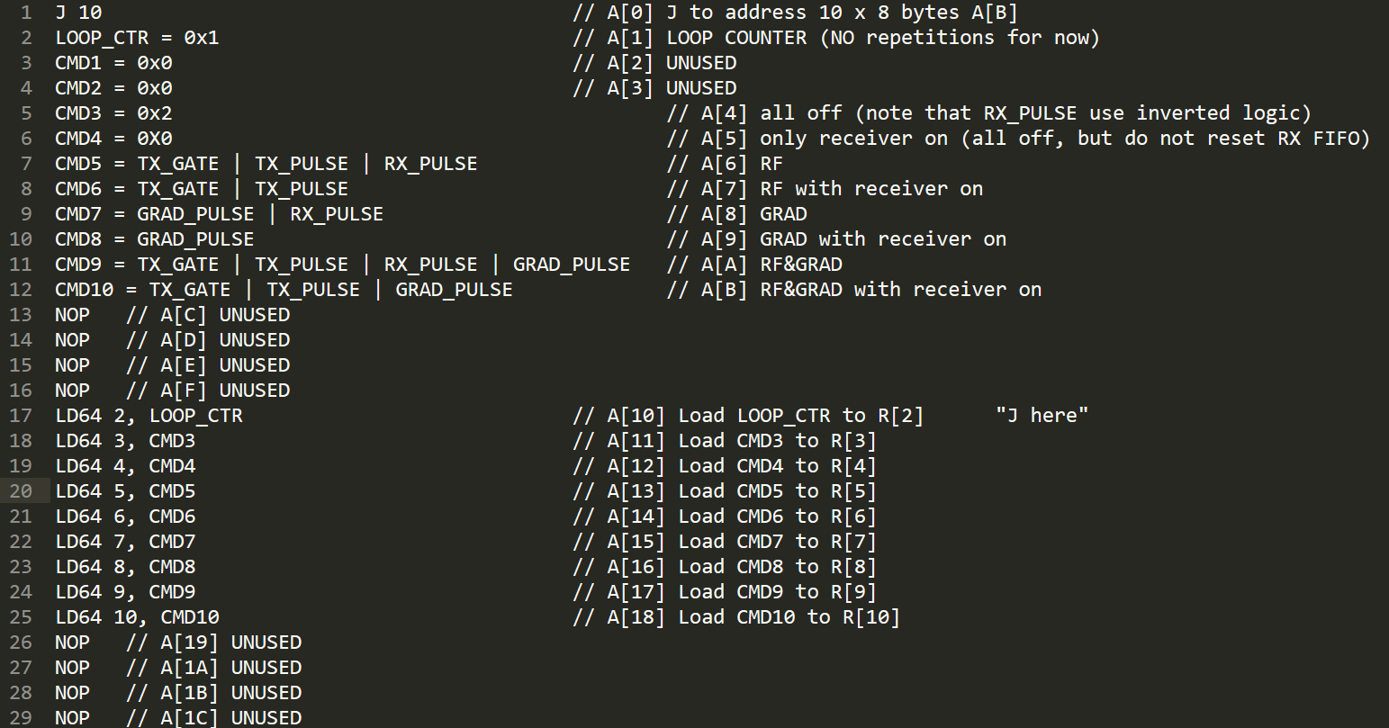



**Sequence commands:**

8 commands are defined for now:

CMD 3, 4 do nothing(wait)

CMD 5, 6 RF

CMD 7, 8 GRAD

CMD 9, 10 RF&GRAD (for slice selective RF pulse)

CMD with odd numbers: receiver off;

CMD with even numbers: receiver on.

I only use TX_GATE, TX_PULSE, RX_PULSE and GRAD_PULSE for now. The RX_GATE command is not enabled for our current system setting.

Note the RX_PULSE use inverted logic. And “cmd3 = 0x2” is the same as “cmd3 = RX_PULSE”.

**Notes for sequence timing programming:**

1. When firing the RF pulse, there will be 50 us lead-in for preparation (e.g. turn on the Tx gate), so the period should be bigger than real RF duration + 50us. Real RF duration should be measured on the scope.
2. The sequence should end with PR 4. (ask Thomas for reason)
3. Although in non-imaging FID and SE sequences, there is no need for gradients, however, in order to enable the gradient offsets, I still need to use PR 8 instead of PR 4 for readout. This can be solved if we later separate gradient offsets and gradient waveforms. In fact, I also use PR 7 instead of PR 3 for waiting to turn on the grad offsets earlier.
4. You should turn off the gradient after playing it (e.g. put a “PR 3, 0” or “PR 4, 0” after it). Otherwise it will continue to play out the gradient waveform in the memory and will wrap around. I am not sure if it is the same with RF.

**Table of RF offsets:**

|  |  |  |  |  |  |
| --- | --- | --- | --- | --- | --- |
| Offset | 0 | 1000 | 2000 | 3000 | 4000 |
| RF | 90 x+ | 180 x+ | 180 y+ | 180 y- | 180 x+ |

All the above are hard pulses

180-Pulses at 1000/2000/3000 use double duration of the 90-pulse.

180-Pulse at 4000 uses double amplitude of the 90-pulse.

|  |  |  |  |  |  |
| --- | --- | --- | --- | --- | --- |
| Offset | 5000 |  |  |  |  |
| RF | SINC |  |  |  |  |

**Table of GRAD offsets:**

Please find them in the server code…

**List of sequences:**

All front-end sequences are under the /sequence folder.

/sequence/basic:

FID and SE sequence for GUI 1 and 2 respectively

/sequence/sig:

Sequences for GUI 3 including FID, SE, GRE and CPMG. The “se_sig_te.txt” is for setting different TEs from the GUI (SE sequence only).

/sequence/img:

Sequences for GUI 4 (2D imaging) including SE, GRE, slice-selective GRE, TSE, EPI and spiral. (slice-selective SE not developed yet)

There are 3 built-in sequences in the server code: FID, SE and GRE.

FID is no longer in use, SE is used for 1D projection and 3D imaging, GRE is used for 3D imaging. However they are exactly equivalent to the SE and GRE sequences in /sequence/img.