## CleverReach Newsletter Subscribers

After installing the extension the default Magento Newsletter Subscribers form will be replaced with the CleverReach information.

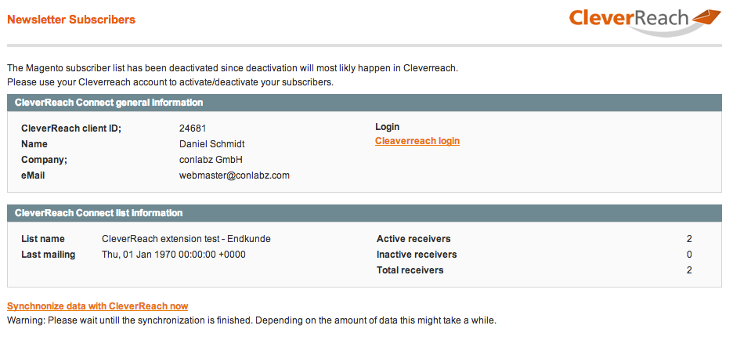

Please synchronize your shop with CleverReach immediately after completing the installation.

This is only required once. All other synchronizations will be executed “on the fly”.

## CleverReach Connect Settings

System -> Configuration -> Customers -> CleverReach Connect

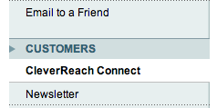

### Settings

**Api Key**

To get the API key go to: Account -> Integrations

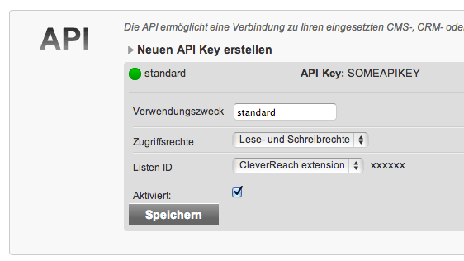

**General List ID**

Your Default Group ID

To find your GroupID go to: Account -> API -> Click to “Edit” and then select your group from the dropdown menu.

**CleverReach Form ID**

This field is required for the use of the CleverReach Opt-in feature. Go to your CleverReach account and create a new form. Then copy the form ID to this field.

The form with the entered ID will be used for the confirmation pages and the subscription success pages.

**Import Orders**

If a new order is placed the user will automatically be added to the default subscription group

**Force Order Reactivation**

If a user creates a new order, he will be added to the newsletter subscription even if he has been removed or deactivated before.

**Separate customers by groups automatically**

During the customer synchronization process, the customers will be added to the associated groups, depending on their Magento Group Id.

**API keys for user groups**

Mapping other (not default) user groups with their CleverReach group IDs and associated forms.

**Hide “General” subscription for Groups**

'No' – Users from custom groups will have the possibility to also subscribe to the General group

'Yes' - Users from custom groups will only have the possibility to subscribe to their own group

CleverReach Settings page

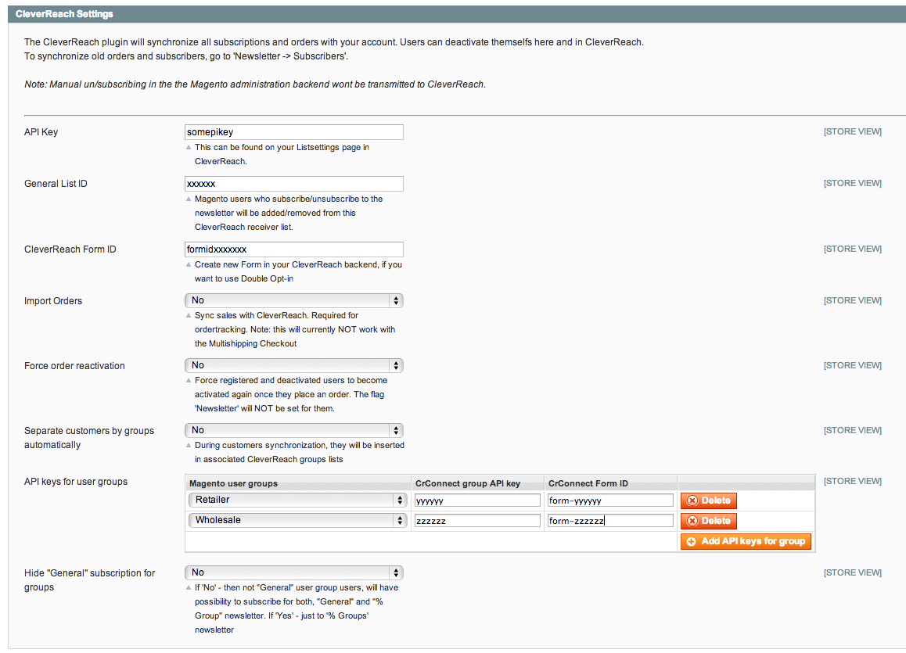

## CleverReach search settings

The CleverReach system has a search function, which allows you to insert products from your shop into newsletter templates.

Please find more details here: <http://www.cleverreach.com/frontend/mycontent.php>

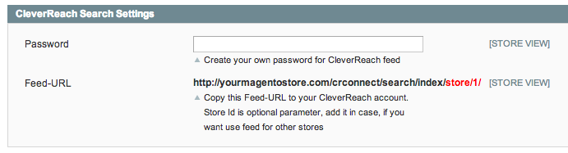

If you want to secure your data feed with a password just enter some password into the “Password” field and then repeat it in your CleverReach account.

