SILVER AuthorizeCIM

User Guide

Date: 03-June-2014
Version 1.0.1

-: Table of Contents :-

- SILVER AuthorizeCIM ....................................................................3
  - Core Features: ..........................................................................3
  - Other Features: .........................................................................4
  - Note: .........................................................................................4

- SILVER AuthorizeCIM – Installation...............................................5

- SILVER AuthorizeCIM – Usage.......................................................7

- SILVER AuthorizeCIM – Support....................................................9

1. SILVER AuthorizeCIM

The Authorize.Net Customer Information Manager (CIM) allows you to store customers' sensitive payment information on secure servers. This method is fully PCI compliant, which is why it does not store any CVV information. SILVER AuthorizeCIM is very useful as one of the payment methods in Magento.

- Core Features:-

→ When an order is placed using this extension, all credit card related sensitive information will be saved on Authorize.net secure servers. This makes your website completely SAFE and PCI compliant.
→ For each order, a unique transaction ID will be created. Using this transaction ID, we can capture payment, make refund and partial refund.
→ We can also use this module as a payment method to place orders through back end. Admin can create orders through Magento back end and get payments online (at the same time) using this Authorized.CIM.
→ You can enable/disable the saved credit card details feature. If it is “enabled”, customer entered CC details will be automatically stored once the transaction is complete. Later, all these saved CCs will be displayed to customers in DROP DOWN to select any one.
→ We can have split invoices using our extension. Multiple invoices can be generated for a single order with online payment capturing.

- Other Features:-

→ This module works with Magento Community Edition: 1.4, 1.4.1.1, 1.4.2, 1.5, 1.6, 1.6.1, 1.6.2.0, 1.7.0.0, 1.7.0.1., 1.7.0.2, 1.8.0.0, 1.8.1.0, 1.9.0.0, 1.9.0.1
→ This extension will work for English language only.
→ This extension can be used for single domain only. For more domains, you can make additional purchases of the same extension.
→ For any support OR assistance, please email us at magento@silvertouch.com .

- Note:-
→ Available Transactions types in our extension as follows:
- Authorize/Capture
- Authorize Only (will 'Capture' upon 'invoice')
- Capture Only
- Split Invoice
- Refund
- Partial Refund
→ NOT available Transactions as compare to other extensions:
- Reauthorize during edit Order
→ Currently there is no option for customers to select if they want to get their CC detail saved or not. However, admin have that option at global level. If it is selected to YES, customers entered CC detail will be saved automatically while placing orders and same can be used later for new orders.

2. SILVER AuthorizeCIM – Installation

Follow the below steps to install and list SILVER AuthorizeCIM in Magento:

→ There are two ways to install the extension:
- Upload the extension package file purchased from SILVER TOUCH TECHNOLOGIES LIMITED via magento connect manager
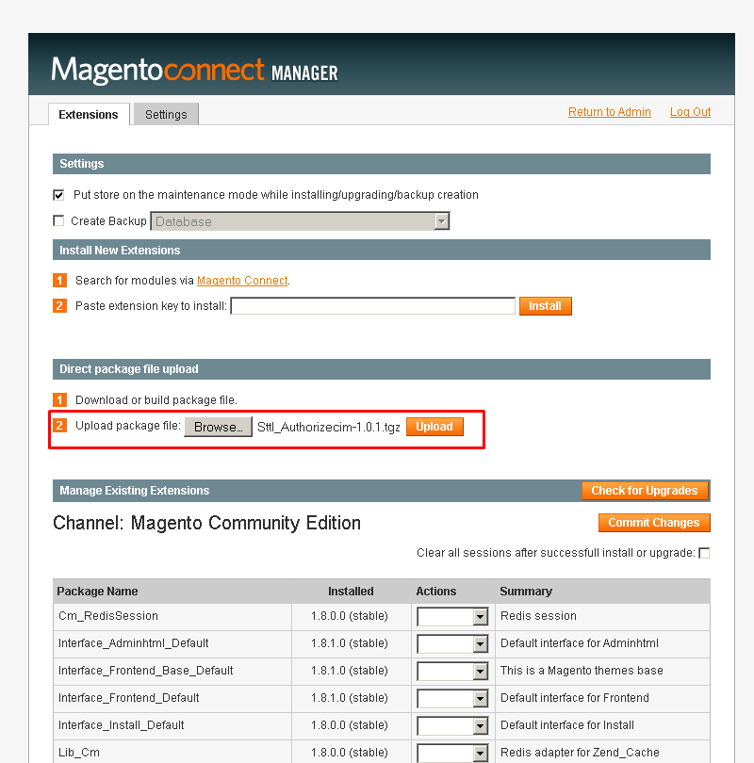
OR
- Unpack the contents of the ‘Extension’ folder from the package file purchased from SILVER TOUCH TECHNOLOGIES LIMITED to your Magento root folder

→ If Cache Control is enabled in Magento then go to 'System > Cache Management' section, and select 'Refresh' under 'All Cache' drop-down menu and press 'Save Cache Settings'.
→ Log out from Magento Admin panel
→ Log into Magento Admin Panel again
→ Now in Back-end you can see in 'System > Configuration → Payment Methods' section in left panel and in that “Authorize.net CIM”.
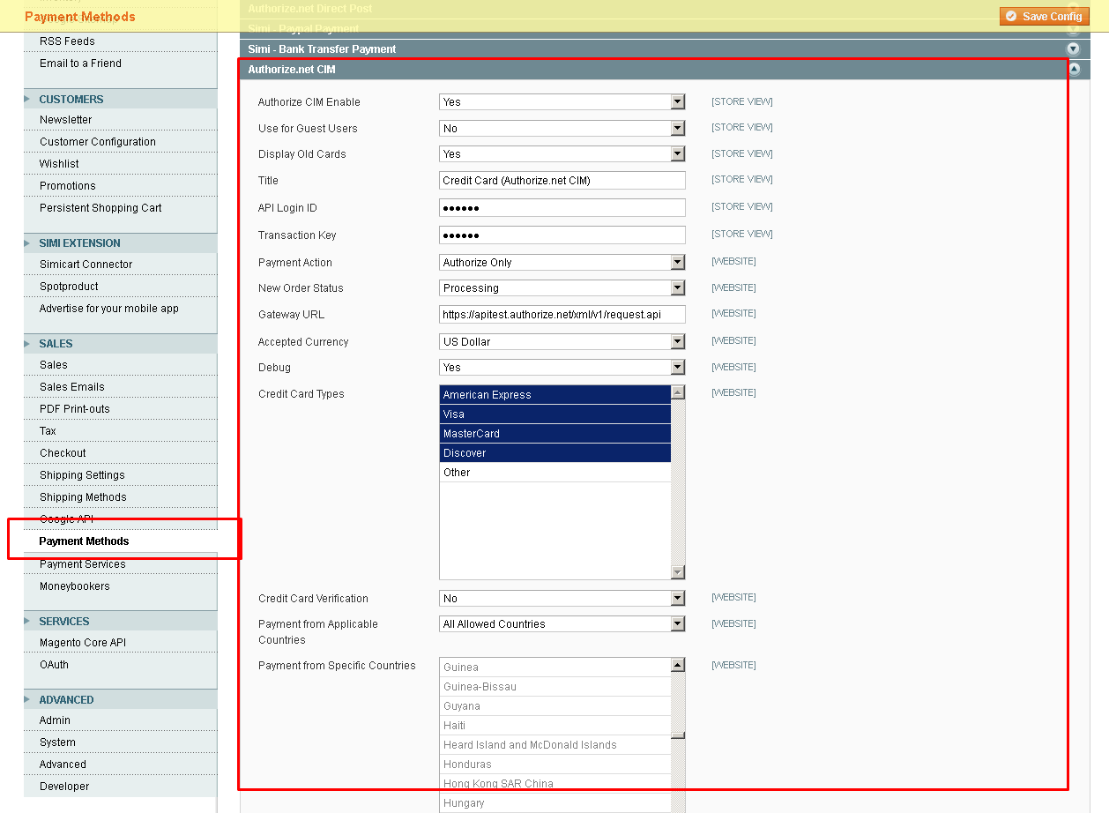
3. SILVER AuthorizeCIM – Usage
→ Go to System->Configuration->SILVER AuthorizeCIM
- Set Authorize CIM Enable => Yes
- Enter API Login ID, Transaction Key (Provided by Authorize.net)
- Provide host and path for integration Authorize.net API
- Select options for displaying saved credit cards at frontend
- Click “Save Config” button

→ Now on frontend, on checkout page, SILVER AuthorizeCIM will be displayed as below:
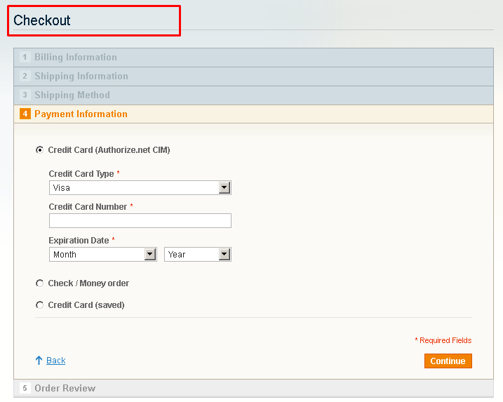

→ If admin has enabled to SAVE CC, all customers entered CC detail will be saved on Authorized.Net secure server and customer can access it as shown in below screen.
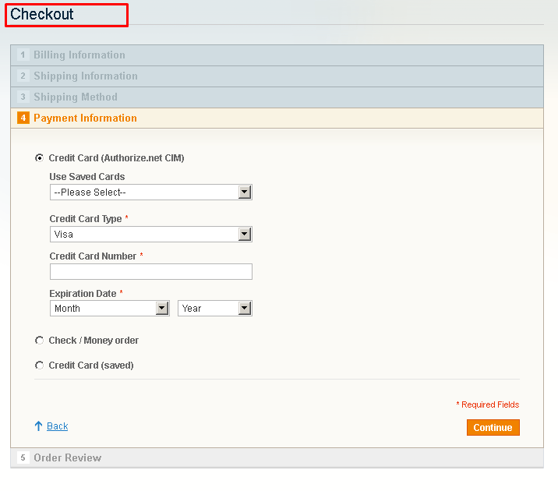
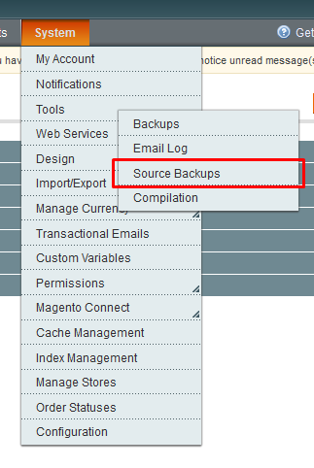

4. SILVER AuthorizeCIM - Support

Silver Touch Technologies Limited offers 1 Year support via Email, Chat or Phone from date of purchase. And updates the customers for any Silver Extensions developed for Magento.

If you require any help related to Silver Extension usage, feel free to contact us at
magento@silvertouch.com .

