Teaser Marketing Bar

Date: 07-May-2013
Version 1.0

-: Table of Contents :-

    - Teaser Marketing Bar.........................................................................3
    - Teaser Marketing Bar Installation......................................................4
    - Teaser Marketing Bar – Usage............................................................5
    - Teaser Marketing Bar – Support......................................................11

1. Teaser Marketing Bar

Teaser Marketing Bar extension provides you with the ability to set your own Message at top of your store and you are also free to set your best products of store.

Features:-

→ Admin can get option to enable / disable for teaser marketing bar.
→ Admin can get facility to enable / disable default bar open.
→ Admin have option to set
- Default Message.
- Store Message.
- HTML Message.
- Products for particular category.
- Start date and end date for Message.
- Color for box which contains Message or deals.
→ As extension provide default css ,you will have separate css for this extension so you are free to set your own design.
Note:-

→ If you want to show products at top of store then please define valid category id and must not be null for get proper result.

2. Teaser Marketing Bar - Installation

Follow the Steps below to Install and list Teaser Marketing Bar under Magento.

- Log out from Magento Admin panel if you are logged in.
- Unpack the contents of the 'Extension' folder from the package file purchased from SILVER TOUCH TECHNOLOGIES LTD., to your Magento root folder.
- Log into Magento Admin Panel.
- If Cache Control is enabled in Magento then go to 'System > Cache Management' section, and select 'Refresh' under 'All Cache' drop-down menu and press 'Save Cache Settings'.

3. Teaser Marketing Bar - Usage
- Now open System > Configuration'
- There is a tab as “STTL” and under this tab you have section as “Teaser Marketing Bar”, by this you are free to manage extension.

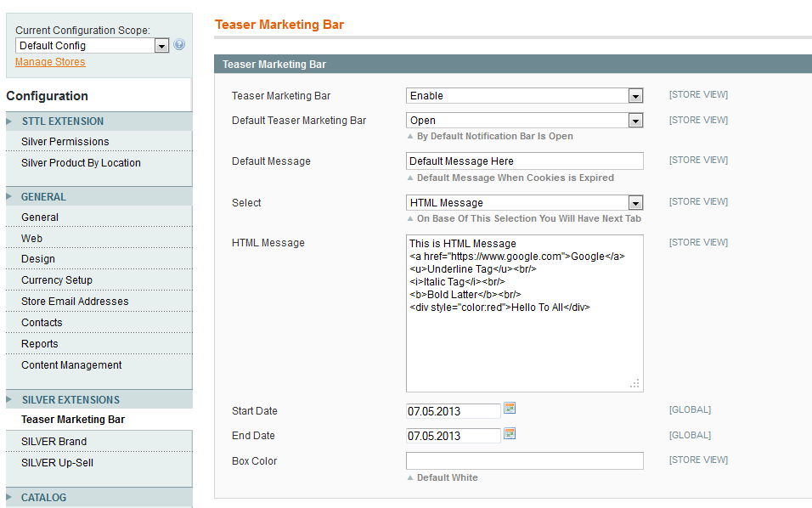

- As you can see window for manage extension, let’s define option as above.
  - Default Message.
  - Store Message.
  - HTML Message.
  - Category ID.
  - Start Date and End Date.
  - Box Color.
- Lets select option one by one and see desire result.

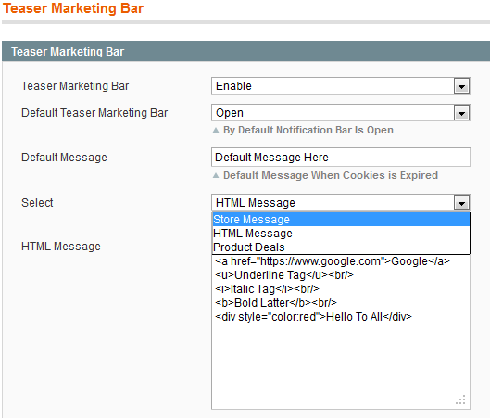

- Please select Store Message first from drop down, define your desire store message and save the changes and see the fronted result as below.

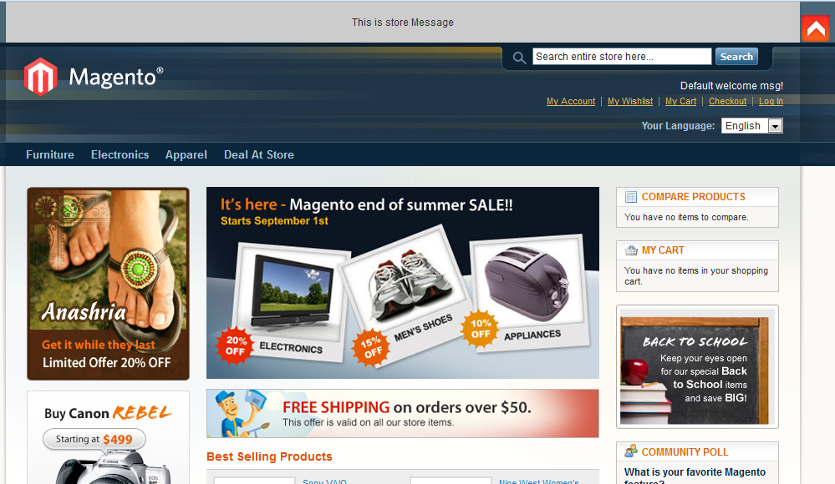

- Please select HTML Message from drop down, define your desire HTML Message and save the changes and see the fronted result as below.

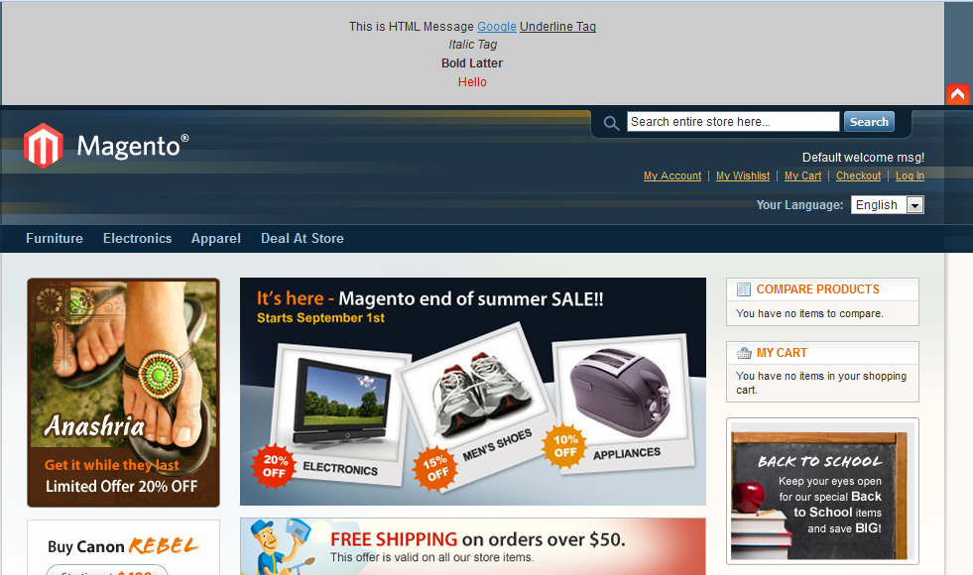

- Lets select Product Deals from drop down, define category ID and save the changes and see the fronted result as below.(be sure for this option you have to define category id and then you can see product of that category on top of store, in my case I have already created new category as name Deal At Store with id 35 )

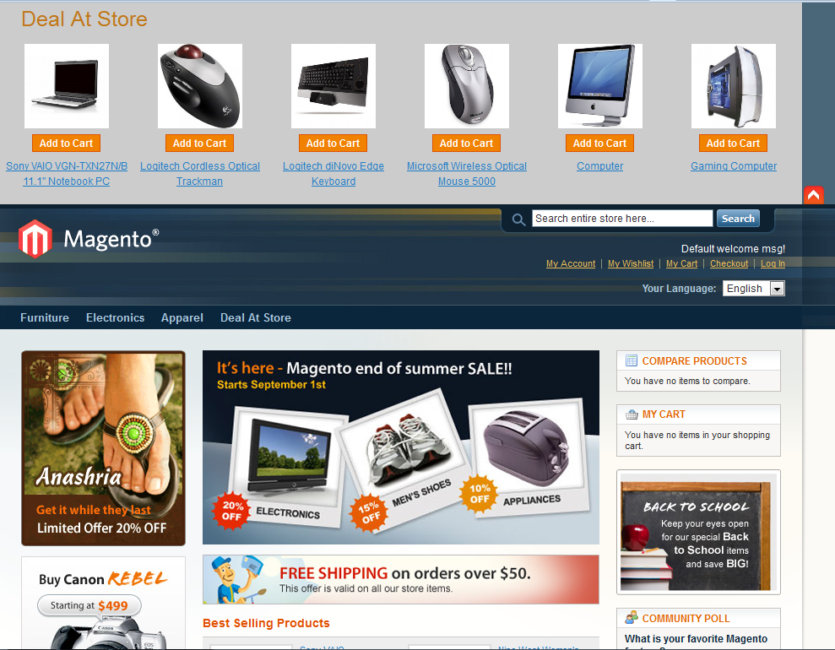

- Lets expire cookies it means set start date and end date as that current date does not exists between these dates, so you can get default Message and this Message is editable by admin.

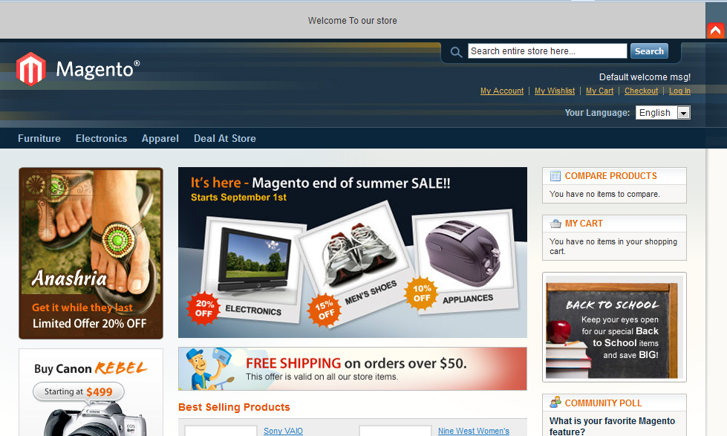

4. Teaser Marketing Bar - Support

Silver Touch Technologies Limited offers 1 Year support via Email, Chat or Phone from date of purchase. And updates the customers for any Silver Extensions developed for Magento.

If you require any help related to Silver Extension usage, feel free to contact us at
magento@silvertouch.com.

