The Crystallographic Restriction Due Sept. 30

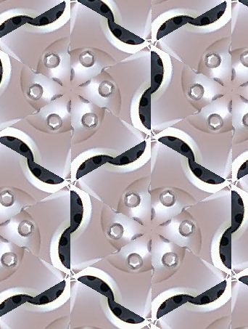
Let G be the symmetries of an infinite pattern, with G having no fixed point or line. Then G may have 1/2 turns (180°), 1/3 turns (120°), 1/4 turns (90°) or 1/6 turns (60°), but no other angles are possible!!!!

That is so cool!!! It makes me want to learn more math and become so smart that and famous that I can transform into my mirror image and play Star Trek.

First, what order turns exist in the hubcap-like pattern here? Mark them on the picture.

Here’s an outline of the proof of the C.R.

Step 1: Suppose there is a 1/5 turn. Find two such turns whose centers are as close together as possible. (If there’s one, there have to be an infinite number – just conjugate by all the translations.)

Step 2: OK, here are your two 1/5 turns, centered at A and B. I’ve drawn the rotations as little pentagons, just to be cute. Let r_{A} and r_{B} be the two rotations. Then r_{A}r_{B}r_{A}⁻¹ is the 1/5 turn centered at B’, and r_{B}⁻¹r_{A}r_{B} is the 1/5 turn centered at A’. (This follows from our conjugation rules: we conjugated r_{A} by r_{B}⁻¹ and we conjugated r_{B} by r_{A}.)

Step 3: But that means A’ and B’ are closer together than A and B were, which contradicts out original choice of A and B.

Some questions:

1. Why are A’ and B’ are closer together than A and B?

2. Why doesn’t this exclude 1/2, 1/3, 1/4 or 1/6 turns?

3. How does this exclude 1/7, 1/8. 1/9, etc. turns?

