
*Please download this document and view it locally*

Getting Started
with





Openmediavault 5

November 13th, 2020 - Rev 1.4

Table of Contents
- Introduction to Openmediavault 6
History 6
Purpose 7
Getting Involved 7
- About this Guide 7
Beginners: 7
Advanced Users: 7
A cautionary note for Advanced Users: 8
Linux Experts, Admin's, and Developers: 8
- Hardware 9
Compatibility: 9
64 bit hardware (amd64): 9
32 bit Hardware (i386): 9
ARM Hardware: 9
Minimum Hardware requirements 9
Recommended Minimum requirements 9
Recommended Hardware and Considerations for a good use experience 10
ARM - Single Board Computers: 10
i386 or amd64 10
Where CPU Power may be Needed – “Transcoding” 11
Pre-2011 Intel and AMD CPU's 11
2011 and Newer Intel CPU's 11
Selecting a Boot Drive 12
Final Notes on Choosing a Boot Drive 12
Hardware - The Bottom Line 13
- Installing on Single Board Computers (SBC's) 14
- Installing on i386 32-bit Platforms 14
- amd64 (64-bit) Platforms 15
Downloading 15
Verify the download 15
Installing - amd64 Platforms 16
Burning a source CD 16
Creating a Bootable ISO Thumb-drive 16
Preparing Flash Media 16
amd64 – Openmediavault Installation 20
First Boot 27
- OMV - Initial Configuration 29
Web console login: 29
SSH Login: 30
- Quick Start Guide for Advanced Users: 31
- Basic OMV Configuration 32
System Settings 32
Network Interfaces – SBC Users 33
Network Interfaces – i386/amd64 Users 34
Server Notifications 35
OMV-Extras 38
Installing OMV-Extras 39
A Basic Data Drive 41
General 41
RAID+USB= Potential Problems 41
Data Storage - Size matters 41
Data Drive Set Up 42
- Creating A Network Share 44
Setting up a Shared Folder 44
Creating a SMB/CIF “Samba” Network Share 45
Explore the New Network Share 46
- The Flash Memory Plugin - amd64 users only 48
Flash Media and Wear Leveling 48
The Purpose of the Plugin 48
Installing the Plugin 48
Option 1: Editing /etc/fstab with nano 50
Option 2: Editing /etc/fstab with WinSCP and Notepad
51
- Final Installation Notes: 52
- Utilities to Help With OMV Management 53
WinSCP 53
Installing WinSCP
53
PuTTY 56
MC (Midnight Commander) 56
Win32DiskImager 58
Virtual Box 58
- Backups and Backup-strategy 59
Backing Up Data 59
- Full Disk Mirroring / Backup with Rsync 60
Recovery from a Data Drive failure - Using an Rsync'ed backup 64
General: 64
Restoration Without a Replacement Drive: 64
- Operating System Backup: 71
The Benefits of Maintaining Operating System Backup 71
**A Last Important Note About Backing Up your OS** 72
Cloning Flash Media 72
- Add-on's – Adding Value to Your OMV server 75
General 75
OMV's Plugin's 75
Dockers - General 75
So, What is a “Docker”? 75
Installing Docker 76
Dockers - It's about choices 80
Selecting a Docker - Primary Considerations 80
- When things go wrong 81
The First Resource – The Internet 81
The OMV Forum 81
Hard Drive Failures and SMART 83
Drive Self-Tests 83
SMART Attributes 84
Common Problems: 85
USB Power - A Common Raspberry PI problem 86

Version History:
December 12th, 2019 - Rev 0.1 (The first draft for OMV5)
December 18th, 2019 - Rev 0.2 (Installing Docker, Portainer. Added a section on R-PI under powering.)
December 21rst, 2019 - Rev 0.3 (i386 install removed and linked to an independent document.)
December 30th, 2019 - Rev 1.0 (Minor clean up edits.)
January 25th, 2020 – Rev 1.1 (Cleaned up TOC errors, minor reorder, minor edits)
January 26th, 2020 – Rev 1.2 (Updated notes on Transcoding and Quick Sync)
February 9th, 2020 – Rev 1.3 (Updated note on plugin's, other minor edits. Added notes and references RE hard drives and SMART attributes.)
November 13th, 2020 – Rev 1.4 (Updated external links, removed dual USB thumbdrive install note, added para and link RE bootable ISO thumb-drives, added note RE alternate 64bit install by script, added project Wiki link. Link for mitigating R-PI WinSCP root restrictions. Notes updated RE cloning SD-cards and Thumb-drives. Minor edits.)

Introduction to Openmediavault
Openmediavault is a File Server / NAS system designed to work on most modern IBM compatible PC systems, to include typical amd64 or i386 PC’s and select ARM devices. Openmediavault (OMV) can be thought of as filling a role similar to Microsoft's Server Essentials, but extends far beyond the role of a basic File Server with additional functionality added VIA plugin’s and Dockers. OMV is designed to work with popular client operating systems and multiple filesystem types, utilizing proven data sharing techniques on small and medium sized Local Area Networks.

In meeting the needs of it's intended users, individuals and small-to-medium-sized businesses, Openmediavault is designed for flexibility.

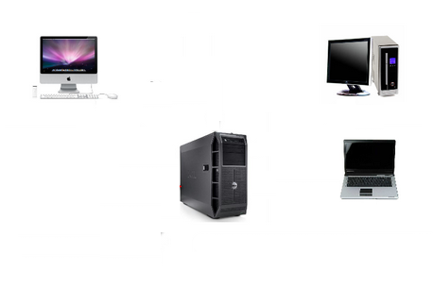


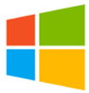
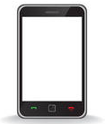


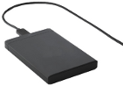

History
Openmediavault's history began with Volker Theile, who was the only active developer of the FreeNAS project by the end of 2009. Volker became interested in completely rewriting FreeNAS, for use on Linux. Initially, he named the rewritten package coreNAS. Shortly thereafter, Volker discarded the name coreNAS in favor of Openmediavault. Openmediavault's initial release was on 17 October 2011. It's built upon very mature and proven software layers and is under constant development. Openmediavault relies on the Debian project and uses their system and repositories as a base. The project focus is on creating and maintaining a stable and extensible NAS system that is intuitive and easy to use.

Purpose
The purpose of Openmediavault (hereafter referred to as “OMV”), is to provide a NAS system that is highly “extensible” with value added plugin’s and access to numerous Dockers that are desirable and beneficial to home users and small businesses at little to no cost.
One of the ambitions of the OMV project is to make advanced NAS technologies and features available to inexperienced users in an easy to use WEB GUI, thereby making it possible for people, without extensive knowledge of Linux, to gain easy access to advanced technologies.

Getting Involved
If businesses and home users find OMV to be beneficial, consider supporting the project with a modest donation. While OMV is free, donations to cover Web site costs, hardware for testing, and other unavoidable expenses are needed and very much appreciated.

Donate to OMV (Main project development) and
Donate to omv-extras.org (Support for Single Board Computers and Development of Plugins.)

The OMV project is looking for coding talent and contributors. If one has developer experience, (BASH, PHP, Python, Javascript) the project would like to hear from you. Users with Linux experience are invited to help out on the OMV Forum.

About this Guide
In computing, generally speaking, there are several ways to do the same thing. By extension, methods and methodology become progressively more advanced as a user's skill level increases. With these notes in mind, methods found in this guide may not be considered as “Best Practice”, especially from a hardened security perspective. The purpose and intent of this guide is to provide a walk-through to get users up and running as quickly and easily as possible.
- This guide contains links to external sources of information and software. It's best used on a PC connected to the Internet.
- This is a community document and a work in progress. Input and feedback are welcome and can be sent to: omvguide@gmail.com

Beginners:
This document is intended for beginners who will, primarily, be using the OMV's GUI. Beginners are assumed to have basic knowledge of computers and their LAN systems, and a Windows or Apple PC.
The focus of this guide will be to take a technically easy route, for the widest possible cross section of new users, toward accomplishing basic tasks using methods and processes that are easy to understand and duplicate.

Advanced Users:
OMV was designed to be intuitive for advanced users and beginners alike.
After the installation is complete, for a streamlined setup, see the Quick Start Guide.

A cautionary note for Advanced Users:
Many of the configuration files traditionally used to customize Debian Linux are controlled by the OMV system database. As a result, manual edits of configuration files may be overwritten as of the next, “on-demand”, configuration change in the OMV GUI. Further, it is possible to “break” OMV with alterations and permissions changes to the files of the boot drive, on the command line.
In the beginning it's best to rely, primarily, on the GUI for configuration and control. Otherwise, before attempting to customize the operating system, backing up the boot drive is highly recommended.

Linux Experts, Admin's, and Developers:
Users in this category may prefer the information available on the Project's Wiki.

Hardware
Hardware requirements to run OMV are very modest, however, actual hardware requirements for specific “use cases” vary widely. The following is intended only as general guidance.

Compatibility:
OMV 5.X is currently supported by Debian 10, “Buster”.
Compatible hardware and other requirements of Debian Linux are available at Debian.org

64 bit hardware (amd64):
The OMV project maintains convenient, fully integrated, OMV/Debian installation ISO's. This is the best method for getting OMV up and running quickly.

32 bit Hardware (i386):
While OMV is supported by 32 bit Debian installations, it's a two step scripted process referenced in; “Installing on i386 32-bit Platforms”. The OMV project does not provide integrated 32 bit installation ISO's.

ARM Hardware:
The OMV project provides scripted installation support for ARM Single Board Computer (SBC) platforms. Supported platforms are the Raspberry Pi, models 2B and higher, and the various ARM platforms supported by Armbian.

Minimum Hardware requirements
OMV/Debian will run on I386, AMD64, and select ARM platforms with 1GB of ram or less, but performance expectations should be adjusted accordingly. The system boot drive should have a minimum of 8GB capacity.

Recommended Minimum requirements
For basic File Server operations - 1 or 2 users:
- Any of the ARM Single Board Computers supported by OMV.
- Intel Core 2 Duo or equivalent AMD processor and 1GB of RAM.
If flash media is used, (USB thumb-drives, SD-cards, etc.) the system boot drive should have at least 16GB capacity, for longer life.

Recommended Hardware and Considerations for a good use experience

i386 or amd64
- Intel i3 (or equivalent AMD processor), 4GB ram or better (ECC preferred) and a 16GB system boot drive will provide good performance in home or small business use cases.
- As the number of NAS users increase and server processes are added, processing power and memory requirements increase.
- For file caching, in support of normal file system operations, performance is better with more RAM.
- The number of a Motherboard's SATA or SAS ports can be a factor if future storage expansion is needed.
- A case design that accommodates the physical installation of additional hard drives can be helpful.
- Integrated video is preferred over add-on Video cards. With OMV's headless server design, add-on Video cards are an excessive and unnecessary power drain, with no performance benefit. Installing a high end, high powered Video card in a headless server is analogous to installing a 65 to 200 watt light bulb in a closet, without a switch, and closing the door.

ARM - Single Board Computers:
Performance levels vary greatly among the various models of Single Board Computer (hereafter referred to as an “SBC”) that are supported by Armbian, Raspbian, and OMV. While most will support file server operations for a few users, if running server add-on's or Dockers is a requirement, research the chosen SBC carefully before buying. Armbian's or OMV's forums may be of assistance, along with Internet product reviews.
**When considering an SBC as a primary NAS server for home use, note that support for SBC's is for the current OMV release only. Accordingly, SBC users should read the ending cautionary note in Operating System Backup.**

Raspberry PI's
(Hereafter referred to as “R-PI's”.)
Given the current market for SBC's, the majority of SBC users will likely be owners of R-PI's.
OMV runs well on the R-PI 4. While OMV will run on an R-PI model 2B and the various models of the R-PI 3, performance is poor. What exactly does “poor performance” mean? In this context, if the R-PI's CPU is running at 100%, OMV my not show up on the network and / or network shares may not open. This may give the false impression that there's a software or permissions problem. In other instances, the WEB GUI login page may not respond.
These issues may appear to be software related problems, but that's not always the case. Older R-PI's are very easily over stressed and, during periods where the CPU is running at 100%, they may not respond to external input. With this performance limitation in mind, earlier versions of the R-PI (2B and 3X models) should be used only as a basic file server for 1 or 2 user home environments, where multitasking is less likely. If running automated tasks, it's best to schedule them to run in the early morning hours when user access would not be affected.
In addition, R-PI's suffer from USB under powering in models 2B and 3X. See notes regarding this issue in USB Power - A Common Raspberry PI problem

Where CPU Power may be Needed – “Transcoding”
If a users' primary consideration in setting a up a media server, CPU selection or identification may need to be carefully considered.
Transcoding is a process for translating media file formats into types that mobile devices understand. Since mobile devices are low powered, they're not capable of re-processing high resolution media files smoothly so the processing burden is often transferred to the media server.

Pre-2011 Intel and AMD CPU's
Plex, a popular media server, recommends at least 2000 on the CPU's PassMark score for each concurrent 1080p transcoded stream. (See the advice article here) However, this advice applies to pre-2011 Intel and AMD CPU's.
Look up an older CPU here  PassMark CPU Benchmarks
___________________________________________________________

2011 and Newer Intel CPU's
As of the beginning of the Sandy Bridge CPU series in 2011 and later, a core has been added to Intel CPU's for the sole purpose of video transcoding. CPU's with Quick Sync, to include Celeron and Atom models that are relatively low powered, do a good job of transcoding for portable devices.
If NAS administrators have numerous smart phone users, in their homes or businesses, who will be watching transcoded video on the small screen, CPU loading and Video processing features may require some additional thought and research.
___________________________________________________________
Additional reading  Intel Quick Sync versus similar AMD technology.

Selecting a Boot Drive
Nearly any type of hard drive, SSD, or flash device (USB thumb-drives and SD-cards) 8GB or larger, will function as an OMV boot drive.
However, some notions of achieving a “Faster” or a “Better Performing NAS server” by using certain types of fast boot media should be dispelled.
Server booting requirements and considerations are different when compared to desktop and business workstation requirements.
- Given OMV's lean configuration, boot times can be fast. Boot times of 1 minute and Shutdown times of 20 seconds are common, even when using relatively slow flash media such as USB thumb-drives and SD-cards. (Recent models can be quite fast – check their benchmarks.)
- Typically servers are rebooted no more than once a week. When automated, a reboot event is usually scheduled after-hours when users are not affected.
- After the boot process is complete, most of OMV's file server functions are running from RAM.
Conclusion – for Linux NAS operations, fast boot media is not important.
- “The WEB/GUI is more responsive with fast media.”
This is the single instance where an SSD or a spinning hard drive may create the illusion of higher performance. In the traditional role of a NAS as a File Server, when the server boots, the Linux kernel and most of the necessary processes required to act as a File Server are loaded into RAM - the fastest possible media for execution.
Navigating OMV's WEB/GUI interface is another matter. Loading WEB pages may call files from the boot drive, which may make the server appear to be slower, when using slow media. However, the speed of the boot drive has little impact on overall file server function and actual NAS performance.
**The above assumes that adequate RAM has been provisioned.**

Final Notes on Choosing a Boot Drive
OMV's boot requirements are very modest:
While some users prefer traditional hard drives or SSD's, the boot requirement can be served with USB thumb-drives and SD-cards, 8GB or larger.
With USB connections on the outside of a PC case, cloning USB drives for operating system backup is an easy process. Given this consideration, some users prefer USB thumb-drives and other external flash media to internal drives. Further, given the ease of operating system recovery in the event of a boot drive failure, beginners are encouraged to consider using flash media.
If flash media is used:
New name brand drives are recommended such as Samsung, SanDisk, etc. While not absolutely essential for the purpose; USB3 thumb-drives are preferred, due to their more advanced controllers, and SD-cards branded A1 for their improved random read/write performance. USB3 thumb-drives and A1 spec'ed SD-cards are faster and, generally speaking, more reliable than similar items with older specifications.
While boot drive size matters, bigger is not always better. An acceptable size trade off for wear leveling and speed of cloning is between 16 and 32GB. (“Wear leveling” will be explained during the installation and configuration of the flash-memory plugin.)
The flash-memory plugin is required for flash media. It's purpose and installation is detailed in The Flash Memory Plugin.
Use-case exceptions where boot media larger than 32GB may be useful:
- Running applications that utilize WEB interfaces, such as Plex, Emby, etc.
- Hosting Web or Media Servers with extensive content.
- Hosting Virtualized Guest operating systems with desktops. (Does not apply to ARM platforms. ARM platforms can not virtualize i386 or amd64 platforms. )
(There's no penalty for starting with a smaller boot drive. Moving to a larger drive, if needed, can be done later.)
** Note: Buying flash devices on-line, even from reputable retailers, comes with the substantial risk of buying fakes. Buying flash drives, in sealed packaging, from walk-in retail stores with liberal return policies is recommended. The use of cheap generics, fakes or knockoffs is highly discouraged. They tend to have a short life and they're known to cause problems, even if they initially test error-free.
In addition, to detect fakes or defective media even when new; all SD-cards and USB thumb-drives, should be formatted and tested in accordance with the process outlined under Format and Testing Flash Media. If they fail error testing, return them for a refund.**
____________________________________________________________

Hardware - The Bottom Line
Again, OMV/Debian's hardware requirements are modest. Nearly any IBM compatible PC or Laptop produced in the last 10 years could be re-purposed as an OMV server.
However, it should be noted that newer hardware is, generally speaking, more power efficient and it's higher performing. The power costs of running older equipment that is on-line, 24 hours a day, can easily pay for newer, more power efficient equipment over time.
Further, the supported ARM platforms are both power efficient and capable of providing file server functions in a home environment. (Again, performance expectations should be adjusted in accordance with the capabilities of the hardware.)

Installing on Single Board Computers (SBC's)

Installation guides for SBC installations are available  here.
__________________________________________________________

Installing on i386 32-bit Platforms

An installation guide for 32-bit installations is available  here.

__________________________________________________________

(Continued)

amd64 (64-bit) Platforms
This guide assumes the user will be installing from a CD, burned from an image found in OMV's files repository, using 64 bit hardware.

Downloading
Beginners should download the latest stable version and burn a CD ISO.
(Rufus or a similar utility can be used to create a bootable USB thumb-drive, to use as installation media, if a CDROM drive is not installed.)
Download OMV from Sourceforge.net and copy or download the SHA or MD5 checksums for your ISO. The checksum value will be used with the MD5 SHA checksum utility. (Windows Notepad can open MD5 files by selecting “All Files”, next to the file name drop down.)
**Note: If users install Beta versions of OMV, they are agreeing to be a “tester”. As part of being a tester, users may experience issues or bugs that can not be resolved and lose data. Plan accordingly, with full data backup.**

Verify the download
After the download is complete, verify the download with a MD5 & SHA chechsum utility.
MD5 and SHA hashes check for image corruption that may have occurred during the download.
**Beginners Note**
DO NOT SKIP THIS STEP. The chance of image corruption is high when downloading and it's pointless to build a server with flawed software. Even the slightest corruption of the installation ISO may ruin your installation and the effects may not be noticed until well after your server is built and in use. Headaches can be avoided by checking the image.

(Continued)

Installing - amd64 Platforms

Burning a source CD
Assuming a CD/DVD drive is installed; in most cases, double clicking an installation file, with an “.ISO” extension, will trigger a CD burning utility on a Windows Computer or a MAC. If help is needed for this process, see the following link.
How to burn an ISO image in Windows 7, 8, 10
________________________________________________

Creating a Bootable ISO Thumb-drive
For PC's without an Optical drive; the OMV ISO can be installed using a Thumbdrive as the ISO source, and install the Debian/OMV system to a second thumb drive.
**Before creating an ISO thumb-drive consider checking the drive using the utilities and process described below in, Preparing Flash Media. **
For assistance in creating a bootable ISO thumb-drive, see the following link.
How to install an ISO file on a USB drive
________________________________________________

** If installing to a standard hard drive or SSD, skip to  Installing Openmediavault. **

________________________________________________

Preparing Flash Media
To use flash media as a boot drive, a couple utilities are recommended:
SDFormatter (get the latest version), and h2testw1.4 .
- SDFormatter installs in the same manner as a typical Windows program.
- h2testw 1.4 is stand-alone “portable” application. Simply unzip h2testw_1.4 onto the desktop, open the folder, and double click the executable.
Due to the rise in counterfeit media and media that reports a fake size, it's recommended that all USB thumb-drives, new or used, be formatted with SDFormatter and tested with h2testw1.4 before using them.

Format and Test Flash Media
Using SDFormatter, do a clean format:
(While SDFormatter was designed for SD-cards, it can format USB thumb-drives for error testing. For those who would prefer a formatter specifically for a USB thumb-drive;  HPUSBDISK.EXE )
SDFormatter will detect a USB thumb-drive. A volume label is optional and the default options are fine.
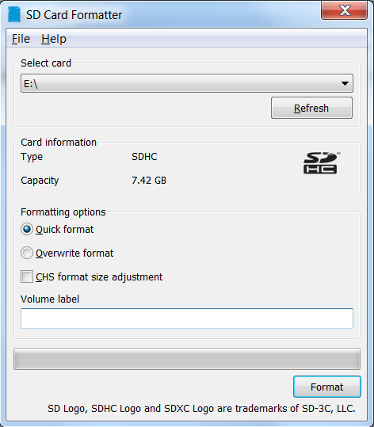
Click on Format

After the drive format is completed, open h2testw and select your language.
Then, click on Select target
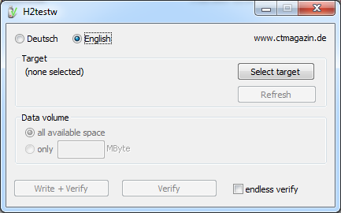

Under Computer, select the flash media previously formatted.
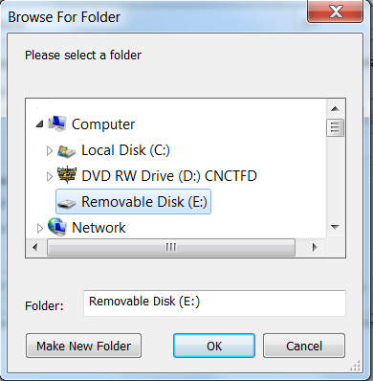

Select Write+Verify. (Do not check endless verify)

A dialog box similar to the following may pop up, drawing attention to a 1MB difference.
Ignore it and click on OK.
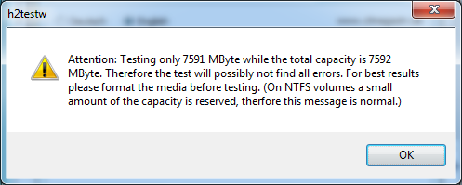
“Without errors” is the desired outcome.
(If media tests with errors or is much smaller than is indicated by its labeled size, don't use it.)

After H2testw verifies the USB thumb-drive, do one more clean format, using SDFormatter, before using the thumb-drive.

amd64 – Openmediavault Installation
- If your PC platform won't boot onto a CD or USB thumb-drive with the installation ISO, it may be necessary to change the boot order in BIOS, to set the CD/DVD drive or USB boot to the top of the boot order. This link may provide assistance on this topic. → How To Enter BIOS
- If difficulties are encountered during the ISO installation, consider the  Alternate 64bit installation guide.
An install walk-through:
Boot Menu: Select Install
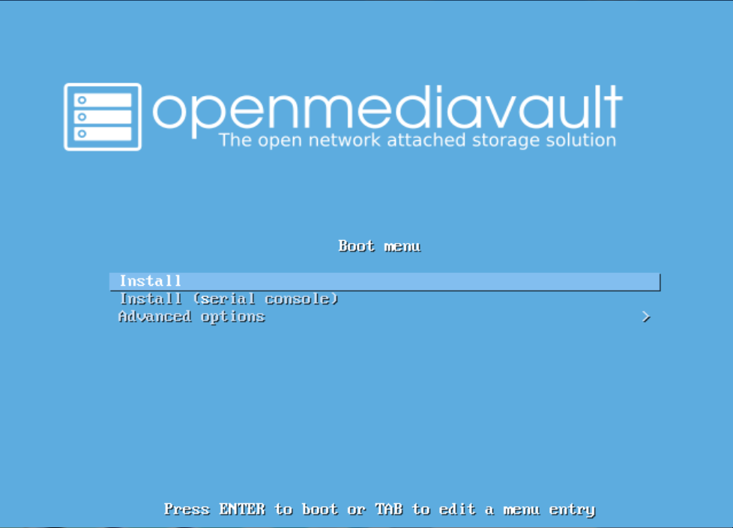
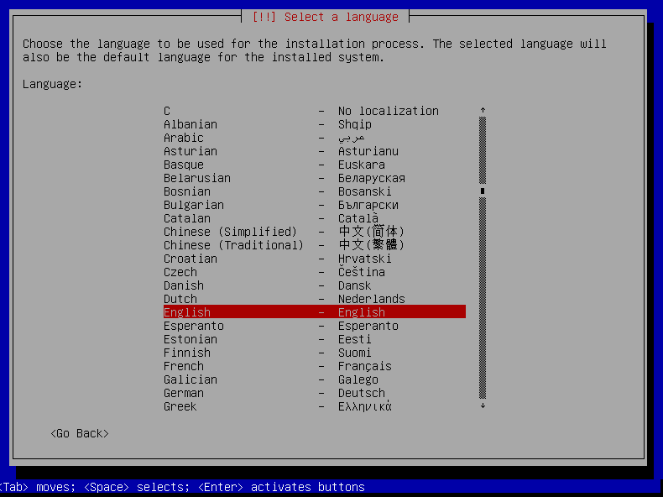
Select a Language: (As needed)
Select your Location: (As appropriate.)
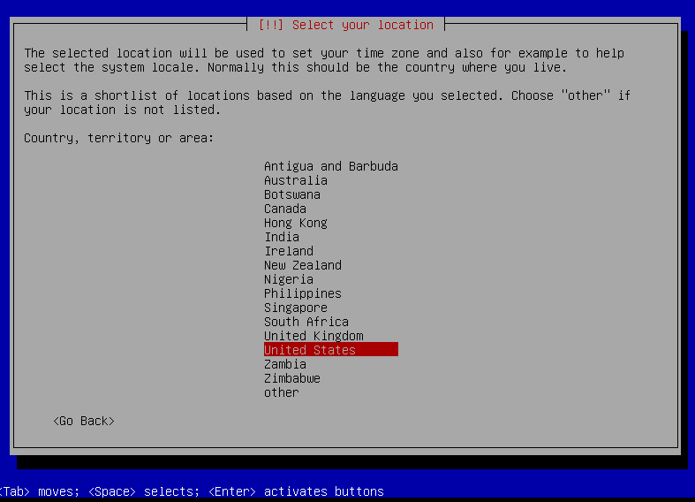
Configure the Keyboard: (Select as appropriate)
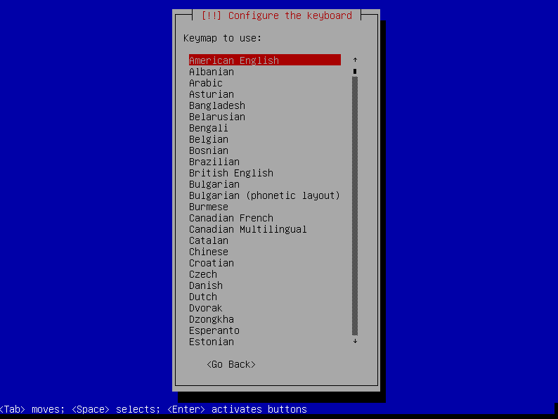

Configure the Network: While the default hostname is fine,
a server name that is a bit shorter might be easier to work with later on. (Something like OMV1).
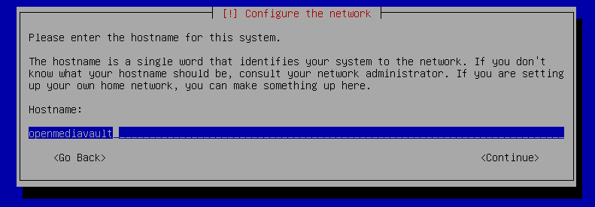
____________________________________________________________

Configure the Network:
If applicable, enter your domain name suffix. Otherwise, for home users and businesses with
peer to peer networks, the default entry is fine.
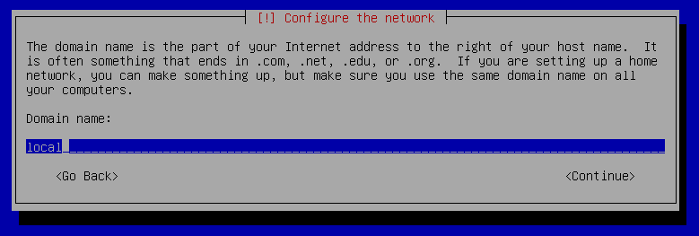

Set up users and passwords:
Follow the on screen guidance for setting the root password.
While not recommended, it would be better to write down the root password, then to forget it.
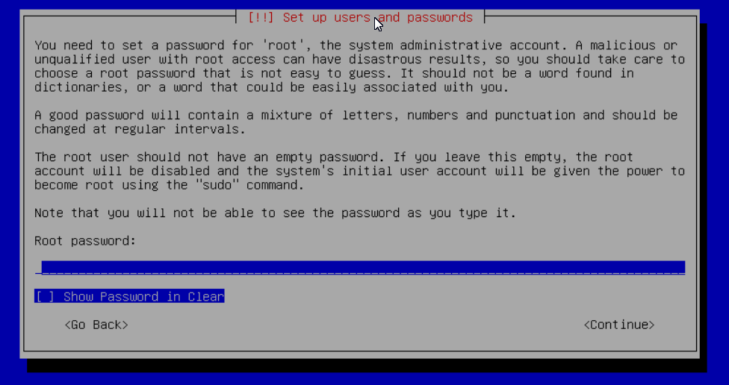
____________________________________________________________
Set up users and passwords:
Follow the on screen guidance for setting up a new admin user and password.
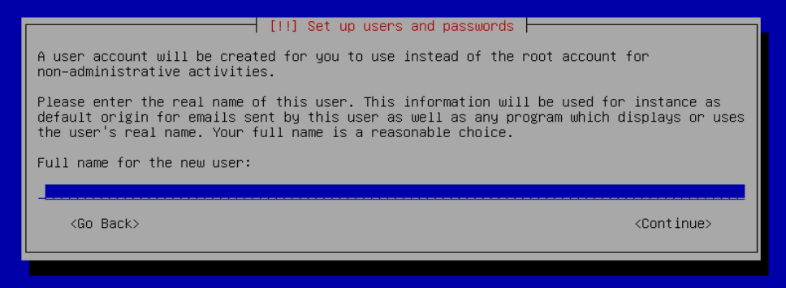
____________________________________________________________
Configure the Clock:
Select your time zone.
(NO PIC)
____________________________________________________________
Partition Disks 1:
If two storage devices are available for installation, this screen is displayed.
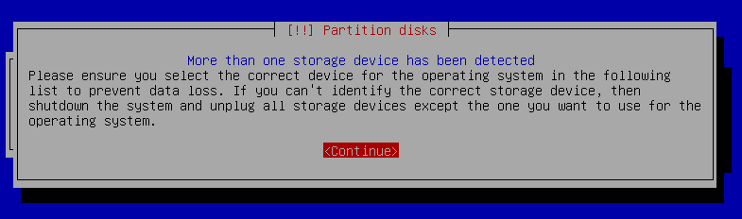
Partition Disks 2:
If installing to a single internal drive, there will be only one selection available. In this particular example, the installation is placed on a USB thumb-drive
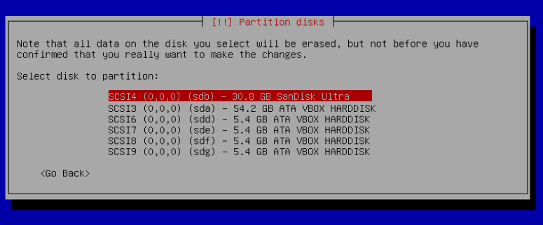
____________________________________________________________
Partition Disk 3:
(No Pic)
A 3rd window asks for confirmation of partition selections. Select Yes.

**If installing to a USB drive, at this point, it is possible to an error may pop-up regarding partitioning the drive, and recommend a reboot. Follow the recommendation. After the reboot, the partition operation should succeed the 2nd time around.**
____________________________________________________________

The system installs..........

Configure the Package Manager:
Debian Archive Mirror Country
(NO PIC)
While the advice given in this screen is true, without testing, there's no way to know which Debian archive mirror is best. Without testing, picking your country or the closest location to your country would be the logical choice.
____________________________________________________________

Configure the Package Manager:
Debian Archive Mirror
(NO PIC)
The default choice is usually best.
____________________________________________________________

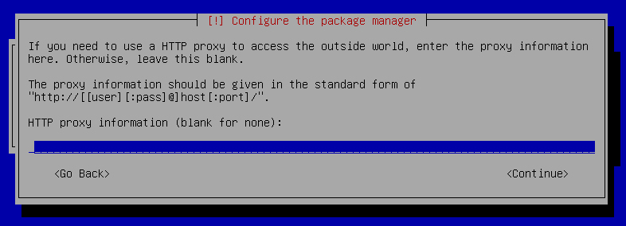
Configure the Package Manager:
HTTP proxy
In most cases this entry will be blank.
(If a proxy is required, note the form of entry required in the dialog box.)
_______________________________________________________________________

____________________________________________________________

** If installing to a hard drive, the following screen may or may not appear. **
Install the GRUB Boot Loader on a Hard Disk:
Select the appropriate boot disk in your server.
(Generally the boot drive will be /dev/sda which is, in most cases, the first sata port.)
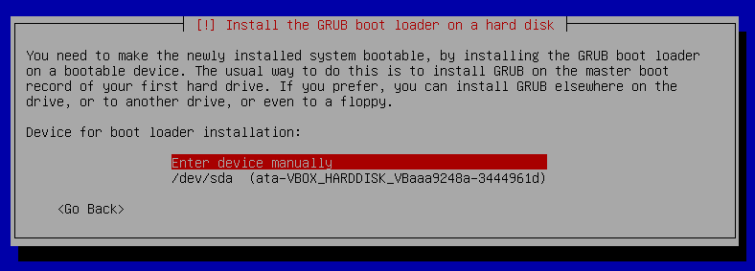

Finish the Installation:
Accept the default.
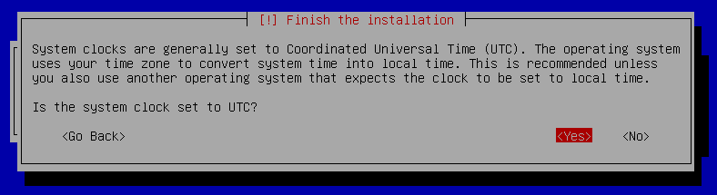

Installation Complete:
Remove the CD or USB installation source, then hit ENTER.
(Otherwise, the installation process may re-start.)
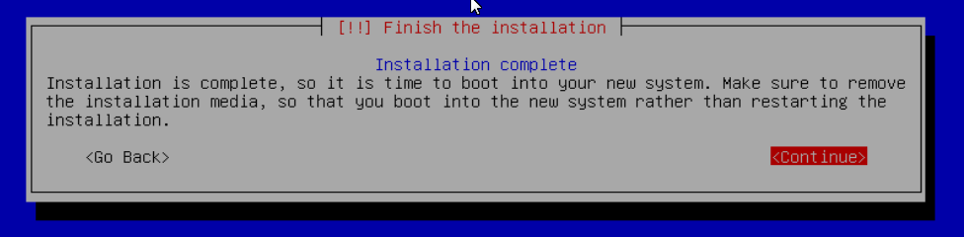

First Boot
Allow the installation to boot. Normally, the text above the login prompt will provide an IP address to be used for opening the console in a web browser. If an IP address is available, skip the following and proceed to
OMV - Initial Configuration.

There are two exception cases on the first boot that users should be aware of.
1.) No address from the DHCP server:
Normally, DHCP will assign an IP address to OMV and the address will be printed to the screen. However, on odd occasions the following issue may be observed.
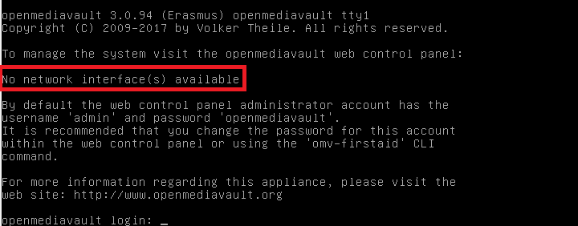
This is due to a slow response from your DHCP server, during a fast boot process.
An easy method of finding the IP address is:
At the login prompt type root
Enter your previously set root password.
At the # prompt type: ip addr
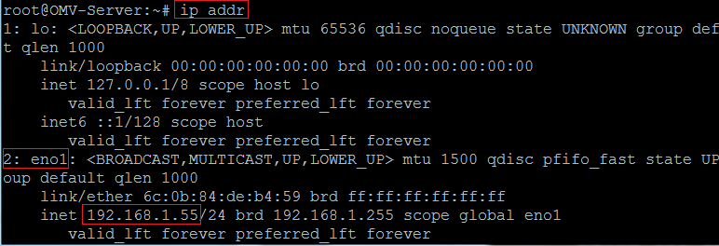
To access the WEB control panel, the IP address for the wired Ethernet interface is needed. In this case it's 192.168.1.55 (/24, the subnet mask, can be ignored.)

2. An odd IP address is assigned, that is not in the user's network:
In the following example, the actual network is 192.168.1.0/24

This is usually a one time event where the fix is simple – simply login as root and type reboot on the command line. The address will be correct the second time around.

____________________________________________________________

** With a known IP address, proceed to OMV - Initial Configuration. **

____________________________________________________________

(Continued)

OMV - Initial Configuration

Web console login:
In a web browser, type in the IP address provided by the first boot screen:
Set the language of your choice.
The user name is admin and default password is openmediavault
(In the following, by clicking on the eye icon , the default password is shown unmasked.)

SSH Login:
Under Services, SSH, check that the toggle switch for “Permit root login” is ON (Green) . If necessary make the change and Save. After clicking on “Save” a yellow banner “The configuration has been changed” will appear. For the change to be applied, the Apply button must be clicked.
(Note: The yellow confirmation banner is a final “SANITY” check and, in most cases, is required to finalize changes.)

Quick Start Guide for Advanced Users:
- In the left hand column, start at the top with General Settings, and work your way down, choosing and activating the services and features you need for your use case.
- For amd64 and i386 users, a static address for the OMV server and setting the address of a public DNS server is recommended. (*SBC users, see the section, Network Interfaces – SBC Users.*)
As an example: Googles servers 8.8.8.8 and 8.8.4.4 support DNSSEC for better security, and “Anycast” which will direct DNS queries to a nearby server with low network latency. There are several choices for Public servers that support these features. List of Public DNS Servers .
- For a browseable network share, a minimum of one shared folder would need to be configured and that folder would need to be added to SMB/CIF to be visible on the network.
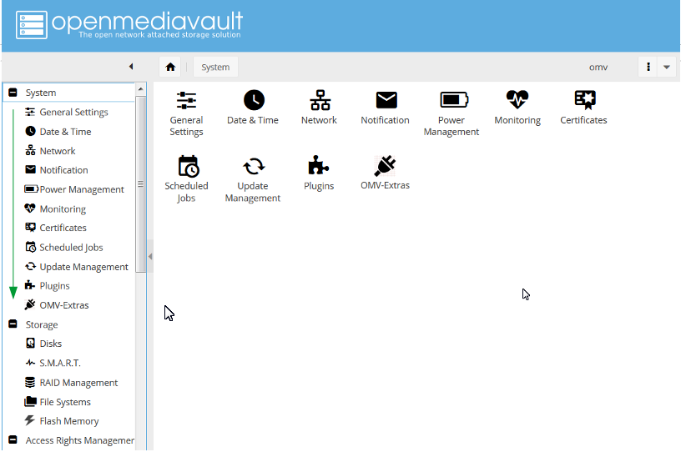

Basic OMV Configuration
This section will guide new users through the initial setup of OMV. It addresses how to add a plugin, enabling OMV-Extras, how to setup a shared folder and make it browseable on the network with an SMB/CIF share.

System Settings
Under System, General Settings, in the Web Administration tab:
To allow a bit more time for configuration in the GUI, beginners should consider lengthening the automatic log out time. When the yellow banner appears, click Apply.
_____________________________________________
In the Web Administrator Password tab, enter a strong password, confirm it and Save.
(This is one of a few instances where the yellow “confirmation” banner does not appear.)
This setting changes the GUI login password. The user “admin” will remain the same.

_____________________________________________

Under System, Date & Time (No Pic)
Select your Time Zone and “toggle ON” Use NTP Server. When OMV toggle switches are ON, they're green. OFF is gray.
_____________________________________________

Under, System, Network, General tab.
Hostname: The hostname is the name that will appear on your network and on the command line. While the default is fine, the hostname can be changed here.
Domain name:
- If needed, the Domain suffix can be changed here. (Very few users will use Fully Qualified Domain Names.)

________________________________________________________

Network Interfaces – SBC Users
Part of the SBC installation process was setting the wired interface to DHCP. SBC users should consider leaving their wired network interface set to DHCP, until Docker and Portainer are installed.
If a static IP address is needed:
Note that your SBC has been assigned an IP address by your LAN's DHCP server. (Typically, a router.) See your routers documentation for information on setting a “Static”, or “Reserved” DHCP lease.

Network Interfaces – i386/amd64 Users
Under, System, Network, Interfaces tab:
Highlight / click on the interface found under the Name column, and click the Edit button.
(**As of the release of Debian 9/OMV4, it's likely that the interface name will no longer be the traditional eth0. A variety of names may be found, such as eno1 or others. Use the first interface line/name found.**)
- It is recommended that users assign a static IP address to the new OMV server that is outside the range of the network's DHCP server.
- It is also recommended that users set a public DNS address.
A list of public DNS servers is available  here. Use a server that supports DNSSEC, for better security, and Anycast, for low latency end point servers that are closer to user locations.
- The Netmask will be as shown, in most cases, and the Gateway address will be the address of the user's router.
**Note** When saving a new static IP address, the user will be “going out on a limb and cutting it off”. Since the address provided by the network DHCP server is different from the static IP address chosen by the user, when the new address is changed, saved and applied, the GUI web page will stop responding. This is normal and expected. Type the new address, entered in the dialog box, into the URL line of your Web browser to reconnect.

Server Notifications
Under System, Notification, Settings:
If enabled, E-mail entries in the Settings Tab are required if users want to take advantage of automated server notifications and reports. Other actions and scripts, in Scheduled Jobs for example, can use this information to E-mail a report of task execution or status, as users may deem necessary.
To gather the required information for entry in the Settings Tab, users should refer to the settings for their E-mail clients. Note that most ISP's are using SSL/TLS secured E-mail connections.

Fill in * fields with user E-mail requirements and settings.

The Notifications tab allows the selection of various functions for monitoring and error reporting.
If using a minimalist platform, such as older hardware or SBC's, E-mail's regarding system resources, memory, etc., may become bothersome. Unchecking Enabled boxes under System would eliminate excess E-mails, while maintaining Storage reports on hard drive health and file system errors.

** Beginners Note**
Using Storage Notifications is highly recommended. If SMART is enabled, under Storage, SMART and short drive self-tests are enabled on spinning drives in the Scheduled tests tab, the system may notify the user of hard drive errors before a hard drive fails completely.
For an explanation of drive self-tests and an example of how to set up a drive self-test, see the section;
Drive Self-Tests

(Optional)
Under System, Power Management
- In the Settings Tab, toggle monitoring on (recommended)
In the Power button drop down, amd64 and i386 users should select the action preferred.
Since power buttons are not available on some SBC installations, SBB users may chose to select “Nothing”.
- The Scheduled Jobs tab allows for the automation of a various power related tasks, such as an scheduled reboot.

(Optional)
Under System, Monitoring:
The initial recommended setting is Enabled.
(Information gathered may be of use in diagnosing potential problems.)

Under System, Update Management:
First, click on the Check button, to refresh available updates for your platform.
(This may take a few minutes)
Checking the box by Package information will update all packages at once. (Recommended for beginners.) Otherwise, individual packages may be selected as desired or needed.
**amd64 and i386 users may be offered a list of “firmware updates”. Select firmware updates that apply to your specific hardware. However, there's no “penalty” for selecting firmware updates that do not apply.**
Beginners should leave the 2nd Tab, Settings, with default settings.

__________________________________________________________

OMV-Extras
((The following does not apply to SBC or i386 users. When using the scripted install, OMV-Extras is installed with OMV by default.))
amd64 users will have a basic set of plugin's appropriate for a basic NAS / File Server. To enable the full range of plugin's available on OMV, the installation of OMV-Extras is required. For a preview of what is available visit http://omv-extras.org and select the version of OMV that's being installed.
** For amd64 users who installed OMV on SD-cards or USB thumb-drives; installing OMV-Extras is a prerequisite for installing the flash-memory plugin. This flash-memory plugin is required for flash media boot drives.**

(Continued)

Installing OMV-Extras
To enable OMV-Extras, a file is downloaded that will be used in the server console.
Select the following link and download the associated file for OMV5.
omv-extras.org/openmediavault-omvextrasorg_latest_all5.deb

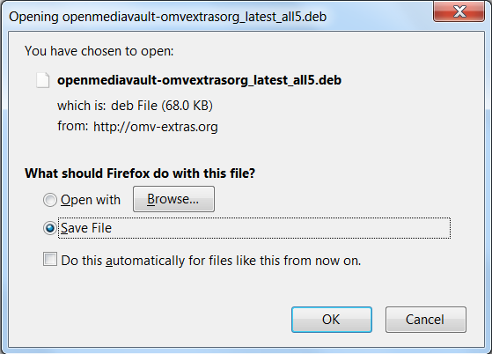
Save the file.
________________________________________________

Under System, Plugins:
Click on the Upload button. Browse to the file downloaded, above. Select it and click OK.

A dialog window will popup that says, “Checking for Plugins”. (OMV-Extras is being added to the default plugin list.)
In the same window (System, Plugins) scroll to the bottom.
Select openmediavualt-omvextrasorg and click the Install box.

(Optional, but recommended)
Under System, OMV-Extras:
In the Repo's Tab, highlight OMV-Extras.org Testing and click Edit. Enable and Save.

To insure that all plugins are available, go back to System, Plugins, and click the Check button. This will refresh the page and fully populate it with plugins that may be missing.

A Basic Data Drive

General
OMV is capable of setting up basic Linux file systems in the GUI, up to, and including, modern “Copy on Write” file systems such as ZFS which combine check summed files, RAID functions, and Logical Volume Management into a single package. However, advanced file systems add complexity which can make administration of a NAS server more challenging for a beginner.
Until some experience is gained, it is recommended that Linux/NAS beginners use single disks with a native Linux file system. In the processes described in the following, EXT4 will be used with a single data drive.
Some Windows users will want to use USB attached hard drives that are formatted NTFS. While this is possible, the drive would need to remain attached or, at a minimum, be connected to the server when OMV boots. It would be better to use a Linux formatted drive and create a Samba share (SMB/CIF) for Windows clients, as described in Setting up a Shared Folder and Creating a SMB/CIF “Samba” share.
A Samba (SMB/CIF) network share understands the Windows file format and can be configured to accommodate DOS and extended file attributes. Samba serves as a transparent “translator” for Windows data storage.

RAID+USB= Potential Problems
Setting up RAID of any type using “USB to drive” connections is discouraged. RAID over USB has known problems. The USB interface (there are several flavors) may filter some the characteristics of hard drives, fail to pass SMART stat's and ATA drive commands, delay the assembly of a RAID array, etc. While USB may work in some RAID cases, it's not as reliable as using a standard hard drive interface. If RAID of any type is considered to be a requirement, drives should be connected with SATA or SAS ports.
If users choose to use RAID over USB connections, it is done at their own risk with the potential for the total loss of stored data. RAID issues involving SBC's, USB connected hard drives, or USB RAID enclosures are not supported on the forum.
RAID is often confused with backup which is far more important. For more information, see the explanation of backup, in Backups and Backup-strategy.

Data Storage - Size matters
In general terms, beginners should do a rough calculation of their storage requirement. When selecting a data drive, the initial fill rate should be between 25 and 50%. As an example, if the calculated data to be stored on the NAS is 1TB, the selected drive should be between 2 and 4TB. With 50%+ drive free space (2 to 3TB) additional data can be accommodated, without the need to expand in the immediate future. When the fill percentage reaches 75%, it's time to plan for more storage.

Data Drive Set Up
**Note for Beginners and SBC users**
OMV is designed to segregate the Operating System (the boot drive) from data storage. This is “best practice” when setting up a server. Accordingly, OMV reserves the drive it is installed on exclusively for the OS. By default, the GUI will not allow the boot drive to be selected when creating a data share. A second hard drive or SSD is required for data storage.
_______________________________________________________

With a data drive installed or connected.
Under Storage, Disks:
Highlight the data disk and click on Wipe. When prompted, click Quick and Yes.
(**Reformatting a disk with GPT formatting present may result in an error. Simply re-run the wipe operation a 2nd time.**)

((The first device in the above list /dev/sda , is the boot drive.))

Under Storage, File Systems:
Click on Create. In the Popup Window use the drop down to select the drive previously wiped. Provide a Label of your choice, accept the default File System EXT4 and click on OK. Confirm the “format device” warning.
Allow a few minutes for the format to complete. When the message “File system creation has completed successfully” is displayed, click on Close.

In the same Window:
Click on the newly created file system line, and click on the Mount button.
When the yellow confirmation banner appears, click on Apply.
The Data Drive is now prepared for a Shared Folder.
___________________________________________

Creating A Network Share
Network shares are the primary reason for setting up and running a NAS. While easy access to data provides convenience to users, storing and backing up data in a centralized location makes it much more manageable.

Setting up a Shared Folder
The majority of the files and folders in a new OMV installation are controlled by the root user. One of the purposes of a Shared Folder is to set permissions that will allow regular users access to folders and files used for data storage. A shared folder could also be called a “base share”. The shared folder created in the following will be the foundation for creating a “Network Share”, covered later.
_______________________________
Under Access Rights Management, click on Shared Folders, then click on the Add button.
In the following example, next to;
Name: Add your new shared folder's name.
Device: Click on the drop down and select the drive that was previously added and formatted.
Path: Accept the default
Permissions: Click on the drop down and select Everyone: read/write

Click the Save button.

The End Result:

__________________________________________________

Creating a SMB/CIF “Samba” Network Share
In order to make your shared folder viewable in Windows Explorer, under Network, it's necessary to make it a Samba share using the SMB (Server Messaging Block) protocol. OMV makes setting up a Samba network share an easy task.
__________________________________
Under Services, click on SMB/CIF. In the Settings tab toggle Enable to On (green) and set your workgroup name. (In Windows, the default workgroup name is, WORKGROUP.) Leave the remainder of settings in this tab at their defaults, and click on Save. (Confirm with “Apply” when the yellow banner pops up.)

Click on the Shares Tab and the +Add button.
In the popup dialog box, set the following:
Shared folder: Click on the drop down and select Music (or the name for the shared folder previously created.)
Public: Click on the drop down and select the Guests Allowed
Scroll down with the right scroll bar and toggle ON (green), Extended attributes and Store DOS attributes. (Leave the remaining settings at defaults.)
Click Save and confirm with “Apply” when the yellow banner appears. The final result should appear as follows.

Explore the New Network Share
You should now have a browseable Server with a Network share named Music, so let's take a look.
Open Windows explorer, scroll down to Network and click on it. There's the new server OPENMEDIAVAULT.

**A few minutes may be required for the Windows Network to “Discover” the new server. If users are using Windows 10 PC's, and the server and share do not appear, see this networking How To.**
Now let's look at the servers new Samba share. It's there and browseable.

This share is “writable” with a standard “Copy and Paste”, from a client PC.

Congratulations! You now have a functional NAS that can be expanded to accommodate additional network shares. Simply repeat the processes in Creating A Network Share to create and make additional shares visible on your network.

The Flash Memory Plugin - amd64 users only
amd64 users who installed OMV on flash media will need to install the flash memory plugin.

Flash Media and Wear Leveling
While modern flash media drive is solid state, it's life is limited by the number of write cycles it can withstand before it goes “read only”. When a specified number of flash memory blocks refuse to erase, the device's controller will set it “read only”. At that point, the device's useful life is over.
To extend the life of flash media, most modern flash devices have wear leveling built into their controllers. If blocks are written, but not erased, they experience no wear. If blocks are erased, the next new write is set on adjacent blocks that have never been written before. As data is erased and written, blocks are used starting at the beginning of the device's addressable storage range and proceeding in sequence, working toward the end. When the end is reached, the process starts at the beginning and cycles through again. This wear leveling process avoids writing a single location to failure, and spreads wear evenly throughout.
With wear leveling and two drives of the same type, a drive that is twice the size will last roughly two times longer than the smaller drive. While this is a strong vote for using a larger flash drive, when backups are considered, drives of twice the size also take twice as long to image and their image files are twice as large. (When using flash media as a boot drive, a practical trade-off should be considered in the suggested 16 to 32GB range.)

The Purpose of the Plugin
The primary purpose of the Flash Memory Plugin is to reduce the number of blocks written and the frequency of writes, to the Flash Device being used as the boot drive. The plugin can reduce the data written to Flash drive by an order of magnitude or, potentially, 1/10th the amount that would otherwise written. By extension, a drive of a given size might last up to 10 times longer than it would without the Flash Media plugin.

Installing the Plugin
The prerequisite for installing this plugin is the installation of OMVExtras. If OMVExtras is not installed, it is required to proceed.

Under System, Plugins, scroll down to Section: Filesystems.
Select openmediavualt-flashmemory and click the Install button.

Under Storage, Flash Memory, the following screen is now available.

The plugin will work as is, but it will be more effective if the guidance under Notes (optional) is followed.
While this guidance shows steps for nano, a Linux command line text editor (option 1);
WinSCP and Windows Notepad can be used if WinSCP is installed (option 2).

Option 1: Editing /etc/fstab with nano
The first example will use nano. This option requires the installation of PuTTY which is detailed here.
_______________________________________________
Using PuTTY, SSH into the server. Log in as root and enter the root password.
On the command line, type the following and hit enter.
nano /etc/fstab
**In nano, the mouse does not move the cursor. The cursor is moved with the keyboard's arrow keys to the insertion point. Type to insert text and use the backspace key to erase text if need. If a mistake is made, exit without saving and go back in again.**
_____________________________________________________________________________
From the plugin's Notes, Step 3:
First: We're going to add two statements ,noatime,nodiratime to the / partition (the root partition) exactly as shown. The text addition is highlighted in green.
Second: Note the partition with swap in it. Per Step 4, we're going to comment this line out, using a # at the beginning of the line. The # is an addition, and is highlighted in green.

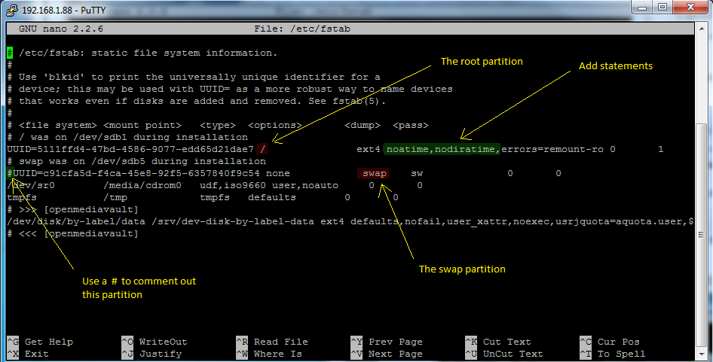
Use Ctrl+o to save, then Ctrl+x to exit
Reboot the server.
On the command line, the following command can be used: reboot
Done.

Option 2: Editing /etc/fstab with WinSCP and Notepad
This option requires the installation of WinSCP which is detailed here
_______________________________________________
Users who are not comfortable with editing fstab using nano can use WinSCP and Windows Notepad to make the needed changes. If WinSCP is not installed, this doc-link to (WinSCP) will describe the process for installing WinSCP and logging into the OMV server for the first time.

When logged in, click on /etc in the left pane. In the right pane, “right” mouse click on fstab, select Edit and Notepad.
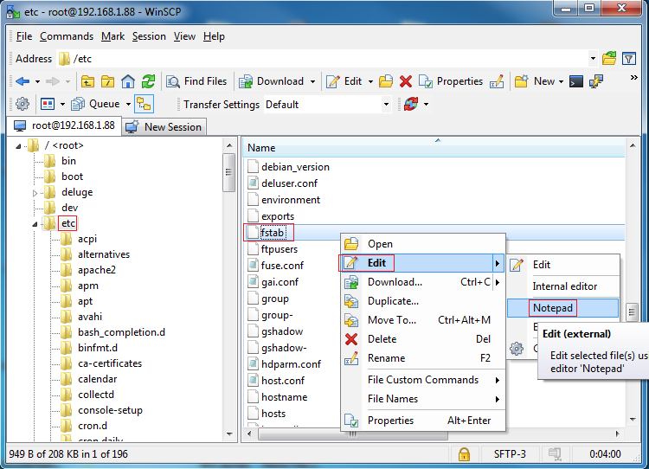

Notepad will open the fstab file.
First: Find the root partition - it's the line with / and insert noatime,nodiratime, after ext4 and one space as shown.
Second: Find the swap partition – it's the line with swap and insert a # at the beginning of the line as shown.
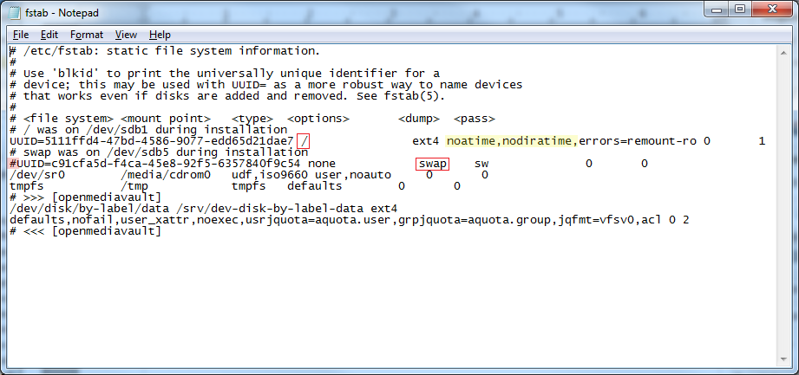
Do File, Save. Close Notepad.
Exit WinSCP.
Reboot the server, from the GUI.
Done

Final Installation Notes:

- Permissions to the shared folder created in this guide, and the SMB network share layered on top of it, are completely open. While these permission settings are OK for home environments, the server should not be exposed to the Internet by forwarding port 80 or 443.
As users gain knowledge and experience, they should consider tightening up permissions on the underlying Shared Folders and SMB/CIFS network shares.
- *Important* Put your new server on a good surge suppression power strip, at the absolute minimum. An UPS system is preferred and is best practice. In consumer electronics, the majority of failures are related to power supplies and adverse conditions created by line power. The prime causes of power issues and failures are short duration surges, high voltage spikes, brown-outs, and sustained over-volt or under-volt conditions. A good UPS system is designed to counteract these problems. Further, the file system on the boot drive is at risk of corruption from sudden (dirty) shutdowns due to power loss. An UPS minimizes these risks.

Utilities to Help With OMV Management
Being able to work from the command line would be very useful to users, who may need to gather detailed information on the OS and platform hardware, for troubleshooting and for an occasional edit to a configuration file. Much can be learned with the following utilities that allow users to look at OMV “under the hood”.
___________________________________

WinSCP
WinSCP allows users, beginners and experienced alike, to visualize the Linux file structure in a manner similar to Windows Explorer. WinSCP installs on a Window Client and connects to Linux servers, allowing users to work with their server remotely.
One of the more useful features of WinSCP is that it gives users the ability to edit Linux configuration files with a familiar editor like Notepad. For experienced Linux Desktop users who would like to use WinSCP, it will run from WINE (in Linux Mint, Ubuntu and others).
WinSCP can be downloaded here. -> WinSCP
_____________________________________________

Installing WinSCP
During the installation process, if prompted, select the Explorer Interface. This display shows the remote file system only. If the Explorer Interface is not offered it can be selected, after the installation, under View, Preferences, Environment, Interface.
_______________________________________
On the first run, the login screen is presented. Click on New Site and type in the IP address of the new server. Click on Save.

In Site name: The server's IP address is displayed. Optionally, the site name can be changed. If using WinSCP for a single server, a desktop short cut may be useful. Click on OK.
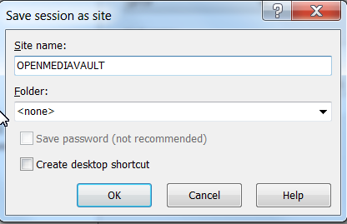
The login screen will come back. Double click on the new site name. The following is normal for the first SSH connection to any client or server. Click Yes.
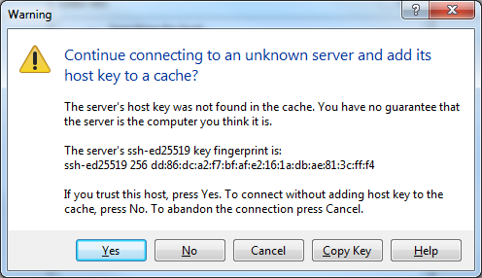
The first prompt is for the username. Enter root
The second prompt is for the root password. Enter the root password.
** R-PI users would enter the user pi and the pi password or a previously added user with admin privileges. Due to the restrictions of a non-root “sudo” environment, WinSCP will be restricted from root functions. This restriction can be mitigated, but it's beyond the scope of this guide. The following link may of assistance: Connect as root (sudo) using WINSCP **

(Continued)
WinSCP opens with a two pane window. Selections are made in the left pane; operations are done on the right. The folder srv was selected on the left. dev-disk-by-label-DATA was highlighted on the right. A right click of the mouse brings up an operations menu. Properties was selected. In this particular popup, permissions could be changed. (This is NOT a recommended action for beginners, without backup. Backup is covered later.)
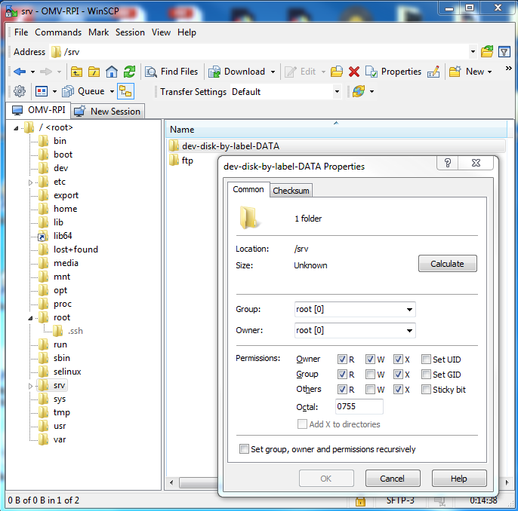
In a similar manner, a configuration file can be highlighted in the right pane. A right click of the mouse brings up the menu, select EDIT and Windows notepad, or the internal editor can be used for editing configuration files. Either choice is much easier than using nano or vi on the Linux command line.
While they can be done in WinSCP, very large file copies, moves, or deletes are best done using Midnight Commander.

(Continued)

PuTTY
PuTTY is similar to a Window's command prompt, but it allows users to work on OMV's command line from a remote PC. If PuTTY was not installed as part of your installation process, install it on a Windows PC. It's available here.  PuTTY
Using PuTTY is as simple as typing in the server's IP address in the Host Name field and clicking on open. There will be a warning for a first time connection – click OK. Then, login on the command line.
_________________________________________

MC (Midnight Commander)
Midnight Commander is a command line file utility that utilizes a very cleverly created graphical environment. It's very useful for navigating through OMV's directory structure. It excels in efficient copying, moving, and deleting folders and files.
The installation process:
- Use PuTTY to get to OMV's command line.
- Log in as root.
- On the command line type the following; apt-get install mc
- When prompted continue with “Y”
When the installation finishes, on the command line, type mc

Midnight Command is a two pane window where the source is the left pane and the destination is the right pane. Copies and moves are done, left to right. Since it's possible to navigate to any location on the OMV host, in either pane, the source and destination can be set for any location.
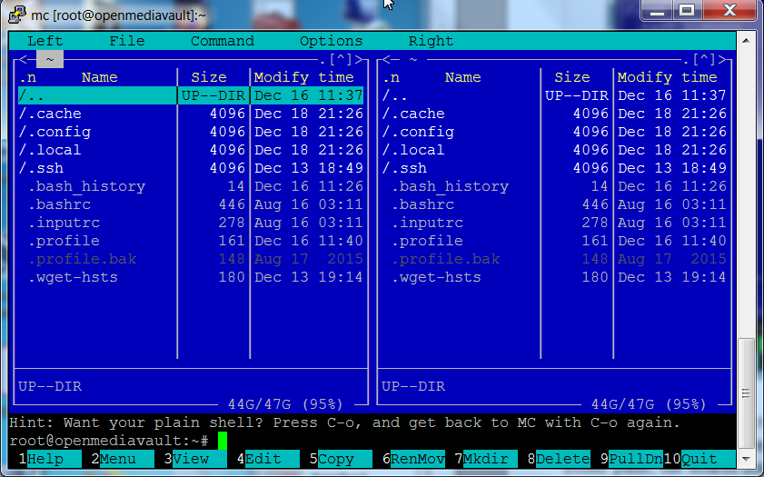
A mouse works in MC. Click on the various menu items at the top and bottom, to select them. Similarly, files or folders can be selected by clicking on them. To level up, click on the /.. at the top left of either window.

**Beginners Note:** Midnight Commander is powerful and potentially dangerous. MC does not have “Undo”. A careless operation on the boot drive, such as accidental file “Move” or “Delete”, can ruin your installation. Work with MC carefully and before doing anything extensive with it, the appropriate backups are recommended. Operating System Backup – Data Backup.

(Continued)

Win32DiskImager
Win32DiskImager is a utility that's designed to write raw image files to SD-cards and USB drives. What makes it stand out from similar utilities is that it can “read” a flash drive and create an image file from the contents of the device. If users decide to use an SD-card or a USB thumb-drive as a boot drive; the ability to read flash media devices makes Win32DiskImager useful for cloning boot drives.
**There is a known bug in Win32DiskImager V1.0.0**
While the exact cause of the bug has yet to be determined, the scope of affected users is very small. However, this bug requires the use of the Verify Only button after every operation. If the Verification hash is successful, the operation is good. If Verification fails, the read or write has failed and the image file or flashed drive cannot be used.**

_________________________________________

Virtual Box
Virtual Box is a cross platform virtualization platform that will work with both servers and clients. For learning about OMV, there simply is no better tool than working with an OMV Virtual Machine (VM). An OMV VM can be built, configured, and put on the local network complete with shares, in the same manner as real hardware. VM's can be created, cloned, used for test beds, and destroyed without consequence. Many advanced OMV users fully test upgrades, Docker's, plugin's, server add-ons and changes in configuration, in OMV VM's before upgrading or reconfiguring their real-world servers.
If users have a Windows client with at least 6GB RAM and plenty of hard disk space, installing Virtual Box is highly recommended. → Virtual Box

Backups and Backup-strategy
It's important to understand the concept of backup and why backup is important. In understanding the concept of backup, an automotive analogy may be helpful.
If one has a car and that car has a spare tire, is the “car” backed up? The answer is “No”. There are a great number of things that can happen to a car that can disable it, until parts are replaced or the car is otherwise repaired. These items would include the battery, alternator, any component of the ignition system, the transmission, the cooling system, etc., etc. To backup the car, a second car is needed. This is why using RAID of any type is not backup. At best RAID could be thought of as a “spare tire” for a PC.
Where the automotive analogy fails, generally speaking, is that when a car fails it can be repaired. In computing, if a user's personal data is lost without backup, it's permanently lost. There are many possible events where data may be corrupted beyond recovery (viruses, ransomware) or is completely lost due to drive failures, a failing drive controller, or other hardware failures. This is why real data back up is far more important than the computing equivalent of a spare tire (RAID).

Backing Up Data
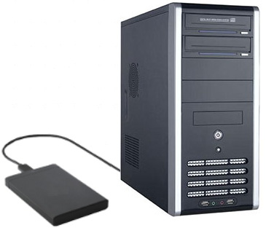
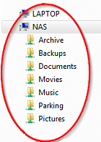
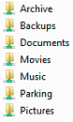
First Level Backup:
Replication To an External Drive
Rsync:
NAS

The scenario depicted in this graphic represents true backup. There are two full copies of data. With two separate copies, this backup strategy is superior to traditional RAID1 for home or small business use cases for a couple reasons.
- Rsync can be used with most USB connected hard drives where RAID1, when used with USB connected drives, is notably unreliable.
- If there's a drive error, an accidental deletion, a virus, or other data related issue; in RAID1 the effects are instantly replicated to the second drive. With Rsync, both drives are independent and, in most cases, the second disk will be available after the source disk fails. In any case, the Rsync replication interval allows time for admin intervention before the second disk is affected.

Full Disk Mirroring / Backup with Rsync
While individual shared folders can be replicated using Services, Rsync, a more efficient approach is using an Rsync Command line, in a scheduled job, under System, Scheduled Jobs to mirror a drive. This method allows for replicating the file and folder contents of an entire data drive, to an external drive or a second internal drive of adequate size.
● To implement something similar to the following example; it's necessary to add and mount a destination drive, in accordance with the section labeled A Basic Data Drive.
● When formatted, the hard drives used in this example were labeled to indicate their function.
**This is a good practice that will help new users to easily identify drives and avoid admin mistakes.**
● Dissimilar sized drives can be used, provide that the destination drive is large enough to hold the source drive's data.

The following Rsync command line is an example of how a data drive can be mirrored onto a second drive.
rsync -av --delete /srv/dev-disk-by-label-DATA/ /srv/dev-disk-by-label-RSYNC/

The source drive is on the left (green) and the destination is on the right (blue). In this example, the entire contents of dev-disk-by-label-DATA would be copied to dev-disk-by-label-RSYNC
The switches are:
-a Archive Mode. Archive mode adds an array of options to an Rsync command. It's the equivalent of switches -r -l -p -t -g -o and -D which copies files and folders recursively, copies links and devices, preserves permissions, groups, owners and file time stamps.
-v Increase Verbosity. This can be useful when examining Rsync command output or log files.
--delete Deletes files in the destination drive that are not in the source. If accidental deletion protection is desired, this switch could be left out of the command line. However, from time to time, it would necessary to be temporarily re-added the --delete switch to purge previously deleted and unwanted files from the destination drive.)
__________________________________________________________________________________

To find the appropriate Rsync command line entries for the user's server, under Storage, File Systems click on down arrow at the top right edge of a column. On the pop down menu, select Columns and check the Mount Point box.
Under the Mount Point column (red boxes) are the full paths needed for the source drive (in this example /srv/dev-disk-by-label-DATA) and the destination drive (in this example /srv/dev-disk-by-label-RSYNC).
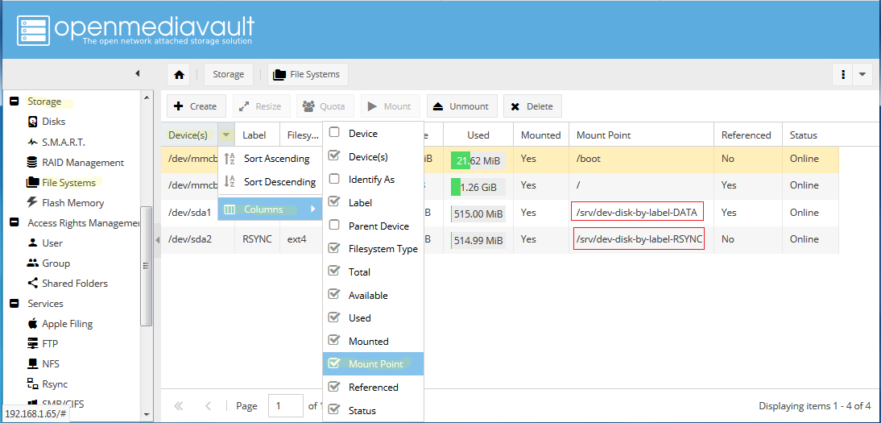
To construct the appropriate command line, add a slash “/” after each drive path, in the full command line as follows:
rsync -av --delete /srv/dev-disk-by-label-DATA/ /srv/dev-disk-by-label-RSYNC/

**Beginners Note, Warning, and Sanity Check**
● Getting the source (left) and destination (right) in the correct order, in the command line, is crucial. If they're accidentally reversed, the empty destination drive will delete all data on the source drive.
● The safest option would be to leave the switch --delete out of the command line until it confirmed that two full copies exist.

As previously mentioned, this Rsync operation can be manually run or automated under:
System, Scheduled Jobs, as shown in the illustration. Copy and paste the Rsync command line into the command box and select scheduling parameters as desired.
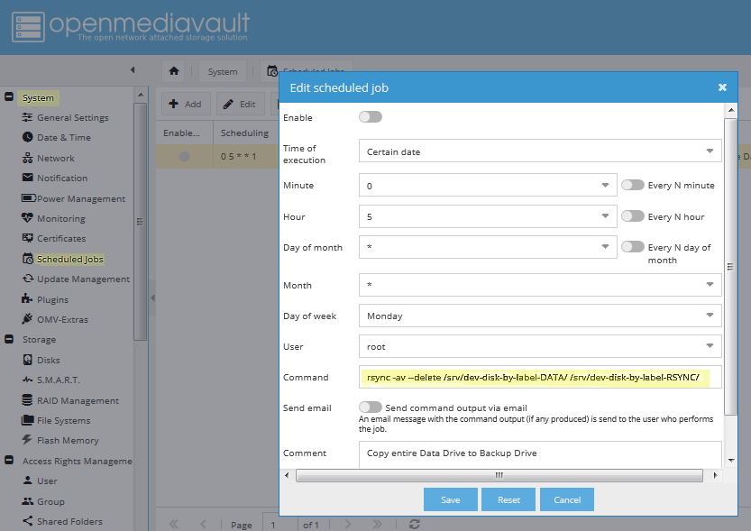
User Options for Backup:
- Automated:
As configured above, and ENABLED (green), this Scheduled Job will run the Rsync command line once a week, on Monday, at 05:00AM. After the first run of the command, which may take an extended period to complete, a week or more would be a good backup interval. Generally speaking, the backup interval should be long enough to allow for the discovery of a data disaster (drive failure, a virus, accidentally deleted files, etc.), with some time to intervene before the next automated backup replicates the problem to the 2nd drive. This is also a drawback of using automation; if data loss or corruption is not noticed by the user, those problems will be replicated to the back up drive during the next Rsync event. Longer automated backup intervals, such as two weeks or even a month, allow more time to discover issues and disable replication.
- Manual Run:
If the job is disabled (the ENABLED toggle switch is gray), the job won't run automatically. However, the job can be run manually, at any time, by clicking on the job and the Run button. This may be the best option for users who do not check their server regularly.

- Delete Protection:
Removing the --delete switch from the command adds delete protection, and may allow the retrieval of files accidentally deleted from the source drive. As previously noted, to clean up the destination drive of intentionally deleted and unwanted files, the --delete switch could be manually entered into the command line, from time to time, as may be deemed necessary.
**Keep in mind: In the event of a failing or failed data drive it is crucial that the drive-to-drive Rsync job – if automated – is turned OFF. Similarly, after noting a problem, do not run the job manually.**
The Bottom Line:
The additional cost for full data backup using Rsync is the cost of an external drive, or an additional internal drive, of adequate size. For the insurance provided, the additional cost is very reasonable.

Recovery from a Data Drive failure - Using an Rsync'ed backup

General:
**Again, as a reminder, when the NAS primary drive is failing or has failed, it's crucial to turn OFF an automated drive-to-drive Rsync command line.**
There are two basic options for restoring data with an Rsycn'ed backup drive - they are “with” or “without” a replacement for the source data drive.

Restoration Without a Replacement Drive:
Without a replacement drive on site, which would be the most likely case for most home users and small businesses, the backup Rsync'ed “destination” disk can become the data source for network shares. This involves repointing existing shared folders, from the old drive location, to the backup drive. All simple services layered on top of the shared folder, to include SMB/CIF shares and other shared folder services, will follow the shared folder to the new location on the back up drive.

Repointing a Shared Folder:
In the following example, the data drive has failed and it's been determined that it's not repairable. Under Storage, File Systems we have a missing source drive (labeled DATA) that's referenced.
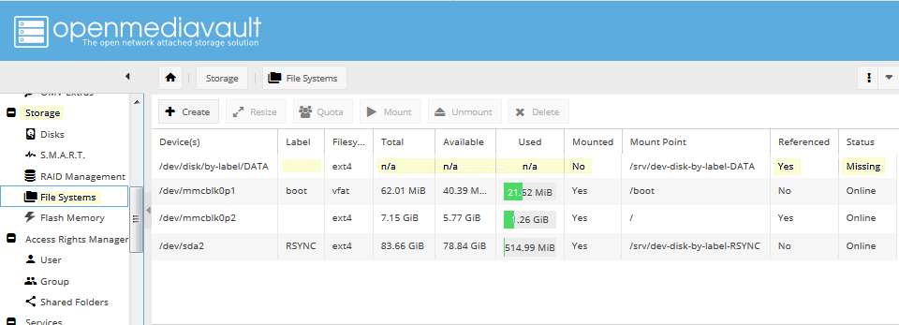
**Note that there may be Error dialog boxes regarding the failed mount of existing shared folders. With a missing and referenced drive, this is to be expected.**
The actual references to the failed DATA drive are the Shared Folders assigned to the drive, named Documents and Music as follows:
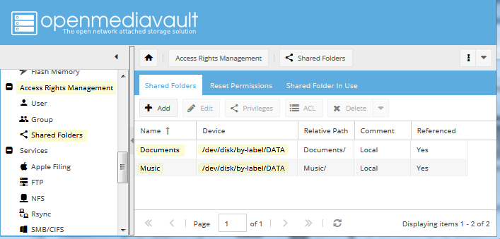
Since the DATA drive no longer exists and there's an exact duplicate of all folders and files on the backup drive, we'll repoint the shared folder named Documents to the RSYNC backup. Click on the Documents Shared Folder, above, and the Edit button.

In the Edit Shared Folder Dialog Box, click the drop down button on the Device Line and select the destination / backup drive. (In this example the drive labeled RSYNC is the backup.) A confirmation dialog box will prompt “Do you really want to relocate the shared folder?” Click “Yes” and “Save”.
(Remember that all contents of the now missing source drive and the destination drive were identical as of the last backup, to include the path statement. Changes are not necessary – repointing the share is just a matter of selecting the backup drive.)
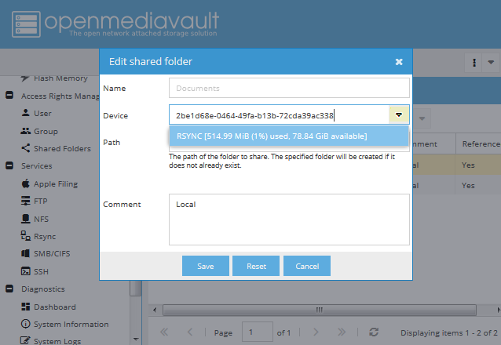
Click on Save, confirm the change, and it's done.

Do the process for for all remaining Shared Folders. (In this example, Music was repointed as well, but not shown.) Again, error dialog boxes may appear during the process. Acknowledge them (with OK) but do not revert, or back out of change confirmations. When all Shared Folders are redirected to the backup drive and saved, the error dialog boxes will end.

In the final result:
With one operation per shared folder, all shared folders have been redirected to the backup drive labeled RSYNC.
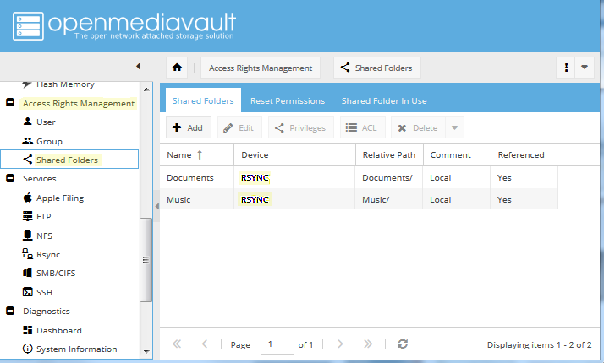
In this case there were SMB network shares layered on top of the Shared Folders above. The SMB network shares followed their associated Shared Folders, without additional configuration, so SMB shares are up and running on the Network.

In addition, most simple services that are applied to these shared folders, would follow the shared folder when it is repointed to the backup drive.

One last operation is needed to completely remove the failed DATA drive. Go to Storage, File Systems and note that missing drive DATA is no longer referenced. When clicking on the failed drive, the Delete button is now active. Delete the drive.
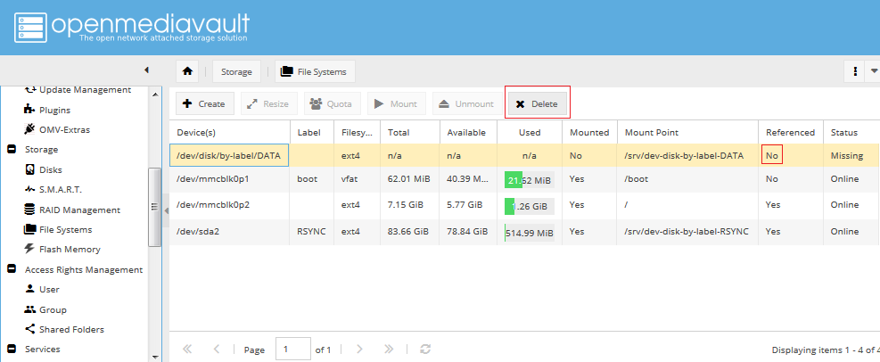
At this point, all shares in this example have been successfully redirected to the backup drive and the server is fully functional again.

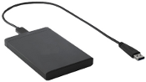
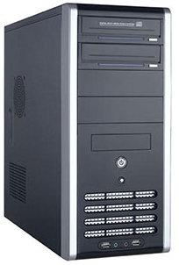
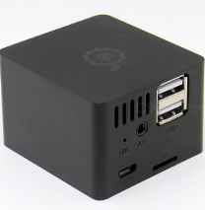
Rsync:
Local Job
(with Remote Mount)
Second Level Backup:
Replication To a Second Host
OMV SBC
OMV-PC

The first item to note, is that this scenario can be accomplished using a LAN client, as the second host, and it could be a Windows client. The additional cost would be the price of a second drive of sufficient size (internal or external) to house the second copy of data, attached to a remote host. The Remote Mount Plugin can mount a Windows network share (a user name and password with write access is required) and Rsync can be configured to replicate NAS data to the Windows share.
As illustrated above, the second host could be a low cost SBC. This scenario can be designed with a number of desirable features.
- First, if backing-up to a second server platform, two fully independent copies of data are possible.
- When using an SBC with OMV installed:
If the primary server failed completely, the second platform can be configured to take over as a backup file server. With all data backed up and resident on the SBC, this data can be made available to the network with SMB shares.
- Other than re-homing clients to the shares on the backup device, there's no recovery time and no “crisis” involved in getting data back on-line. It's already there.
The costs for this level of backup are very reasonable, with the cost of a hard drive of adequate size and an SBC. Good performing SBC's are available for $50 USD or less. Older PC platforms or laptops could be configured as a backup server as well.

As an illustration of the backup server concept, the following is a File explorer example of an OMV NAS server and an SBC used for backing-up the main server's files.

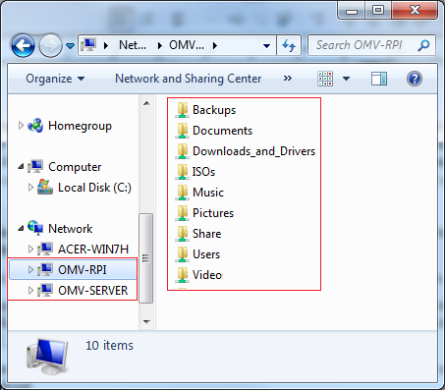
While a Raspberry PI is among the lowest performing of the SBC's available, it will run OMV and is capable of replicating data shares in the background, albeit very s-l-o-w-l-y. This particular R-PI (OMV-RPI) is replicating all of the data shares of the OMV-SERVER and is re-sharing the same data to the network. Again, Rsync replication jobs of individual shares can be scheduled as desired, or triggered manually.
** The Practical details for setting up Primary Server to Backup Server share replication, using Remote Mount and Local Rsync Jobs will be covered in a future version of this guide.**

While replication to an independent host is an excellent method of avoiding data loss catastrophes, there are other potential events which can threaten irreplaceable data. Fires, roof or plumbing leaks and other unforeseen events can result in the loss of data, even on two independent hosts. For these reasons, backup professionals and experienced server administrators recommend an off-site copy. While this may seem extreme, it's actually fairly easy to accomplish. It can be done with an SBC or an old laptop, connected wirelessly, and housed in a utility shed with AC power. Some users set up a backup host in a family members' house, and replicate changed data over the internet.
In the bottom line, if users want to keep their irreplaceable data, an absolute minimum of two full copies is recommended, with a 3rd off-site copy preferred. As previously noted, effective backup strategies do not have to be expensive and are relatively easy to set up.
For further information on Backup concepts and best practices, an excellent explanation of Backup is provided by Backblaze.com .

Operating System Backup:
By design, the OMV/Debian operating system installs on its own partition, segregated from data. This makes copying or cloning the OMV boot/OS drive an easy process. So, one might ask, why is a clone or a copy of the operating system important?
Building OMV, from scratch, using the installer ISO is a 15-minute proposition, give or take. While it takes longer, roughly 45 minutes to an hour, the actual hands-on portion of an SBC build is even less.
As users configure their servers, add services, reconfigure shares, move their data around, tweak access controls, etc., servers tend to become “works in progress”. Configuring a server to the user's preferences can be an evolution that may take weeks or even months. If a complete server rebuild is required, the customization, add-ons, and the collection of various user tweaks may take several hours to recreate. It is this time and effort that Operating System Backup will preserve.
There are several ways to duplicate an operating system boot drive, but many can be technically involved; requiring network access to remote servers, bootable utilities and somewhat complex processes.
Given the low cost of flash media and with sockets mounted on the outside of a PC case, SD-cards and USB thumb-drives lend themselves to cloning and very quick recovery.

The Benefits of Maintaining Operating System Backup
In accordance with “Murphy's Law”, users may encounter issues where things go wrong. As examples, users may test software on their active server or try new settings. On occasion, installing an add-on may have unintended consequences. Trying new settings or working on the command line, may break OMV in a way that might not be recoverable. In other cases, there may be instances where a software update goes south – the source repository may go off-line in the middle of an update resulting in broken packages.
In all of these cases, having a confirmed working clone of the boot drive will allow users to “drop back” to a known good state. The “FIX” would be as simple as shutting down and booting the server on a known working clone.
The advantages of maintaining operating system backup are obvious. Beginners, with very little knowledge of Linux, can work with their servers without fear, which facilitates learning. If a Linux update causes ill effects, it's possible to drop back and selectively install packages to isolate the exact cause of the problem. If an add-on update doesn't work (direct installed software, a plugin, Docker, etc.), the user can gracefully back out of the update and leave the older (but working) software package in place.
It's the easiest, quickest, and most effective fix, for resolving problems with OMV and the underlying Debian Operating System.

The practical issues of maintaining boot drive clones – when to update and rotate?
- It makes sense to apply Linux Operating System updates and wait a week or so, to insure that all is working and that there are no ill effects. If all is well, update the backup and rotate.
- The above would also apply to add-on packages, Docker, or plugin upgrades. (Plex, Urbackup, Pi-Hole, etc.)

- If a network share is added, deleted, or any aspect of the NAS is reconfigured that changes the operation of the NAS; the backup would need to be updated. (Otherwise, the configuration of the previously cloned boot drive would not mesh with the configuration and contents of data storage drives.)
- If a cloning mistake is made (let's respect Murphy's Law), a 3rd clone could become a “fallback of last resort”. Given that Linux package upgrades and OMV sub-version upgrades have little to no effect on network shares or the high level configuration of the NAS, a 3rd clone can be maintained that is updated only when the NAS configuration is changed.

**A Last Important Note About Backing Up your OS**
Just as it is in the commercial world, where support for a product may be discontinued, the open source community is constantly moving forward as well.
Users may believe that an ISO file, or image, contains all the software needed for a build. In some current build cases, that assumption would be incorrect. Linux distro's, during the initial build and to finalize the installation, may depend on on-line software repositories. After the installation is complete, patches and updates may be applied which rely on on-line repositories as well.
Can it be assumed that those same software repositories and resources will be available on some future date, exactly as they were at the time of a current build? The answer is “No”. Distributions of a specific Linux version, complete with specific applications, fully patched and updated, can be built for a limited time.
Therefore, if users have extensively configured builds, are using specialty hardware (such as SBC's) or are using OMV to serve a critical function; it would be wise to backup the boot drive to an image file, or Clone the fully configured working installation to separate media, and save one or more copies for future use.
______________________________________________________________________________

Cloning Flash Media
To avoid issues that can result from dissimilar sizes, it's best to clone images from/to identical SD-cards or USB thumb-drives. Otherwise, it's easier to clone if a new drive is slightly larger than the working drive.
(And while it's an advanced technique, Gparted can be used to slightly shrink flash drive partitions, to fit on the smaller of the two flash drives.)
The Cloning Process for USB thumbdrives and SD-Cards
- Install Win32Diskimager on a Windows PC.
- Format the new SD-Card or USB thumb-drive with SDFormatter
- Test the new card or USB drive with h2testw1.4, One test is enough. (Do not select endless verify.)
If the device registers errors, or if the capacity is significantly different from what is that's marked on the label (a fake), return it for refund or throw it away.
**At this point you should consider marking your working SD-card (with permanent marker?) to make sure you don't mix it up with the blank card. Otherwise, it is possible to read a “blank card” and use the blank image to "overwrite" the working card.**
- Insert the working card and start Win32Diskimager
SANITY Check, make sure you inserted your working SD-card / USB thumb-drive at this point.
**Note: Windows will not be able to read the format of the partitions on the working boot drive and offer to format it for you. DO NOT format the drive. Close the dialog box with the X.
- In most instances, Win32Diskimager will detect USB thumb-drives and SD-cards, and set the Device drive letter. However, it would be prudent to check the letter Windows assigns to the drive with Windows Explorer.
-First click on the folder ICON and navigate to the location where you'll store your image file. Type a name in the file line. (OMV-RPI2.img was used for this example, but users can add a date to the name as well, such as OMV-RPI2-04-30-2018.img)
- Check the box for “Read Only Allocated Partition”. (With larger drives, this option avoids imaging unused space which saves significant time when reading a drive to a new image and, later, when writing the image to another drive.)
- Click Read.
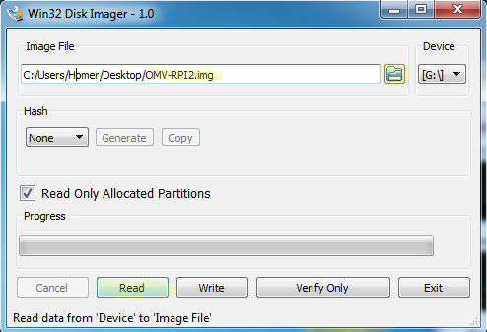
- When the read is done, this is crucial, click the Verify Only button. This will compare the image file just created, to the boot drive. DO NOT SKIP Verification. (Win32Diskimager has a known bug which affects some use cases.)
- If verification passes, pull the working boot drive and store it close by. If verification FAILS, the image file is corrupt and cannot be used.
**If the user/admin is running a business or is in another time sensitive scenario, where the NAS server can not be out of service for an extended period; the server can be booted on the source drive while the clone is being written. Thereafter, the drive swap could be accomplished during a low use period.**
While the resultant image file may be quite large, if the file is retained, it can be written again at a later date. In such a case, the image file itself can be saved as a dated backup and archived.

- Insert the new flash drive and start Etcher. (Etcher typically detects flash drives as well.)
- Select the image file previously created, verify the destination flash media drive, and click the FLASH! button.
One of Etcher's features is that it writes the image and verifies it in a single operation. If the operation is successful, the working boot drive has been cloned. Insert the new clone into the server and boot it up. With a successful boot up on the clone, user/admin's will have two verified copies of their server's boot drive.
**Note – Win32diskimager will write an SD-Card or USB drive, but verification is required and it's a second operation. Etcher combines the write and verification in a single process. If users walk away, during the write operation, which can take a long of time, Etcher is the best choice for writing flash media.

Add-on's – Adding Value to Your OMV server

General
The OMV Forum has an extensive Guides section. Whether a user's preference is videos or printed text, there's something for everyone among the numerous “How-To's”. Beginners and Advanced users alike should take a few minutes to familiarize themselves with the content in the Guides section of the Forum.

OMV's Plugin's
OMV has numerous plugin's. Some are integrated into the base package by OMV's developer Volker Theile. Examples are iSCSItarget, usbbackup, among others.
Still more were created by OMV plugin developers, such as Remote Mount, the flash-memory plug-in, backup plugins, and more.
Many plugins are integrations of third party packages such as SNAPRAID, MergerFS, etc. While questions or issues regarding the integration of plugin's, into OMV, are of interest to OMV's developers, questions on the operation of plugin's are best directed to the application's supporting web site.

Dockers - General
While Dockers are an avenue toward adding extensive functionality to OMV, they are an advanced topic that may prove to be frustrating for beginners. To get started, beginners should consider installing Docker, then Portainer, as found under System, OMV-Extras. While it's command line oriented, this Docker Tutorial is very helpful for understanding basic concepts. User authored Docker - How To's can be found on the OMV forum.

So, What is a “Docker”?
Dockers are a type of Virtual Machine (VM) that share the Linux kernel and memory spaces with the host. A Docker is spawned from a Docker image. The resultant VM equivalent, that's built from a Docker image, is referred to as a “container”. A container is fully self-sufficient, bare-bones, Linux operating system. The idea behind a Docker image is to create a Linux installation, that is as small and as lean as possible, that includes all necessary dependencies required to run the Docker application and nothing more. Since these containers tend to be very small, they can be constructed and destroyed in rapidly. (After downloading, usually, in a matter of seconds.)
Dockers are more resource efficient when compared to running a full VM in a hypervisor, due to direct allocation of hardware resources. Typically, VM hypervisors provision fixed blocks of memory and may require access to dedicated hard disk space or block device partitions. Whether these dedicated resources are used by the VM or not, they're no longer available to the Host operating system or other VM's. A Docker, on the other hand, uses the needed memory space to run its processes and the host's hard drive for storage, without wasted resources. Resource management is lean and tight, allowing more Docker containers to run concurrently with much greater efficiency.

(Continued)

Installing Docker
Installing OMV-Extras is a prerequisite to installing Docker.
Under System, OMV-Extras, in the Setting tab, scroll down to the Docker section.
Before installing Docker, take note of the Docker Storage location. /var/lib/docker is on the boot drive. This location is not an issue for hard drives and SSD's of medium capacity (notionally, 128GB or larger.) However, when using flash media to boot (8 to 32GB), the boot drive is not a good location for media servers or downloader type Dockers. There are two possible solutions:
- The easiest solution is to change the Docker Storage path to a data drive. If the default path is changed, downloader output and metadata created by media servers (Plex and others) will be stored on a data drive by default.
- A more advanced solution would be to leave the default storage location in place (var/lib/docker) and configure the Downloaders and media servers to store their output and metadata on a data drive, but this requires individual configuration of each Docker.

To install Docker, click the Docker Button and select Install.
An install dialog box will popup and scroll as files are downloaded and installed. At the end, Done will be displayed. Click the Close button.
The Status line will report: Installed and running.

(Continued)

Installing Portainer
Under System, OMV-Extras, in the Setting tab, scroll down to the Portainer section.

General:
While Portainer is a Docker itself, it is the control interface through which Dockers are downloaded and configured in OMV.

Click the Install Portainer button.

An install dialog box will popup and scroll as files are downloaded and installed. At the end, Done will be displayed. Click the Close button.
With a successful install, the Status line will change to reflect “up” time:
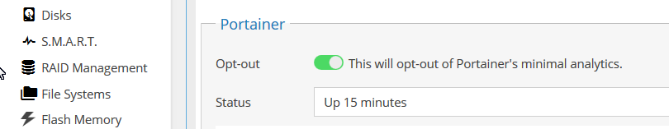

Finally, click on the Open Web button.
At this point, Portainer is completely unconfigured. The first configuration requirement is setting a password for the Admin user. Take note of this password. It will be needed to log into Portainer again.
Then click on Create User
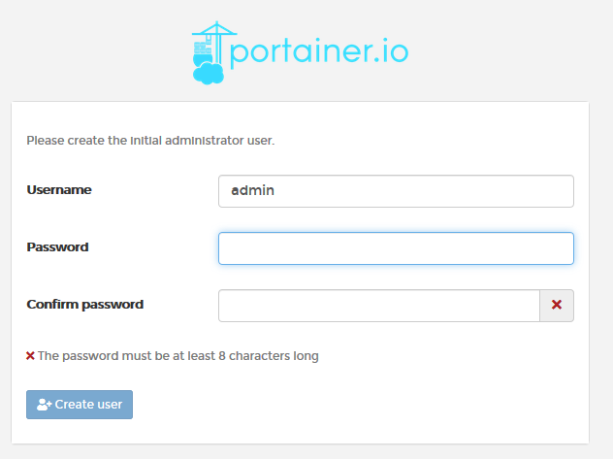
((In the next log in, there will be a login dialog with two empty fields. Enter the username admin in the top field and the password in the bottom field.)
_______________________________________________________________
When this screen pops up, Click on Local, then Connect

Dismiss the News and Click on Local

The following screen will now be the “Home” screen. Using “Local” menu selections on the left, this is where Docker Images are downloaded, containers are created, etc.
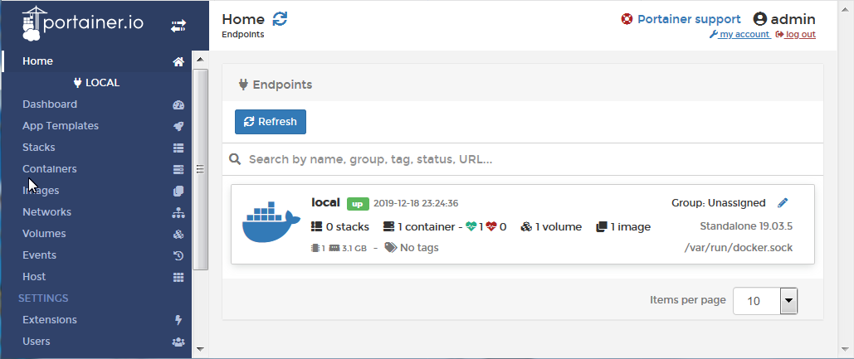
This concludes the installation of Docker and Portainer.

_________________________________________________________________

(Continued)

Dockers - It's about choices
While there are 100,000+ Dockers, available on the Docker Hub, all are not created equal. The offerings, from Docker authors, range from a one-off experiment with no documentation (users are on their own) to organizations like Linuxserver.io that specialize in building first-rate Docker images. Linuxserver.io offers Dockers that have been thoroughly tested, they support multiple architectures, they provide detailed container setup instructions, their offerings are “Tagged” and they retain inventories of their older images.

Selecting a Docker - Primary Considerations
First:
When installing a Docker, for the greatest chance of success, it is suggested that users follow the guidance provided in Guides Section of the OMV forum.
Second:
Potential Docker users should first look for Dockers that support their architecture. The three primary architectures supported by OMV are ARMHF or ARM64, i386(32 bit), and amd64(64 bit). In most cases, 32bit Dockers will run on 64bit hardware.
**While there may be exceptions, i386 and amd64 Docker images may not run on ARM platforms. “Multi-arch” (multiple architecture) Docker images are more platform flexible.**
Third:
To increase the chance of success, when attempting to install a Docker without a guide, look for the more popular Dockers with the highest number of “pulls” on the Docker Hub. (hub.docker.com) There are good reasons why these Dockers are broadly popular – they tend to work.
Forth:
In the vast majority of cases, Dockers that fail to work won't have anything to do with OMV or the Docker Plugin. Their issues tend to be with selecting the wrong architecture, selecting the wrong network mode (host, bridged, macvlan) for the application, other configuration issues (such as port 80 OMV/Docker conflicts), permissions problems, or the Dockers themselves.
Since most Dockers share Network ports with the host (OMV), it's important to use ports that are not currently in use. To get a better understanding of network ports and for commands that will reveal ports that are in use, refer to this forum post for more information:
[How-To] Define exposed ports in Docker which do not interfere with other services/applications

When things go wrong
First take note of any error dialog boxes. On most Windows and Linux machines it's possible to copy and paste the text out of a dialog box by holding down the left mouse button and dragging the mouse pointer over text, to highlight it. Then use the keys with Ctrl+c (to copy), then click in a Notepad document and use Ctrl+v (to paste). This basic information will be helpful, in searching out the details related to the problem.

The First Resource – The Internet
Users should search the internet first. The solutions for many generic problems can be found with duckduckgo, google and other search engines. When searching on key words that match error message or the problem users may be having, in some cases, answers can be found quickly in real time. This is the fastest and often the best way to learn how to fix server problems. Since OMV is based on “Debian”, it may be a useful search term.
While the search function of the OMV forum site will produce “hits” on search criteria, it is by no means all inclusive. If OMV is included in search criteria, a Google search may generate more result hits on information found on the OMV forum, than the forum's integrated search function.
With information from searches, users should make an effort to address their own issues. This approach tends to be the path to the fastest answers and greatly facilitates the learning process.

The OMV Forum
When coming to the forum for help:
First search the forum. In many cases, user problems can be resolved with a few searches and a bit of reading. However, look at the dates of posts and the version of OMV referenced. Posts that are 3 or more years old may not apply to the current OMV version.
If posting a problem on the forum, start at the forum index, and look for the category that looks to be appropriate for the post. Along with an explanation of the the issue, the OMV version, the appropriate logs and command line output, if known, and the hardware platform in use are the absolute minimums required. Realize that, without information, even the most experienced users, Moderators, and / or Developers will not be able to provide assistance.
- While OMV's forum is known for responsiveness, it's unrealistic to expect answers in real time. It may be a matter of days before a forum member, who is familiar with the described problem, will read and respond to a post.
- When looking at answers, try to focus on the information presented, not the perceived tone. Remember that support is provided “gratis”, so act accordingly.
- Be open-minded. The reason why users post on the forum should be because they couldn't solve a problem on their own. With that in mind, when an experienced forum user replies, taking the time to make a suggestion or requesting more information, forum users should follow up and post the result. Whether the issue is fixed or not, user posts help other users with the same or a similar problem.
(Continued)

- If a forum post or a “How To” fixes your problem, or gets you through a configuration issue, consider giving the author a “Like” or “Thanks”. The gesture is free and it's an indicator to other users who may have the same problem. In essence, you'd be saying “I agree” or “this worked for me”.
- When users are experiencing problems with their data store (a file system issue, a hard drive, array, etc.) the working assumption on the part of experienced forum users and moderators will be that users have full data backup. Accordingly, recommendations for correcting filesystems, hard drives, and RAID array issues may result in the loss of data. Keep this in mind.

Hard Drive Failures and SMART
Hard drives are the hardware component most likely to fail, in a server, over time. With continuous use, spinning hard drives last roughly 4 to 7 years, but there are notable exceptions where hard drive life may be significantly shorter or longer.
Given that storage failure is inevitable, the best overall strategy to avoid losing data is 100% backup of the entire data store. Further, it is equally important to monitor the condition of a server's storage media to prevent silent data corruption and, unknowingly, replicating corrupted data to a backup device.
Another characteristic of hard drives is that they rarely fail all at once. While it is possible for a drive to fail abruptly, and without notice, it is a fairly rare occurrence. Typically hard drives begin to fail slowly, gradually accelerating toward a point in time where they become unreadable. This unfortunate circumstance, data lost to a corrupted or completely unreadable hard drive, might be avoidable with automated testing and monitoring.

Drive Self-Tests
Drive self-tests are a tool for early discovery of hard drive issues. Periodic testing of hard drives will uncover the majority of hard drive issues as they begin to develop and, hopefully, before a drive fails completely. The following illustration shows the setup for automated short tests, for an individual hard drive. (Each hard drive will require its own scheduled tests.) In this example, a short self-test is run every Saturday at 1:00AM)
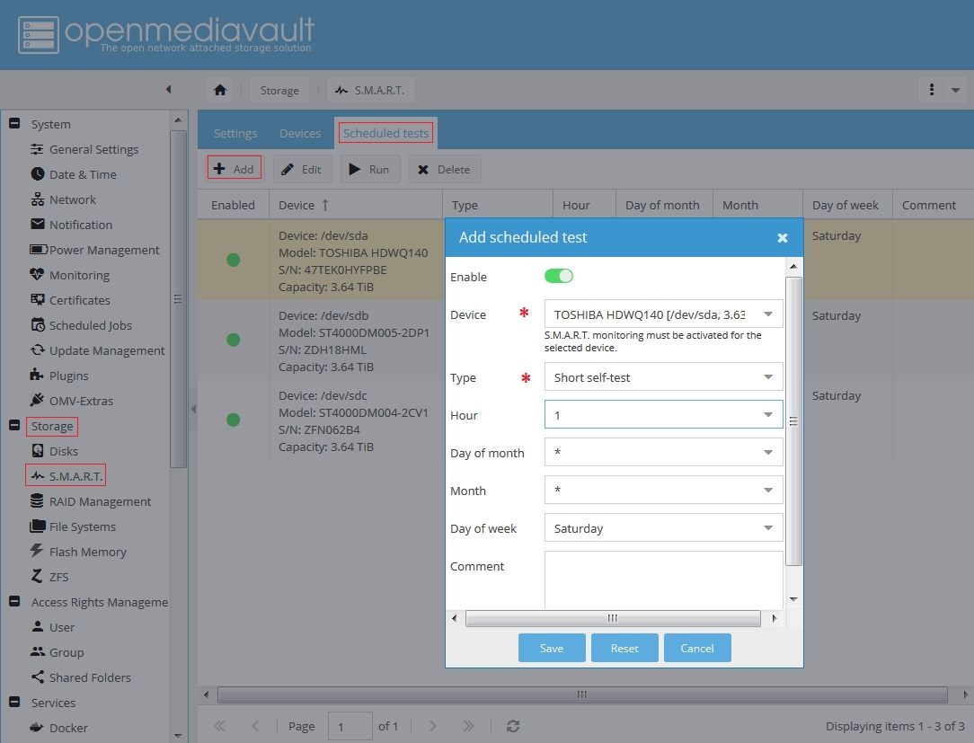
A Short self-test runs for a few minutes and is an “on-line” procedure, meaning that drives are still accessible during the test. A Long self-test is an “off-line” test, meaning drives are not accessible during the test.
While a Short test does a quick check of a drive's components, a Long test does everything in a Short test, then checks the media (platters) for bad sectors and other imperfections. Repairs are made, if possible, such as reallocating bad sectors.
The down side of a Long test is that it is LONG, where spindle speed and drive size are factors in the length of the test. Long tests are off-line and, since entire platter surfaces are scanned, it may push a failing drive closer to failure as the test detects and attempts to repair problems.
There are many opinions on which tests to use and the frequency of testing.
- Some data center admins schedule short self-tests once a week and a long test once every 30 to 60 days. (Remember, when scheduling a Long self-test, schedule it for after-hours periods where the server is not in use.)
- Some home NAS admin's schedule a short test, once a week, skipping Long tests altogether.
There's no exact right or wrong but the self-test tool should be used as an aid to monitor drive health, in avoiding data corruption and loss.

SMART Attributes
There are numerous SMART attributes to consider. Unfortunately, only a handful are standardized among the various drive OEM's and many have little to no practical meaning to the end user. Given the variation between drive OEM's, the interpretation of a specific SMART stat may require going to the drive OEM's support site.
((A good explanation of individual SMART attributes, and a brief explanation for each, can be found  here.))
Where spinning drives are concerned, thanks to the ongoing BackBlaze drive study, a correlation has been made between impending drive failure and specific SMART stat's.
SMART stats loosely related to drive failure:
SMART 5 – Reallocated_Sector_Count.
SMART 187 – Reported_Uncorrectable_Errors.
SMART 188 – Command_Timeout.
SMART 197 – Current_Pending_Sector_Count.
SMART 198 – Offline_Uncorrectable.
Any one count of the above stats may be meaningless, but it should be noted and closely monitored. If any of the above begin to increment upward, as of the 2nd or 3rd count, home or small business admins might want to consider replacing the drive as soon as possible.
SMART 199 - UltraDMA CRC errors
While not directly linked to drive failure, counts on SMART stat 199 are usually hardware or cable related.
(A loose cable / a bad cable, a connectivity problem, or an interface issue of some kind.)

Drive Failure - The Bottom Line
When using scheduled drive self-tests in conjunction with SMART E-mail notifications (see Server Notifications), server admin's and home users will be afforded better protection against the data corruption and data loss due to a failing hard drive.

Common Problems:
Problem: After a reboot, the web page is not available. (Bad Gateway or 404 error.)
Solution: This may happen on an odd occasion. Instead of doing a dirty shutdown, SSH in with PuTTY, and issue the command: reboot. The system will reboot. Login.
Problem: Web interface has missing fields and/or items showing that have been uninstalled.
Solution: Clear your browser cache and, always, login to the Web console using the user, admin.
Problem: I mounted the drive using the command line and I can't select that drive in the shared folder device dropdown.
Solution: Never mount a drive with anything other than the OMV web interface. This creates the necessary database entries to populate the device dropdown.
Problem: I only see a few items in the web interface like the user section of Access Rights Management.
Solution: You did not login as the admin user. This is the only user that can access everything.
Problem: Samba is slow.
Solution: Read these threads - Tuning Samba for more speed and Tuning Samba for more speed 2
(**This does not apply to SBC images – Samba has already been optimization on these platforms.**)
Problem: You see an error where a domain name/host could not be resolved
Solution: You probably need to set your DNS server in System -> Network -> Interfaces
Problem: "No Network Interfaces" when looking at the console, after boot up.
Solution: Most of the time, this is caused by the system taking too long to get a DHCP IP address before the message is written. The adapter's address can be checked by logging in with any user (root is a good choice) and typing ip addr
Problem: I have an SBC and I'm having trouble with RAID. (OR) I have a USB connected RAID array or enclosure.
N/A: USB RAID is not supported.

USB Power - A Common Raspberry PI problem

General:
Many problems with R-PI's, in versions prior to the R-PI4, are related to under-powering. The issues caused by under-powering can range from bizarre behavior to data corruption on storage devices.

Do I have a problem?
With all peripherals attached that are normally used – use the command dmesg on the CLI and scroll through the output. If an undervoltage situation exists, it will be noted in the output.

What is the problem?
Beyond using a power supply with the appropriate current rating for the R-PI model, it should be noted that a USB power source must meet certain voltage specifications “at the socket”. In essence, the output voltage of a USB power supply can't be increased to compensate for external voltage losses typical when using a long USB cable with small gauge wire.
Aggravating matters is that models prior to the R-PI4 use a micro USB plug as the power connection. The contacts for micro USB are tiny and cables for micro USB tend have small gauge wires which drop voltage significantly.
Consider the following chart of voltage losses, versus length and gauge
(Note that voltage drops increase as current requirements rise.)

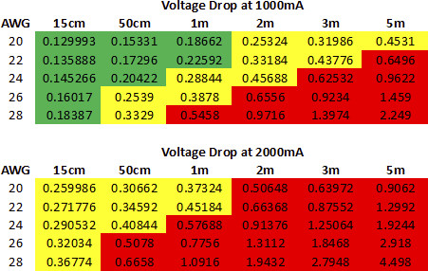
(Continued)

Potential Remedies:
- Use a power supply that meets at least the minimum recommended current rating for the R-PI model being used.
- Use the shortest possible USB cable. Cables that are 1 foot / 30cm or less, made of thick gauge wire are preferred. If a short USB cable is not long enough to place an R-PI in a convenient location, use an AC extension cord rather than a long USB cable.
- Avoid using USB powered hard drives. The additional current load will drop voltage and may stress a weak power supply. A self powered drive dock is preferred.
- Avoid leaving peripherals attached, such as a monitor, keyboard or a mouse. They consume power.

