Building a new version of MDT

[Adrian.Pop@liu.se](mailto:Adrian.Pop@liu.se)

2012-05-17

# Update your subversion

<https://openmodelica.org/svn/MDT/trunk>

# Refresh all your projects (the workspace)

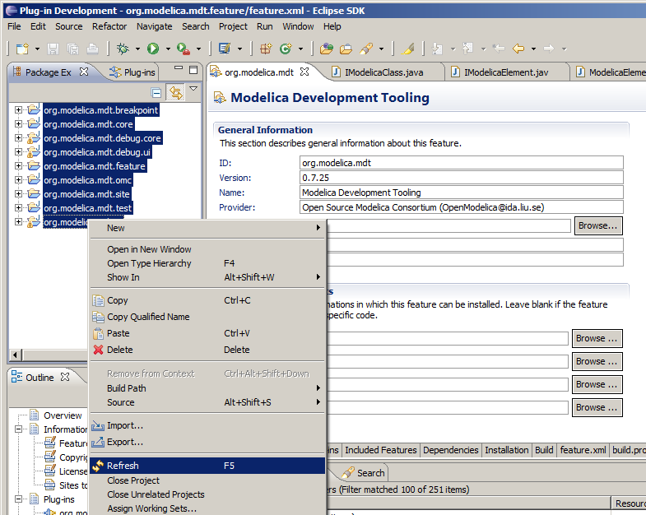

# Clean your project

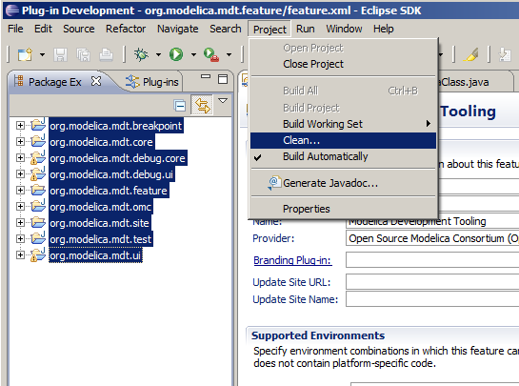

The project will now build automatically, see that there are no errors!

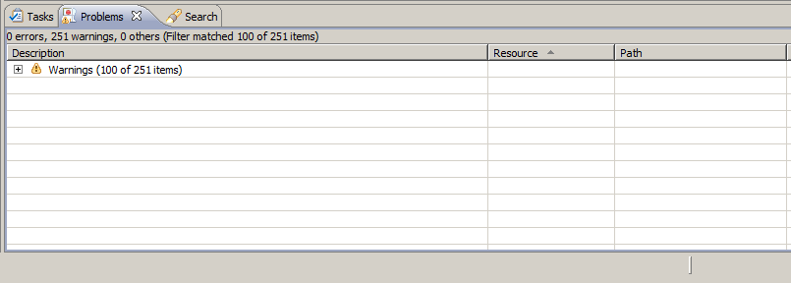

# Open the org.modelica.mdt.feature project feature.xml file

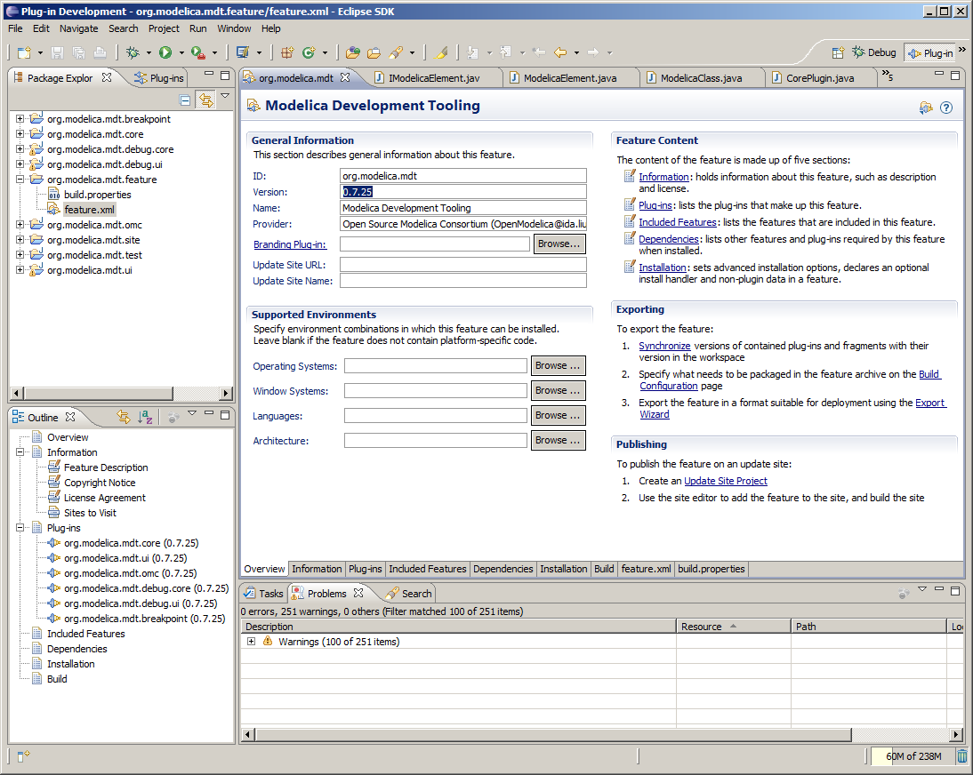

The tab Overview should be selected.

# Change the version number

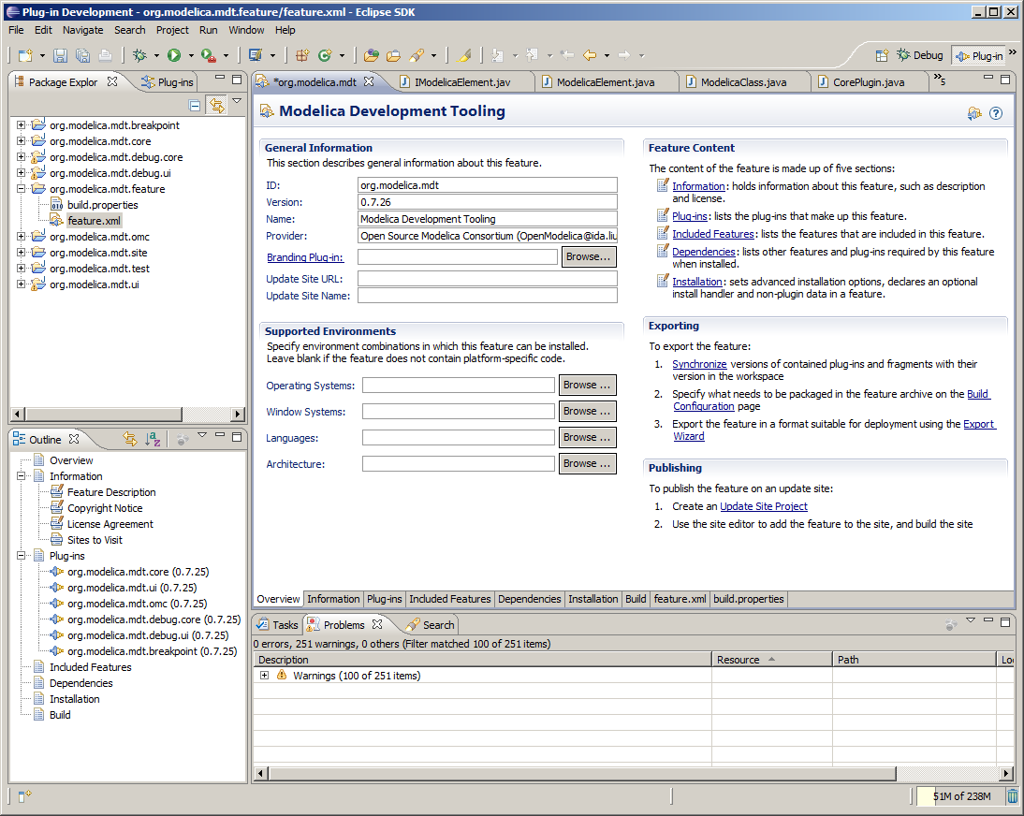

Press Tab so that the new version number is picked up.

# Click on Plug-ins tab and then Versions

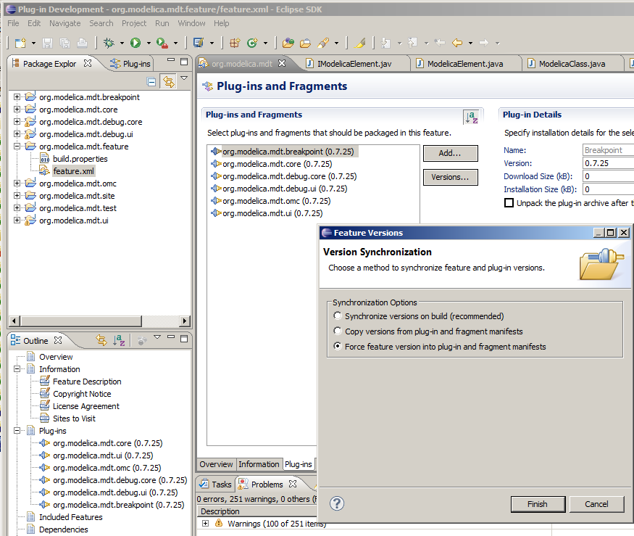

Have “Force feature version into plug-in and fragment manifests” selected, and then click Finish.

# Save all files

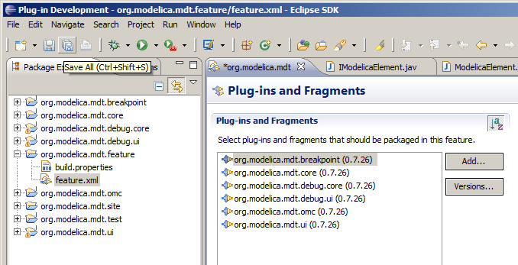

Now the versions have changed in all plug-ins.

# Clean all projects again (Project->Clean) to rebuild them

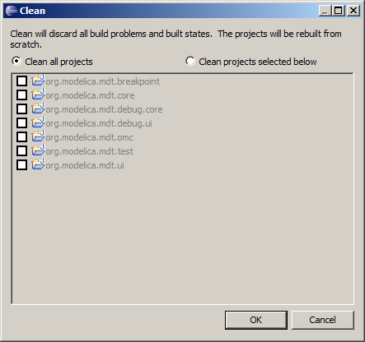

Note that Project->Build Automatically should be checked!   
See that there are no errors in the Problems view.

# Export the feature

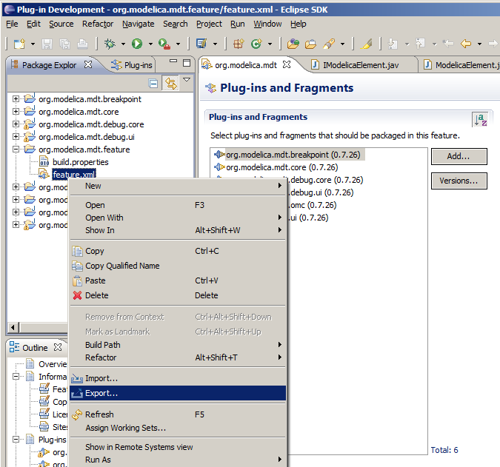

Right click on feature.xml, say Export.

# Select Deployable features

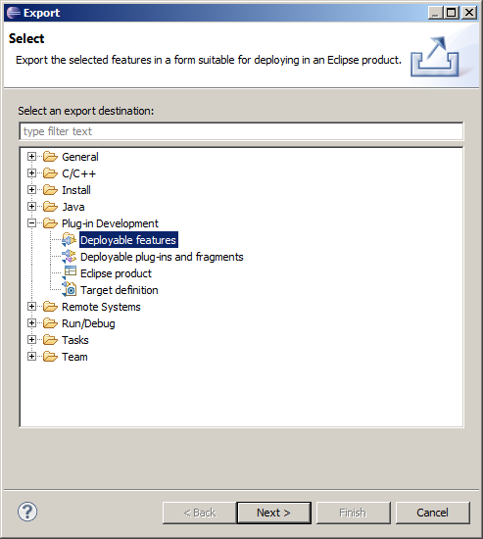

Then click Next and select Directory and set the path where you want them exported and the Options.

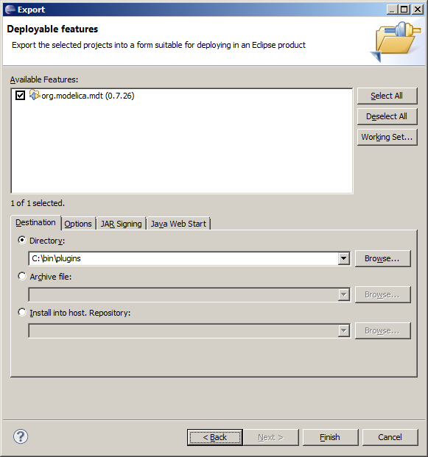

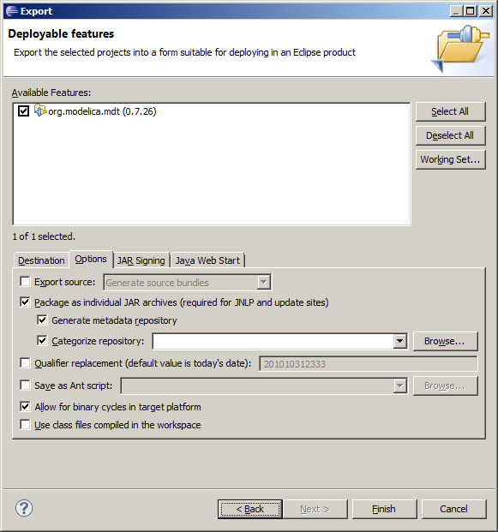

Now click Finish.



Eclipse is exporting Features, you can see it on the status bar. Close Eclipse when this is done.

# The exported Features directory

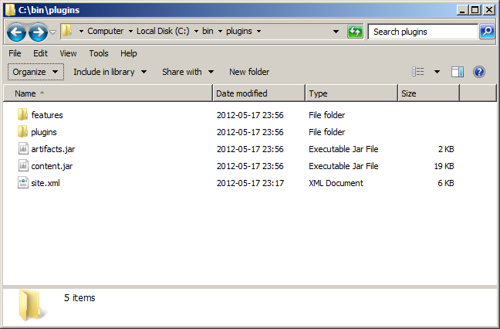

Looks like this with features and plugins directory.

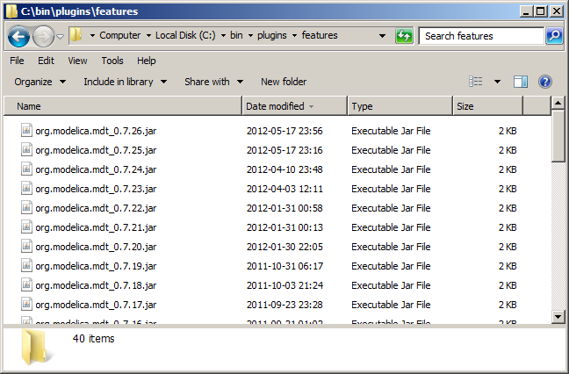

The new feature version 0.7.26 is now present.

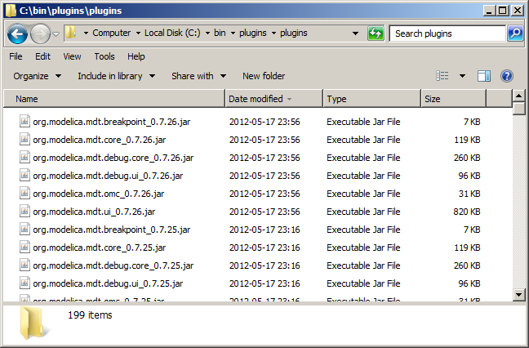

All the new plugins for version 0.7.26 are now present.

# Edit site.xml and add the new feature version

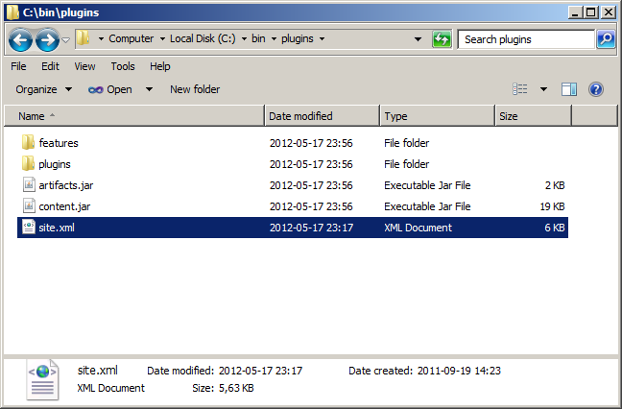

Copy the last one and paste it and change the version number.

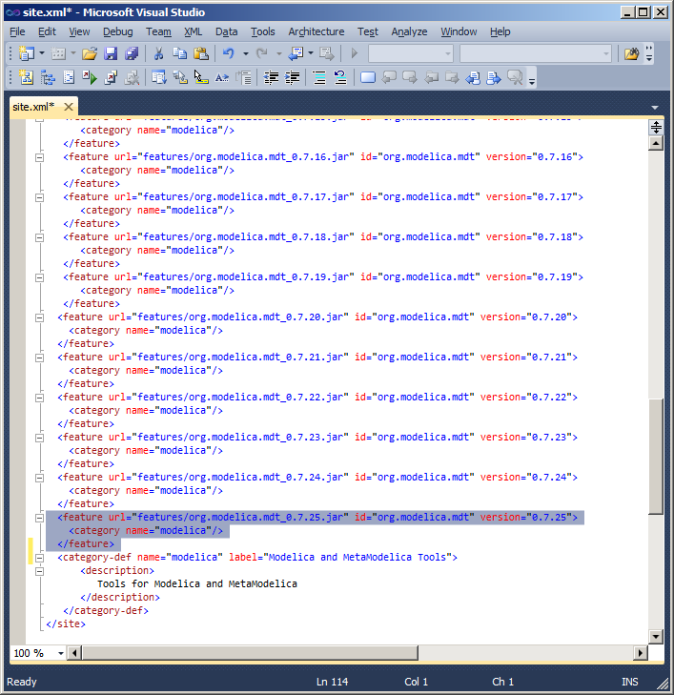

**Remember to change in BOTH PLACES! _0.7.25.jar and version=“0.7.25”!**

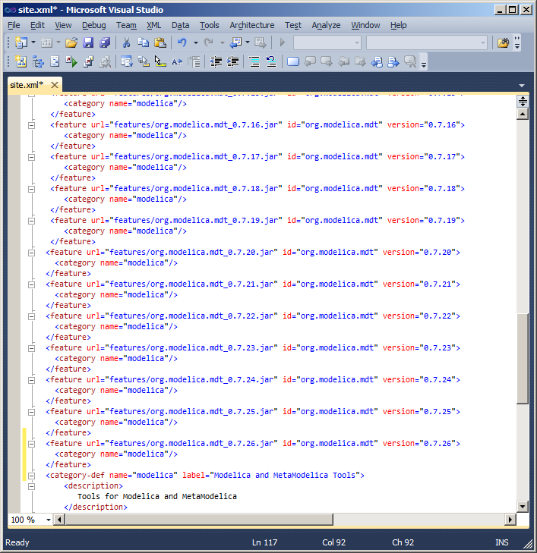

Save site.xml, exit the editor.

# Unpack artifacts.jar and content.jar

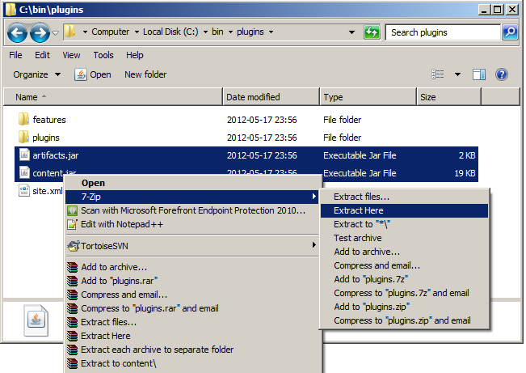

# Copy exported files to SVN working copy

Copy and replace all the selected files from the exported feature directory to your working copy of MDT/trunk/org.modelica.mdt.site

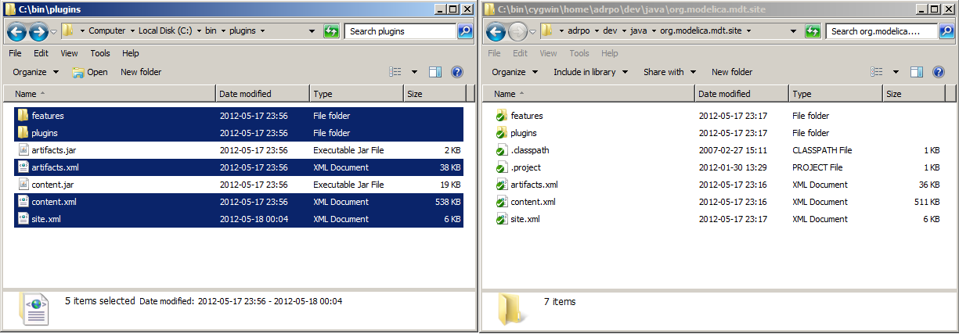

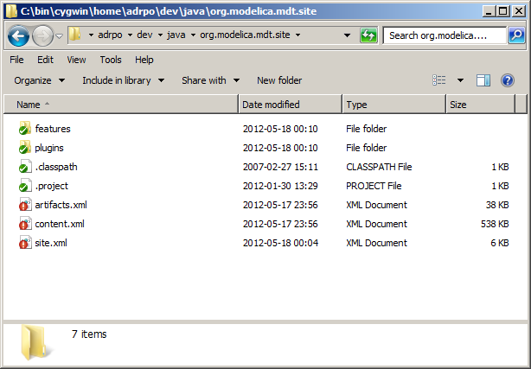

Now add all the new jars to Subversion! Right click in that directory, say TortoiseSVN->Add.

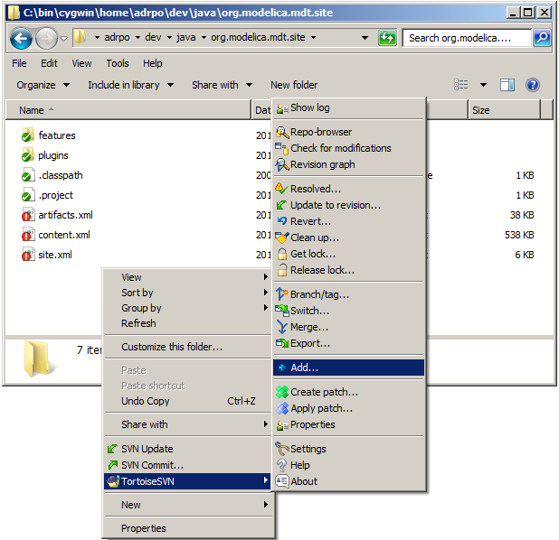

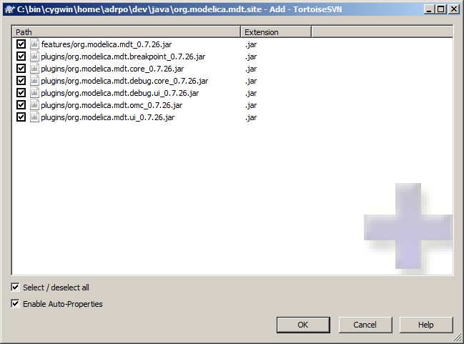

Click OK.

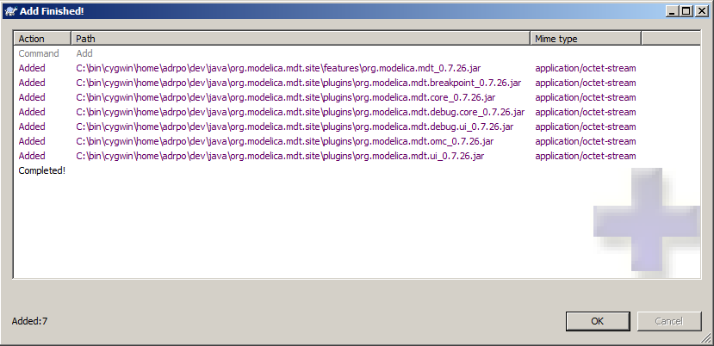

Click OK.

# Commit your changes

Go one level (top MDT directory) up and commit your changes.

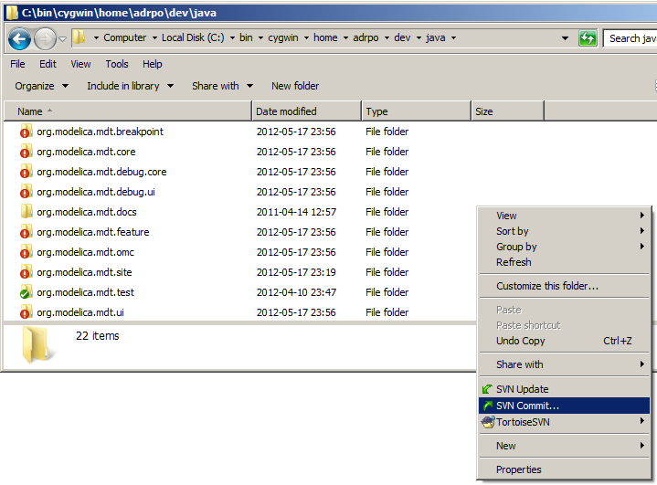

See that all the changed files are there and write a commit log, then Click OK.

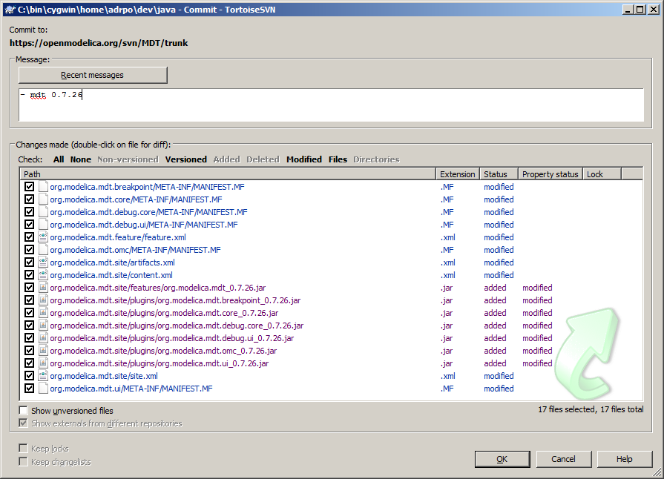

Files are now commited.

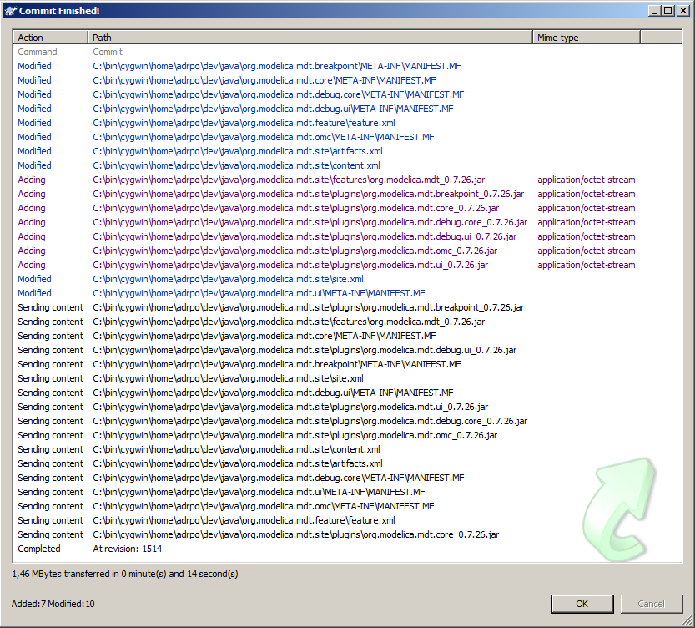

# Copy the new files to the update site

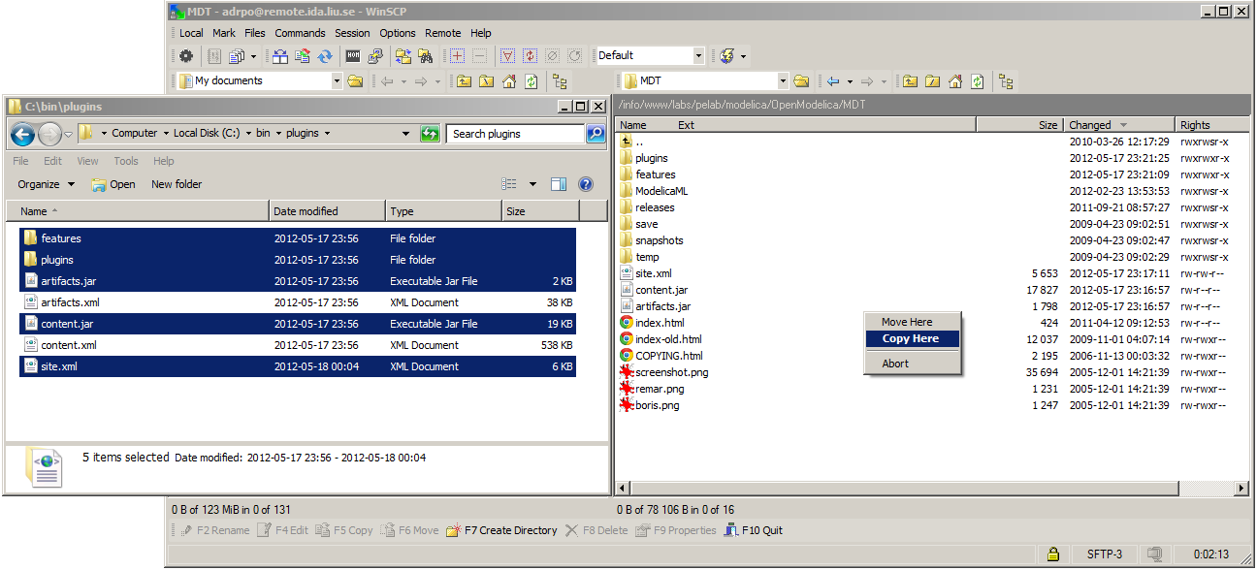

Select “New and updated files(s) only”, then click “Copy”.

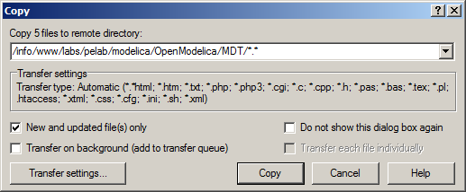

Copy is under way

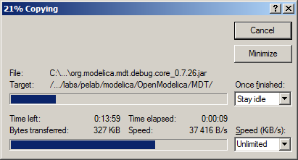

# The end

Be proud, you’ve just made a new MDT version ☺.