OPC and OPC UA Interfaces
In addition to OMI, OpenModelica can also be stimulated through the OPC interface. At the moment OPC DA and OPC UA interfaces are supported. As OPC UA is seen as the technology that will replace the regular OPC in the future, the OPC UA implementation is concentrated on more than OPC DA.

Introduction to the OPC Interfaces
In this chapter, the basics of OPC are explained. In addition, a literature survey [OPC_1] has been made for the project “OPC Interfaces in OpenModelica”. In that survey, OPC is explained on a higher level generally as well as from the viewpoint of OpenModelica.
OPC is a set of specifications which defines a common interface for communication between software packages and hardware devices of different kinds. The most used of the OPC interfaces, OPC DA (3.00) specification [OPC_2], defines how to get and set data in real time devices using client-server communication paradigm and Ethernet based communication. OPC DA uses Microsoft COM (Component Object Model) technology.
The next generation of OPC specifications is OPC Unified Architecture. It combines the different OPC interfaces under one specification. The basic idea behind OPC UA is the same even though the technology behind is different. Unlike the regular OPC specification, OPC UA is platform independent and has new features, such as method calls, included. A binary transfer protocol is provided for a better performance, as well as the XML based one. The OPC UA specification is defined in a 13-part specification downloadable in OPC Foundation homepage [OPC_3].
Since OPC and OPC UA are rather large specifications, their usage cannot be discussed here in detail. For a deeper understanding of the technology behind OPC and OPC UA the reader should get familiar with the interface specifications above. However, for both of the interfaces there exist test clients which can be used to utilize the interfaces in a quick and easy manner. A couple of test clients are introduced in section 1.1.3.

Implemented Features
Both the OPC UA and the OPC DA interface (combined with the Simulation Control (SC) interface) provide a very similar functionality. Thus only OPC UA is discussed extensively here. In subsection 1.1.2.2 the most noteworthy differences in features between OPC UA and OPC are discussed.
To utilize either of the OPC interfaces, the OPC branch needs to be merged to c_runtime. UA Server is linked to the simulation executable by adding -lOPCregistry -lua_server at the end of the compiling script. OPC DA server is linked to the simulation executable by adding -lOPCregistry -lOPCKit at the end of the compiling script. At the moment there is no option in the OMC to do this automatically.

OPC UA
After an OPC UA client has established a connection to an OpenModelica simulation, the following features can be utilized. In Figure 5-1 UA Expert connected to an OpenModelica simulation (‘dcmotor’) with the OPC UA server included, a view of the UA Expert test client is shown. The client is connected to an example OpenModelica simulation, namely the ‘dcmotor’ [OPC_4]. In the following, all the examples use Figure 5-1 UA Expert connected to an OpenModelica simulation (‘dcmotor’) with the OPC UA server included to explain the concepts.

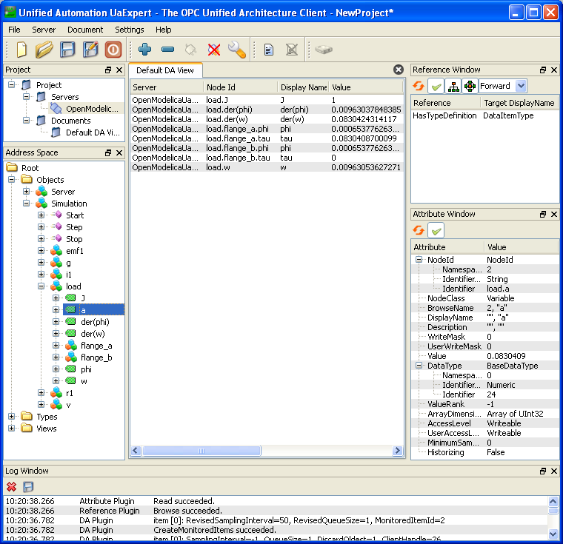
Figure 5-1 UA Expert connected to an OpenModelica simulation (‘dcmotor’) with the OPC UA server included
Browse
The data structure (in OPC UA terminology: address space) of the OpenModelica simulation can be browsed. The address space consists of nodes and references between them. The part of the address space in which all the elements of the simulation are is a tree under the ‘Simulation’ node. This is shown in the left plane in Figure 5-1. In addition, the three methods are there as nodes as well; these methods are discussed later.
Read
Values of variables and parameters can be read through OPC UA after each simulation step. In addition to that, OPC UA offers some metadata, the majority of which is not utilized, though. The value and the metadata can be found on the right plane in Figure 5-1.
Write
Values of attributes and parameters can also be altered during the simulation between the simulation steps. When a value has been changed, the simulation is initialized with the new values and continued. This is needed if variables are wished to be changed, however a parameter change would not require this. Hence the implementation should be fixed on this matter.
Subscribe
Variable (and parameter) values can be subscribed. There are two alternative types of subscription: The first option is that the OPC UA server sends the value of the subscribed variable to the client each time after a defined time interval has passed (real time). The other one is that the value is sent to the client after each simulation step. In UA Expert, variables can be subscribed by dragging them to the middle plane.
Start, Stop, Step
The simulation can be controlled by the three methods: start(), stop(), and step(). With the OPC UA server included, the OpenModelica simulation starts in a stopped state. With start() and stop() methods this state can be changed. The simulation can also be run one step at a time with step().

OPC DA and Simulation Control (SC)
The OPC DA server offers roughly the same functionality than the OPC UA server. The biggest conceptual difference between the two specifications is groups: Before variables and parameters can be used in any way they have to be grouped. A group is an entity consisting of items. A group can contain any variables and parameters as items. The other major differences between the two interfaces are described in the following.
Browse
The data structure of OPC DA is a tree consisting of branches and leaves. The leaves correspond to variables and parameters whereas the branches form the tree-like structure (e.g. ‘load’ and ‘flange_a’ are shown as branches in the dcmotor example).
Read
Reading values doesn’t differ much from OPC UA, except that the items read have to be grouped. There is also almost no metadata available through the OPC DA.
Write
There are no major differences.
Subscribe
The biggest difference in OPC DA is that single items cannot be subscribed. Instead, a subscription can be made for a group.
Start, Stop, Step
OPC DA interface doesn’t enable methods as such. Thus a proprietary interface, Simulation Control (SC), is used. In practice this means that in addition to the OPC DA client an SC client must be run alongside.

Test clients
There are free test clients available in the Internet to test the OPC and OPC UA interfaces. One test client for each interface is shortly presented below. In addition, a test client for the SC interface is published as part of OpenModelica.
UA Expert by Unified Automation is an OPC UA test client with a GUI. It supports all the functionalities provided by the OPC UA in OpenModelica. The latest version of UA Expert can be downloaded for free from the Unified Automation homepage [OPC_5].
For OPC DA there are numerous test clients available. The one which was most used for testing the OPC server is MatrikonOPC Explorer. It supports all the OPC DA functionalities needed to access data in OpenModelica. As well as UA Expert, this test client has a graphical user interface. The latest version of MatrikonOPC Explorer can be downloaded for free from the MatrikonOPC homepage [OPC_6].
As the SC interface is a non-standard interface, there are no clients for it in the Internet. SimpleOPCClient is a small test client for OPC and SC interfaces published with OpenModelica. Besides some basic OPC features, this test client allows the simulation to be controlled, i.e. start(), stop(), and step() functions can be used with it. Unlike the commercial products above, SimpleOPCClient is published in source code format.

References
- OPC Interfaces in OpenModelica – Technical Specification (Task 5.3); Online: https://openmodelica.org/svn/OpenModelica/trunk/doc/opc/
OPC_Interfaces_in_OpenModelica.pdf (Accessed 10 June 2011).
- OPC DA 3.00 Specification; Online: http://opcfoundation.org/DownloadFile.aspx?CM=3&RI=67&CN=KEY&CI=283&CU=6 (Accessed 9 June 2011).
- The OPC Foundation – The Interoperability Standard for a Connected World; Online: http://opcfoundation.org/ (Accessed 8 June 2011).
- OpenModelica: DC Motor model; Online: https://openmodelica.ida.liu.se/svn/
OpenModelica/tags/OPENMODELICA_1_5_0/Examples/dcmotor.mo (Accessed 10 June 2011).
- Unified Automation GmbH | OPC UA Clients; Online: http://www.unified-automation.com/opc-ua-clients/ (Accessed 9 June 2011).
- MatrikonOPC: Free OPC Downloads; Online: http://www.matrikonopc.com/downloads/ (Accessed 9 June 2011).

