Concept Paper
Backend Redesign

Authors’:
Dipl.-Ing. Jens Frenkel
Dresden University of Technology
Institute of Processing Machines and Mobile Machinery
D-01062 Dresden
Germany
Tel: +49 351 463-39278
Fax: +49 351 463-37731
eMail: Jens.Frenkel@tu-dresden.de

Version
- 2009-09-11 - First Draft – Jens Frenkel

Version 2
Goals of Redesign 4
Realisation of Redesign 4
EquationSystem Library 7
The EquationSystem Pipeline 7
Current Backend Overview 8
Plan of Reuse 9

Goals of Redesign

During the implementation of the tearing algorithm, the relaxation algorithm and the bugfixes to get the multi body elementary models running, I realized that the current implementation of the backend is quite complex and sometimes changes to the source code often cause unexpected side effects. This leads to an unnecessary long time to get familiar with the code and complicates maintenance and the implementation of new features. I guess to speed up the development process of the compiler and to increase the development team some redesign work has to be done. The goals for the redesign are:
- increase the clarity of the code
- decrease the error-proneness
- improve the extensibility
- modularise the code introducing levels of hierarchy
If it is possible to achieve the goals I guess the compiler will be faster and it is a lot easier for new and old developers to implement new features.

Realisation of Redesign

How it is possible to achieve the goals? I guess, the existing code has to be re-structured. How should it be done? It might be beneficial to introduce a hierarchy for expressions, componentreferences, equations, algorithms and equationsystems (see Figure 1). Each of these modules is only allowed to use the modules directly related to it. For example the equations module uses the expressions module and the expression uses the componentreferences module. Together all the modules build a symbolic Equationsystem Library. More complex algorithms like „remove simple equations“, BLT-sorting, index reduction, tearing, relaxation, etc, uses the Equationsystem Library and may only perform operations on the system of equations. This would enable us to preserve consistency of the system of equations, make it easier to implement complex optimization algorithms, generate a comprehensive testcase environment for the Equationsystem Library and so on.

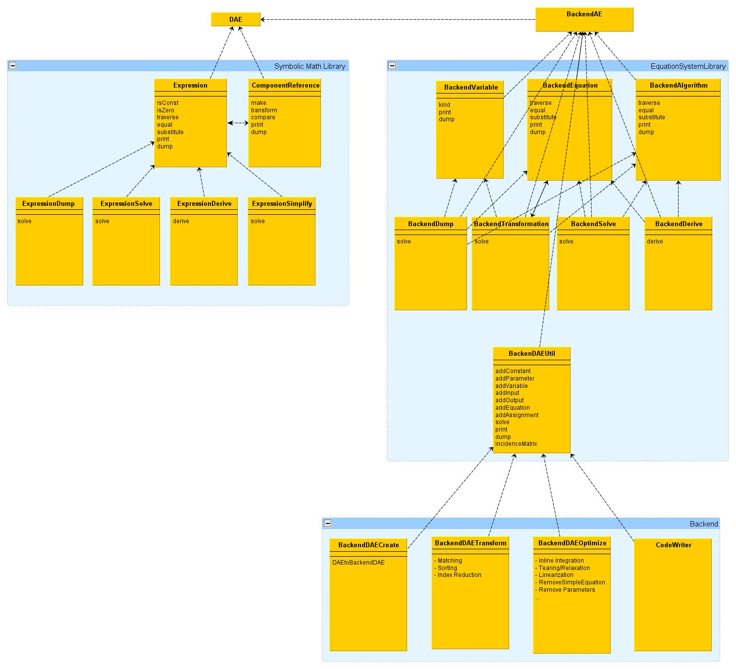
Figure 1

The next step after restructuring is to implement a new data flow in the backend. The idea is to have the equation system and a set of optimisation modules. The equationsystem is pushed from every module to the next like in a pipeline. With new flags it is maybe possible to enable/disable certain optimisation modules. The pipeline consists of 4 main parts (see Figure 2):

- the equation system optimization part
- the BLT and index reduction part
- the assignment optimisation part
- and the code writing part

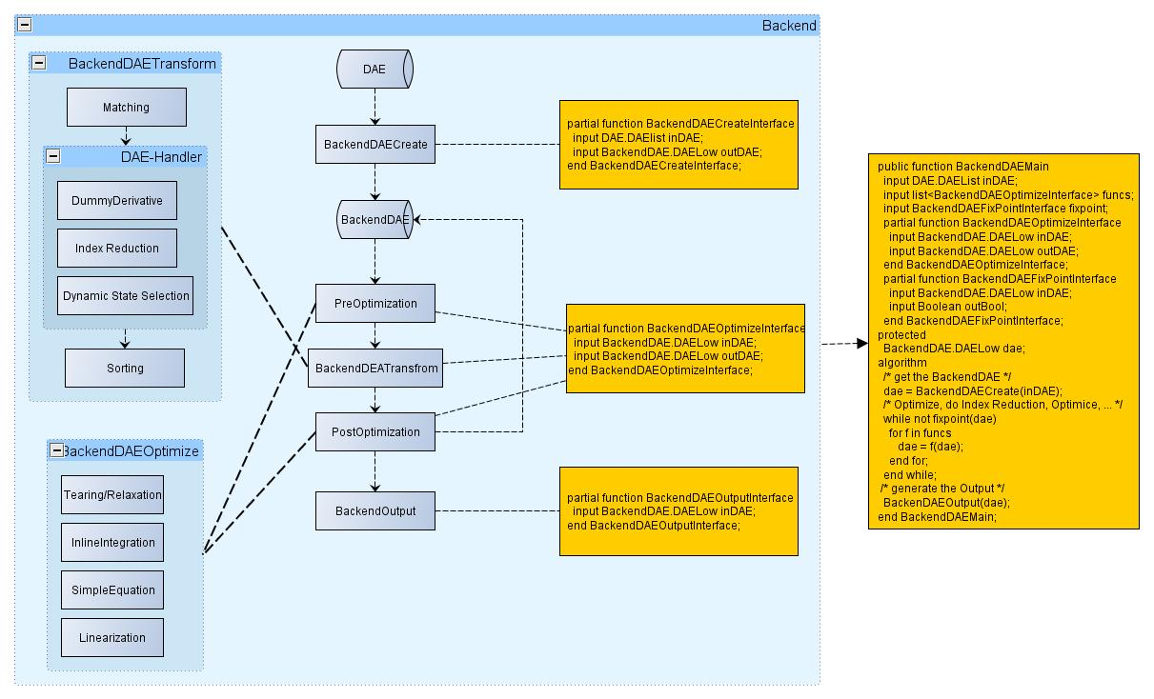
Figure 2

A next really important tasks is to implement more interfaces to export and import the system of equations. This expand the usability of the compiler. Now the only task of the compiler is to generate a executable to simulate the model. If the compiler has interfaces to export and import the system of equations in an easy style to parse (for example XML) the usability will be increase dramatically (see Figure 3).

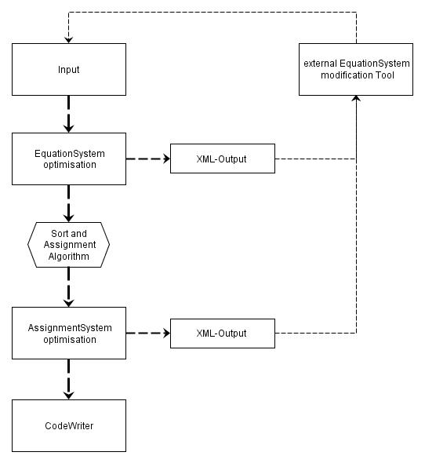
Figure 3

EquationSystem Library
The EquationSystem Libray (ESL) should support the implementation of the optimisation and modification modules. It consists of several classes like ComponentRef, Variable, Expression, Equation, Assignment, EquationSystemElement and EquationSystem. Supporting the implementation means to provide a set of function/operations to modify the system of equations. This set of functions/operations makes sure that the system of equations stays valid after every operation. A valid state implies that there are neither unknown component references nor an expression with wrong operation types or an equation with different shape types of the left hand side and the right hand side. It does not mean however to make sure the system of equations is well-constrained (have for each variable an equation or assignment).

EquationSystem Libray Test Environment

To ensure the set of functions/operations of the ESL working correct there should be a number of test cases for each function. To avoid unexpected influences I assume it is the best to implement the tests in MetaModelica.

The EquationSystem Pipeline
The EquationSystem Pipeline (ESP) consists of different stages. It simply starts with the input of the variables, equations and assignments to build a system of equations and ends with a compiler optimised high efficient simulation code. In between the start phase and the end phase are the EquationSystem optimisation phase, the EquationSytem modification phase and the Assignment optimisation phase. Each of these three phases has its own module which operates on the system of equations. The modules for optimisation are may be combined in different orders.

Input Phase
The input Phase consist of
- lowering

EquationSystem Optimisation Phase
- remove simple equations
- expandDerOperator
- function inlining

EquationSystem Modification Phase
- reduce Index
- dummy derivative
- dynamic state selection
- ...
- sort the equations and assignments (Tarjans)

Assignment Optimisation Phase
- late function inlining
- remove simple assignments

Code Writer Phase
The Code Writer Phase will be done by the Modelica Text Template Language Susan Codegeneration Modules.

Current Backend Overview

The current OpenModelicaCompiler Backend consists of the following Moduls:
- BackendVarTransform
- DAELow
- DAELow_stub
- Derive
- Inline
- PartFn
- TaskGraph
- TaskGraphExt
- SimCode
The main tasks of the Backend are
- build a system of equations from flattened Modelica Model
- remove simple equations
- get a valid matching
- detect all state variables
- sort the equations
- assign the equations and subsystems of equations ( linear and nonlinear time continues and discrete equationsystems)
Additional tasks are
- function inlining (before and after Pantelitis Algorithm)
- collect all information for the event handling

Plan of Reuse

The following section should discuss the possibility of which parts of the current code could be reused or moved and what needs to be reimplemented.

- lower DAE – reused in build equationsystem phase
- remove simple equation – reused, advanced use incidence Matrix
- expand “der” Operator – reused, advanced use incidence Matrix
- find Zero crossings - reused
- incidence Matrix – advanced, pig up all variables (states, algs, params, consts)
- matching Algorithm -reused
- function inlining -reused
- strong connected components – reused
- translateDAE – reused
- calculateValues – reused, advanced
- SimCode.mo
  - The parts of SimCode which assign the equations will be reused but moved to another module. Between the new module and the SimCode module will be the assignment optimisation module.

