The varaible uDC from OpenModelica plot command in the Rectifier.mo model
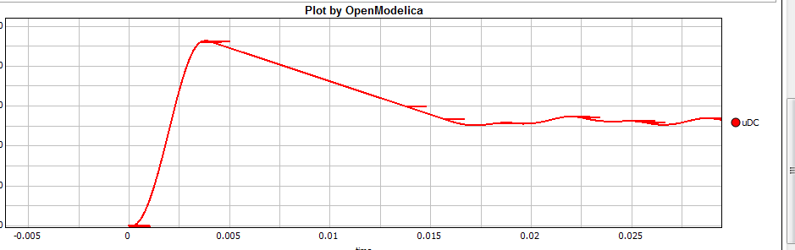
The same variable from Dymola,OBS inital value is not okay
