Events reduced to Alarms
[edit] Why Alarms
Ever since I started using OpenNMS, I have all wondered what the heck it means to acknowledge an Event. Well, it really doesn't mean anything to me unless the event is something that I acutally cared about. Now, OpenNMS gives you the ability to indicate which events are important and they become alarms. Also, with this ability, you can now reduce these important events to one row in the alarms table with a reduction key tag (<reductionKey>) in the event configuration files. This allows you to decide the granularity of the reduction as you will see in the sample images below (also see: Configuring alarms).
[edit] The new Alarms link
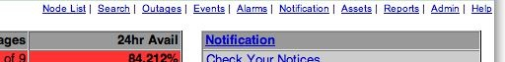
[edit] Alarms with new style sheet and sorted by severity
This is much nicer and generally more useful than the raw events.
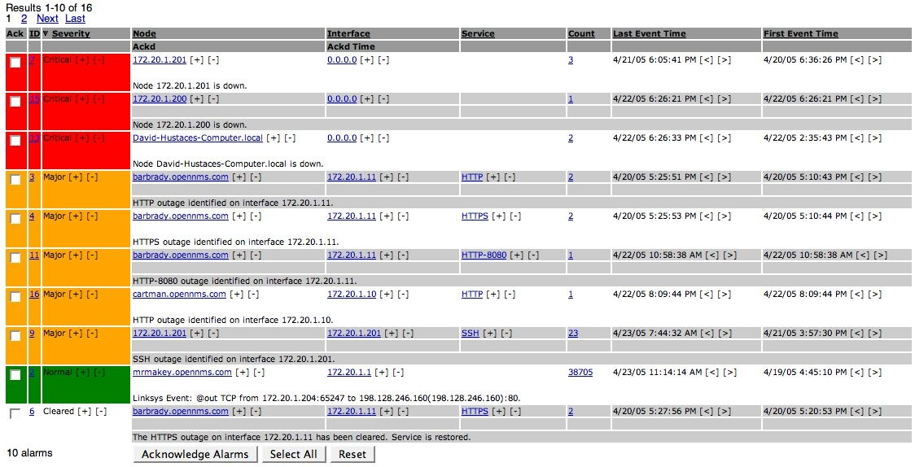
[edit] Alarms sorted by count
This shows the number of events that were reduced to a single alarm row.
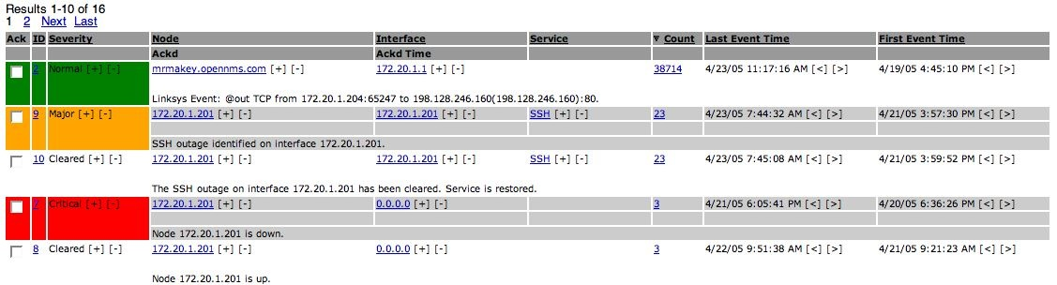
[edit] Un-reduced event list
Click on a count in the alarm listing and and jump to the list of un-reduced events for that alarm.
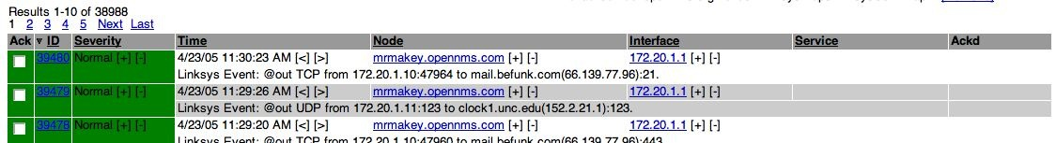
[edit] See Also
Configuring alarms

Retrieved from "http://www.opennms.org/wiki/Alarms"

