Script Portlet Samples for IBM Script Portlet

Overview

This is a set of examples that illustrate some basic techniques for using the IBM Script Portlet for WebSphere Portal. The samples show how to use some Portal features such as Public Render Parameters, and there are examples of using open source libraries.
To use these examples you will need to have WebSphere Portal 8.0.0.1 or later with the IBM Script Portlet installed. These samples were built and tested with the IBM Script Portlet release 1.3 from April 2015. See the References section below for information on obtaining IBM Script Portlet.

The samples include:
- Hello, World
- jQuery Eventing (two cooperating portlets)
- jqPlot Chart
- jQuery DataTables
- Load WCM Content
- Launch Script
- Public Render Parameters (two cooperating portlets)
- WCM tag samples
- Imported content files
- Portlet Preferences
- Media File Sample

There are instructions for using the sample code near the end of this document.

Hello, world
This is an extremely simple HTML snippet and JS function. Clicking the button shows a JS alert popup.

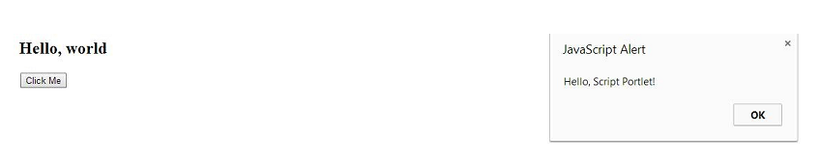

jQuery Eventing
This sample uses jQuery eventing, with bind() and trigger() functions. A list of customers is defined in the Customer List portlet, and a click event on each customer is used to fire the event by calling trigger() with a queue object. In the details portlet, the bind() function is called using the same queue object. When the event is received, it looks up a customer ID from the customersData array and updates the display.

To use this sample, put two Script Portlets on the page side-by-side. In the left-hand portlet use the event_source code, and in the right-hand portlet use the event_target code.

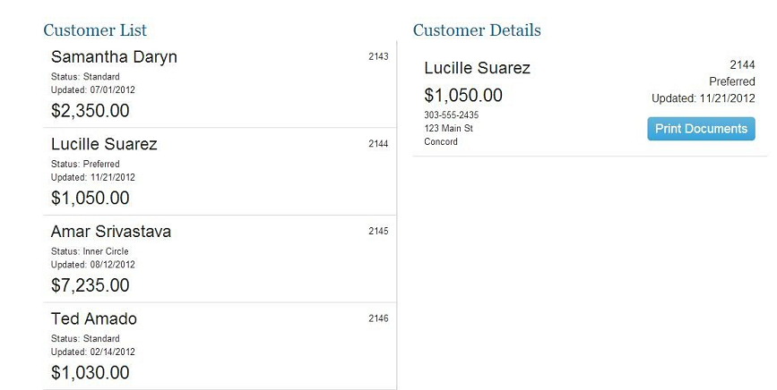

jqPlot Chart
This example show a chart created with the jQPlot open source charting library. The data for this chart in this example is defined right in the JS code. In a real world implementation the data would come from a REST service.

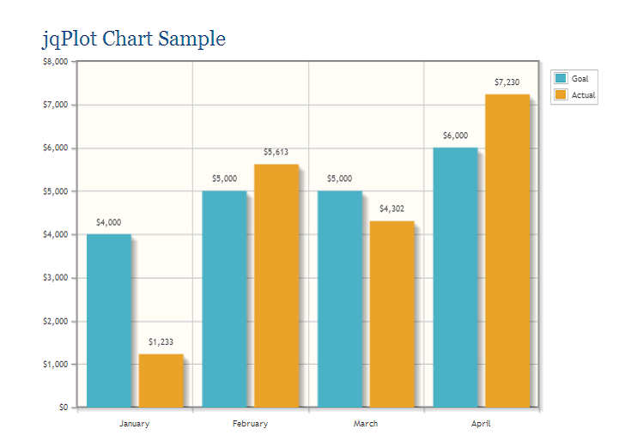

jQuery DataTables
This sample shows the jQuery DataTables library. The Customers data in this case comes
from a JS variable. See this web site for more information on the jQuery DataTables library: https://datatables.net/

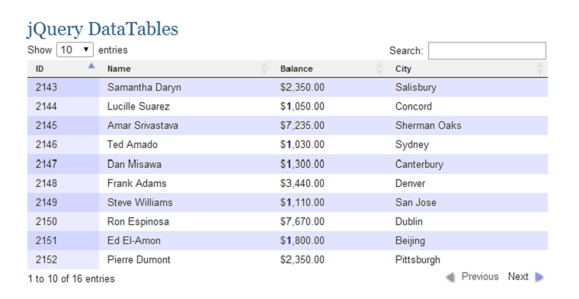

Load WCM Content
This example shows how to load any WCM content via Ajax. In this example, the url points to the web content library and the “articles” site area. You can type any content in that site area and this script will load it and display it in a div.

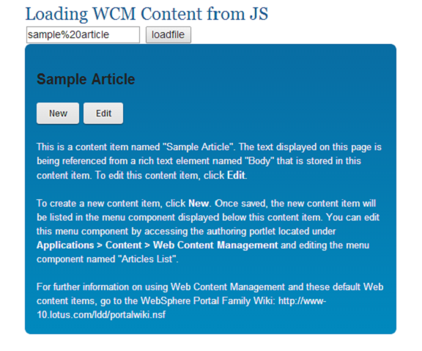

Launch Script
This example shows how to get the contents of a script via Ajax, and how to take that content and render it in a dynamically-created modal dialog. This can be useful when you want to launch dialogs/applications programmatically and you don't want to use iFrames, for example if you need to support mobile devices. You could also use the WCM Menu Component to pick which scripts should be displayed based on a
Personalization rule.

NOTE: To run this sample you must update the URL in the JavaScript to the URL to a script content item in your WCM library. For example, the screenshot shows the “Hello, world” sample Script Portlet launched in a popup dialog. There are a few ways of finding the URL for a Script Portlet Content Item. One way is to use a browser tool to get the URL from the “src” attribute of the iFrame which is used by the preview window of the Script Portlet Editor. Another way is to use the public WCM URL tag, or you could use the public WCM servlet rendering URL format.

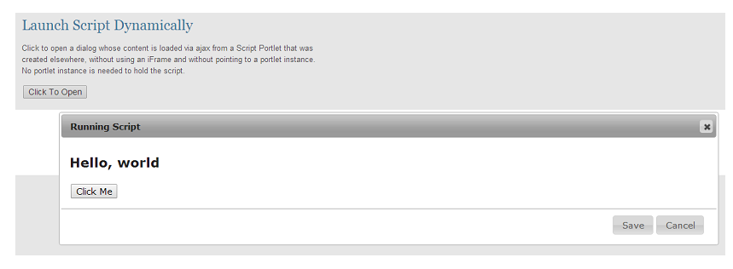

Public Render Parameters
This sample shows how to set and retrieve a Public Render Parameter (PRP). The
parameter that's used is the pre-defined "CUSTOM_CONTEXT" parameter defined by the WCM Rendering Portlet. The top portlet shows a list of customer names that are defined in a JS variable and used to populate a SELECT list. When the form is submitted it sets the PRP value. The bottom portlet then retrieves the PRP value and uses it to select the customer from the list.

To use this sample, put two Script Portlets on the page, one above the other. In the top
portlet use the prp_set code, and in the bottom portlet use the prp_retrieve code.

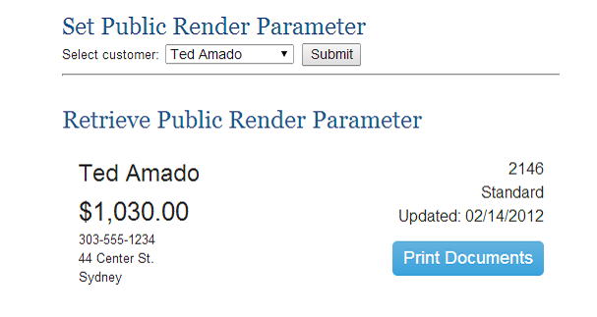
WCM Tag Samples
This sample shows how to use some of the WCM tags that are available. For example, you can retrieve the current user’s name, or get a “namespace” value that will be unique for this instance on a page.
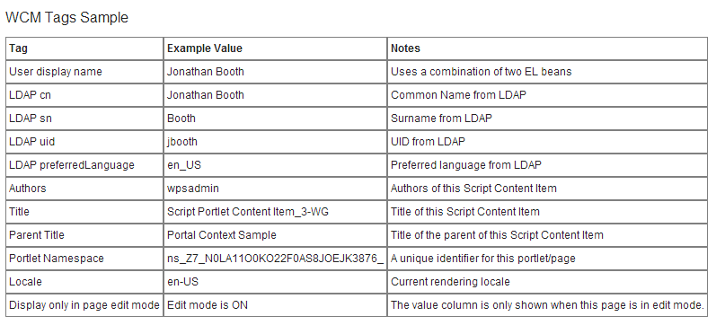

Imported Content Files
This sample shows the use of imported content: an image, a JSON data file, and an HTML fragment. All are loaded via Ajax calls. Each of these files is referenced with a relative link in the index.html page, and each relative link is replaced by a WCM Element tag when imported. The WCM element name is the same as the relative pathname. The JSON file and the HTML fragment are loaded by the application JavaScript code. The URLs are read from the hidden "a" tags that are in the index.html file.

The Javascript that loads the HTML fragment and the JSON file may not run standalone (from the file system) from all browsers due to security restriction.

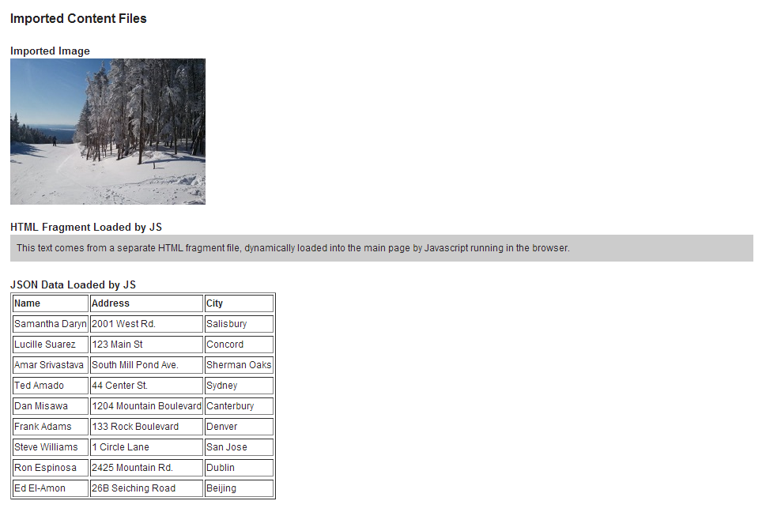
Portlet Preference Files
This sample shows the use of preference js api. The data that is read from a JSON file is displayed as a table using Jquery. The columns that are displayed in the table are controlled by preference values that are stored in the portlets preferences. This allows a user to use the same portlet to display different data depending on the preferences that are set for that instance of the portlet. For this sample the preferences are an array of strings that indicate weather a column is visible or not. The preference api supports the setting different kinds of preferences from simple strings, js arrays or JSON objects, it is up to you to identify the type of data your portlets need. Every script portlet can have preferences as needed and the preference definition can be customized to the specific instance.

WCM Tag Samples
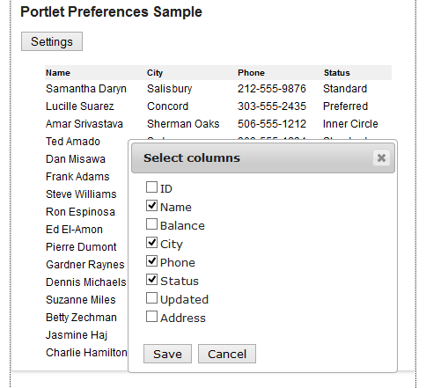
Media File Sample
This sample shows how you can reference other file types such as video. The portlet include a reference to a video file and automatically plays this video when the portlet's page is refreshed.

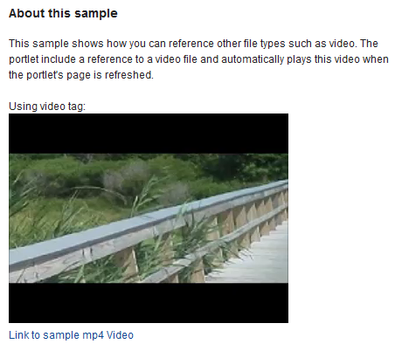

How to use the sample code
First, unzip the script_portlet_samples.zip file onto your computer. Each sample has a folder that contain the files for one Script Portlet. For each portlet there is an index.html file, a JavaScript file, sometimes a CSS file and a zip for all these individual files. You can add these items to your server so you can copy them to a page as content or link them to a page using the content toolbar. To do this run the push_all_samples command file in the samples directory. There is also a zipped version of each of the samples that you can use to import the sample into an existing script portlet.

For the samples that have no dependency on WebSphere Portal, you can actually test the application on its own simply by using a web browser to view the index.html file on your file system. For example, the jqPlot Chart and jQuery DataTables samples can be tested in this way. Then you can create Script Portlets for each sample as described next.

Here are the steps for using the code for these samples:
- Go to the Portal page where the portlet will be and go into Edit mode for the page. Add the Script Portlet to the page by selecting it from the Content tab in Edit mode. You will then see the Import button in the portlet.
- Click on the import button and select the zip file from the samples folder.
- Click the “Import” button.
Or if you have pushed them to your server you can copy them by:
- Go to the Portal page where the portlet will be and go into Edit mode for the page. Add the Script Portlet to the page by selecting it from the Content tab in Edit mode. You will then see the Import button in the portlet.
- Click on the import button and select the copy existing content tab
- Select the item you want to copy.
- Click the “Copy” button.
Or if you have pushed them to your server that has a content toolbar you can link them by:
- Go to the Portal page where the portlet will be and go into Edit mode for the page.
- Click on the create button to open the toolbar.
- Choose the Content tab.
- Click on the Script Portlet Applications.
- Click the Add button for the portlet you want to link to.
- Or drag the portlet onto your portal page.
Note there is a difference between linking to a content item and copying it. If you link any future changes to that content item affect all instances of porlets that are linked to it. It also means that if the original is deleted all the linked portlets no longer have any content. Where a copy, only the original content item is updated and if you want these changes on items that were created through copy you would need to replace them again.

You should then see the sample running in the Portlet.

References
The Script Portlet is available as a download on the Portal Catalog here: IBM Script Portlet for WebSphere Portal

