Release Notes for XPages RDBMS Enablement Project 1.0.0 (20140627)

Contents:
Introduction
Installation Instructions
Download Manifest

Introduction
The XPages RDBMS Enablement (XRE) project contains sample materials that demonstrate the capabilities of the XPages Relational Database Management System (RDBMS) feature that is part of the XPages Extension Library (ExtLib). The XRE project consists of an XPages application and an OSGi plugin which acts as a wrapper for Apache Derby.

The sample application was formerly provided as part of the XPages Extension Library itself, but has been removed from ExtLib. It now exists only in this project. The sample OSGi plugin was formerly part of the Experimental XPages Extension Library (ExtLibX), but has been removed from ExtLibX, and it also now only exists in this project.

Important Note: This project is only compatible with an IBM Domino v9.0.1 server to which release 9.0.1.v00_07 (or later) of the 9.0.1 XPages Extension Library has been installed. If your server has an earlier release of ExtLib installed, then you must upgrade to release 9.0.1.v00_07 at a minimum. The reason for this is that the XPages Relational feature migrated into the core ExtLib in the 9.0.1.v00_07 release, and other materials also needed to be relocated as part of that migration.

Installation Instructions

Download and install the 9.0.1 XPages Extension Library from OpenNTF, release 7 or later (http://extlib.openntf.org/). The instructions for that installation are provided in the ExtLib documentation.

To install the sample Apache Derby OSGi plugin, you can use one of these two methods:

1. Install via the update site
This is the recommended method for installing the sample plugin. First, unzip the contents of the updateSiteOpenNTF.zip file from the XRE project download, to a location on your machine.

If you are not familiar with using an update site, see the following page for details on the steps to create an update site on your Domino server:
http://www-10.lotus.com/ldd/ddwiki.nsf/xpAPIViewer.xsp?lookupName=XPages+Extensibility+API#action=openDocument&res_title=XPages_Extension_Library_Deployment&content=apicontent&sa=true

Next, open the Domino server's update site in the Notes client, and select the Import Local Update Site button. Selecting the Browse button here will launch a dialog that allows for the selection of a site.xml file from an Eclipse plugin project as shown in Figure 01.

Figure 01
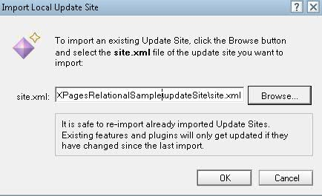
Selecting this file and pressing the OK button begins the import process. The view of the update site database will be updated with a document representing the import of the plugin as shown in Figure 02.

Figure 02

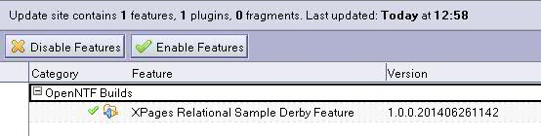
The Domino server is now ready to include this plugin as part of the runtime (the Update Site NSF must be included in the notes.ini variable OSGI_HTTP_DYNAMIC_BUNDLES – e.g. OSGI_HTTP_DYNAMIC_BUNDLES=UpdateSite1.nsf – if newly added, the Domino server will have to be restarted to pick up this notes.ini setting).

The HTTP task must be restarted on the Domino server for the runtime to pick up this new plugin - “restart task http.” If this process is successful, the following message will appear in the server console stating that “...NSF Based plugins are being installed in the OSGi runtime...”

2. Manually install the plugin to the server
The XRE zip file also contains the raw jar file that is the OSGi plugin for Apache Derby, org.openntf.xsp.relational.derby_1.0.0.yyyyMMddHHmm.jar.
This can be manually installed to a Domino server, by copying the jar file to <DOMINO_INST_DIR>/data/domino/workspace/applications/eclipse/plugins
Restart the server and the new plugin should be picked up by the runtime.

Using either of the two above installation methods, you can verify that the sample plugin is now running as part of the runtime. To do this, type “tell http osgi ss org.openntf.xsp.relational” into the Domino server console. A list should appear on the console showing the deployed sample plugin on the server as follows:

Listing 01
> tell http osgi ss org.openntf.xsp.relational
27/06/2014 13:47 Framework is launched.
27/06/2014 13:47 id State Bundle
27/06/2014 13:47 33 RESOLVED org.openntf.xsp.relational.derby_1.0.0.201406271422.jar

After installing the ExtLib and the OSGi Derby plugin to the server, you can then install the sample application (XPagesJDBC.nsf) to your server. To do this, simply copy the .NSF file to the data directory (or a subdirectory of it) on your Domino server.

Package Description of Download

When you expand the zip encapsulating this release, XPagesRDBMSEnablement_1.0.0_201406271423.zip, you will see the following artifacts as shown in Table 01.

Table 01
Artifact | Description
XPagesJDBC.nsf | A sample application that uses the XPages Relational feature and the provided Apache Derby OSGi plugin.
org.openntf.xsp.relational.derby_1.0.0.<datestamp>.jar | The sample OSGi plugin that acts as a wrapper for Apache Derby.
updateSiteOpenNTF.zip | Eclipse update site that contains the sample OSGi plugin above, which allows for easy installation to a Domino server.
srcOpenNTF.zip | Archive file containing all the sources corresponding to the XPages RDBMS Enablement (updateSiteOpenNTF.zip)
LICENSE | Details of the Apache License governing use, reproduction and distribution of the XPages RDBMS Enablement on OpenNTF.org.
NOTICE | File containing copyright notices from the various technologies that comprise this release of the XPages RDBMS Enablement.
readme.pdf | The document you are now reading.

