Laboratory 7

CS 1323, Spring 2015

# Learning Objectives

1. Write a program that compiles and executes. (10 points)
2. Create multiple String objects. (10 points)
3. Use a single String reference to access two different String objects. (10 points)
4. Create two meaningful methods that use parameters. At least one must have a non-null return value. (20 points)
5. Call both methods created above with meaningful arguments. (10 points)
6. Call one method multiple times with different arguments. (10 points)
7. Write a program that allows you to play a single preselected MadLib. (20 points)

10 points will be awarded for the proper documentation of the program, including meaningful comments, proper indentation, meaningful use of whitespace, and meaningful variable names.

Section 10: This project may be submitted and graded in lab, or on the Janux dropbox by 11:59 p.m. on Wednesday, March 4. Students in this section must attend the lab to receive credit.

Section 1: This project should be submitted in the Janux dropbox by 11:59 p.m on March 4.

# Description

Mad libs are a kids’ game. You enter categories of words (noun, place, adjective, etc.) without knowing what story they will be placed into. Then you read the stories with the substituted words. If the people who choose the words are creative and lucky, this can be really fun.

The MadLib below came from: <http://www.madglibs.com/> . Go and play the game first if you’re not familiar with it.

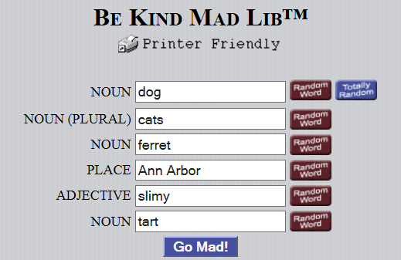

Here is the resulting story:

Be kind to your dog-footed cats  
For a duck may be somebody`s ferret,  
Be kind to your cats in Ann Arbor  
Where the weather is always slimy.  
  
You may think that this is the tart,  
Well it is.

To meet objective 3, you use one reference to refer two String objects. For example, the reference for the String object “Noun” that was used to tell the user that they should select a noun, could be replaced by the reference for the String object “dog”, entered by the user. The Mad-Lib above would therefore need only 6 String references for 12 String objects.

One method should take the descriptor (like “Noun” above), ask the user for input, and return the reference for the String object the user enters (to “dog” in the example). This method would be called six times in the Mad-Lib above.

The other method should print out the finished Mad-Lib. This method will only be called once. You will need to figure out the signature on your own.