REUSE MANUAL
NEYS
10xxxxxx.1
Implementation

Table of Contents
Table of Contents i
SECTION 1. Introduction 1
1.1 Purpose of the reuse Manual 1
1.2 PURPOSE OF THE REUSABLE SOFTWARE COMPONENT 1
1.3 GENERAL INFORMATION 2
1.3.1 POINT OF CONTACT 2
1.3.2 CERTIFICATION LEVEL 2
1.3.3 LEGAL RESTRICTIONS 2
Section 2. INSTALLATION 3
2.1 PARTIAL REUSE 3
2.2 MODIFICATIONS 3
Section 3. ENVIRONMENT 4
3.1 HARDWARE 4
3.1.1 DEVELOPMENT 4
3.1.2 TARGET 4
3.2 SOFTWARE 4
3.2.1 OPERATING SYSTEM 4
3.2.2 COMPILERS 4
3.3 ASSUMPTIONS AND PERFORMANCE LIMITATIONS 5
Section 4. Global RSC Environment 6
4.1 TYPES 6
4.2 CONSTANTS 6
4.3 VARIABLES 6
4.4 INCLUDE FILES 7
SECTION 5. FUNCTIONS 8
5.1 SET_NEYS_PARAMETERS 8
5.1.1 DESCRIPTION 8
5.1.2 INTERFACES AND EXAMPLES 8
5.1.3 DECLARATIONS 9
5.1.4 DEPENDENCIES 9
5.1.5 ERROR HANDLING 10
5.2 GET_NEYS_PARAMETERS 10
5.2.1 DESCRIPTION 10
5.2.2 INTERFACES AND EXAMPLES 10
5.2.3 DECLARATIONS 11
5.2.4 DEPENDENCIES 11
5.2.5 ERROR HANDLING 11
5.3 Convert_Geodetic_To_NEYS 11
5.3.1 DESCRIPTION 11
5.3.2 INTERFACES AND EXAMPLES 12
5.3.3 DECLARATIONS 12
5.3.4 DEPENDENCIES 13
5.3.5 ERROR HANDLING 13
5.4 Convert_NEYS_TO_GEODETIC 13
5.4.1 DESCRIPTION 13
5.4.2 INTERFACES AND EXAMPLES 13
5.4.3 DECLARATIONS 14
5.4.4 DEPENDENCIES 14
5.4.5 ERROR HANDLING 14
APPENDIX A STRUCTURE/DEPENDENCY DIAGRAMS 16
APPENDIX B DEFINITIONS/GLOSSARY 17
APPENDIX C REFERENCES 19

SECTION 1. Introduction

1.1 Purpose of the reuse Manual
This document describes the characteristics of the NEYS reusable software component and provides instructions on its installation and operation. The manual is a self-contained reference for the software engineer intending to incorporate the component in another software system. This manual was written with the assumption that the user has a basic working knowledge of C and is familiar with fundamental C concepts and terminology.

1.2 PURPOSE OF THE REUSABLE SOFTWARE COMPONENT
The purpose of NEYS is to provide a reusable component that supports the following coordinate conversions:
- Geodetic coordinates (latitude and longitude, in radians) to Ney’s (Modified Lambert Conformal Conic) projection coordinates (easting and northing, in meters) with two standard parallels,
- Ney’s (Modified Lambert Conformal Conic) projection coordinates (easting and northing, in meters) with two standard parallels to Geodetic coordinates (latitude and longitude, in radians).
A particular ellipsoid is specified in terms of the following parameters:
- Semi-Major Axis (a): Radius (in meters) at the equator, and
- Flattening (f): Ratio of the difference between the semi-major axis and polar radius of the Earth to its semi-major axis.
A particular variation of the Ney’s (Modified Lambert Conformal Conic) projection with two standard parallels is specified in terms of the following parameters:
- Central Meridian – Longitude, in radians, at the origin of the projection coordinate system,
- Origin Latitude – Latitude, in radians, at the origin of the projection coordinate system,
- 1st Standard Parallel – Latitude, in radians, of the first of the two standard parallels, where the point scale factor is 1.0,
- False Easting – A coordinate value, in meters, assigned to the central meridian of the projection to avoid the inconvenience of using negative coordinates, and
- False Northing – A coordinate value, in meters, assigned to the origin latitude of the projection to avoid the inconvenience of using negative coordinates.
Note that the second standard parallel is held constant at ±89 59 59.0°, depending on the hemisphere of the Origin Latitude.

1.3 GENERAL INFORMATION

1.3.1 POINT OF CONTACT
U.S. Army Topographic Engineering Center (USATEC)
Geospatial Information Division (GID)
ATTN: CETEC-GD-A (Dan Specht)
7701 Telegraph Road
Alexandria, VA 22315-3864
Dan Specht (703) 428 - 6761 Project Manager

1.3.2 CERTIFICATION LEVEL
This RSC has been certified at level 4. A level 4 component satisfies the criteria for reliability, testing, and documentation for the Army Reuse Center (ARC). The component comes with test materials and a Reuse Manual that aids in integrating the component into a software system.

1.3.3 LEGAL RESTRICTIONS
This Reusable Software Component (RSC) contains data with Unlimited Government Rights.

Section 2. INSTALLATION
The following is a list of the compilation files for the NEYS component:
Source Code Files:
neys.c
Header Files :
neys.h
Data Files :
none
The compilation instructions for the NEYS component are as follows:
DOS Makefile (Uses Microsoft C):

cl /nologo /W3 /FR /G2 /DNDEBUG /Gs /Ox /AM /D_DOS /c neys.c
UNIX Makefile (Uses gcc compiler):

cc -g -O -ansi -Wall -c neys.c
The compilation order of the NEYS component relative to other components is unconstrained.

2.1 PARTIAL REUSE
The NEYS component does not allow for partial reuse.

2.2 MODIFICATIONS
The NEYS component does not permit modifications.

Section 3. ENVIRONMENT
This section provides details on the environment under which NEYS was developed, tested, and executed.

3.1 HARDWARE

3.1.1 DEVELOPMENT
The following is a list of hardware configurations under which NEYS was developed and tested.
- SUN SparcStation 20
- IBM compatible Pentium PC

3.1.2 TARGET
The following is a list of hardware configurations under which NEYS was executed.
- SUN SparcStation 20
- IBM compatible Pentium PC

3.2 SOFTWARE

3.2.1 OPERATING SYSTEM
The following is a list of operating systems under which NEYS was executed and tested.
- Solaris 2.7
- Windows 2000/NT

3.2.2 COMPILERS
The following is a list of compilers on which NEYS was compiled successfully.
- GCC version 2.95.2
- Microsoft Visual C++ version 6

3.3 ASSUMPTIONS AND PERFORMANCE LIMITATIONS
There are no hardware or environment constraints. There are no limitations.
This RSC is written in ANSI C.

Section 4. Global RSC Environment

4.1 TYPES
Not applicable.

4.2 CONSTANTS
The following is a list of significant visible constants declared globally in NEYS with their descriptions.

NEYS_NO_ERROR : No errors occurred in function
NEYS_LAT_ERROR : Latitude outside of valid range
(-90 to 90 degrees)
NEYS_LON_ERROR : Longitude outside of valid range
(-180 to 360 degrees)
NEYS_EASTING_ERROR : Easting outside of valid range
(depends on ellipsoid and projection
parameters)
NEYS_NORTHING_ERROR : Northing outside of valid range
(depends on ellipsoid and projection
parameters)
NEYS_FIRST_STDP_ERROR : First standard parallel outside of valid
range (±71 or ±74 degrees)
NEYS_ORIGIN_LAT_ERROR : Origin latitude outside of valid range
(-89 59 59.0 to 89 59 59.0 degrees)
NEYS_CENT_MER_ERROR : Central meridian outside of valid range
(-180 to 360 degrees)
NEYS_A_ERROR : Semi-major axis less than or equal to zero
NEYS_INV_F_ERROR : Inverse flattening outside of valid range
(250 to 350)

4.3 VARIABLES
The following is a list of significant global variables declared in NEYS with their descriptions.

Ellipsoid Parameters:
static double Neys_a : Semi-major axis of ellipsoid, in meters
static double Neys_f : Flattening of ellipsoid

Projection Parameters:
static double Neys_Std_Parallel_1 : Lower standard parallel latitude, in radians
static double Neys_Std_Parallel_2 : Upper standard parallel latitude, in radians
static double Neys_Origin_Lat : Latitude of origin, in radians
static double Neys_Origin_Long : Longitude of origin, in radians
static double Neys_False_Easting : False easting, in meters
static double Neys_False_Northing : False northing, in meters

Maximum variance for easting and northing values:
static double Neys_Delta_Easting
static double Neys_Delta_Northing

4.4 INCLUDE FILES

math.h : Standard C math library
lambert.h : Ney’s depends on Lambert Conformal Conic neys.h : Error codes and prototype error checking

4.5 DEPENDENCIES
Besides the standard ANSI C math library, software external to the RSC also includes:
LAMBERT, since the Ney’s (Modified Lambert Conformal Conic) projection is a modified version of the Lambert Conformal Conic projection.

SECTION 5. FUNCTIONS

5.1 SET_NEYS_PARAMETERS

5.1.1 DESCRIPTION
This function sets the ellipsoid and Ney’s (Modified Lambert Conformal Conic) projection parameters to the specified values.

5.1.2 INTERFACES AND EXAMPLES
The following is a list of the formal arguments required to use this function.
long Set_Neys_Parameters (double a,
double f,
double Origin_Latitude,
double Central_Meridian,
double Std_Parallel_1,
double False_Easting,
double False_Northing);
a Semi-major axis of ellipsoid, in meters (input),
f Flattening of ellipsoid (input),
Origin_Latitude Latitude, in radians, at the origin of the projection (input),
Central_Meridian Longitude, in radians, at the origin of the projection (input),
Std_Parallel_1 Latitude, in radians, of the lower standard parallel (input),
False_Easting Coordinate value, in meters, assigned to the central meridian (input),
False_Northing Coordinate value, in meters, assigned to the origin latitude (input).
Example:
status = Set_Neys_Parameters (a, f, Origin_Latitude, Central_Meridian, Std_Parallel_1, False_Easting, False_Northing)
Inputs:
a 6378137.0
f 1 / 298.257223563
Origin_Latitude 80.0
Central_Meridian 0.0
Std_Parallel_1 71.0
False_Easting 0.0
False_Northing 0.0
Outputs:
None.

5.1.3 DECLARATIONS

5.1.3.1 TYPES
Not applicable.

5.1.3.2 CONSTANTS
Not applicable.

5.1.3.3 VARIABLES
Not applicable.

5.1.4 DEPENDENCIES
Set_Lambert_Parameters, in the LAMBERT component – used to set the parameters of the Lambert Conformal Conic projection.

5.1.5 ERROR HANDLING
This function returns the following status codes:

NEYS_NO_ERROR : No errors occurred in function
NEYS_FIRST_STDP_ERROR : First standard parallel outside of valid
range (±71 or ±74 degrees)
NEYS_ORIGIN_LAT_ERROR : Origin latitude outside of valid range
(-89 59 59.0 to 89 59 59.0 degrees)
NEYS_CENT_MER_ERROR : Central meridian outside of valid range
(-180 to 360 degrees)
NEYS_A_ERROR : Semi-major axis less than or equal to zero
NEYS_INV_F_ERROR : Inverse flattening outside of valid range
(250 to 350)

5.2 GET_NEYS_PARAMETERS

5.2.1 DESCRIPTION
This function returns the current values of the ellipsoid parameters and Ney’s (Modified Lambert Conformal Conic) projection parameters.

5.2.2 INTERFACES AND EXAMPLES
The following is a list of the formal arguments required to use this function.
void Get_Neys_Parameters (double *a,
double *f,
double *Origin_Latitude,
double *Central_Meridian,
double *Std_Parallel_1,
double *False_Easting,
double *False_Northing);
a Semi-major axis of ellipsoid, in meters (output),
f Flattening of ellipsoid (output),
Origin_Latitude Latitude, in radians, at the origin of the projection (output),
Central_Meridian Longitude, in radians, at the origin of the projection (output),
Std_Parallel_1 Latitude, in radians, of the lower standard parallel (output),
False_Easting Coordinate value, in meters, assigned to the central meridian (output),
False_Northing Coordinate value, in meters, assigned to the origin latitude (output).

5.2.3 DECLARATIONS

5.2.3.1 TYPES
Not applicable.

5.2.3.2 CONSTANTS
Not applicable.

5.2.3.3 VARIABLES
Not applicable.

5.2.4 DEPENDENCIES
None.

5.2.5 ERROR HANDLING
No errors are reported by this function.

5.3 Convert_Geodetic_To_NEYS

5.3.1 DESCRIPTION
This function converts Geodetic coordinates (latitude and longitude, in radians) to Ney’s (Modified Lambert Conformal Conic) projection coordinates (easting and northing, in meters), using the current ellipsoid and Ney’s (Modified Lambert Conformal Conic) projection parameters.

5.3.2 INTERFACES AND EXAMPLES
The following is a list of the formal arguments required to use this function.
long Convert_Geodetic_To_Neys (double Latitude,
double Longitude,
double *Easting,
double *Northing);
Latitude Latitude, in radians (input),
Longitude Longitude, in radians (input),
Easting Easting (X), in meters (output),
Northing Northing (Y), in meters (output).
Example:
status = Convert_Geodetic_To_Neys (Latitude, Longitude, Easting, Northing)
Inputs:
Latitude: 35.0
Longitude: 75.0
Outputs:
Easting: 6235144
Northing: -598756

5.3.3 DECLARATIONS

5.3.3.1 TYPES
Not applicable.

5.3.3.2 CONSTANTS
Not applicable.

5.3.3.3 VARIABLES
Not applicable.

DEPENDENCIES
Convert_Geodetic_To_Lambert, in the LAMBERT component – used to convert geodetic (latitude and longitude) coordinates to Lambert Conformal Conic (easting and northing) projection coordinates.

5.3.5 ERROR HANDLING
This function returns the following status codes:

NEYS_NO_ERROR : No errors occurred in function
NEYS_LAT_ERROR : Latitude outside of valid range
(-90 to 90 degrees)
NEYS_LON_ERROR : Longitude outside of valid range
(-180 to 360 degrees)

5.4 Convert_NEYS_TO_GEODETIC

5.4.1 DESCRIPTION
This function converts Ney’s (Modified Lambert Conformal Conic) projection coordinates (easting and northing, in meters) to Geodetic coordinates (latitude and longitude, in radians), using the current ellipsoid and Ney’s (Modified Lambert Conformal Conic) projection parameters.

5.4.2 INTERFACES AND EXAMPLES
The following is a list of the formal arguments required to use this function.
long Convert_Neys_To_Geodetic (double Easting,
double Northing,
double *Latitude,
double *Longitude);
Easting Easting (X), in meters (input),
Northing Northing (Y), in meters (input),
Latitude Latitude, in radians (output),
Longitude Longitude, in radians (output).
Example:
status = Convert_Neys_To_Geodetic (Easting, Northing, Latitude, Longitude)
Inputs:
Easting: 6235144
Northing: -598756
Outputs:
Latitude: 35.0
Longitude: 75.0

5.4.3 DECLARATIONS

5.4.3.1 TYPES
Not applicable.

5.4.3.2 CONSTANTS
Not applicable.

5.4.3.3 VARIABLES
Not applicable.

DEPENDENCIES
Convert_Lambert_To_Geodetic, in the LAMBERT component – used to convert Lambert Conformal Conic (easting and northing) projection coordinates to geodetic (latitude and longitude) coordinates.

5.4.5 ERROR HANDLING
This function returns the following status codes:

NEYS_NO_ERROR : No errors occurred in function
NEYS_EASTING_ERROR : Easting outside of valid range
(depends on ellipsoid and projection
parameters)
NEYS_NORTHING_ERROR : Northing outside of valid range
(depends on ellipsoid and projection
parameters)

APPENDIX A STRUCTURE/DEPENDENCY DIAGRAMS
This component consists of a single compilation unit and depends on the LAMBERT component and the ANSI C standard math library.

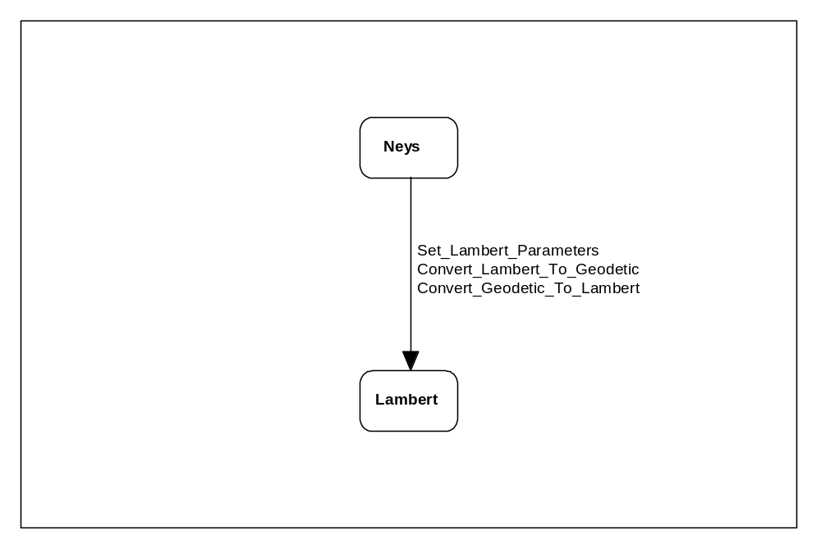

APPENDIX B DEFINITIONS/GLOSSARY
Central Meridian – Longitude at the horizontal center of a projection.
Coordinate – Linear or angular quantities that designate the position that a point occupies in a given reference frame or system. Also used as a general term to designate the particular kind of reference frame or system, such as Cartesian or spherical coordinates.
Ellipsoid – The surface generated by an ellipse rotating about one of its axes.
False Easting – A coordinate value (in meters) assigned to the central meridian of the projection to avoid the inconvenience of using negative coordinates.
False Northing – A coordinate value (in meters) assigned to the origin latitude of the projection to avoid the inconvenience of using negative coordinates.
Geodetic Coordinates – The quantities of latitude and longitude that define the position of a point on the surface of the earth with respect to the reference ellipsoid. Also, imprecisely called geographic coordinates.
Geodetic Latitude – The angle between the plane of the equator and the normal to the ellipsoid through the computation point. Geodetic latitude is positive north of the equator and negative south of the equator.
Geodetic Longitude – The angle between the plane of a meridian and the plane of the prime meridian. A longitude can be measured from the angle formed between the local and prime meridians at the pole of rotation of the reference ellipsoid, or by the arc along the equator intercepted by these meridians.
Lambert Conformal Conic Projection – A conformal projection in which the projected parallels are arcs of concentric circles centered at the pole. The projected meridians are radii of concentric circles that meet at the pole. There are one or two parallels, called standard parallels, along which the point scale factor is one.
Map Projection – A function relating coordinates of points on a curved surface (usually an ellipsoid or sphere) to coordinates of points on a plane. A map projection may be established by analytical computation or, less commonly, may be constructed geometrically.
Map Scale – The ratio between a distance on a map and the corresponding actual distance on the earth’s surface.
Meridian – A north-south reference line, particularly a great circle through the geo–graphical poles of the earth, from which longitudes and azimuths are determined; or the intersection of a plane forming a great circle that contains both geographic poles of the earth, and the ellipsoid.
Ney’s (Modified Lambert Conformal Conic) Projection – A conformal projection in which the projected parallels are complete concentric circles centered at the pole. The projected meridians are radii of concentric circles that meet at the pole. There are two parallels, called standard parallels, along which the point scale factor is one. One parallel is at either ±71 or ±74 degrees. The other parallel is at ±89 59 59.0 degrees, depending on which hemisphere the other parallel is in.
Origin Latitude – Latitude of the origin of the projected coordinate system.
Parallel – A line on the earth, or a representation thereof, which represents the same latitude at every point.
Scale Factor (Projection) – A multiplier for reducing a distance in a map projection to the actual distance on the chosen reference ellipsoid.

APPENDIX C REFERENCES
(1) Topographic Engineering Center, TEC-SR-7, Handbook for transformation of DATUMS, PROJECTIONS, GRIDS, AND COMMON COORDINATE SYSTEMS, January 1996.
(2) Snyder, J. P., Geological Survey Professional Paper 1395 Map Projections - A Working Manual, 1987.

