REUSE MANUAL
UTM
10xxxxxx.1
Implementation

Table of Contents
TABLE OF CONTENTS
SECTION 1. INTRODUCTION
1.1 PURPOSE OF THE REUSE MANUAL
1.2 PURPOSE OF THE REUSABLE SOFTWARE COMPONENT
1.3 GENERAL INFORMATION
1.3.1 POINT OF CONTACT
1.3.2 CERTIFICATION LEVEL
1.3.3 LEGAL RESTRICTIONS
SECTION 2. INSTALLATION
2.1 PARTIAL REUSE
2.2 MODIFICATIONS
SECTION 3. ENVIRONMENT
3.1 HARDWARE
3.1.1 DEVELOPMENT
3.1.2 TARGET
3.2 SOFTWARE
3.2.1 OPERATING SYSTEM
3.2.2 COMPILERS
3.3 ASSUMPTIONS AND PERFORMANCE LIMITATIONS
SECTION 4. GLOBAL RSC ENVIRONMENT
4.1 TYPES
4.2 CONSTANTS
4.3 VARIABLES
4.4 INCLUDE FILES
4.5 DEPENDENCIES
SECTION 5. FUNCTIONS
5.1 SET_UTM_PARAMETERS
5.2 GET_UTM_PARAMETERS
5.3 CONVERT_GEODETIC_TO_UTM
5.4 CONVERT_UTM_TO_GEODETIC
APPENDIX A STRUCTURE/DEPENDENCY DIAGRAMS
APPENDIX B DEFINITIONS/GLOSSARY
APPENDIX C REFERENCES

SECTION 1. Introduction

1.1 Purpose of the reuse Manual
This document describes the characteristics of the UTM reusable software component and provides instructions on its installation and operation. The manual is a self-contained reference for the software engineer intending to incorporate the component in another software system. This manual was written with the assumption that the user has a basic working knowledge of C and is familiar with fundamental C concepts and terminology.

1.2 PURPOSE OF THE REUSABLE SOFTWARE COMPONENT
The purpose of UTM is to provide a reusable software component which supports the following coordinate conversions :
- Geodetic coordinates (latitude and longitude in radians) to Universal Transverse Mercator (UTM) projection coordinates (zone, hemisphere, easting in meters, and northing in meters), with an option to specify the zone,
- Universal Transverse Mercator (UTM) projection coordinates (zone, hemisphere, easting in meters, and northing in meters) to Geodetic coordinates (latitude and longitude in radians).
A particular ellipsoid is specified in terms of the following parameters:
- Semi-Major Axis (a): Radius (in meters) at the equator, and
- Flattening (f): Ratio of the difference between the semi-major axis and polar radius of the Earth to its semi-major axis.

1.3 GENERAL INFORMATION

1.3.1 POINT OF CONTACT
U.S. Army Topographic Engineering Center (USATEC)
Geospatial Information Division (GID)
ATTN: CETEC-GD-A (Dan Specht)
7701 Telegraph Road
Alexandria, VA 22315-3864
Dan Specht (703) 428 - 6761 Project Manager

1.3.2 CERTIFICATION LEVEL
This RSC has been certified at level 4. A level 4 component satisfies the criteria for reliability, testing, and documentation for the Army Reuse Center (ARC). The component comes with test materials and a Reuse Manual that aids in integrating the component into a software system.

1.3.3 LEGAL RESTRICTIONS
This Reusable Software Component (RSC) contains data with Unlimited Government Rights.

Section 2. INSTALLATION
The following is a list of the compilation files for the UTM component:
Source Code Files:
utm.c
Header Files :
utm.h
Data Files :
none
The compilation instructions for the UTM component are as follows:
DOS Makefile (Uses Microsoft C):

cl /nologo /W3 /FR /G2 /DNDEBUG /Gs /Ox /AM /D_DOS /c utm.c
UNIX Makefile (Uses gcc compiler):

cc -g -O -ansi -Wall -c utm.c
The compilation order of the UTM component relative to other components is unconstrained.

2.1 PARTIAL REUSE
The UTM component does not allow for partial reuse.

2.2 MODIFICATIONS
The UTM component does not permit modifications.

Section 3. ENVIRONMENT
This section provides details on the environment under which UTM was developed, tested, and executed.

3.1 HARDWARE

3.1.1 DEVELOPMENT
The following is a list of hardware configurations under which UTM was developed and tested.
- SUN SparcStation 20
- IBM compatible Pentium PC

3.1.2 TARGET
The following is a list of hardware configurations under which UTM was executed.
- SUN SparcStation 20
- IBM compatible Pentium PC

3.2 SOFTWARE

3.2.1 OPERATING SYSTEM
The following is a list of operating systems under which UTM was executed and tested.
- Solaris 2.7
- Windows 2000/NT

3.2.2 COMPILERS
The following is a list of compilers on which UTM was compiled successfully.
- GCC version 2.95.2
- Microsoft Visual C++ version 6

3.3 ASSUMPTIONS AND PERFORMANCE LIMITATIONS
There are no hardware or environment constraints. There are no limitations.
This RSC is written in ANSI C.

Section 4. Global RSC Environment

4.1 TYPES
Not applicable.

4.2 CONSTANTS
The following is a list of significant visible constants declared globally in UTM with their descriptions.

UTM_NO_ERROR : No errors occurred in function
UTM_LAT_ERROR : Latitude outside of valid range
(-80.5 to 84.5 degrees)
UTM_LON_ERROR : Longitude outside of valid range
(-180 to 360 degrees)
UTM_EASTING_ERROR : Easting outside of valid range
(100,000 to 900,000m)
UTM_NORTHING_ERROR : Northing outside of valid range
(0 to 10,000,000m)
UTM_ZONE_ERROR : Zone outside of valid range
(1 to 60)
UTM_HEMISPHERE_ERROR : Invalid hemisphere (‘N’ or ‘S’)
UTM_ZONE_OVERRIDE_ERROR : Zone outside of valid range
(1 to 60, within 1 of ‘natural’ zone)
UTM_A_ERROR : Semi-major axis less than or equal to zero
UTM_INV_F_ERROR : Inverse flattening outside of valid range
(250 to 350)

4.3 VARIABLES
The following is a list of significant global variables declared in UTM with their descriptions.

Ellipsoid Parameters:
static double UTM_a : Semi-major axis of ellipsoid in meters
static double UTM_f : Flattening of ellipsoid

Zone Override:
static long UTM_Zone_Override : Override zone

4.4 INCLUDE FILES

tranmerc.h : UTM depends on Transverse Mercator
utm.h : Used for prototype checking

4.5 dependencies
The following is a list of the software external to the RSC and its descriptions.
TRANSVERSE MERCATOR, since the Universal Transverse Mercator projection in each zone is a special case of the Transverse Mercator projection.

SECTION 5. FUNCTIONS

5.1 SET_UTM_PARAMETERS

5.1.1 DESCRIPTION
This function sets the ellipsoid parameters, and optional zone override parameter, to the specified values.

5.1.2 INTERFACES AND EXAMPLES
The following is a list of the formal arguments required to use this function.
long Set_UTM_Parameters (double a,
double f,
long Override_Zone)
a Semi-major axis of ellipsoid in meters (input),
f Flattening of ellipsoid (input),
Override_Zone UTM zone to be used in subsequent coordinate conversions, zero indicates no override specified (input).
Example:
status = Set_UTM_Parameters (a, f, Override_Zone)
Inputs:
a 6378137.0
f 1 / 298.257223563
Override_Zone 0 (no override specified)
Outputs:
None.

5.1.3 DECLARATIONS

5.1.3.1 TYPES
Not applicable.

5.1.3.2 CONSTANTS
Not applicable.

5.1.3.3 VARIABLES
Not applicable.

5.1.4 DEPENDENCIES
None.

5.1.5 ERROR HANDLING
This function returns the following status codes:

UTM_NO_ERROR : No errors occurred in function
UTM_ZONE_OVERRIDE_ERROR : Zone outside of valid range
(1 to 60, within 1 of ‘natural’ zone)
UTM_A_ERROR : Semi-major axis less than or equal to zero
UTM_INV_F_ERROR : Inverse flattening outside of valid range
(250 to 350)

5.2 GET_UTM_PARAMETERS

5.2.1 DESCRIPTION
This function returns the current values of the ellipsoid parameters, and optional zone override parameter.

5.2.2 INTERFACES AND EXAMPLES
The following is a list of the formal arguments required to use this function.
void Get_UTM_Parameters (double *a,
double *f,
long *Override)
a Semi-major axis of ellipsoid in meters (output),
f Flattening of ellipsoid (output),
Override UTM zone to be used in subsequent coordinate conversions, zero indicates no override specified (output).

5.2.3 DECLARATIONS

5.2.3.1 TYPES
Not applicable.

5.2.3.2 CONSTANTS
Not applicable.

5.2.3.3 VARIABLES
Not applicable.

5.2.4 DEPENDENCIES
None.

5.2.5 ERROR HANDLING
No errors are reported by this function.

5.3 Convert_Geodetic_To_UTM

5.3.1 DESCRIPTION
This function converts Geodetic coordinates (latitude and longitude in radians) to Universal Transverse Mercator (UTM) projection coordinates (zone, hemisphere, easting in meters, and northing in meters), using the current ellipsoid parameters, and the optional zone override parameter.

5.3.2 INTERFACES AND EXAMPLES
The following is a list of the formal arguments required to use this function.
long Convert_Geodetic_To_UTM (double Latitude,
double Longitude,
long *Zone,
char *Hemisphere,
double *Easting,
double *Northing)
Latitude Latitude in radians (input),
Longitude Longitude in radians (input),
Zone UTM zone (1 to 60) (output),
Hemisphere Northern (‘N’) or Southern (‘S’) hemisphere (output),
Easting Easting (X) in meters (output),
Northing Northing (Y) in meters (output).
Example:
status = Convert_Geodetic_To_UTM (Latitude, Longitude, Zone, Hemisphere, Easting, Northing)
Inputs:
Latitude: 35.0
Longitude: -75.0
Outputs:
Zone: 18
Hemisphere: ‘N’
Easting: 500000
Northing: 3873042

5.3.3 DECLARATIONS

5.3.3.1 TYPES
Not applicable.

5.3.3.2 CONSTANTS
Not applicable.

5.3.3.3 VARIABLES
Not applicable.

5.3.4 DEPENDENCIES
Set_Transverse_Mercator_Parameters, in the TRANSVERSE MERCATOR component – used to set the parameters of the Mercator projection, and
Convert_Geodetic_To_Transverse_Mercator, in the TRANSVERSE MERCATOR component – used to convert geodetic (latitude and longitude) coordinates to Transverse Mercator (easting and northing) projection coordinates.

5.3.5 ERROR HANDLING
This function returns the following status codes:

UTM_NO_ERROR : No errors occurred in function
UTM_LAT_ERROR : Latitude outside of valid range
(-80.5 to 84.5 degrees)
UTM_LON_ERROR : Longitude outside of valid range
(-180 to 360 degrees)
UTM_EASTING_ERROR : Easting outside of valid range
(100,000 to 900,000m)
UTM_NORTHING_ERROR : Northing outside of valid range
(0 to 10,000,000m)
UTM_ZONE_OVERRIDE_ERROR : Zone outside of valid range
(1 to 60, within 1 of ‘natural’ zone)

5.4 Convert_UTM_TO_GEODETIC

5.4.1 DESCRIPTION
This function converts Universal Transverse Mercator (UTM) projection coordinates (zone, hemisphere, easting in meters, and northing in meters) to Geodetic coordinates (latitude and longitude in radians), using the current ellipsoid parameters.

5.4.2 INTERFACES AND EXAMPLES
The following is a list of the formal arguments required to use this function.
long Convert_UTM_To_Geodetic (long Zone,
char Hemisphere,
double Easting,
double Northing,
double *Latitude,
double *Longitude)
Zone UTM zone (1 to 60) (input),
Hemisphere Northern (‘N’) or Southern (‘S’) hemisphere (input),
Easting Easting (X) in meters (input),
Northing Northing (Y) in meters (input),
Latitude Latitude in radians (output),
Longitude Longitude in radians (output).
Example:
status = Convert_UTM_To_Geodetic (Zone, Hemisphere, Easting, Northing, Latitude, Longitude)
Inputs:
Zone: 18
Hemisphere: ‘N’
Easting: 500000
Northing: 3873042
Outputs:
Latitude: 35.0
Longitude: -75.0

5.4.3 DECLARATIONS

5.4.3.1 TYPES
Not applicable.

5.4.3.2 CONSTANTS
Not applicable.

5.4.3.3 VARIABLES
Not applicable.

5.4.4 DEPENDENCIES
Set_Transverse_Mercator_Parameters, in the TRANSVERSE MERCATOR component – used to set the parameters of the Mercator projection, and
Convert_Transverse_Mercator_To_Geodetic, in the TRANSVERSE MERCATOR component – used to convert Transverse Mercator (easting and northing) projection coordinates to geodetic (latitude and longitude) coordinates.

5.4.5 ERROR HANDLING
This function returns the following status codes:

UTM_NO_ERROR : No errors occurred in function
UTM_LAT_ERROR : Latitude outside of valid range
(-80.5 to 84.5 degrees)
UTM_EASTING_ERROR : Easting outside of valid range
(100,000 to 900,000m)
UTM_NORTHING_ERROR : Northing outside of valid range
(0 to 10,000,000m)
UTM_ZONE_ERROR : Zone outside of valid range
(1 to 60)
UTM_HEMISPHERE_ERROR : Invalid hemisphere (‘N’ or ‘S’)

APPENDIX A STRUCTURE/DEPENDENCY DIAGRAMS
This component consists of a single compilation unit and depends on the TRANSVERSE MERCATOR component.
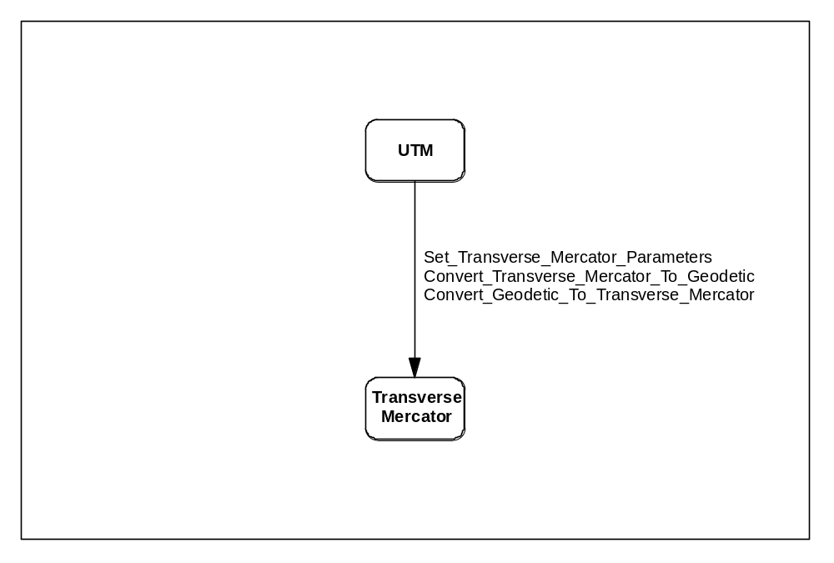

APPENDIX B DEFINITIONS/GLOSSARY
Coordinate – Linear or angular quantities that designate the position that a point occupies in a given reference frame or system. Also used as a general term to designate the particular kind of reference frame or system, such as Cartesian or spherical coordinates.
Ellipsoid – The surface generated by an ellipse rotating about one of its axes.
Geodetic Coordinates – The quantities of latitude and longitude that define the position of a point on the surface of the earth with respect to the reference ellipsoid. Also, imprecisely called geographic coordinates.
Geodetic Latitude – The angle between the plane of the equator and the normal to the ellipsoid through the computation point. Geodetic latitude is positive north of the equator and negative south of the equator.
Geodetic Longitude – The angle between the plane of a meridian and the plane of the prime meridian. A longitude can be measured from the angle formed between the local and prime meridians at the pole of rotation of the reference ellipsoid, or by the arc along the equator intercepted by these meridians.
Map Projection – A function relating coordinates of points on a curved surface (usually an ellipsoid or sphere) to coordinates of points on a plane. A map projection may be established by analytical computation or, less commonly, may be constructed geometrically.
Meridian – A north-south reference line, particularly a great circle through the geo–graphical poles of the earth, from which longitudes and azimuths are determined; or the intersection of a plane forming a great circle that contains both geographic poles of the earth, and the ellipsoid.
Parallel – A line on the earth, or a representation thereof, that represents the same latitude at every point.
Transverse Mercator Projection – A conformal projection for which the scale factor is one along the central meridian. The line Y = 0 is the projection of the equator, and the line X=0 is the projection of the central meridian.
Universal Transverse Mercator (UTM) Projection – A family of projections based on the Transverse Mercator projection, in which the ellipsoid is divided into 60 longitudinal zones fo 6 degress each. The X value, called the easting, has a value of 500,000m at the central meridian of each zone. The Y value, called the northing, has a value of 0m at the equator for the northern hemisphere, increasing toward the north pole, and a value of 10,000,000m at the equator for the southern hemisphere, decreasing toward the south pole. The point scale factor along the central meridian is 0.9996.

APPENDIX C REFERENCES
(1) Topographic Engineering Center, TEC-SR-7, Handbook for transformation of DATUMS, PROJECTIONS, GRIDS, AND COMMON COORDINATE SYSTEMS, January 1996.

