<config>  
<output path=’C:\Users\ndavis\git\OnfInfoModelOutput\ModelDescriptions\TR-512.A.13_OnfCoreIm-Appendix-SoftwareExamples.docx' />  
</config>

<context model=’C:\Users\ndavis\git\ONFInfoModel\OnfModel\CoreModel.uml' element=’{0}’ importedBundles='gmf;papyrus' searchMetamodels='true'/>

<gendoc><drop/>

Change path substrings above from “{path for output files}\” to your local path for the output files and “{path for CoreModel}\” to your local path for the Core Model. <drop/>

DELETE: Prior to publishing this –gd.docx (including for review), change path substrings above from “C:\Users\ndavis\git\OnfInfoModelOutput\” to “{path for output files}\” and from “C:\Users\ndavis\git\ONFInfoModel\OnfModel\” to “{path for CoreModel}\” <drop/>



Core Information Model (CoreModel)

TR-512.A.13

Appendix – Software Examples

Version 1.4

November 2018

ONF Document Type: Technical Recommendation

ONF Document Name: Core Information Model version 1.4

**Disclaimer**

THIS SPECIFICATION IS PROVIDED “AS IS” WITH NO WARRANTIES WHATSOEVER, INCLUDING ANY WARRANTY OF MERCHANTABILITY, NONINFRINGEMENT, FITNESS FOR ANY PARTICULAR PURPOSE, OR ANY WARRANTY OTHERWISE ARISING OUT OF ANY PROPOSAL, SPECIFICATION OR SAMPLE.

Any marks and brands contained herein are the property of their respective owners.

Open Networking Foundation

1000 El Camino Real, Suite 100, Menlo Park, CA 94025

[www.opennetworking.org](http://www.opennetworking.org)

©2017 Open Networking Foundation. All rights reserved.

Open Networking Foundation, the ONF symbol, and OpenFlow are registered trademarks of the Open Networking Foundation, in the United States and/or in other countries. All other brands, products, or service names are or may be trademarks or service marks of, and are used to identify, products or services of their respective owners.

Finalizing this document once generated… delete this text prior to publication:

* Replace “{{..}}” with square brackets (which trip up Gendoc)
* Select text in document from beginning of table of contents (first line) to end of document
  + Click menu item “Update Field” (on this large block of text)
    - if “Update Table…” dialogue appears select “Update entire table”
  + Repeat “update fields” 2 more times (on the same large block of text)
    - if “Update Table…” dialogue appears select “Update entire table”
* Remove reviewer comment

Note that the table of contents and figures need to be updated several times as the table length changes the page numbering and the cross references will need to be re-updated.

Table of Contents

Disclaimer 2

Open Networking Foundation 2

Document History 3

1 Introduction 4

1.1 References 4

1.2 Definitions 4

1.3 Conventions 4

1.4 Viewing UML diagrams 4

1.5 Understanding the figures 4

1.6 Appendix Overview 4

2 Introduction to this Appendix document 5

3 General Examples 5

3.1 Routing ‘Process’ on a Router 5

3.2 Simple Host with Host OS VMM 7

3.3 Simple Host with Container Engine and Containers 9

3.4 CPU, Memory & Storage Example 10

3.5 FPGA Example 11

3.6 Soft Switch Example 13

3.7 Constraint Domain Example 15

List of Figures

Figure 1-1 Methodology of IM and DS Development **Error! Bookmark not defined.**

Document History

| **Version** | **Date** | **Description of Change** |
| --- | --- | --- |
| 1.4 | November 2018 | Version 1.4 (Initial Version) |

# Introduction

This document is an addendum to the TR-512_v1.4 ONF Core Information Model and forms part of the description of the ONF-CIM. For general overview material and references to the other parts refer to [TR-512.1](../TR-512.1_OnfCoreIm-Overview.pdf).

## References

For a full list of references see [TR-512.1](../TR-512.1_OnfCoreIm-Overview.pdf).

## Definitions

For a full list of definition see [TR-512.1](../TR-512.1_OnfCoreIm-Overview.pdf).

## Conventions

See [TR-512.1](../TR-512.1_OnfCoreIm-Overview.pdf) for an explanation of:

* UML conventions
* Lifecycle Stereotypes
* Diagram symbol set

## Viewing UML diagrams

Some of the UML diagrams are very dense. To view them either zoom (sometimes to 400%) or open the associated image file (and zoom appropriately) or open the corresponding UML diagram via Papyrus (for each figure with a UML diagram the UML model diagram name is provided under the figure or within the figure).

## Understanding the figures

Figures showing fragments of the model using standard UML symbols and also figures illustrating application of the model are provided throughout this document. Many of the application-oriented figures also provide UML class diagrams for the corresponding model fragments (see [TR-512.1](../TR-512.1_OnfCoreIm-Overview.pdf) for diagram symbol sets). All UML diagrams depict a subset of the relationships between the classes, such as inheritance (i.e. specialization), association relationships (such as aggregation and composition), and conditional features or capabilities. Some UML diagrams also show further details of the individual classes, such as their attributes and the data types used by the attributes.

## Appendix Overview

This document is part of the Appendix to TR-512. An overview of the Appendix is provided in [TR-512.A.1](TR-512.A.1_OnfCoreIm-AppendixOverview.pdf).

# Introduction to this Appendix document

This document provides examples of the use of the CIM software model.

The examples in this document extend the simple examples given in [TR-512.12](TR-512.12_OnfCoreIm-Software.pdf).

# General Examples

## Routing ‘Process’ on a Router

Assume a scenario where an OSPF software process can support multiple OSPF instances.

The software is installed as a single binary (unit of installation).

The device lists the running processes, so we can track the routing software process.



Figure 6-17 The Routing “process” on router

Figure 2 shows the instance diagram equivalent of figure 1.

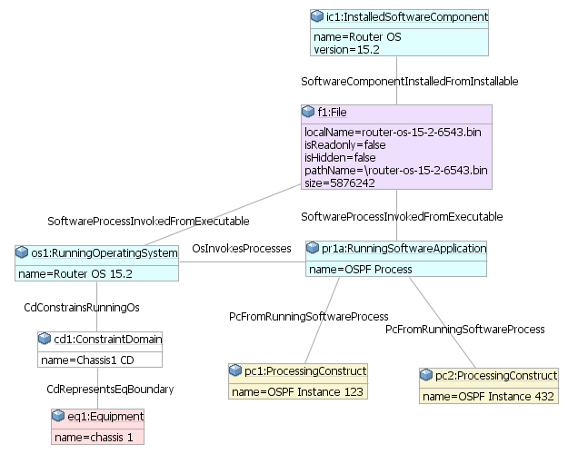

Figure 6-17 The instance model for the routing “process” on router

Note that here we are using a ConstraintDomain that is related to a physical boundary for the operating system. Another alternative could be to use an existing ‘NetworkElement’ boundary or to use an existing ControlConstruct control domain boundary.

## Simple Host with Host OS VMM

This is a more complex example because there is also the VMM/VM virtualization layer to represent.

Assume that a host runs a VMM as a process under its operating system (rather than a bare metal VMM). The host operating system is also running other normal software processes. The VMM is running many VMs.

One thing to note is that there are two separate ‘namespaces’ in this example (which can be conveniently represented using a ConstraintDomain). Both the guest and the host operating systems can have separate files such as c:\word\myDoc.doc with different content, because these are in different FileSystems. Also the guest and the host operating systems can both have separate software processes with the same process id.



Figure 6-17 Simple host with host OS VMM

Note also that because the ONF CIM doesn’t currently have a storage model, the FileSystem instance has been directly related to the ConstraintDomain (FileSystemWithinCD). If a storage model is added in the future, then this association needs to be removed and replaced with an association to the storage function.

The control point of view will be explored in a later example, so it has deliberately been omitted from these earlier examples to simplify the diagrams and help focus on the software aspects.

The figure below shows the instance diagram equivalent of the figure above.

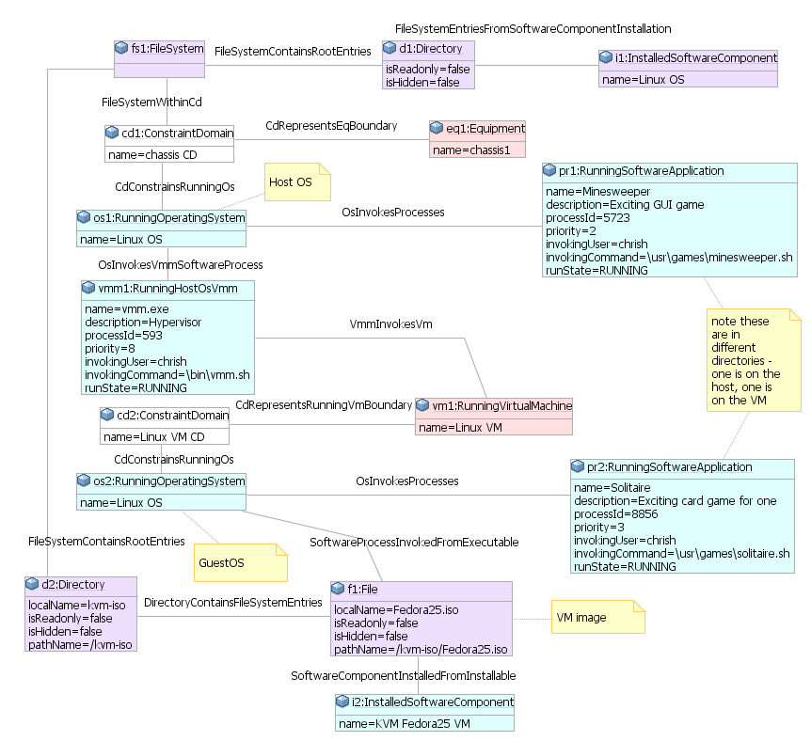

Figure 6-17 Instance model for simple host with host OS VMM

Note that there are two operating system instances in the example (host and guest).

Note that here we are using a ConstraintDomain that is related to a physical boundary for the host operating system. The guest operating system’s ConstraintDomain is the Linux VM. Another alternative could be to use an existing ‘NetworkElement’ boundary or to use an existing ControlConstruct control domain boundary.

## Simple Host with Container Engine and Containers

This is very similar to the VMM / VM case

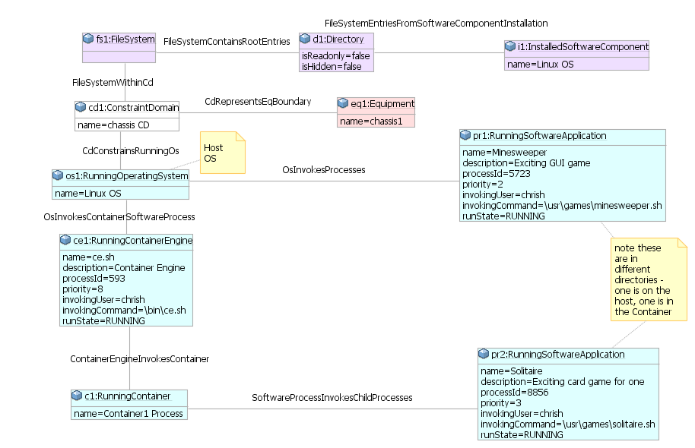

Figure 6-17 Instance model for simple host with container engine and containers

Note that there is only one operating system instance in the example.

Note that here we are using a ConstraintDomain that is related to a physical boundary for the operating system. Another alternative could be to use an existing ‘NetworkElement’ boundary or to use an existing ControlConstruct control domain boundary.

## CPU, Memory & Storage Example

We now have all of the model concepts that we need to show how we can link software processes to hardware.

Assume that we have a chassis holding compute blades. Each blade is essentially separate, so we can create a constraint domain relating to each physical blade boundary.



Figure 6-17 Compute blade in a chassis

Note that at this stage, we don’t have classes to represent CPU or Memory (or Storage) in the ONF CIM, so what we are showing below are just placeholder instances showing how future classes could link in.

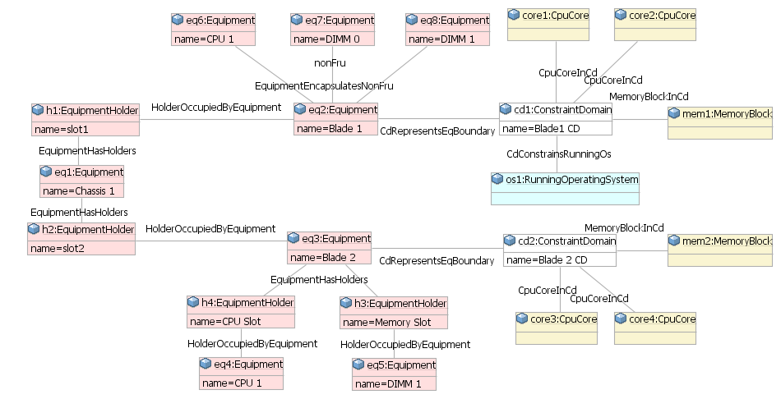

Figure 6-17 Instance model for compute blade in a chassis

## FPGA Example

In this example we will focus on a single physical blade and then focus on a FPGA within that blade.

There could be many variations in an actual implementation, so this example should be seen as ‘illustrative’ rather than ‘definitive’.

Assuming that our physical unit is a blade server in a chassis, it will be represented as in our previous example.

We then create a new ConstraintDomain for our FPGA and represent the software and functions within the FPGA. Note that the information available from the FPGA may be limited or comprehensive, depending on the implementation.



Figure 6-17 Field Programable Gate Array (FPGA)

Figure 9 shows the instance diagram equivalent of figure 8.

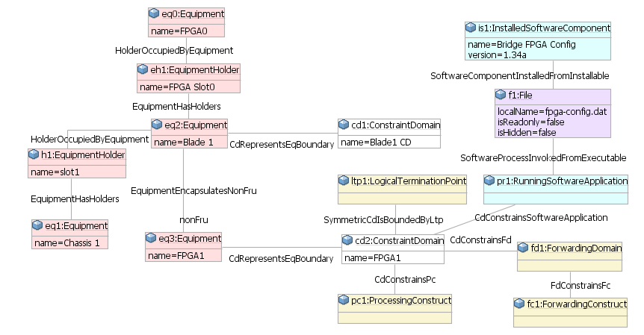

Figure 6-17 instance model for an FPGA

## Soft Switch Example

There are a number of soft switches available, both vendor proprietary and open source.

We will use Open vSwitch for our example because it is well known and has useful documentation.

An Open vSwitch could be running directly on a server or via a VM or container. This example shows the direct case, but it can be combined with the previous examples for the other cases.



Figure 6-17 Soft switch example

We can see from the documentation extracts above that the vSwitch process can support many bridges (the functional switch blocks).

Our block diagram is consistent with our previous examples, but now we are also showing detail within each ProcessingConstruct and the related ForwardingDomain and its ports and the related LTP.

Note that in this case the legacy NetworkElement concept has been used to define the constraint boundary – of course a physical boundary or ControlDomain constraint boundary will also work.



Figure 6-17 Ethernet bridge

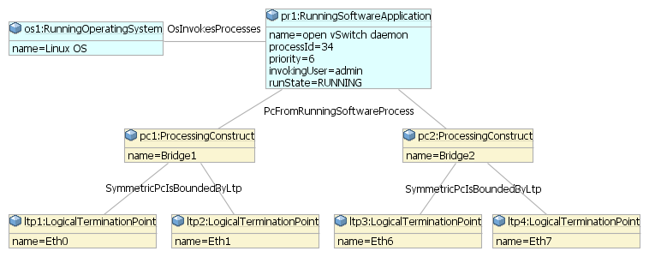

Figure 6-17 Instance example for Ethernet bridge

In some cases a port on one bridge and a port on another bridge may go to the same hardware port.

## Constraint Domain Example

Now we will look at how the software model aligns with the ControlConstruct concept.

The figure below shows a diagram modified from the previous “Simple Host with Host OS VMM” example.

Adding the control information adds a lot of complexity to the diagram (which is why it has been left off the previous examples).

There may be a number of variations to this example, but a common scenario is where there is:

* a management interface to manage the host operating system
* a separate management interface to manage the VMM and to enable the creation, configuration and removal of VMs (often provided with the VMM software)
* a management interface to manage each of the guest operating systems



Figure 6-17 Considering control

Note that the diagram highlights the information available from each ControlConstruct. The references that cross the ControlDomain boundaries are the ones that a network management system will need to stitch together to provide a consistent end-to-end view.

**End of Document**

</gendoc><drop/>

To take latest template: <drop/>

* delete text from “Template version…” to end of file <drop/>
* insert a line in “Normal” style<drop/>
* insert text (Insert 🡪 Object 🡪 Text from File… (alt njf)) from: <drop/>
  + TR-512.GT_OnfCoreIm-CommonGendocTemplate-Fragments.docx <drop/>

Template version 0.0.11 1 June 2018 <drop/>

# Fragment: Insert class <drop/>

<fragment name=’insertClass’ importedBundles=’commons;gmf;papyrus’><drop/>  
<arg name=’cl’ type=’uml::Class’/><drop/>  
<arg name=’className’ type=’String’/><drop/>  
<arg name=’packageName’ type=’String’/><drop/>  
[if (not cl.qualifiedName.contains(packageName))]<drop/>  
[else] <drop/>  
[if(cl.name.contains(className))]<drop/>

Qualified Name: [cl.qualifiedName/]

[if cl.ownedComment->notEmpty()]<drop/>

[for (co:Comment | cl.ownedComment)] <drop/>

<dropEmpty>[cleanAndFormat(co._body.clean())/]</dropEmpty>

[/for]<drop/>

[else]To be provided

[/if]<drop/>

[if (cl.isAbstract)]<drop/>

This class is abstract.

[/if]<drop/>

[if (cl.oclAsType(uml::Class).general ->notEmpty())]<drop/>

Inherits properties from:

[for (gen:Class | cl.oclAsType(uml::Class).general)]<drop/>

* [gen.name/]

[/for]<drop/>

[/if]<drop/>

[for (st:Stereotype | cl.getAppliedStereotypes())]<drop/>  
[if(not st.name.contains(‘OpenModelClass’))]<drop/>

This class is [st.name/].

[else] <drop/>  
[/if]<drop/>  
[/for]<drop/>  
[else] <drop/>  
[/if]  
[/if]  
</fragment><drop/>

# Fragment: Insert standard diagram <drop/>

<fragment name=’insertStandardDiagram’ importedBundles=’commons;gmf;papyrus’><drop/>  
<arg name=’p’ type=’uml::Package’/><drop/>  
<arg name=’diagramName’ type=’String’/><drop/>  
<arg name=’diagramTitle’ type=’String’/><drop/>

[for (d:Diagram|p.getPapyrusDiagrams())]<drop/>

[if d.name.contains(diagramName)]

<drop/>

<image object='[d.getDiagram()/]' maxW='true' keepH='false' keepW = ‘false’></image>

CoreModel diagram: [d.name/]

Figure 6-2 [diagramTitle/]

[else]<drop/>

[/if]<drop/>

[/for]<drop/>  
</fragment><drop/>

# Fragment: Insert small diagram <drop/>

<fragment name=’insertSmallDiagram’ importedBundles=’commons;gmf;papyrus’><drop/>  
<arg name=’p’ type=’uml::Package’/><drop/>  
<arg name=’diagramName’ type=’String’/><drop/>  
<arg name=’diagramTitle’ type=’String’/><drop/>

[for (d:Diagram|p.getPapyrusDiagrams())]<drop/>

[if d.name.contains(diagramName)]

<drop/>

<image object='[d.getDiagram()/]' maxW='true' keepH='false' keepW = ‘false’></image>

CoreModel diagram: [d.name/]

Figure 6-2 [diagramTitle/]

[else]<drop/>

[/if]<drop/>

[/for]<drop/>  
</fragment><drop/>

# Fragment: Insert attribute row brief not Obsolete<drop/>

<fragment name=’insertAttributeRowBriefNotObsolete’ importedBundles=’commons;gmf;papyrus’><drop/>

Does not work unless we have Mature stereotype… <drop/>  
<arg name=’p’ type=’uml::Property’/><drop/>

[for (st:Stereotype | p.getAppliedStereotypes())]<drop/>

[if(not st.name.contains(‘OpenModelAttribute’))]

[if(not st.name.contains(‘Obsolete’))]

| [p.name/] | [for (st:Stereotype | p.getAppliedStereotypes())]<drop/>  [if(not st.name.contains(‘OpenModelAttribute’))] [st.name/]  [/if]<drop/>  [/for]<drop/>  Do NOT remove the previous line as word throws an error if the cell is empty <drop/> | [if p.ownedComment->notEmpty()]<drop/>  [for (c:Comment | p.ownedComment)] <drop/>  [cleanAndFormat(c._body.clean())/]  [/for]  [else] [if (p.name.contains (‘_’))]See referenced class  [else]To be provided  [/if]<drop/>  [/if]<drop/>  Do NOT remove the previous line as word throws an error if the cell is empty <drop/> |
| --- | --- | --- |

[/if]<drop/>

[/if]<drop/>

[/for]<drop/>  
</fragment><drop/>

# Fragment: Insert attribute row brief <drop/>

<fragment name=’insertAttributeRowBrief’ importedBundles=’commons;gmf;papyrus’><drop/>  
<arg name=’p’ type=’uml::Property’/><drop/>

| [p.name/] | [for (st:Stereotype | p.getAppliedStereotypes())]<drop/>  [if(not st.name.contains(‘OpenModelAttribute’))] [st.name/]  [/if]<drop/>  [/for]<drop/>  Do NOT remove the previous line as word throws an error if the cell is empty <drop/> | [if p.ownedComment->notEmpty()]<drop/>  [for (c:Comment | p.ownedComment)] <drop/>  [cleanAndFormat(c._body.clean())/]  [/for]  [else] [if (p.name.contains (‘_’))]See referenced class  [else]To be provided  [/if]<drop/>  [/if]<drop/>  Do NOT remove the previous line as word throws an error if the cell is empty <drop/> |
| --- | --- | --- |

</fragment><drop/>

# Fragment: Start attribute table brief <drop/>

<fragment name=’insertAttributeTableHeader’ importedBundles=’commons;gmf;papyrus’><drop/>  
<arg name=’cl’ type=’uml::Class’/><drop/>

|  |  |  |
| --- | --- | --- |
| **Attribute Name** | **Lifecycle Stereotype (empty = Mature)** | **Description** |

</fragment><drop/>

# Fragment: Insert Attribute table brief <drop/>

<fragment name=’insertAttributeTableBrief’ importedBundles=’commons;gmf;papyrus’ importedFragments='insertAttributeTableHeader;insertAttributeRowBrief’><drop/>  
<arg name=’cl’ type=’uml::Class’/><drop/>  
[if cl.ownedAttribute->notEmpty()]<drop/>

Table 1: Attributes for [cl.name/]

<table><drop/>

[cl.insertAttributeTableHeader ()/]

[for (p:Property|cl.ownedAttribute)]<drop/>

[if (not p.name.contains(‘_’))]<drop/>

[p.insertAttributeRowBrief ()/]

[/if]<drop/>

[/for]<drop/>

[for (p:Property|cl.ownedAttribute)]<drop/>

[if (p.name.contains(‘_’))]<drop/>

[p.insertAttributeRowBrief ()/]

[/if]<drop/>

[/for]<drop/>

</table><drop/>

[/if]<drop/>

</fragment><drop/>

# Fragment: Insert Ten Specified Attribute table brief <drop/>

<fragment name=’insertTenSpecifiedAttributeTableBrief’ importedBundles=’commons;gmf;papyrus’ importedFragments='insertAttributeTableHeader;insertAttributeRowBrief’><drop/>  
<arg name=’cl’ type=’uml::Class’/><drop/>

<arg name=’p1’ type=‘String’/><drop/>

<arg name=’p2’ type=‘String’/><drop/>  
<arg name=’p3’ type=‘String’/><drop/>  
<arg name=’p4’ type=‘String’/><drop/>  
<arg name=’p5’ type=‘String’/><drop/>  
<arg name=’p6’ type=‘String’/><drop/>  
<arg name=’p7’ type=‘String’/><drop/>  
<arg name=’p8’ type=‘String’/><drop/>  
<arg name=’p9’ type=‘String’/><drop/>  
<arg name=’p10’ type=‘String’/><drop/>  
[if cl.ownedAttribute->notEmpty()]<drop/>

Table 1: Attributes for [cl.name/]

<table><drop/>

[cl.insertAttributeTableHeader ()/]

[for (p:Property|cl.ownedAttribute)]<drop/>

[if (p.name.contains(p1) or p.name.contains(p2) or p.name.contains(p3) or p.name.contains(p4) or p.name.contains(p5) or p.name.contains(p6) or p.name.contains(p7) or p.name.contains(p8) or p.name.contains(p9) or p.name.contains(p10))]<drop/>

[if (not p.name.contains(‘_’))]<drop/>

[p.insertAttributeRowBrief ()/]

[/if]<drop/>

[/if]<drop/>

[if (p.name.contains(p1) or p.name.contains(p2) or p.name.contains(p3) or p.name.contains(p4) or p.name.contains(p5) or p.name.contains(p6) or p.name.contains(p7) or p.name.contains(p8) or p.name.contains(p9) or p.name.contains(p10))]<drop/>

[if (p.name.contains(‘_’))]<drop/>

[p.insertAttributeRowBrief ()/]

[/if]<drop/>

[/if]<drop/>

[/for]<drop/>

</table><drop/>

[/if]<drop/>

</fragment><drop/>

# Fragment: Insert DataType <drop/>

<fragment name=’insertDataType’ importedBundles=’commons;gmf;papyrus’><drop/>  
<arg name=’dt’ type=’uml::DataType’/><drop/>  
<arg name=’dataTypeName’ type=’String’/><drop/>  
<arg name=’packageName’ type=’String’/><drop/>  
[if (dt.qualifiedName.contains(packageName))]<drop/>  
[if(dt.name.contains(dataTypeName))]<drop/>

Qualified Name: [dt.qualifiedName/]

[for (co:Comment | dt.ownedComment)]<drop/>

<dropEmpty>[cleanAndFormat(co._body.clean())/]</dropEmpty>

[/for]<drop/>  
[if (dt.oclAsType(uml::DataType).general ->notEmpty())]<drop/>

Inherits properties from:

[for (tp:DataType | dt.oclAsType(uml::DataType).general)]<drop/>

* [tp.name/]

[/for]<drop/>

[for (gen:Class | dt.oclAsType(uml::DataType).general)]<drop/>

* [gen.name/]

[/for]<drop/>

[/if]<drop/>

[for (st:Stereotype | dt.getAppliedStereotypes())]<drop/>  
This class is [st.name/].

[/for]<drop/>  
[else] <drop/>  
[/if]  
[/if]  
</fragment><drop/>

# Fragment: Start Data Type attribute table brief <drop/>

<fragment name=’insertDataTypeAttributeTableHeader’ importedBundles=’commons;gmf;papyrus’><drop/>  
<arg name=’dt’ type=’uml::DataType’/><drop/>

|  |  |  |
| --- | --- | --- |
| **Attribute Name** | **Lifecycle Stereotype (empty = Mature)** | **Description** |

</fragment><drop/>

# Fragment: Insert Data Type Attribute table brief <drop/>

<fragment name=’insertDataTypeAttributeTableBrief’ importedBundles=’commons;gmf;papyrus’ importedFragments='insertDataTypeAttributeTableHeader;insertAttributeRowBrief’><drop/>  
<arg name=’dt’ type=’uml::DataType’/><drop/>  
[if dt.ownedAttribute->notEmpty()]<drop/>

Table 1: Attributes for [dt.name/]

<table><drop/>

[dt.insertDataTypeAttributeTableHeader ()/]

[for (p:Property|dt.ownedAttribute)]<drop/>

[p.insertAttributeRowBrief ()/]

[/for]<drop/>

</table><drop/>

[/if]<drop/>

</fragment><drop/>

# Fragment: Insert enums <drop/>

<fragment name=’insertEnums’ importedBundles=’commons;gmf;papyrus’><drop/>  
<arg name=’dt’ type=’uml::DataType’/><drop/>

#### [dt.name/]

Qualified Name: [dt.qualifiedName/]

[for (co:Comment | dt.ownedComment)]<drop/>

<dropEmpty>[cleanAndFormat(co._body.clean())/]</dropEmpty>

[/for]<drop/>

Applied stereotypes:

[if dt.getAppliedStereotypes()->notEmpty()] <drop/>

[for (st:Stereotype | dt.getAppliedStereotypes())]<drop/>

* [st.name/]

[/for]<drop/>

[else] No stereotypes applied

[/if]<drop/>

[if (dt.oclAsType(uml::DataType).general ->notEmpty())]<drop/>

Inherits literals from:

[for (tp:DataType | dt.oclAsType(uml::DataType).general)]<drop/>

* [tp.name/]

[/for]

[/if]<drop/>

[if (dt.oclAsType(Enumeration).ownedLiteral->notEmpty())]<drop/>

Contains Enumeration Literals:

[for (e:EnumerationLiteral|dt.oclAsType(Enumeration).ownedLiteral)]<drop/>

* [e.name/]:
  + [for (co:Comment | e.ownedComment)]<drop/>
  + <dropEmpty>[cleanAndFormat(co._body.clean())/]
  + </dropEmpty>[/for]<drop/>
  + [if dt.getAppliedStereotypes()->notEmpty()] <drop/>
  + Applied stereotypes:
    - [for (st:Stereotype | e.getAppliedStereotypes())]<drop/>
    - [st.name/]
    - [/for]<drop/>
  + [/if]<drop/>

[/for]<drop/>

[/if]<drop/>

</fragment><drop/>