<config>  
<output path=’C:\Users\ndavis\git\OnfInfoModelOutput\ModelDescriptions\TR-512.13_OnfCoreIm-Party.docx' />  
</config>

<context model=’C:\Users\ndavis\git\ONFInfoModel\OnfModel\Party.uml' element=’{0}’ importedBundles='gmf;papyrus' searchMetamodels='true'/>

<gendoc><drop/>

Change path substrings above from “{path for output files}\” to your local path for the output files and “{path for CoreModel}\” to your local path for the Core Model. <drop/>

DELETE: Prior to publishing this –gd.docx (including for review), change path substrings above from “C:\Users\ndavis\git\OnfInfoModelOutput\” to “{path for output files}\” and from “C:\Users\ndavis\git\ONFInfoModel\OnfModel\” to “{path for CoreModel}\” <drop/>



Core Information Model (CoreModel)

TR-512.13

Party

Version 1.6

January 2024

ONF Document Type: Technical Recommendation

ONF Document Name: Core Information Model version 1.6

**Disclaimer**

THIS SPECIFICATION IS PROVIDED “AS IS” WITH NO WARRANTIES WHATSOEVER, INCLUDING ANY WARRANTY OF MERCHANTABILITY, NONINFRINGEMENT, FITNESS FOR ANY PARTICULAR PURPOSE, OR ANY WARRANTY OTHERWISE ARISING OUT OF ANY PROPOSAL, SPECIFICATION OR SAMPLE.

Any marks and brands contained herein are the property of their respective owners.

Open Networking Foundation  
1000 El Camino Real, Suite 100, Menlo Park, CA 94025  
[www.opennetworking.org](http://www.opennetworking.org)

©2024 Open Networking Foundation. All rights reserved.

Open Networking Foundation, the ONF symbol, and OpenFlow are registered trademarks of the Open Networking Foundation, in the United States and/or in other countries. All other brands, products, or service names are or may be trademarks or service marks of, and are used to identify, products or services of their respective owners.

**Important note**

This Technical Recommendations has been approved by the Project TST, but has not been approved by the ONF board.  This Technical Recommendation is an update to a previously released TR specification, but it has been approved under the ONF publishing guidelines for ‘Informational’ publications that allow Project technical steering teams (TSTs) to authorize publication of Informational documents.  The designation of ‘-info’ at the end of the document ID also reflects that the project team (not the ONF board) approved this TR.

Finalizing this document once generated… delete this text prior to publication:

* Replace “{{..}}” with square brackets (which trip up Gendoc)
* Select text in document from beginning of table of contents (first line) to end of document
  + Click menu item “Update Field” (on this large block of text)
    - if “Update Table…” dialogue appears select “Update entire table”
  + Repeat “update fields” 2 more times (on the same large block of text)
    - if “Update Table…” dialogue appears select “Update entire table”
* Remove reviewer comment

Note that the table of contents and figures need to be updated several times as the table length changes the page numbering and the cross references will need to be re-updated.

Table of Contents

Disclaimer 2

Open Networking Foundation 2

Document History 4

1 Introduction 4

2 Model Overview 5

2.1 Model Focuses 5

2.1.1 Core Network Model Overview 5

2.1.2 Core Foundation Model 6

2.1.3 Layered Topology 8

2.2 Other documents 10

2.3 Supporting Guidelines 10

2.4 Key reference material 10

3 Summary of main changes between version 1.1 and 1.2 11

4 References 11

5 Definitions 12

5.1 Terms defined elsewhere 12

5.2 Terms defined in this TR 12

6 Abbreviations and acronyms 13

7 Conventions 15

7.1 Lifecycle Stereotypes 15

7.2 Diagram Keys 15

8 Future CoreModel areas 17

9 Terminology Translation table 18

10 Back matter 19

10.1 Editors 19

10.2 Contributors 19

List of Figures

Figure 1-1 Methodology of IM and DS Development 6

Document History

| **Version** | **Date** | **Description of Change** |
| --- | --- | --- |
| 1.0 | September 2021 | Initial Version |
| 1.6 | January 2024 | Updated release and dates. |

# Introduction to the document suite

This document is an addendum to the TR-512 ONF Core Information Model and forms part of the description of the ONF-CIM. For general overview material and references to the other parts refer to [TR-512.1](../TR-512.1_OnfCoreIm-Overview.pdf).

## References

For a full list of references see [TR-512.1](../TR-512.1_OnfCoreIm-Overview.pdf).

## Definitions

For a full list of definition see [TR-512.1](../TR-512.1_OnfCoreIm-Overview.pdf).

## Conventions

See [TR-512.1](../TR-512.1_OnfCoreIm-Overview.pdf) for an explanation of:

* UML conventions
* Lifecycle Stereotypes
* Diagram symbol set

## Viewing UML diagrams

Some of the UML diagrams are very dense. To view them either zoom (sometimes to 400%) or open the associated image file (and zoom appropriately) or open the corresponding UML diagram via Papyrus (for each figure with a UML diagram the UML model diagram name is provided under the figure or within the figure).

## Understanding the figures

Figures showing fragments of the model using standard UML symbols as well as figures illustrating application of the model are provided throughout this document. Many of the application-oriented figures also provide UML class diagrams for the corresponding model fragments (see [TR-512.1](../TR-512.1_OnfCoreIm-Overview.pdf) for diagram symbol sets). All UML diagrams depict a subset of the relationships between the classes, such as inheritance (i.e. specialization), association relationships (such as aggregation and composition), and conditional features or capabilities. Some UML diagrams also show further details of the individual classes, such as their attributes and the data types used by the attributes.

# Introduction to Party

The focus of this document is on concepts relating to “who”.

This topic is a common one and there are a number of good models that can be leveraged.

Recording information about a person will be useful, but in business, many interactions are done via legal (company) entities.

Our model will need to link the company organization to the people it employs and who interact on its behalf.

The common modelling term used for both person and organization is party, which will be used throughout this document.

One approach that could be used in a model is just to add person name and company / department name attributes spread throughout the model as required. The problem is that name is often not a good identifier (someone might get married and hence change their name for instance) and then updating the data will become very complex.

The best approach is to factor out all party related information into a separate set of classes and to reference it from the rest of the model as required, and this is the approach taken in this document.

Note also that this document doesn’t propose a full, robust enterprise grade party model as it is targeted at supporting a network management environment only.

A data dictionary that sets out the details of all classes, data types and attributes is also provided ([TR-512.DD](TR-512.DD_OnfCoreIm-DataDictionary.pdf)).

# Party model detail

[for(p:Package|Package.allInstances())]<drop/>

Inserts the diagram identified in first quotes with the title identified in second quotes <drop/>  
[p.insertStandardDiagram(‘Party’, ’Party Model’)/]

[/for]<drop/>

## Party Model

[for (cl:Class | Class.allInstances()->sortedBy(name))]<drop/>

[if (cl.qualifiedName.contains(‘Party’))]<drop/>

### [cl.name/]

Inserts the details of the class in first quotes from the package in second quotes <drop/>  
[cl.insertClass(cl.name,’Party’)/]

Inserts the attributes of the class <drop/>   
[cl.insertAttributeTableBrief ()/]

[/if]<drop/>

[/for]<drop/>

## Further detail

To link the Party model into the CIM core, it makes sense to decouple the network function classes from the Party model. The network functions deliberately don't have an abstract parent (for modularity reasons) which means that the best approach is to link the inventory model to the Party model via ConstraintDomain. This decouples the two modules (reducing the number of associations) and allows inventory items to be grouped before relating them to a Party (and or group Parties before relating them to inventory), reducing the number of association *instances* to be managed and also giving much more sensible semantics.

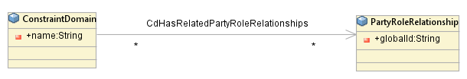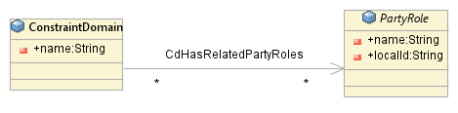

Figure 3‑3 Party Linkage to the CIM Core model

# Party model examples

## Employee

Here we create a PartyRoleRelationship for each organization parent and then add in all of its children.

This enables us to build an organization hierarchy and attach employees where required in the hierarchy, as shown in the instance diagram below.

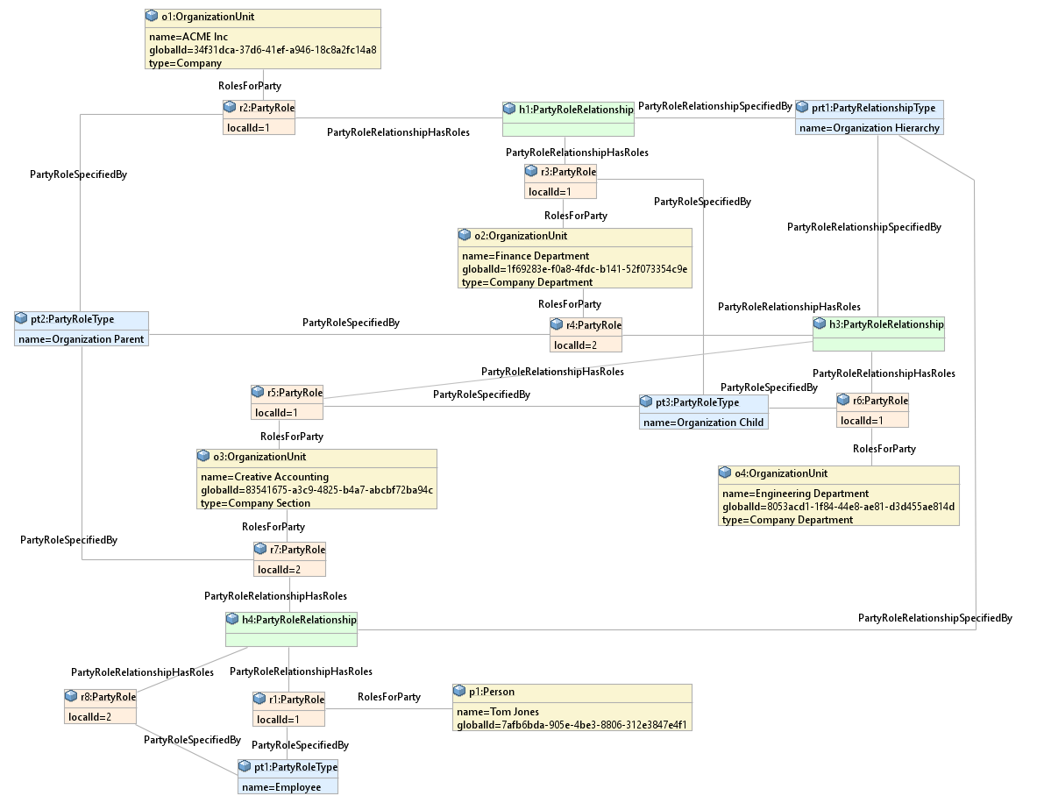

Figure 4‑2 Organization Hierarchy Example

## Customer Contact

In an implementation, model adjustment for efficiency may be considered. The case below provides an example.

In some cases, the implementer may want to not instantiate the PartyRoleRelationship and all of the PartyRoles. One case may be for customers of our company. In this case we may just decide to instantiate the ‘remote ends’ of the PartyRoleRelationship.

John Swan is a customer of ours and we have both email and phone contact details for him.

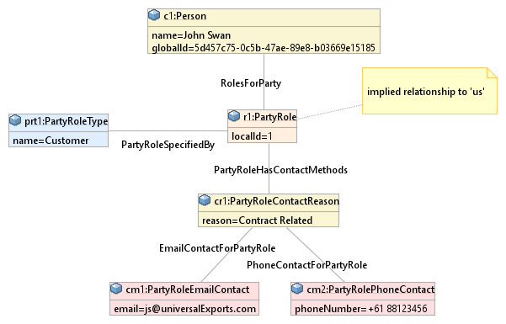

Figure 4‑4 Customer Contact Example

However, it can also be argued that there are probably many 1000s of customers, and corresponding PartyRole instances, but only one instance of the relationship and one instance of the supplier role. Hence, it is probably not a relevant saving. Keeping the navigation uniform is probably more appropriate.

An alternative way of considering the potential efficiency is that the PartyRoleRelationship has been collapsed into the Party.

Any adjustments of the sort discussed here are considered implementation choices and not considerations for the Core model.

## Device Owner

Our data center hosts equipment owned by various Tenants.

A ConstraintDomain is created to group all the devices for a given tenant, and it is then related to the PartyRole.

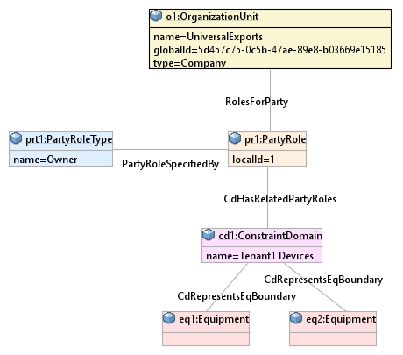

Figure 4‑6 Device Owner Example

**End of Document**

</gendoc><drop/>

To take latest template: <drop/>

* delete text from “Template version…” to end of file <drop/>
* insert a line in “Normal” style<drop/>
* insert text (Insert 🡪 Object 🡪 Text from File… (alt njf)) from: <drop/>

TR-512.GT_OnfCoreIm-CommonGendocTemplate-Fragments.docx <drop/>

Template version 0.0.11 1 June 2018 <drop/>

# Fragment: Insert class <drop/>

<fragment name=’insertClass’ importedBundles=’commons;gmf;papyrus’><drop/>  
<arg name=’cl’ type=’uml::Class’/><drop/>  
<arg name=’className’ type=’String’/><drop/>  
<arg name=’packageName’ type=’String’/><drop/>  
[if (not cl.qualifiedName.contains(packageName))]<drop/>  
[else] <drop/>  
[if(cl.name.contains(className))]<drop/>

Qualified Name: [cl.qualifiedName/]

[if cl.ownedComment->notEmpty()]<drop/>

[for (co:Comment | cl.ownedComment)] <drop/>

<dropEmpty>[cleanAndFormat(co._body.clean())/]</dropEmpty>

[/for]<drop/>

[else]To be provided

[/if]<drop/>

[if (cl.isAbstract)]<drop/>

This class is abstract.

[/if]<drop/>

[if (cl.oclAsType(uml::Class).general ->notEmpty())]<drop/>

Inherits properties from:

[for (gen:Class | cl.oclAsType(uml::Class).general)]<drop/>

* [gen.name/]

[/for]<drop/>

[/if]<drop/>

[for (st:Stereotype | cl.getAppliedStereotypes())]<drop/>  
[if(not st.name.contains(‘OpenModelClass’))]<drop/>

This class is [st.name/].

[else] <drop/>  
[/if]<drop/>  
[/for]<drop/>  
[else] <drop/>  
[/if]  
[/if]  
</fragment><drop/>

# Fragment: Insert standard diagram <drop/>

<fragment name=’insertStandardDiagram’ importedBundles=’commons;gmf;papyrus’><drop/>  
<arg name=’p’ type=’uml::Package’/><drop/>  
<arg name=’diagramName’ type=’String’/><drop/>  
<arg name=’diagramTitle’ type=’String’/><drop/>

[for (d:Diagram|p.getPapyrusDiagrams())]<drop/>

[if d.name.contains(diagramName)]

<drop/>

<image object='[d.getDiagram()/]' maxW='true' keepH='false' keepW = ‘false’></image>

CoreModel diagram: [d.name/]

Figure 12-1 [diagramTitle/]

[else]<drop/>

[/if]<drop/>

[/for]<drop/>  
</fragment><drop/>

# Fragment: Insert small diagram <drop/>

<fragment name=’insertSmallDiagram’ importedBundles=’commons;gmf;papyrus’><drop/>  
<arg name=’p’ type=’uml::Package’/><drop/>  
<arg name=’diagramName’ type=’String’/><drop/>  
<arg name=’diagramTitle’ type=’String’/><drop/>

[for (d:Diagram|p.getPapyrusDiagrams())]<drop/>

[if d.name.contains(diagramName)]

<drop/>

<image object='[d.getDiagram()/]' maxW='true' keepH='false' keepW = ‘false’></image>

CoreModel diagram: [d.name/]

Figure 13-1 [diagramTitle/]

[else]<drop/>

[/if]<drop/>

[/for]<drop/>  
</fragment><drop/>

# Fragment: Insert attribute row brief not Obsolete<drop/>

<fragment name=’insertAttributeRowBriefNotObsolete’ importedBundles=’commons;gmf;papyrus’><drop/>

Does not work unless we have Mature stereotype… <drop/>  
<arg name=’p’ type=’uml::Property’/><drop/>

[for (st:Stereotype | p.getAppliedStereotypes())]<drop/>

[if(not st.name.contains(‘OpenModelAttribute’))]

[if(not st.name.contains(‘Obsolete’))]

| [p.name/] | [for (st:Stereotype | p.getAppliedStereotypes())]<drop/>  [if(not st.name.contains(‘OpenModelAttribute’))] [st.name/]  [/if]<drop/>  [/for]<drop/>  Do NOT remove the previous line as word throws an error if the cell is empty <drop/> | [if p.ownedComment->notEmpty()]<drop/>  [for (c:Comment | p.ownedComment)] <drop/>  [cleanAndFormat(c._body.clean())/]  [/for]  [else] [if (p.name.contains (‘_’))]See referenced class  [else]To be provided  [/if]<drop/>  [/if]<drop/>  Do NOT remove the previous line as word throws an error if the cell is empty <drop/> |
| --- | --- | --- |

[/if]<drop/>

[/if]<drop/>

[/for]<drop/>  
</fragment><drop/>

# Fragment: Insert attribute row brief <drop/>

<fragment name=’insertAttributeRowBrief’ importedBundles=’commons;gmf;papyrus’><drop/>  
<arg name=’p’ type=’uml::Property’/><drop/>

| [p.name/] | [for (st:Stereotype | p.getAppliedStereotypes())]<drop/>  [if(not st.name.contains(‘OpenModelAttribute’))] [st.name/]  [/if]<drop/>  [/for]<drop/>  Do NOT remove the previous line as word throws an error if the cell is empty <drop/> | [if p.ownedComment->notEmpty()]<drop/>  [for (c:Comment | p.ownedComment)] <drop/>  [cleanAndFormat(c._body.clean())/]  [/for]  [else] [if (p.name.contains (‘_’))]See referenced class  [else]To be provided  [/if]<drop/>  [/if]<drop/>  Do NOT remove the previous line as word throws an error if the cell is empty <drop/> |
| --- | --- | --- |

</fragment><drop/>

# Fragment: Start attribute table brief <drop/>

<fragment name=’insertAttributeTableHeader’ importedBundles=’commons;gmf;papyrus’><drop/>  
<arg name=’cl’ type=’uml::Class’/><drop/>

|  |  |  |
| --- | --- | --- |
| **Attribute Name** | **Lifecycle Stereotype (empty = Mature)** | **Description** |

</fragment><drop/>

# Fragment: Insert Attribute table brief <drop/>

<fragment name=’insertAttributeTableBrief’ importedBundles=’commons;gmf;papyrus’ importedFragments='insertAttributeTableHeader;insertAttributeRowBrief’><drop/>  
<arg name=’cl’ type=’uml::Class’/><drop/>  
[if cl.ownedAttribute->notEmpty()]<drop/>

Table 2: Attributes for [cl.name/]

<table><drop/>

[cl.insertAttributeTableHeader ()/]

[for (p:Property|cl.ownedAttribute)]<drop/>

[if (not p.name.contains(‘_’))]<drop/>

[p.insertAttributeRowBrief ()/]

[/if]<drop/>

[/for]<drop/>

[for (p:Property|cl.ownedAttribute)]<drop/>

[if (p.name.contains(‘_’))]<drop/>

[p.insertAttributeRowBrief ()/]

[/if]<drop/>

[/for]<drop/>

</table><drop/>

[/if]<drop/>

</fragment><drop/>

# Fragment: Insert Ten Specified Attribute table brief <drop/>

<fragment name=’insertTenSpecifiedAttributeTableBrief’ importedBundles=’commons;gmf;papyrus’ importedFragments='insertAttributeTableHeader;insertAttributeRowBrief’><drop/>  
<arg name=’cl’ type=’uml::Class’/><drop/>

<arg name=’p1’ type=‘String’/><drop/>

<arg name=’p2’ type=‘String’/><drop/>  
<arg name=’p3’ type=‘String’/><drop/>  
<arg name=’p4’ type=‘String’/><drop/>  
<arg name=’p5’ type=‘String’/><drop/>  
<arg name=’p6’ type=‘String’/><drop/>  
<arg name=’p7’ type=‘String’/><drop/>  
<arg name=’p8’ type=‘String’/><drop/>  
<arg name=’p9’ type=‘String’/><drop/>  
<arg name=’p10’ type=‘String’/><drop/>  
[if cl.ownedAttribute->notEmpty()]<drop/>

Table 3: Attributes for [cl.name/]

<table><drop/>

[cl.insertAttributeTableHeader ()/]

[for (p:Property|cl.ownedAttribute)]<drop/>

[if (p.name.contains(p1) or p.name.contains(p2) or p.name.contains(p3) or p.name.contains(p4) or p.name.contains(p5) or p.name.contains(p6) or p.name.contains(p7) or p.name.contains(p8) or p.name.contains(p9) or p.name.contains(p10))]<drop/>

[if (not p.name.contains(‘_’))]<drop/>

[p.insertAttributeRowBrief ()/]

[/if]<drop/>

[/if]<drop/>

[if (p.name.contains(p1) or p.name.contains(p2) or p.name.contains(p3) or p.name.contains(p4) or p.name.contains(p5) or p.name.contains(p6) or p.name.contains(p7) or p.name.contains(p8) or p.name.contains(p9) or p.name.contains(p10))]<drop/>

[if (p.name.contains(‘_’))]<drop/>

[p.insertAttributeRowBrief ()/]

[/if]<drop/>

[/if]<drop/>

[/for]<drop/>

</table><drop/>

[/if]<drop/>

</fragment><drop/>

# Fragment: Insert DataType <drop/>

<fragment name=’insertDataType’ importedBundles=’commons;gmf;papyrus’><drop/>  
<arg name=’dt’ type=’uml::DataType’/><drop/>  
<arg name=’dataTypeName’ type=’String’/><drop/>  
<arg name=’packageName’ type=’String’/><drop/>  
[if (dt.qualifiedName.contains(packageName))]<drop/>  
[if(dt.name.contains(dataTypeName))]<drop/>

Qualified Name: [dt.qualifiedName/]

[for (co:Comment | dt.ownedComment)]<drop/>

<dropEmpty>[cleanAndFormat(co._body.clean())/]</dropEmpty>

[/for]<drop/>  
[if (dt.oclAsType(uml::DataType).general ->notEmpty())]<drop/>

Inherits properties from:

[for (tp:DataType | dt.oclAsType(uml::DataType).general)]<drop/>

* [tp.name/]

[/for]<drop/>

[for (gen:Class | dt.oclAsType(uml::DataType).general)]<drop/>

* [gen.name/]

[/for]<drop/>

[/if]<drop/>

[for (st:Stereotype | dt.getAppliedStereotypes())]<drop/>  
This class is [st.name/].

[/for]<drop/>  
[else] <drop/>  
[/if]  
[/if]  
</fragment><drop/>

# Fragment: Start Data Type attribute table brief <drop/>

<fragment name=’insertDataTypeAttributeTableHeader’ importedBundles=’commons;gmf;papyrus’><drop/>  
<arg name=’dt’ type=’uml::DataType’/><drop/>

|  |  |  |
| --- | --- | --- |
| **Attribute Name** | **Lifecycle Stereotype (empty = Mature)** | **Description** |

</fragment><drop/>

# Fragment: Insert Data Type Attribute table brief <drop/>

<fragment name=’insertDataTypeAttributeTableBrief’ importedBundles=’commons;gmf;papyrus’ importedFragments='insertDataTypeAttributeTableHeader;insertAttributeRowBrief’><drop/>  
<arg name=’dt’ type=’uml::DataType’/><drop/>  
[if dt.ownedAttribute->notEmpty()]<drop/>

Table 4: Attributes for [dt.name/]

<table><drop/>

[dt.insertDataTypeAttributeTableHeader ()/]

[for (p:Property|dt.ownedAttribute)]<drop/>

[p.insertAttributeRowBrief ()/]

[/for]<drop/>

</table><drop/>

[/if]<drop/>

</fragment><drop/>

# Fragment: Insert enums <drop/>

<fragment name=’insertEnums’ importedBundles=’commons;gmf;papyrus’><drop/>  
<arg name=’dt’ type=’uml::DataType’/><drop/>

#### [dt.name/]

Qualified Name: [dt.qualifiedName/]

[for (co:Comment | dt.ownedComment)]<drop/>

<dropEmpty>[cleanAndFormat(co._body.clean())/]</dropEmpty>

[/for]<drop/>

Applied stereotypes:

[if dt.getAppliedStereotypes()->notEmpty()] <drop/>

[for (st:Stereotype | dt.getAppliedStereotypes())]<drop/>

* [st.name/]

[/for]<drop/>

[else] No stereotypes applied

[/if]<drop/>

[if (dt.oclAsType(uml::DataType).general ->notEmpty())]<drop/>

Inherits literals from:

[for (tp:DataType | dt.oclAsType(uml::DataType).general)]<drop/>

* [tp.name/]

[/for]

[/if]<drop/>

[if (dt.oclAsType(Enumeration).ownedLiteral->notEmpty())]<drop/>

Contains Enumeration Literals:

[for (e:EnumerationLiteral|dt.oclAsType(Enumeration).ownedLiteral)]<drop/>

* [e.name/]:
  + [for (co:Comment | e.ownedComment)]<drop/>
  + <dropEmpty>[cleanAndFormat(co._body.clean())/]
  + </dropEmpty>[/for]<drop/>
  + [if dt.getAppliedStereotypes()->notEmpty()] <drop/>
  + Applied stereotypes:
    - [for (st:Stereotype | e.getAppliedStereotypes())]<drop/>
    - [st.name/]
    - [/for]<drop/>
  + [/if]<drop/>

[/for]<drop/>

[/if]<drop/>

</fragment><drop/>