<config>  
<output path=’C:\Users\ndavis\git\OnfInfoModelOutput\ModelDescriptions\TR-512.A.1_OnfCoreIm-AppendixOverview.docx' />  
</config>

<context model=’C:\Users\ndavis\git\ONFInfoModel\OnfModel\CoreModel.uml' element=’{0}’ importedBundles='gmf;papyrus' searchMetamodels='true'/>

<gendoc><drop/>

Change path substrings above from “{path for output files}\” to your local path for the output files and “{path for CoreModel}\” to your local path for the Core Model. <drop/>

DELETE: Prior to publishing this –gd.docx (including for review), change path substrings above from “C:\Users\ndavis\git\OnfInfoModelOutput\” to “{path for output files}\” and from “C:\Users\ndavis\git\ONFInfoModel\OnfModel\” to “{path for CoreModel}\” <drop/>



Core Information Model (CoreModel)

TR-512.A.1

Appendix Overview

Version 1.5

September 2021

ONF Document Type: Technical Recommendation

ONF Document Name: Core Information Model version 1.5

**Disclaimer**

THIS SPECIFICATION IS PROVIDED "AS IS" WITH NO WARRANTIES WHATSOEVER, INCLUDING ANY WARRANTY OF MERCHANTABILITY, NONINFRINGEMENT, FITNESS FOR ANY PARTICULAR PURPOSE, OR ANY WARRANTY OTHERWISE ARISING OUT OF ANY PROPOSAL, SPECIFICATION OR SAMPLE.

Any marks and brands contained herein are the property of their respective owners.

Open Networking Foundation  
1000 El Camino Real, Suite 100, Menlo Park, CA 94025  
[www.opennetworking.org](http://www.opennetworking.org)

©2021 Open Networking Foundation. All rights reserved.

Open Networking Foundation, the ONF symbol, and OpenFlow are registered trademarks of the Open Networking Foundation, in the United States and/or in other countries. All other brands, products, or service names are or may be trademarks or service marks of, and are used to identify, products or services of their respective owners.

**Important note**

This Technical Recommendations has been approved by the Project TST, but has not been approved by the ONF board.  This Technical Recommendation is an update to a previously released TR specification, but it has been approved under the ONF publishing guidelines for ‘Informational’ publications that allow Project technical steering teams (TSTs) to authorize publication of Informational documents.  The designation of ‘-info’ at the end of the document ID also reflects that the project team (not the ONF board) approved this TR.

Finalizing this document once generated… delete this text prior to publication:

* Replace “{{..}}” with square brackets (which trip up Gendoc)
* Select text in document from beginning of table of contents (first line) to end of document
  + Click menu item “Update Field” (on this large block of text)
    - if “Update Table…” dialogue appears select “Update entire table”
  + Repeat “update fields” 2 more times (on the same large block of text)
    - if “Update Table…” dialogue appears select “Update entire table”
* Remove reviewer comment

Note that the table of contents and figures need to be updated several times as the table length changes the page numbering and the cross references will need to be re-updated.

Table of Contents

Disclaimer 2

Open Networking Foundation 2

Document History 4

1 Introduction 4

2 References 4

3 Definitions 4

4 Conventions 4

5 Introduction to the Core Network Model 5

5.1 Understanding the figures 6

6 Forwarding and Termination model detail 6

6.1.1.1 LogicalTerminationPoint (LTP) 7

6.1.1.2 LayerProtocol (LP) 8

6.1.2 Forwarding 9

6.1.2.1 ForwardingDomain (FD) 9

6.1.2.2 ForwardingConstruct (FC) 10

6.1.2.3 FcPort 11

6.1.2.4 Link 12

6.1.2.5 LinkPort 13

6.1.3 NetworkElement, NetworkControlDomain and SdnController 14

7 Explanatory Figures 14

7.1 Forwarding 14

7.1.1 Basic Forwarding 14

7.1.2 Forwarding the topology 15

7.2 Termination 16

7.3 Directionality 22

8 Fragment: Insert class <drop/> 28

9 Fragment: Insert standard diagram <drop/> 28

10 Fragment: Insert small diagram <drop/> 29

11 Fragment: Insert attribute row brief <drop/> 30

12 Fragment: Start attribute table brief <drop/> 30

13 Fragment: Insert Attribute table brief (old) <drop/> 30

14 Fragment: Insert Attribute table brief <drop/> 31

15 Fragment: Insert Ten Specified Attribute table brief <drop/> 31

List of Figures

Figure 1-1 Methodology of IM and DS Development 6

Document History

| **Version** | **Date** | **Description of Change** |
| --- | --- | --- |
|  |  | Appendix material was not published prior to Version 1.3 |
| 1.3 | September 2017 | Version 1.3 {{Published via wiki only}} |
| 1.3.1 | January 2018 | Addition of text related to approval status. |
| 1.4 | November 2018 | Addition of further description and text on new appendix documents. |
| 1.5 | September 2021 | Enhancements to model structure |

# Introduction to the document suite

This document is an appendix of the addendum to the TR-512 ONF Core Information Model and forms part of the description of the ONF-CIM. For general overview material and references to the other parts refer to [TR-512.1](../TR-512.1_OnfCoreIm-Overview.pdf).

## References

For a full list of references see [TR-512.1](../TR-512.1_OnfCoreIm-Overview.pdf).

## Definitions

For a full list of definition see [TR-512.1](../TR-512.1_OnfCoreIm-Overview.pdf).

## Conventions

See [TR-512.1](../TR-512.1_OnfCoreIm-Overview.pdf) for an explanation of:

* UML conventions
* Lifecycle Stereotypes
* Diagram symbol set

## Viewing UML diagrams

Some of the UML diagrams are very dense. To view them either zoom (sometimes to 400%) or open the associated image file (and zoom appropriately) or open the corresponding UML diagram via Papyrus (for each figure with a UML diagram the UML model diagram name is provided under the figure or within the figure).

## Understanding the figures

Figures showing fragments of the model using standard UML symbols and also figures illustrating application of the model are provided throughout this document. Many of the application-oriented figures also provide UML class diagrams for the corresponding model fragments (see [TR-512.1](../TR-512.1_OnfCoreIm-Overview.pdf) for diagram symbol sets). All UML diagrams depict a subset of the relationships between the classes, such as inheritance (i.e. specialization), association relationships (such as aggregation and composition), and conditional features or capabilities. Some UML diagrams also show further details of the individual classes, such as their attributes and the data types used by the attributes.

# Introduction to the Appendix

This section provides an overview of the TR-512.A.x appendix documents (the “A series”). Each appendix document described has a hyperlink that will take you to the document in your system[1]. The documents are all in the “ModelDescriptions” folder.

These appendix documents provide descriptive support for the CIM by explaining the rationale behind the model and giving examples. The Appendix documents are summarized in the following sections.

## Model Structural Patterns and Architecture ([TR-512.A.2](TR-512.A.2_OnfCoreIm-Appendix-ModelStructurePatternsAndArchitecture.pdf))

This document explains the model patterns and architecture that underpin the CIM. It:

* Works through the key patterns in the model such as hypergraph and component-system.
* Discusses the fundamentals of transport and how these are described in terms of the patterns
* Shows some high level examples of the patterns
* Explains how the patterns can be intertwined to form the architecture of the network from a control perspective

The descriptions in this document are built from descriptions in earlier referenced works.



Figure 6-17 The Component

In TR-512 V1.4, the Component-system pattern has been further defined.

The following figure shows the essential structure of the Component – System pattern. The essence of Component – Port remains as above, but the System has gained explicit boundary ports. This enhanced model form better enables the recursion from opaque component through System surface to System detail.

[for(p:Package|Package.allInstances())]<drop/>

Inserts the diagram identified in first quotes with the title identified in second quotes <drop/>  
[p.insertStandardDiagram(‘Patterns-ComponentSystemPattern’, ’The Component – System Pattern’)/]

[/for]<drop/>

## Rationale Behind the CIM ([TR-512.A.3](TR-512.A.3_OnfCoreIm-Appendix-ModelRationale.pdf))

This document provides the drivers for the CIM work and highlights benefits of the work to the industry.

The document explains that management of networks and devices today is a complex operational challenge resulting from, and exacerbated by, the plethora of conflicting standards and incompatible implementations. Almost all of the existing models use inconsistent terminology and outdated concepts that aren’t applicable to SDN/NFV scenarios.

The document goes on the explain that the ONF Information Modeling team:

* Has defined a consistent set of fundamental concepts and the relationship among them by leveraging the knowledge gained from years of management standards evolution and pragmatic implementation/software development experience. These concepts are capable of representing both legacy management and SDN/NFV concepts/scenarios, while allowing for consistent management in hybrid environments.
* Employs a realistic federated model with a layered model architecture and managed dependencies. This is comprised of a stable core model (which is itself modular for scalability) and technology-specific model extensions that can be added in a timely manner without destabilizing the core.

It is emphasized that the ONF Information model is not a purist, theoretical artifact, but a pragmatic one that forms part of a tooling chain, enabling context and technology specific interfaces in different languages to be generated from a key set of definitions.

The document explains the growing utilization of the ONF CIM across various bodies such as ITU-T SG15, ETSI NFV, MEF and TMF, as well as by some major service providers.

## Analogue and Media (L0) examples ([TR-512.A.4](TR-512.A.4_OnfCoreIm-Appendix-AnalogueAndMediaExamples-L0.pdf))

This document explains the model in terms of examples applied to the analogue space of Layer 0 (L0). The document focuses on optical photonics and guides the use of the model to represent both device functions and network structures.



Figure 3-14 Network Domain Channel formed from Media Channels

In V1.4 overhead and monitoring were considered and this led to a bidirectional treatment of assemblies of channels.



Figure 6-35 Simplified representation showing OMS/OTS, NMCA, and OTSi termniation

## Circuit Switched (L1 & L2) examples ([TR-512.A.5](TR-512.A.5_OnfCoreIm-Appendix-CircuitSwitchedExamples-L1-L2.pdf))

This document was added in V1.3.1. It introduces a model of layer protocols for circuit switched systems. The figures show a compact diagrammatic representation of the order of layer protocols for various port types.



Figure 3-14 Basic OTN device example showing compact representation of a STM-16 Tributary

At this point the document provides a few basic examples. It is intended that, in subsequent releases the document will progress from basic single device circuit switched examples through to complex protection scenarios and multi-layer circuit switched examples. The document will also provide multi-layer examples where:

* Circuit switched forwarding is carried by an analogue server
* An analogue signal is carried by a circuit switched system
* There is a critical differential delay and a critical round trip delay consideration

## Packet Switched (L2 & L3) examples ([TR-512.A.6](TR-512.A.6_OnfCoreIm-Appendix-PacketSwitchedExamples-L2-L3.pdf))

The document provides a view of basic packet switched examples and then works through to complex network scenarios including multi-layer packet switched examples.



Figure 3-2 STM-1 Circuit Emulation Service over Ethernet

The document provides multi-layer examples where:

* Packet switched forwarding is carried by a circuit switched server
* Circuit switched forwarding is carried by a packet switched server
* Packet switched forwarding is carried by an analogue server.

## Control and Interaction examples ([TR-512.A.7](TR-512.A.7_OnfCoreIm-Appendix-ControlAndInteractionExamples.pdf))

The document focusses on examples of control structures progressing from basic single device control examples through to complex peered control and multi-level control scenarios.

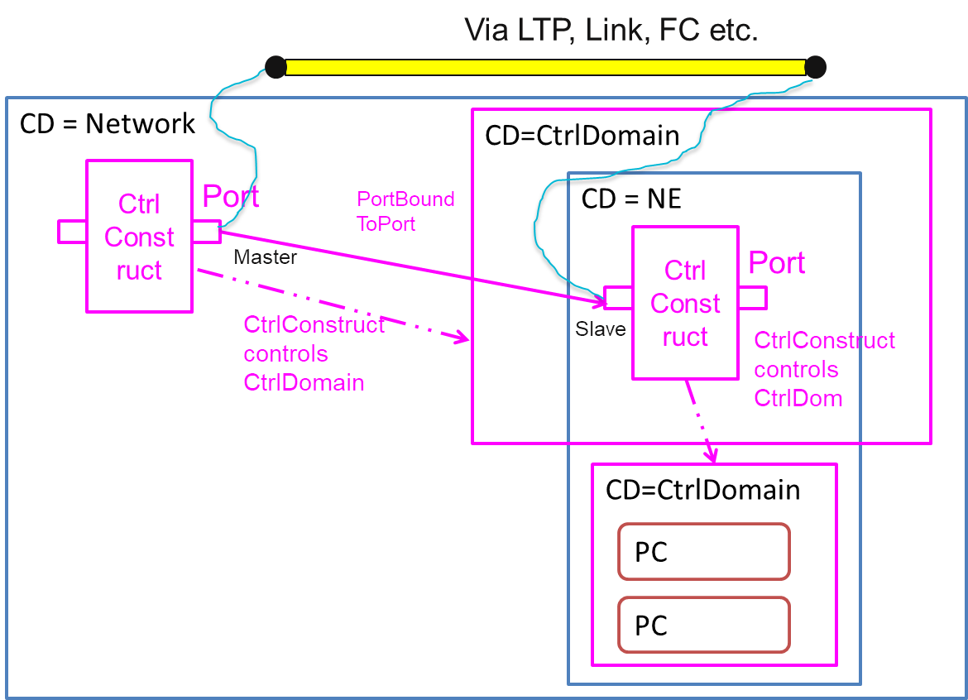

Figure 3‑2 - Basic ControlConstruct layering Use Case

The document will consider interaction examples in a future release.

## Timing & Synchronization examples ([TR-512.A.8](TR-512.A.8_OnfCoreIm-Appendix-TimingAndSynchronizationExamples.pdf))

This document provides a description of time and frequency synchronization in a telecommunications network and provides examples of the use of the model to represent these synchronization functions.



Figure 6-17 Example synchronization distribution network

## Processing Construct examples ([TR-512.A.9](TR-512.A.9_OnfCoreIm-Appendix-ProcessingConstructExamples.pdf))

This document provides various examples of the use of the ProcessingConstruct model to represent complex functions.



Figure 6-17 “Virtual Device”

## Specification examples ([TR-512.A.10](TR-512.A.10_OnfCoreIm-Appendix-SpecificationExamples.pdf))

This document provides various examples of the use of the CIM specification model to express constraints in various real contexts.



Figure 6-17 Example Use of FD Spec

## Resilience examples ([TR-512.A.11](TR-512.A.11_OnfCoreIm-Appendix-ResilienceExamples.pdf))

This document provides various examples of the use of the ONF CIM to represent common resilience schemes. This document is not exhaustive. The model is built from a several generalized constructs that should readily support many other protection schemes not described here.



Figure 6-2 Simple summary example of 1?1 cases (represented via partition)

## Application (L4 and above) examples (TR-512.A.12)

This document is not part of this release, it will be provided in a later release. The document will progress from basic simple application through to complex application assemblies.

## Software examples ([TR-512.A.13](TR-512.A.13_OnfCoreIm-Appendix-SoftwareExamples.pdf))

This document provides examples of the use of the CIM software model starting from basic cases such as a routing process in a router as shown below.



Figure 6-17 The Routing “process” on router

The document progresses from the basic examples through increasingly complex cases to sophisticated examples including details of control.

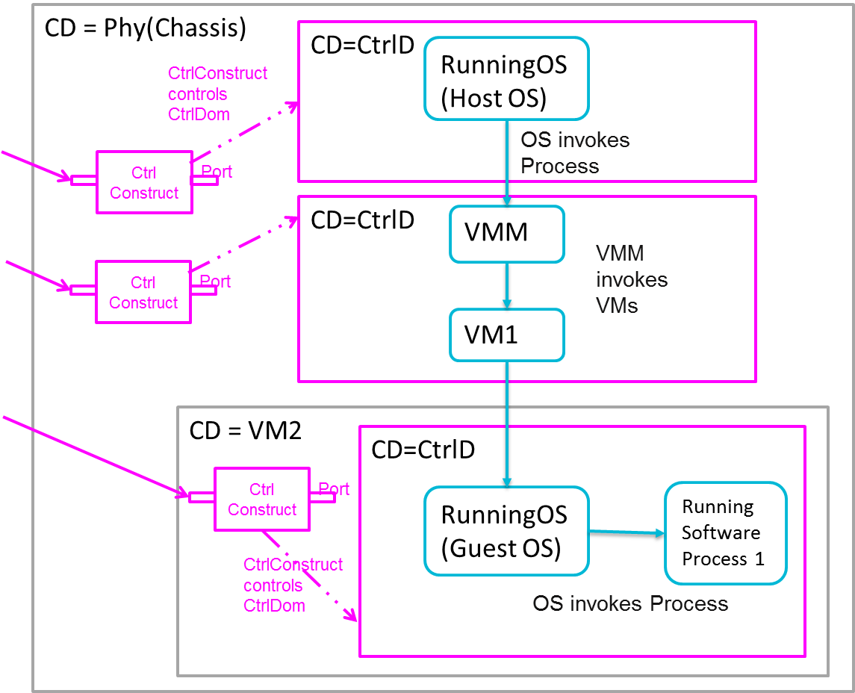

Figure 6-17 Considering control

**End of Document**

</gendoc><drop/>

To take latest template: <drop/>

* delete text from “Template version…” to end of file <drop/>
* insert a line in “Normal” style<drop/>
* insert text (Insert 🡪 Object 🡪 Text from File… (alt njf)) from: <drop/>
  + TR-512.GT_OnfCoreIm-CommonGendocTemplate-Fragments.docx <drop/>

Template version 0.0.11 1 June 2018 <drop/>

# Fragment: Insert class <drop/>

<fragment name=’insertClass’ importedBundles=’commons;gmf;papyrus’><drop/>  
<arg name=’cl’ type=’uml::Class’/><drop/>  
<arg name=’className’ type=’String’/><drop/>  
<arg name=’packageName’ type=’String’/><drop/>  
[if (not cl.qualifiedName.contains(packageName))]<drop/>  
[else] <drop/>  
[if(cl.name.contains(className))]<drop/>

Qualified Name: [cl.qualifiedName/]

[if cl.ownedComment->notEmpty()]<drop/>

[for (co:Comment | cl.ownedComment)] <drop/>

<dropEmpty>[cleanAndFormat(co._body.clean())/]</dropEmpty>

[/for]<drop/>

[else]To be provided

[/if]<drop/>

[if (cl.isAbstract)]<drop/>

This class is abstract.

[/if]<drop/>

[if (cl.oclAsType(uml::Class).general ->notEmpty())]<drop/>

Inherits properties from:

[for (gen:Class | cl.oclAsType(uml::Class).general)]<drop/>

* [gen.name/]

[/for]<drop/>

[/if]<drop/>

[for (st:Stereotype | cl.getAppliedStereotypes())]<drop/>  
[if(not st.name.contains(‘OpenModelClass’))]<drop/>

This class is [st.name/].

[else] <drop/>  
[/if]<drop/>  
[/for]<drop/>  
[else] <drop/>  
[/if]  
[/if]  
</fragment><drop/>

# Fragment: Insert standard diagram <drop/>

<fragment name=’insertStandardDiagram’ importedBundles=’commons;gmf;papyrus’><drop/>  
<arg name=’p’ type=’uml::Package’/><drop/>  
<arg name=’diagramName’ type=’String’/><drop/>  
<arg name=’diagramTitle’ type=’String’/><drop/>

[for (d:Diagram|p.getPapyrusDiagrams())]<drop/>

[if d.name.contains(diagramName)]

<drop/>

<image object='[d.getDiagram()/]' maxW='true' keepH='false' keepW = ‘false’></image>

CoreModel diagram: [d.name/]

Figure 6-2 [diagramTitle/]

[else]<drop/>

[/if]<drop/>

[/for]<drop/>  
</fragment><drop/>

# Fragment: Insert small diagram <drop/>

<fragment name=’insertSmallDiagram’ importedBundles=’commons;gmf;papyrus’><drop/>  
<arg name=’p’ type=’uml::Package’/><drop/>  
<arg name=’diagramName’ type=’String’/><drop/>  
<arg name=’diagramTitle’ type=’String’/><drop/>

[for (d:Diagram|p.getPapyrusDiagrams())]<drop/>

[if d.name.contains(diagramName)]

<drop/>

<image object='[d.getDiagram()/]' maxW='true' keepH='false' keepW = ‘false’></image>

CoreModel diagram: [d.name/]

Figure 6-2 [diagramTitle/]

[else]<drop/>

[/if]<drop/>

[/for]<drop/>  
</fragment><drop/>

# Fragment: Insert attribute row brief not Obsolete<drop/>

<fragment name=’insertAttributeRowBriefNotObsolete’ importedBundles=’commons;gmf;papyrus’><drop/>

Does not work unless we have Mature stereotype… <drop/>  
<arg name=’p’ type=’uml::Property’/><drop/>

[for (st:Stereotype | p.getAppliedStereotypes())]<drop/>

[if(not st.name.contains(‘OpenModelAttribute’))]

[if(not st.name.contains(‘Obsolete’))]

| [p.name/] | [for (st:Stereotype | p.getAppliedStereotypes())]<drop/>  [if(not st.name.contains(‘OpenModelAttribute’))] [st.name/]  [/if]<drop/>  [/for]<drop/>  Do NOT remove the previous line as word throws an error if the cell is empty <drop/> | [if p.ownedComment->notEmpty()]<drop/>  [for (c:Comment | p.ownedComment)] <drop/>  [cleanAndFormat(c._body.clean())/]  [/for]  [else] [if (p.name.contains (‘_’))]See referenced class  [else]To be provided  [/if]<drop/>  [/if]<drop/>  Do NOT remove the previous line as word throws an error if the cell is empty <drop/> |
| --- | --- | --- |

[/if]<drop/>

[/if]<drop/>

[/for]<drop/>  
</fragment><drop/>

# Fragment: Insert attribute row brief <drop/>

<fragment name=’insertAttributeRowBrief’ importedBundles=’commons;gmf;papyrus’><drop/>  
<arg name=’p’ type=’uml::Property’/><drop/>

| [p.name/] | [for (st:Stereotype | p.getAppliedStereotypes())]<drop/>  [if(not st.name.contains(‘OpenModelAttribute’))] [st.name/]  [/if]<drop/>  [/for]<drop/>  Do NOT remove the previous line as word throws an error if the cell is empty <drop/> | [if p.ownedComment->notEmpty()]<drop/>  [for (c:Comment | p.ownedComment)] <drop/>  [cleanAndFormat(c._body.clean())/]  [/for]  [else] [if (p.name.contains (‘_’))]See referenced class  [else]To be provided  [/if]<drop/>  [/if]<drop/>  Do NOT remove the previous line as word throws an error if the cell is empty <drop/> |
| --- | --- | --- |

</fragment><drop/>

# Fragment: Start attribute table brief <drop/>

<fragment name=’insertAttributeTableHeader’ importedBundles=’commons;gmf;papyrus’><drop/>  
<arg name=’cl’ type=’uml::Class’/><drop/>

|  |  |  |
| --- | --- | --- |
| **Attribute Name** | **Lifecycle Stereotype (empty = Mature)** | **Description** |

</fragment><drop/>

# Fragment: Insert Attribute table brief <drop/>

<fragment name=’insertAttributeTableBrief’ importedBundles=’commons;gmf;papyrus’ importedFragments='insertAttributeTableHeader;insertAttributeRowBrief’><drop/>  
<arg name=’cl’ type=’uml::Class’/><drop/>  
[if cl.ownedAttribute->notEmpty()]<drop/>

Table 1: Attributes for [cl.name/]

<table><drop/>

[cl.insertAttributeTableHeader ()/]

[for (p:Property|cl.ownedAttribute)]<drop/>

[if (not p.name.contains(‘_’))]<drop/>

[p.insertAttributeRowBrief ()/]

[/if]<drop/>

[/for]<drop/>

[for (p:Property|cl.ownedAttribute)]<drop/>

[if (p.name.contains(‘_’))]<drop/>

[p.insertAttributeRowBrief ()/]

[/if]<drop/>

[/for]<drop/>

</table><drop/>

[/if]<drop/>

</fragment><drop/>

# Fragment: Insert Ten Specified Attribute table brief <drop/>

<fragment name=’insertTenSpecifiedAttributeTableBrief’ importedBundles=’commons;gmf;papyrus’ importedFragments='insertAttributeTableHeader;insertAttributeRowBrief’><drop/>  
<arg name=’cl’ type=’uml::Class’/><drop/>

<arg name=’p1’ type=‘String’/><drop/>

<arg name=’p2’ type=‘String’/><drop/>  
<arg name=’p3’ type=‘String’/><drop/>  
<arg name=’p4’ type=‘String’/><drop/>  
<arg name=’p5’ type=‘String’/><drop/>  
<arg name=’p6’ type=‘String’/><drop/>  
<arg name=’p7’ type=‘String’/><drop/>  
<arg name=’p8’ type=‘String’/><drop/>  
<arg name=’p9’ type=‘String’/><drop/>  
<arg name=’p10’ type=‘String’/><drop/>  
[if cl.ownedAttribute->notEmpty()]<drop/>

Table 1: Attributes for [cl.name/]

<table><drop/>

[cl.insertAttributeTableHeader ()/]

[for (p:Property|cl.ownedAttribute)]<drop/>

[if (p.name.contains(p1) or p.name.contains(p2) or p.name.contains(p3) or p.name.contains(p4) or p.name.contains(p5) or p.name.contains(p6) or p.name.contains(p7) or p.name.contains(p8) or p.name.contains(p9) or p.name.contains(p10))]<drop/>

[if (not p.name.contains(‘_’))]<drop/>

[p.insertAttributeRowBrief ()/]

[/if]<drop/>

[/if]<drop/>

[if (p.name.contains(p1) or p.name.contains(p2) or p.name.contains(p3) or p.name.contains(p4) or p.name.contains(p5) or p.name.contains(p6) or p.name.contains(p7) or p.name.contains(p8) or p.name.contains(p9) or p.name.contains(p10))]<drop/>

[if (p.name.contains(‘_’))]<drop/>

[p.insertAttributeRowBrief ()/]

[/if]<drop/>

[/if]<drop/>

[/for]<drop/>

</table><drop/>

[/if]<drop/>

</fragment><drop/>

# Fragment: Insert DataType <drop/>

<fragment name=’insertDataType’ importedBundles=’commons;gmf;papyrus’><drop/>  
<arg name=’dt’ type=’uml::DataType’/><drop/>  
<arg name=’dataTypeName’ type=’String’/><drop/>  
<arg name=’packageName’ type=’String’/><drop/>  
[if (dt.qualifiedName.contains(packageName))]<drop/>  
[if(dt.name.contains(dataTypeName))]<drop/>

Qualified Name: [dt.qualifiedName/]

[for (co:Comment | dt.ownedComment)]<drop/>

<dropEmpty>[cleanAndFormat(co._body.clean())/]</dropEmpty>

[/for]<drop/>  
[if (dt.oclAsType(uml::DataType).general ->notEmpty())]<drop/>

Inherits properties from:

[for (tp:DataType | dt.oclAsType(uml::DataType).general)]<drop/>

* [tp.name/]

[/for]<drop/>

[for (gen:Class | dt.oclAsType(uml::DataType).general)]<drop/>

* [gen.name/]

[/for]<drop/>

[/if]<drop/>

[for (st:Stereotype | dt.getAppliedStereotypes())]<drop/>  
This class is [st.name/].

[/for]<drop/>  
[else] <drop/>  
[/if]  
[/if]  
</fragment><drop/>

# Fragment: Start Data Type attribute table brief <drop/>

<fragment name=’insertDataTypeAttributeTableHeader’ importedBundles=’commons;gmf;papyrus’><drop/>  
<arg name=’dt’ type=’uml::DataType’/><drop/>

|  |  |  |
| --- | --- | --- |
| **Attribute Name** | **Lifecycle Stereotype (empty = Mature)** | **Description** |

</fragment><drop/>

# Fragment: Insert Data Type Attribute table brief <drop/>

<fragment name=’insertDataTypeAttributeTableBrief’ importedBundles=’commons;gmf;papyrus’ importedFragments='insertDataTypeAttributeTableHeader;insertAttributeRowBrief’><drop/>  
<arg name=’dt’ type=’uml::DataType’/><drop/>  
[if dt.ownedAttribute->notEmpty()]<drop/>

Table 1: Attributes for [dt.name/]

<table><drop/>

[dt.insertDataTypeAttributeTableHeader ()/]

[for (p:Property|dt.ownedAttribute)]<drop/>

[p.insertAttributeRowBrief ()/]

[/for]<drop/>

</table><drop/>

[/if]<drop/>

</fragment><drop/>

# Fragment: Insert enums <drop/>

<fragment name=’insertEnums’ importedBundles=’commons;gmf;papyrus’><drop/>  
<arg name=’dt’ type=’uml::DataType’/><drop/>

#### [dt.name/]

Qualified Name: [dt.qualifiedName/]

[for (co:Comment | dt.ownedComment)]<drop/>

<dropEmpty>[cleanAndFormat(co._body.clean())/]</dropEmpty>

[/for]<drop/>

Applied stereotypes:

[if dt.getAppliedStereotypes()->notEmpty()] <drop/>

[for (st:Stereotype | dt.getAppliedStereotypes())]<drop/>

* [st.name/]

[/for]<drop/>

[else] No stereotypes applied

[/if]<drop/>

[if (dt.oclAsType(uml::DataType).general ->notEmpty())]<drop/>

Inherits literals from:

[for (tp:DataType | dt.oclAsType(uml::DataType).general)]<drop/>

* [tp.name/]

[/for]

[/if]<drop/>

[if (dt.oclAsType(Enumeration).ownedLiteral->notEmpty())]<drop/>

Contains Enumeration Literals:

[for (e:EnumerationLiteral|dt.oclAsType(Enumeration).ownedLiteral)]<drop/>

* [e.name/]:
  + [for (co:Comment | e.ownedComment)]<drop/>
  + <dropEmpty>[cleanAndFormat(co._body.clean())/]
  + </dropEmpty>[/for]<drop/>
  + [if dt.getAppliedStereotypes()->notEmpty()] <drop/>
  + Applied stereotypes:
    - [for (st:Stereotype | e.getAppliedStereotypes())]<drop/>
    - [st.name/]
    - [/for]<drop/>
  + [/if]<drop/>

[/for]<drop/>

[/if]<drop/>

</fragment><drop/>

1. The link will only work if you have unzipped the whole package as one.